**Introduction**

Machine learning has been gaining momentum over last decades: self-driving cars, efficient web search, speech and image recognition. The successful results gradually propagate into our daily live. **Machine learning** is a class of artificial intelligence methods, which allows the computer to operate in a self-learning mode, without being explicitly programmed. It is a very interesting and complex topic, which could drive the future of technology.

Two months ago I wanted to change my life and I enrolled in the programming course from [Digital Academy — Czechitas, Prague](https://www.czechitas.cz/en/portfolio/digital-academy). In addition to studying basic subjects, my task was to invent and develop my own project. I decided to focus on machine learning. During my course I was lucky to meet a mentor — Jan Matoušek from [Data Mind](http://www.datamind.cz/en), who helped me to discover a new world of artificial neural networks.

**Neural network**

Is a machine learning algorithm, which is built on the principle of the organization and functioning of biological neural networks. This concept arose in an attempt to simulate the processes occurring in the brain by Warren McCulloch and Walter Pitts in 1943.

Neural networks consist of individual units called **neurons**. Neurons are located in a series of groups — **layers**(see figure allow). Neurons in each layer are connected to neurons of the next layer. Data comes from the input layer to the output layer along these compounds. Each individual node performs a simple mathematical calculation. Тhen it transmits its data to all the nodes it is connected to.

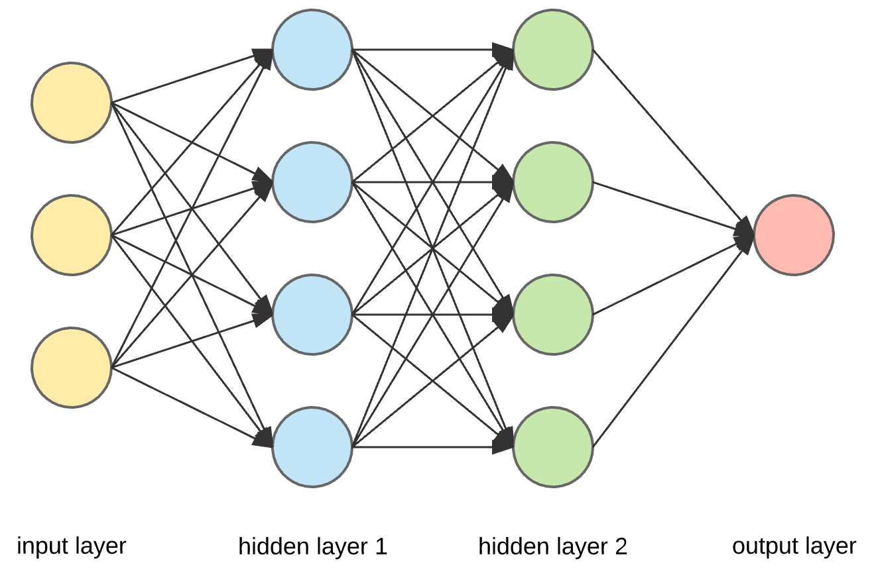

The last wave of neural networks came in connection with the increase in computing power and the accumulation of experience. That brought **Deep learning**, where technological structures of neural networks have become more complex and able to solve a wide range of tasks that could not be effectively solved before. Image classification is a prominent example.

**Convolutional neural networks and image classification**

Convolutional neural networks (CNN) is a special architecture of artificial neural networks, proposed by Yann LeCun in 1988. CNN uses some features of the visual cortex. One of the most popular uses of this architecture is image classification. For example Facebook uses CNN for automatic tagging algorithms, Amazon — for generating product recommendations and Google — for search through among users’ photos.

Let us consider the use of CNN for image classification in more detail. The main task of image classification is acceptance of the input image and the following definition of its class. This is a skill that people learn from their birth and are able to easily determine that the image in the picture is an elephant. But the computer sees the pictures quite differently:

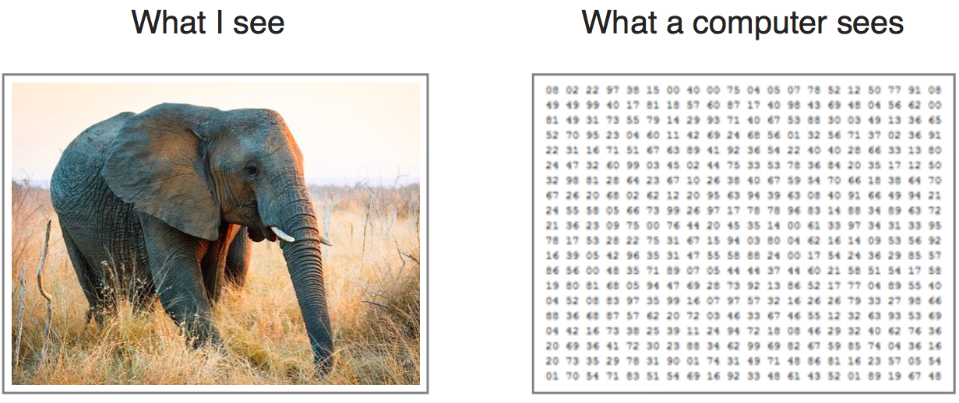

Instead of the image, the computer sees an array of pixels. For example, if image size is 300 x 300. In this case, the size of the array will be 300x300x3. Where 300 is width, next 300 is height and 3 is RGB channel values. The computer is assigned a value from 0 to 255 to each of these numbers. Тhis value describes the intensity of the pixel at each point.

To solve this problem the computer looks for the characteristics of the base level. In human understanding such characteristics are for example the trunk or large ears. For the computer, these characteristics are boundaries or curvatures. And then through the groups of convolutional layers the computer constructs more abstract concepts.

In more detail: the image is passed through a series of convolutional, nonlinear, pooling layers and fully connected layers, and then generates the output.

**The** **Convolution layer** is always the first. Тhe image (matrix with pixel values) is entered into it. Imagine that the reading of the input matrix begins at the top left of image. Next the software selects a smaller matrix there, which is called a **filter**(or neuron, or core). Then the filter produces convolution, i.e. moves along the input image. The filter’s task is to multiply its values by the original pixel values. All these multiplications are summed up. One number is obtained in the end. Since the filter has read the image only in the upper left corner, it moves further and further right by 1 unit performing a similar operation. After passing the filter across all positions, a matrix is obtained, but smaller then a input matrix.

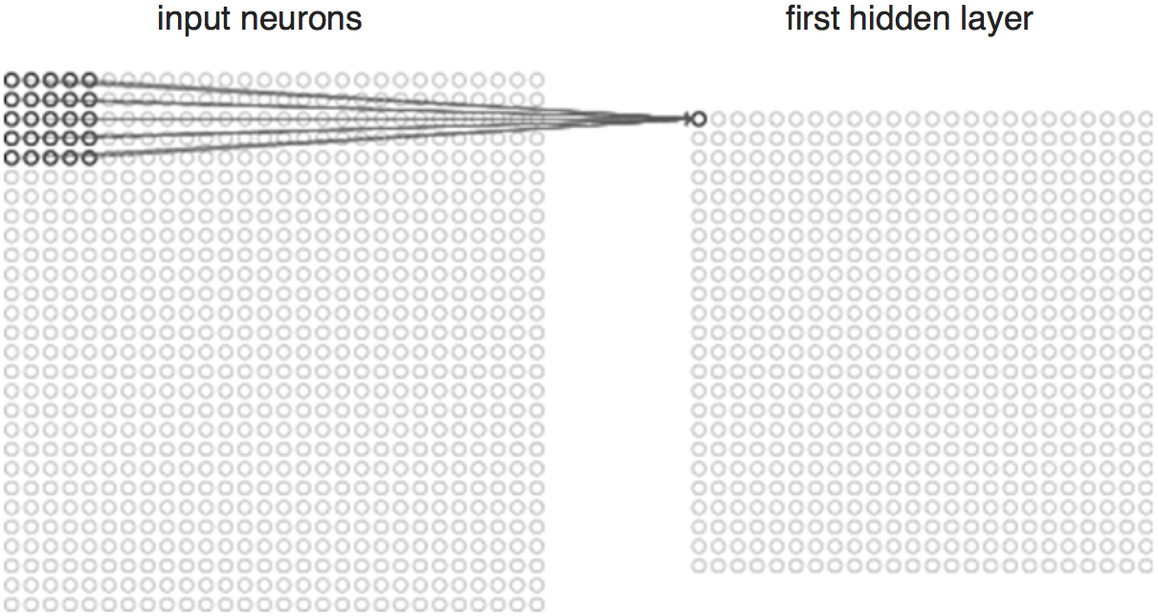

This operation, from a human perspective, is analogous to identifying boundaries and simple colours on the image. But in order to recognize the properties of a higher level such as the trunk or large ears the whole network is needed.

The network will consist of several convolutional networks mixed with nonlinear and pooling layers. When the image passes through one convolution layer, the output of the first layer becomes the input for the second layer. And this happens with every further convolutional layer.

**The nonlinear layer**is added after each convolution operation. It has an activation function, which brings nonlinear property. Without this property a network would not be sufficiently intense and will not be able to model the response variable (as a class label).

**The pooling layer** follows the nonlinear layer. It works with width and height of the image and performs a downsampling operation on them. As a result the image volume is reduced. This means that if some features (as for example boundaries) have already been identified in the previous convolution operation, than a detailed image is no longer needed for further processing, and it is compressed to less detailed pictures.

After completion of series of convolutional, nonlinear and pooling layers, it is necessary to attach **a** **fully connected layer**. This layer takes the output information from convolutional networks. Attaching a fully connected layer to the end of the network results in an N dimensional vector, where N is the amount of classes from which the model selects the desired class.

A fragment of the code of this model written in Python will be considered further in the practical part.