Crop Yield Prediction using Machine Learning Algorithm

In this project we are using machine learning Decision Tree algorithm to predict Crop Yield of Indian agriculture and to train machine learning algorithm we have used below dataset

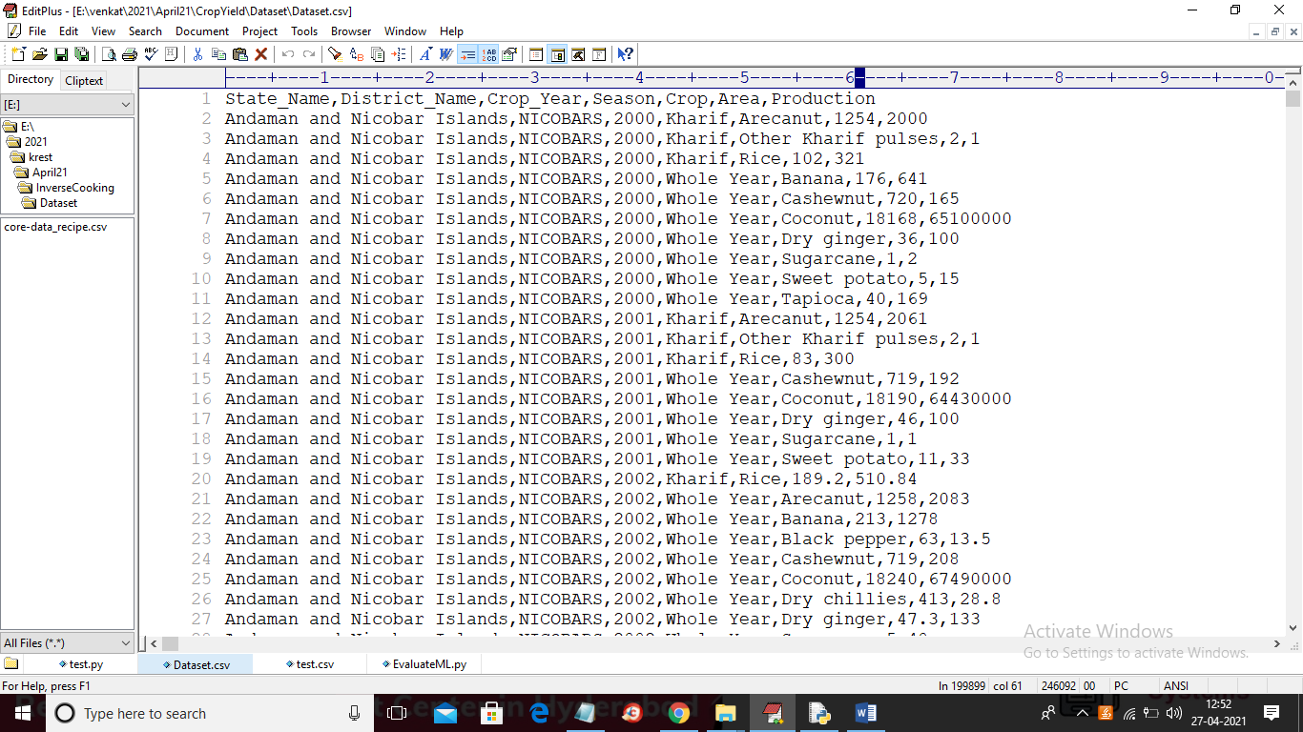

In above dataset first row contains column names and other rows contains column values and in above screen last column production we will take as class label and other columns will be taken as training features. After training ML with above dataset then we will upload below test dataset to predict yield

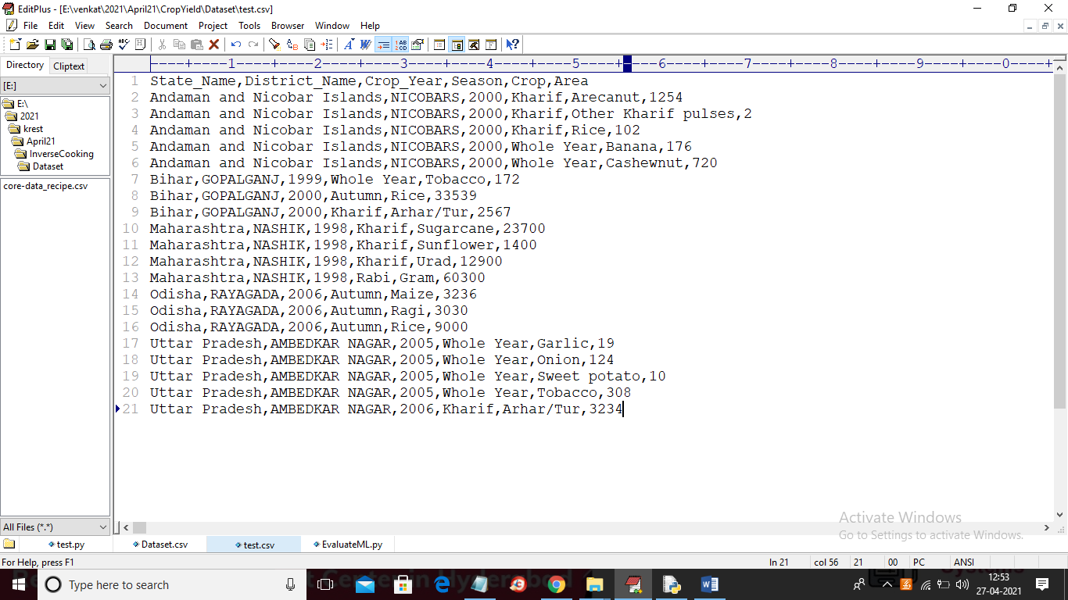

In above screen in test data production column is missing and this column will be predicted by ML algorithm

SCREEN SHOTS

To run project double click on ‘run.bat’ file to get below screen

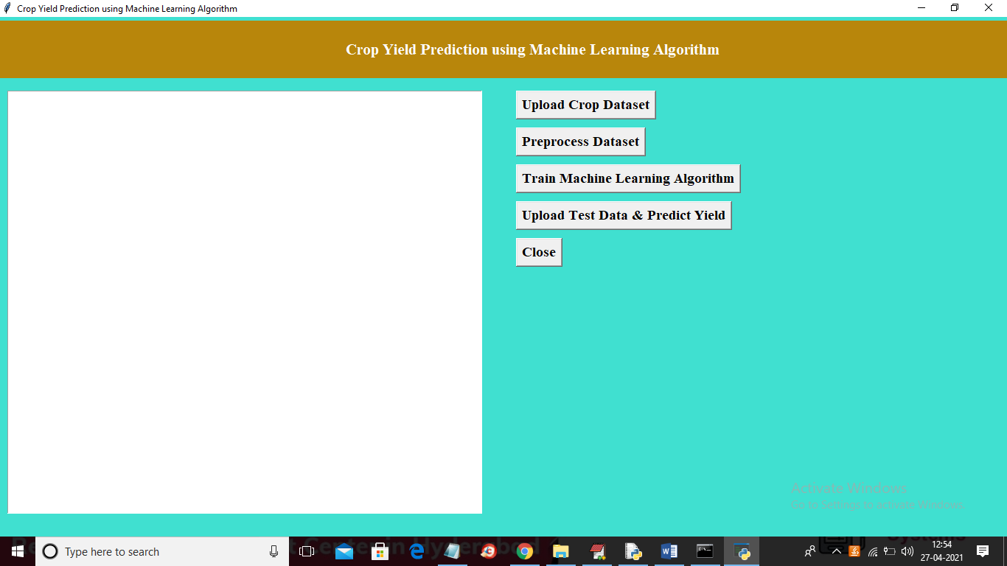

In above screen click on ‘Upload Crop Dataset’ button to upload dataset

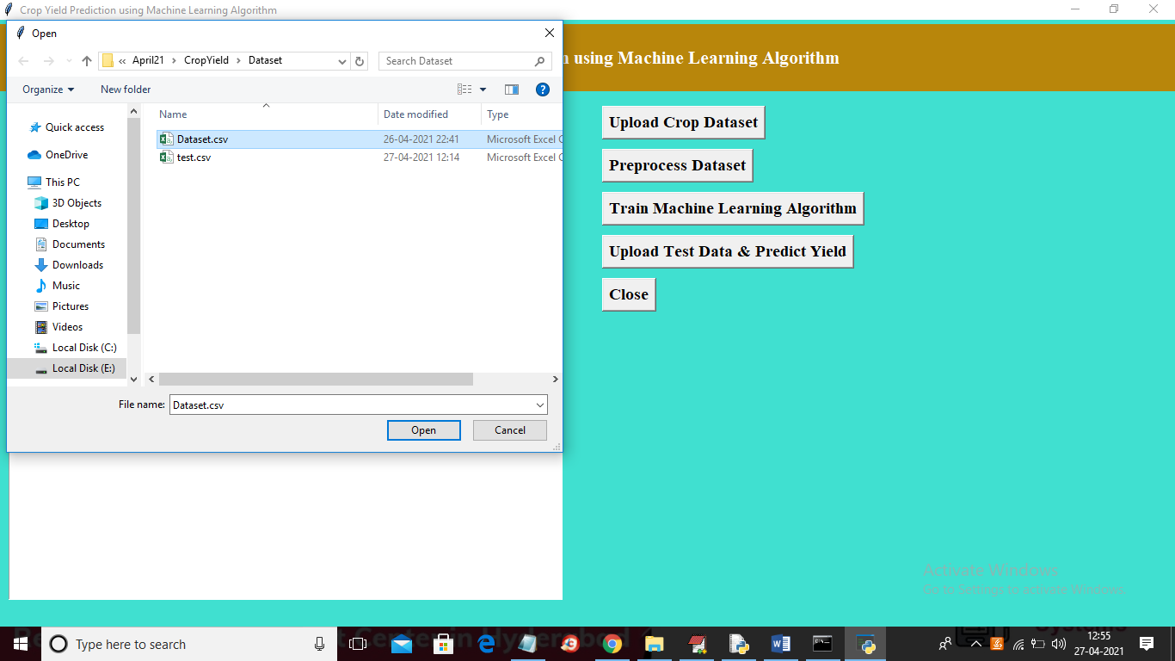

In above screen selecting and uploading ‘Dataset.csv’ file and then click on ‘Open’ button to load dataset and to get below screen

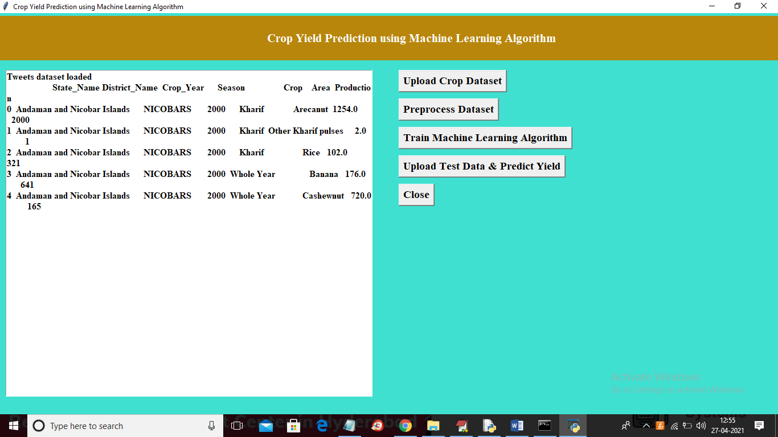

In above screen dataset loaded and we can see dataset contains some non-numeric values and ML will not take non-numeric values so we need to preprocess dataset to convert non-numeric values to numeric values by assigning ID to each non-numeric value. So click on ‘Preprocess Dataset’ button to process dataset

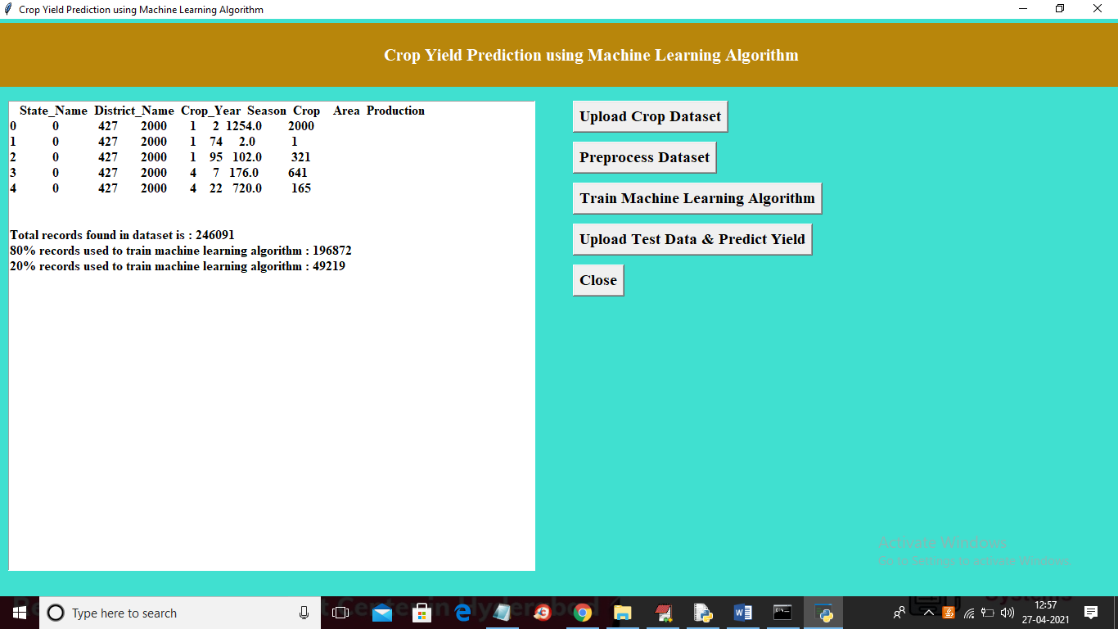

In above screen all non-numeric values converted to numeric format and in below lines we can see dataset contains total 246091 records and application using (80%) 196872 records to train ML and using (20%) 49219 records to test ML prediction error rate (RMSE (root mean square error)). Now click on ‘Train Machine Learning Algorithm’ button to train Decision Tree Machine learning algorithm on above dataset and then calculate prediction error rate

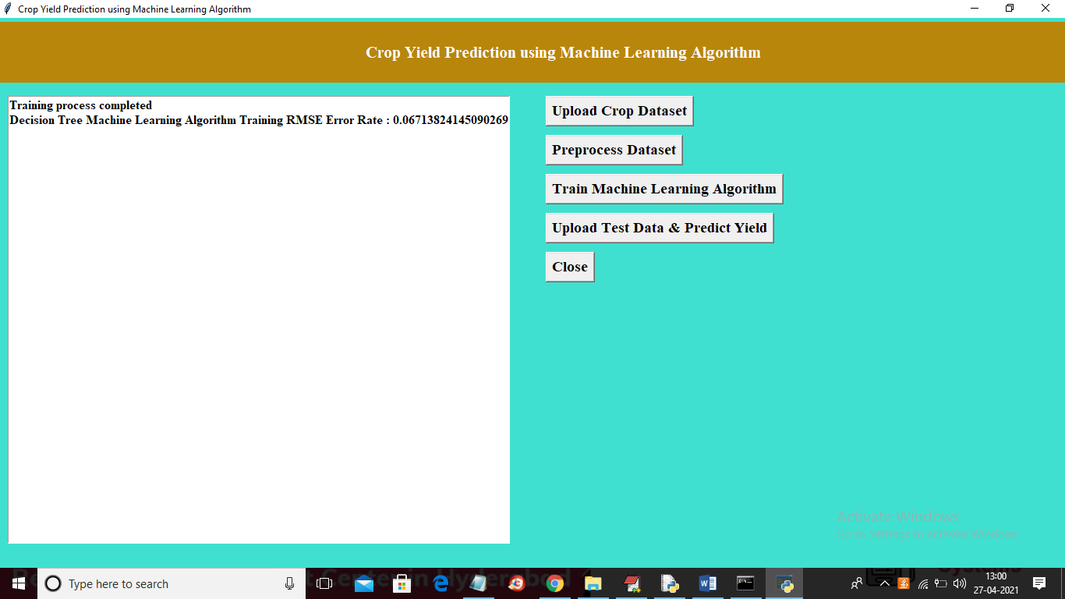

In above screen ML is trained and we got prediction error rate as 0.067% and now Decision Tree model is ready and now click on ‘Upload Test Data & Predict Yield’ button to upload test data and then application will predict production

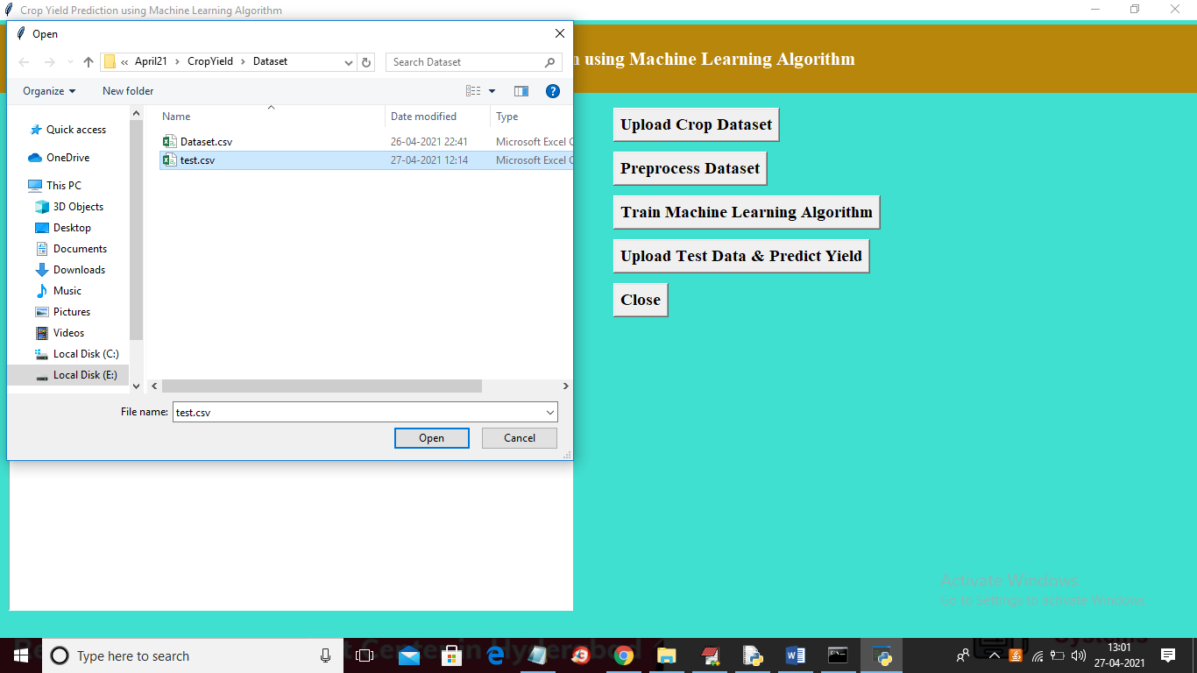

In above screen selecting and uploading ‘test.csv’ file and then click on ‘Open’ button to load test data and then application will give below prediction result

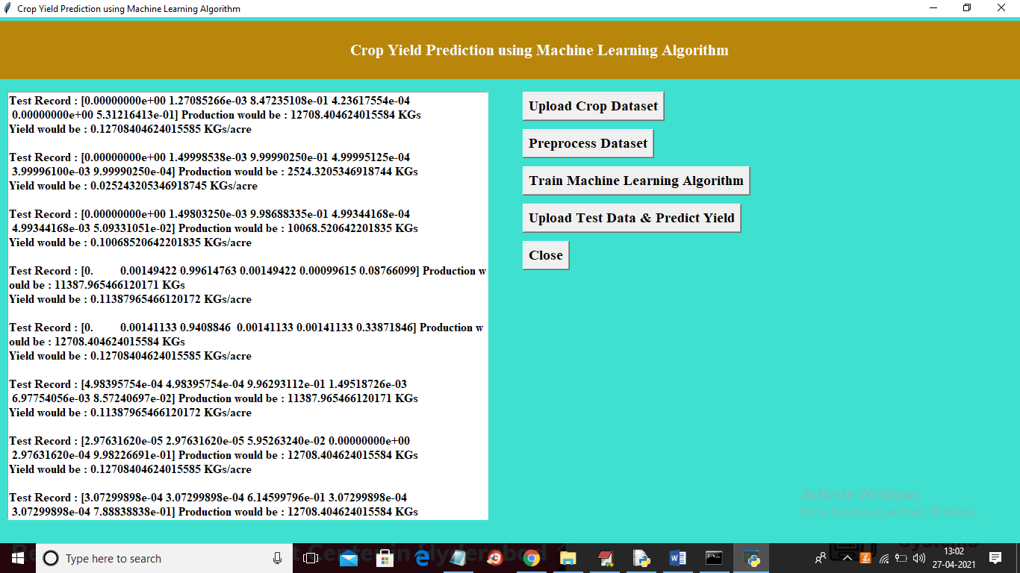

In above screen each test record is separated with newline and in above screen in square bracket we can see test data values and after square bracket we can see predicted production and after that we can see predicted YIELD per acre. So each test record and its prediction is separated with newline. You can scroll down above text area to view all records.