Web-Based Music Genre Classification for Timeline Song Visualization and Analysis

In this paper author is using various machine learning algorithms such as Linear SVM and Ensemble Decision Tree and have also experiment with deep learning algorithms such as Feed Forward Neural Networks and LSTM (long short term memory) to classify music genre (type of music like HIP HOP, JAZZ, Disco or etc. In all algorithms LSTM is giving better accuracy. To implement this project author has used YouTube dataset called AUDIODATASET and we are also using same dataset to implement this project.

Below is the dataset screen shots which contains various music Genre and this dataset available inside ‘AudioSetData’ folder

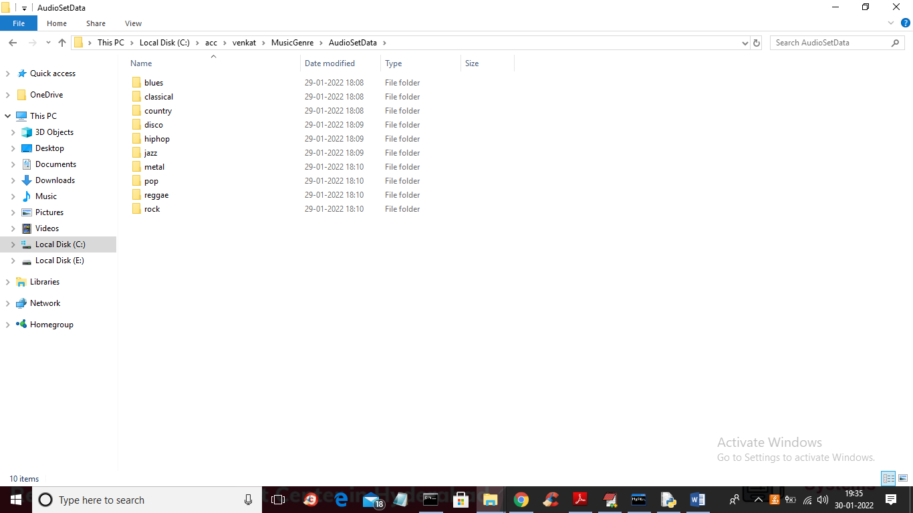

In above screen different folder contains music of different Genre and just go inside any folder to view that Genre audio file like below screen

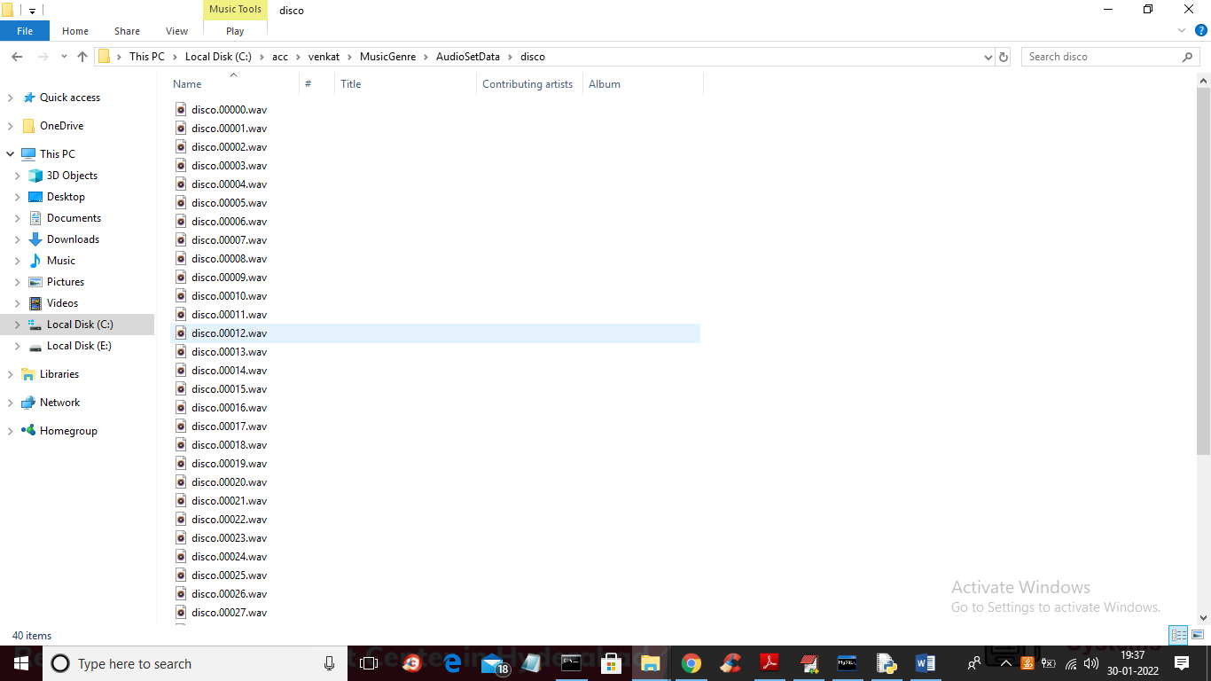

In above screen you can see audio files of type disco and we will used same dataset to classify music genre.

To design this project we have implemented following modules

1. User Login: using this module user can login to application and after login can train with SVM, LSTM and then classify music genre
2. New User Signup Here: using this module user can signup with the application and then can login
3. Train SVM: using this module we extract features from dataset using MFCC algorithm and this extracted features will get train with SVM and then will calculate accuracy, average precision, AUC and recall with confusion matrix graph. Here extracted features dataset will be split into train and test where 80% data used for training and 20% for testing
4. Train Decision Tree: using this module we extract features from dataset using MFCC algorithm and this extracted features will get train with Decision Tree and then will calculate accuracy, average precision, AUC and recall with confusion matrix graph. Here extracted features dataset will be split into train and test where 80% data used for training and 20% for testing
5. Train LSTM: using this module we extract features from dataset using MFCC algorithm and this extracted features will get train with LSTM and then will calculate accuracy, average precision, AUC and recall with confusion matrix graph. Here extracted features dataset will be split into train and test where 80% data used for training and 20% for testing
6. Train Feed Forward Network: using this module we extract features from dataset using MFCC algorithm and this extracted features will get train with Feed Forward Neural Network and then will calculate accuracy, average precision, AUC and recall with confusion matrix graph. Here extracted features dataset will be split into train and test where 80% data used for training and 20% for testing
7. Music Genre Classification: using this module user can upload test audio files from ‘testMusicFiles’ folder and then LSTM will predict/classify type of that uploaded music Genre

SCREEN SHOTS

To run project first create database in MYSQL by copying content from DB.txt file and paste in MYSQL

Double click on ‘run.bat’ file to start DJANGO server like below screen

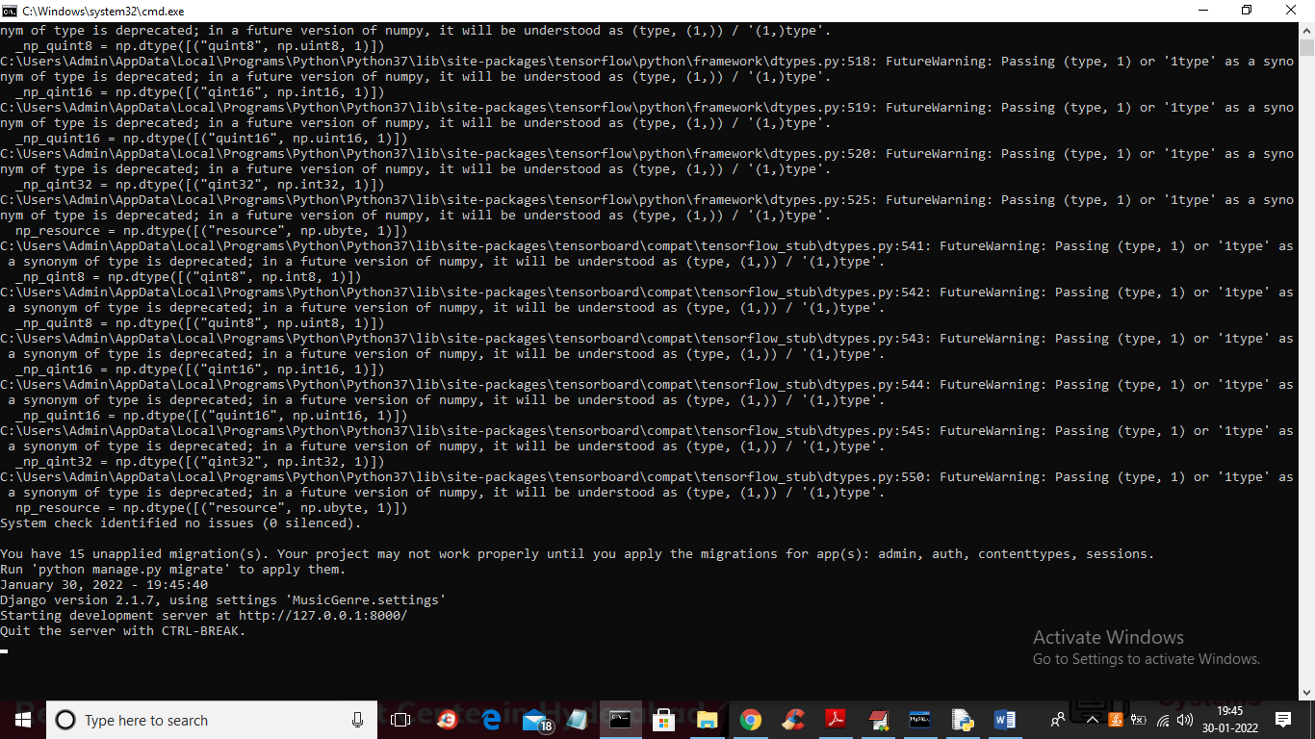

In above screen DJANGO server started and now open browser and enter URL as <http://127.0.0.1:8000/index.html> and press enter key to get below page

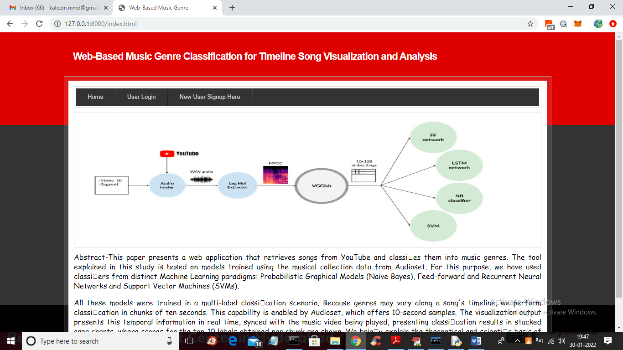

In above screen click on ‘New User Signup Here’ link to get below screen

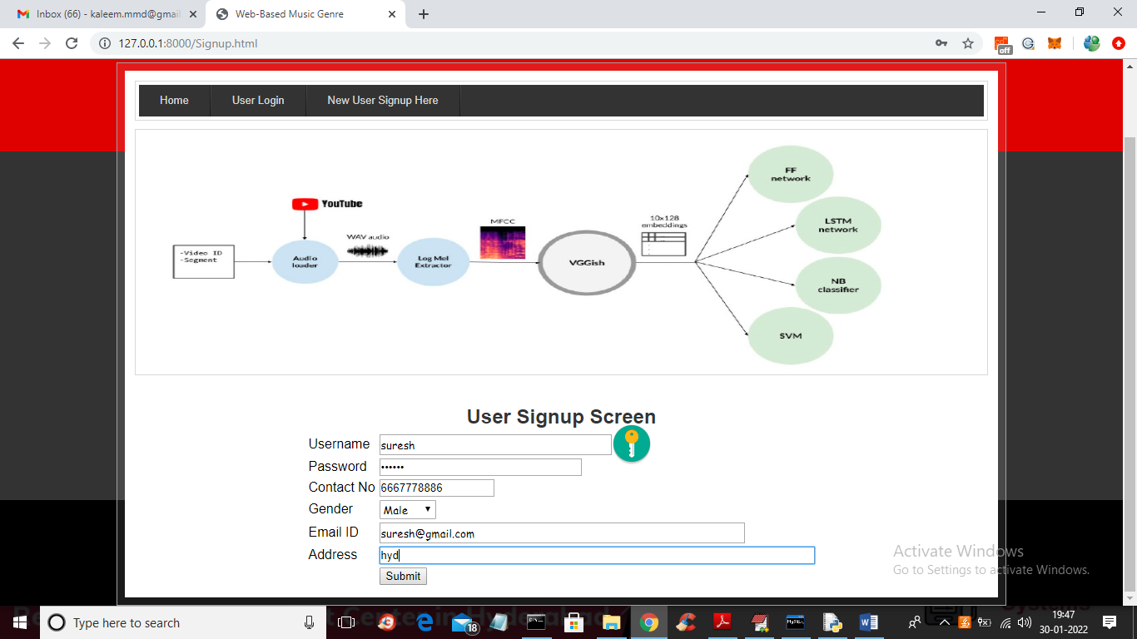

In above screen user is entering signup details and then click on ‘Submit’ button to get below screen

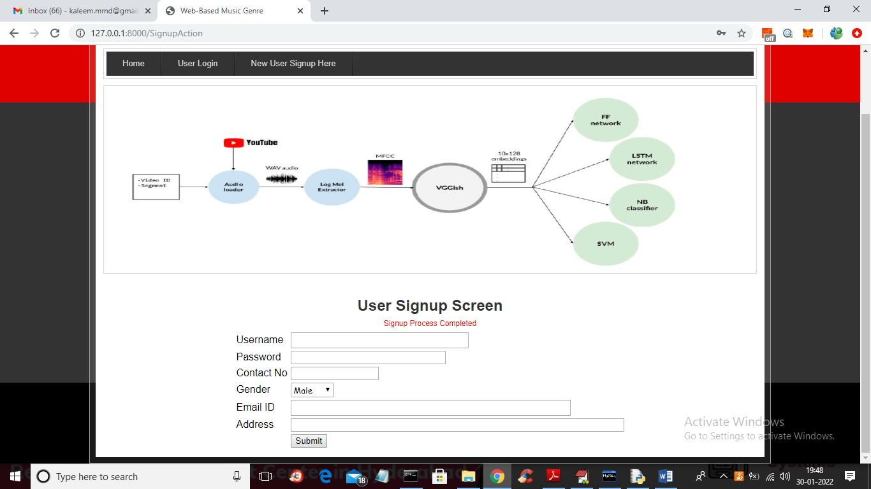

In above screen signup task completed and now click on ‘User Login’ link to get below login screen

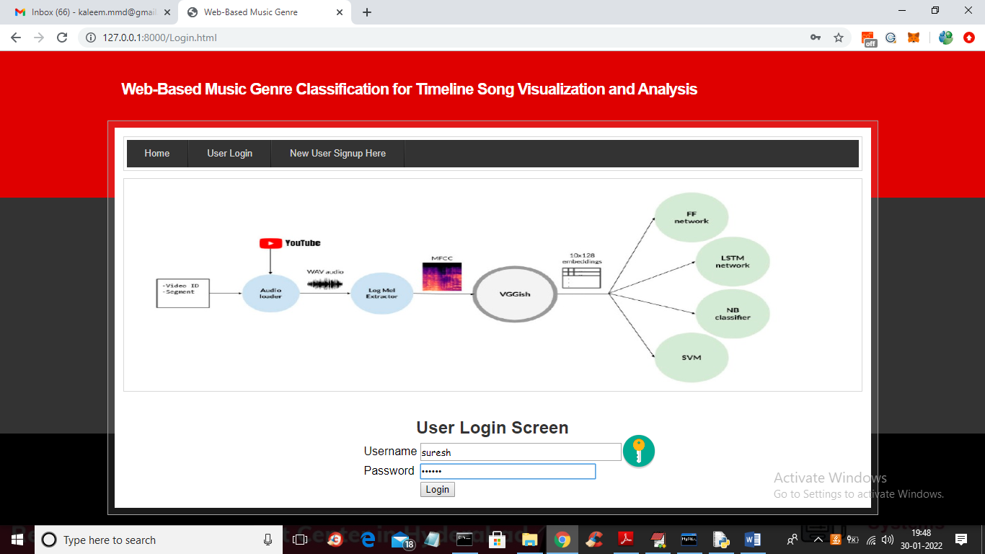

In above screen user is login and after login will get below screen

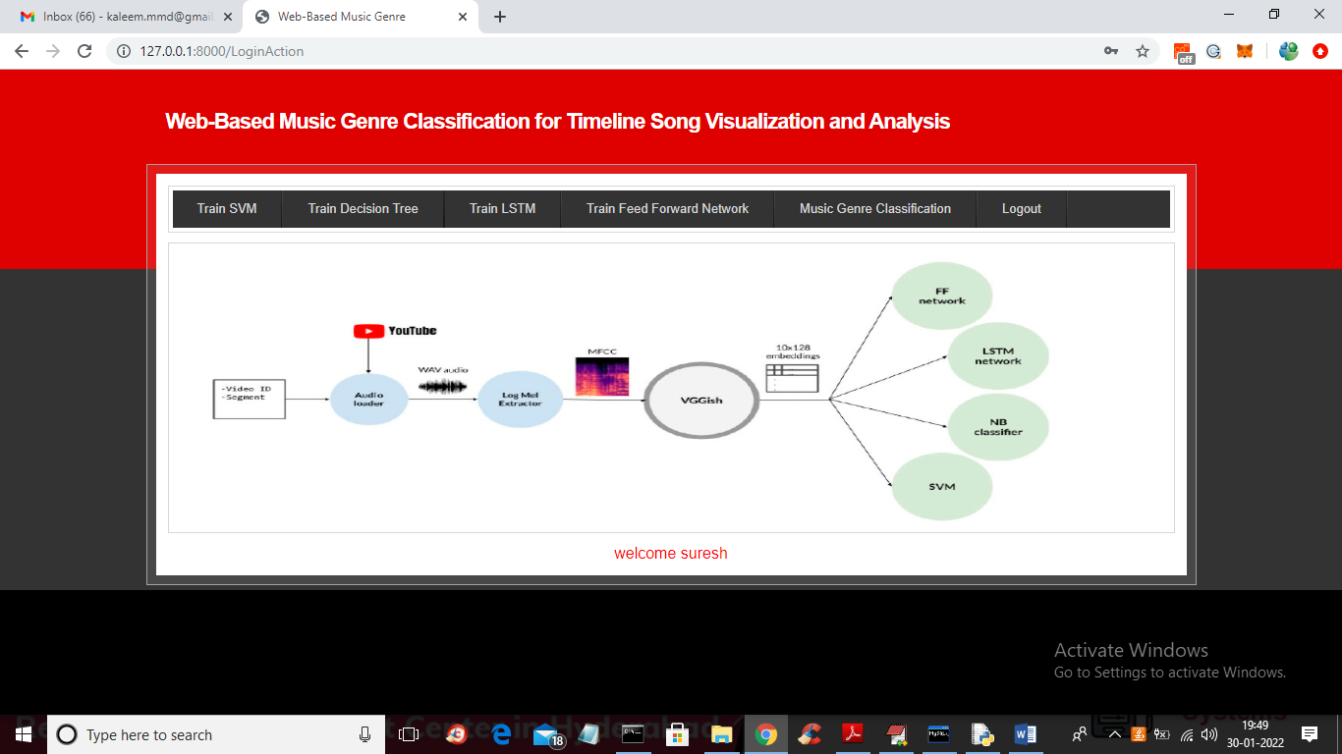

In above screen user can click on ‘Train SVM’ link to train SVM algorithm and get below classification result on test data using SVM

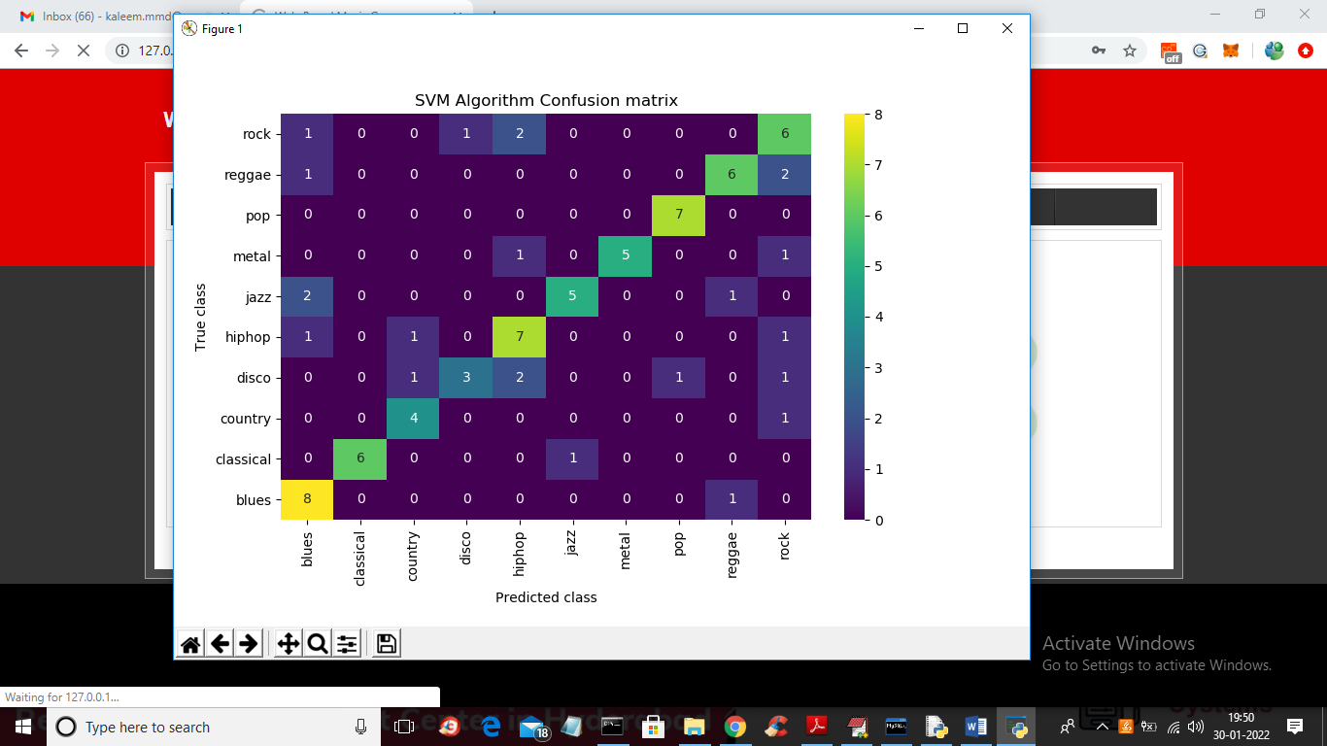

In above SVM confusion matrix graph x-axis represents predicted music genre classes and y-axis represented TRUE test classes and all values in horizontal part are correct prediction by SVM remaining values greater than 0 in other boxes are the wrong prediction and we can see SVM has predicted so many wrong classes and now close above graph to get below SVM precision value

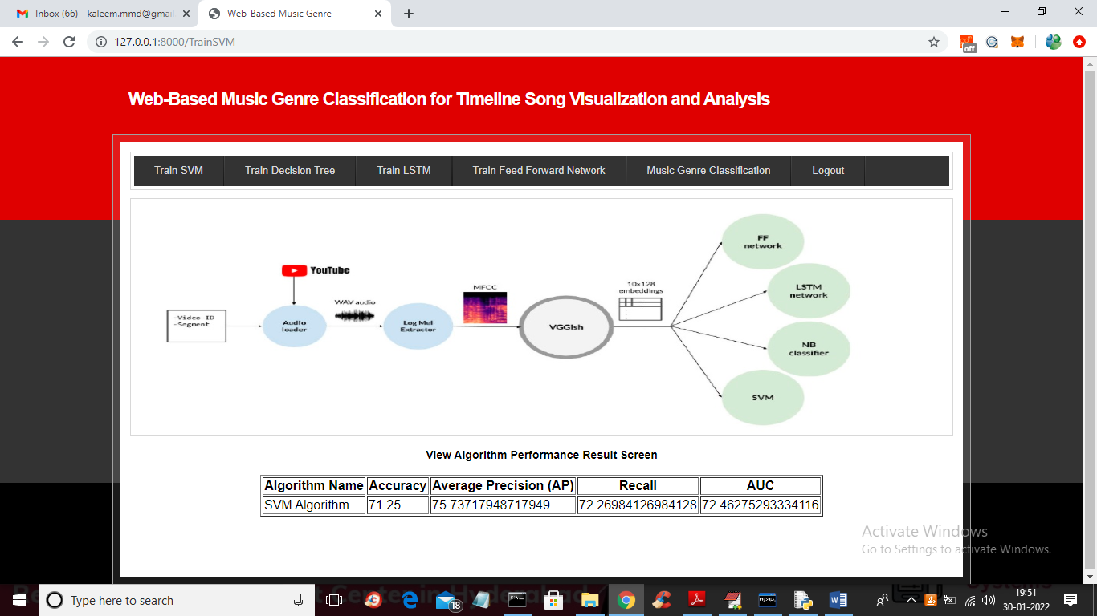

In above screen with SVM we got precision value as 75% and now click on ‘Train Decision Tree’ link to train decision algorithm and get below graph

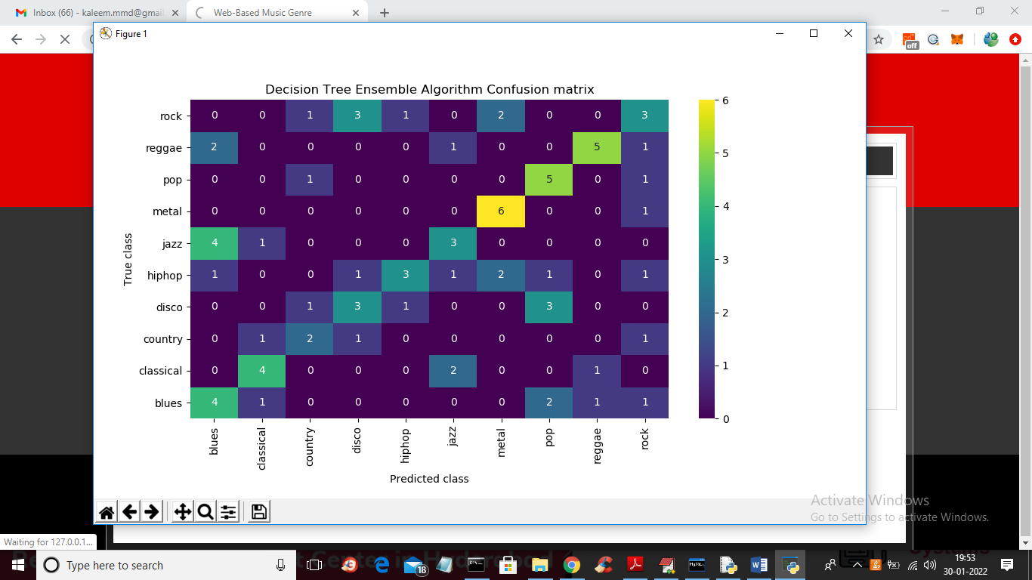

In above screen with decision tree also so many wrong classes are predicted and now close above graph to get decision tree precision

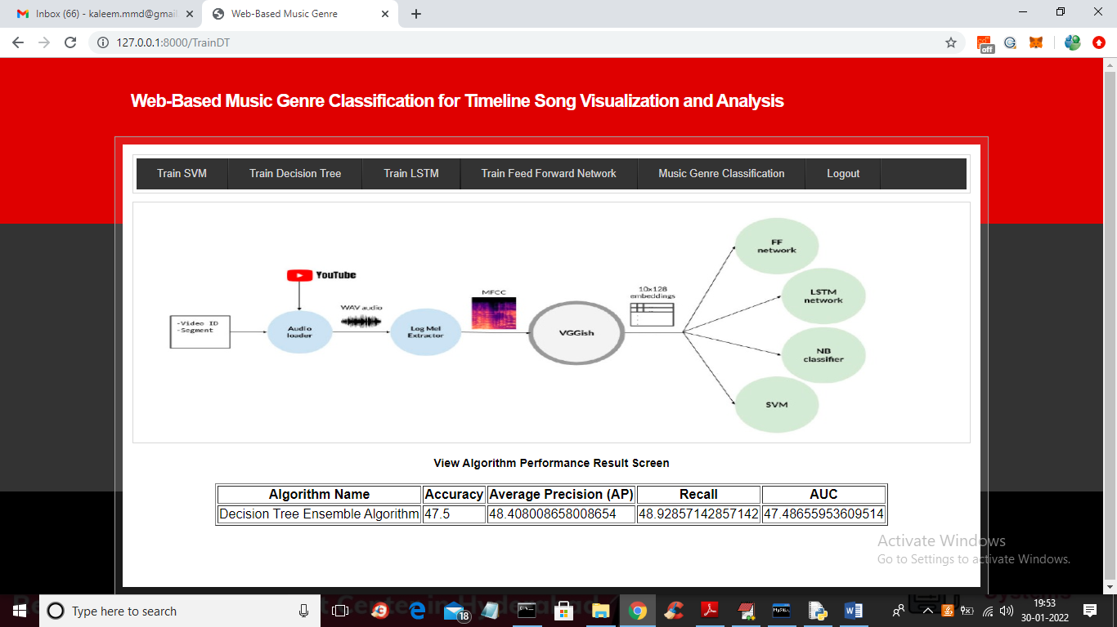

In above screen with decision tree algorithm we got 48% precision so its performance is not good and now click on ‘Train LSTM’ to train LSTM and get below output

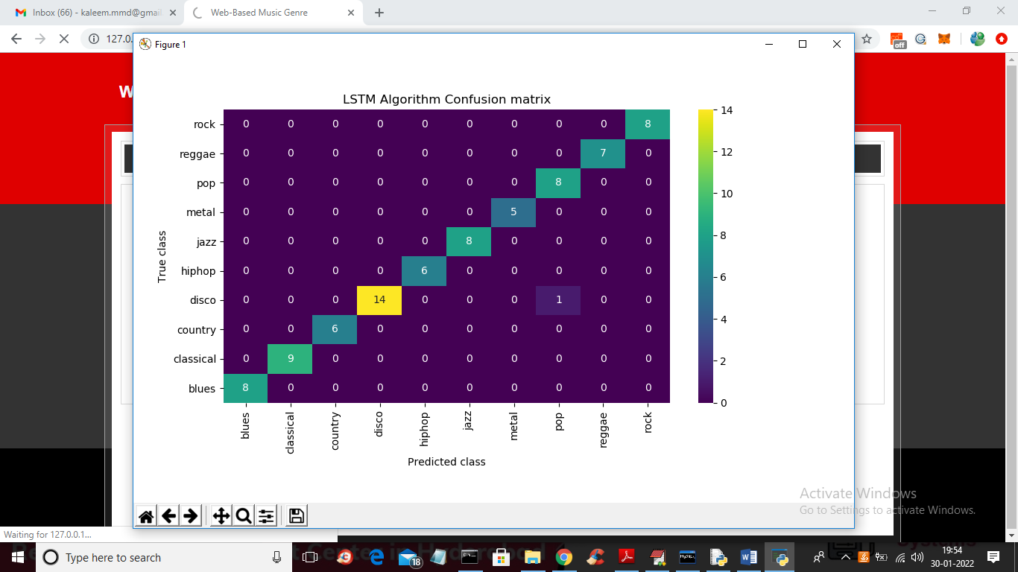

In above LSTM confusion matrix in diagnol boxes all classes are correctly predicted and only 1 class in other boxes is wrongly predicted so LSTM is good in performance and now close above graph to get below LSTM precision

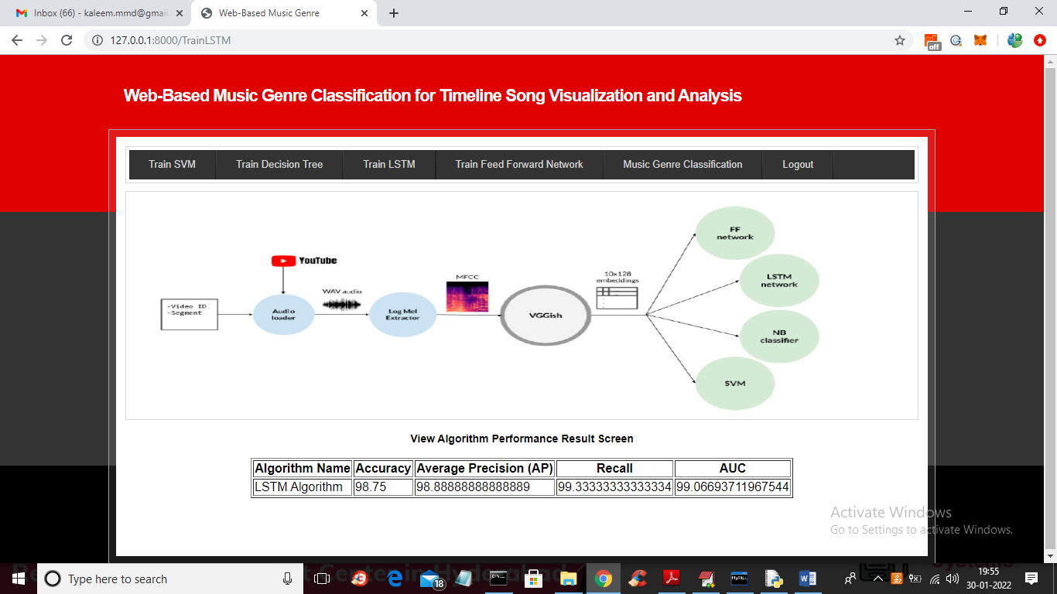

In above screen with LSTM we got 98% precision so its performance is best compare to other algorithm and now click on ‘Train Feed Forward Network’ link to get below output

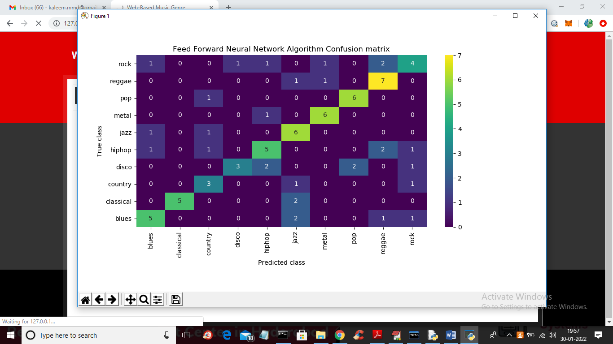

In above screen with feed forward neural network we can see in diagnol only few classes are correctly predicted so its performance also not good and now close above graph to get feed forward output

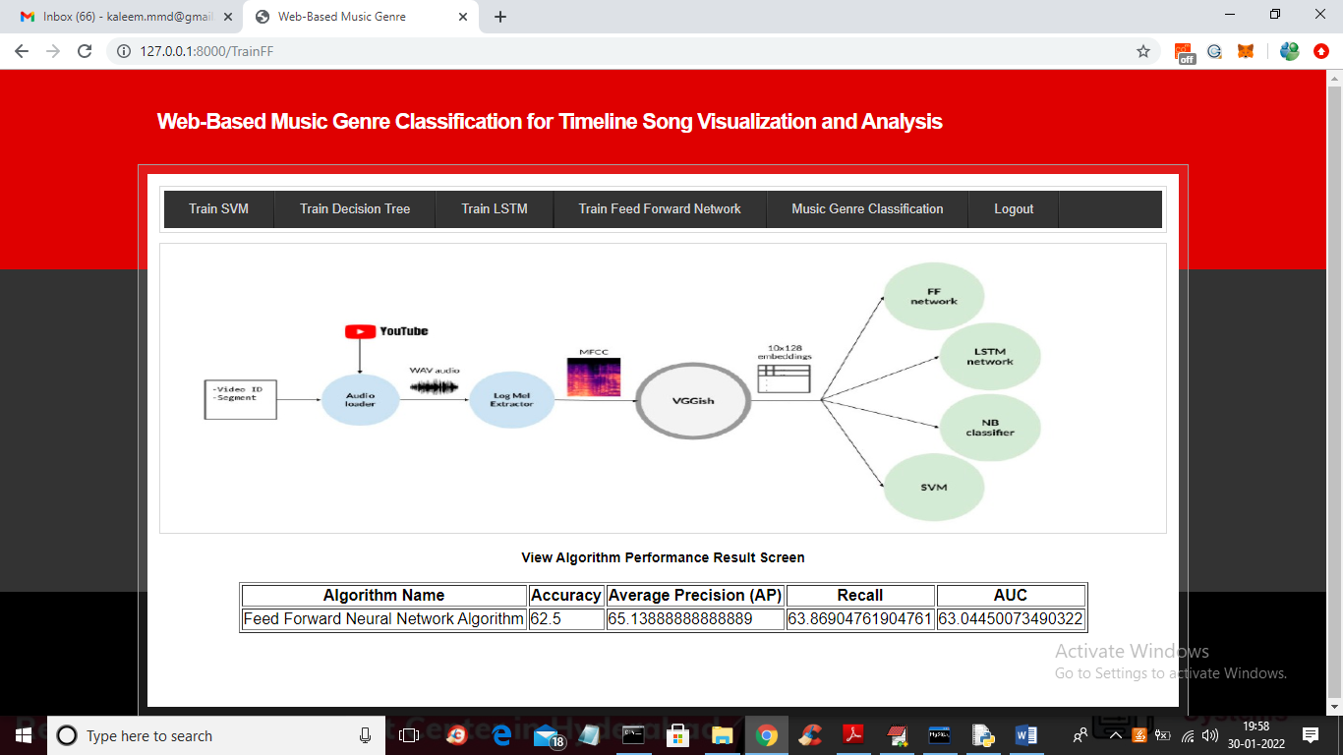

In above screen with Feed Forward we got precision as 65% and we can see in all algorithms LSTM got better performance and in paper also author saying LSTM is better in performance and now click on ‘Music Genre Classification’ link to get below screen

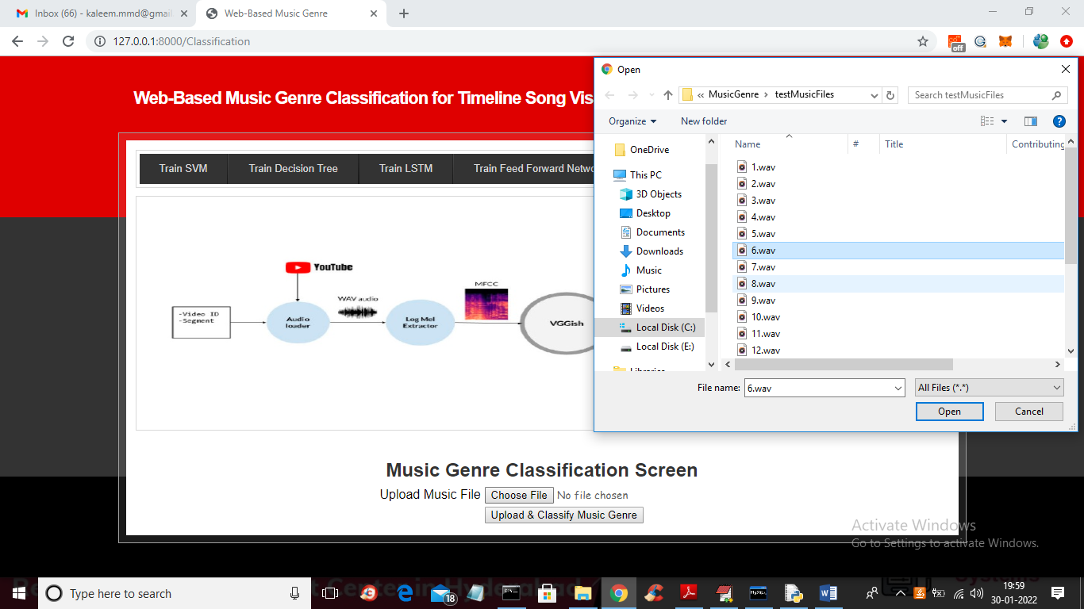

In above screen browsing and uploading ‘6.wav’ file and then click on ‘Open’ button to load audio file and then click on ‘Upload & Classify Music Genre’ button so LSTM can predict or classify music Genre from uploaded audio like below screen

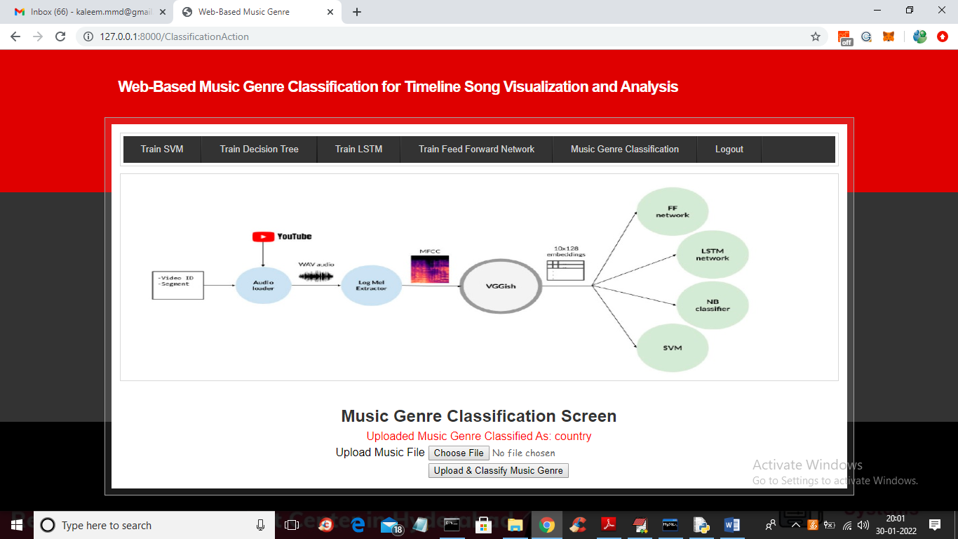

In above screen in red colour text we can see uploaded music genre classified as ‘Country’ and now test other files

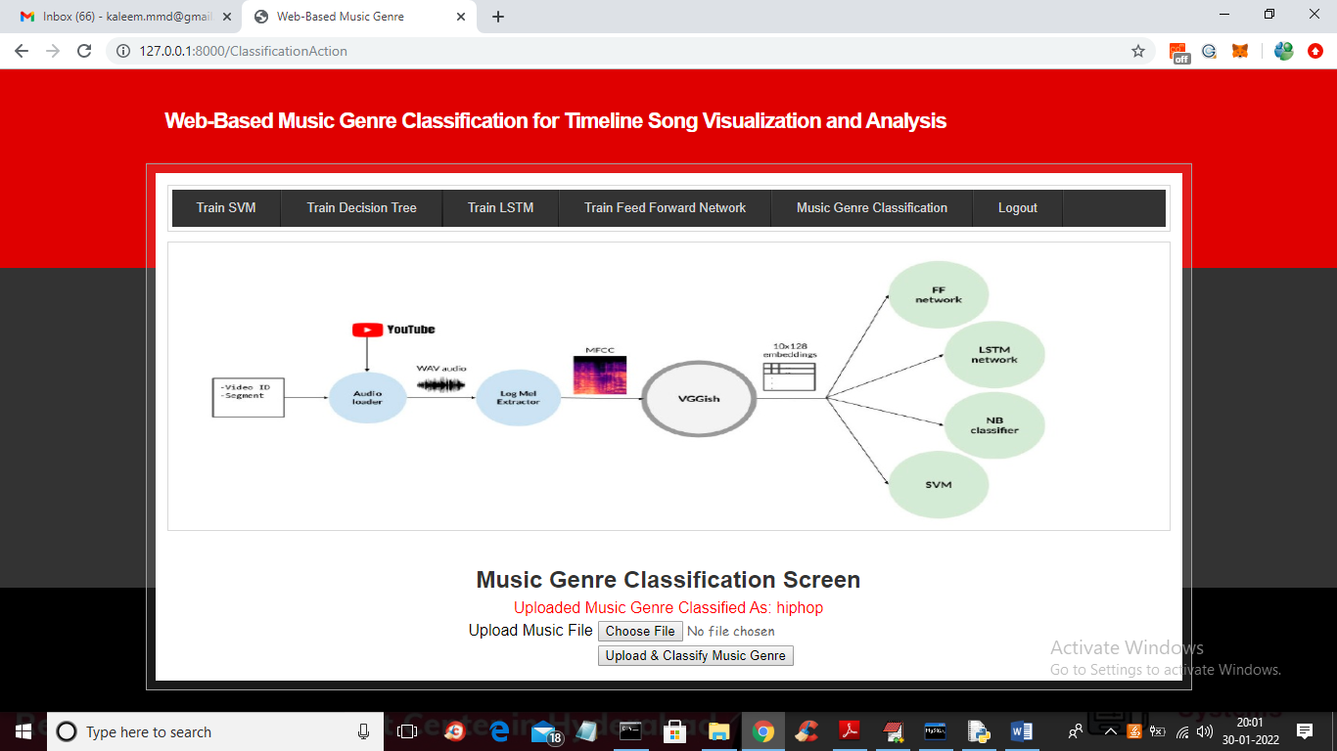

In above screen another audio genre classified as ‘hiphop’ and similarly you can upload other files and classified them