PSO Optimized LSTM output

In this project as extension we have added PSO optimized features algorithm which will select optimal features from the dataset and this optimized features will get retrain with LSTM to reduce MSE error rate. The lower the MSE the better is the algorithm. In below screen we are showing code for PSO features optimization

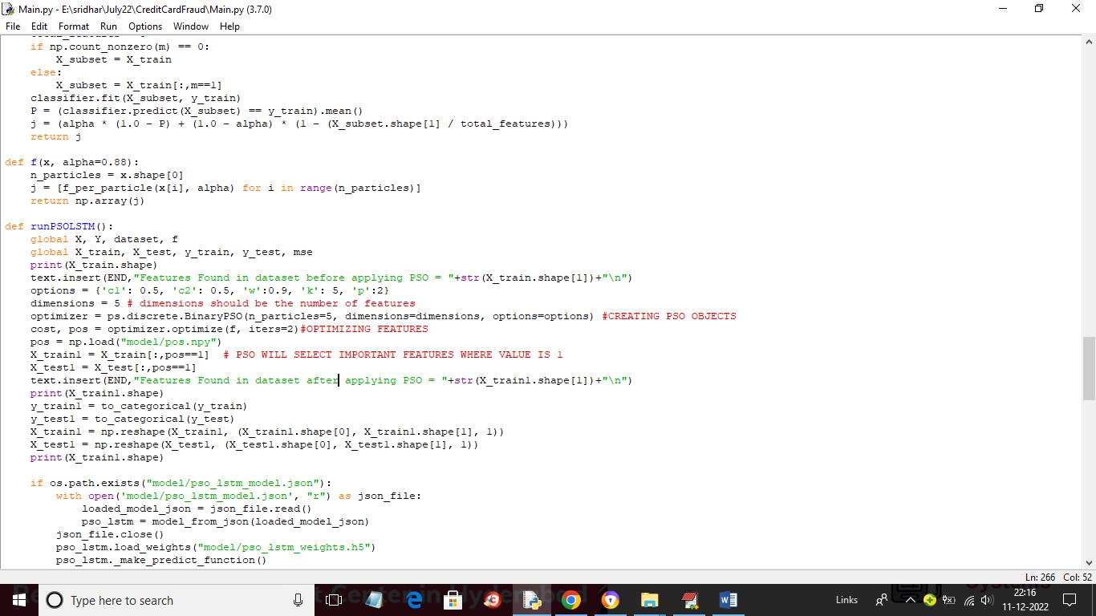

In above screen read red colour comments to know about PSO features optimization.

SCREEN SHOTS

Now run the code to get below screen

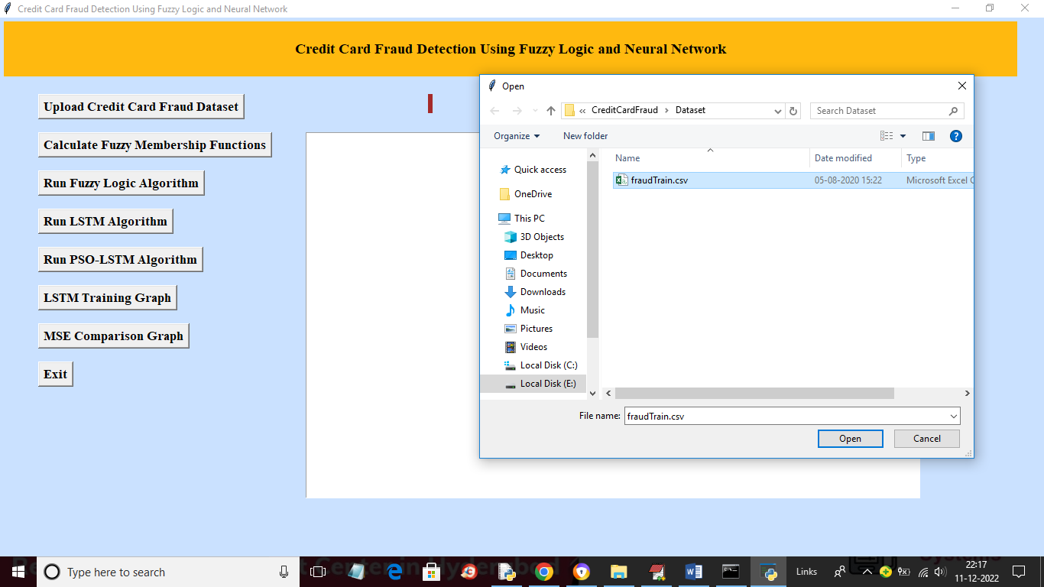

In above screen upload the dataset to get below output

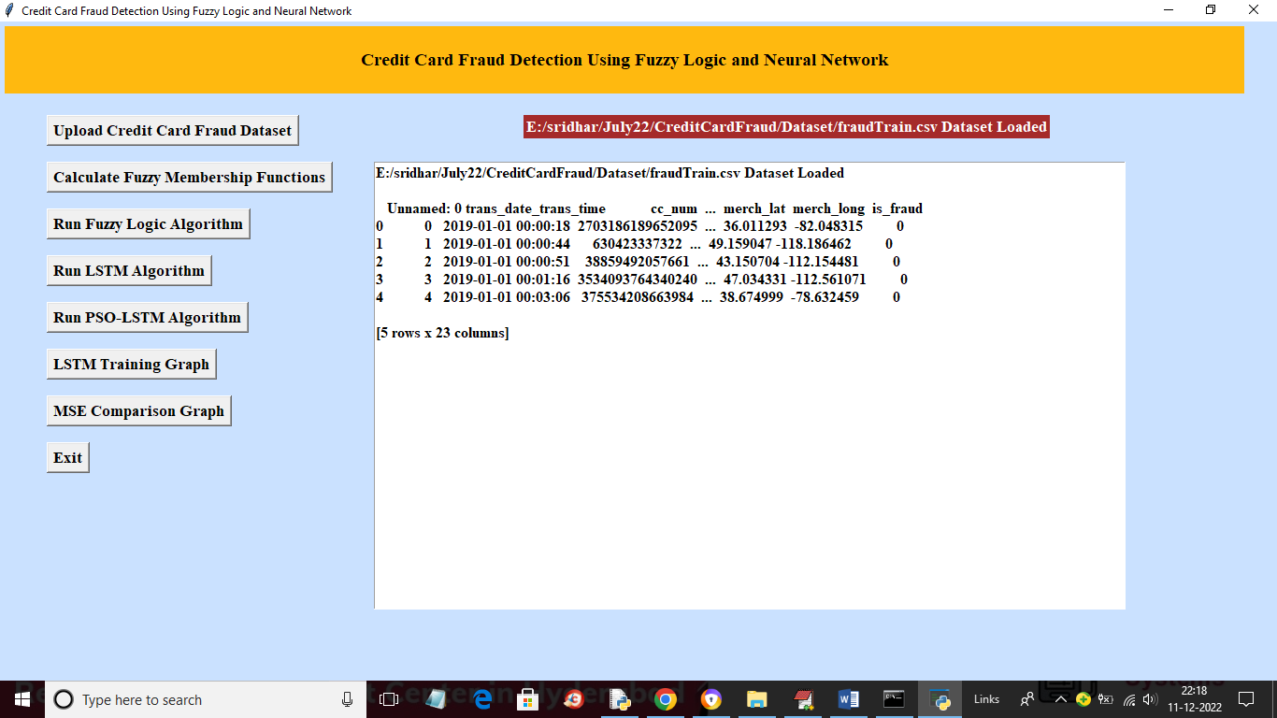

In above screen dataset loaded and now click on ‘Fuzzy Membership’ button to get below output

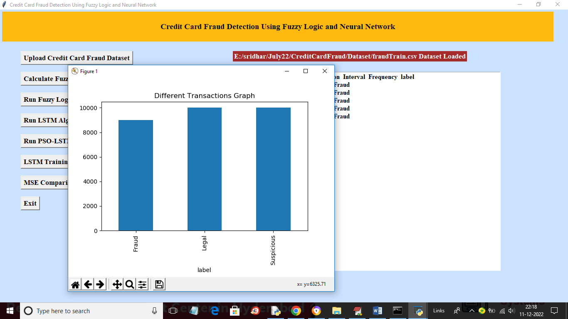

In above screen using fuzzy technique we calculated different labels and now run Fuzzy logic button

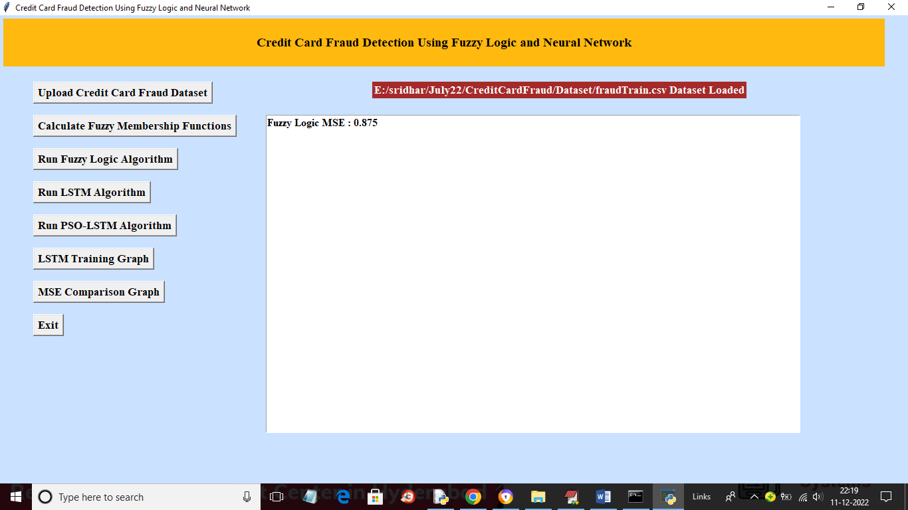

In above screen with FUZZY LOGIC we got MSE as 0.87% and now run LSTM algorithm button to get below output

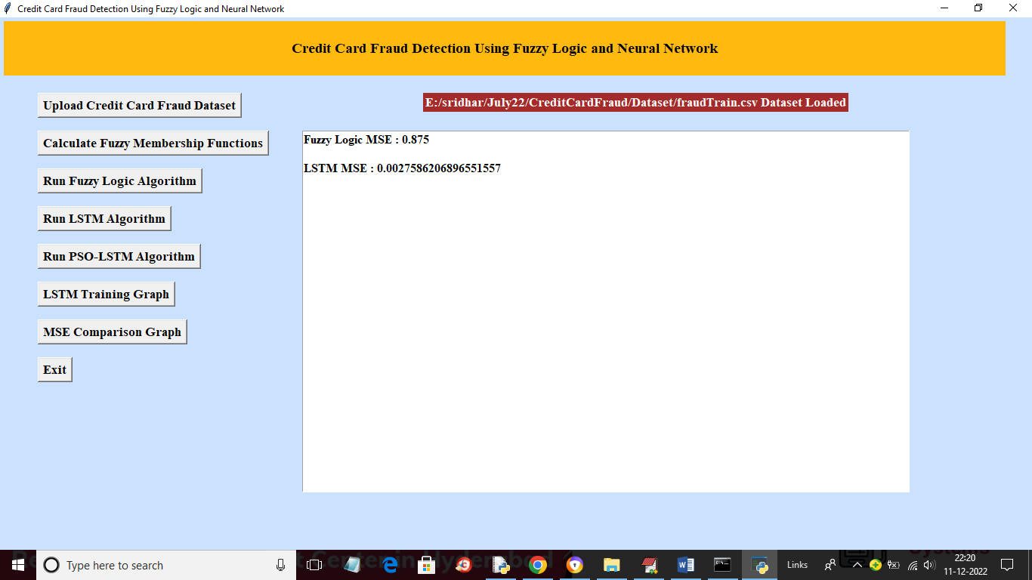

In above screen with LSTM we got MSE as 0.0027% and now click on ‘Run PSO-LSTM Algorithm’ button to get below output

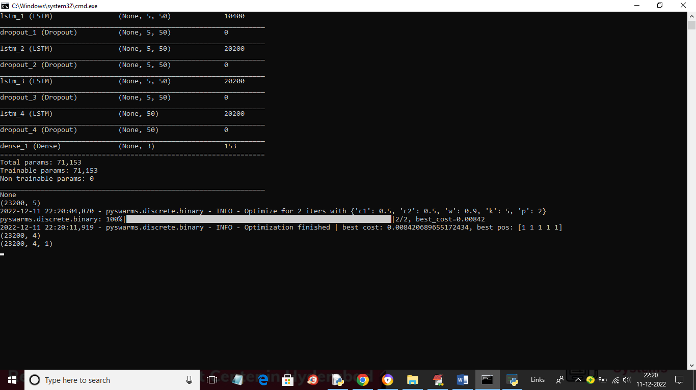

In above screen PSO optimization started and after optimization will get below output

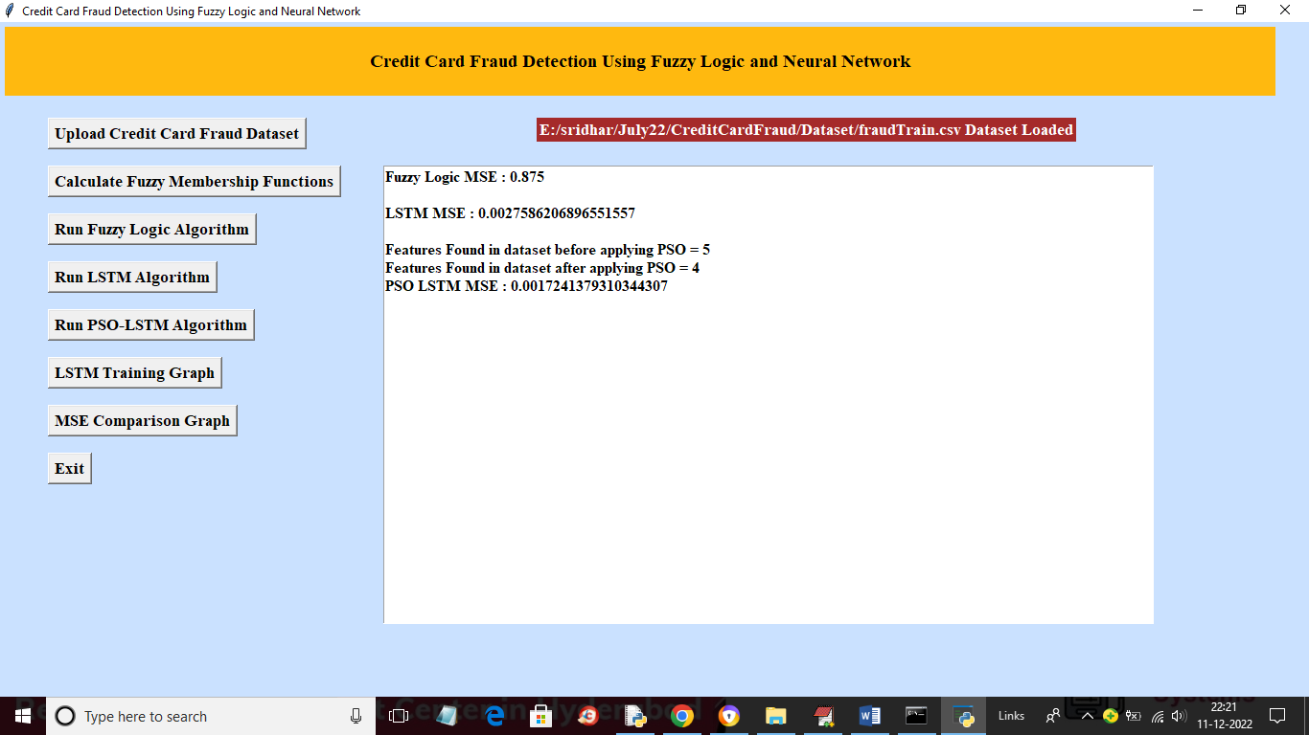

In above screen before applying PSO dataset were having 5 features and after applying PSO it got reduced to 4 and we got PSO LSTM MSE as 0.0017 which is lesser than normal LSTM and now click on ‘LSTM Training Graph’ button to get below graph

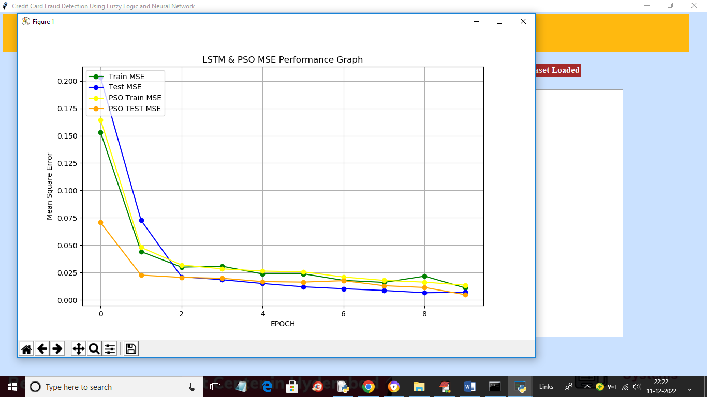

In above graph orange line is for PSO TEST MSE and this PSO TEST MSE is lesser than normal LSTM. Now close above graph and then click on ‘MSE Comparison Graph’ button to get below MSE graph

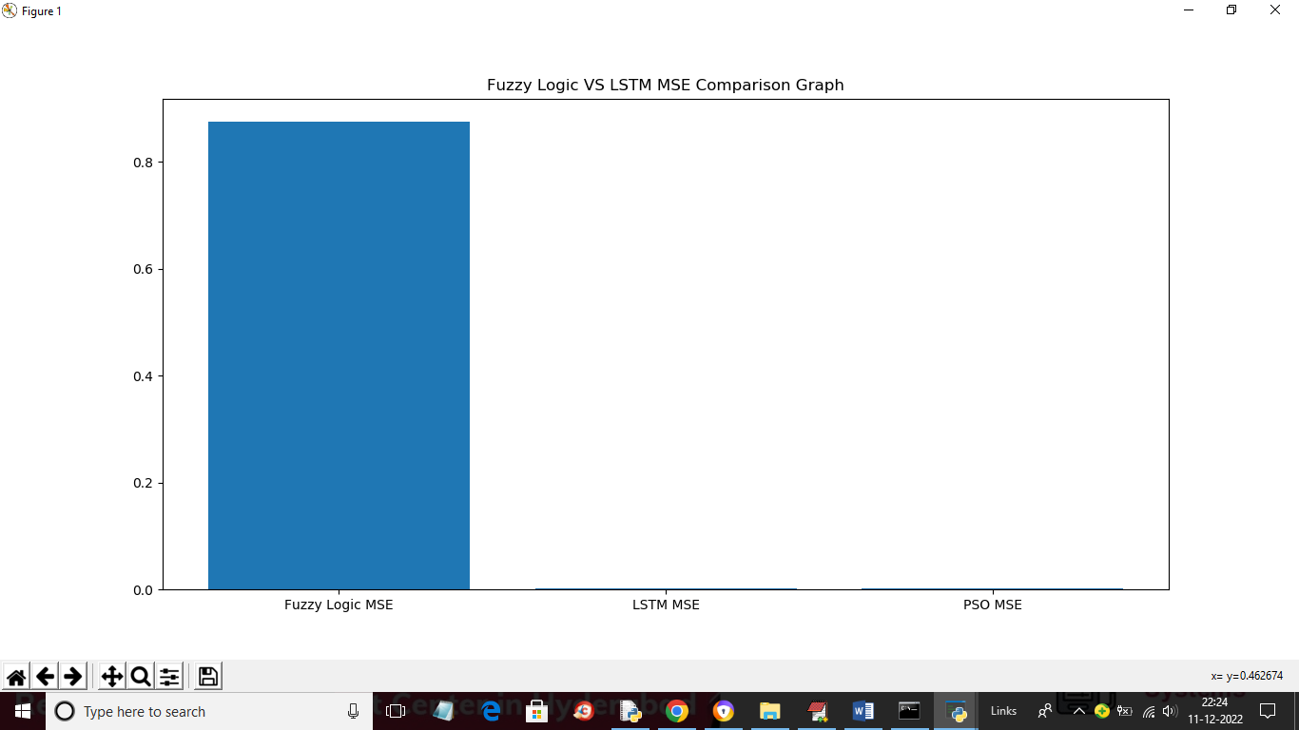

In above graph we can see PSO MSE error is too small compare to FUZZY so for LSTM and PSO LSTM we can small bar as this bars having very much less MSE error. So from above graphs we can say after applying PSO we can reduce algorithm MSE error rate