Project Report of Srikanth Thirumalasetti Roll #2019900090

Abstract:
To address the limitations of NLP technologies that are currently being used at Proxzar and to ensure that Proxzar stays true to her vision of being a light-weight cutting-edge technology platform, I’ve chosen this project to do a pilot test and implement a BERT model that was fine-tuned on QA task.
A pre-trained BERT model – base, uncased, 12 layer, 768 hidden, 12 heads, 110M parameters – was chosen for fine-tuning on SQuAD 1.1 dataset and a text corpus from Proxzar website has been used for final prediction to compare the results with the existing NLP tools implementation that uses the same text corpus.

Introduction
We use Stanford CoreNLP and IIITB research labs SIML framework to build our QA systems. These NLP tools gave us a decent understanding of the semantics of a language and how various components of NLP like tokenizers, lemmatizers, POS taggers, dependency parsers and co-refs resolution etc.. could be harnessed to find the meaning and context of words, which ultimately helps in first understanding the user intents and thereafter, generating a correct response.
We’ve built our own knowledge graph by extending the pre-trained models provided by CoreNLP and SIML framework’s NLP engine.
Since we are using pre-trained models from the above said technologies, there was always a need to improve the performance of the end hybrid models that we are building.
When I first heard about the Transformer model in our NLA class, I was very excited and read the paper as suggested in the class. The curiosity was essentially borne out of the fact that the knowledge accrued from hundreds of research papers on studying the semantics of a language by several computational linguists and researchers seems to have been overtaken by this Transformer model, which as I see it, is nothing but words attending to words themselves through a set of floating point numbers that are manipulated by another set of mathematical functions – and, without the aid of a wireframe like a neural network!
This excited me to propose studying and implementing a flavour of this model as my project, which was gracefully accepted by Prof.Manish Srivatsava, our NLA faculty.
The project is essentially an implementation based out of the Transformer model.
Technologically speaking, Proxzar’s technology strategy requires using Tensorflow 2.0 with Keras integration so as to facilitate flexibility and ease of building machine learning models.
The Tensorflow 2.0 ecosystem with modules involved in building and deploying ML models is in Appendix A. I’ve tick-marked some of these modules that were originally planned to be used as part of this project implementation.
Initially, I reviewed the BERT implementation using Hugging Face transformers⁹. However, when researching the code at HF’s github repo⁹, it was found that they have a ready-to-use or a COTS implementation of both pre-trained and fine-tuned BERT models. Pl see the literature survey section on how they fine-tuned and packaged several BERT models for respective end tasks. While, HF models can be added as a layer to a Keras model, nevertheless, it is a round-about way of building models using tf.Keras.
Hence, it was decided to use the native methods by using tf.keras API for fine-tuning pre-trained BERT models from official repo of Tensorflow².
Accordingly, a project plan was prepared with tasks involved on how to implement BERT by fine-tuning and saving it as a tf.Keras model (in TF2.0 saved model format).
The project plan with outcomes is in Appendix B and the final code implementation is in Appendix C.

Literature Survey

Hugging Face Transformers:
Hugging Face has made BERT implementation for downstream tasks super-easy. Even they have a ready to use fine-tuned model like the one we are building as part of this project!
It only takes a few lines of code to start using their model. Here’s a short demo of the said fine-tuned model:
from transformers import BertTokenizer, BertForQuestionAnswering
import torch
tokenizer = BertTokenizer.from_pretrained(‘bert-base-uncased’)
model = BertForQuestionAnswering.from_pretrained(‘bert-large-uncased-whole-word-masking-finetuned-squad’)
question, text = “What is a proxy?”, “Proxy is an alias of an expert who has curated content on Proxzar. A proxy could be delivered as a chatbot or an enterprise search application or a virtual assistant or as a mobile application.”
encoding = tokenizer.encode_plus(question, text)
input_ids, token_type_ids = encoding[“input_ids”], encoding[“token_type_ids”]
start_scores, end_scores = model(torch.tensor([input_ids]), token_type_ids=torch.tensor([token_type_ids]))
all_tokens = tokenizer.convert_ids_to_tokens(input_ids)
answer = ‘ ‘.join(all_tokens[torch.argmax(start_scores) : torch.argmax(end_scores)+1)
return answer
Further simplifying the above code, Hugging Face has implemented Pipeline objects which automatically handle tokenization, loading the model weights and running the inputs through the model and thereby, making it super-super-easy. The above 10 lines of code can be condensed into 3 lines of code as shown below:
from transformers import pipeline
ppln = pipeline(‘question-answering’)
json = ppln({ ‘question’:’What is a proxy?’, ‘answer’:’Proxy is an alias...’})
>>> { ‘score’: 0.3875, ‘start’: 20, ‘end’ : 40, ‘answer’:’alias of an expert’ }

Tensorflow2 with Keras integration
Tensorflow 2.0 natively implements Keras API to facilitate ease of model building and training. However, it comes with a cost – Keras models cannot be trained across all types of distribution strategies. As of this writing, in TF 2.0 with Keras integration, only mirrored distribution strategy is fully supported.
Distributed training on multiple GPUs on a single machine is done by encapsulating model building inside tf.distribute.MirroredStrategy().scope object. And, distributed training on multiple GPUs on multiple machines with same # of GPUs is done similarly.
The official Google BERT models¹ are built using Tensorflow 1.1. While some of the modules like run_squad.py and tokenization.py support TF 2.0, nevertheless, it becomes challenging (at least for a beginner to the art of building machine learning models!) to upgrade other important modules like modeling.py to TF 2.0.
Since our technology strategy requires using TF 2.0 with Keras for training and building machine learning models, two options were explored for fine-tuning BERT:
- Using the script run_squad.py provided by Tensorflow official² models and scripts for both fine-tuning and prediction. The fine-tuned BERT model could itself be hosted on a high-end system with multiple GPUs for prediction or inference.
- Using tf.keras API without external libraries like bert-for-tf2 or keras-bert or bert-as-a-service or keras wrapper to HF transformers etc.. This option demands re-writing the official scripts from scratch. While this option definitely gives the ultimate freedom and flexibility to experiment and build new models, nevertheless, it also has a very steep learning curve that might take time stretching beyond the duration of this course (NLA #573).
Reviewing the above two options, it has been decided to use run_squad.py to quickly be able to fine-tune a pre-trained BERT model (base, uncased) and save it as TF2.0 model in saved model format that could be easily added as a layer in tf.keras for further customization, inference and also, be able to deploy it on external inference engines that deliver high-performance.
An online python notebook on Google colab was used to share the implementation details with code and project status, which are listed in Appendix C.

Tensorflow2 External Libraries For BERT
Below are some of the external libraries that were reviewed as part of my project:
- bert-for-tf2⁶: This is a very interesting library that was built from scratch in TF2.0 (and with support to TF1.1). It is interesting as it includes support for a new transfer learning technique called adapter modules⁵ (other two techniques of transfer learning are feature-based and fine-tuning). Unlike the fine-tuning method, which saves the complete model with new fine-tuned weights, adaptive modules method creates and maintains two sets of weights (in two different files) – one from the pre-trained model (with frozen weights) and the other the newly learnt weights. This model is open-sourced and is being actively maintained by the author on github⁶.
- bert-as-a-service⁷: This library encodes an input sentence using any of the pre-trained BERT models. The input and encoded output sentence are channeled through an external messaging library called ZeroMQ. It doesn’t provide any API methods for fine-tuning. Instead, it can encode an input sentence by inferring from a fine-tuned model.
- keras-bert⁸: This library, while not completely re-written, has several methods to import an official pre-trained BERT model as a layer into Keras. It has methods to support prediction of missing words from a pre-trained BERT model. Currently, no methods are available for fine-tuning a pre-trained model. While it is open-source, it is not being actively maintained. The last update was made more than 8 months ago.
bert-for-tf2 would’ve been a good choice that stands between the above two options that I was mentioning in the previous section for BERT implementation and also, somewhat aligns with Proxzar’s technology strategy. However, after reviewing the open source code in the library⁶, it was found that it currently supports classification tasks (as at the time of this writing). Since, our task is QA, which requires computing the start and end logits and sent as output from the model, this library (though built from scratch in TF2 and Keras) was not considered for use in the project.

Additional Options For Fine-tuning
While reading several blog articles and whitepapers on fine-tuning BERT for downstream tasks like sentence classification, QA and sentiment analysis, it was found that there might be additional options to fine-tune BERT. These options along with two options that I was mentioning in the previous section for BERT implementation are briefly presented in the below table – along with their pros and cons:
Sl # | Using tf.keras | Using run_squad.py | Using tf.estimator | Using tf.Module
1 | Predictions or inference can be done at lower computing costs. | This is the most easiest option to implement as official scripts are available in TF2.0. | Official scripts and several demos use this API.  Good amount of literature is also available. | Extensive literature available on how to implement BERT for fine-tuning on downstream tasks using TF1.1.
2 | Ease of maintenance of models that were already built for respective downstream tasks | Fine-tuning can be done using existing SQuAD 1.1 or 2.0 files for our QA task.  Also, any future fine-tuning on simple custom corpus can be done by converting it in SQuAD format. | In TF2.0, this API has limited support for distributed training which is required for fine-tuning using GPUs. | Deprecated in TF2.0.  Existing code as implemented in open source version of official Google implementation needs to be updated.
3 | Model building could be standardized by building a global lib, like, proxzar.libs.bert for BERT or proxzar.libs.elmo for ELMO etc.., thereby reducing learning time for new hires. | If we have large custom datasets or multiple QnAs like Microsoft MARCO, then, it’ll be round-about method to first convert the custom dataset into SQuAD 1.1 or 2.0 format and then feed it for fine-tuning BERT on this custom dataset.
4 | Very steep learning curve to implement.  It could extend beyond the course duration.  Some of it can be mitigated by using TF2 external libraries. | Building a TF 2.0 model using this approach is restricted to a single Q&A task and that too for providing single answer to a factoid question in a closed-domain Q&A system using SQuAD format.  In other words, this approach is NOT scalable across other NLP tasks.
5 | With current knowledge, abilities and time constraints - loading and fine-tuning BERT for QA without the help of external libraries is a huge challenge. | tf.Keras not used as part of the final solution, which means the Technology strategy is NOT being fully implemented.
6 | Couldn’t find a right library that could’ve helped in using this option (pl see the section on libraries reviewed). | Very minimum learning outcomes for the ML model developers!

Research Methods
Secondary research was used to gain knowledge and collate information by reading several blog articles, whitepapers and github code repositories as listed in the references section.

Findings and Analysis

Transformer Architecture
Transformer model as mentioned in the paper was designed to overcome the limitations of the recurrence models, which hitherto were the start-of-the-art sequence to sequence translation models. Recurrence models inherently sequential nature of processing inputs precludes parallelization within training examples, which inhibits training with large batch sizes because of resulting memory issues.
Transformer model architecture doesn’t use any of the recurrent networks and solely relies on attention mechanism for generating word embeddings that are rich in context. Further, the model allows parallel processing – thereby significantly enhancing the ability to use large text corpus for training within the same memory constraints imposed otherwise.
Transformer model has a total of 6 encoders and 6 decoders. Input to the model includes a sequence of word embeddings and the sequence is input at once – as opposed to inputting one token at a time in recurrence models.
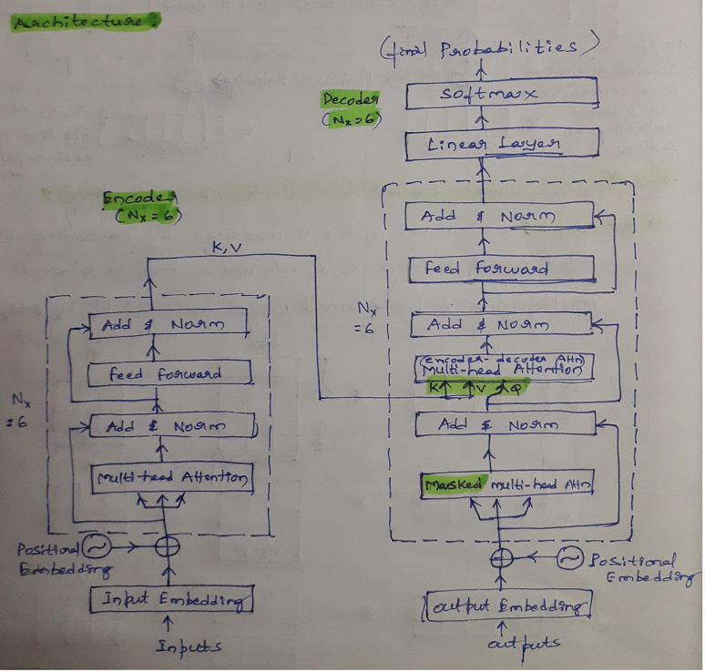
Each encoder has the following layers:
- Self-attention
- LayerNorm (Add & Norm)
- Feed forward
- LayerNorm
Flow of information between these layers in each encoder is explained in the below sketch:
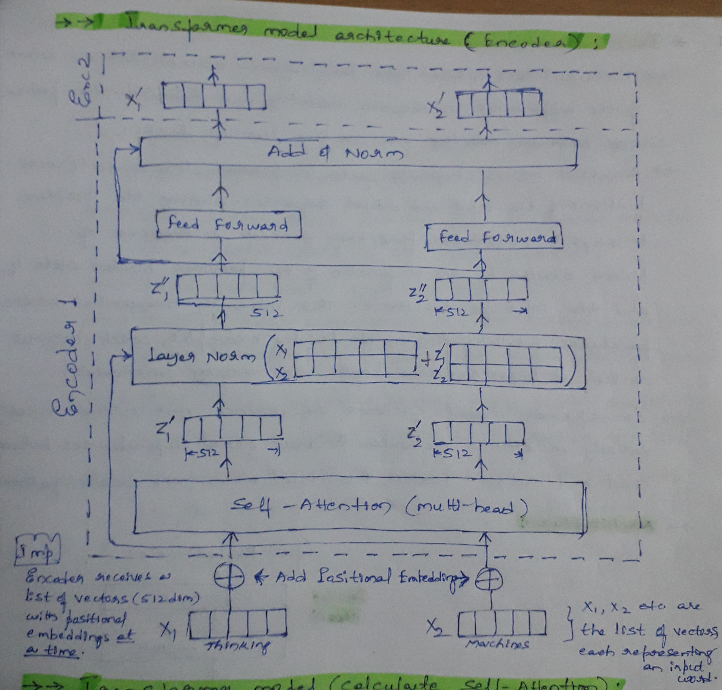
Each decoder has additional layer for masked multi-head attention apart from other layers as in each encoder. Further a linear and softmax layers are used to generate the final probabilities.
For an excellent explanation of the complete encoder-decoder architecture, pl refer to the Illustrated Transformer¹³ by Jay Alammar.

BERT Architecture
Bi-directional Encoder Representations From Transformer (BERT) is a new language representation model. Out of the two existing techniques for applying pre-trained language representations viz., feature-based and fine-tuning, authors of BERT have chosen the second technique (fine-tuning).
BERT authors have attempted to address the limitations of the uni-directional models like Open-AI GPT, which incorporate context in only one direction (from left to right). Per the authors of BERT paper, the limitations of uni-directional models are addressed by training the model with what they called as masked-language modeling (MLM) technique.
BERT model is essentially built in two phases viz: 1) pre-training and 2) fine-tuning.

Pre-training
Authors of BERT paper have pre-trained using 2 unsupervised tasks: 1) MLM and 2) NSP (next sentence prediction). The pre-training corpus includes Wikipedia (2500M words) + Bookscorpus (800M words) with a total vocabulary size of nearly 30,000 words (actually word-pieces).
The # of layers, hidden units and attention heads vary across several models that were pre-trained by the authors. A couple of pre-trained models specs are:
BERT Base – uncased, 12 transformer layers, 12 attention heads, 768 hidden units with 110 million parameters / weights
BERT Large – uncased, 24 transformer layers, 16 attention heads, 1024 hidden units with 340 million parameters/ weights

Fine-tuning
The self-attention mechanism of the Transformer model allows BERT to model across several downstream tasks. BERT facilitates fine-tuning of the pre-trained models across 11 different NLP tasks like, Named Entity Recognition (NER), sentence pair classification, question-answering etc..

Architecture
Each transformer layer resembles an encoder in the original Transformer model, but for the total hidden units. For e.g., Transformer model has 512 hidden units to represent a token, while BERT base has 768 dimensions and BERT large 1024.
Each layer takes in a list of token embeddings and produces the same # of embeddings on the output.
Two special tokens viz., [cls] and [sep] are used to separate sentence pairs in the input sequence. Also, [cls] is the first token of the input sequence and is used as an aggregate of the sequence representation, which could be directly used in any downstream classification tasks by simply connecting an additional sigmoid layer for final classification.

High-level Schematic of Inputs and Outputs in BERT
Below sketch explains the sequence of information flow in BERT layers from input to output:
(Source: The Illustrated BERT- https://jalammar.github.io/illustrated-bert)

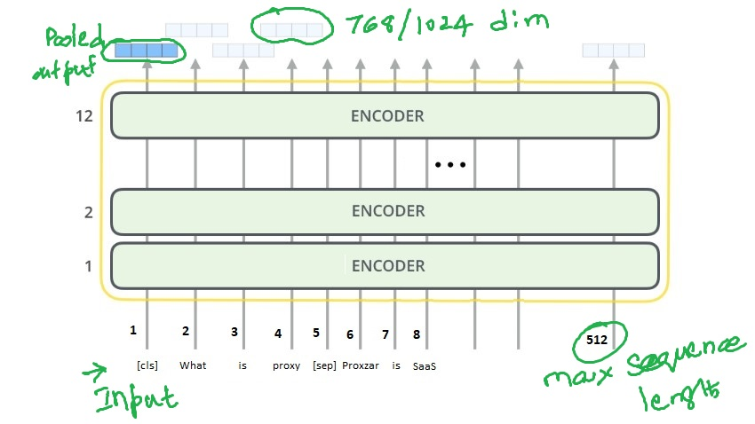
BERT Final Output Representation of Input Sequences
BERT generates embeddings that could be categorized as:
- pooled output
- sequence output
Pooled output has the aggregated set of contextual embeddings of the complete sequence and stored in the token [cls], which means classification. This token output can be directly used in any classification tasks. The shape of pooled output is: Batch size x Embedding dimension.
Sequence output on the other hand has contextual embeddings of each token in the sequence and can be used in downstreams tasks like question-answering or NER etc.. The shape of the sequence output is: Batch size x Maximum sequence length x Embedding dimension.
Below sketch attempts to explain how BERT generates pooled and sequence outputs for a given set of input sentences:
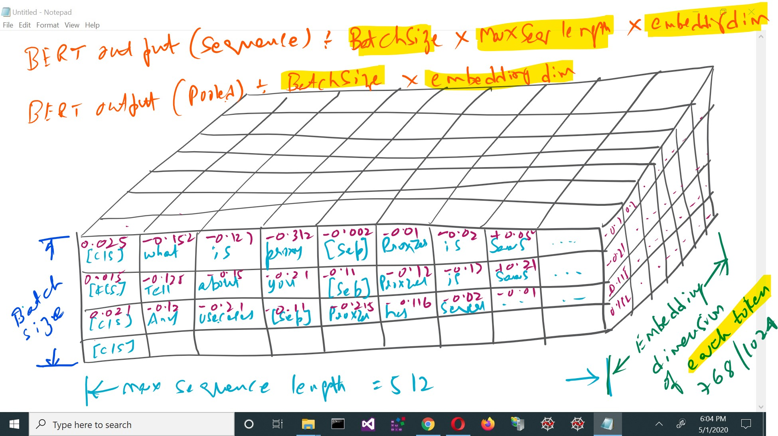

BERT for Feature Extraction
Apart from using pre-trained BERT models for fine-tuning on the downstream tasks, it also provides an additional advantage. The bi-directional embeddings generated by BERT are very rich in context. These contextual word embeddings can also be used for feature extraction. For e.g., the below sketch (sourced from The Illustrated Bert of Jay Alammar) shows the F1 score of using these embeddings for NER task:
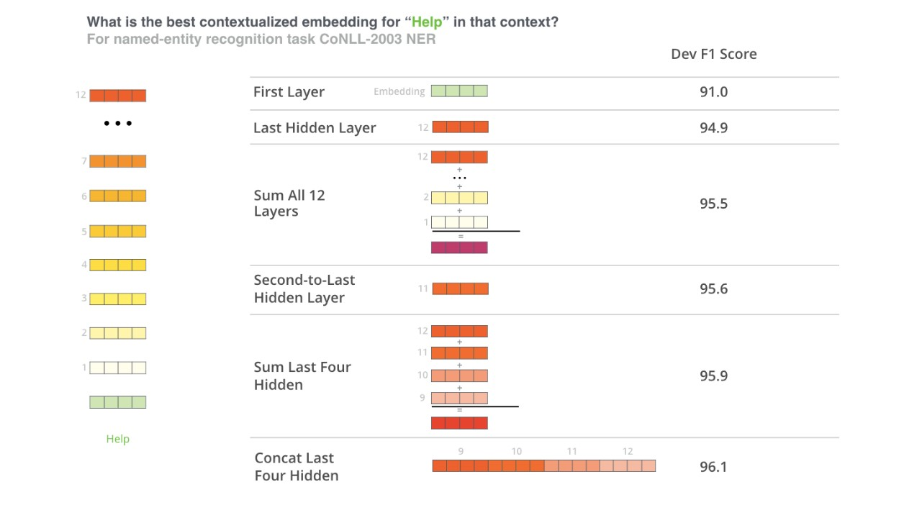

Original Google Implementation (TF 1.1) of run_squad.py
As it was decided to use the run_squad.py option to fine-tune BERT as mentioned elsewhere in this document, I started with the original implementation of the scripts by the BERT authors. The script works with TF 1.1. This script imports several modules that needs to be updated to TF 2.0. However, to get an understanding of how the script is fine-tuning a given pre-trained model, I reviewed the code in this script. Notes of my review are in Appendix D.

Observations From Fine-tuning BERT using run_squad.py

Layer-wise Representations Of Our Fine-tuned BERT Model
Appendix E

Limitations

Planned versus Actual

Future Scope

Fine-tune Using tf.keras From Scratch

Build Alogorithms That Can Effectively Manage Max Sequence Length

References
- Google Research on BERT: https://github.com/google-research/bert
- Tensorflow models: https://github.com/tensorflow/models/tree/master/official
- Saving and loading a Tensorflow model using the SavedModel API: https://medium.com/@jsflo.dev/saving-and-loading-a-tensorflow-model-using-the-savedmodel-api-17645576527
- Parameter-Efficient Transfer Learning for NLP: https://arxiv.org/abs/1902.00751
- bert-for-tf2: https://github.com/kpe/bert-for-tf2
- bert-as-a-service: https://github.com/hanxiao/bert-as-service
- keras-bert: https://github.com/CyberZHG/keras-bert
- Hugging face transformers: hhttps://github.com/huggingface/transformers
- Transformer model for language understanding: https://www.tensorflow.org/tutorials/text/transformer
- Distributed training with Keras: https://www.tensorflow.org/tutorials/distribute/keras
- Tensorflow datasets: https://github.com/tensorflow/datasets/blob/master/tensorflow_datasets/text/squad.py
- Issue with saving fine-tuned model: https://github.com/tensorflow/models/issues/8399
- The Illustrated Transformer - Jay Alammar: http://jalammar.github.io/illustrated-transformer/
- The Illustrated BERT: http://jalammar.github.io/illustrated-bert/
- A visual guide to using BERT for the first time: http://jalammar.github.io/a-visual-guide-to-using-bert-for-the-first-time/
- BERT in Keras with Tensorflow hub: https://towardsdatascience.com/bert-in-keras-with-tensorflow-hub-76bcbc9417b
- BERT fine-tuning for Tensorflow 2.0 with Keras API: https://medium.com/@brn.pistone/bert-fine-tuning-for-tensorflow-2-0-with-keras-api-9913fc1348f6
- Google BERT - Pretraining and Finetuning for NLP tasks: https://medium.com/@ranko.mosic/googles-bert-nlp-5b2bb1236d78
- Neural Question And Answering using SQuAD dataset and Attention: https://medium.com/@raman.shinde15/neural-question-and-answering-using-sqad-dataset-and-attention-983d3a1dd42c
- Fine-tuning BERT with Keras and tf Module: https://towardsdatascience.com/fine-tuning-bert-with-keras-and-tf-module-ed24ea91cff2

Appendix A
Note: The tick-marked modules were originally planned to be used as part of this project implementation, but, subsequently dropped due to limitations as cited elsewhere in this document.
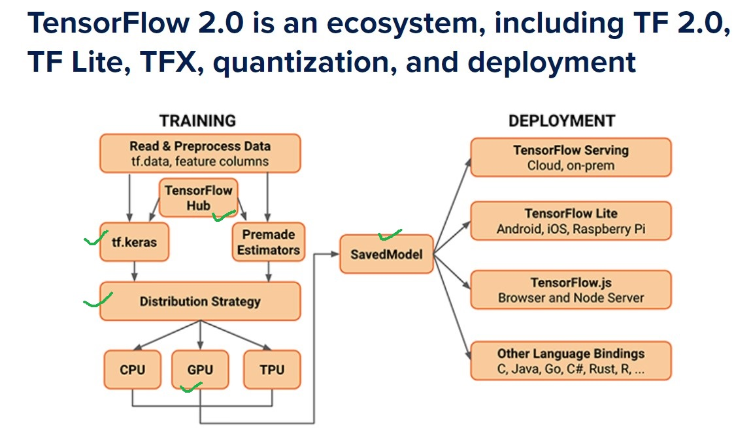

Appendix B
Sl# | Action Item | ETC | Remarks
1 | Build BERT model after fine-tuning pre-trained BERT base, uncased, 12-layer model using SQuAD 1.1 dataset and save it in TF2.0 saved model format. | April 18th 2020 | The currently available official version of run_squad.py that does the fine-tuning and saving it in TF2.0 saved model format is throwing errors. Re-run the file to save in .ckpt format for next action: predictions.
2 | Run predictions using the fine-tuned model with external test set from Proxzar. | April 22nd 2020 | Coded a C# console app that converts the questions/ contexts file in .csv format into SQuAD1.1 json format for input to predictions.  Changed the official repo to kamalkraj’s github repo (to get an updated.  Unable to generate predictions with the new run_squad.py file.
3 | Performance metrics of fine-tuned model. | April 22nd 2020 | Fine-tuned model performance:  EM: 79.60  F1: 87.47
4 | Generate qualitative comparison report by comparing existing implementation of Q&A systems at Proxzar with this BERT implementation. | April 24th 2020 | Couldn’t complete with TF2.0 run_squad script.
5 | Submit the project as per the institution guidelines. | May 1st 2020

Appendix C
- Code implementation: Fine-tuning pre-trained BERT model using SquAD 1.1 training data. It is a python notebook on Google Colab. It can be accessed by clicking here.
- Code implementation: Generating predictions from the above fine-tuned model. It is a python notebook on Google Colab. It can be accessed by clicking here.
- Code implementation: C# program to convert questions/contexts tsv file into SQuAD 1.1 json format. It is hosted on github and can be accessed by clicking here.

Appendix D
Google's BERT implementation: run_squad.py notes:
1. SquadExample class is used to build an input sequence as follows:
- "qas_id:<question id>, question_text:tokenization.printable_text(question_text), doc_tokens:" ".join(doc_tokens)
- if is_training = False, then,
-- start_position = -1
-- end_position = -1
-- orig_answer_text = ""
2. InputFeatures class essentially copies the parameters to instance variables for the class. This is done to maintain the feature set in a single instance at one place.
3. The method read_squad_examples essentially returns a list of SquadExample class.
4. The method convert_examples_to_features is essentially generating tokens and input ids comprising of sub-tokens, segment ids and writing to the file in the output_dir with the name 'eval.tf_record'. If it is training, the name of this file is 'train.tf_record'.
5. The method create_model creates and initialized weights as defined in the bert config file. It internally calls the BertModel method of modeling.py.
6. The method model_fn_builder encapsulates the information that is an implementation of tf.estimator API (for training and predicting a model on TPU). If TPU is not provided, it defaults to CPU or GPU.
7. The method input_fn_builder encapsulates the information that is an implementation of tf.estimator.
8. The method write_predictions writes the predictions to the final predictions output file.
9. The method get_final_text gets the actual word from the tokenized predicted text.
10. The class FeatureWriter implements writing to TF record files.
11. The method validate_flags_or_throw validates if the flags as set are correct as per the bert configuration.
12. Actual implementation of the above methods and classes in main():
- bert_config = modeling.BertConfig.from_json_file(FLAGS.bert_config_file)
- validate_flags_or_throw(bert_config)
- tf.gfile.MakeDirs(FLAGS.output_dir)
- tokenizer = tokenization.FullTokenizer(vocab_file, do_lower_case)
- TPU calls for cluster resolver and input pipeline config
- if training, train_examples = read_squad_examples(input_file, is_training=True)
- TPU call: model_fn = model_fn_builder(bert_config,init_checkpoint=FLAGS.init_checkpoint,...)
- TPU call: estimator = tf.contrib.tpu.TPUEstimator(use_tpu=FLAGSS.use_tpu, model_fn=model_fn,config=run_config,train_batch_size=FLAGS.train_batch_size,predict_batch_size=FLAGS.predict_batch_size)
- if FLAGS.do_train: write training data to TF record file for training and call input_fn_builder
- if FLAGS.do_predict: write eval data to TF record file for evaluation, call input_fn_builder and call estimator.predict

Appendix E

