**Affiliation:** Department of Computer Science and Engineering,Nalla Narasimha Reddy

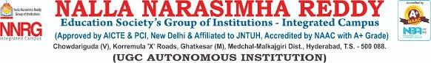

**ABSTRACT**

**VOICE-BASED VIRTUAL ASSISTANT FOR WINDOWS**

**Authors:** T.Srikanth(217Z1A6756) ,K.Srija reddy(217Z1A6732), D.Abhiram(217Z1A6701)

**Affiliation:** Department of Computer Science and Engineering,Nalla Narasimha Reddy Educational Society’s Group of Institutions

The goal of this project is to develop a voice-based virtual assistant for Windows, designed to enhance user interaction through natural language processing and voice recognition technologies. This assistant aims to facilitate various tasks, providing an intuitive and hands-free user experience for managing applications, scheduling, and information retrieval.The system leverages advanced neural network models for speech recognition and natural language understanding. Key components of the assistant include a speech-to-text engine, natural language processing module, and a command execution interface. The speech-to-text engine converts spoken language into text, which is then processed by the natural language processing module to understand and interpret user commands. Finally, the command execution interface interacts with the Windows operating system to perform the desired actions.Key functionalities of the assistant include opening and closing applications, managing files, setting reminders, sending emails, and retrieving information from the web. Techniques such as voice activity detection, intent recognition, and context management were implemented to ensure accurate and efficient performance. The system also supports customization and learning from user interactions to improve accuracy and user experience over time.

**Keywords:** Voice Assistant, Natural Language Processing, Speech Recognition, Virtual Assistant, Human-Computer Interaction