Detailed Design
Document
for
Sports and Physical Education
07.03.17
LAB: TUESDAY, TEAM-5
TEAM MEMBERS
Sai Krishna .S ( B121722 )
Ramu.M ( B121732 )
Rajashekar.B ( B121706 )
Srikanth.M ( B121769 )
Sathish.K ( B121811 )
Version 1.0
Table of Contents
1. Introduction...............................................................................................................................3
1.1 Goals and Objectives........................................................................................................................3
1.2 Scope of Solution..............................................................................................................................3

2. Architecture and Component Level Design............................................................................3

2.1 Architecture diagram............................................................................................................3
2.2 Description of Components..................................................................................................4
2.2.1 Class Diagram..........................................................................................................4
2.2.2 Home........................................................................................................................5
2.2.3 Material....................................................................................................................6
2.2.4. Material registeration..............................................................................................7
2.2.5 Login........................................................................................................................8
3. Data architecture.......................................................................................................................9

3.1 Data Description.....................................................................................................................9
3.2 Entity-Relationship Diagram.................................................................................................9
3.3 Data Dictionary....................................................................................................................10
3.4 Client & Server....................................................................................................................11
3.4.1 Class Description.................................................................................................11
3.4.2 Functional Description........................................................................................11

1.0 Introduction

- This section provides an overview of the entire design document. This document describes all data, architectural, interface and component-level design for the software.

1.1. Goals and Objectives

- This software will be useful for RGUKT. Through this application students and faculty would know the information about the Sports and Physical education.

1.2. Scope of Solution

- This software will be useful for RGUKT. Through this application students and
faculty would know the information about the sports and physical education in scope

2.0 Architecture Overview

2.1 Architecture diagram
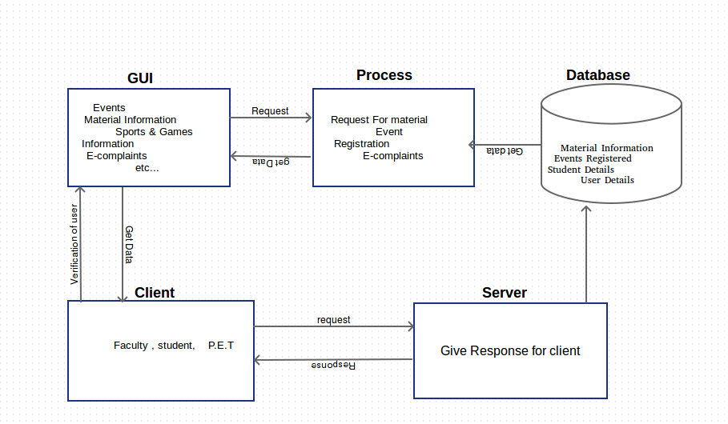

2.2 Description of Components

2.2.1 Class Diagram:

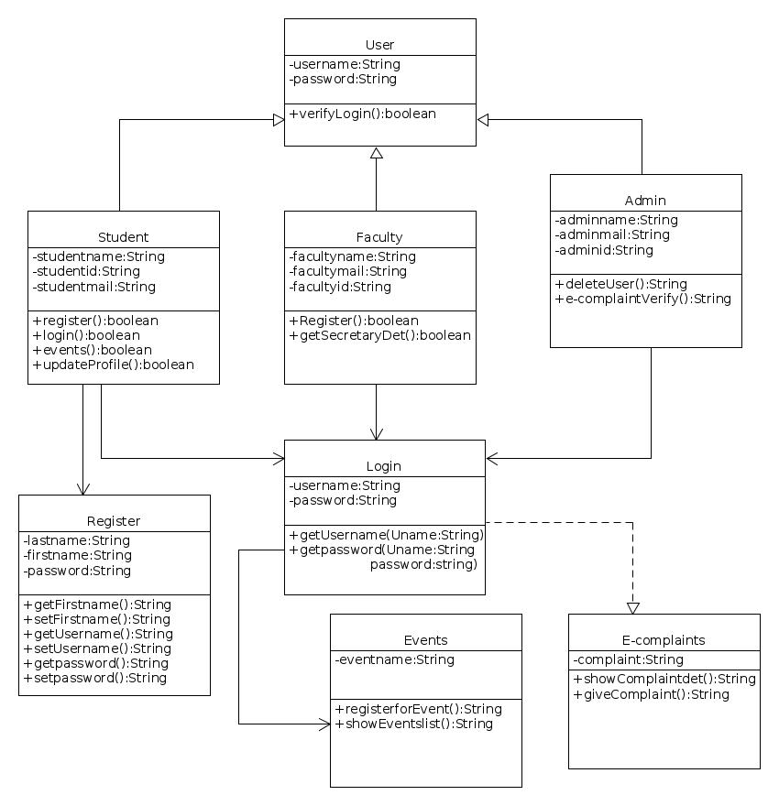

Graphical User Interface

2.2.2 Home

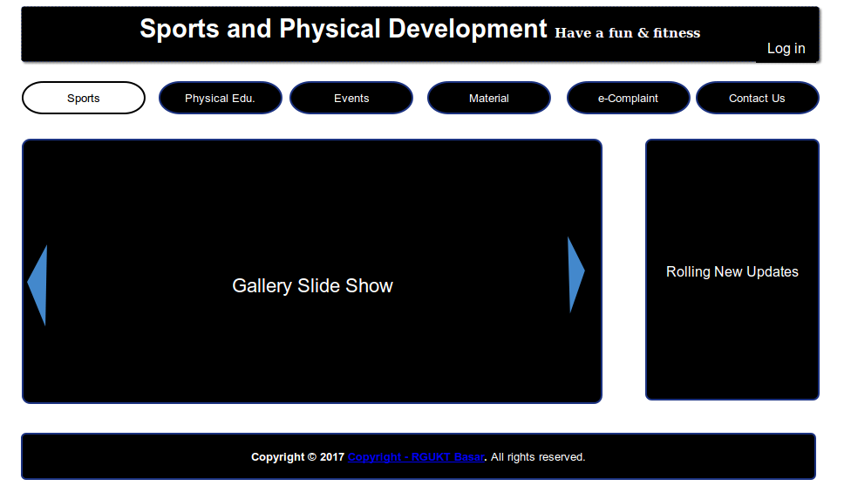
It is home page where any body can see this page and he/she can information about Sports and Physical Education.

Attributes:

e-Notice
Gallery
Login
Contact Us

Methods:
Precondition : User must have Internet facility to view our website.

Postcondition : User can see the home page of our website.

Algorithm : If URL in user browser == our website URL and then
user can see our website.
Error Checking : if user don’t enter correct URL he will have error below mentioned way.
-Please check address.
-Server not found.
Security:
Nobody can get to know the who are the users of our website.

2.2.3 Material

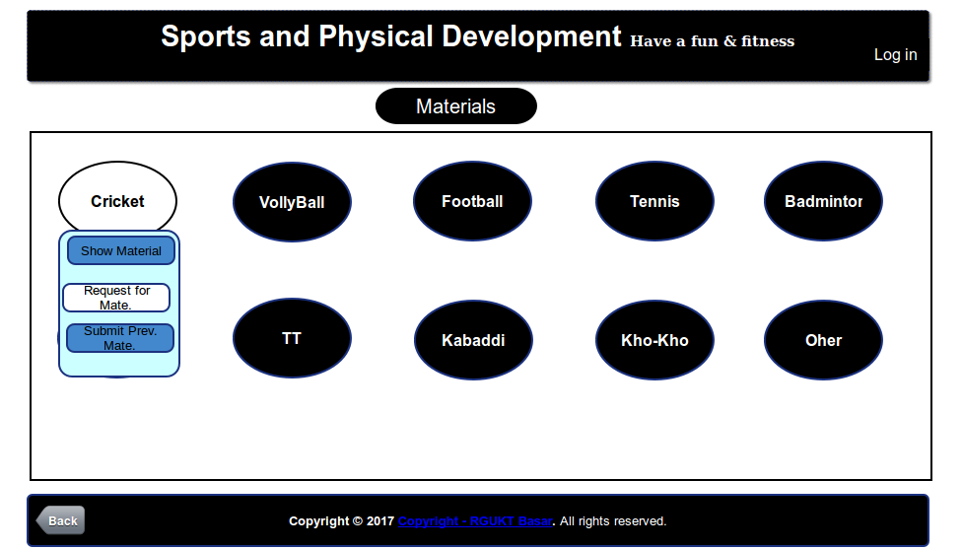

Attributes:

Select Game
Drop your game
Game options

Methods:
Precondition : User should have desire to play games.

Postcondition : User can see the Material page of our website.

Algorithm : If URL in user browser == our website material page URL and then
user can see our website.
Error Checking : if user don’t enter correct URL he will have error below mentioned ways.

-Please check address.
-Server not found.

2.2.4. Material registeration

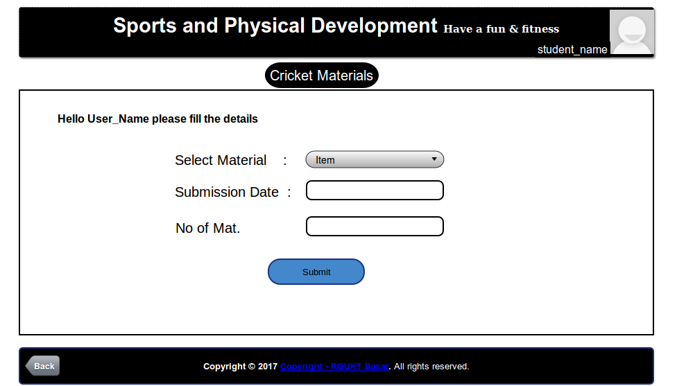

Attributes:

Select item
Submission date
No of Materials
Submit option

Methods:
Precondition : User must be logged into website before he request for the material

Postcondition : User can request the material.

Algorithm : If URL in user browser == our website material URL and then
user can see our website.

Error Checking :If user don’t have a account he will have error below
mentioned way.
-Please login.
Security:

Nobody can get to know the who are the users of our website.

2.2.5 :Login

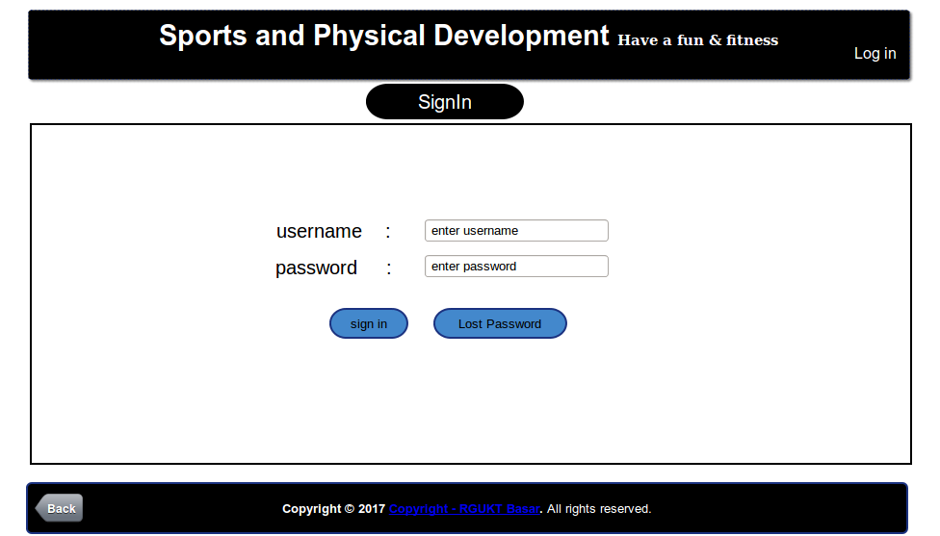

Attributes:

Username
Password
submit
cancel

Methods:
Precondition : User must be enter password to login into our website

Postcondition : User can view his details and request for material

Algorithm : If URL in user User name and password == our database User name password and then
user can view his profile and request the material.

Error Checking :If user don’t have a account he will have error below
mentioned way and if he enter wrong password.

-Please login.
-Please check User name or Password
Security:
Nobody can get to know the who are the users s our website.

3 Data architecture

3.1 Data Description

Data and their fields (Material Information,e-complaints,reply,registraion for events,gallery,request for material,sports &games information,show secratery details) are collected from users and stored in database.Data is searched using Query object and its fields.Search results are generated from the database and displayed to the user.

3.2 Entity-Relationship Diagram

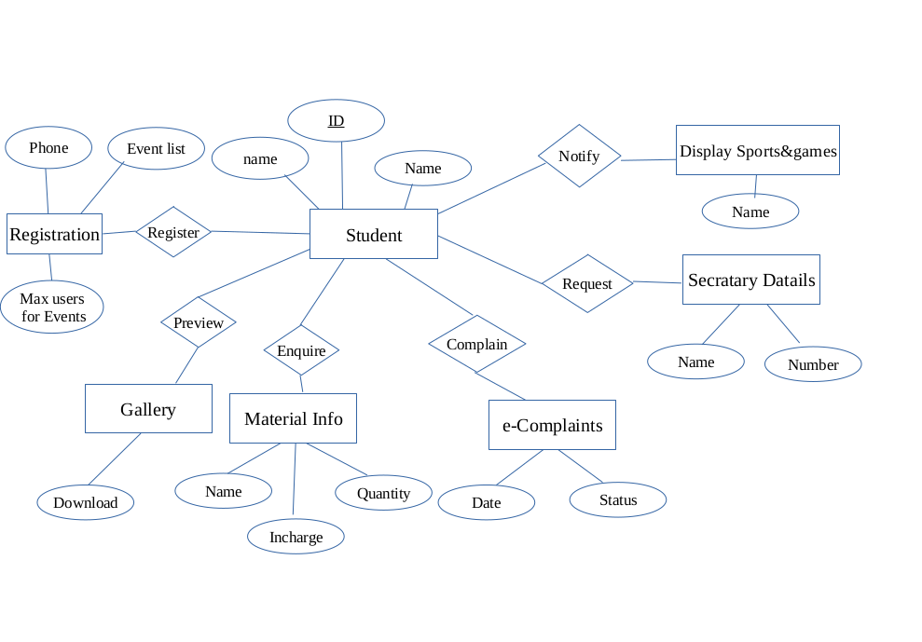

3.3 Data Dictionary

Data Dictionary:

Student:
Field | Type | Other Information
Id | varchar | Primary key:  size:7
name | varchar | Size:50
password | varchar | Size:20

Display Sports &Game Information:
Name | varchar | Size:20

Secretary Details:
Name | varchar | Size:20
Phone Number | number | Size:10

E-complaints:
Date | Date | Size:8
Status | varchar | Size:20

Material Information:
Name | varchar | Size:20
Quantity | number | Size:3
Incharge | varchar

Register:
Events list | varchar | Size:20
Max_Students for Event | number | Size:2
Phone Number | number | Size:10

3.4 Client and Server Module:

3.4.1 Class Description:

- Student or Faculty : It contains basic information of the Student or Faculty Details
- Login : It deals with the authentication of user
- Register : It will register for the new user
- Events: It deals about the events and their Information
- Admin: I tgives the privilege to the user
- User : It will give details about the user

3.4.2 Functional Description:

+verifyLogin(): Checks the user entered credentials with data base values. If he entered correct details he will redirect to his profile.

+register(): It will register the user registration by taking filled form. It means he will be the user of the application.

+updateProfile():This function can update the user profile when he call this module.

+setUsername():It will set the new user name of already registered user.

+setPassword(): It will set the new password for the user.

+getSecretaryDet():It will give secretaries details when user invoke this function.

+e_complaintVerify():It will verify the user lodged complaint.It is all about verification it could be done by admin.

+registerEvent():This function would register the user for selected event if he satisfy all creteria put by event department.

+showEventList():This wil show the events of department of Sports and Physical education.

+giveComplaint():This function could lodge complaint if user invoke it ,means if user would like to give complaint he should invoke it.

+deleteUser():If user done any malicious thing in server the admin can delete user account,means user couldn't have permission to log into the website.

Tools Used in Module :
Apache server
Programming Language used : php

