CIVIC TICKET
Public Works & Complaint Registry — Ward-level Civic Complaint Management System

PROJECT REPORT
Sections: Abstract · System Architecture · Architecture Drawings · Data Dictionary · Design Patterns

1. Abstract
Civic Ticket is a web-based civic complaint management system designed to bridge the communication gap between citizens and municipal ward authorities in addressing everyday public infrastructure issues such as potholes, overflowing garbage bins, faulty streetlights, and water supply disruptions. Traditional complaint redressal in most wards relies on phone calls, in-person visits, or informal channels, which offer no visibility into whether an issue has been acknowledged, who is responsible for it, or how long it has been pending — leading to duplicated complaints, delayed action, and citizen distrust in civic bodies.
The proposed system allows any citizen to file a complaint with a title, category, description, photograph, and a precise location marked on an interactive ward map. Before submission, the system checks for existing nearby reports of the same category and nudges the citizen to upvote a duplicate instead of fragmenting the record. Filed complaints appear on a public board where residents can upvote issues to signal urgency, comment with additional context, and track status through three stages — Open, In Progress, and Resolved.
On the administrative side, the system enforces category-specific service-level timelines and automatically escalates unresolved complaints through a review, ward-officer, and commissioner tier as they age, so nothing quietly falls through the cracks. Ward staff, authenticated via a passcode-protected panel, can assign complaints to specific officers, update statuses, attach a resolution-proof photograph, and export the full complaint register as CSV for offline reporting. A dedicated analytics dashboard gives administrators a real-time ledger of total complaints, resolution rate, average resolution time, citizen satisfaction ratings, category and status breakdowns, and a 14-day filing trend, while a lightweight polling mechanism keeps the shared board synchronized across concurrent users.
By combining transparent public tracking, automated accountability through SLA-based escalation, and data-driven administrative oversight, Civic Ticket aims to reduce complaint resolution time, improve civic accountability, and rebuild citizen trust in local governance.

2. System Architecture
Civic Ticket follows a layered, client-only architecture — the entire application runs inside the user's browser as a single-page React app, with a hosted key-value storage service standing in for a traditional application server and database. There is no separate backend codebase to deploy or maintain; the browser is both the client and the orchestrator of all business logic.

2.1 Presentation Layer
Reusable React components responsible purely for rendering and capturing user interaction — this layer contains no business rules.
- Submission form — captures title, category, description, photo, and a map-based location pin
- Public board — renders the ticket list/map views with search, filter, and sort controls
- Analytics ledger — renders summary statistics and breakdown charts
- Admin panel — a passcode-gated interface for status updates, officer assignment, and CSV export

2.2 Application (Logic) Layer
Holds the system's decision-making logic, implemented through React state and handler functions.
- Computing category-specific SLA escalation tiers based on complaint age
- Calculating a priority score (escalation weight + upvotes) to rank the admin work queue
- Detecting duplicate nearby complaints before submission
- Filtering, sorting, and searching the complaint list
- Reconciling updates from other users via periodic polling (“live sync”)

2.3 Data (Persistence) Layer
Persistence is handled through a browser-accessible key-value storage API, split into two logical stores:
- Shared registry — the complete public complaint dataset (status, upvotes, comments, photos, assignment, resolution proof), readable and writable by all users, making the board collaborative
- Personal store — a private, per-user record of which ticket IDs the citizen has filed, used for “Filed by you” tags and “Only mine” filtering

2.4 Data Flow
A citizen submits a report through the Presentation Layer → the Logic Layer validates it, checks for duplicates, and timestamps it → the record is written to the Shared registry in the Data Layer. The same record then flows back through the Logic Layer for escalation and priority calculation before being rendered on the Public Board and in Admin views. Status or assignment changes made by a ward officer follow the same round-trip, updating the Shared registry so all connected clients converge on the same state.

3. Architecture Drawings
The following two drawings represent the system from complementary perspectives: how the code is structurally layered, and how data flows between the actors and the system.

3.1 Layered System Architecture Diagram
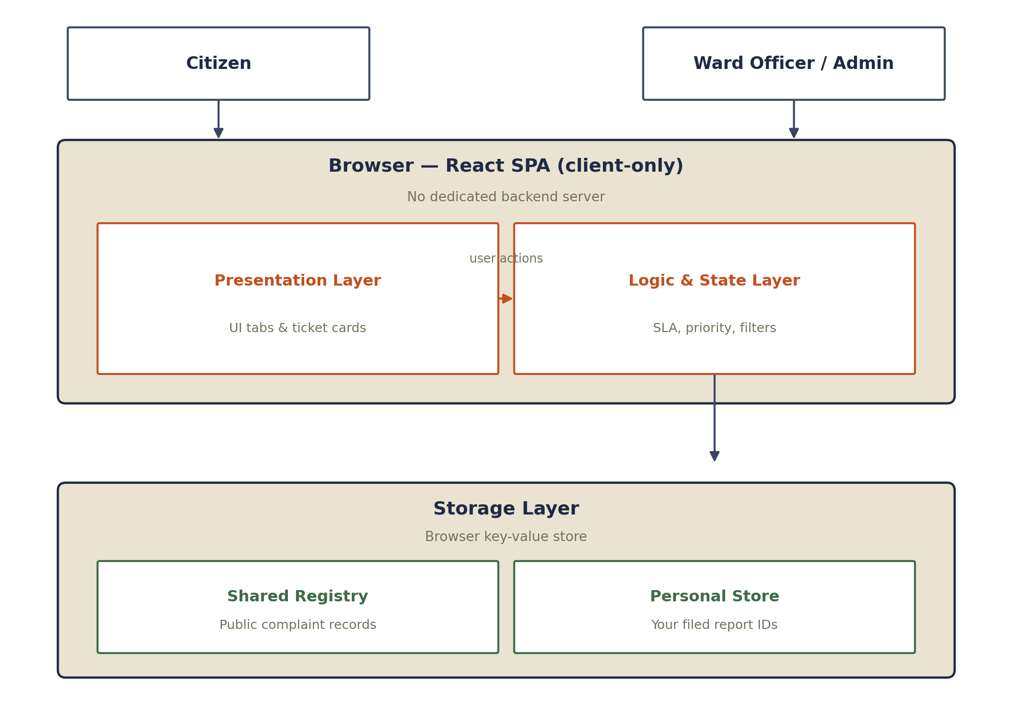
Figure 3.1 — Layered client-only architecture: Presentation and Logic layers inside the browser, backed by a Storage layer.

3.2 Data Flow Diagram (Level 0 — Context Diagram)
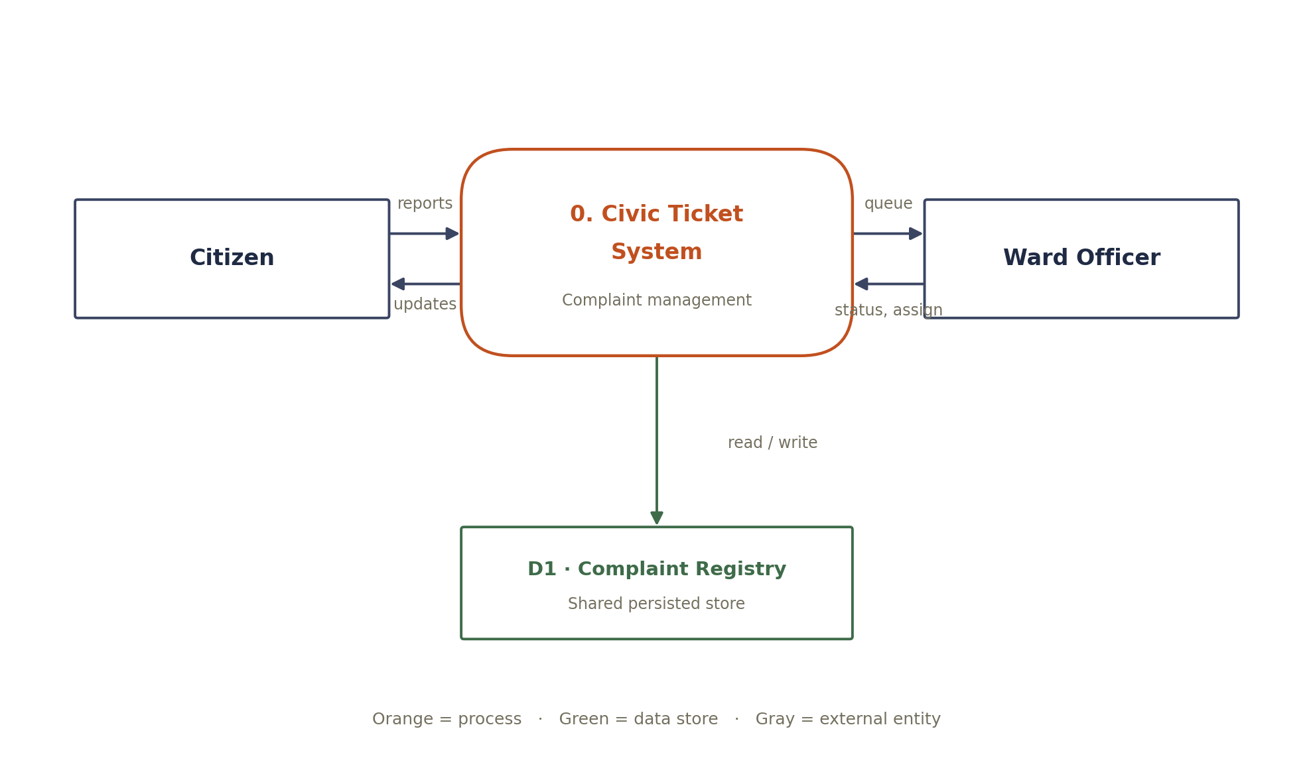
Figure 3.2 — Context-level DFD showing data exchanged between the Citizen, the Civic Ticket System process, the Ward Officer, and the complaint data store.

4. Data Dictionary — Hidden & Internal Data
Beyond the fields visibly displayed on the public board, the system maintains several categories of data that are private, computed, or otherwise not surfaced directly to the user.

4.1 Private, Per-User Data
Field | Where it lives | Why it's hidden
myReportIds | Personal store (civic-ticket:my-reports) | Only the filer's browser session can see which ticket IDs they submitted — powers “Filed by you” tags and “Only mine” filtering without exposing filer identity to others

4.2 Computed / Internal Fields
Field | Computed from | What's shown instead
priorityScore | Escalation tier × 25 + upvotes | Never a raw number — only reflected as row order in the admin priority queue
ts (timestamp) | Date.now() at filing | Rendered only as relative text (“2 days ago”), never the epoch value
x, y (map coords) | Click position on the SVG map | Used to place the pin and calculate duplicate-report distance — never shown as numbers
Escalation tier | Age vs. CATEGORY_SLA thresholds | Shown only once a threshold is crossed — the underlying day-count math isn't exposed

4.3 Present but Not Directly Surfaced
Field | Status | Note
resolvedAt | Stored on the complaint | Used only to compute “resolved in N days” — not shown as a raw date
rating | Present in the data model | Only surfaced in aggregate (average citizen satisfaction)

4.4 Known Limitation
The admin passcode (WARD14) is a plain string inside the client-side JavaScript bundle. Because this is a client-only architecture with no backend, the passcode is visible to anyone who inspects the browser's source — it functions as a UX gate, not real access control. Any report or presentation on this project should state this explicitly as a known limitation rather than implying server-enforced authentication.

5. Design Patterns Used
The codebase follows several recognizable software design patterns — both classic Gang-of-Four patterns and common frontend architectural patterns — summarized below.
Pattern | Category | Where applied
MVVM | Architectural | complaints state = Model; JSX components = View; hooks/handlers = ViewModel
Container / Presentational | Structural | CivicComplaintPortal owns state and logic; TicketStub, TownMap, Ledger, StampBadge, StarRating are pure presentational components
Facade | Structural (GoF) | persistComplaints() hides the two-step complexity of updating UI state and writing to storage behind one call
State | Behavioral (GoF) | STATUS finite state machine (open → progress → resolved); a second, time-driven state machine layers escalation tiers on top
Strategy | Behavioral (GoF) | sortBy and adminSort swap comparator logic at runtime without the rendering code knowing which is active
Observer (approximated) | Behavioral (GoF) | Polling diffs shared storage against local state and flips hasRemoteUpdate, which the UI “subscribes” to via the refresh banner
Memoization | Optimization | useMemo caches filtered and nearbyDuplicate so expensive recomputation only reruns when dependencies change
Configuration-over-code | Data-driven design | CATEGORIES, CATEGORY_SLA, ESCALATION_LABELS, and OFFICERS are declared as data tables rather than hard-coded logic

5.1 Model / ViewModel / View with Pattern Call-outs
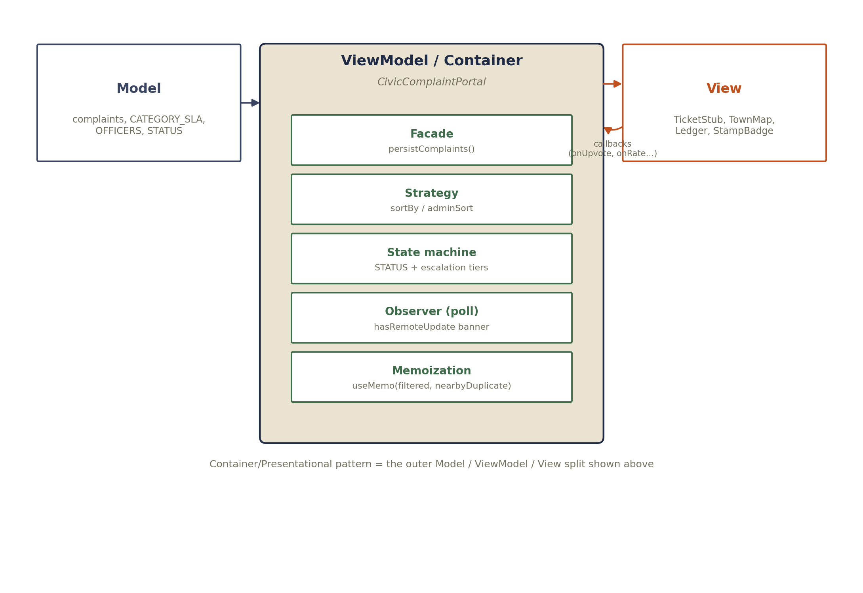
Figure 5.1 — The Container/Presentational split (Model / ViewModel / View) with the internal patterns used inside the ViewModel layer.

