Distributed Operating System Project

Sanjay Reddy Banda – 58782239

Deepthi Byneedi – 36871955

**Steps to run:**

1. The name of project is *LucasPyramid_FSharp_Akka*

2. To run the project, type- *dotnet fsi –langversion:preview proj1.fsx <N> <k>*

**Observations:**

1. We have made 8 workers. Work is equally divided among these workers such that each worker gets N/8 unit of the work from the boss actor. Cases with 8(system cores), 16, 32, 64, 128, 256, 512, 1024 workers have been run, but the maximum ratio of CPU to real time ratio of 6.36829 was achieved when using 8 workers for input (10^8, 24). Each worker gets a work unit of approximately 10^7
2. Result of *dotnet fsi –langversion:preview proj1.fsx 10^6 4* is null and doesn’t return any value.
3. Result of *dotnet fsi –langversion:preview proj1.fsx 10^6 4* is:
   1. Real - 0.276s
   2. CPU – 0.375s
   3. Ratio – 1.35
4. We have solved following problems ( d) is the biggest problem :
   1. input-(10^6,24)
      1. Real- 0.356s
      2. CPU- 0.562s
      3. Ratio= 1.578
   2. input-(10^7,24)
      1. Real- 0.846 s
      2. CPU- 3.312 s
      3. Ratio= 3.914
   3. input-(10^8,24)
      1. Real- 5.475s
      2. CPU- 34.578s
      3. Ratio= 6.315
   4. input-(10^9,24)
      1. Real- 54.791s
      2. CPU- 344.156s
      3. Ratio= 6.281

**CPU Utilization on Various Inputs:**

1. N = 10^6, k = 24 2. N = 10^7, k = 24

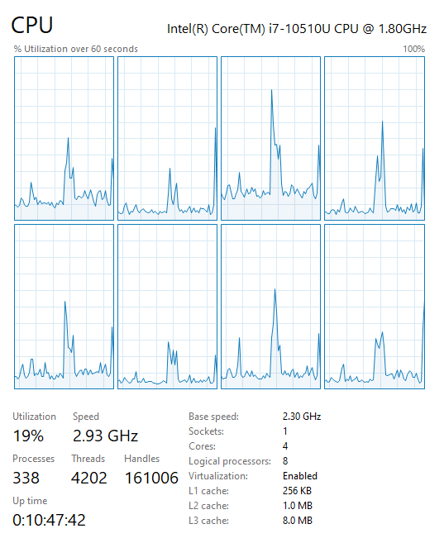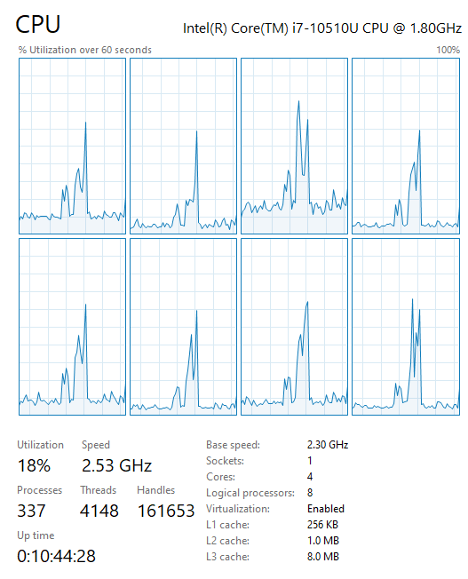

1. N = 10^8, k =24 4. N = 10^9, k= 24

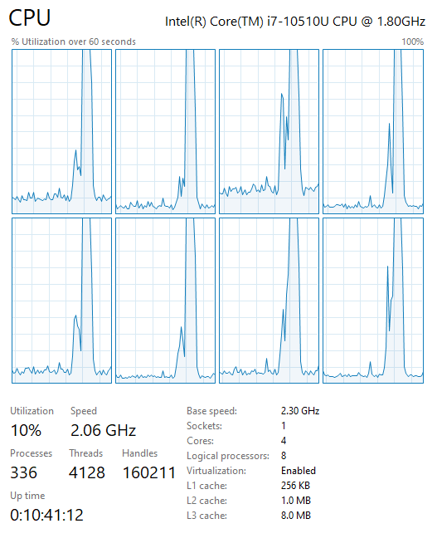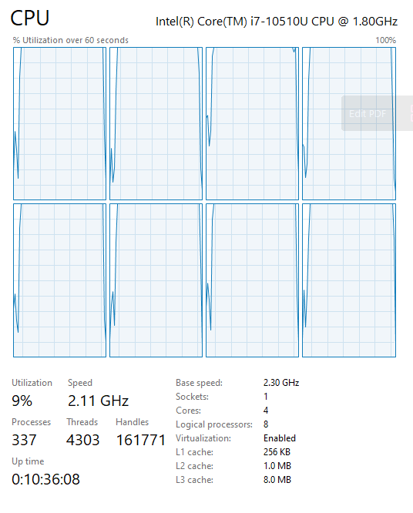**Thank you 😉**