Distributed Operating System Project

Sanjay Reddy Banda – 58782239

Deepthi Byneedi – 36871955

Steps to run:

1. The name of project is *LucasPyramidMultipleSystems*

2. First to run the server type – dotnet fsi – *langversion:preview* server.fsx

3. To run the client type - *dotnet fsi –langversion:preview client.fsx <N> <k> <serverIp> <port>*

**Design:**

**Server Design:**

1. Created a server actor which waits for the mail from the client.
2. Once the server receives message form client work message is kept in server Dispatcher mailbox.
3. Dispatcher actor will divide the problem and distributes the work among the available worker actors.
4. Result is kept back into the client mailbox.
5. Once the server computation is done it will send an End message to the client Mailbox.

**Client Design:**

1. On Client startup client actor is created and “init” message will be kept in client mailbox.
2. Client actor will divide the job into subparts and sends some part of work to the server mailbox and other part is computed locally by creating dispatcher actor.
3. Client actor will also handle the data coming from the server and prints the screen.
4. Once Client actor gets job done message from server and localJobDone is set true and kills the actor system and program terminates.

**Hardware Info:**

Machine 1: Intel-i7 8-Core Machine

Machine 2: Intel-i7 8-Core Machine

**Observations:**

1. We have made 8 workers. Work is equally divided among these workers such that each worker gets N/8 unit of the work from the boss actor. Cases with 8(system cores), 16, 32, 64, 128, 256, 512, 1024 workers have been run, but the maximum ratio of CPU to real time ratio of 6.36829 was achieved when using 8 workers for input (10^8, 24). Each worker gets a work unit of approximately 10^7
2. Result of *dotnet fsi –langversion:preview LucasPyramidValues.fsx 10^6 4* is null and doesn’t return any value.

**Server Console:**

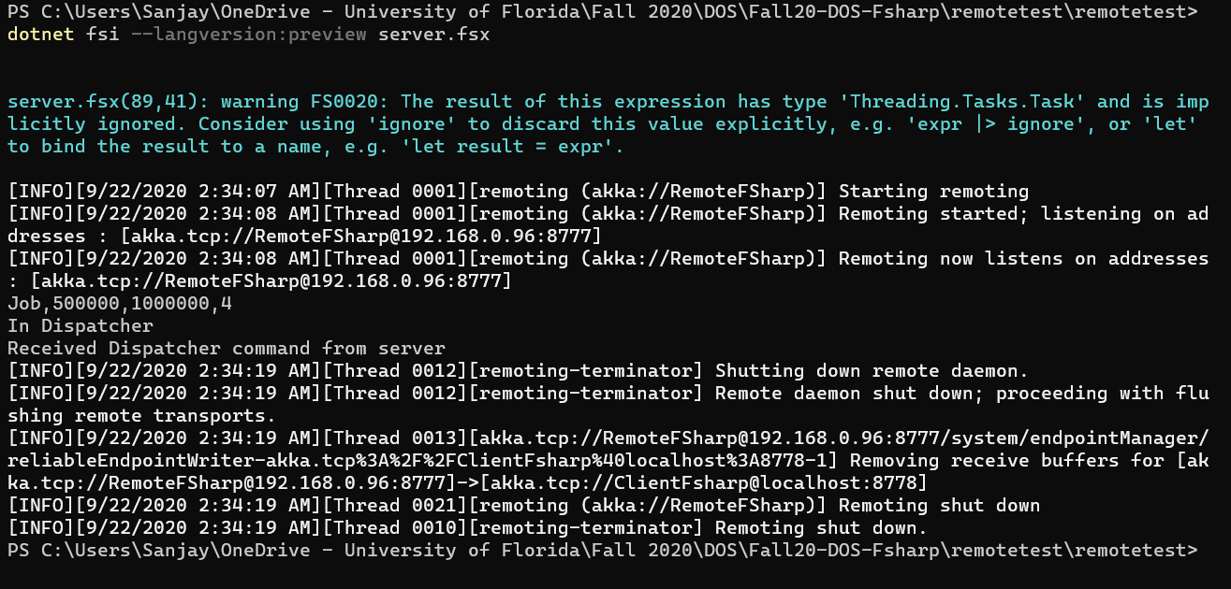

**Client Console:**

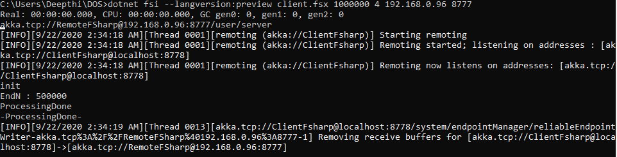

1. Result of *dotnet fsi –langversion:preview LucasPyramidValues.fsx 10^6 4* is:
   1. Real - 0.376s
   2. CPU – 0.485s
   3. Ratio – 1.28