**M1_Cricket_Game**

* Cricket Game Mini Project in c programm

[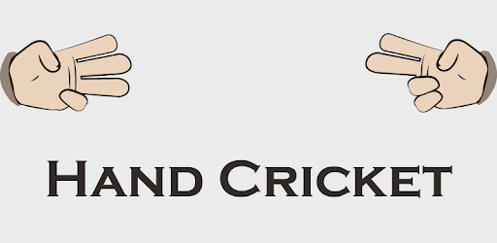](https://github.com/srikanthbandi949/M1_Cricket_Game/blob/main/6_Images_And_Videos/HandCricket.png)

**SDLC Activity Based Learning**

| **Build** | **Code Quality** | **Valgrind** | **Unity** | **Git inspector** |
| --- | --- | --- | --- | --- |
|  |  |  |  |  |

**Folder Structure**

| **Folder** | **Description** |
| --- | --- |
| 1_Requiremets | Documents detailing Requirements(High level and Low level requirements) |
| 2_Architecture | Structural and Behavioural design(Flow charts , usecase diagrams) |
| 3_Implementation | All code and code files |
| 4_TestPlanAndOutput | Documents with test plan and output |
| 5_Report | Whole Report of the project |
| 6_Images_And_Videos | Project necessary images and videos wiil be here |

**Contriutors List and Summary**

| **PS NO.** | **Name** | **Features** | **Number of testcases implemented** | **No_of testcases passed** | **No_of testcases failed** |
| --- | --- | --- | --- | --- | --- |
| 99007538 | Srikanth Bandi | Entire Project: Requirements, Architecture, Implementation, Test plan,Report | 2 | 2 | 0 |

**References**

* Cricket - The game of life implementation book by **Scyld Burry**
* W3 Schools, Geeks for geeks

# Certificates

* Solo learn certificate
* Linux Certificate
* Guthub completion
* Hackerearth certificate

# Requirements

# Description

The project is titled as **Hand Cricket Game** and developed using C language. Hand Cricket is an indoor game which can be played by kids with their hands.This game is made for two players. The two players will have to decide who is going to guess the toss. After winning the toss, the player has to select whether he has to bat/bowl first. The player who is going to bat first, need to open their fingers randomly at the same time bowler also open his fingers . He has to randomly open the fingers randomly . If the fingers count is morethan 6 like 7,8,9 counts as 0 , then it will be considered as a dot ball. The obtained score will be added to the batsman's score everytime. The batsman will be out if the fingers open by the bowler will be same as batsman. Then, the second player has to play in the same process.

# Requirements

# High Level Requirements

| **S.No** | **Description** |
| --- | --- |
| HR-1 | Main Menu |
| HR-2 | Played by 2 players |
| HR-3 | Toss |
| HR-4 | Batting/Bowling |
| HR-5 | Total score |

# Low Level Requirements

| **S.No** | **Description** |
| --- | --- |
| LR-1 | Main menu consists of four options as 1. Fixed overs, 2. play Until Out, 3. Instructions, 4. Exit. Players need to select one of them |
| LR-2 | Ask the players to enter their names |
| LR-3 | Ask the players to select the toss as 1/2 ad shows who won the toss |
| LR-4 | Asks the toss winner to select batting/bowling and make him ready for selected option |
| LR-5 | Implement total score of the batsman and prints and repeat with other batsman the same procedure |

# SWOT Aalysis

|  |  |
| --- | --- |
| Strength | Easy to use and time pass game which can play easily and quickly in free time |
| Weakness | It is a two player game only |
| Opportunity | Quickly understand makes more demand in future , and also GUI also implemented in future |
| Threat | Animated applications are available so compitition is high and hard |

# 4W's & 1H

#### Who

* everyone now-a-days wants to play a game in their free time and it is an indoor game
* all age group persons can play

#### What

* It is a two player game which is hand cricket, they can play easily by sitting in their places without going anywhere
* Also compete with each other

#### When

* When ever we have free time we can play it can be played in little free time also
* Due to corona we all are in home, so we can play this game without going any where by sitting at our places

#### Where

* We can play this game at any place like Home, Classroom, Ground etc.,
* Without going to anywhere by sitting on our chairs also we can play

#### How

* When ever we start the game it shows how to play , how to use the buttons
* It is developed in c language so we can easily play this game by reading the instructions
* It is simple game we just want two players to play , if we have two players we can play by reading the instructions

## Architecture

# Design

* Structural
* Behavioural
  + FlowCharts
  + Use case diagrams

### FlowChart

[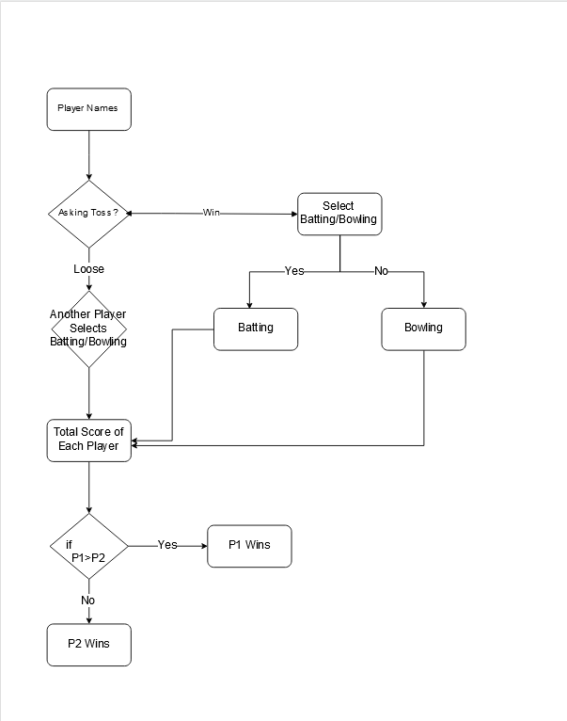](https://github.com/srikanthbandi949/M1_Cricket_Game/blob/main/2_Architecture/FlowChart.png)

#### You can see all the project code in this **3_Implementation** folder

* **Documentation** folder -> contains doxygen file
* **inc** folder -> header files as .h files
* **src** folder -> source code files .c files
* **test** folder -> source code file for unit testing .c files
* **unity** folder -> unit testing files
* **Makefile** -> contains all the paths and how to execute and run through a single makefile
* **doxyfile** -> contain doxygen file with doxygen comments

# Test Plan

* All code is categerosied into three parts main sourcecode and headerfile
* inc
  + header files
    - handcricket.h
* src
  + source files represents batting and toss
    - playerbatting.c and playertoss.c
* main code which is
  + handcricket.c file this is main file
* Makefile
  + with this file we run this game where we merge the all folders code such as source code and headerfiles and maincode and make them compile and run without errors
* unity
  + consists of unittest file which is handcrickettest with this file we run the testcases , here we pass the testcases to the fie and make the expected output to the given inputs
  + it consists of unittesting files which are present in unity folder with the help of that unity files we run the testcases withn the handcrickettest file

### Testcase

* Here we pass two names which asks us to give and after we give that names it asks us to choose the toss, after choosing the tos it shows who own the toss, and asks the winner to select batting/bowling, After select batting/bowling it asks the player to eneter to bowl and batsmen to enter to bat and after that it sums the batsmen score until gameover and repeat same with another batsmen and At the last it shows both players score , Whoever score more he is the winner and says congrats.

#### Captured screenshots

[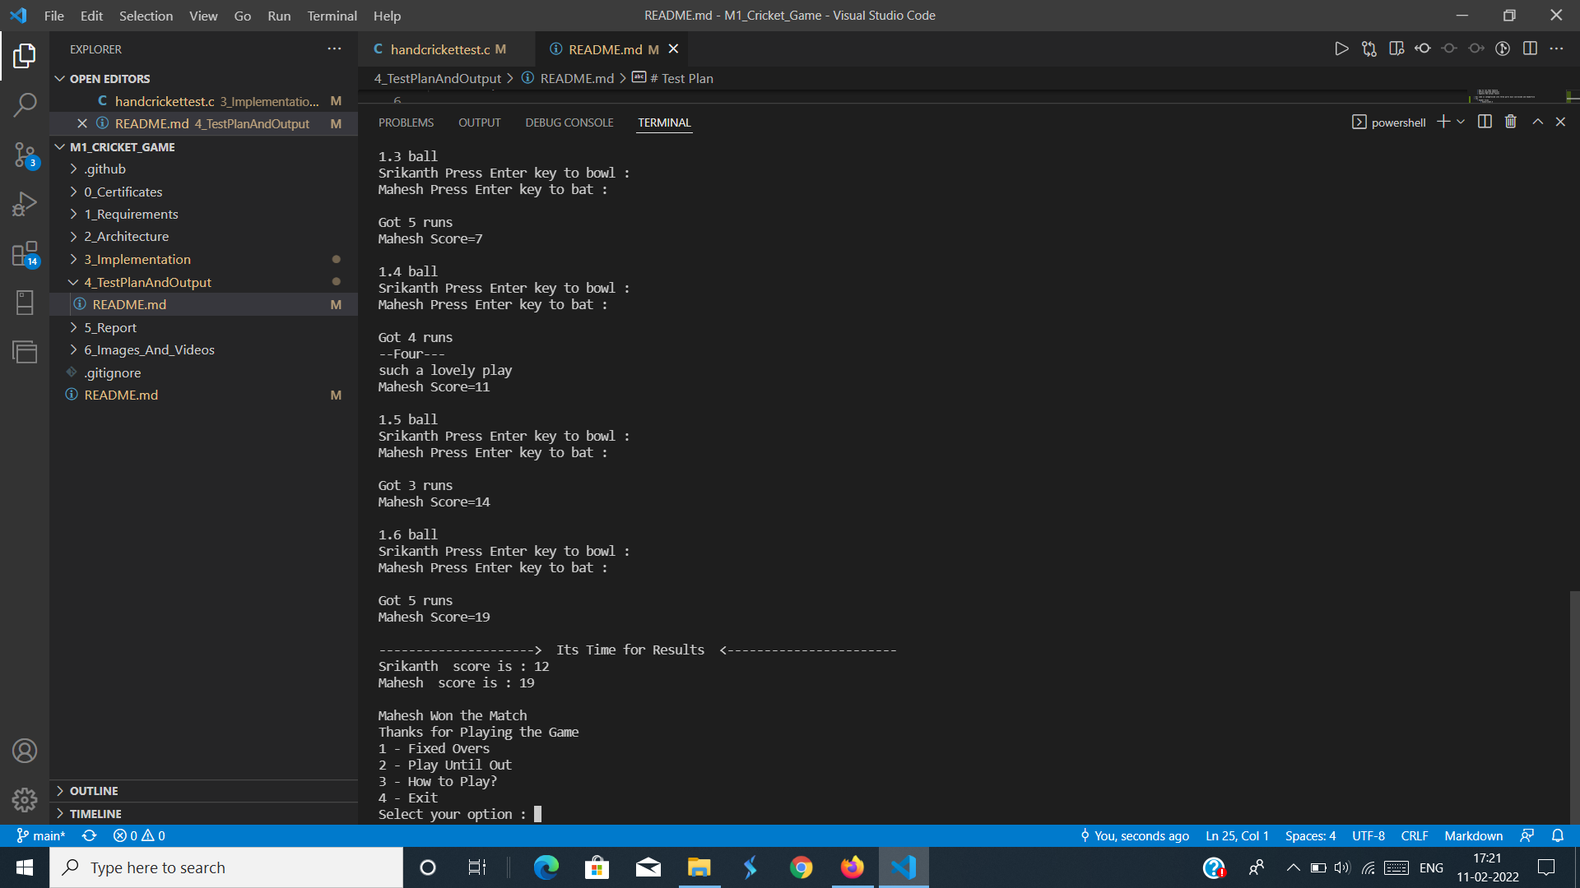](https://github.com/srikanthbandi949/M1_Cricket_Game/blob/main/4_TestPlanAndOutput/testscreenshot.png)

[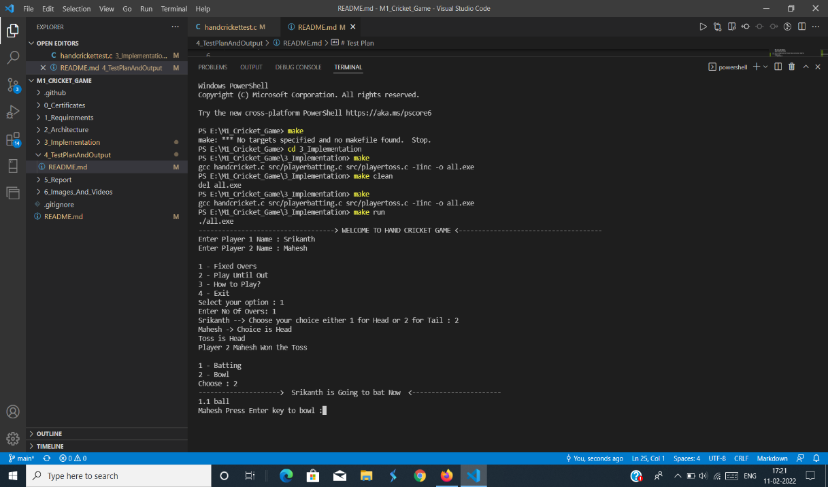](https://github.com/srikanthbandi949/M1_Cricket_Game/blob/main/4_TestPlanAndOutput/testshot.png)

# Table

* ID, Description of the test cases , input values , Expected Output, Actual output

| **ID** | **Description** | **input values** | **Expected output** | **Actual Output** |
| --- | --- | --- | --- | --- |
| '1' | Passing names of players, it saves names and make the players to choose the toss | Dhoni,Virat | Dhoni win the toss | Dhoni win the toss |
| '2' | toss winner selecting batting/bowling if he selected batting then it prints another one is bowling | batting | Dhoni choose batting | Dhoni choose batting |