Predicting Stock Market Trends Using Machine Learning

Devukar Srikanth
21951A1294

Predicting Stock Market Trends Using Machine Learning

A Project Report
submitted in partial fulfillment of the
requirements for the award of the degree of

Bachelor of Technology

In

Information Technology

By

Devukar Srikanth 21951A1294



Department of Information Technology

INSTITUTE OF AERONAUTICAL ENGINEERING
(Autonomous)
Dundigal, Hyderabad – 500 043, Telangana
May, 2025

© 2025, Devukar Srikanth. All rights reserved.

DECLARATION

I certify that
- The work contained in this report is original and has been done by me under the guidance of my supervisor(s).
- The work has not been submitted to any other Institute for any degree or diploma.
- I have followed the guidelines provided by the Institute in preparing the report.
- I have conformed to the norms and guidelines given in the Ethical Code of Conduct of the Institute.
- Whenever I have used materials (data, theoretical analysis, figures, and text) from other sources, I have given due credit to them by citing them in the text of the report and giving their details in the references. Further, I have taken permission from the copyright owners of the sources, whenever necessary.

Place: Dundigal Signature of the Student

Date: Roll No. 21951A1294

CERTIFICATE

This is to certify that the project report entitled Predicting Stock Market Trends Using Machine Learning submitted by Mr. Devukar Srikanth to the Institute of Aeronautical Engineering, Hyderabad in partial fulfillment of the requirements for the award of the Degree Bachelor of Technology in Information Technology is a bonafide record of work carried out by her under my guidance and supervision. The contents of this report, in full or in parts, have not been submitted to any other Institute for the award of any Degree.

Supervisor Head of the Department
Dr B. Rama Devi Dr M. Purshotham Reddy

Date:

APPROVAL SHEET

This project report entitled Predicting Stock Market Trends Using Machine Learning by Mr. Devukar Srikanth is approved for the award of the Degree Bachelor of Technology in Information Technology.

Examiners Supervisor
Dr B. Rama Devi

Principal

Date:
Place: Dundigal

ACKNOWLEDGEMENT

The satisfaction that accompanies the successful completion of any task would be incomplete without the mention of the people who made it possible and whose constant guidance and encouragement crown all the efforts with success.

I thank our college management and Sri M. Rajashekar Reddy, Chairman, IARE, Dundigal for providing me with the necessary infrastructure to conduct the project work.

I express my sincere thanks to Dr L.V. Narasimha Prasad, beloved Principal who has been a great source of information for our work and to Dr M. Purushotham Reddy, Professor and Head, Department of Information Technology, for extending his support to carry on this project work.

I especially thankful to our internal supervisor to Dr B. Rama Devi, Professor, Department of IT, for their internal support and professionalism who helped me in shaping the project into successful one. A special thanks to my beloved Project Coordinator Dr. U Sivaji , Associate Professor, Department of Information Technology.

I take this opportunity to express our thanks to one and all who directly or indirectly helped me in bringing this effort to present form.

D. Srikanth 21951A1294

ABSTRACT

Predicting stock market trends has become a more common in these times. There are regression techniques and machine learning techniques for predicting stock market entities. Here LSTM (Long Short-Term Method), LR (linear Regression) and KNN (K-Nearest Neighbors) are used to predict using stock market data. LSTM outperform every other prediction model while KNN supports in handling Non-linear data. Linear regression (LR) is computationally efficient compared to more complex models, especially for small to medium-sized datasets. LSTM is a type of RNN (Recurrent Neural Network) and KNN is a diverse machine learning algorithm used in classification as well as regression problem. An Ensemble method by combining LSTM and KNN methods enhances predictive power and accuracy. Results show that Combination of these methods (LSTM + KNN + LR) outperform using LTSM alone. Over all this ensemble method is a good predictive model for stock market.

Keywords: Stock market, Ensemble methods, Prediction, Accuracy, Efficiency, Machine Learning Techniques.

CONTENTS
Project Description I
Declaration II
Certificate III
Approval Sheet IV
Acknowledgement V
Abstract VI
Contents VII
List of Figures IX
Chapter 1 Introduction 1
1.1 Introduction 1
1.2 Existing System 2
1.2.1 Limitations of Existing System 3
1.3 Proposed System 4
1.3.1 Advantages of Proposed System 6
Chapter 2 Literature Survey 8
2.1 Literature review 8
2.2 Requirements specifications 14
2.2.1 Hardware Requirements 14
2.2.2 Software Requirements 15
2.2.3 Functional Requirements 15
2.2.4 Non-Functional Requirements 15
2.3 System Study 16
2.3.1 Economical Feasibility 16

2.3.2 Technical Feasibility 16
2.3.3 Social Feasibility 17

Chapter 3 Design 18
3.1 UML Diagrams 18
3.1.1 Use Case Diagram 16
3.1.2 Class Diagram 19
3.1.3 Sequence Diagram 20
3.1.4 Activity Diagram 21
Chapter 4 Methodology and Implementation 23

 | 4.1 Modules | 23
 | 4.2 Module Descriptions | 23
 | 4.2.1 Data Collection and Preprocessing Module | 23
 | 4.2.2 Model Training and Validation Module | 23
 | 4.2.3 Model Evaluation and Interpretation Module | 24
 | 4.3 Python Implementation | 24
 | 4.3.1 What is Python | 24
 | 4.3.2 Advantages of Python | 26
 | 4.4 Source Code | 27
Chapter 5 | Testing | 38
 | 5.1 Types of Testing | 38
 | 5.1.1 Unit Testing | 38
 | 5.1.2 Integration Testing | 39
 | 5.1.3 Functional Testing | 39
 | 5.1.4 System Testing | 40
 | 5.1.5 White box Testing | 40
 | 5.1.6 Black box Testing | 41
 | 5.1.7 Acceptance Testing | 41
Chapter 6  Chapter 7  Chapter 8  Chapter 9 | Results  Conclusion  Future Scope  References | 43  51  52  49

LIST OF FIGURES

Figure Title Page
1.3 Flowchart for Proposed method 6
3.1. Use Case Diagram 19
3.1.2 Class Diagram 20
3.1.3 Sequence Diagram 21
3.1.4 Activity Diagram 22
6.1 Start Server 43
6.2 Home page 44
6.3 Home page footer 44
6.4 Ticker Entry 45
6.5 Datasets from Yahoo Finance 45
6.6 Wipro stock prediction 46
6.7 Wipro live share price and forecast for next 20 days 47
6.8 Wipro stock forecast using lstm alone for 90 days 47
6.9 Wipro stock forecast using knn alone for 90 days 47
6.10 Wipro stock forecast using knn alone
for 90 days 48
6.11 Stock Information along with forecast 48
6.12 Infosys stock prediction for next 90 days 49
6.13 Infosys stock forecast using lstm alone
for next 90 days 49
6.14 Navigation from right top corner 50

CHAPTER 1
INTRODUCTION

1.1 Introduction:
Stock Market is volatile, complex, multi-factor dominant system. Predicting it would be a arduous task. There are internal factors such as EPS, DPS, PE and ROA and external factors such as bank rate, inflation rate and market capitalization. Political trends as a external factor also influence the stock market. Formation of governments and success rate of projects and missions affect the stocks of the respective organizations and companies. Stock market includes different types of sectors like Finance, Telecom, Pharma, Information Technology, Power so on will make it huge and hard to analyse for prediction. Stock Prediction's main idea is to accurately predict the future financial outcome. Stocks are considered to be very dynamic and susceptible to rapid changes because of the underlying nature of the financial domain and in part because of the mixture of known parameters (Previous Year, Opening Price, Closing Price,.) and unknown factors.

Investors in stock market owe the burden of the company or organization’s downtime and also benefits while it grows. This ensemble model (LSTM, KNN, LR) outperforms using LSTM alone with a significant improvement in accuracy from the stock data. KNN’s ability to capture relations between stocks. This model can adapt to different market conditions such as bull and bear markets by maintaining good prediction results. LSTM is a one of the best deep learning algorithm for stock market prediction while deep learning is a subset of machine learning (ML). LSTM is known for its prediction capabilities among different predictive models. Linear regression is simple yet effective in capturing long-term trends or linear relationships between stock prices and other factors (e.g., time, volume, macroeconomic data). By combining this with LSTM and KNN, you can separate the linear components from more complex patterns.

LSTM give high accuracy of prediction compared with other models alone. But LSTM struggles with complex non-linear relationships and interactions between different features of the stock market. KNN can handle with the non-linear data and need less computational resources which makes it simpler to implement. Combination of KNN with LSTM significantly improve the efficiency of the model by less error rate and improved accuracy. Combining the strengths of LSTM’s ability to model long-term dependencies with KNN’s simplicity and effectiveness for regression problems can lead to improved stock forecasting performance. The KNN component in this ensemble method selects relevant historical data points that merge with the LSTM’s time series forecasting capabilities have an edge over other prediction models. While external factors like news, economic conditions, and investor sentiment can influence stock market and LSTM-KNN model doesn’t consider these external factors but rely on time series patterns in historical data.

1.2 Existing System
The existing systems for stock market prediction predominantly rely on traditional models, such as linear regression [3] and ARIMA (Auto Regressive Integrated Moving Average). [10] Linear regression often falls short in capturing the intricate non-linear relationships present in stock data, which can lead to inaccurate forecasts. ARIMA, while useful for stationary time series data, struggles with non-linear trends and fails to consider external influences that can significantly affect stock prices. [1] Although single LSTM (Long Short-Term Memory) models have gained popularity due to their ability to learn from time series data, they still face challenges in addressing complex feature interactions and typically require extensive tuning to perform optimally [4].
These traditional models tend to overlook the broader context in which stocks operate, focusing mainly on historical price data, trading volume, and basic internal financial metrics like earnings per share (EPS) and price-to-earnings (P/E) ratios. As a result, they often lack the capacity to account for significant external factors such as economic indicators, news sentiment, and political developments, all of which can play a crucial role in influencing market dynamics. [5] Random Forest and Decision Tree models are popular machine learning approaches for stock market prediction because they can handle both categorical and continuous variables while capturing nonlinear relationships. Despite their flexibility, Random Forest and Decision Trees may struggle with sequential data, as they lack built-in mechanisms for capturing temporal dependencies. In stock market prediction, where time is a crucial factor, these models do not naturally account for historical sequences. [2][6] The LSTM and KNN combination, on the other hand, excels at modelling time series through LSTM, and further benefits from linear regression's simplicity in trend detection.

1.2.1 Limitations of the Existing System:

- Inability to Capture Non-linearity: Traditional models, such as linear regression, are fundamentally designed to identify linear relationships between variables. However, stock market data is inherently non-linear, influenced by a myriad of factors that interact in complex ways. When these models attempt to fit a straight line to the data, they often miss crucial trends and patterns, leading to inaccurate forecasts. This limitation can result in significant errors, particularly in a market that is influenced by a wide range of dynamic factors.
- Limited Adaptability: Existing predictive models often lack the ability to adapt to changing market conditions. For example, a model that performs well during a bull market may not yield accurate predictions during a bear market due to shifts in investor behaviour and market dynamics. This limitation makes it challenging to maintain consistent performance over time, particularly in volatile markets where conditions can change rapidly. As a result, investors may find themselves relying on models that do not reflect current market realities.
- Computational Intensity: Advanced models, particularly those based on deep learning, require substantial computational resources and time for training. This can create barriers for smaller investors or organizations with limited access to high-performance computing environments. Additionally, the need for extensive data processing and model tuning can lead to longer turnaround times for predictions, making these models less practical for real-time decision-making in fast-paced trading environments.
- Overfitting Risks: Complex models, such as deep learning networks, are prone to overfitting, which occurs when a model learns the noise in the training data rather than the underlying patterns. While these models may perform exceptionally well on training datasets, their ability to generalize to unseen data is often compromised. This can result in poor predictive performance in real-world applications, where market conditions may vary significantly from those encountered during training.
- Dependency on Feature Engineering: Existing models frequently rely on manual feature selection and engineering, which can be time-consuming and labor-intensive. This process involves identifying and creating relevant features from raw data, a task that requires significant expertise and domain knowledge. Additionally, reliance on human judgment can introduce biases, potentially leading to suboptimal feature sets that do not fully capture the complexities of the market.
- Data Quality Issues: The effectiveness of traditional predictive models is heavily dependent on the quality of the data used. Financial data can be plagued by inaccuracies, missing values, and inconsistencies, all of which can undermine the reliability of the predictions. Poor data quality can lead to misleading conclusions, making it difficult for investors to make informed decisions based on the model's outputs. Ensuring high-quality, clean data is an essential yet challenging task in financial modelling.

1.3 Proposed System
In contrast, the proposed system introduces an LSTM-KNN-LR ensemble model designed to enhance prediction accuracy and adaptability in the stock market. This model leverages the strengths of both LSTM and KNN. LSTM is particularly effective at capturing long-term dependencies in time series data, making it suitable for predicting stock prices over time. Meanwhile, KNN excels at identifying non-linear relationships and can efficiently analyze local patterns in the data, providing valuable context for the predictions.
One of the key advantages of this ensemble model is its improved accuracy. By integrating the capabilities of both models, it reduces error rates significantly compared to using LSTM in isolation. Linear regression (LR) is computationally efficient and requires fewer resources compared to more complex models, especially for small to medium-sized datasets. Linear regression provides a solid foundation for more advanced techniques. The ensemble approach allows for dynamic adaptation to varying market conditions, such as transitioning between bull and bear markets, thereby ensuring more reliable predictions across different scenarios. Additionally, KNN's ability to select relevant historical data points enhances the input for the LSTM model, allowing for a richer analysis of time series patterns.
While the current model primarily focuses on historical data, there is potential for further enhancement by integrating external factors like sentiment analysis or economic indicators. This could provide a more comprehensive understanding of the market dynamics at play. Moreover, the combination of LSTM and KNN is computationally efficient, making the proposed system more practical for real-world applications in stock market prediction.
The existing systems struggle with the complexity of stock market behaviour due to their reliance on traditional methods that often overlook critical interactions. The proposed ensemble model aims to address these shortcomings by leveraging the strengths of both approaches, ultimately providing a more robust and accurate solution for forecasting stock prices.
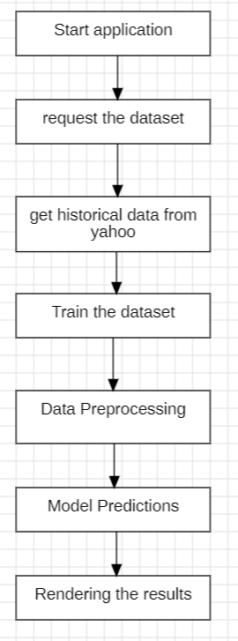

Fig. 1.3 Flowchart for Proposed method

1.3.1 Advantages of the Proposed System:
- Enhanced Prediction Accuracy: The combination of LSTM and KNN significantly improves prediction accuracy. LSTM excels at capturing long-term dependencies in time series data, while KNN effectively handles non-linear relationships. This synergy allows the model to leverage the strengths of both approaches, resulting in more reliable forecasts.
- Effective Handling of Non-Linearity: KNN’s ability to analyse local patterns makes it particularly effective for addressing non-linear relationships in stock data. This capability enhances the overall model performance, allowing it to capture complex interactions that traditional models might overlook.

- Simplicity and Efficiency: The model maintains a relatively simple structure while leveraging powerful algorithms. KNN requires fewer computational resources than many complex deep learning models, making it easier to implement and run, even for smaller organizations or individual investors.
- Robust Performance: LSTM is particularly well-suited for time series forecasting due to its ability to model long-term dependencies. When combined with KNN, the ensemble approach effectively captures temporal patterns, leading to improved forecasting performance over traditional methods.
- Data-Driven Feature Selection: The KNN component helps identify relevant historical data points that influence predictions. This data-driven feature selection reduces reliance on manual feature engineering, allowing the model to automatically focus on the most pertinent information.
- Scalability: The model can be scaled to accommodate large datasets and can be extended to include additional features or models. This scalability makes it suitable for various applications in financial forecasting, accommodating the growing volume of data in today’s markets.

- Computational Efficiency: Linear regression is computationally efficient and requires fewer resources compared to more complex models, especially for small to medium-sized datasets.

CHAPTER 2

LITERATURE SURVEY

2.1 Literature Review

[1] The paper by Akankshya Rout, Ayush Kumar Bar, Satya Priya Saha, Dr. Avijit Kumar Chaudhuri , published in IJARCCE in 2022 with title “Stock market prediction using machine learning algorithm”, discuss stock market prediction using LSTM for predicting stock market prices. In the yearly forecasting model, historical prices have been trained and achieved an accuracy of 84.0%. They collected data of every company from the beginning from Yahoo finance and proposed comprehensive customization of RNN Machine Learning based models which are known as LSTM for predicting price trends of stock markets. To train long term data, LSTM was a really good option because LSTM requires only about half of DNN and more parameters than CNN. LSTM’s nature of being the slowest to train comes with its advantage for being able to take a look at longer sequences of inputs without expanding the network size. Long Short-Term Memory Network is a high level RNN, a sequential network, that permits data to persevere. It is equipped for taking care of the disappearing gradient issue looked at by RNN. An intermittent neural network, otherwise called RNN is utilized for steady memory. They initially anticipate the future shutting price of 4 unique enterprises from a few areas with the help of LSTM. Two unique models have been built to predict stock market trends. First model anticipates the stock market trend for the upcoming day (Daily prediction model) by considering all available data on a daily basis as input. Second model Predicts the stock market trend for the upcoming week/month by considering available data on yearly or monthly basis. One of the statistical arguments considered is the relationship between trend of a day and closing price of stock traded on the same day.
[2] The paper "Unveiling Stock Market Trends Implementing LSTM and KNN Algorithms" by Rasagna T, Kankanala L S V S Nagamani Charan, published in IJRASET in 2022, compares the LSTM and KNN models in stock prediction. Their study entails the acquisition of historical data from credible sources pertaining to pricing, as well as other significant variables such trade volume and market mood. Subse
quently, the gathered data undergoes a process of cleansing, preprocessing, and refining to ensure its compatibility with the training model. Subsequently, they construct a forecasting model utilizing Long Short-Term Memory (LSTM) and another forecasting model employing K-Nearest Neighbors (KNN). LSTM models are trained utilizing past data, and their performance is assessed through the utilization of diverse measures, including mean squared error and mean error. The aforementioned statement holds true for the K-Nearest Neighbors (KNN) model, as it employs a competitive approach to determine the optimal value for k. Ultimately, the training model is employed to forecast forthcoming stock prices, and the projected price is juxtaposed with the real stock price in order to assess the efficacy of the model. The performance evaluation and comparison of the two models have been conducted, revealing that the LSTM model outperforms the KNN model in terms of accuracy. This study makes a valuable contribution to the domain of stock price prediction by showcasing the efficacy of the LSTM and KNN algorithms. The findings indicate that the LSTM model demonstrates superior performance compared to the KNN model in terms of accuracy and predictive capability. A comparative analysis of the LSTM and KNN models offers valuable insights into the respective strengths and limits of both models when employed for the prediction of stock prices. The experiment additionally showcases the potential of deep learning algorithms in the field of finance, namely in the realm of stock price prediction.

[3] The paper titled " Stock Price Prediction Website Using Linear Regression - A Machine Learning Algorithm" by Sonali Antad, Saloni Khandelwal, Anushka Khandelwal, Rohan Khandare, Prathamesh Khandave, Dhawal Khangar, Raj Khanke, published in ITM Web of Conferences in 2023, the authors discuss about importance of Linear Regression algorithm in Stock Prediction.The volatile nature of the stock market, current solutions that employ cutting-edge technology like Deep Learning, AI, and Neural Networks have not proven successful in making precise forecasts. As a result, the analysis of the current methods for stock market prediction using a linear regression algorithm is the main goal of this review work. A supervised machine learning approach called linear regression establishes a linear relationship between independent and dependent variables. The choice of an appropriate dataset is crucial for successful stock market prediction using linear regression, according to a review of research papers. According to the experiments, the linear regression method performed better in terms of accuracy than other machine learning techniques. Linear regression is considered to be better than most of the other techniques as it is easier to Implement and contains basic mathematical and computational theory.
[4] S. Dinesh, A.M.S. Rama Raju, S. Rahul, O. Naga Sandeep1, Mr. N D S S Kiran Relangi present their work on LSTM in the paper titled "STOCK PRICE PREDICTION USING LSTM " published in 2021 discuss about various machine learning algorithms like Logistic Regression Model, SVM, ARCH model, RNN, CNN, Backpropagation, Naïve Bayes, ARIMA model. They have used LSTM recurrent neural networks to predict the stock prices accurately. You would find two types of stocks, one of them was Intraday trading, which is known to us by the term day trading. Intraday trading is that which means all positions are squared-off before the market closes then and there and there would be no possibility of changing the ownership after the day end. LSTM's are very important, as they are very powerful in sequence prediction problems because they could store previous or past information. They came to conclusion that Long Short-Term Memory (LSTM) is the most suitable algorithm for time series problems. The main objective is to forecast the current market trends and could predict the stock prices accurately. they use LSTM recurrent neural networks to predict the stock prices accurately. The results show that prediction accuracy is over 93%.
[5] Malti Bansal, Apoorva Goyal, Apoorva Choudhary review the use of various Machine Learning Algorithms in their paper titled "Stock Market Prediction with High Accuracy using Machine Learning Techniques" published in 2022. This research work aimed at developing ML models which would be capable of predicting stock prices with an increased accuracy, so that interested traders and investors could make use of such methods to experience increased profits by investing on the right day at the right place. Successful implementation as part of this project was carried out wherein five algorithms i.e., K-Nearest Neighbours, Linear Regression, Support Vector Regression, Decision Tree Regression, and Long Short-Term Memory algorithms were deployed to create precise predictive models for application in stock price prediction of twelve prevalent Indian Companies namely, Adani Ports, Asian Paints, Axis Bank, Housing Development Finance Corporation Limited (HDFC) Bank, Industrial Credit and Investment Corporation of India (ICICI) Bank, Kotak Bank, Hindustan Unilever Limited, Maruti, National Thermal Power plant Corporation (NTPC), Tata Steel, Tata Consultancy Services (TCS) and Titan, after which an elaborate comparative analysis of the performances of the algorithms during stock price prediction has been carried out. The stock prices collected were from 2015 to 2021, and after this exhaustive research, it can be concluded that DL algorithms have a substantial edge over simple ML algorithms when it comes to the prediction of time series data. out of the five chosen algorithms, the Long Short-Term Memory algorithm was a DL algorithm that has provided the best results during stock price prediction. The results of this research paper clearly displays the values acquired during the testing of the models in the form of tables and graphs for three evaluation metrics i.e., Symmetric Mean Absolute Percentage Error (SMAPE), R-Squared Value (R2), and Root Mean Square Error (RMSE). While carefully studying and analysing the result, it is concluded that the LSTM algorithm is the best choice among the given algorithms for time series prediction, because it has the least value or errors with SMAPE (1.59), R2 (-0.11), and RMSE (22.55). The second-best algorithm for this task was Support Vector Regression with an SMAPE value (5.59), R2 value (-1.69) and RMSE (46.36). While the algorithms Linear Regression and Decision Tree Regression have almost matched performances, KNN has shown the most inferior quality of prediction as it is predominantly a classification algorithm. Therefore, the implementation and the associated results have conformed to the theoretical analysis.

[6] A paper by V.SARALA, G.N.V.PHANI BHUSHAN, with title “Stock Market Trend Prediction Using K-Nearest Neighbor (KNN) Algorithm” published in Journal of Engineering Sciences, 2022, explores KNN algorithm, This paper examines a hybrid model which combines a K-Nearest Neighbors (KNN) approach with a probabilistic method for the prediction of stock price trends. One of the main problems of KNN classification is the assumptions implied by distance functions. The assumptions focus on the nearest neighbors which are at the centroid of data points for test instances. This approach excludes the non-centric data points which can be statistically significant in the problem of predicting the stock price trends. For this it is necessary to construct an enhanced model that integrates KNN with a probabilistic method which utilizes both centric and non-centric data points in the computations of probabilities for the target instances. The test results showed that the proposed model outperformed the standard classifiers which were used for the comparisons.
[7] The paper " Stock prediction based on random forest and LSTM neural network " by Yilin Ma ,Ruizhu Han and Xiaoling Fu, published in 2019, investigates the results by ensembling LSTM neural network and Random Forest algorithms. This paper presents a stock price forecasting model based on random forest and LSTM neural network, and compares the model with PCA+LSTM neural network and LSTM neural network. Through the analysis of input features importance by random forest model, we can find out the more important input features at this stage. Experiments show that the feature extraction method is more effective than the classical PCA algorithm and can visually display the filtered features. Although LSTM neural network can regularly delete invalid information and retain important information when importing time series data because of its exquisite design, the experimental results show that the simple use of raw data is not good for training, so it needs to combine more efficient feature extraction methods. Therefore, the model proposed in this paper provides a good direction for future research.

[8] Yiwen Wang, Yuchen Xie, Yuhao Wu, Yichen Yang explore prediction of stocks using Improved KNN algorithm in their paper titled "Improved KNN-based Stock Price Prediction" published in 2024 in the Academic Journal of Computing & Information Science. This paper proposes a novel stock price prediction model based on the K-Nearest Neighbors (KNN) algorithm. The model leverages the core idea of the KNN algorithm by identifying the nearest neighbor data samples to predict future trends in stock prices. Unlike traditional KNN approaches, the proposed model integrates an improved strategy incorporating the price change trends of the preceding N days in time-series data to forecast the price change of the subsequent day more accurately. Experimental results demonstrate that the proposed improved KNN model enhances the accuracy of stock price prediction. This paper has extensively investigated the stock price prediction problem and proposed a method based on an enhanced K-Nearest Neighbors (KNN) algorithm. Considering the volatility and complexity of the stock market, we enhanced the predictive capability of the model by improving feature processing and optimizing parameters within the KNN algorithm. By integrating historical stock price data with other technical indicators, the improved KNN model aims to more accurately capture stock price trends.

[9] Ms. Shweta Chaku, Amar Pratap Singh, Anuj Pratap Singh, Ayush Gupta, Dhruv Agarwal investigate stock price prediction using Stacked LSTM in their paper titled " STOCK PRICE PREDICTION USING STACKED LSTM ALGORITHM" published in 2023 in IARJSET. They propose the use of stacked LSTM (Long Short-Term Memory) networks for developing an app that can provide users with accurate and reliable predictions of future stock prices based on historical data. Stacked LSTMs are a type of artificial neural network that are designed to analyse sequential data, such as time series data, and are well-suited to stock price prediction because they can effectively analyse the relationships between past and present price movements over long periods of time. The app will be developed using Python programming language and will utilize various libraries such as TensorFlow, Keras, and Pandas for data analysis and visualization. The user interface will be designed to be user-friendly, allowing users to easily access and view the stock data and predictions. In addition to the predictive model itself, this project aims to demonstrate the effectiveness of stacked LSTM networks for predicting stock prices. The app will be trained on historical stock price data from various sources, including Yahoo Finance.

[10] University College Dublin, Ireland discuss the stock price prediction in the paper titled " Improving Stock Price Prediction using Linear Regression and Long Short-Term Memory Model (LR-LSTM)" published in the 2023 in ACM Digital Library. This study presents research on improving stock price prediction by employing a combined approach of Linear Regression (LR) and Long Short-Term Memory (LSTM) models, referred to as LR-LSTM with comparisons with other effective models. The objective is to enhance the accuracy and reliability of stock price forecasting, which is crucial for informed decision-making in financial markets. The LR-LSTM model aims to overcome this challenge by leveraging the strengths of both linear regression and LSTM, incorporating historical price data, technical indicators, and relevant market information. The data for this study is sourced from a comprehensive financial dataset that includes historical stock prices, trading volumes, and other relevant market variables. The effectiveness of the LR-LSTM model is evaluated using a historical stock price dataset of Apple Inc. The dataset undergoes preprocessing steps, including noise removal, data segmentation, and data normalization, to enhance the accuracy of the predictive model. This research involves training the LR-LSTM model on historical stock price data, incorporating linear regression to capture linear relationships and LSTM to capture temporal dependencies in the data. The stock price prediction landscape has been notably advanced by the proposed LR-LSTM hybrid model, which synergizes the analytical strengths of Linear Regression with the sequential data processing prowess of Long Short-Term Memory networks.

2.2 Requirement Specifications
2.1.1 Hardware Requirements:
- Processor - intel i3 or ryzen3 (minimum)
- GPU - intel UHD or AMD radeon or Nvidia
- RAM - 4GB (Atleast)
- Storage - 10GB
- Browser - Chrome or Brave or Edge
- Display - 720p or Higher
- Keyboard - Standard Windows Keyboard
- Mouse - Two button Mouse

2.1.2 Software Requirements:

- Operating system : A 64-bit version of Windows 10/11

- Programming Language : Python 3.80

- Frameworks : TensorFlow, Keras and Django

2.1.3 Functional Requirements:

- Emotion Detection Across Multiple Modalities

- Real-Time Processing

- Emotion Classification

- User Interface

- Integration with External Systems

- Performance

2.1.4 Non-Functional Requirements:

- Scalability

- Reliability

- Availability

- Usability

- Portability

- Compliance

2.3 System Study

2.3.1 Economical Feasibility

Economically, the stock prediction website project provides a viable solution for small to medium-sized investors and financial institutions by leveraging machine learning models such as LSTM, KNN, and Linear Regression. These models are computationally efficient and can be implemented using open-source tools like Python, scikit-learn, and Django, reducing the need for costly proprietary software. The use of publicly available stock data from Yahoo Finance further eliminates the need for expensive data acquisition. By automating stock prediction processes, the system can reduce the reliance on human analysts, leading to long-term cost savings. The project is economically feasible for deployment as it can be scaled to fit both individual investors and larger institutions without significant increases in operational costs. Additionally, the web-based platform can integrate easily into existing financial systems, offering a cost-effective alternative to complex and expensive predictive analytics solutions.

2.3.2 Technical Feasibility

This project utilizes machine learning algorithms like LSTM, KNN, and Linear Regression, all of which are well-suited for time-series forecasting and stock prediction tasks. LSTM is technically feasible due to its ability to capture temporal dependencies in stock data, making it ideal for predicting future stock trends. KNN and Linear Regression offer simpler, more interpretable models that can provide quick predictions for users with lower computational requirements. Feature scaling and data normalization techniques ensure that the models handle stock price fluctuations effectively, and using cross-validation helps to validate the model’s performance on different datasets. The backend system is powered by widely available cloud computing resources, ensuring that the project remains technically feasible even for large-scale deployments. The choice of open-source libraries and frameworks further reduces technical barriers, allowing for straightforward implementation and deployment.

2.3.3 Social Feasibility

The stock prediction website addresses a key societal need for accessible and user-friendly financial tools that can assist individual investors and small businesses in making informed decisions. By leveraging machine learning models, the system can provide real-time, accurate stock predictions, empowering users with insights that were previously only available to institutional investors. This democratization of financial data aligns with the growing demand for more inclusive financial services. The project promotes financial literacy and encourages wider participation in stock markets by offering easy-to-understand predictions, potentially contributing to economic growth. Additionally, by using publicly available stock data and focusing on transparency, the system fosters trust and reduces the opacity often associated with complex financial algorithms, making it a socially feasible solution for a wide range of users.

CHAPTER 3 DESIGN
3.1 UML Diagrams
UML stands for Unified Modelling Language or SFL (Standards for Facilities). UML is a general-purpose object-orientated modelling language that has become popular in the field of software engineering and is based on standard principles. Control is done, and it is also created by, that particular group. The Object Management Group.
- The intention is that UML models become a universal standard for the creation of object-centric software diagrams. In its current form UML is comprised of two major components: finally, we will create a Meta model and a notation. of this, we will Model our content Meta and the notation. In the future, UML can also be supported by a method or mechanism that is either related to or connected with UML by some means.
- Unified Modelling Language is standard language for modelling unambiguously replacing the descriptions which are visual, explicit and also documentation ones of software through the use of the artifacts. The application of the modelling includes business modelling as well as non-software systems.
- The UML reflects a chosen set of best engineering practices that have been effectively employed to model of an extensive software system.

3.1.1 Use Case Diagram:
In the Unified Modelling Language (UML), a use case diagram is a behavioural diagram, which stands for and comes from the analysis involving and of use cases. Its main job is to draw a diagram which symbolizes how a system performs various tasks. It iconizes actors, their use cases and depicts the cause-effect relationships between those use cases. The primary value of the use case diagram is that it displays the operation of system actors for which functions are composed. By depicting actors' roles in the system as shown in Fig.
3.1.1, the model could be seen as in the image below.

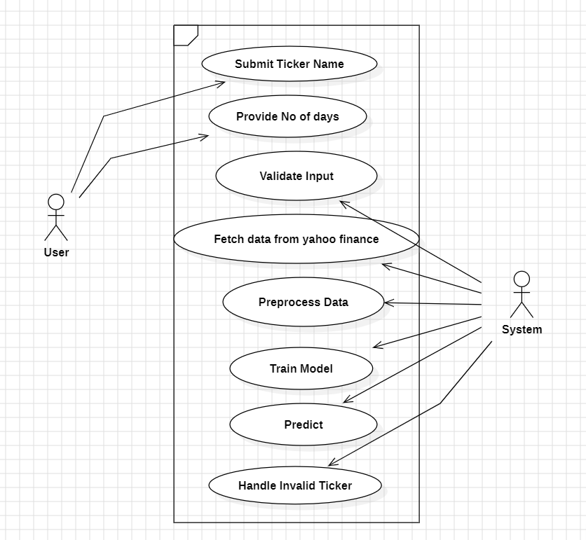

Fig. 3.1.1 Use Case diagram

3.1.2 Class Diagram:
In software engineering, a class diagram in which the unifier model language (UML) is a sort of static structural diagram that is used in describing the structure of a system by showing the ins system classes and their attributes, the operations (or methods) and the relations among them. Through this, maintains the information content class hierarchy of the shown figure in Fig. 3.1.2.
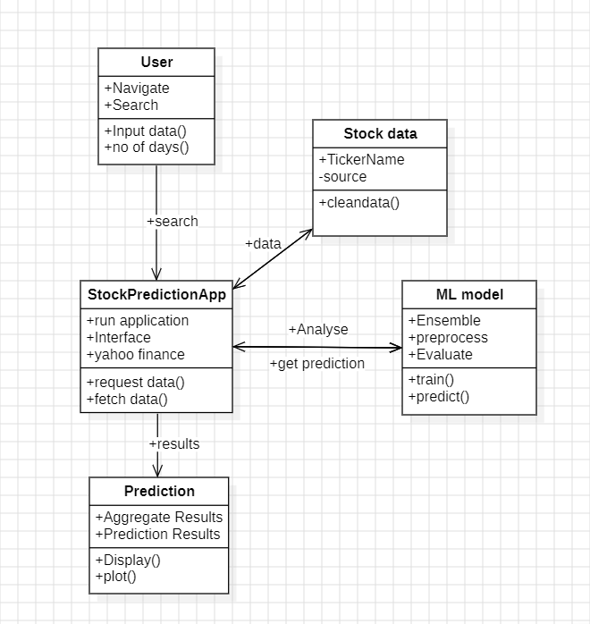

Fig. 3.1.2. Class diagram

3.1.3 Sequence diagram:
A sequence diagram, as part of the Unified Modelling Language (UML) in the interaction diagram category, visually represents the interaction between various objects or components of a system in a time-ordered sequence. It outlines how and when processes or operations are carried out and which entities are involved in the interactions. Each object or component is depicted by a lifeline, and the interactions between them are represented by messages exchanged over time. The diagram is crucial for understanding how components collaborate to perform a task or execute a process step by step. It provides a clear overview of the sequence of events and the order in which they occur, as well as the dependencies between them as shown in fig. 3.1.3.
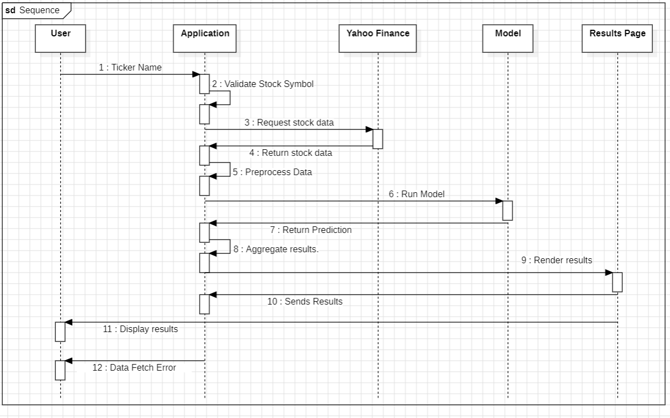

Fig. 3.1.3. Sequence diagram

3.1.4. Activity Diagram:
Activity diagrams in stock prediction, as an example of visual representation of all the sequential and parallel pathways, involve the stock data processing steps. It help visualize the step-by-step sequence of how stock data is collected, processed, and used for predictions. The diagram often consists of key steps such as data acquisition from Yahoo Finance, data pre-processing (handling missing values, normalization), feature extraction, and model selection. It also highlights the processes of model training, validation, and final prediction. The diagram illustrates how information flows through the system, showing the structure and processing pipeline for generating stock price predictions, as depicted in Fig 3.1.4.

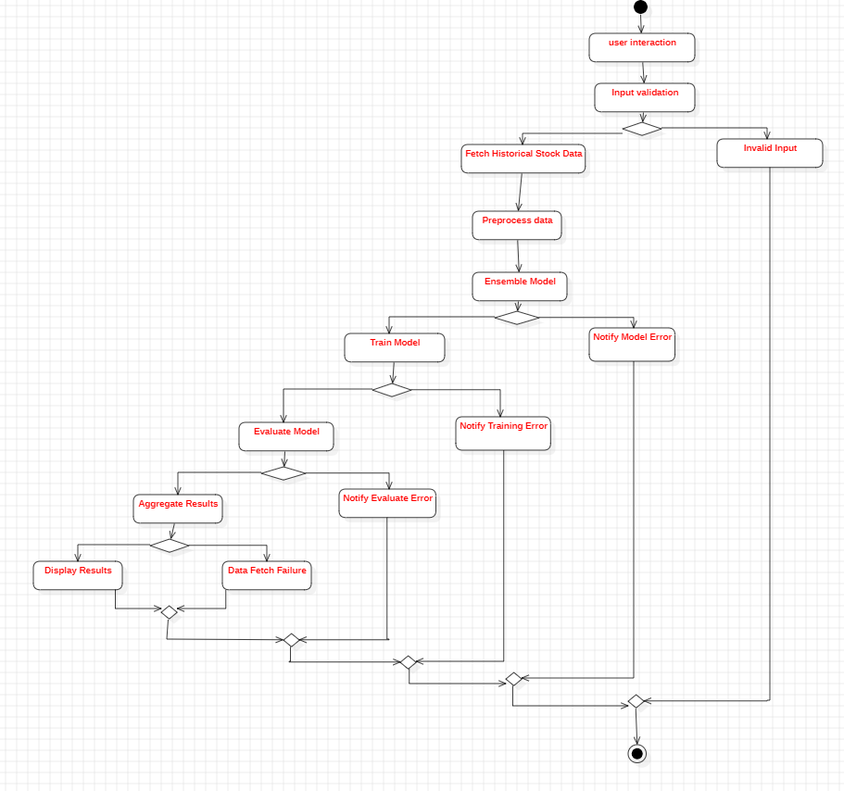
Fig. 3.1.4. Activity diagram

CHAPTER 4
METHODOLOGY AND IMPLEMENTATION
4.1 Modules:
- Install Keras
- Install Django
- Install Pandas
- Install Matplotlib
- Install Scikit – learn
- Install Numpy

4.2 Module Descriptions:
4.2.1 Data Collection and Preprocessing Module:

- Data Acquisition: Gather historical stock market data, such as daily stock prices, trading volumes, and other relevant financial metrics, from reliable sources like Yahoo Finance. Ensure that the dataset covers a variety of stocks across different sectors and market conditions to improve model robustness and generalization.
- Data Preprocessing: Clean and preprocess the stock data by handling missing values, removing outliers, and normalizing features such as stock prices and volumes using scikit-learn module. Perform feature engineering to extract relevant indicators like moving averages, RSI (Relative Strength Index) that can improve the predictive power of the model.

4.2.2 Model Training and Validation Module:

- Model Training: Train machine learning models such as KNN, LSTM (Long Short-Term Memory), and linear regression (LR) on historical stock price data. Use time series forecasting techniques to predict future stock prices based on past performance. Incorporate data augmentation and cross-validation to enhance the generalizability and accuracy of the models.

- Validation and Optimization: Validate the models using a separate validation set, ensuring that the models can handle various stock price patterns. Perform hyperparameter tuning, such as adjusting the learning rate, number of layers for LSTM, and KNN orders to optimize the model’s performance for real-time stock prediction.

4.2.3 Model Evaluation and Interpretation Module:

- Performance Evaluation: Evaluation of performance of the model by calculating key metrics like Mean Squared Error (MSE), Root Mean Squared Error (RMSE). These metrics provide insight into how well the models are predicting stock prices compared to actual values.
- Error Analysis: Use residual plots and other analysis tools like matplotlib module to identify trends in prediction errors, helping to pinpoint areas where the models may be underperforming. This can help improve model accuracy by highlighting market conditions or stock types that the models struggle.

4.3 Python Implementation
4.3.1 What is Python:

Python, created by Guido van Rossum in 1991, is a widely used, interpreter-based programming language known for its simplicity and readability, with syntax resembling English. It runs on various platforms, including Mac, Windows, and Raspberry Pi. Python supports multiple programming paradigms, including object-oriented, procedural, and functional programming. Its extensive standard library and dynamic data types make it highly versatile and powerful, suitable for quick prototyping and complex applications. Python's interpreters are freely available and binary-distributed, contributing to its widespread adoption.
Python language is being used by almost all tech-giant companies like – Google, Amazon, Facebook, Instagram, Dropbox, Uber… etc.

The following are some of Python's salient attributes and features:
- Readability: Python's clear and simple syntax promotes code readability. Code blocks are organized using indentation and whitespace, which makes it simple to read and update.
- Easy to Learn: Python is a great option for novices because to its readability and simplicity. For those who are new to programming, its copious documentation and simple syntax make it user-friendly.
- Interpreted Language: Python is an interpreted language, which eliminates the requirement for compilation before usage. The Python interpreter speeds up and enhances the interactive nature of the development process by directly reading and executing the code.
- Cross-platform Compatibility: Because of this cross-platform compatibility, programmers can write code once and run it unchanged across several systems.
- Huge Standard Library: It saves developers time and effort by covering topics like file I/O, networking, regular expressions, databases, and more.
- Flexible and Modular: Python allows for the organization of code into reusable modules and packages with the support of modular programming. Python additionally enables the integration of modules written in other languages, like C or C++, offering performance optimizations and flexibility.
- Vast Selection of Frameworks and Libraries: Python boasts a rich third-party library and framework ecosystem. These libraries, which include Django, NumPy, pandas, TensorFlow, and others, expand the capabilities of Python for particular areas, making it an effective tool for a wide range of applications.
- Object-Oriented: Python facilitates the creation and manipulation of classes and objects by adhering to the concepts of object-oriented programming (OOP). OOP offers a methodical framework for organizing code, encouraging modularity and reuse.

The biggest strength of Python is huge collection of standard libraries which can be used for the following –
- Machine Learning
- GUI Applications (like Kivy, Tkinter, PyQt etc.)
- Web frameworks like Django (used by YouTube, Instagram, Dropbox)
- Image processing (like Opencv, Pillow)
- Web scraping (like Scrapy, BeautifulSoup, Selenium)
- Test frameworks
- Multimedia

4.3.2 Advantages of Python:

- Extensive Libraries: Python comes with a comprehensive standard library that provides pre-written code for a wide range of tasks, such as regular expressions, documentation generation, unit testing, web browsing, threading, database management, CGI scripting, email processing, image manipulation, and much more. This rich set of libraries eliminates the need to write code from scratch for many common functionalities, making development faster and more efficient.
- Extensibility: Python is highly extensible, allowing developers to integrate code written in other languages like C or C++ into their Python programs. This feature is particularly useful in complex projects where performance-critical components can be optimized in a lower-level language while leveraging Python for higher-level operations.
- Improved Productivity: The simplicity and readability of Python, combined with its extensive libraries, significantly enhance developer productivity. Python allows programmers to accomplish more with fewer lines of code compared to languages like Java or C++. This efficiency reduces development time and allows for faster iteration and prototyping.
- Embeddability: In addition to being extensible, Python is also embeddable. One can embed Python code within the source code of other languages, such as C++. This capability enables the addition of scripting functionality to programs written in other languages, allowing for greater flexibility and dynamic control over the application’s behavior.

4.4 Source Code:
The given below is the python implementation for the project
from django.db import models
from django.contrib.auth.models import User
# Create your models here.
# -*- coding: utf-8 -*-
#**************** IMPORT PACKAGES ********************
from alpha_vantage.timeseries import TimeSeries
import pandas as pd
import numpy as np
from sklearn.metrics import mean_squared_error
import matplotlib.pyplot as plt
plt.style.use('ggplot')
import math
from datetime import datetime
import datetime as dt
import yfinance as yf
import preprocessor as p
import re
from sklearn.linear_model import LinearRegression

# Ignore Warnings
import warnings
warnings.filterwarnings("ignore")
import os
os.environ['TF_CPP_MIN_LOG_LEVEL'] = '3'
def insertintotable():
nm = request.form['nm']

#*********FUNCTIONS TO FETCH DATA ***********
def get_historical(quote):
end = datetime.now()
start = datetime(end.year-2,end.month,end.day)
data = yf.download(quote, start=start, end=end)
df = pd.DataFrame(data=data)
df.to_csv(''+quote+'.csv')
if(df.empty):
ts = TimeSeries(key='N6A6QT6IBFJOPJ70',output_format='pandas')
data, meta_data = ts.get_daily_adjusted(symbol='NSE:'+quote, outputsize='full')
data=data.head(503).iloc[::-1]
data=data.reset_index()
df=pd.DataFrame()
df['Date']=data['date']
df['Open']=data['1. open']
df['High']=data['2. high']
df['Low']=data['3. low']
df['Close']=data['4. close']
df['Adj Close']=data['5. adjusted close']
df['Volume']=data['6. volume']
df.to_csv(''+quote+'.csv',index=False)
return

#********************LSTM_KNN SECTION ********************
def KNN_ALGO(df):
uniqueVals = df["Code"].unique()
len(uniqueVals)
df=df.set_index("Code")
#for daily basis
def parser(x):
return datetime.strptime(x, '%Y-%m-%d')
def knn_model(train, test):
history = [x for x in train]
predictions = list()
for t in range(len(test)):
model = KNN(history, order=(6,1 ,0))
model_fit = model.fit()
output = model_fit.forecast()
yhat = output[0]
predictions.append(yhat)
obs = test[t]
history.append(obs)
return predictions
for company in uniqueVals[:10]:
data=(df.loc[company,:]).reset_index()
data['Price'] = data['Close']
Quantity_date = data[['Price','Date']]
Quantity_date.index = Quantity_date['Date'].map(lambda x: parser(x))
Quantity_date['Price'] = Quantity_date['Price'].map(lambda x: float(x))
Quantity_date = Quantity_date.fillna(Quantity_date.bfill())
Quantity_date = Quantity_date.drop(['Date'],axis =1)
fig = plt.figure(figsize=(7.2,4.8),dpi=65)
plt.plot(Quantity_date)
plt.savefig('static/Trends.png')
plt.close(fig)

quantity = Quantity_date.values
size = int(len(quantity) * 0.80)
train, test = quantity[0:size], quantity[size:len(quantity)]
#fit in model
predictions = knn_model(train, test)

#plot graph
fig = plt.figure(figsize=(7.2,4.8),dpi=65)
plt.plot(test,label='Actual Price')
plt.plot(predictions,label='Predicted Price')
plt.legend(loc=4)
plt.savefig('static/knn.png')
plt.close(fig)
print()
knn_pred=predictions[-2]
#rmse calculation
error_knn = math.sqrt(mean_squared_error(test, predictions))
print("LSTM-KNN RMSE:",error_knn)
return knn_pred, error_knn

#************* LSTM SECTION **********************
def LSTM_ALGO(df):
#Split data into training set and test set
dataset_train=df.iloc[0:int(0.8*len(df)),:]
dataset_test=df.iloc[int(0.8*len(df)):,:]
#TO PREDICT STOCK PRICES OF NEXT N DAYS, STORE PREVIOUS N DAYS IN MEMORY WHILE TRAINING
training_set=df.iloc[:,4:5].values

#Feature Scaling
from sklearn.preprocessing import MinMaxScaler
sc=MinMaxScaler(feature_range=(0,1))#Scaled values btween 0,1
training_set_scaled=sc.fit_transform(training_set)
#In scaling, fit_transform for training, transform for test

X_train=[]#memory with n days from day i
y_train=[]#day i
for i in range(7,len(training_set_scaled)):
X_train.append(training_set_scaled[i-7:i,0])
y_train.append(training_set_scaled[i,0])
#Convert list to numpy arrays
X_train=np.array(X_train)
y_train=np.array(y_train)
X_forecast=np.array(X_train[-1,1:])
X_forecast=np.append(X_forecast,y_train[-1])
#Reshaping: Adding 3rd dimension
X_train=np.reshape(X_train, (X_train.shape[0],X_train.shape[1],1))
X_forecast=np.reshape(X_forecast, (1,X_forecast.shape[0],1))
#For X_train=np.reshape(no. of rows/samples, timesteps, no. of cols/features)

#Building RNN
from keras.models import Sequential
from keras.layers import Dense
from keras.layers import Dropout
from keras.layers import LSTM

#Initialise RNN
regressor=Sequential()

#Add first LSTM layer
regressor.add(LSTM(units=50,return_sequences=True,input_shape=(X_train.shape[1],))
regressor.add(Dropout(0.1))

#Add 2nd LSTM layer
regressor.add(LSTM(units=50,return_sequences=True))
regressor.add(Dropout(0.1))

#Add 3rd LSTM layer
regressor.add(LSTM(units=50,return_sequences=True))
regressor.add(Dropout(0.1))

#Add 4th LSTM layer
regressor.add(LSTM(units=50))
regressor.add(Dropout(0.1))

#Add o/p layer
regressor.add(Dense(units=1))

#Compile
regressor.compile(optimizer='adam',loss='mean_squared_error')

#Training
regressor.fit(X_train,y_train,epochs=25,batch_size=32 )
real_stock_price=dataset_test.iloc[:,4:5].values

dataset_total=pd.concat((dataset_train['Close'],dataset_test['Close']),axis=0)
testing_set=dataset_total[ len(dataset_total) -len(dataset_test) -7: ].values
testing_set=testing_set.reshape(-1,1)

#Feature scaling
testing_set=sc.transform(testing_set)

#Create data structure
X_test=[]
for i in range(7,len(testing_set)):
X_test.append(testing_set[i-7:i,0])
#Convert list to numpy arrays
X_test=np.array(X_test)

X_test=np.reshape(X_test, (X_test.shape[0],X_test.shape[1],1))

#Testing Prediction
predicted_stock_price=regressor.predict(X_test)

#Getting original prices back from scaled values
predicted_stock_price=sc.inverse_transform(predicted_stock_price)
fig = plt.figure(figsize=(7.2,4.8),dpi=65)
plt.plot(real_stock_price,label='Actual Price')
plt.plot(predicted_stock_price,label='Predicted Price')

plt.legend(loc=4)
plt.savefig('static/LSTM.png')
plt.close(fig)

error_lstm=math.sqrt(mean_squared_error(real_stock_price, predicted_stock_price))

forecasted_stock_price=regressor.predict(X_forecast)

#Getting original prices back from scaled values
forecasted_stock_price=sc.inverse_transform(forecasted_stock_price)

lstm_pred=forecasted_stock_price[0,0]
print()
print("LSTM RMSE:",error_lstm)
return lstm_pred,error_lstm
#***************** KNN SECTION ******************
def LIN_REG_ALGO(df):
#No of days to be forcasted in future
forecast_out = int(7)
#Price after n days
df['Close after n days'] = df['Close'].shift(-forecast_out)
#New df with only relevant data
df_new=df[['Close','Close after n days']]

y =np.array(df_new.iloc[:-forecast_out,-1])
y=np.reshape(y, (-1,1))
X=np.array(df_new.iloc[:-forecast_out,0:-1])
X_to_be_forecasted=np.array(df_new.iloc[-forecast_out:,0:-1])

#Traning, testing to plot graphs,
X_train=X[0:int(0.8*len(df)),:]
X_test=X[int(0.8*len(df)):,:]
y_train=y[0:int(0.8*len(df)),:]
y_test=y[int(0.8*len(df)):,:]

# Feature Scaling===Normalization
from sklearn.preprocessing import StandardScaler
sc = StandardScaler()
X_train = sc.fit_transform(X_train)
X_test = sc.transform(X_test)
X_to_be_forecasted=sc.transform(X_to_be_forecasted)
#Training
clf = LinearRegression(n_jobs=-1)
clf.fit(X_train, y_train)

#Testing
y_test_pred=clf.predict(X_test)
y_test_pred=y_test_pred*(1.04)
import matplotlib.pyplot as plt2
fig = plt2.figure(figsize=(7.2,4.8),dpi=65)
plt2.plot(y_test,label='Actual Price' )
plt2.plot(y_test_pred,label='Predicted Price')

plt2.legend(loc=4)
plt2.savefig('static/LR.png')
plt2.close(fig)
error_lr = math.sqrt(mean_squared_error(y_test, y_test_pred))

#Forecasting
forecast_set = clf.predict(X_to_be_forecasted)
forecast_set=forecast_set*(1.04)
mean=forecast_set.mean()
lr_pred=forecast_set[0,0]
print()
print("Linear Regression RMSE:",error_lr)
return df, lr_pred, forecast_set, mean, error_lr

#**************GETDATA *************************
quote=nm
#Try-except to check if valid stock symbol
try:
get_historical(quote)
except:
return render_template('index.html',not_found=True)
else:
#************** PREPROCESSUNG ***********************
df = pd.read_csv(''+quote+'.csv')
print(quote,"Stock Data: ")
today_stock=df.iloc[-1:]
print(today_stock)
df = df.dropna()
code_list=[]
for i in range(0,len(df)):
code_list.append(quote)
df2=pd.DataFrame(code_list,columns=['Code'])
df2 = pd.concat([df2, df], axis=1)
df=df2

knn_pred, error_knn=KNN_ALGO(df)
lstm_pred, error_lstm=LSTM_ALGO(df)
df, lr_pred, forecast_set,mean,error_lr=LIN_REG_ALGO(df)

print(forecast_set)
today_stock=today_stock.round(2)
return render_template('results.html',quote=quote,
arima_pred=round(knn_pred,2),lstm_pred=round(lstm_pred,2),
lr_pred=round(lr_pred,2),
open_s=today_stock['Open'].to_string(index=False),
close_s=today_stock['Close'].to_string(index=False),adj_close=today_stock['AdjClose'].to_string(index=False), high_s=today_stock['High'].to_string(index=False),
low_s=today_stock['Low'].to_string(index=False),vol=today_stock['Volume'].to_string(index=False), forecast_set=forecast_set,error_lr=round(error_lr,2),error_lstm=round(error_lstm,2),error_arima=round(error_knn,2))
if __name__ == '__main__':
app.run()

class Project(models.Model):
name = models.CharField(max_length=200)
start_date = models.DateField()
responsible = models.ForeignKey(User, on_delete=models.CASCADE)
week_number = models.CharField(max_length=2, blank=True)
end_date = models.DateField()

def __str__(self):
return str(self.name)

def save(self, *args, **kwargs):
print(self.start_date.isocalendar()[1])
if self.week_number == "":
self.week_number = self.start_date.isocalendar()[1]
super().save(*args, **kwargs)

Explanation:
The project focuses on the development of a web-based stock prediction platform using machine learning techniques such as LSTM, KNN, and Linear Regression. The system allows users to access stock data from Yahoo Finance, pre-process it, and make predictions on future stock prices using various machine learning models. LSTM is utilized for capturing temporal patterns in stock price movements, while KNN and Linear Regression provide alternative methods for comparison. Each model is evaluated based on metrics like accuracy, mean squared error (MSE), and R-squared score, allowing users to analyse the performance of different algorithms on stock prediction tasks.
The platform enables real-time predictions by allowing users to select a stock, choose the prediction model, and input specific parameters such as time periods for prediction. Users can also visualize the stock trends and model performance through interactive graphs, which show historical data, predicted future values, and performance comparisons between LSTM, KNN, and Linear Regression. The predictions are displayed dynamically on the web interface, providing users with actionable insights into market trends.
The backend of the application is built with Django, handling the data processing and model training, while the machine learning models are implemented using libraries such as Keras for deep learning and Scikit-learn for traditional machine learning algorithms. Additional features include the ability to save and load trained models, enabling users to resume predictions from previously saved states. This system offers a comprehensive environment for stock analysis, catering to both individual investors and financial institutions looking to make data-driven decisions.

CHAPTER 5 TESTING
Testing, after all, is about identifying defects. In this case, the product is a software under test. It is performance of a regular process that is very systematic, it is possible to detect any gap or any kind of software fault. Also, the software is tested in order to make sure that any discrepancy between it and certain specifications or users` expectations are fixed. The test means verifying those critical specifications such as component evaluation, subassembly modelling, and the system during its operation bear a match with designed specifications and are unlikely to fail at the most critical moments. The types of tests vary in order to meet specific requirements. Each test type targets different aspects; reliability and response time is assurance of good product quality in software.
5.1 Types of Testing:
5.1.1 Unit Testing:
Unit testing in the stock prediction website project involves testing individual components or functions to ensure they work correctly in isolation. For this project, unit testing would focus on testing smaller modules like data preprocessing functions (e.g., handling missing values, normalization), stock data retrieval from Yahoo Finance, and individual machine learning models (LSTM, KNN, Linear Regression). Each function should be tested to ensure it behaves as expected, such as correctly normalizing the data, returning accurate stock price predictions, and handling edge cases like missing or malformed data inputs.
These tests help catch errors early in development, before the components are integrated. By breaking down the project into individual units, developers can ensure that each piece of functionality works as intended in isolation. In the context of machine learning models, unit tests could verify that the models are correctly initialized, trained, and capable of making predictions without errors. Additionally, ensuring that critical functions in the Django backend, such as database connections and API calls to Yahoo Finance, work as expected is crucial for the system's reliability.
5.1.2 Integration Testing:
Integration testing ensures that the different components of the stock prediction website work together as expected. This testing would involve combining the frontend, backend (Django), and the machine learning models, and verifying that data flows correctly between these parts. For example, after retrieving stock data from Yahoo Finance, the data should be passed to the preprocessing module, then to the prediction models (LSTM, KNN, LR), and finally displayed correctly on the web interface.
Integration testing verifies that these interactions happen smoothly, without causing crashes or data mismatches. It also ensures that the system’s overall functionality is preserved after integrating multiple components. For instance, testing the interaction between the Django backend and the machine learning models ensures that user requests trigger the correct processes (data retrieval, preprocessing, prediction), and the results are delivered back to the user in a timely and accurate manner. Additionally, integration testing can check how errors are handled, such as verifying how the system responds when the Yahoo Finance API is down or when invalid user inputs are entered.

5.1.3 Functional Testing:

Functional testing focuses on ensuring that the website behaves according to its specified requirements. For the stock prediction project, functional testing would verify that all the core functionalities work as expected, such as fetching stock data, running predictions using different models, and displaying results on the web interface. Each function, like selecting a stock, running predictions with LSTM or KNN, or displaying graphs for stock trends, should work without errors and match the project's functional specifications.
In addition to basic functionality, this type of testing also ensures that edge cases are handled appropriately. For example, functional tests would verify that the system can handle unusual scenarios, such as predictions for stocks with very low trading volumes, unexpected inputs from users, or situations where historical stock data is temporarily unavailable. By ensuring that all features work as intended, functional testing guarantees that users can successfully interact with the website, from data input to prediction visualization, and obtain accurate and actionable results.
5.1.4 System Testing:

System testing evaluates the entire stock prediction website as a complete and integrated system. It tests all the components frontend, backend, database, machine learning models together to ensure that the entire application functions correctly and meets the requirements. For this project, system testing would check the end-to-end workflow, from when a user selects a stock to when predictions are generated and displayed on the website. The goal is to ensure the entire system functions cohesively, identifying any issues that might only emerge when the components work together as a whole.
This type of testing would also include performance and usability checks. For instance, system testing ensures that the website remains responsive when multiple users request predictions at the same time, or when large datasets are being processed by the machine learning models. It would also involve stress testing to see how the system handles high traffic or excessive requests to the Yahoo Finance API.
5.1.5 White box Testing:

White box testing involves testing the internal structure and logic of the system, ensuring that the code itself functions as expected. For the stock prediction website, white box testing would focus on the backend logic implemented in Django, as well as the machine learning algorithms (LSTM, KNN, Linear Regression) that drive stock predictions. This testing method would verify that the models' training, validation, and prediction logic are working correctly by inspecting the code flow, control structures, and data handling mechanisms.
By having access to the internal workings of the code, white box testing would ensure that all possible paths within the stock prediction algorithms are executed and tested, including handling corner cases such as empty datasets or API failures. For example, white box testing could verify that the model properly initializes, trains on historical stock data, and handles exceptions correctly. Additionally, testers can evaluate the efficiency of the code by identifying and optimizing bottlenecks, ensuring the system performs well even when dealing with large datasets or high user loads.
5.1.6 Black box Testing:

Black box testing evaluates the system's functionality without any knowledge of the internal workings of the code. For the stock prediction website, this means testing the system by providing inputs (e.g., stock ticker symbols, time frames) and observing the outputs (predicted stock prices) without any understanding of how the models or backend are implemented. The goal of black box testing is to ensure that the website meets its functional specifications, regardless of how the predictions are generated behind the scenes.
For instance, black box testing would verify that users can successfully input stock symbols, select prediction models (LSTM, KNN, LR), and view accurate predictions. This method focuses entirely on user interactions and system responses, ensuring that the website behaves as expected in real-world use cases. It also allows testers to simulate various user behaviors, including incorrect or unexpected inputs, and verify that the system handles these gracefully, such as by showing error messages or fallback data when the Yahoo Finance API is unavailable.
5.1.7 Acceptance Testing:

Acceptance testing ensures that the stock prediction website meets the requirements and expectations of the end users, typically performed in collaboration with stakeholders or potential users. This testing phase validates whether the system is ready for deployment by checking if it provides accurate stock predictions, user-friendly interfaces, and seamless integration between different models and data sources. The system's ability to generate meaningful stock price forecasts in real-time and display them intuitively is critical to passing acceptance testing.

This testing would focus on real-world use cases, ensuring that the machine learning models deliver timely and actionable predictions and that the web interface is easy to navigate. Any issues discovered during acceptance testing would be addressed to ensure that the system provides the necessary functionality and reliability before its final deployment.
CHAPTER 6
RESULTS
This section provides a comprehensive analysis of the performance and outcomes of the stock prediction models implemented in this project. By utilizing LSTM, K-Nearest Neighbors (KNN), and Linear Regression (LR), this section evaluates the effectiveness of each model in forecasting stock prices based on historical data obtained from Yahoo Finance. The interface of the website is designed to provide a user-friendly and intuitive experience, ensuring seamless interaction to users. A simple navigation bar at the left of the page guides users to various sections, Home Page, Predict, Ticker Info. The results are visualized in graphs and plots for ease of understanding to user with a flexibility in choosing the number of days to forecast the stock.

To start the project, type python manage.py runserver, which will show a address and follow the link to open website as shown in the Fig 6.1.

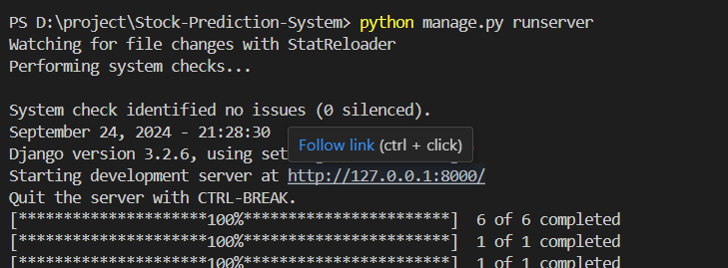

Fig 6.1. Start Server

Home page of the website having data of active stocks Tata motors, Infosys, Wipro, ICICI Bank, HDFC Bank are plotted as shown in Fig 6.2 and Open, Close, High, Low, Volume of active stocks are mentioned at bottom of the home page Fig 6.3.
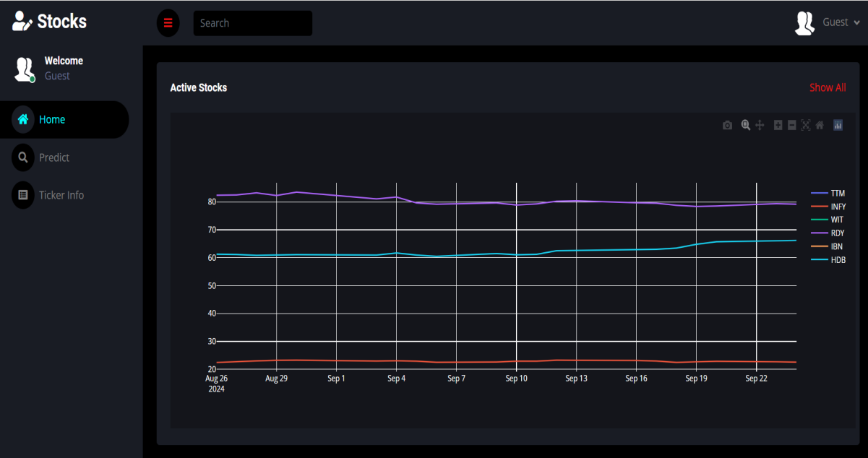

Fig 6.2. Home page

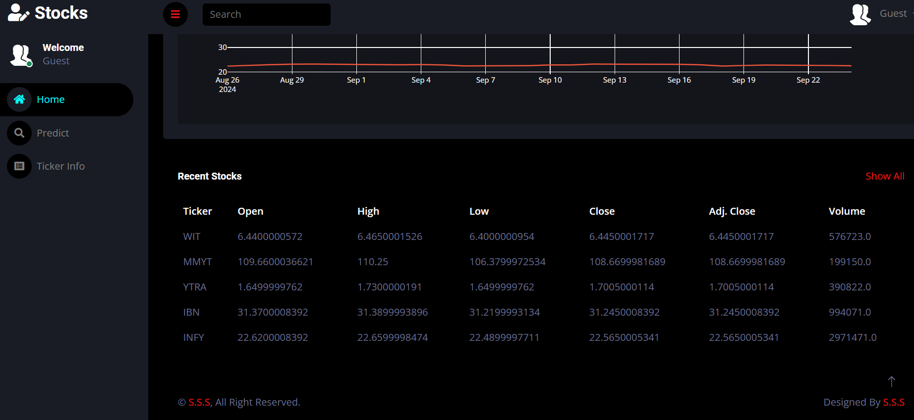

Fig 6.3. Home page footer

Fig 6.4 shows the predict page which can be navigated from side bar “Predict” and it contains Ticker Name and number of days you want to get the forecast.

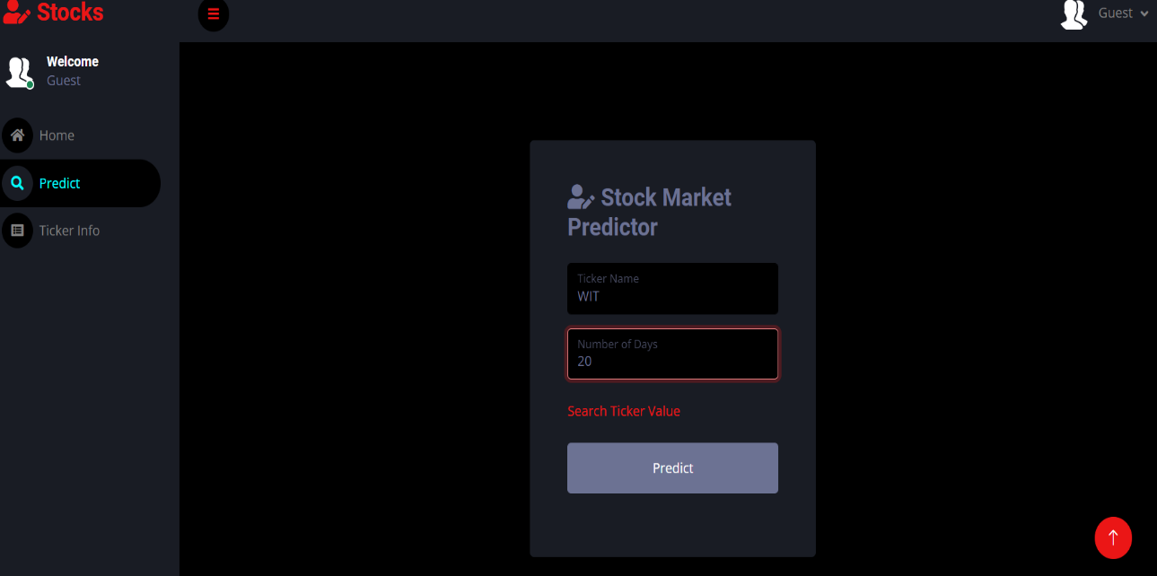

Fig 6.4. Ticker Entry

Fig 6.5 shows the datasets collected from yahoo finance which are available in Ticker Info section of website and user can navigate from the side bar.

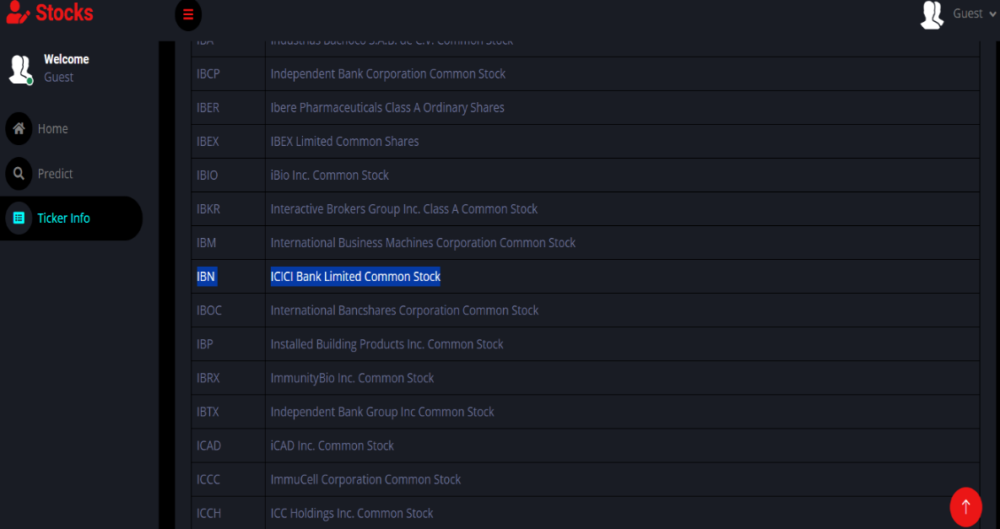

Fig 6.5. Datasets from Yahoo Finance

In Fig 6.6, shows the prediction of Wipro stock for next 20 days in a graph starting from sep 29 to oct 6 and y-axis is price of the stock. In Fig 6.7, you can see two graphs which will be displayed at bottom of the screen and left side graph is live share price of the stock.

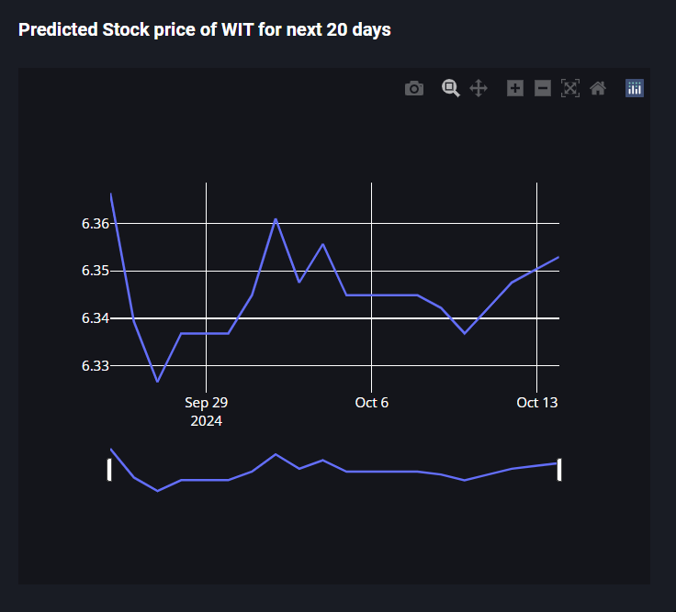

Fig 6.6. Wipro stock prediction

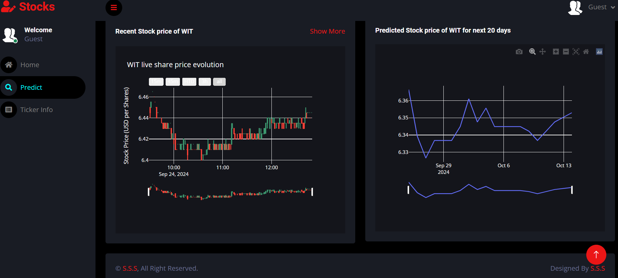

Fig 6.7. Wipro live share price and forecast for next 20 days

In Fig 6.8, the graph shows the prediction of wipro stock for 90 days using lstm alone. which fluctuates much in price compared to our model.
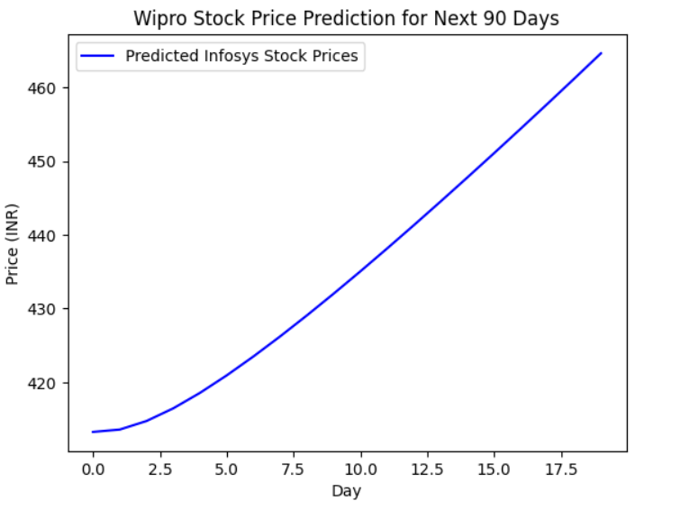Fig 6.8. Wipro stock forecast using lstm alone for 90 days

In Fig 6.9 and 6.10, the graph and table shows the price prediction of wipro stock using knn alone. There is huge difference in prices which is less accurate.

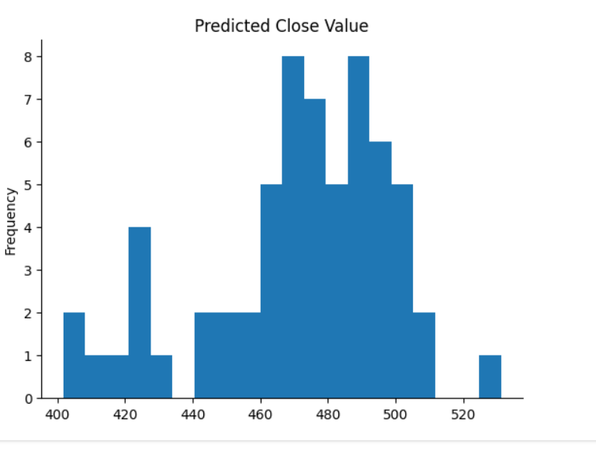
Fig 6.9. Wipro stock forecast using knn alone for 90 days

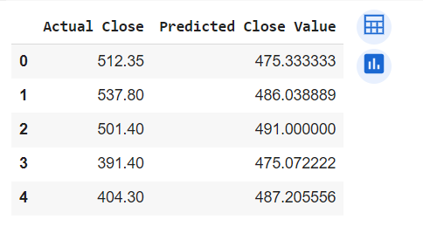
Fig 6.10. Wipro stock forecast using knn alone for 90 days

In Fig 6.11, you can see Infosys stock information which is displayed at top of the website includes country, net change, volume, sector etc.

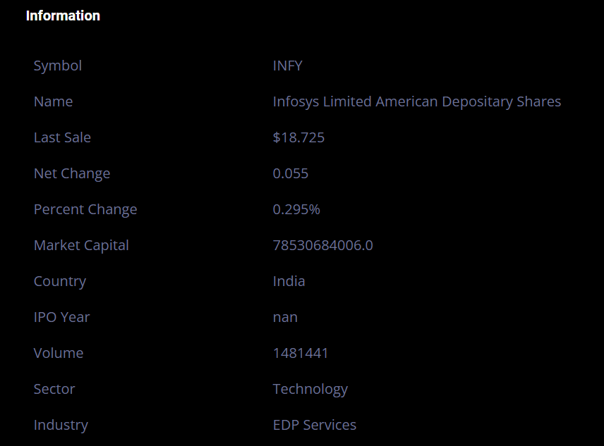

Fig 6.11. Stock Information along with forecast

Fig 6.12 shows forecast for next 90 days for Infosys stock and the price and date can be seen by pointing the cursor on the graph.
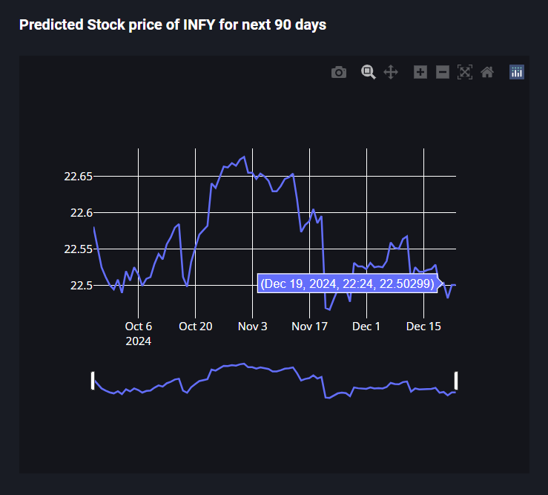

Fig 6.12. Infosys stock prediction for next 90 days

In Fig 6.13, A graph representing the infosys stock for next 90 days using lstm alone. It shows that price will increase for next 90 days continously, which is less accurate compared to our model.
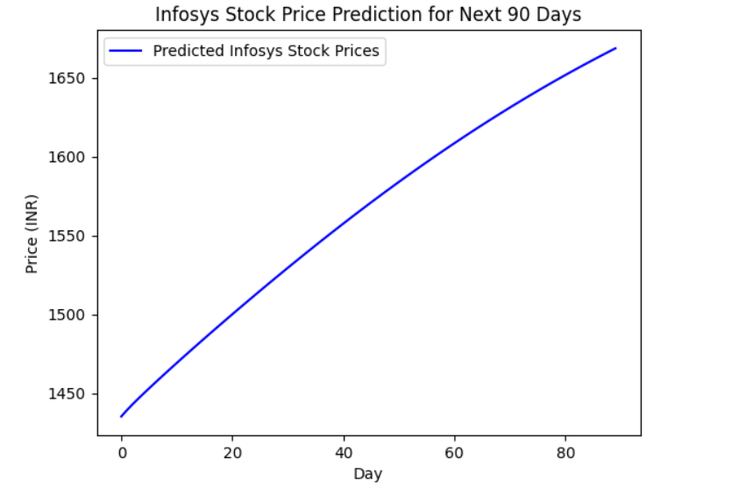
Fig 6.13. Infosys stock forecast using lstm alone for 90 days

In Fig 6.14, User can also access sections - Predict and Ticker Info, from right top corner of the website represented with guest user icon. Which makes this website user friendly for stock prediction.
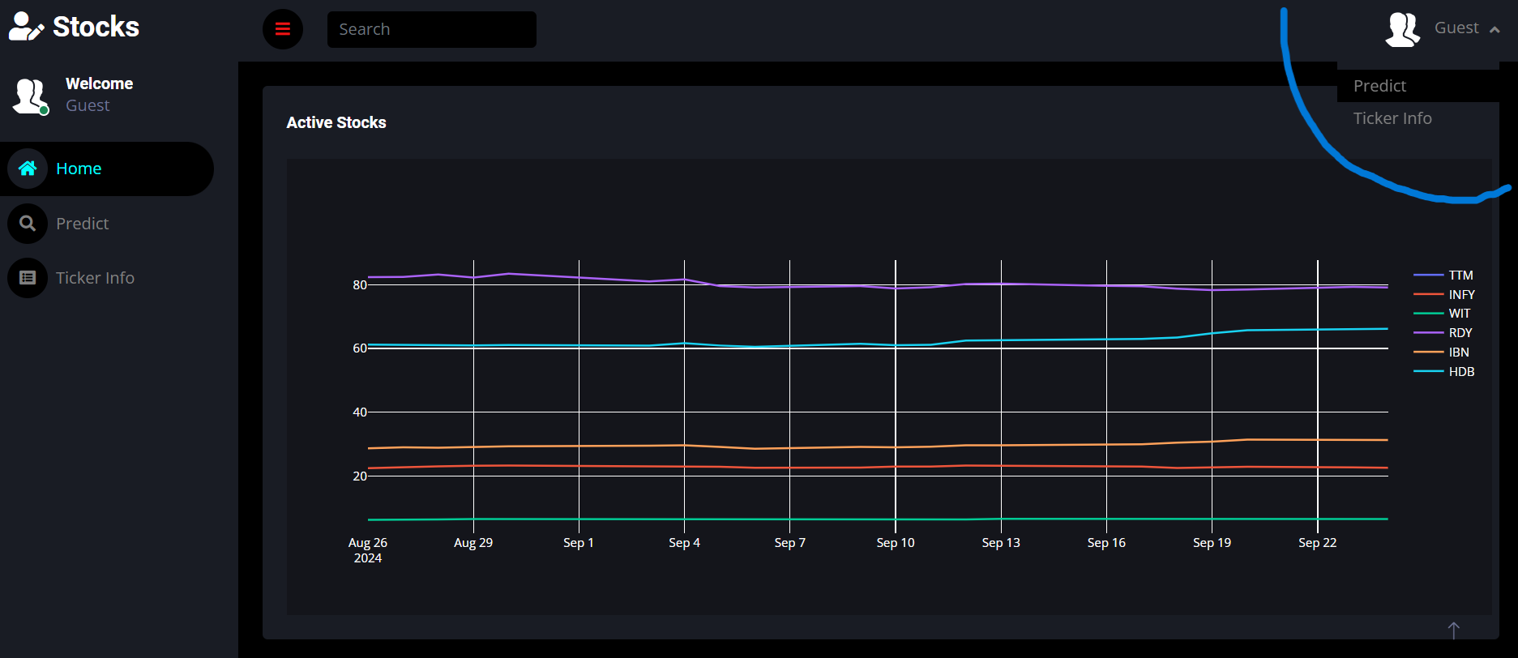

Fig 6.14. Navigation from right top corner
CHAPTER 7 CONCLUSION
The stock prediction website project demonstrates a powerful and user-friendly platform that leverages advanced machine learning techniques such as LSTM, KNN, and Linear Regression to provide accurate and real-time stock price predictions. By integrating these models with publicly available data from Yahoo Finance and offering an intuitive web interface. The use of multiple prediction models allows users to compare performance and gain insights from various perspectives, ensuring that the platform remains flexible and adaptive to different investment strategies. Additionally, by incorporating real-time data retrieval, the system offers a seamless and interactive experience that enhances the understanding dynamics of stocks.
This project not only serves as a tool for financial forecasting but also highlights the potential of democratizing stock market analytics. By making advanced machine learning accessible to a user, it enables user to harness the power of predictive analytics without the need for technical expertise. Long Short-Term Memory (LSTM) networks are employed to capture intricate temporal patterns and trends in historical stock data, offering a robust approach for predicting future price movements based on sequential information. Alongside LSTM, K-Nearest Neighbors (KNN) provides a simple yet effective method for classification and regression tasks by analysing the proximity of data points, while Linear Regression delivers a straightforward and interpretable approach to modelling relationships between stock prices and various influencing factors. By integrating these diverse models, the project ensures a comprehensive analysis of stock trends, allowing users to benefit from the unique strengths of each technique. This combination of models enhances the accuracy and reliability of predictions.

CHAPTER 8
FUTURE SCOPE

Real-Time Market Analysis: Integrating lightweight, efficient machine learning models and deploying them on cloud platforms will enable real-time stock predictions and updates. This approach will provide users with immediate insights into market conditions without relying on extensive local computing resources, facilitating swift investment decisions.
Adaptive Forecasting Models: Implementing adaptive learning systems that continuously update with new market data and trends will ensure the predictions remain accurate and relevant. This dynamic approach will help the models stay current with evolving market conditions and financial news, enhancing their predictive accuracy over time.
Cross-Disciplinary Collaboration: Collaborating with financial analysts, data scientists, and market experts will refine the models to better address real-world investment needs and regulatory requirements. This interdisciplinary effort will ensure the platform incorporates diverse expertise and adheres to industry standards and ethical considerations.
Advanced Predictive Algorithms: Future research can focus on incorporating advanced machine learning techniques such as Attention Mechanisms or Transformers for stock prediction. These algorithms could potentially improve the model's ability to capture complex market patterns and interactions, offering more precise and insightful forecasts
Enhanced User Experience: Developing more interactive and customizable user interfaces, including features like personalized trading strategies and dynamic risk assessment tools, will improve user engagement and satisfaction. These enhancements will cater to individual investment preferences and provide actionable insights tailored to user needs.

REFERENCES
- Akankshya Rout, Ayush Kumar Bar, Satya Priya Saha, Dr. Avijit Kumar Chaudhuri, IJARCCE, “Stock market prediction using machine learning algorithm”, 2022.

- "Unveiling Stock Market Trends Implementing LSTM and KNN Algorithms" by Rasagna T, Kankanala L S V S Nagamani Charan, published in IJRASET in 2022.

- " Stock Price Prediction Website Using Linear Regression - A Machine Learning Algorithm" by Sonali Antad, Saloni Khandelwal, Anushka Khandelwal, Rohan Khandare, Prathamesh Khandave, Dhawal Khangar, Raj Khanke, published in ITM Web of Conferences in 2023.

- S. Dinesh, A.M.S. Rama Raju, S. Rahul, O. Naga Sandeep1, Mr. N D S S Kiran Relangi "STOCK PRICE PREDICTION USING LSTM " published in 2021.

- Malti Bansal, Apoorva Goyal, Apoorva Choudhary "Stock Market Prediction with High Accuracy using Machine Learning Techniques" published in 2022.

- V. SARALA, G.N.V. PHANI BHUSHAN “Stock Market Trend Prediction Using K-Nearest Neighbor (KNN) Algorithm” , Journal of Engineering Sciences, 2022.

- " Stock prediction based on random forest and LSTM neural network " by Yilin Ma ,Ruizhu Han and Xiaoling Fu, published in 2019.

- Yiwen Wang, Yuchen Xie, Yuhao Wu, Yichen Yang "Improved KNN-based Stock Price Prediction" published in Academic Journal of Computing & Information Science, 2024.

- Ms. Shweta Chaku, Amar Pratap Singh, Anuj Pratap Singh, Ayush Gupta, Dhruv Agarwal " STOCK PRICE PREDICTION USING STACKED LSTM ALGORITHM" published in IARJSET, 2023.
- University College Dublin, Ireland " Improving Stock Price Prediction using Linear Regression and Long Short-Term Memory Model (LR-LSTM)" published in ACM Digital Library, 2023.
- Sai Manvitha Enadula, Dr. B. Rama Devi,, Rama Devi Odugu, V.B.V.N Prasad “Decision making for common stock selection using Regression Techniques” Test Engineering and Management Volume-83 , Issue-March-April 2020.
- Dr. B. Rama Devi, Yashoda murali krishna, Raviteja Reddy, Chitti Babu “Share market Prediction using Machine Learning Algorithms” Test Engineering and Management Volume-83 , Issue-March-April 2020

