User Manual and Documentation
for Android App of Health Records

Joshua Reisenauer
Muhammad Khan
Binh Vu
Jerry Arnold
ECS 4485.502
November XX, 2010

Table of Contents

I Introduction p3
II Purpose of Application p
III Step by Step Tutorial p
IV Structure of Application p
V Development of Application p
VI Summary p

Introduction
Health Foundation is the name of the app this manual describes. Health Foundation is an application for the google android phone. Internet access is required to use this application, all data is pulled from a database. The doctor must first have an account with the database before using this application.

Purpose of Application
Health Foundation is intended for doctors, allowing quick access to their patients records from an android phone. The scope of data presented to the doctor is as minimal as possible in order to ensure clean and simple interfaces. The most important data presented to the doctor includes patient vital signs, notes written by other doctors, medications patient is on and appointments this patient has with other doctors.

Step by Step Tutorial
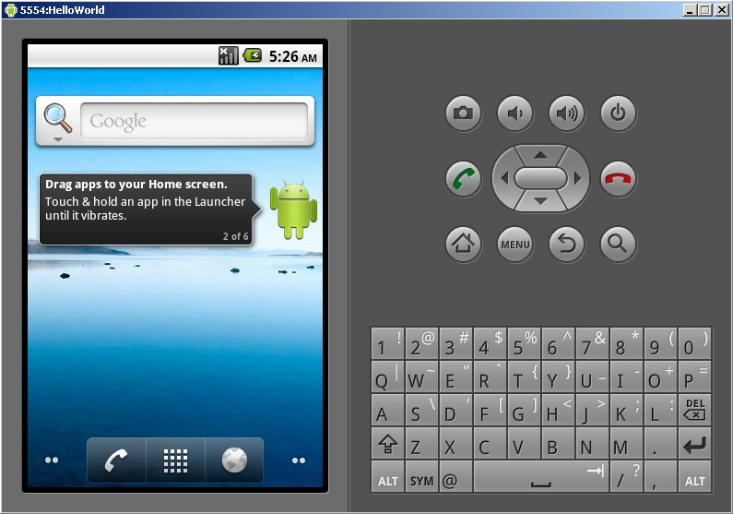

-When Main Menu is loaded click on the middle button on the lower portion of the screen. This will load up the app listing page.

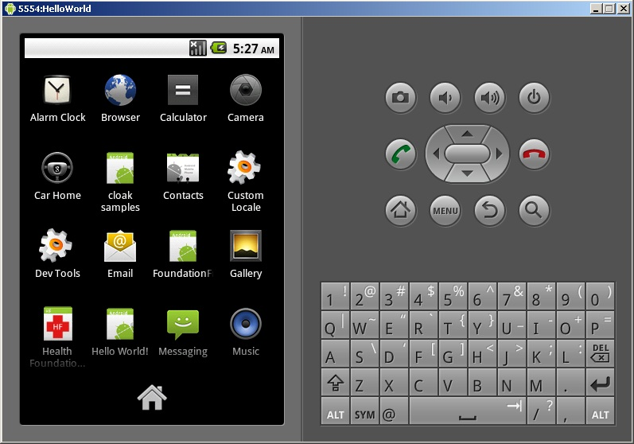

-When app listing page has loaded it should have a little icon in the list named health foundation with a red cross on it. Click this icon, it will load health foundation.

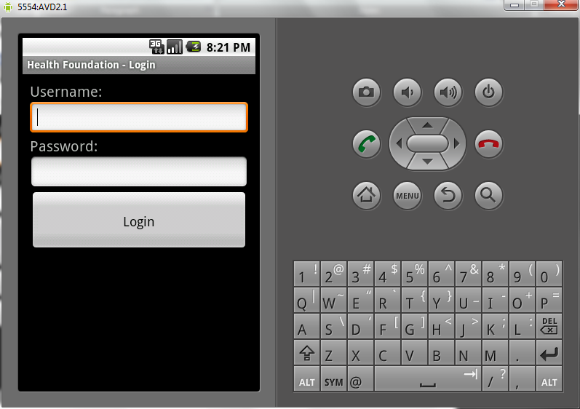

-When health foundation has loaded the menu similar to the one above will appear. Enter your user name and password and click login. If you do not currently have an account set one up through the database website. When you log in it will automatically move you into the Doctor menu.

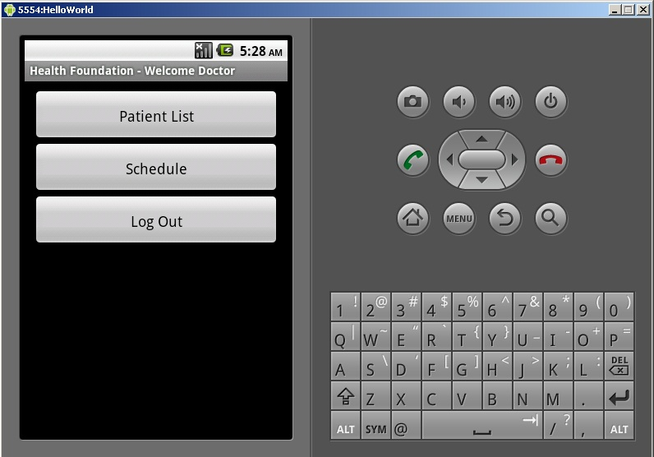

-The doctor menu will look like the one above. Clicking on patient list will show you a listing of all patients including the patients of other doctors in your database. Clicking schedule will open a menu allowing you to create/edit/delete calendar entries. When done using health foundation always make sure to return to the doctor menu and click log out.

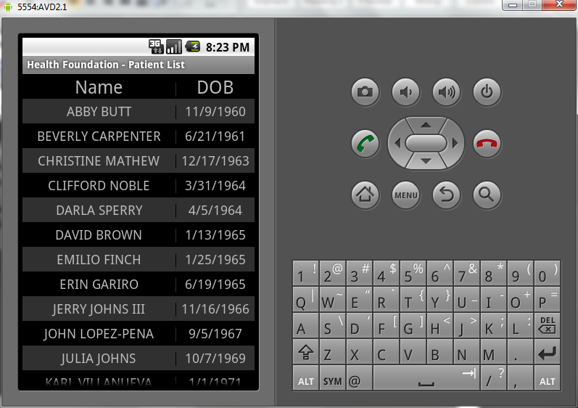

-Patient list menu will look like the above picture. Moving your finger across the screen vertically will scroll the list entries. Selecting a name in the list will open the patient menu for that particular person.

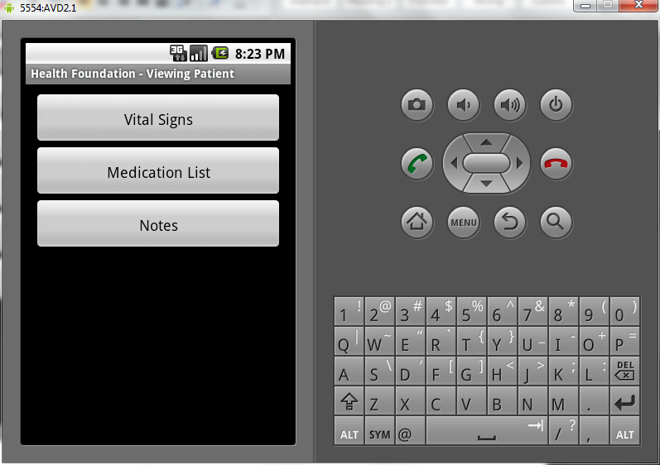

-For the patient menu. Clicking vital signs will display patients temperature, code, body mass index and date it was taken. Medication List will display Drug name dosage, units, and current prescription status. Notes are for notes about this patient which can be viewed by all other doctors of this patient. Appointments will display a list of appointments this patient is scheduled for.

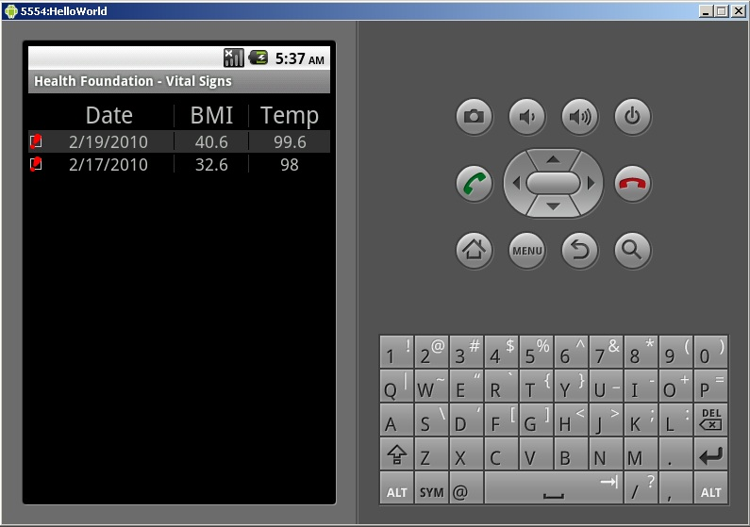

-The vitals menu will display individual vital sign measurements, sorting date in descending order by default.

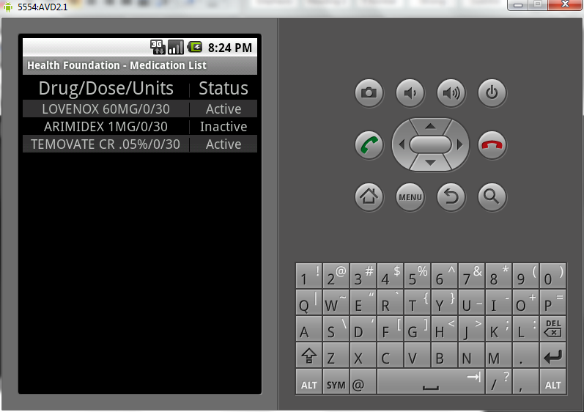

-For medications menu, Status/Drug/Dose/Units are displayed. Active medications are listed first.

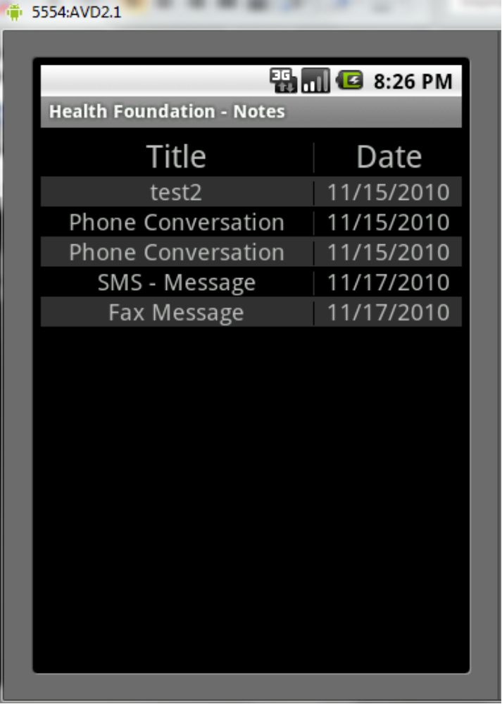

-Patient notes menu above will display all notes made by doctors for this patient. All notes are sorted by date by default. To add a note go to the off screen menu interface to click add. To edit or delete simply click on one of the notes.

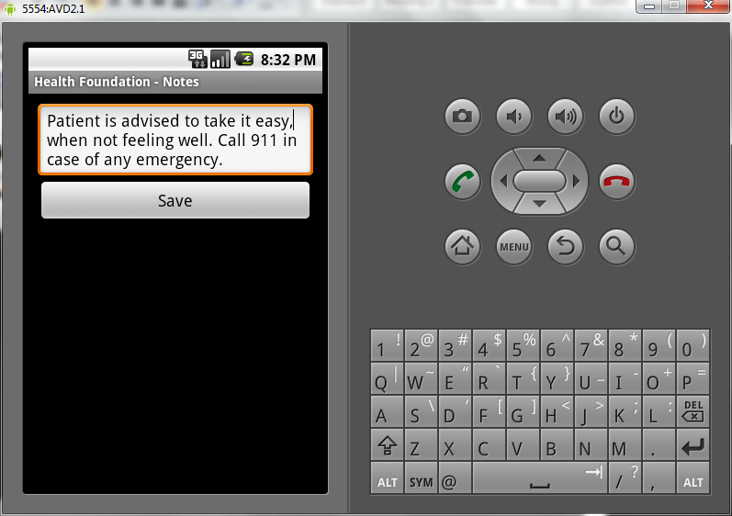

-When a note is clicked it might just look like the one above. Clicking save will update the note to the database.

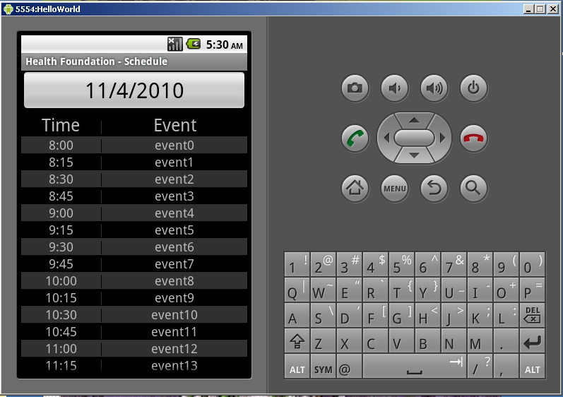

-The schedule in the doctors menu will look like the picture above. Listed by time by default, to add a new schedule entry click the big button with today's date listed on it. To modify or delete a previous entry simply click on one of the entries.

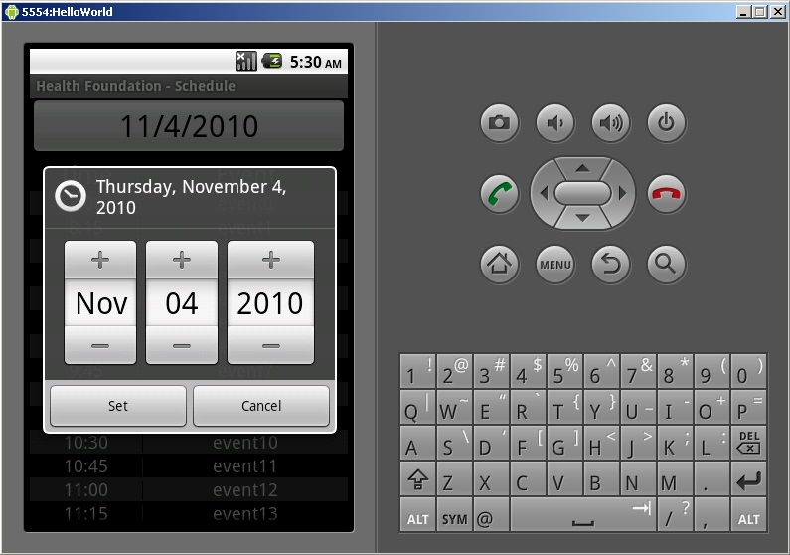

-When you clicked on the big button from the previous page it will load a calendar cog like the one above. Choose the approximate date for an upcoming event and click set. This will generate a hollow event entry now another menu will pop up asking for an event description.

Structure of Application
The team started with the idea of a mobile phone medical record app and expanded it into the set of following requirements.
  - Build a framework on the java android platform that could be used to create medical record applications.
  - Build a test application to show off the functionality of the framework.
  - Integrate the application with OpenEMR, Microsoft Health Vault, and Google Health medical record systems.
  - Incorporate encryption for every data transmission.
  - Design a user interface system to allow seamless navigation.

As the team further designed the project we realized that the original plan to build a framework for accessing medical record apps on Android was not feasible. the Team instead set it’s sites on creating a mobile app, that employed all the features the framework would have. The team restructured some of the initial requirements and came to the conclusion that only one database system was needed for this project. OPenEMR was ultimately chosen as the database that would be used because of it was open source.
The team assembled a list of use cases [look at document all-use-cases]. From the use cases we built a UML diagram [see Appendix A.1.1]. We centered the application logic around a series of list menu’s each of which progressed to a deeper level. Doctor view is a list that takes you to a list of patients or a list of schedules. Patient list takes you to each patient view which in turn offers choices to see sub lists like vital signs or medication list. Square buttons are used to present a menu and a grid of boxes on a black background used for lists. User interfaces were designed from the use cases [See Appendix 2]. Login prompt was designed with a clean and simple look. Doctor and patient views only had buttons each equidistant from each other. All the other views where based off of the list view and broken down by query data pulled from tables in database.

Development of Application

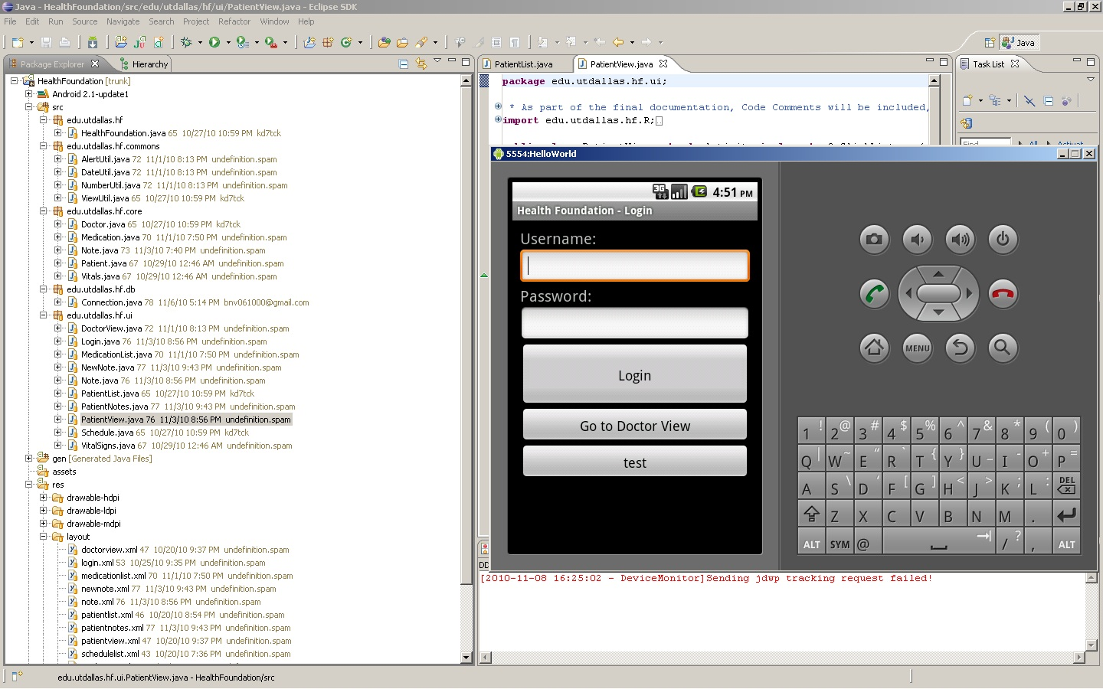

Development of Health Foundation was done in eclipse IDE using Android SDK version 2.1. A version control system was set up with google code under eclipse labs named testehr. Android SDK emulator was used to test the application in a virtual environment and two android phones where used for testing the app in real world circumstances. Development work for the project was split accordingly. Jerry Arnold did most of the coding and UI. Muhammad Khan did database queries, database structure and a little of the coding. Binh Vu did the php server side database calls and some of the app coding. Joshua Reisenauer did the documentation and a little of the coding.
Part way into development the team discovered there was no mysql connection drivers for Android SDK. The team weighed it’s options and determined it would be simpler to create a php server side app to act as a middle man between the app and the mysql server. The client side sends a command option to the php app or server side and depending on what command was sent a series of queries are generated by the client and sent to the server side. The server side will then pass the queries to the database, pull all related records and forward each back to the client side.
Towards the end of development the team members decided there was not enough time to complete some portions of the project. The Lab and Lab review portions where not completed, the team felt due to time constraints this portion would most likely be the most difficult to implement. Another change made to the original scope of the project was the addition of a php serverside app that acted as a middle man to the database for the application. Mysql drivers are not included by default in Android, thus it was necessary to create a server app to pass queries for us.

Appendix
A.1.1
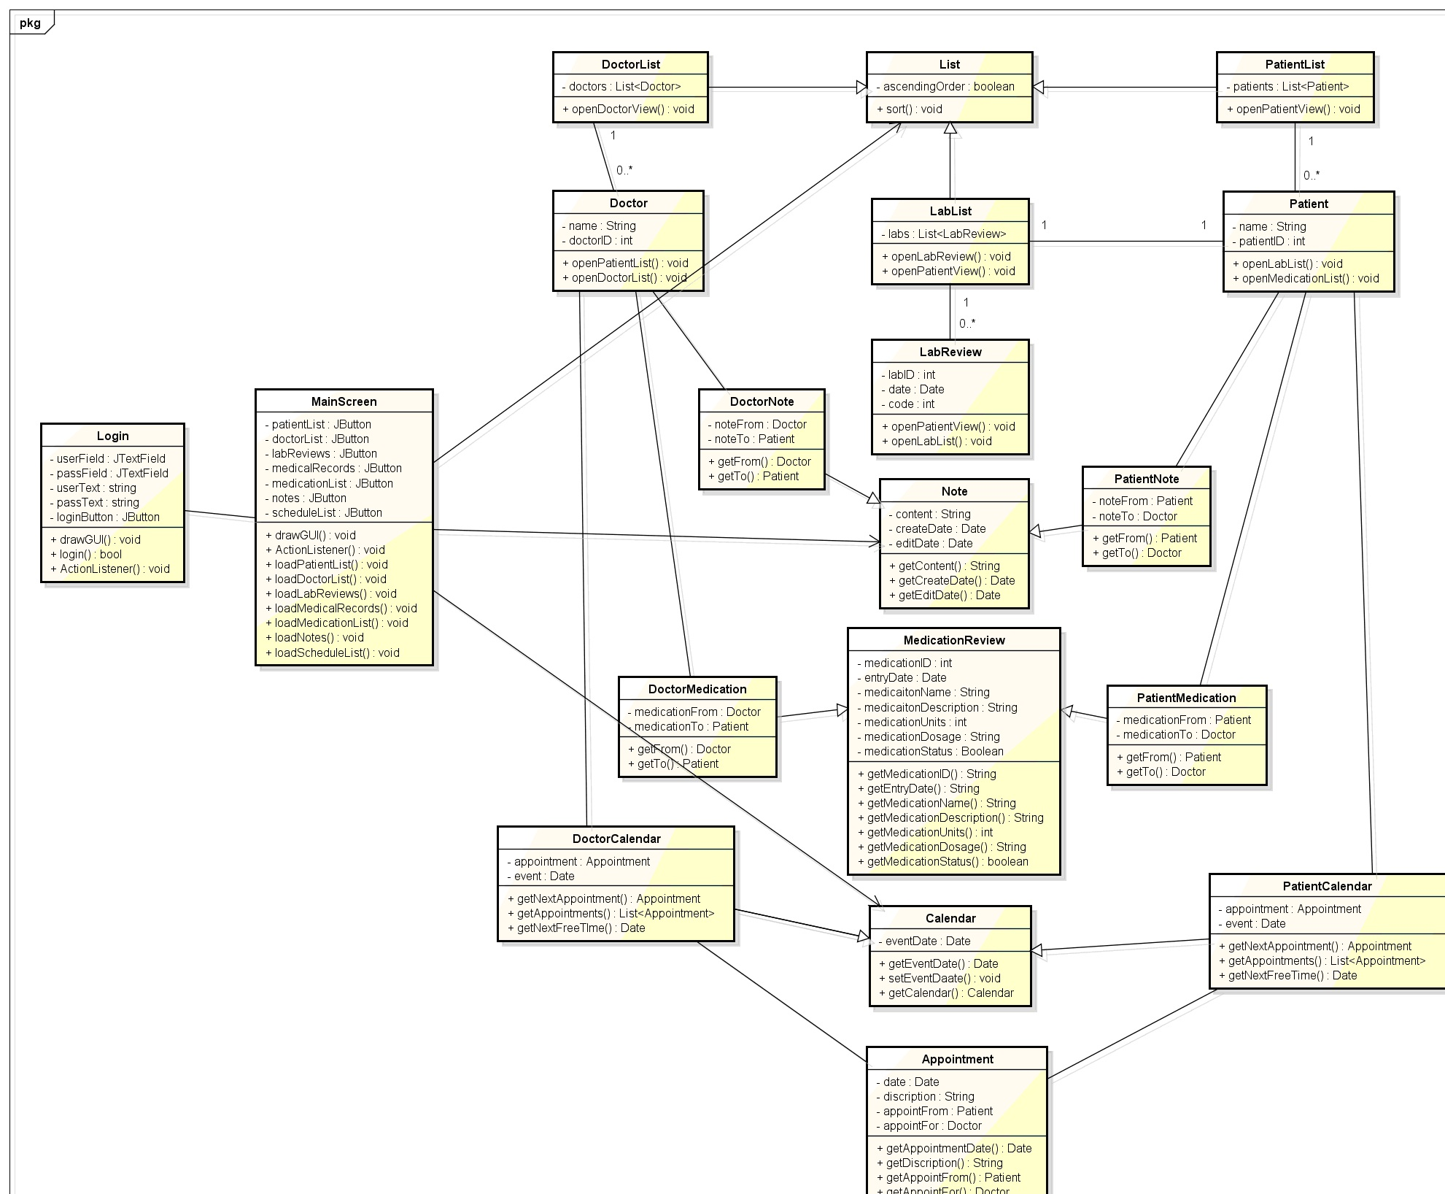
-UML diagram.

A.2.1
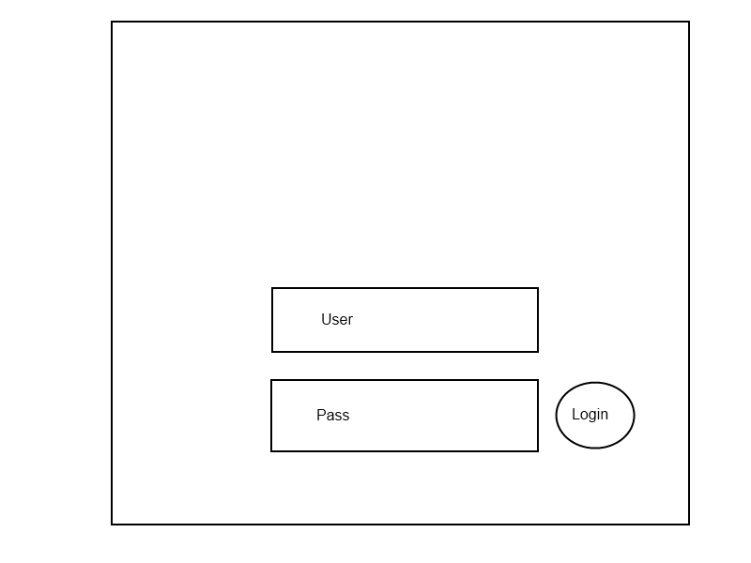
-Login Prompt (2.2)
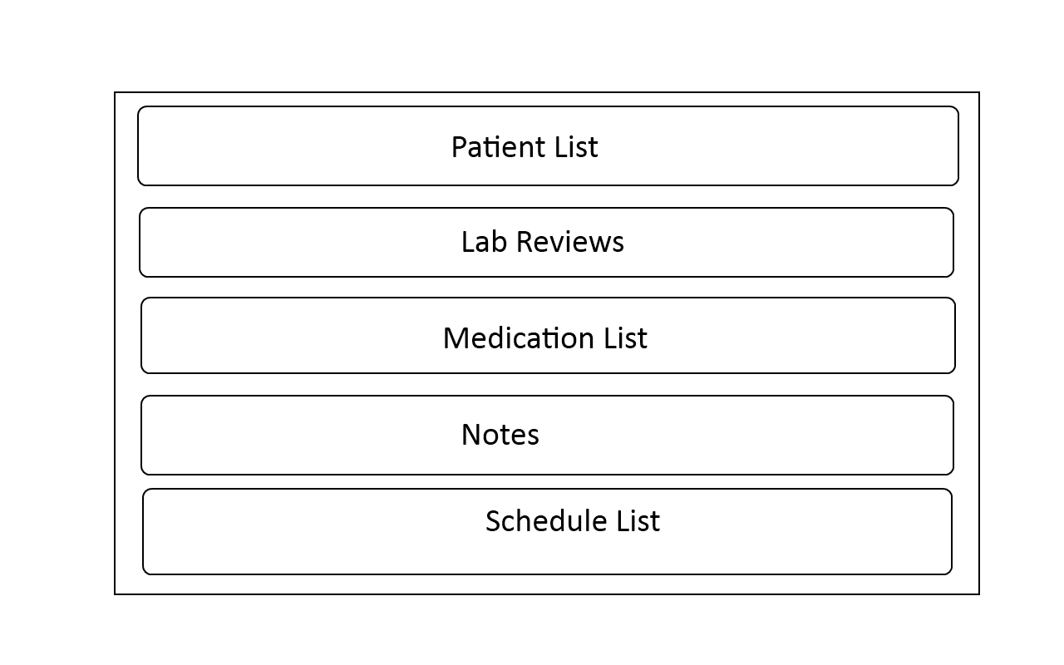
-Doctor View (2.3)
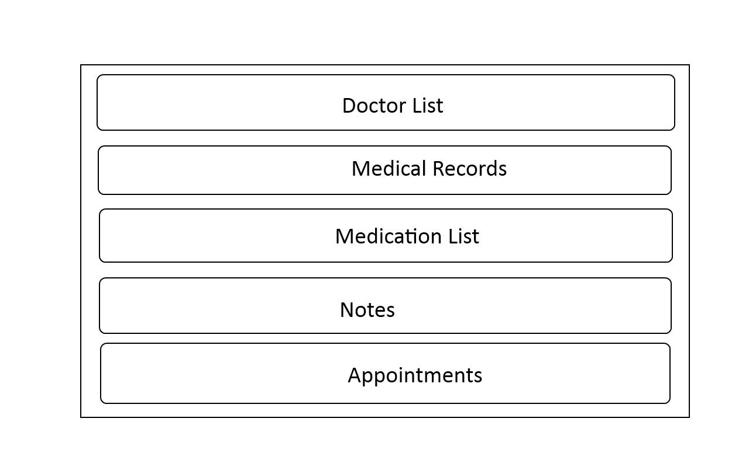
-Patient View (2.4)
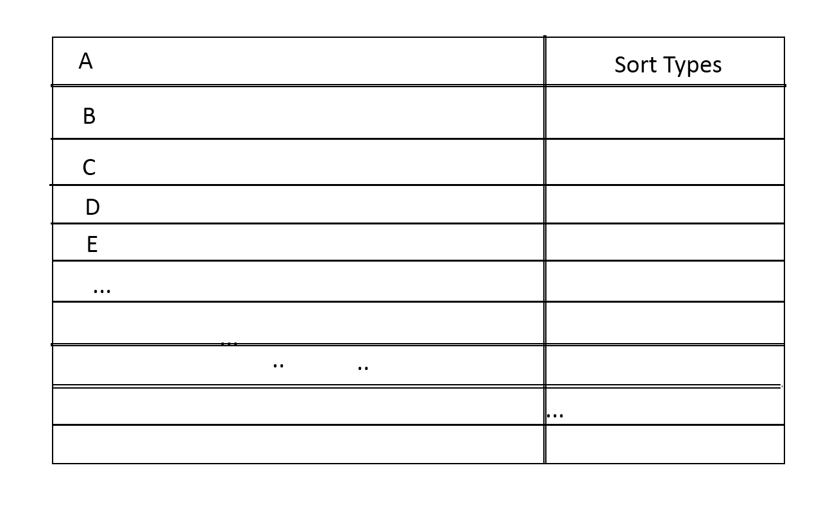
-List View (2.5)
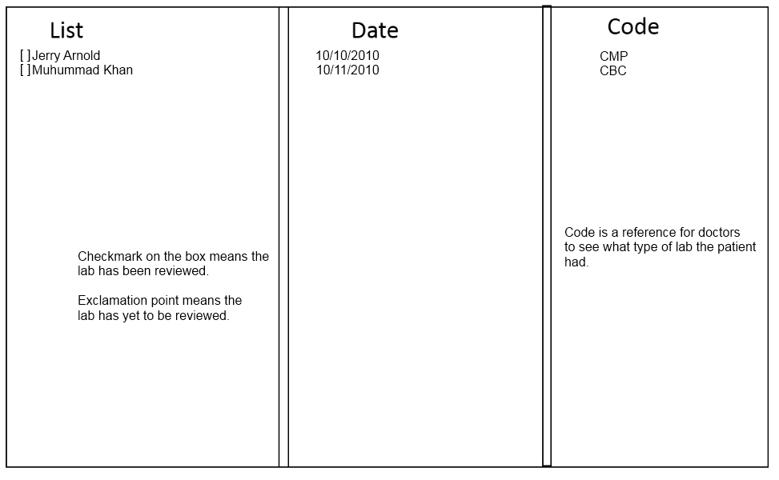
-Lab Review (2.6)
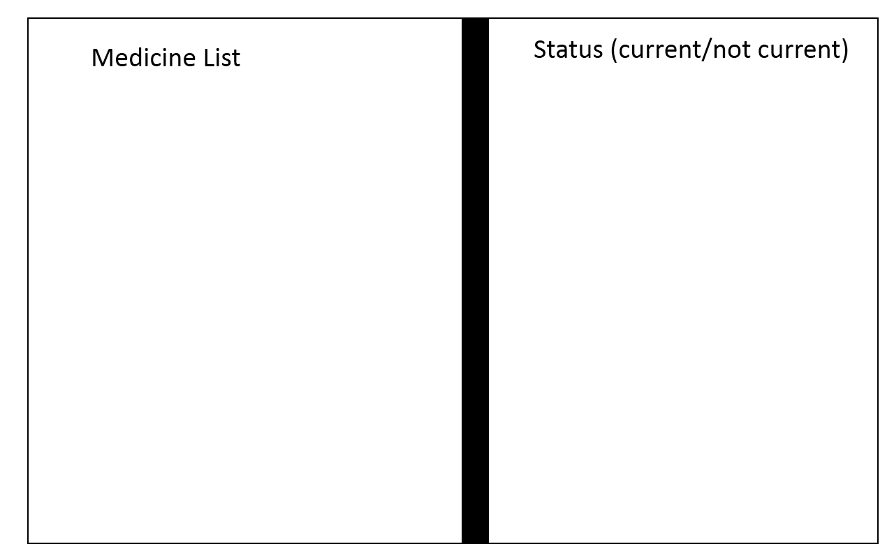
-Medication List (2.7)
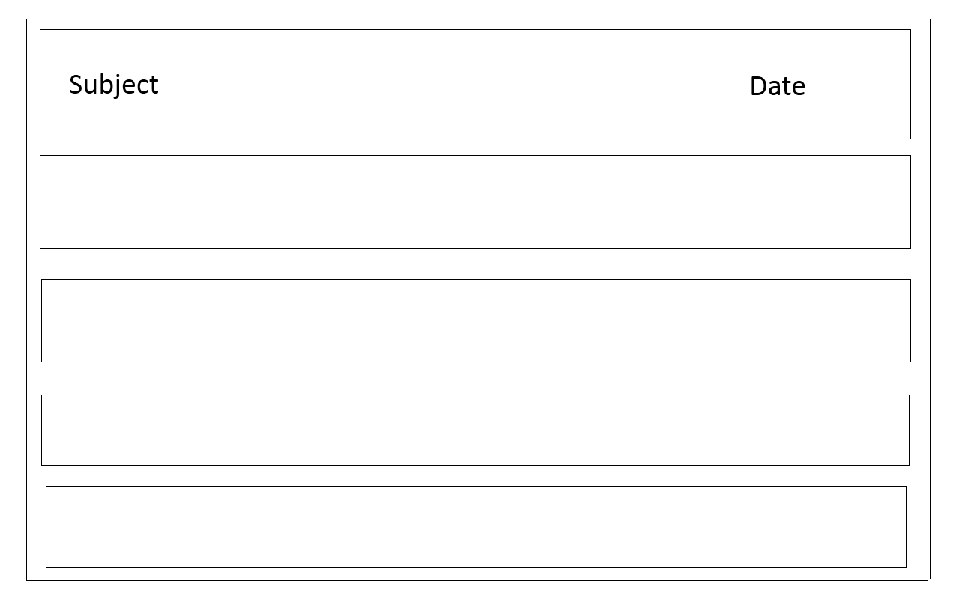
-Screen Notes (2.8)
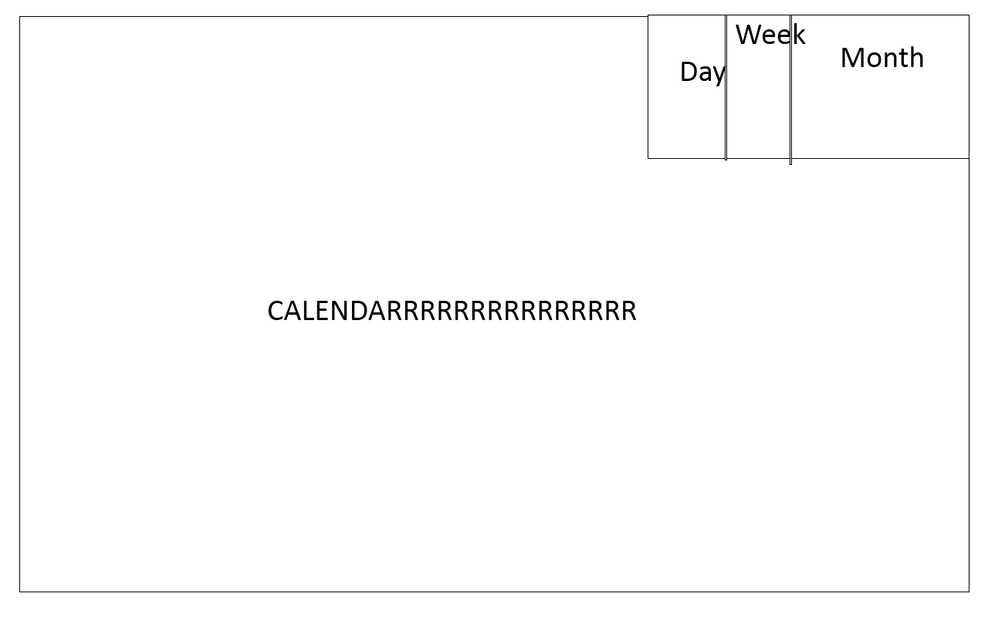
-Screen Calender (2.9)

