**MINIMAX**

The key to the Minimax algorithm is a back and forth between the two players, where the player whose turn it is to play desires to pick the move with the maximum score. In turn, the scores for each of the available moves are determined by the opposing player deciding which of its available moves has the minimum score. And the scores for the opposing players moves are again determined by the turn-taking player trying to maximize its score and so on all the way down the move tree to an end state. The key improvement to this algorithm, such that, no matter the board arrangement, the perfect player will play perfectly unto its demise, is to take the "depth" or number of turns till the end of the game into account. The perfect player should play perfectly, but prolong the game as much as possible.

Alpha beta pruning:

Alpha-beta pruning is an improvement over the minimax algorithm. The problem with minimax is that the number of game states it has to examine is exponential in the number of moves. While it is impossible to eliminate the component completely, we are able to cut it in half. It is possible to compute the correct minimax decision without looking at every node in the tree. Borrowing the idea of pruning, or eliminating possibilities from consideration without having to examine them, the algorithm allows us to discard large parts of the tree from consideration. When applied to a standard minimax tree, it returns the same move as minimax would, but prunes away branches that cannot possibly influence the final decision.

Alpha-beta pruning can be applied to trees of any depth and it often allows to prune away entire sub trees rather than just leaves. Here is the general algorithm:

1. Consider a node n somewhere in the tree, such that one can move to that node.
2. If there is a better choice m either at the parent of the node n or at any choice point further up, n will never be reached.
3. Once we have enough information about n to reach this conclusion, we can prune it.

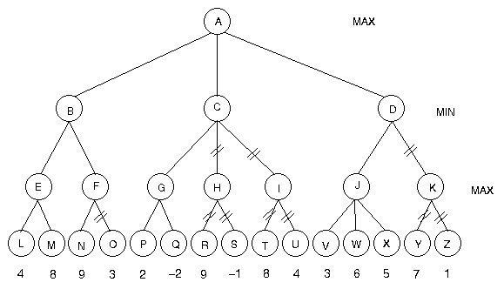

This is an example of alpha beta pruning wherein the nodes which make no difference in the final decision will be pruned. This will improve the efficiency of the algorithm and unwanted nodes are not taken into consideration.