Full Stack Development with MERN Project Documentation format

# Introduction

* **Project Title:** **OrderOnTheGo - SB Foods**
* **Team Members:**

1. **Team Leader :** Reddy Nandini

Coordinator

Builds RESTful APIs using Node.js and Express.js, manages authentication and server logic.

1. **Team member :** Rajulapati Chandrika

Works on the React-based UI, handles component design, page routing, and user interactions.

1. **Team member :** Rajulapati Vijay

Designs and manages MongoDB schemas, handles CRUD operations and ensures data consistency.

1. **Team member :** Ramagani Srikanth

Responsible for overall planning, coordination, GitHub management, and integration of frontend and backend.

# Project Overview

**Purpose:** The purpose of the **OrderOnTheGo - SB Foods** project is to develop a full-stack web application that simplifies the process of browsing, selecting, and ordering food online. It aims to provide users with a seamless food ordering experience through a modern and responsive web interface.

The application is designed to:

* Enable customers to browse food items anytime
* Add items to a cart and place orders conveniently
* Eliminate the need for physical visits or calls to restaurants
* Provide a backend system to handle product management and order storage

Ultimately, the goal is to replicate the core functionality of platforms like **Swiggy**, **Zomato**, or **Uber Eats** using open-source technologies.

#### **Features: For Users:**

* **Sign Up / Log In** – Create an account and access your orders.
* **Browse Food Items** – View a list of available dishes with images, prices, and descriptions.
* **Add to Cart** – Add favorite food items to your cart.
* **Cart Storage** – Your cart items are saved even if you refresh the page.
* **Place Orders** – Enter your address and choose payment method to place an order.
* **Order Confirmation** – Get a message when your order is successfully placed.

#### **For Admin (Future Scope):**

* **Add or Update Products** – Admin can manage food items.
* **View Orders** – Admin can see orders placed by users.

# Architecture

### **Frontend (React.js)**

* Built using React with multiple pages (Home, Products, Cart, etc.)
* Uses React Router for navigation and Context API for managing the cart
* Axios is used for API calls to the backend
* Cart and user info are stored in localStorage

### **Backend (Node.js + Express.js)**

* Handles API routes like register, login, get products, and place orders
* Uses Express middleware for JSON handling and CORS
* Connects to MongoDB using Mongoose

### **Database (MongoDB)**

* Stores user, product, and order data
* Collections:
  + users: name, email, password, address
  + products: name, description, price, image
  + orders: userId, items, address, payment method

# Setup Instructions

### Prerequisites

* **Node.js & npm** – For running frontend and backend
* **MongoDB** – Local database (use Compass or terminal)
* **Git** – To clone the project
* **VS Code** – Recommended editor

### Installation Steps

**Clone the Project**

git clone https://github.com/srikanthramagani/OrderGo.git

cd OrderGo

1. **Install & Run Backend**

cd server

npm install

node server.js

1. **Install & Run Frontend**  
   Open a new terminal:

cd client

npm install

npm start

1. **Start MongoDB**
   * Use MongoDB Compass or run mongod in terminal.

Your app will run at:

* Frontend: http://localhost:3000
* Backend API: http://localhost:5000

# Folder Structure

* + **Client(React frontend):**

client/

├── public/ → Static assets

├── src/

│ ├── components/

│ │ └── pages/ → All page components (Home, Cart, Login, etc.)

│ ├── context/ → Cart context (global state)

│ ├── App.jsx → Main component with routes

│ └── index.js → Entry point of the app

* + **Server(Node.js backend):**

server/

├── models/ → Mongoose schemas (User, Product, Order)

├── server.js → Main Express server file

# Running the Application

### **Frontend :**

cd client

npm start

Runs the React app at: http://localhost:3000

### **Backend :**

cd server

npm start # Or use: node server.js

Runs the Node.js server at: http://localhost:5000

# API Documentation

### **POST /api/register : Registers a new user.**

### **POST /api/login** : **Logs in an existing user.**

### **GET /api/products** : **Retrieves a list of available food products.**

### **POST /api/orders** : **Places a new order.**

# Authentication

### How Authentication Works:

* Users register by providing their name, email, password, and address using the endpoint:

POST /api/register

* They log in with their email and password using:

POST /api/login

### Method Used:

* The current setup uses **basic email and password matching**.
* There is **no token-based authentication** or sessions implemented at this stage.
* After login, the user’s details can be stored on the frontend (e.g., in localStorage) to maintain the login state.

### Recommendations for Improvement:

To enhance security in the future, it is recommended to:

* Implement **JWT (JSON Web Token)** authentication.
* Use **middleware** to protect private API routes.
* Store tokens securely (e.g., in localStorage or HTTP-only cookies).

# User Interface

# Home page:

# 

# All breakfast serving restaurants:

# Registration page:

# 

# Login page:

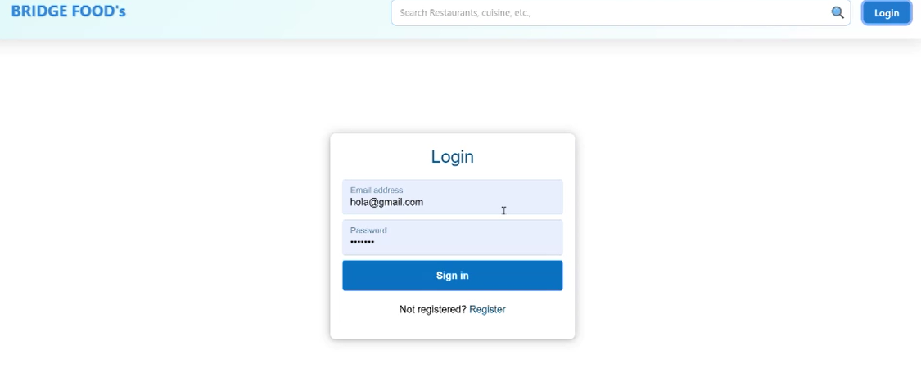

**Admin dashboard:**

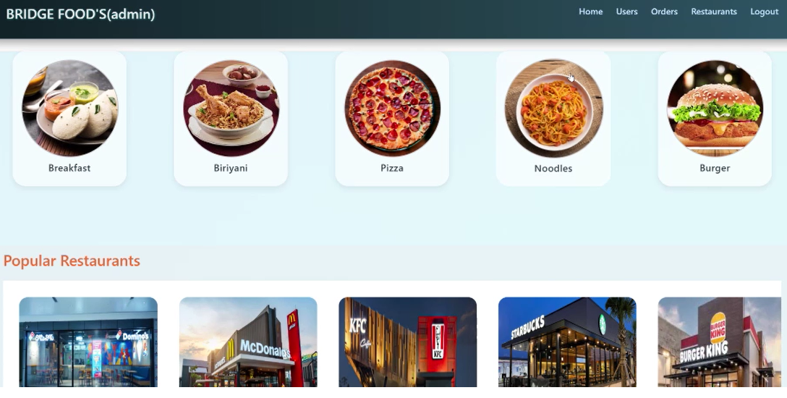

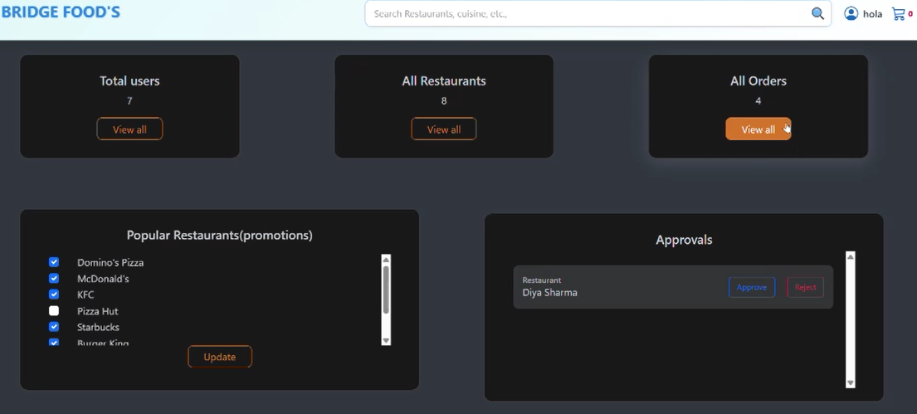

**List of orders:**

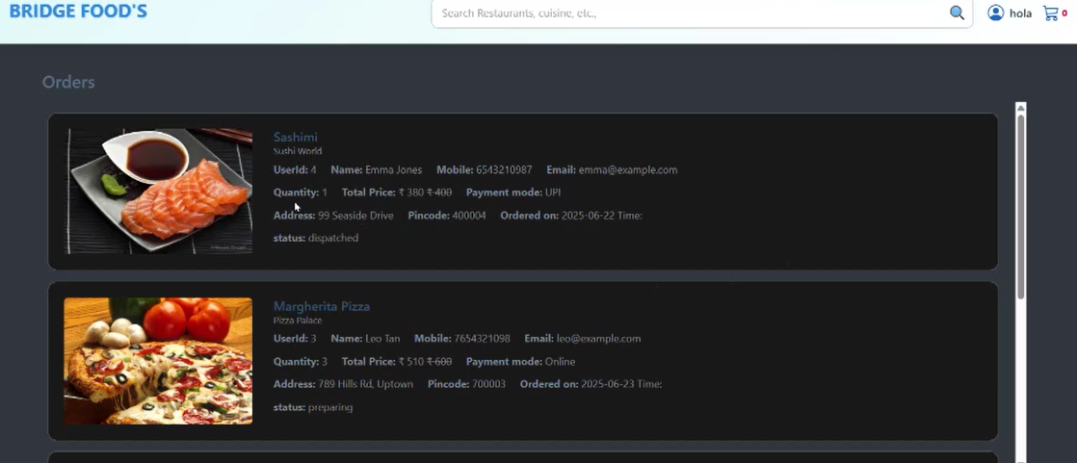

**Checkout:**

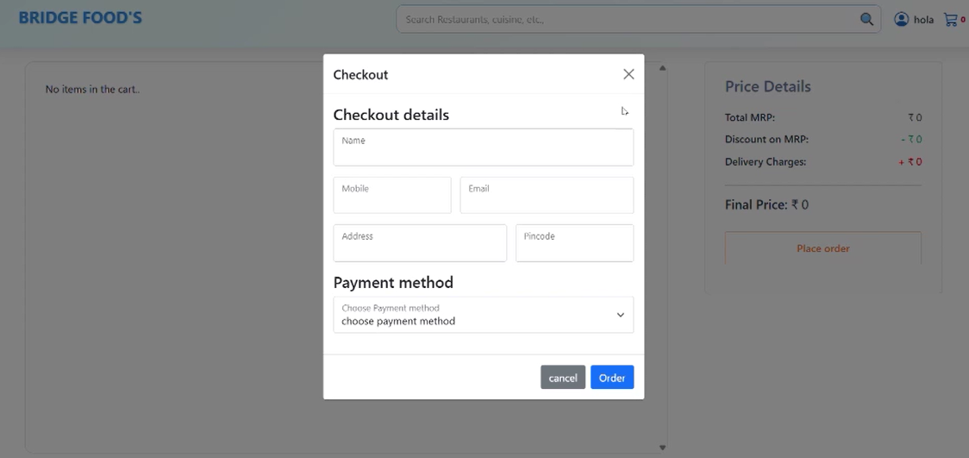

**Orders:**

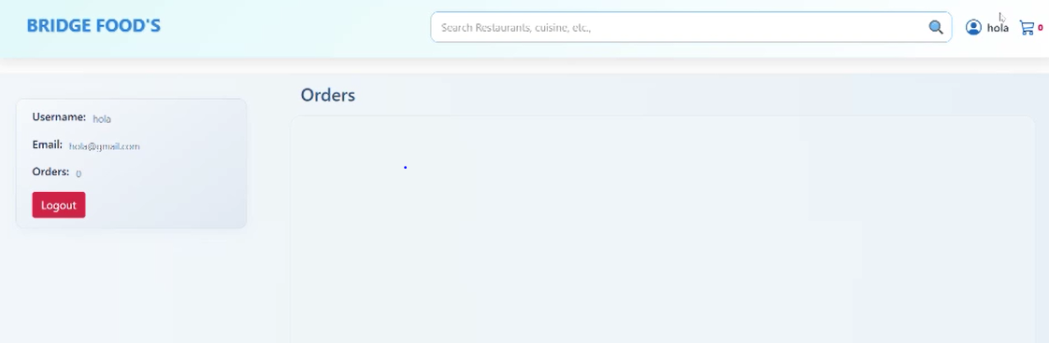

# Testing

* **Manual testing** was done by using the app (register, login, cart, order flow).
* **Postman** was used to test backend APIs.
* **Browser DevTools** helped inspect React components and API requests.

# Screenshots or Demo

Demo Video Check out a quick demo of OrderGo in action:Watch Demo on YouTube <https://youtu.be/Pdqh0A7nmxo>

# Known Issues

* + **No authentication tokens** – Login does not use JWT or sessions, so user sessions are not fully secure.
  + **No order history** – Users cannot view past orders after placing them.
  + **Cart resets on logout** – Cart is stored in localStorage and clears when browser data is cleared or user logs out.
  + **No automated testing** – All testing is manual; no test scripts are in place.
  + **No real-time updates** – Admin actions like order status changes aren’t reflected instantly on user side.

# Future Enhancements

* Use **Jest** for frontend tests.
* Use **Supertest** for backend API testing.
* Payment integration with Razorpay/Stripe
* Role-based admin access