**Project Design Phase**

**Solution Architecture**

|  |  |
| --- | --- |
| Date | 15 February 2025 |
| Team ID | LTVIP2025TMID55302 |
| Project Name | OderGo – Food Ordering MERN App |
| Maximum Marks | 4 Marks |

**Solution Architecture:**

Solution architecture is a complex process – with many sub-processes – that bridges the gap between business problems and technology solutions. Its goals are to:

* Find the best tech solution to address problems such as food waste, inefficient ordering, and restaurant-user coordination.
* Describe the structure, behavior, and key technical elements of the OderGo application for project stakeholders.
* Define features like user authentication, filtering, cart management, and admin controls with planned development phases.
* Provide clear architecture and data flow specifications for developers, testers, and deployment teams.

**Example - Solution Architecture Diagram:**

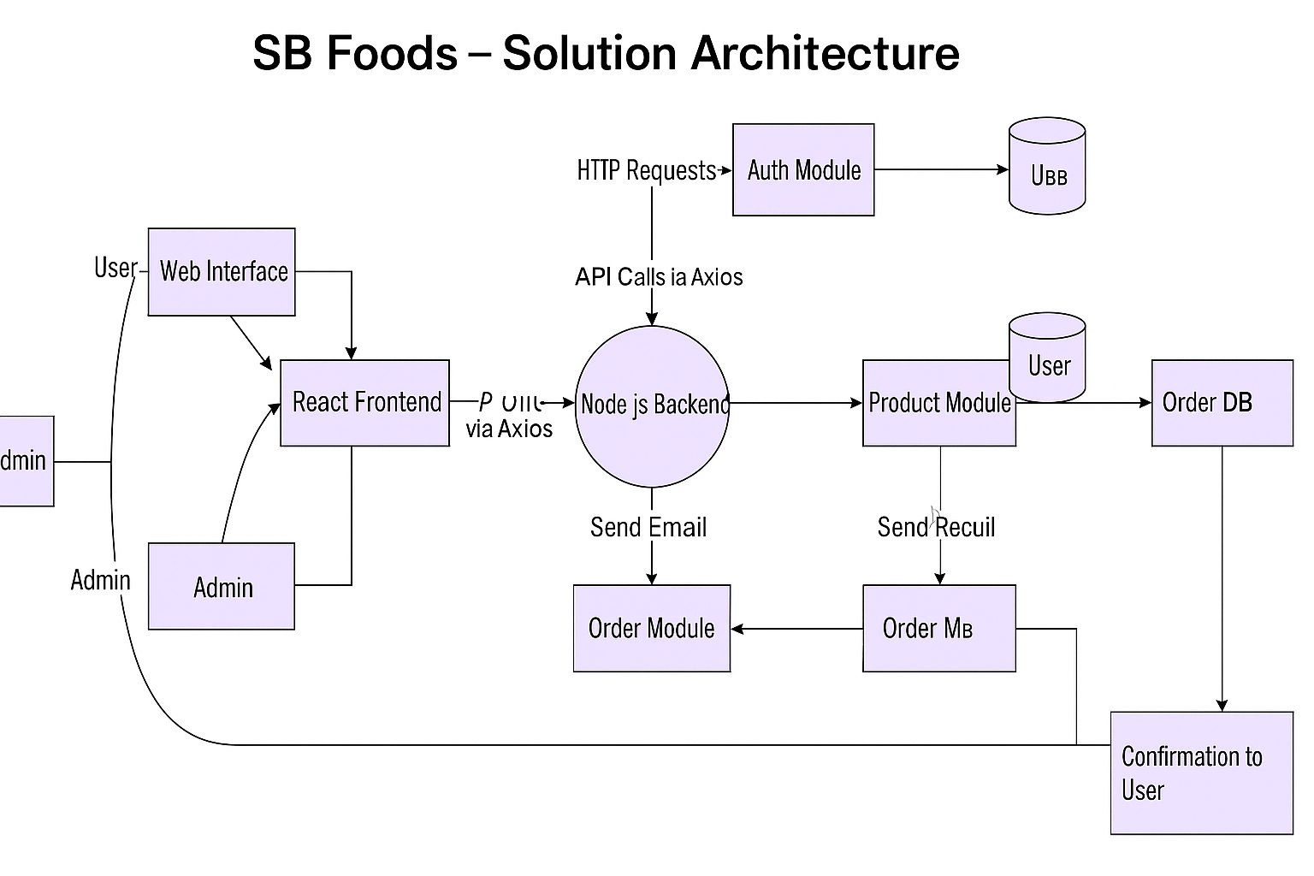

*Figure 1: Architecture and data flow of the voice patient diary sample application*