1. Knowledge-bi will help to get insight from graph data.
2. We can upload ntriple, nquads, owl, turtle file data or we can connect Fuseki server or AllegroGraph server.
3. We can do sparql to selected database or we can do federated query.
4. We can visualize the data in charts(bar, pie etc)
5. We can visualize the data in graph .
6. We can upload CSV/TSV it will automatically convert the data to graph data format with given relationships then we can query this data using sparql.

**Knowledge-BI UI**

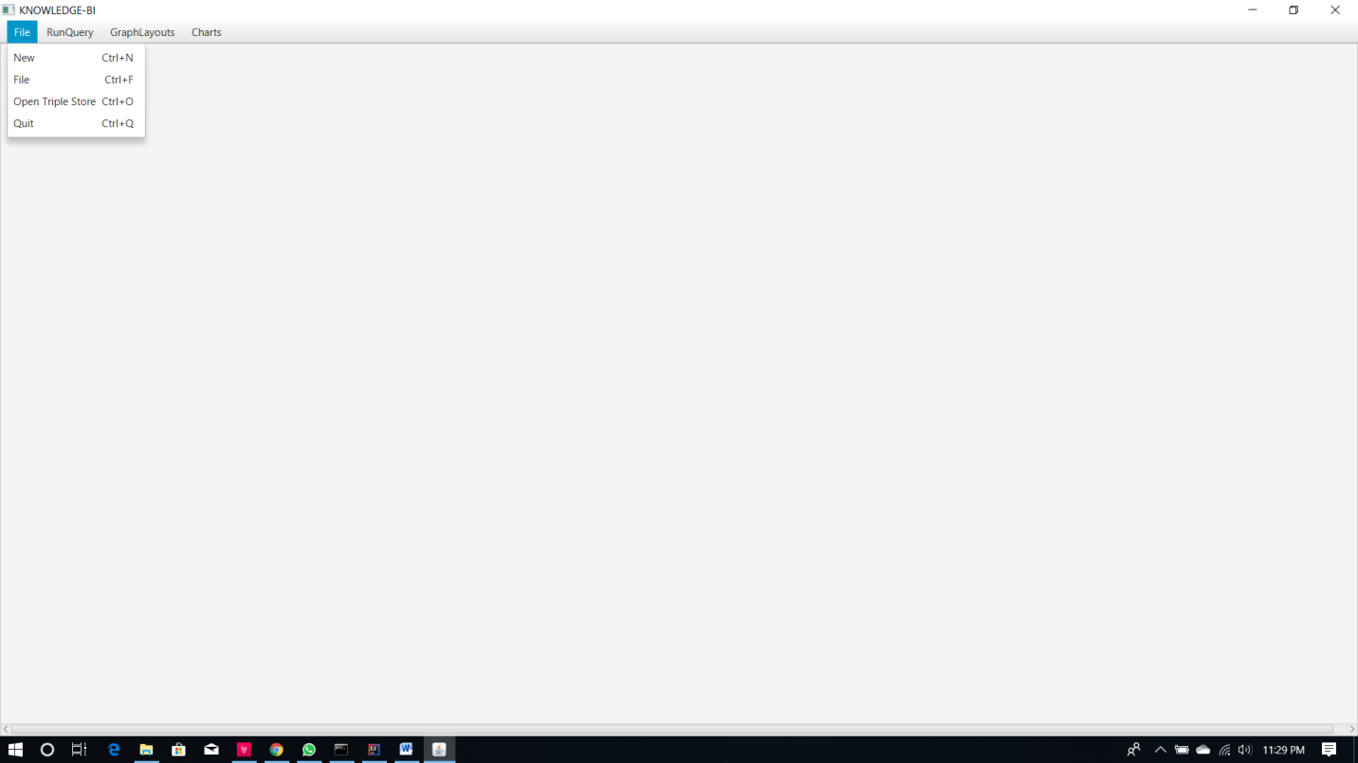

Connect to databases

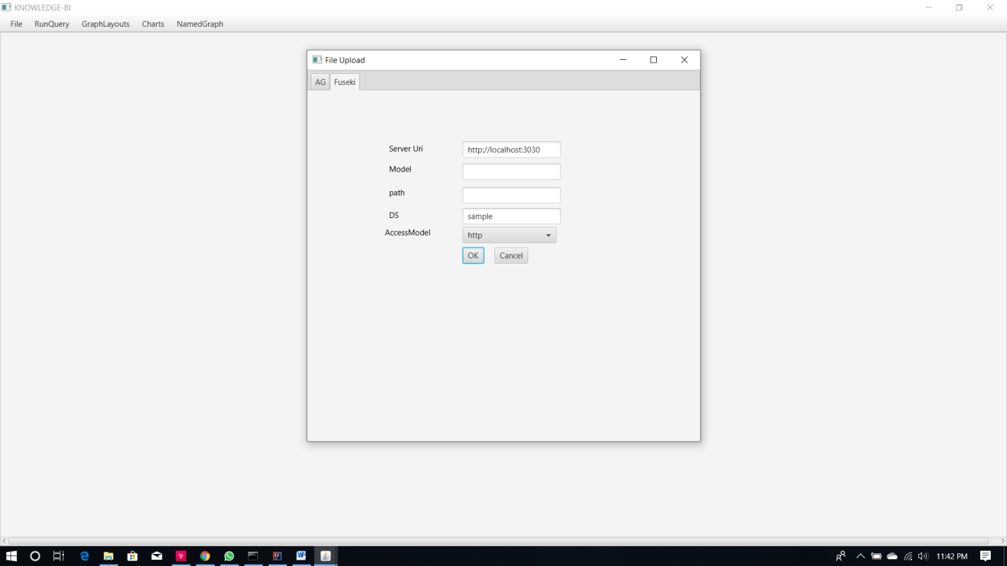

Visualizing data in table, charts and graph format

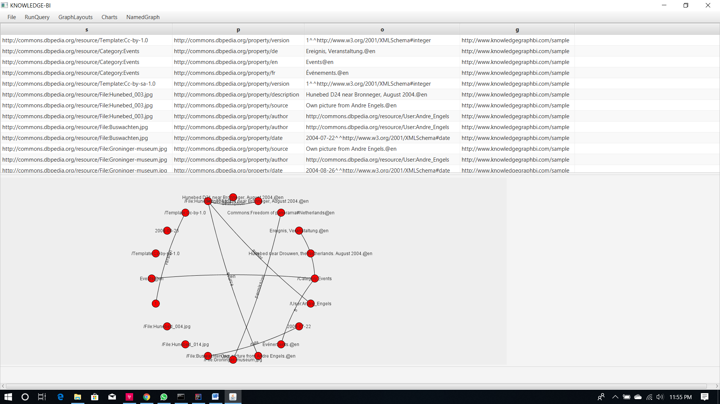

Upload data to connected data

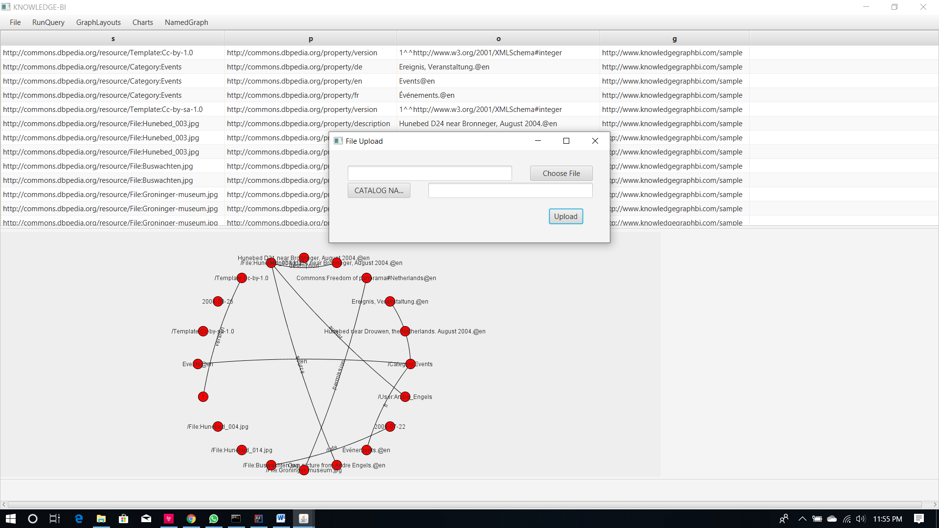

Doing Sparql

