Software Requirements Specification (SRS)
Project: Bank Management System
Version: 1.0
Authors: < Instructor / Student>
Date: 06/09/2026
Status: Model Answer / Approved

Revision History
Version | Date | Author | Change Summary | Approval
1.0 | 06-09-2026 | SRIKANTH V REDDY — PES2UG24CS519  T. MAHALAKSHMI — PES2UG24CS558  SUDHANWA — PES2UG24CS531  SRUJAN — PES2UG24CS526 | Initial SRS for Bank Management System | Pending

Approvals
Role | Name | Signature / Email | Date
Course Coordinator

Table of Contents
- 1. Introduction
- 2. Overall Description
- 3. External Interface Requirements
- 4. System Features (Detailed)
- 5. Non-Functional Requirements (Detailed)
- 6. Quality Attributes & Acceptance Tests
- 7. UML Use-Case Diagrams
- 8. Requirements Traceability Matrix (RTM)

1. Introduction

1.1 Purpose
This document is a Software Requirements Specification (SRS) for a Bank Management System. It defines the functional and non-functional requirements, external interfaces, security expectations, and verification criteria for managing customers, accounts, banking transactions, loans, reports, and administrative operations.

1.2 Scope
The system covers customer registration and authentication, account creation and management, deposits, withdrawals, fund transfers, transaction history, loan management, notifications, reporting, and administrative control. It is intended to support day-to-day banking operations through a secure software system. Internal implementation details of external banking networks and third-party financial institutions are outside the scope.

1.3 Audience
The intended audience includes developers, QA engineers, database administrators, bank staff, system administrators, project evaluators, and other stakeholders involved in the development, testing, deployment, or maintenance of the system.

1.4 Definitions
BMS – Bank Management System; KYC – Know Your Customer; OTP – One-Time Password; UI – User Interface; API – Application Programming Interface; DB – Database; MFA – Multi-Factor Authentication; TLS – Transport Layer Security; RBAC – Role-Based Access Control; RTM – Requirements Traceability Matrix.

2. Overall Description

2.1 Product Perspective
The Bank Management System is a centralized application that provides controlled access to banking operations. It interacts with a database for customer and account records, authentication services for secure login, notification services for alerts, and optional external payment or banking APIs for supported transactions.

2.2 Major Product Functions
- Customer registration and secure login.
- Customer profile and KYC information management.
- Creation, update, activation, and closure of bank accounts.
- Balance inquiry and transaction history.
- Cash deposit and withdrawal recording.
- Fund transfer between eligible accounts.
- Beneficiary management.
- Cheque/deposit transaction recording where applicable.
- Loan application, approval, repayment, and status tracking.
- Interest and charge calculation according to configured rules.
- Account statements and transaction reports.
- Notifications for important banking events.
- Role-based administrative management.
- Audit logging and system monitoring.
- Backup, recovery, and data reconciliation support.

2.3 User Roles and Characteristics
- Customer: uses the system to manage personal accounts, view balances, perform permitted transactions, and access statements.
- Bank Staff: handles customer service, account operations, deposits/withdrawals, transfers, and loan-related activities according to assigned permissions.
- Administrator: manages users, roles, configurations, system parameters, and operational monitoring.
- Auditor: reviews audit logs, reports, and transaction records without changing operational data.

2.4 Operating Environment
The system may operate as a web-based or desktop banking application backed by a relational database server. Supported environments include modern Windows/Linux servers, modern web browsers for browser-based clients, a secure LAN/WAN, and reliable database and application servers.

2.5 Constraints
- Banking and customer data must be protected from unauthorized access.
- Financial transactions must maintain database consistency and must not result in unintended duplicate postings.
- Role-based permissions shall restrict sensitive administrative functions.
- The system shall use approved security mechanisms for authentication, encryption, and audit logging.
- Availability of external services may affect functions that depend on third-party APIs.

3. External Interface Requirements

3.1 User Interfaces
The system shall provide a clear dashboard with navigation for customers, bank staff, administrators, and auditors according to their roles. Forms shall provide validation messages, confirmation prompts for financial transactions, and readable transaction summaries. Sensitive fields such as passwords and OTPs shall be masked.

3.2 Hardware Interfaces
- Client computers or approved banking terminals.
- Secure keyboard/touch input for customer and staff operations.
- Optional receipt or statement printer.
- Server hardware and storage for application and database services.

3.3 Software Interfaces
- Relational Database Management System for persistent customer, account, transaction, and loan data.
- Authentication/OTP service for identity verification and multi-factor authentication.
- Notification service for email/SMS/app alerts where configured.
- Optional external payment or inter-bank transfer API through authenticated and encrypted connections.

3.4 Communications
- All client-server and external API communication shall use TLS 1.2 or higher.
- API requests shall use authenticated sessions or tokens.
- Timeout, retry, and error-handling mechanisms shall prevent inconsistent transaction states.
- Sensitive information shall not be transmitted through unsecured channels.
Minimum project requirement: at least 15 functional requirements, 5 non-functional requirements, 2 security objectives, and 5 security requirements are specified below.

4. System Features (Detailed)
Each subsection groups related functional requirements, following the structure of the provided ATM SRS template. Each requirement includes an identifier, requirement statement, type, priority, source/stakeholder, acceptance criteria/test reference, and dependencies.

4.1 Authentication & User Management
Requirements covering secure login, OTP verification, customer information, and account lifecycle operations.
Req ID | Requirement | Type | Priority | Source/Stakeholder | Acceptance Criteria / Test Case | Comments / Dependencies
BMS-F-001 | The system shall authenticate customers and staff using valid credentials before granting access. | Functional | High | Security / Banking | Valid credentials create an authenticated session. Test: TC-AUTH-01 | Authentication service required
BMS-F-002 | The system shall support OTP-based second-factor verification for configured high-risk logins or transactions. | Functional | High | Security / Customer | Correct OTP permits the operation; invalid/expired OTP is rejected. Test: TC-AUTH-02 | OTP service required
BMS-F-003 | The system shall allow customers to view and update permitted profile and KYC info | Functional | High | Customer Service | Permitted fields can be updated and stored correctly. Test: TC-CUST-01 | KYC validation rules
BMS-F-004 | The system shall allow authorized bank staff to create a new customer account with a unique account number. | Functional | High | Bank Staff | New account is created with unique identifier and required details. Test: TC-ACC-01 | Database
BMS-F-005 | The system shall allow authorized staff to activate, freeze, and close accounts according to business rules. | Functional | High | Bank Staff | Only authorized roles can change account status. Test: TC-ACC-02 | RBAC required

4.2 Balance Inquiry & Transaction History
Requirements covering balance visibility, transaction history, and account statements.
Req ID | Requirement | Type | Priority | Source/Stakeholder | Acceptance Criteria / Test Case | Comments / Dependencies
BMS-F-006 | The system shall display the current available balance for an authorized account. | Functional | High | Customer / Staff | Displayed balance matches the ledger after completed transactions. Test: TC-BAL-01 | Transaction ledger
BMS-F-011 | The system shall display transaction history for a selected account within a user-specified date range. | Functional | Medium | Customer / Staff | Returned records match account and selected date range. Test: TC-HIST-01 | Transaction records
BMS-F-012 | The system shall generate downloadable or printable account statements for authorized users. | Functional | Medium | Customer / Staff | Statement contains correct account, date, opening/closing balance, and transactions. Test: TC-STMT-01 | Reporting module

4.3 Cash Deposit
Requirements covering deposit recording and account crediting.
Req ID | Requirement | Type | Priority | Source/Stakeholder | Acceptance Criteria / Test Case | Comments / Dependencies
BMS-F-007 | The system shall record cash deposits and credit the specified account after successful validation. | Functional | High | Bank Staff | Valid deposit creates a transaction and updates balance exactly once. Test: TC-DEP-01 | Transaction database

4.4 Cash Withdrawal
Requirements covering withdrawal validation, limits, and account debit operations.
Req ID | Requirement | Type | Priority | Source/Stakeholder | Acceptance Criteria / Test Case | Comments / Dependencies
BMS-F-008 | The system shall record cash withdrawals only when the account has sufficient available balance and applicable limits permit the withdrawal. | Functional | High | Bank Staff | Insufficient balance or exceeded limit prevents posting. Test: TC-WD-01 | Business rules

4.5 Funds Transfer
Requirements covering account-to-account transfers and beneficiary management.
Req ID | Requirement | Type | Priority | Source/Stakeholder | Acceptance Criteria / Test Case | Comments / Dependencies
BMS-F-009 | The system shall transfer funds between eligible accounts after validating source balance, destination account, and transaction limits. | Functional | High | Customer / Staff | Valid transfer debits source and credits destination exactly once. Test: TC-TRF-01 | Atomic database transaction
BMS-F-010 | The system shall allow authorized users to add, modify, and remove beneficiaries subject to verification rules. | Functional | Medium | Customer | Beneficiary changes are validated and reflected in the account. Test: TC-BEN-01 | Authentication required

4.6 Loan Management
Requirements covering loan applications, decisions, schedules, and repayments.
Req ID | Requirement | Type | Priority | Source/Stakeholder | Acceptance Criteria / Test Case | Comments / Dependencies
BMS-F-013 | The system shall accept loan applications and store applicant, amount, tenure, and supporting details. | Functional | High | Customer / Loan Staff | Application receives unique ID and status. Test: TC-LOAN-01 | Loan module
BMS-F-014 | The system shall allow authorized loan officers to approve, reject, or return loan applications with an audit record. | Functional | High | Loan Staff | Decision changes application status and records user/time/reason. Test: TC-LOAN-02 | RBAC and audit log
BMS-F-015 | The system shall calculate loan repayment schedules using the configured interest rate, tenure, and repayment rules. | Functional | High | Loan Staff | Generated schedule matches configured calculation rules. Test: TC-LOAN-03 | Interest configuration
BMS-F-016 | The system shall record loan repayments and update the outstanding loan balance. | Functional | High | Loan Staff / Customer | Repayment reduces outstanding principal/charges correctly. Test: TC-LOAN-04 | Loan ledger

4.7 Notifications
Requirements covering alerts for important banking and security events.
Req ID | Requirement | Type | Priority | Source/Stakeholder | Acceptance Criteria / Test Case | Comments / Dependencies
BMS-F-017 | The system shall send notifications for configured events such as successful transfers, withdrawals, password changes, and loan status changes. | Functional | Medium | Customer / Security | Configured event produces a notification without exposing sensitive credentials. Test: TC-NOTIF-01 | Notification service

4.8 Administration & Monitoring
Requirements covering administration, reporting, auditing, and operational oversight.
Req ID | Requirement | Type | Priority | Source/Stakeholder | Acceptance Criteria / Test Case | Comments / Dependencies
BMS-F-018 | The system shall allow administrators to create, disable, and assign roles to system users according to RBAC rules. | Functional | High | Administrator | Only authorized administrators can modify roles. Test: TC-ADMIN-01 | RBAC
BMS-F-019 | The system shall generate operational reports for transactions, accounts, loans, and user activity. | Functional | Medium | Management / Auditor | Reports contain correct filtered totals and records. Test: TC-REP-01 | Reporting database
BMS-F-020 | The system shall maintain an audit trail for security-sensitive and financial operations, including user, timestamp, action, and result. | Functional | High | Security / Auditor | Required events are recorded and retrievable. Test: TC-AUD-01 | Audit log storage

Each requirement includes an identifier, requirement statement, type, priority, source/stakeholder, acceptance criteria or test reference, and relevant dependency.

5. Non-Functional Requirements (Detailed)
Req ID | Requirement | Category | Priority | Acceptance Criteria / Measurement
BMS-NF-001 | For normal load, 90% of standard read or transaction requests shall receive a response within 3 seconds. | Performance | High | 90th percentile response time ≤ 3 seconds in performance testing. Test: TC-PERF-01
BMS-NF-002 | The system shall provide at least 99.9% monthly availability excluding approved maintenance windows. | Reliability | High | Availability report ≥ 99.9% per month. Test: TC-OPS-01
BMS-NF-003 | The system shall protect sensitive customer and financial data using encryption in transit and appropriate protection at rest. | Security/Compliance | High | Security assessment confirms encryption controls. Test: TC-SEC-01
BMS-NF-004 | The system shall maintain timestamped audit logs for financial and security-sensitive operations and retain them according to organizational policy. | Audit/Data Retention | High | Audit records can be retrieved and verified for required retention period. Test: TC-AUD-02
BMS-NF-005 | The user interface shall be usable on supported browsers and provide clear validation, readable labels, and accessible navigation. | Usability/Accessibility | Medium | Usability and accessibility review passes agreed checklist. Test: TC-UX-01

5.1 Security

5.1.1 Security Objectives
- SO-001 – Confidentiality: prevent unauthorized disclosure of customer credentials, personal information, account details, and financial data.
- SO-002 – Integrity and Accountability: ensure financial transactions cannot be altered without authorization and that security-sensitive and financial actions are traceable through audit records.

5.1.2 Security Requirements
Req ID | Requirement | Type | Priority | Acceptance Criteria / Test Case
BMS-SR-001 | TLS 1.2 or higher shall be mandatory for all client-server and external API connections. | Security | High | Network security test confirms no unsecured sensitive connection is accepted.
BMS-SR-002 | Passwords shall be stored only as strong salted hashes and shall never be stored in plaintext. | Security | High | Database/security inspection confirms plaintext passwords are absent.
BMS-SR-003 | The system shall enforce role-based access control for customer, staff, administrator, and auditor functions. | Security | High | Unauthorized role attempts are denied. Test: TC-SEC-02.
BMS-SR-004 | The system shall lock or temporarily block an account after a configurable number of consecutive failed authentication attempts and record the event. | Security | High | Threshold is enforced and an audit event is generated. Test: TC-SEC-03.
BMS-SR-005 | The system shall record security-sensitive and financial actions with user identity, timestamp, operation, outcome, and relevant transaction reference without logging passwords or OTP values. | Security | High | Audit review confirms required fields and absence of credentials. Test: TC-SEC-04.

6. Quality Attributes & Acceptance Tests
Exit criteria for acceptance: all high-priority functional requirements shall be implemented and verified; no critical security or data-integrity defects shall remain open; applicable non-functional requirements shall meet their stated measurements; and the RTM shall show coverage of requirements by test cases.
- Authentication test suite – valid/invalid credentials, OTP, lockout, and role checks.
- Account test suite – customer creation, account activation/freezing/closure, and balance validation.
- Transaction test suite – deposits, withdrawals, transfers, limits, duplicate prevention, and ledger consistency.
- Loan test suite – application, approval/rejection, schedule calculation, and repayments.
- Reporting test suite – statements, transaction history, and operational reports.
- Security test suite – encryption, password storage, RBAC, audit logging, and session controls.
- Performance and usability test suite – response time, availability, validation, and supported UI behavior.

7. UML Use-Case Diagrams
The following diagrams represent the major interactions between external actors and the Bank Management System. They are included as two diagrams as required by the SRS template.

7.1 Customer and Bank Staff Use Cases
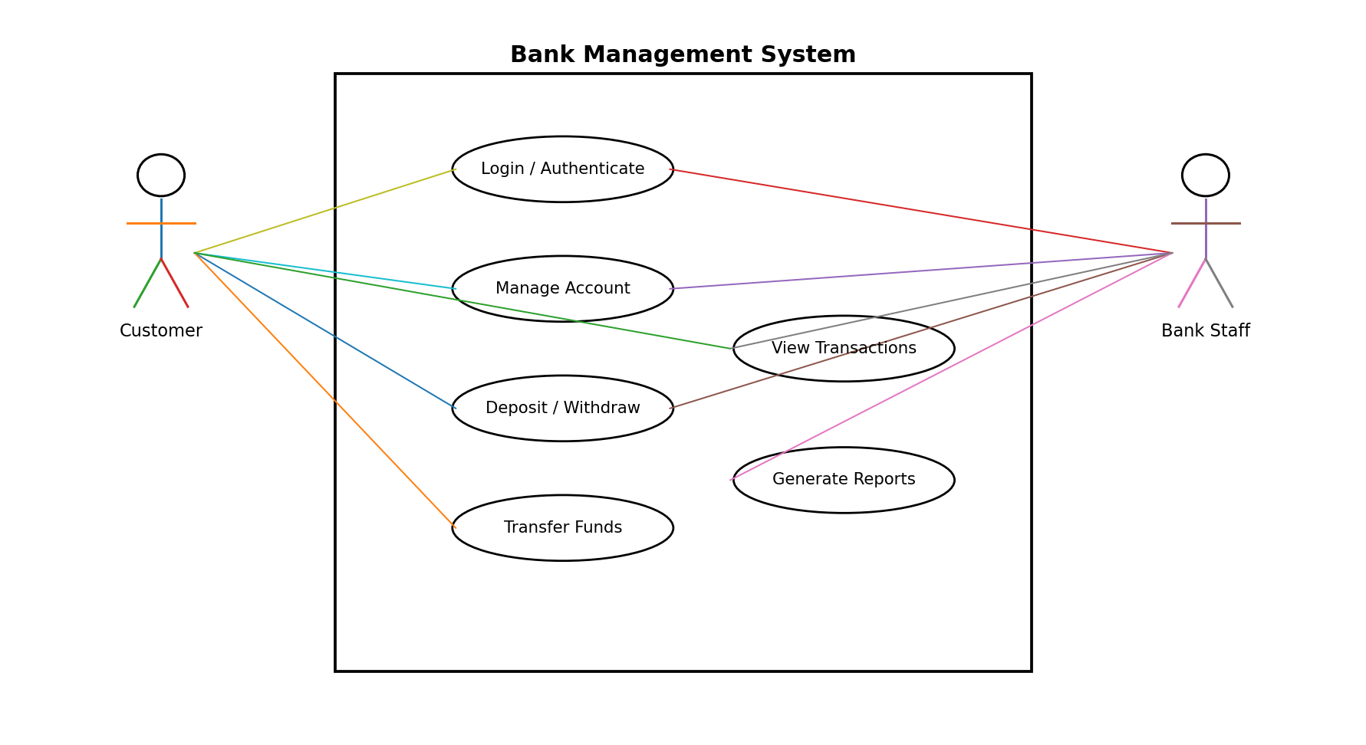

7.2 Administration and Audit Use Cases
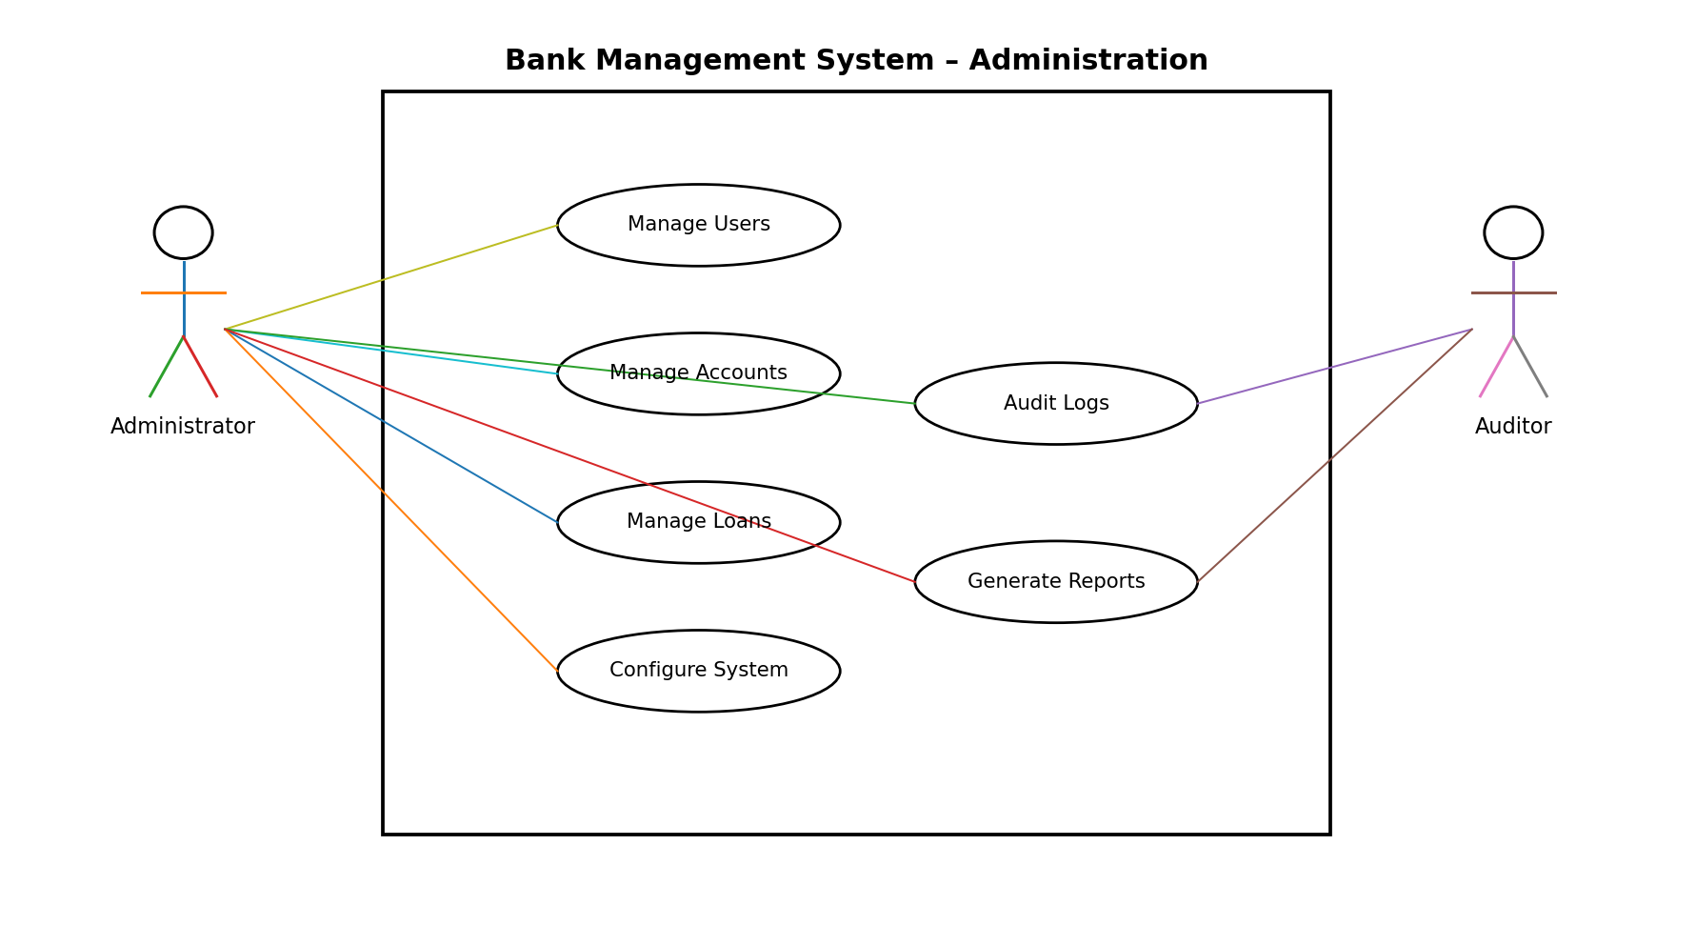

8. Requirements Traceability Matrix (RTM)
Req ID | Requirement Short | Section Ref / Design Spec | Module | Test Case(s) | Status (N/P/A) | Comments
BMS-F-001 | User authentication | 4 / DS-AUTH-01 | Authentication Module | TC-AUTH-01 | N
BMS-F-007 | Record deposits | 4 / DS-TRANS-01 | Transaction Module | TC-DEP-01 | N
BMS-F-009 | Transfer funds | 4 / DS-TRANS-02 | Transfer Module | TC-TRF-01 | N
BMS-F-013 | Loan application | 4 / DS-LOAN-01 | Loan Module | TC-LOAN-01 | N
BMS-F-018 | Manage users and roles | 4 / DS-ADMIN-01 | Admin Module | TC-ADMIN-01 | N
BMS-F-020 | Audit trail | 4 / DS-AUD-01 | Audit Module | TC-AUD-01 | N
BMS-NF-001 | Response time target | 5 / DS-PERF-01 | Application/API | TC-PERF-01 | N
BMS-NF-002 | Availability target | 5 / DS-OPS-01 | Deployment/Monitoring | TC-OPS-01 | N
BMS-SR-001 | TLS requirement | 5.1.2 / DS-SEC-01 | Security/API Layer | TC-SEC-01 | N
BMS-SR-003 | RBAC enforcement | 5.1.2 / DS-SEC-02 | Authorization Module | TC-SEC-02 | N

