Challenging Task – 1

Name: PANDUGA VENKATA JAYA SRIKANTH REDDY

Reg NO:- 21MIS1095

Task:- Connecting Pulse Oxilometer to Raspberrypi and display the values

Components:- Raspberrypi, Oxilometer Sensor

Procedure:

Connect Oxilometer Sensor GND to Raspberrypi pin – 6

Connect Oxilometer Sensor VCC to Raspberrypi pin – 1 3.3V

Connect Oxilometer Sensor GPIO to Raspberrypi pin – 11, GPIO 17

Setup ythe MQTT Nodes in NodeRed and Publish the topic topic/pulse

Node Red Configuration

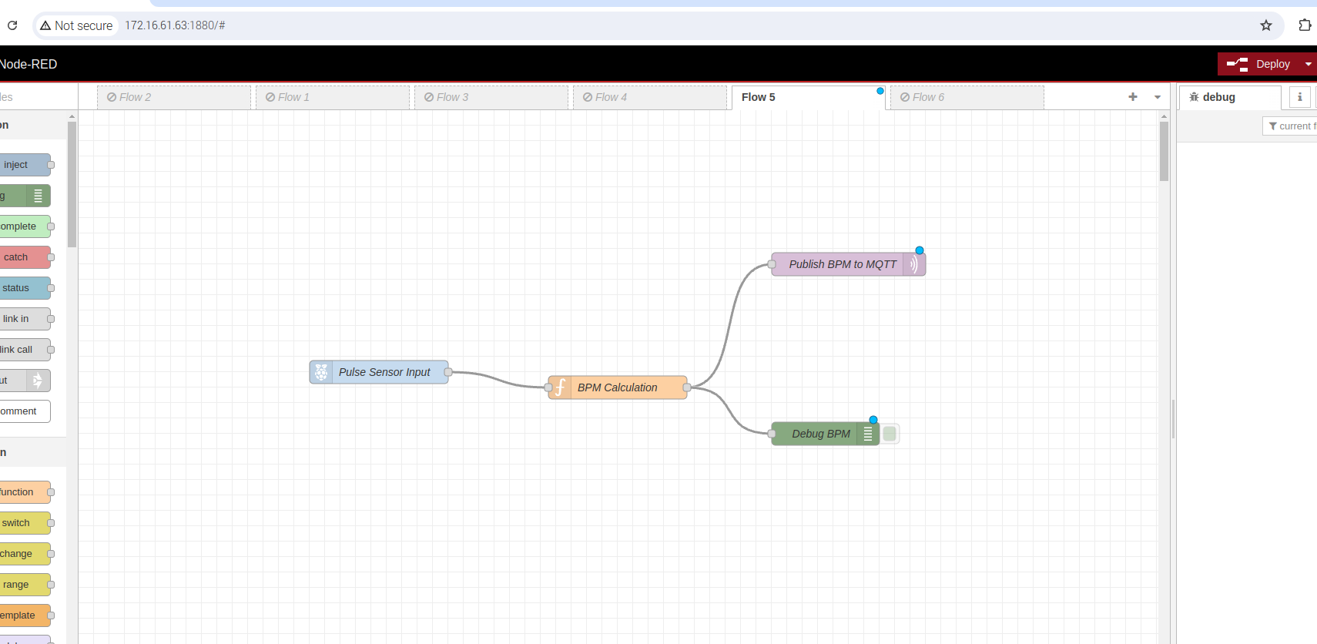  
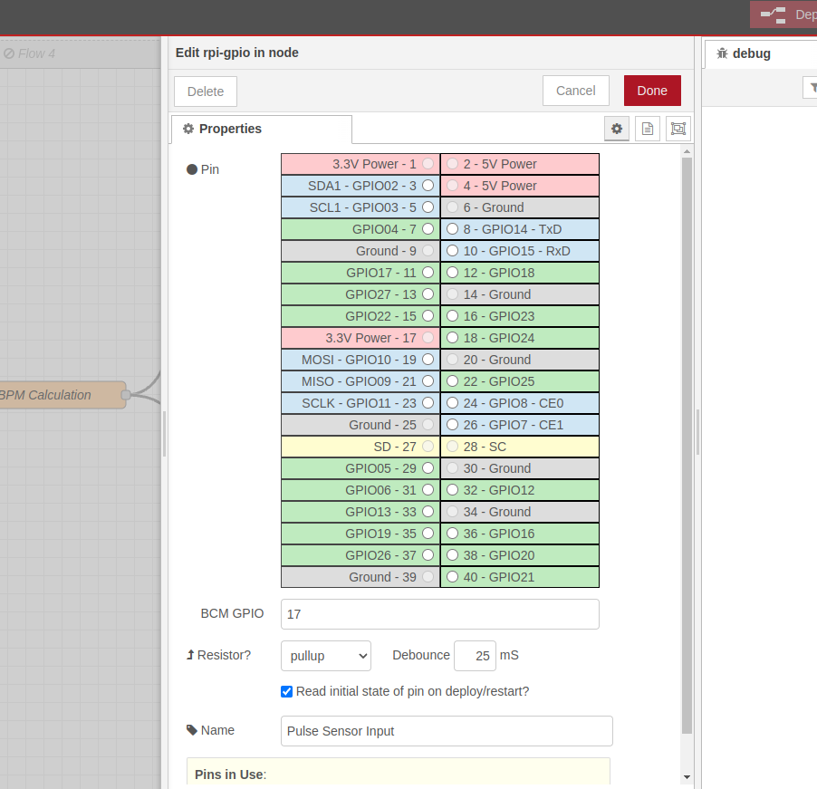

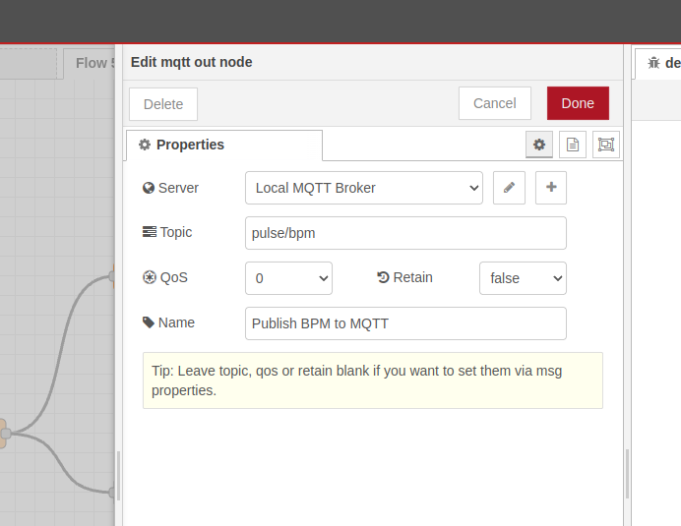  
Output Sensor Readings using MQTT

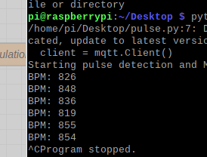

Function code to calculate BPM

var pulse_count = context.get('pulse_count') || 0;

var last_time = context.get('last_time') || Date.now();

// Detect pulse

if(msg.payload == 1){

pulse_count += 1;

}

// Calculate BPM every 60 seconds

var current_time = Date.now();

if (current_time - last_time >= 60000) {

var bpm = pulse_count;

pulse_count = 0;

last_time = current_time;

// Send BPM as output

msg.payload = bpm;

// Store count and time for next cycle

context.set('pulse_count', pulse_count);

context.set('last_time', last_time);

return msg.payload;

}

return null;

**Complete Node Red Config. Code**

[

{

"id": "c343a7f6786650ef",

"type": "tab",

"label": "Flow 5",

"disabled": false,

"info": "",

"env": []

},

{

"id": "f597441665fdd0cd",

"type": "rpi-gpio in",

"z": "c343a7f6786650ef",

"name": "Pulse Sensor Input",

"pin": "17",

"intype": "up",

"debounce": "2",

"read": true,

"bcm": true,

"x": 390,

"y": 340,

"wires": [

[

"dc48b9a1cbfacd36"

]

]

},

{

"id": "dc48b9a1cbfacd36",

"type": "function",

"z": "c343a7f6786650ef",

"name": "BPM Calculation",

"func": "var pulse_count = context.get('pulse_count') || 0;\nvar last_time = context.get('last_time') || Date.now();\n\n// Detect pulse\nif(msg.payload == 1){\n pulse_count += 1;\n}\n\n// Calculate BPM every 60 seconds\nvar current_time = Date.now();\nif (current_time - last_time >= 60000) {\n var bpm = pulse_count;\n pulse_count = 0;\n last_time = current_time;\n // Send BPM as output\n msg.payload = bpm;\n // Store count and time for next cycle\n context.set('pulse_count', pulse_count);\n context.set('last_time', last_time);\n return msg.payload;\n}\nreturn null;",

"outputs": 1,

"timeout": "",

"noerr": 0,

"initialize": "",

"finalize": "",

"libs": [],

"x": 700,

"y": 360,

"wires": [

[

"6a038aa1d56f12f0",

"512cc1f234624ae0"

]

]

},

{

"id": "6a038aa1d56f12f0",

"type": "mqtt out",

"z": "c343a7f6786650ef",

"name": "Publish BPM to MQTT",

"topic": "pulse/bpm",

"qos": "0",

"retain": "false",

"respTopic": "",

"contentType": "",

"userProps": "",

"correl": "",

"expiry": "",

"broker": "mqtt-broker",

"x": 1000,

"y": 200,

"wires": []

},

{

"id": "512cc1f234624ae0",

"type": "debug",

"z": "c343a7f6786650ef",

"name": "Debug BPM",

"active": true,

"tosidebar": true,

"console": false,

"tostatus": false,

"complete": "payload",

"targetType": "msg",

"statusVal": "",

"statusType": "auto",

"x": 1030,

"y": 400,

"wires": []

},

{

"id": "mqtt-broker",

"type": "mqtt-broker",

"name": "Local Broker",

"broker": "localhost",

"port": "1883",

"clientid": "node-red-client",

"autoConnect": true,

"usetls": false,

"protocolVersion": 4,

"keepalive": "60",

"cleansession": true,

"autoUnsubscribe": true,

"birthTopic": "",

"birthQos": "0",

"birthPayload": "",

"closeTopic": "",

"closePayload": "",

"willTopic": "",

"willQos": "0",

"willPayload": ""

}

]