Data Analytics Techniques
  - A Comprehensive Report on the Application of Several Data Analytic Techniques
Student:
Srikanth Shilesh Pasam (10387794)
Teacher:
Dr. Shazia A Afzal
Course:
Data Analytics and Visualization – B9IS107 – CA

Table of Contents
List of Illustrations 3
Part 1 – Data Warehouse 4
Introduction 4
Reason for Selecting Subject Area and Data 5
Vision and Goals 6
Key Stakeholders 6
Business Requirements 7
Schema/Dimensional Model 8
Implementation of Data Warehouse 8
ETL to Populate the Data Warehouse 10
Visualization and Reports 13
Tableau Visualizations 13
Reports – SSRS 17
Conclusion 20
Part 2 – Data Mining 21
Choosing and Exploring Data 22
Data Source 22
Data Exploration 22
Analysis, Cleaning & Preparing Data 23
Importing Libraries and Loading Dataset 23
Key Statistics 23
Visualizations 24
Regression Equation 26
Model Building, Testing & Evaluation 27
Model Output 27
Key Insights 28
Recommendations 29
Conclusion 29
Bibliography 30
Appendix 1 – Tables for Data Warehouse 31
Appendix 2 – Create Table Queries for Data Warehouse 33
Appendix 3 – SSRS Report Queries 36
Appendix 4 – Python Code 37
Appendix 5 – Part 2 Dataset 42

List of Illustrations
Figure 1 - Schema 10
Figure 2 - ETL 11
Figure 3 – ETL Step 1 12
Figure 4 – ETL Step 2 12
Figure 5 – ETL Step 3 13
Figure 6 – ETL Step 4 13
Figure 7 – Tableau 1 - Cost by Manufacture 14
Figure 8 – Tableau 2 - Cost by Type 15
Figure 9 – Tableau 3 - Software Licensing Cost 16
Figure 10 – Tableau 4 - Monthly Software Cost 17
Figure 11 - SSRS 18
Figure 12 - BI Report 1 – Hardware Cost 19
Figure 13 - BI Report 2 – Software Cost 19
Figure 14 - BI Report 3 – Software Descriptions 20
Figure 15 - BI Report 4 – Support Staff Names 20
Figure 16 - Importing Libraries & Loading Dataset 24
Figure 17 - Key Statistics 25
Figure 18 - Box Plot 25
Figure 19 - Heat Map 26
Figure 20 – Histogram 26
Figure 21 - QQ Plot 27

Part 1 – Data Warehouse

Introduction
A data warehouse is a type of data management system that is designed to enable and support business intelligence (BI) activities, especially analytics. Data warehouses are solely intended to perform queries and analysis and often contain large amounts of historical data. The data within a data warehouse is usually derived from a wide range of sources such as application log files and transaction applications.
A data warehouse centralizes and consolidates large amounts of data from multiple sources. Its analytical capabilities allow organizations to derive valuable business insights from their data to improve decision-making. Over time, it builds a historical record that can be invaluable to data scientists and business analysts. Because of these capabilities, a data warehouse can be considered an organization’s “single source of truth.”
A typical data warehouse often includes the following elements:
- A relational database to store and manage data
- An extraction, loading, and transformation (ELT) solution for preparing the data for analysis
- Statistical analysis, reporting, and data mining capabilities
- Client analysis tools for visualizing and presenting data to business users
- Other, more sophisticated analytical applications that generate actionable
- information by applying machine learning and artificial intelligence (AI) algorithms
(What is a Data Warehouse?, no date)

Reason for Selecting Subject Area and Data
The collection of related structures of data is said to be data warehouse. Each structure can be called as database/table and records key performance indicators (KPI). This helps us track a performance of each table separately or clubbed tables which is said to be the entire entity’s key performance indicator (KPI).
For the purpose of demonstration of data warehousing techniques, IT inventory system for Dublin Business School is chosen. There are several departments which are functional in Dublin Business school and these departments are using numerous software and hardware which are considered as IT assets. All the details pertaining to software types, installation date, hardware warranties etc. are currently being maintained in Excel spreadsheets. Data dictionary is also included in the report in Appendix 1. Brief details are exhibited in the table 1 below:
Table Name | Details
HARDWARE_TYPES | All kinds of hardware being used such as routers, LCDs, CPUs, Laptops etc.
HARDWARE | Details of the hardware, such as purchase date, warranty details, cost etc.
SOFTWARE_TYPES | All kinds of software installed such as operating systems, Antiviruses, Programming Languages, etc.
SOFTWARE | Details of the hardware, such as purchase date, renewal details, licensing cost, etc.
Table 1

Vision and Goals
The IT inventory system is designed in order to keep track of all the IT assets used by Dublin Business School. The hardware and software components used within the organization can be kept track efficiently. This will enable the IT administrators to keep track of all the systems, manage the updates and upgrade the devices effectively as and when required.
- Maintain a list of all the hardware devices in the organization.
- Have a record of all the invoices and purchase order to better manage the expenses.
- Keep track of all the software’s installed in the devices.
- Manage the various subscriptions and renewals associated with software licensing across all the devices in the organization.

Key Stakeholders
Considering that the organization chosen for this analysis is a college, the following are the stakeholders who will be impacted by the IT Inventory Management System:
- Students
- Professors
- Administration Department
- Finance Team managing the procurement of IT assets
- IT Admins

Business Requirements
The business requirements for Dublin Business School with respect to the IT Inventory management System is listed below:
- As IT Admins of DBS, we want the ITIMS to effectively keep track of all the hardware devices in the college.
- As part of the finance team, we want the ITIMS to keep a record of all the invoices and purchase orders of all devices in the college.
- As a professor, I want the ITIMS to have a list of all the software’s installed in the devices in college so that I can better plan my labs for my students.
- As part of the administration department, we want the ITIMS to keep track of the various vendors so that we can estimate and plan the future expenses.

Schema/Dimensional Model
Using star schema, we can develop a data warehouse wherein one or more fact tables and dimensional tables can be produced.

Fact table data comprises of any data which is quantifiable / measurable such as software cost, hardware cost etc. Whereas dimensional table data can be the attributes such as, hardware type, software type etc.

Implementation of Data Warehouse
Star schema developed for this project can be seen in figure 1 below.
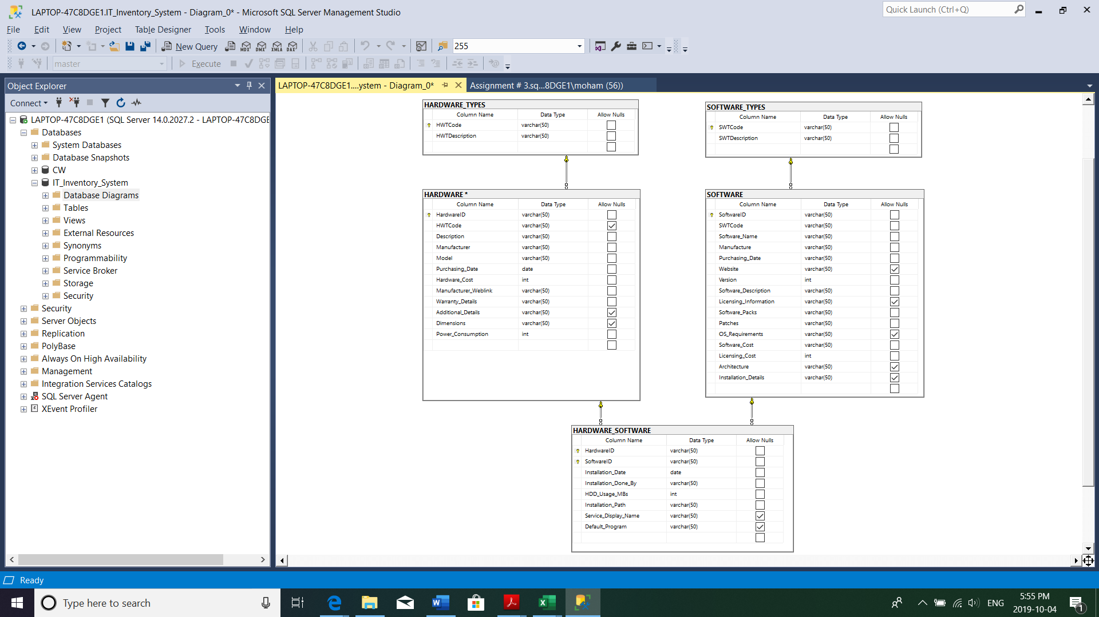
Figure 1 - Schema

ETL to Populate the Data Warehouse
ETL is a process whereby data is loaded into the data warehouse from the source system. Brief explanation of ETL steps are cited in steps and Figure 2 below.

- Extraction
It is a first step where data is collected from several sources such as XLS, TXT, XML etc.

- Transformation
It is a second step wherein the collected data is transformed prior loading into the data warehouse. This may include tweaking in data-type format, data merging & splitting format, currency conversion etc.

- Loading
Finally, this is a last step whereby the data is transformed is ready to be uploaded to the data warehouse.
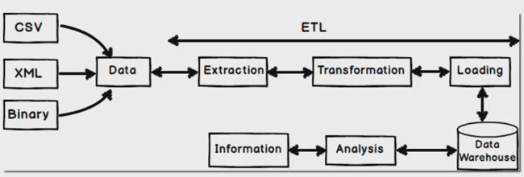
Figure 2 - ETL

Source: Internet

As part of the ETL process I will be using Power BI to perform this step and screen shots of the Extract, Transform and Load activities can be seen from Figure 3 till Figure 6 on next page.
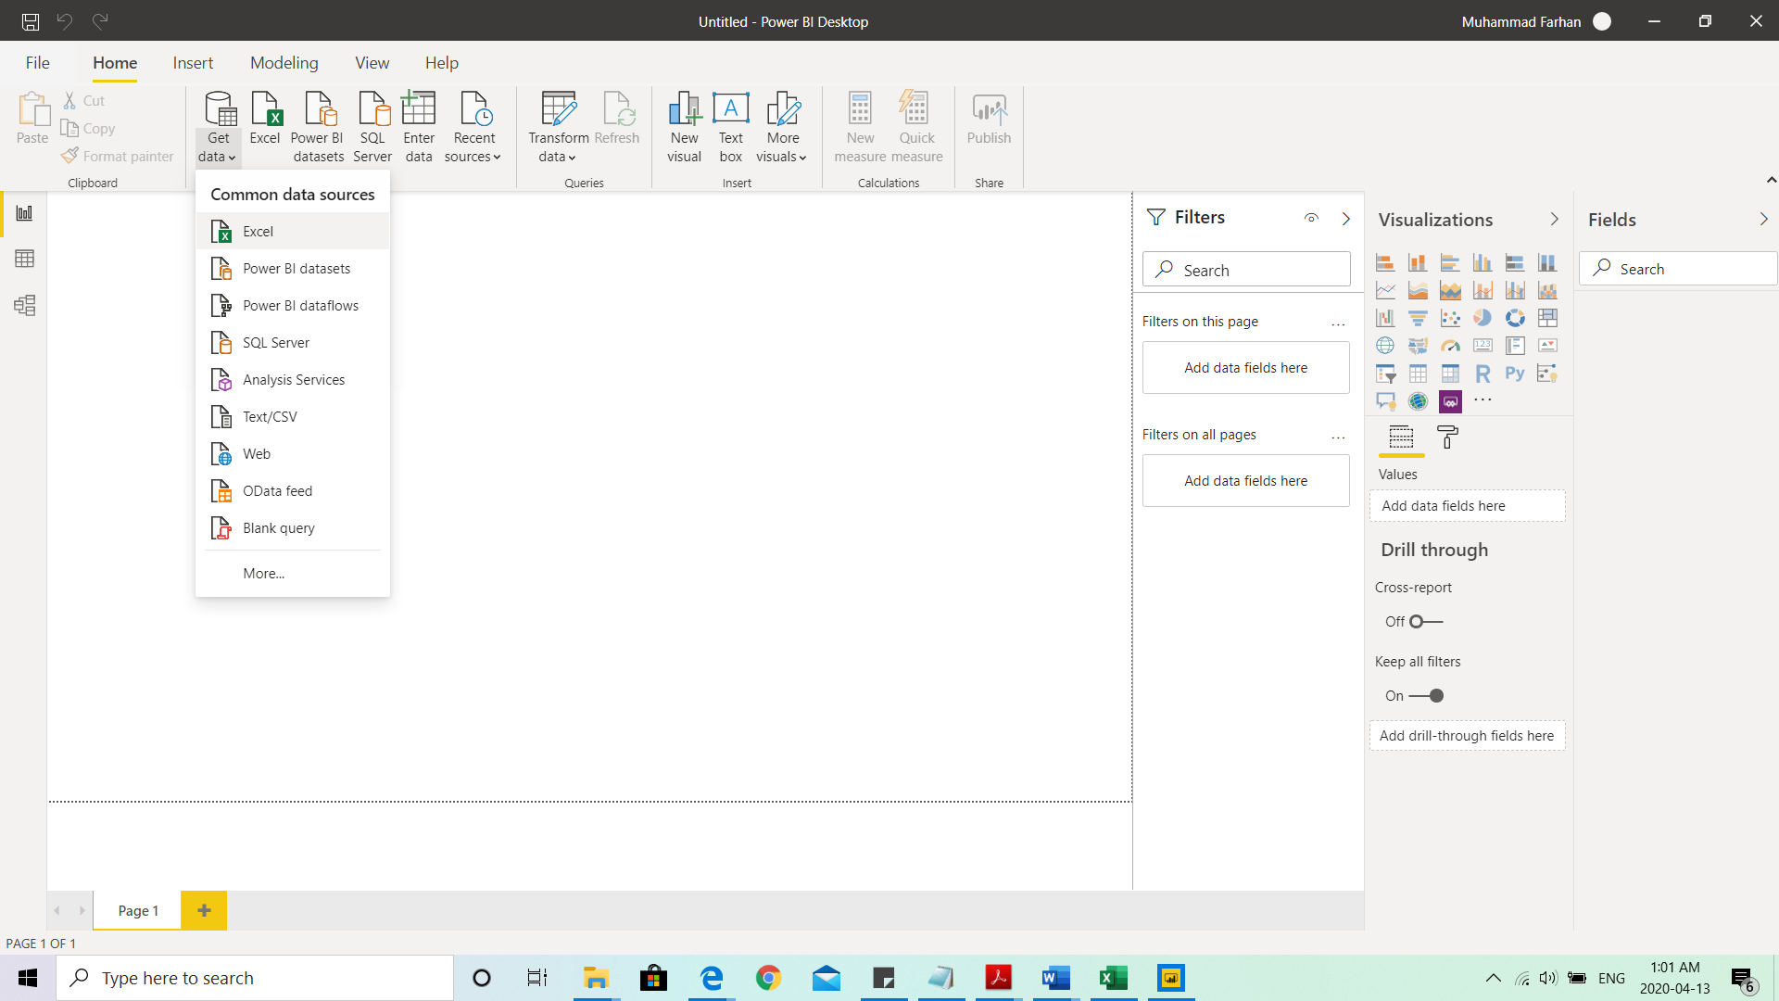
Figure 3 – ETL Step 1

Open Power BI and click on
get data and choose Excel

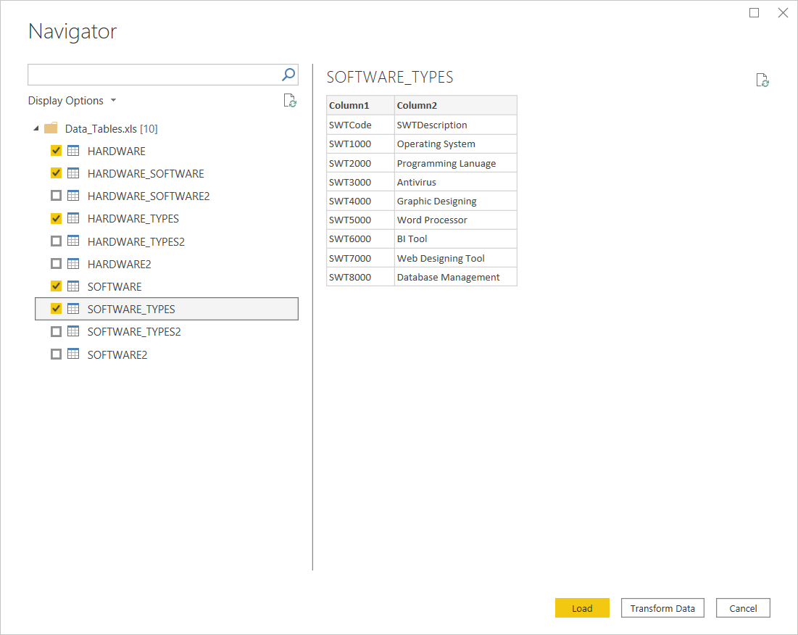
Figure 4 – ETL Step 2
Choose the tables you would
like to select and click on
Transform Data

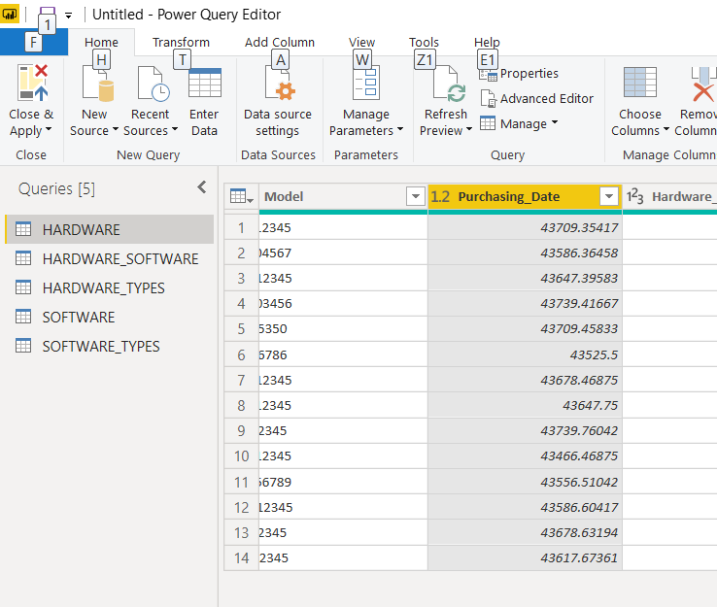
Figure 5 – ETL Step 3
As you can see that
Purchasing_Date
column needs to be
formatted.

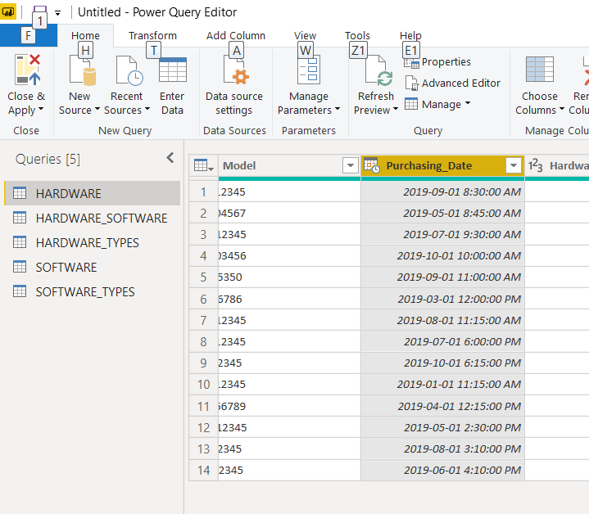
Figure 6 – ETL Step 4
As you can see that date is
appearing correctly after
changing the date format.

We will repeat the same steps
in each table wherever date
format needs to be changed.

Visualization and Reports

Tableau Visualizations
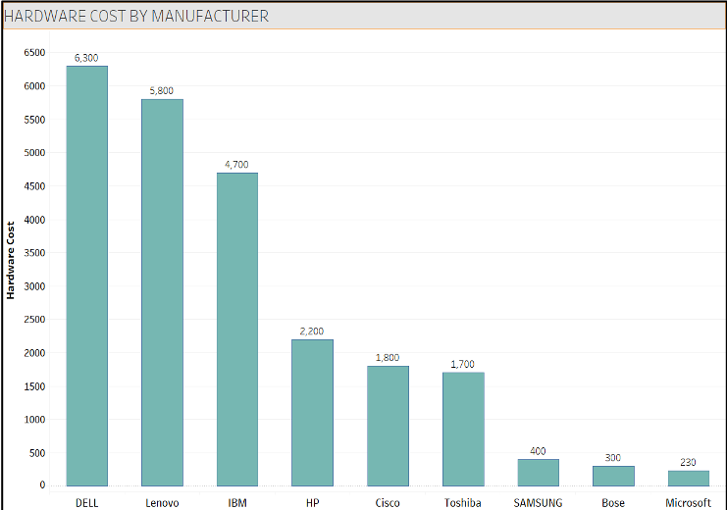
Figure 7 – Tableau 1 - Cost by Manufacture
It is evident from Figure 7 depicting the Hardware cost by manufacturer that most hardware installed and used at Dublin Business School several departments are of Dell Brand, whereas Microsoft brand shows the least hardware installed at the premises.
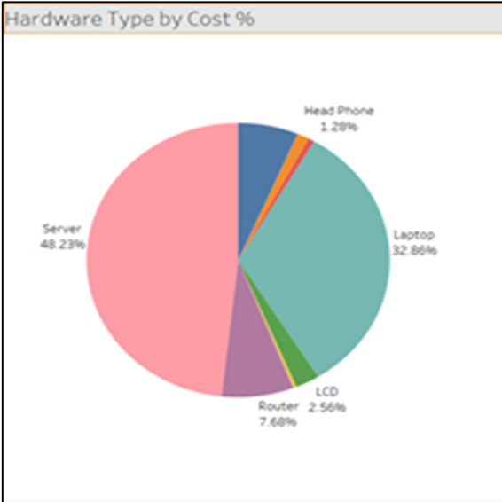
Figure 8 – Tableau 2 - Cost by Type
Pie Chart in Figure 8 of Hardware type by Cost percentage showing that our major spend is on buying of servers i.e. 48% followed by Laptops (33%) while the least percentage spend is on accessories i.e. headphones etc.
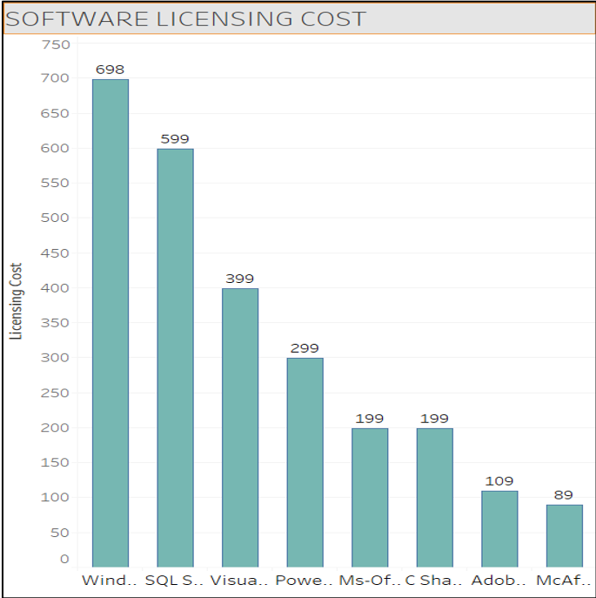
Figure 9 – Tableau 3 - Software Licensing Cost
It is exhibited from Figure 9 which is of software licensing cost that most of the software cost is going towards the operating systems followed by database management system, programming languages, so on and so forth.
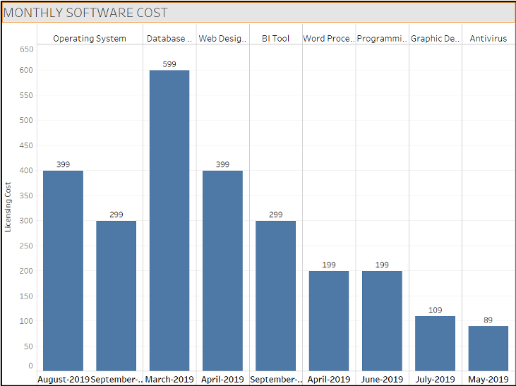
Figure 10 – Tableau 4 - Monthly Software Cost
Figure 10 shows the monthly software cost by type. As we move along the months in 2019, we can see that database management software would be renewed in March 2020 & 21 so cost planning is essential.

Reports – SSRS
There are 4 BI reports generated using SQL Server Reporting Services. Below screen shot (Figure 11) is taken from SSRS while producing the reports.
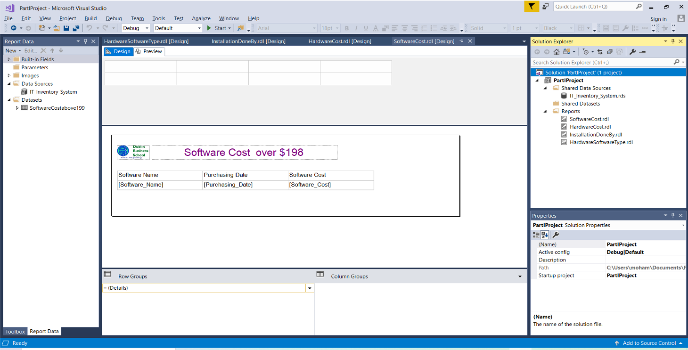
Figure 11 - SSRS

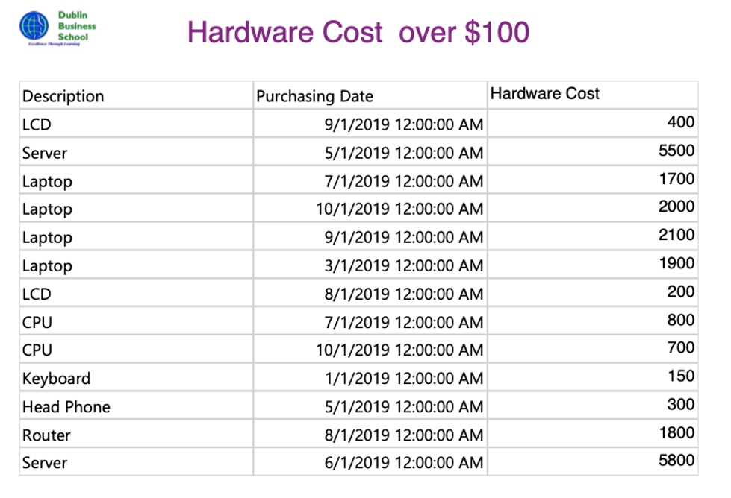
Figure 12 - BI Report 1 – Hardware Cost

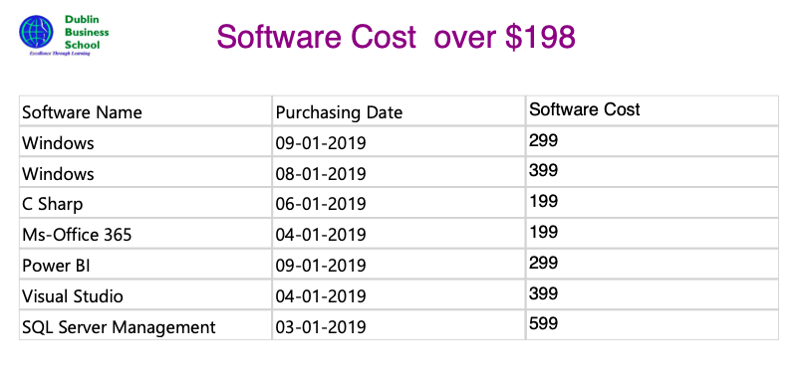
Figure 13 - BI Report 2 – Software Cost
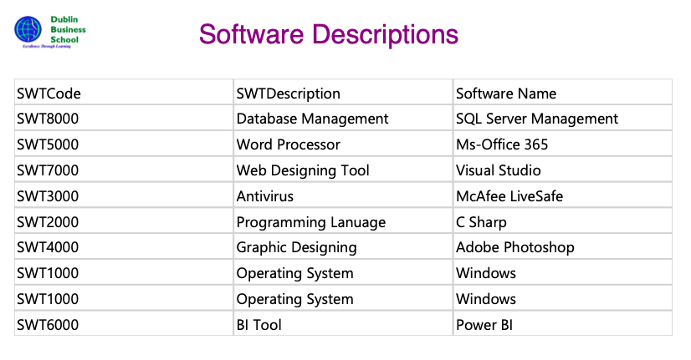
Figure 14 - BI Report 3 – Software Descriptions

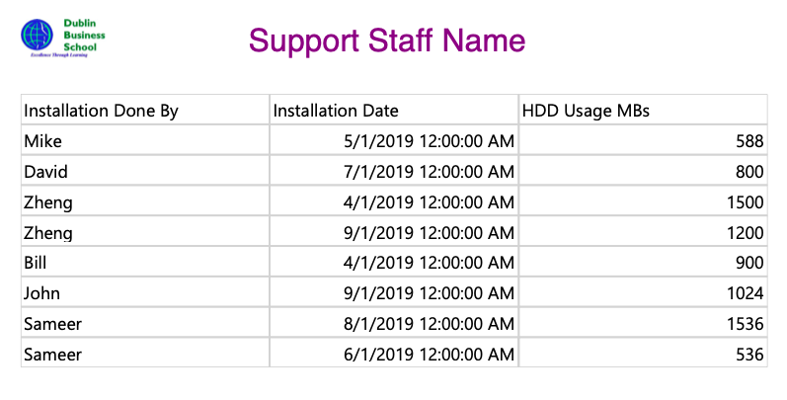
Figure 15 - BI Report 4 – Support Staff Names

Conclusion

Through the implementation of the IT Inventory Management System, Dublin Business School will be able to effectively keep a record of all their IT hardware and software assets. The system also proves useful to keep a record of the current software versions being used along with their licensing period dates. By clearly tracking this, the corresponding team can ensure that all the necessary components are available for the students and professors without any interruptions.

Part 2 – Data Mining
Data mining is the practice of automatically searching large stores of data to discover patterns and trends that go beyond simple analysis. Data mining uses sophisticated mathematical algorithms to segment the data and evaluate the probability of future events. Data mining is also known as Knowledge Discovery in Data (KDD).
The key properties of data mining are:
- Automatic discovery of patterns
- Prediction of likely outcomes
- Creation of actionable information
- Focus on large data sets and databases
Data mining can answer questions that cannot be addressed through simple query and reporting techniques (Data Mining Concepts, no date).

Choosing and Exploring Data

Data Source
The source of the data used for this section is Kaggle (http://www.kaggle.com). Kaggle provides a huge collection of various kinds of datasets which are very useful for various data science analysis or research projects. The original dataset is included along with this report in Appendix 5.

Data Exploration
This dataset comprises of high-performance concrete strength levels. Overall dataset has 1030 observations with 9 numeric variables are used. Table 2 below depicts the variables used in the dataset:
Independent Variables
Dependant Variable
Variables
Cement - kg in a m3 mixture
Blast Furnace Slag - kg in a m3 mixture
Fly Ash - kg in a m3 mixture
Water - kg in a m3 mixture
Superplasticizer - kg in a m3 mixture
Coarse Aggregate - kg in a m3 mixture
Fine Aggregate - kg in a m3 mixture
Age - Day (1~365)
Concrete compressive strength (CMS)
Table 2

Analysis, Cleaning & Preparing Data

Importing Libraries and Loading Dataset
Libraries like Panda, Numpy and Matplotlib are imported to the Python script in order to run the analysis. Dataset is also loaded as illustrated in the Figure 16 below:
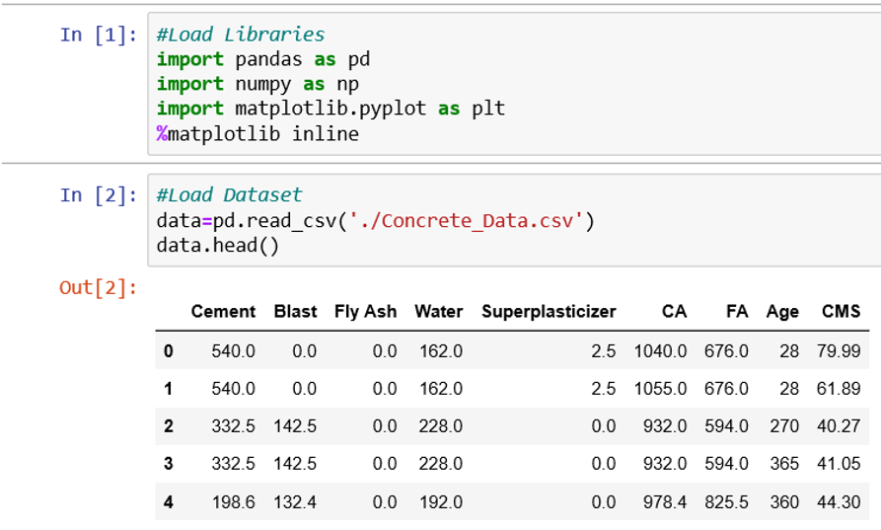
Figure 16 - Importing Libraries & Loading Dataset

Key Statistics
Except Age, Blast, Fly Ash & Superplasticizer, other variables are almost normally distributed. Wherever Mean and Median (50% or 50th percentile) are almost same, implies that this particular variable has no outliers and it is normally distributed. It can be seen in Figure 17 below:
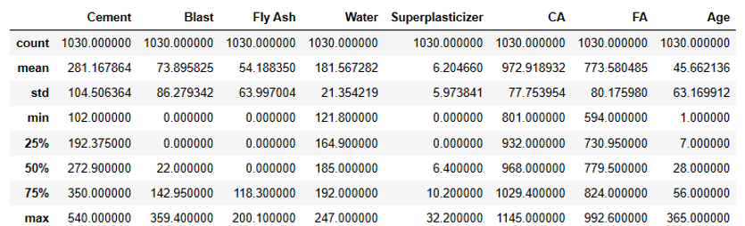
Figure 17 - Key Statistics

Visualizations
Given below is the box plot in Figure 18 shows that outliers (extreme values) in the dataset in each feature.
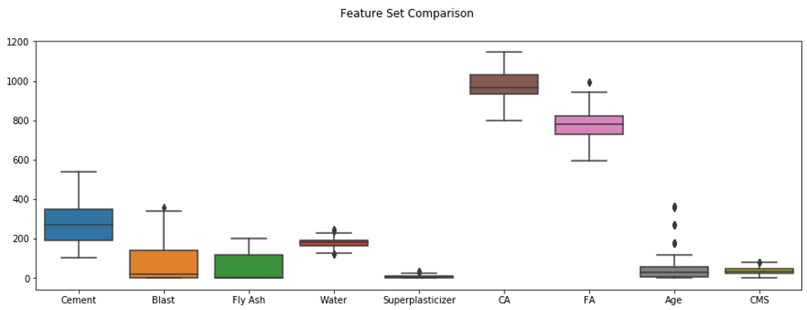
Figure 18 - Box Plot

Given below is the heat map in Figure 19 shows correlation amongst all features exist in the dataset. As we move along upward (above 0) it implies that there is a positive correlation and below 0 signifies negative correlation.
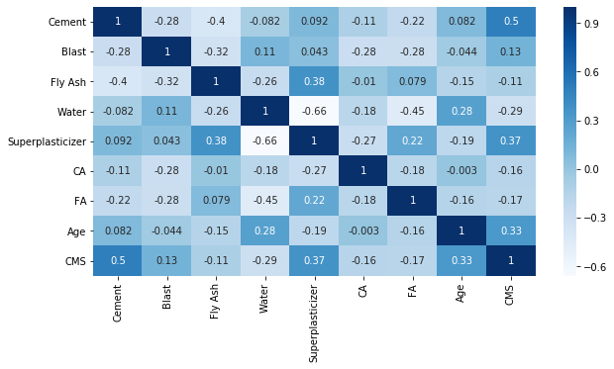
Figure 19 - Heat Map
+ve
correlation
-ve
correlation

Given below is the histogram in Figure 20 shows that CMS feature is normally distributed.
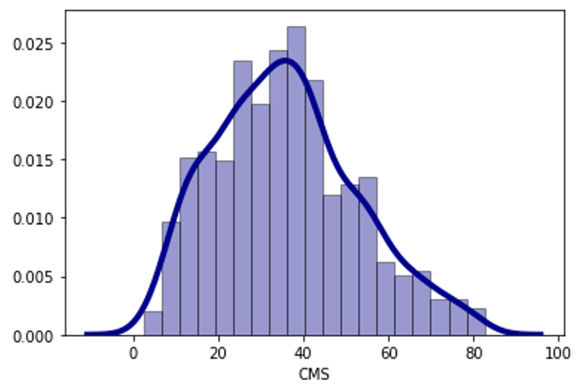
Figure 20 – Histogram

Given below is the QQ Plot in Figure 6 represents another way of checking data normality.
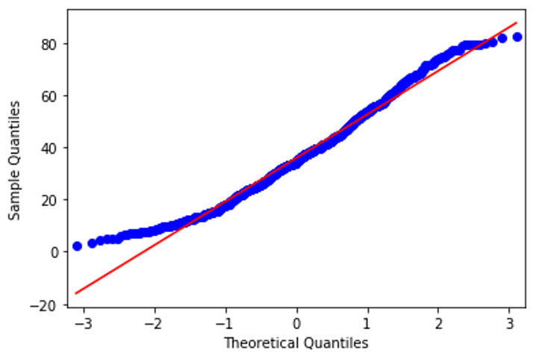
Figure 21 - QQ Plot

Regression Equation
Y = β0 + β1x1 + β2x2 + ... + βpxp + e
where: Y = Response or a dependant variable
β0 = Y intercept
x1 = Predictor, explanatory or independent variable
β1 = Coefficient or Slope
e = Random error or noise

Model Building, Testing & Evaluation

Model Output
Intercept: 35.95
Coefficients:
- Cement 13.027382
- Blast 8.952089
- Fly Ash 5.955866
- Water -2.849777
- Superplasticizer 1.737942
- CA 1.592146
- FA 2.035610
- Age 7.219311
R²: 0.62 or 62%
Mean Absolute Error: 8.22
Mean Squared Error: 113.66
Root Mean Squared Error: 10.66

Now let us create a multiple regression equation for our dataset using above information.
CMS = 35.95 + 13.02 (Cement) + 8.95 (Blast) + 5.96 (Fly Ash) – 2.85 (Water) + 1.74 (Superplasticizer) + 1.59 (CA) + 2.04 (FA) + 7.22 (Age)

- Only Water (predictor) is inversely proportional to CMS which means the higher the water level is lower the CMS would be.
- Rest of the predictor values are directly proportional to CMS which indicates that higher the predictor value will increase the CMS value.
- A unit change in Cement will change the CMS by 13.02
- A unit change in Blast will change the CMS by 8.95
- A unit change in Fly Ash will change the CMS by 5.96
- A unit change in Water will change the CMS by 2.85 (inversely proportional)
- A unit change in Superplasticizer will change the CMS by 1.74
- A unit change in CA will change the CMS by 1.59
- A unit change in FA will change the CMS by 2.04
- A unit change in Age will change the CMS by 7.22

Key Insights
- It is evident that R2 value is 62% which is not close to 100% hence it signifies that only 62% of the variation in CMS is accounted for by its regression on different independent variables such as cement, blast, fly ash etc.
- Another indicator is the value of root mean squared error which shows how well the prediction using the independent variables would be.
- As a rule of thumb root mean squared error should not be more than the 10% of the mean of dependent variable.
- In our case the root mean squared error is 10.66 and the mean of CMS is 35.8 so the 10% of mean of CMS is 3.58 which is lower than the root mean squared error hence it indicates that our algorithm was not accurate using these independent variables and it did not do reasonably good predictions.

Recommendations
- We need more independent variables in order to accurately predict the variable.
- Moreover, additional data would also help in predicting the dependent variable more accurately.
- Some of the independent variables data does not have a linear relationship so we might need to look at the linearity of the data.
- Some of the independent variables do not have a high enough correlation to the values we are trying to predict. Hence high correlated data would be beneficial.

Conclusion

With the help of Data Analysis through predictive modelling and visualization, we are able to observe multiple factors that can affect the composition of cement. These results will prove to be highly valuable for civil engineers and contractors. This technique can also be employed by the researchers who study and experiment with creating new and improved cement technologies. Instead of browsing through large datasets of numbers, these data analysis and visualization techniques will make working with data easier and more efficient.

Bibliography
Data Mining Concepts (no date). Available at: https://docs.oracle.com/cd/B28359_01/datamine.111/b28129/process.htm#CHDFGCIJ (Accessed: 23 April 2020).
What is a Data Warehouse? (no date). Available at: https://www.oracle.com/ie/database/what-is-a-data-warehouse/ (Accessed: 23 April 2020).

Appendix 1 – Tables for Data Warehouse
No. of Entity | Entity  (table) | No. of Attributes | Attribute  (Field) | Data Type  (Text / Number / Date) | Length | Primary Key  (Yes/No) | Foreign Key (FK)  (Yes/No) | Reference Table  (FK only) | Constraint  (Data Validation) | Example
1 | HARDWARE_TYPES | 1 | HWTCode | Var Char | 50 | Yes | No |  | Not Null | Blank field not allowed
1 | HARDWARE_TYPES | 2 | HWTDescription | Var Char | 50 | No | No |  | Not Null | Blank field not allowed
2 | SOFTWARE_TYPES | 1 | SWTCode | Var Char | 50 | Yes | No |  | Not Null | Blank field not allowed
2 | SOFTWARE_TYPES | 2 | SWTDescription | Var Char | 50 | No | No |  | Not Null | Blank field not allowed
3 | HARDWARE | 1 | HardwareID | Var Char | 50 | Yes | No |  | Not Null | Blank field not allowed
3 | HARDWARE | 2 | HWTCode | Var Char | 50 | No | Yes | HARDWARE_TYPES | Not Null | Blank field not allowed
3 | HARDWARE | 3 | Description | Var Char | 50 | No | No |  | Not Null | Blank field not allowed
3 | HARDWARE | 4 | Manufacturer | Var Char | 50 | No | No |  | Not Null | Blank field not allowed
3 | HARDWARE | 5 | Model | Var Char | 50 | No | No |  | Not Null | Blank field not allowed
3 | HARDWARE | 6 | Purchasing_Date | Date | 9 | No | No |  | Not Null | Blank field not allowed
3 | HARDWARE | 7 | Hardware_Cost | Int | 8 | No | No |  | Not Null | Blank field not allowed
3 | HARDWARE | 8 | Manufacturer_Weblink | Var Char | 50 | No | No |  | Not Null | Blank field not allowed
3 | HARDWARE | 9 | Warranty_Details | Var Char | 50 | No | No |  | Not Null | Blank field not allowed
3 | HARDWARE | 10 | Additional_Details | Var Char | 50 | No | No
3 | HARDWARE | 11 | Dimensions | Var Char | 50 | No | No
3 | HARDWARE | 12 | Power_Consumption | Int | 8 | No | No |  | Not Null | Blank field not allowed
4 | SOFTWARE | 1 | SoftwareID | Var Char | 50 | Yes | No |  | Not Null | Blank field not allowed
4 | SOFTWARE | 2 | SWTCode | Var Char | 50 | No | Yes | SOFTWARE_TYPES | Not Null | Blank field not allowed
4 | SOFTWARE | 3 | Software_Name | Var Char | 50 | No | No |  | Not Null | Blank field not allowed
4 | SOFTWARE | 4 | Manufacture | Var Char | 50 | No | No |  | Not Null | Blank field not allowed
4 | SOFTWARE | 5 | Purchasing_Date | Date | 9 | No | No |  | Not Null | Blank field not allowed
4 | SOFTWARE | 6 | Website | Var Char | 50 | No | No
4 | SOFTWARE | 7 | Version | Int | 8 | No | No |  | Not Null | Blank field not allowed
4 | SOFTWARE | 8 | Software_Description | Var Char | 50 | No | No |  | Not Null | Blank field not allowed
4 | SOFTWARE | 9 | Licensing_Information | Var Char | 50 | No | No
4 | SOFTWARE | 10 | Software_Packs | Var Char | 50 | No | No |  | Not Null | Blank field not allowed
4 | SOFTWARE | 11 | Patches | Var Char | 50 | No | No |  | Not Null | Blank field not allowed
4 | SOFTWARE | 12 | OS_Requirements | Var Char | 50 | No | No
4 | SOFTWARE | 13 | Software_Cost | Var Char | 50 | No | No |  | Not Null | Blank field not allowed
4 | SOFTWARE | 14 | Licensing_Cost | Int | 8 | No | No |  | Not Null | Blank field not allowed
4 | SOFTWARE | 15 | Architecture | Var Char | 50 | No | No
4 | SOFTWARE | 16 | Installation_Details | Var Char | 50 | No | No
5 | HARDWARE_SOFTWARE | 1 | HardwareID | Var Char | 50 | Yes | Yes | HARDWARE | Not Null | Blank field not allowed
5 | HARDWARE_SOFTWARE | 2 | SoftwareID | Var Char | 50 | Yes | Yes | SOFTWARE | Not Null | Blank field not allowed
5 | HARDWARE_SOFTWARE | 3 | Installation_Date | Date | 9 |  |  |  | Not Null | Blank field not allowed
5 | HARDWARE_SOFTWARE | 4 | Installation_Done_By | Var Char | 50 |  |  |  | Not Null | Blank field not allowed
5 | HARDWARE_SOFTWARE | 5 | HDD_Usage | Int | 8 |  |  |  | Not Null | Blank field not allowed
5 | HARDWARE_SOFTWARE | 6 | Installation_Path | Var Char | 50 |  |  |  | Not Null | Blank field not allowed
5 | HARDWARE_SOFTWARE | 7 | Service_Display_Name | Var Char | 50
5 | HARDWARE_SOFTWARE | 8 | Default_Program | Var Char | 50

Appendix 2 – Create Table Queries for Data Warehouse
--CREATING DATABASE
CREATE DATABASE IT_Inventory_System;

--CREATING TABLES
--HARDWARE TYPE
CREATE TABLE HARDWARE_TYPES (
HWTCode varchar(50) NOT NULL,
HWTDescription varchar(50) NOT NULL,
PRIMARY KEY (HWTCode)
);

--SOFTWARE TYPE
CREATE TABLE SOFTWARE_TYPES (
SWTCode varchar(50) NOT NULL,
SWTDescription varchar(50) NOT NULL,
PRIMARY KEY (SWTCode)
);

--HARDWARE
CREATE TABLE HARDWARE (
HardwareID varchar(50) NOT NULL,
HWTCode varchar(50) NOT NULL,
Description varchar(50) NOT NULL,
Manufacturer varchar(50) NOT NULL,
Model varchar(50) NOT NULL,
Purchasing_Date date NOT NULL,
Hardware_Cost int NOT NULL,
Manufacturer_Weblink varchar(50) NOT NULL,
Warranty_Details varchar(50) NOT NULL,
Additional_Details varchar(50),
Dimensions varchar(50),
Power_Consumption int NOT NULL,
PRIMARY KEY (HardwareID),
FOREIGN KEY (HWTCode) REFERENCES [dbo].[HARDWARE_TYPES]([HWTCode])
);

--SOFTWARE
CREATE TABLE SOFTWARE (
SoftwareID varchar(50) NOT NULL,
SWTCode varchar(50) NOT NULL,
Software_Name varchar(50) NOT NULL,
Manufacture varchar(50) NOT NULL,
Purchasing_Date varchar(50) NOT NULL,
Website varchar(50),
Version int NOT NULL,
Software_Description varchar(50) NOT NULL,
Licensing_Information varchar(50),
Software_Packs varchar(50) NOT NULL,
Patches varchar(50) NOT NULL,
OS_Requirements varchar(50),
Software_Cost varchar(50) NOT NULL,
Licensing_Cost int NOT NULL,
Architecture varchar(50),
Installation_Details varchar(50),
PRIMARY KEY (SoftwareID),
FOREIGN KEY (SWTCode) REFERENCES [dbo].[SOFTWARE_TYPES]([SWTCode])
);

--HARDWARE_SOFTWARE
CREATE TABLE HARDWARE_SOFTWARE (
HardwareID varchar(50) NOT NULL,
SoftwareID varchar(50) NOT NULL,
Installation_Date date NOT NULL,
Installation_Done_By varchar(50) NOT NULL,
HDD_Usage_MBs int NOT NULL,
Installation_Path varchar(50) NOT NULL,
Service_Display_Name varchar(50),
Default_Program varchar(50),
PRIMARY KEY (HardwareID, SoftwareID),
FOREIGN KEY (HardwareID) REFERENCES [dbo].[HARDWARE]([HardwareID]),
FOREIGN KEY (SoftwareID) REFERENCES [dbo].[SOFTWARE]([SoftwareID])
);

--INSERTING VALUES IN THE COLUMNS
--HARDWARE_TYPES
INSERT INTO [dbo].[HARDWARE_TYPES] VALUES ('HWT1000', 'LCD');
INSERT INTO [dbo].[HARDWARE_TYPES] VALUES ('HWT2000', 'CPU');
INSERT INTO [dbo].[HARDWARE_TYPES] VALUES ('HWT3000', 'Keyboard');
INSERT INTO [dbo].[HARDWARE_TYPES] VALUES ('HWT4000', 'Mouse');
INSERT INTO [dbo].[HARDWARE_TYPES] VALUES ('HWT5000', 'Head Phone');
INSERT INTO [dbo].[HARDWARE_TYPES] VALUES ('HWT6000', 'Routers');
INSERT INTO [dbo].[HARDWARE_TYPES] VALUES ('HWT7000', 'Server');
INSERT INTO [dbo].[HARDWARE_TYPES] VALUES ('HWT8000', 'Laptop');

--SOFTWARE_TYPES
INSERT INTO [dbo].[SOFTWARE_TYPES] VALUES ('SWT1000', 'Operating System');
INSERT INTO [dbo].[SOFTWARE_TYPES] VALUES ('SWT2000', 'Programming Lanuage');
INSERT INTO [dbo].[SOFTWARE_TYPES] VALUES ('SWT3000', 'Antivirus');
INSERT INTO [dbo].[SOFTWARE_TYPES] VALUES ('SWT4000', 'Graphic Designing');
INSERT INTO [dbo].[SOFTWARE_TYPES] VALUES ('SWT5000', 'Word Processor');
INSERT INTO [dbo].[SOFTWARE_TYPES] VALUES ('SWT6000', 'BI Tool');
INSERT INTO [dbo].[SOFTWARE_TYPES] VALUES ('SWT7000', 'Web Designing Tool');
INSERT INTO [dbo].[SOFTWARE_TYPES] VALUES ('SWT8000', 'Database Management');

--HARDWARE
INSERT INTO [dbo].[HARDWARE] VALUES ('H1000', 'HWT1000', 'LCD', 'SAMSUNG', 'SG12345', '09-01-2019', '400', 'http://www.samsung.ca', '1 year', 'Extended Warranty', '21in', '110');
INSERT INTO [dbo].[HARDWARE] VALUES ('H2000', 'HWT1000', 'LCD', 'HP', 'HP12345', '08-01-2019', '200', 'http://www.hp.ca', '6 months', 'Used', '17in', '110');
INSERT INTO [dbo].[HARDWARE] VALUES ('H3000', 'HWT2000', 'CPU', 'DELL', 'DE12345', '07-01-2019', '800', 'http://www.dell.ca', '1 year', 'New', '10in x 10in', '110');
INSERT INTO [dbo].[HARDWARE] VALUES ('H4000', 'HWT2000', 'CPU', 'IBM', 'IB12345', '10-01-2019', '700', 'http://www.dell.ca', '1 year', 'New', '10in x 10in', '110');
INSERT INTO [dbo].[HARDWARE] VALUES ('H5000', 'HWT3000', 'Keyboard', 'Microsoft', 'MI12345', '01-01-2019', '150', 'http://www.microsoft.ca', '1 year', 'New', '10in x 5in', '110');
INSERT INTO [dbo].[HARDWARE] VALUES ('H6000', 'HWT4000', 'Mouse', 'Microsoft', 'MI56789', '04-01-2019', '80', 'http://www.microsoft.ca', '1 year', 'New', '3in x 3in', '110');
INSERT INTO [dbo].[HARDWARE] VALUES ('H7000', 'HWT5000', 'Head Phone', 'Bose', 'BO12345', '05-01-2019', '300', 'http://www.bose.ca', '2 years', 'New', '5in x 7in', '110');
INSERT INTO [dbo].[HARDWARE] VALUES ('H8000', 'HWT6000', 'Router', 'Cisco', 'CI12345', '08-01-2019', '1800', 'http://www.cisco.ca', '3 years', 'New', '20in x 10in', '110');
INSERT INTO [dbo].[HARDWARE] VALUES ('H9000', 'HWT7000', 'Server', 'Lenovo', 'LE12345', '06-01-2019', '5800', 'http://www.lenovo.ca', '5 years', 'New', '15in x 15in', '110');
INSERT INTO [dbo].[HARDWARE] VALUES ('H10000', 'HWT7000', 'Server', 'DELL', 'DE04567', '05-01-2019', '5500', 'http://www.dell.ca', '5 years', 'New', '15in x 15in', '110');
INSERT INTO [dbo].[HARDWARE] VALUES ('H11000', 'HWT8000', 'Laptop', 'Toshiba', 'TO12345', '07-01-2019', '1700', 'http://www.toshiba.ca', '1 year', 'New', '17in', '110');
INSERT INTO [dbo].[HARDWARE] VALUES ('H12000', 'HWT8000', 'Laptop', 'HP', 'HP03456', '10-01-2019', '2000', 'http://www.hp.ca', '1 year', 'New', '15.1in', '110');
INSERT INTO [dbo].[HARDWARE] VALUES ('H13000', 'HWT8000', 'Laptop', 'IBM', 'IB35350', '09-01-2019', '2100', 'http://www.ibm.ca', '1 year', 'New', '15.1in', '110');
INSERT INTO [dbo].[HARDWARE] VALUES ('H14000', 'HWT8000', 'Laptop', 'IBM', 'IB06786', '03-01-2019', '1900', 'http://www.ibm.ca', '1 year', 'New', '15.1in', '110');

--SOFTWARE
INSERT INTO [dbo].[SOFTWARE] VALUES ('S1000', 'SWT1000', 'Windows', 'Microsoft', '09-01-2019', 'http://www.microsoft.ca', '7', 'Operating System', 'Lifetime', 'Service Pack 3', '0', 'Core i5', '299', '299', '32 bit', 'Installed on 09-01-2019');
INSERT INTO [dbo].[SOFTWARE] VALUES ('S2000', 'SWT1000', 'Windows', 'Microsoft', '08-01-2019', 'http://www.microsoft.ca', '10', 'Operating System', 'Lifetime', 'Service Pack 1', '0', 'Core i7', '399', '399', '64 bit', 'Installed on 08-01-2019');
INSERT INTO [dbo].[SOFTWARE] VALUES ('S3000', 'SWT2000', 'C Sharp', 'Microsoft', '06-01-2019', 'http://www.microsoft.ca', '5', 'Programming Language', 'Lifetime', '0', '0', 'Core i3', '199', '199', '64 bit', 'Installed on 06-01-2019');
INSERT INTO [dbo].[SOFTWARE] VALUES ('S4000', 'SWT3000', 'McAfee LiveSafe', 'McAfee', '05-01-2019', 'http://www.mcafee.ca', '9', 'Antivirus', '1 year', 'Service Pack 1001', '0', 'Dual Core', '89', '89', '64 bit', 'Installed on 05-01-2019');
INSERT INTO [dbo].[SOFTWARE] VALUES ('S5000', 'SWT4000', 'Adobe Photoshop', 'Adobe', '07-01-2019', 'http://www.adobe.ca', '11', 'Graphic Designing', '1 year', 'SP01', '2', 'Core i3', '109', '109', '64 bit', 'Installed on 07-01-2019');
INSERT INTO [dbo].[SOFTWARE] VALUES ('S6000', 'SWT5000', 'Ms-Office 365', 'Microsoft', '04-01-2019', 'http://www.microsoft.ca', '365', 'Word Processor', 'Lifetime', 'SP3', '4', 'Core i3', '199', '199', '64 bit', 'Installed on 04-01-2019');
INSERT INTO [dbo].[SOFTWARE] VALUES ('S7000', 'SWT6000', 'Power BI', 'Microsoft', '09-01-2019', 'http://www.microsoft.ca', '11', 'BI Tool', 'Lifetime', 'SP1', '1', 'Core i5', '299', '299', '64 bit', 'Installed on 09-01-2019');
INSERT INTO [dbo].[SOFTWARE] VALUES ('S8000', 'SWT7000', 'Visual Studio', 'Microsoft', '04-01-2019', 'http://www.microsoft.ca', '9', 'Web Designing Tool', '1 year', 'SP1', '1', 'Core i5', '399', '399', '64 bit', 'Installed on 04-01-2019');
INSERT INTO [dbo].[SOFTWARE] VALUES ('S9000', 'SWT8000', 'SQL Server Management', 'Microsoft', '03-01-2019', 'http://www.microsoft.ca', '17', 'Database Management', '2 years', 'SP3', '6', 'Core i5', '599', '599', '64 bit', 'Installed on 03-01-2019');

--HARDWARE_SOFTWARE
INSERT INTO [dbo].[HARDWARE_SOFTWARE] VALUES ('H3000', 'S1000', '09-01-2019', 'John', '1024', 'C: Drive', 'Full Service', 'Yes');
INSERT INTO [dbo].[HARDWARE_SOFTWARE] VALUES ('H4000', 'S2000', '08-01-2019', 'Sameer', '1536', 'C: Drive', 'Full Service', 'Yes');
INSERT INTO [dbo].[HARDWARE_SOFTWARE] VALUES ('H9000', 'S3000', '06-01-2019', 'Sameer', '536', 'C: Drive', 'Full Service', 'Yes');
INSERT INTO [dbo].[HARDWARE_SOFTWARE] VALUES ('H10000', 'S4000', '05-01-2019', 'Mike', '588', 'C: Drive', 'Full Service', 'Yes');
INSERT INTO [dbo].[HARDWARE_SOFTWARE] VALUES ('H11000', 'S5000', '07-01-2019', 'David', '800', 'C: Drive', 'Partial Service', 'Yes');
INSERT INTO [dbo].[HARDWARE_SOFTWARE] VALUES ('H12000', 'S6000', '04-01-2019', 'Zheng', '1500', 'C: Drive', 'Partial Service', 'Yes');
INSERT INTO [dbo].[HARDWARE_SOFTWARE] VALUES ('H13000', 'S7000', '09-01-2019', 'Zheng', '1200', 'C: Drive', 'Partial Service', 'Yes');
INSERT INTO [dbo].[HARDWARE_SOFTWARE] VALUES ('H14000', 'S8000', '04-01-2019', 'Bill', '900', 'C: Drive', 'Partial Service', 'Yes');

Appendix 3 – SSRS Report Queries
Included in the submission folder

Appendix 4 – Python Code
The python code is included below and also available at the following link:

https://drive.google.com/file/d/1Vhbv-Jd4lIZMRkL6CexsCYXczqqf2a3h/view?usp=sharing

Download the file from the link to be able to view it properly.

Appendix 5 – Part 2 Dataset

