**TRAFFIC CONTROL SYSTEMExecutive summary**

This report tells about the traffic control system that can create a huge problem in the flow of the vehicles. Thus it is important to control the traffic by using certain systematic methods. This report tells about some of the operational systems and some of the method of implementation. This report tells about the procedure of the control system that is to be analyzed. The report also talks about the specification that is required in the system. The report tells about some of the functional requirements that are to be used in operational management. This report tells about the process model in which agile Model is being used. This report tells about some of the emergency approach systems. The architect of the control system is being used in this report. Some use case diagrams and the URL diagrams are being used in this report to analyze the traffic control system. In this report, risk management is being discussed. Some of the sequence diagram and the activity diagram is being used in this report. In this report, the test plan is to be used to test the various cases in the implementation system. In this report, some of the basic plans and the sample code are being used to evaluate the traffic control system.

Table of Contents

Introduction 4

System Requirements Specification 4

Process Model 7

Analysis and Design Specification 9

Emergency Vehicle Approach System 9

Architecture of Traffic Control System 10

UML diagrams 12

Class Diagram 12

Use Case Diagram 13

Activity Diagram 14

Sequence Diagram 15

Justification 16

Test Plan 17

Risk Plan 19

First Release Plan 22

Sample Code 23

Conclusion 25

Reference List 27

Appendices 30

# Introduction

The overcrowding of traffic vehicles on roads and lanes require an effective system of traffic handling and supervision. Traffic congestion poses a huge problem for the flow of vehicles on the roads leading to various other socio-economic problems. Also, the limited amount of land resource does not allow the extension of the roads or make a broader way for the traffic to flow. Thus, urban roads need to control to design and implement a system of highly automated and effective traffic control system. The growing concern for high traffic pressure and road congestion produces the need for an automated system of traffic handling at a convenient method.

The report is based on a “Traffic Control System” having a definite process of operation and method of implementation. The control system will follow a definite sequence of the procedure. The adaptive control method for the traffic control method is used in creating the design and the framework of the traffic control system. The report will analyse the design requirements of an effective traffic control systems which will help to define the functional and nonfunctional requirements of the control system. The report also highlights the various components of the design and the architecture of the system, along with a clear justification for the choice of the process model. The UML diagrams are also used to present the operational and functional concept of the design process. Also, the test plan, risk plan and the first release plan are provided in the report. A code for the "traffic control system" is also produced in the report.

# System Requirements Specification

The system requirements for “Traffic Control System” design determine the overall specifications for the system. The requirement specification outline the various features of the system and the elements required for the design process. The specifications can be categorized as functional and nonfunctional requirements. The Functional Requirements for the operational model is listed as under:

1. Fixed timing or actuated timing should be used with a central control system that uses red-yellow-green for the standard signal indications.
2. An "emergency override system" of EVA (emergency Vehicle approach) should be considered for the design specifications. (Ghani, 2016)

**User Story 1**: As an Ambulance Driver, I want the traffic signal control to have an emergency system so that I will not have to wait at the traffic with the patient.

1. The system should be designed in such a way that it allows the admin to "rewrite the traffic data". It should also allow the admin to access a graphical representation of the traffic for conducting the diagnostic tests. The system should also contain a control system for the admin to manage the heavy traffic situations or reconfigure the device in case of emergency. The system should also allow the admin to adjust the timing of the signalling system.

**User Story 2:** As a Traffic Control Operator, I want the system to have an inbuilt feature for "signal time adjustments" so that I can adjust the time of the signal during certain emergency cases.

1. The system should also incorporate the pedestrian crossings faces, push buttons and signals. The signal system should include the “audio and vibrotactile” signals showing the “WALK/DON’T WALK” indications.

**User Story 3:** As a senior citizen, I want the traffic signal system to have an audio signalling feature so that I can be extra careful while crossing the road.

1. The system also includes a countdown feature for the pedestrians to know the time left for them to cross the street before the signal goes red.

**User Story 4:** As a citizen, I would want the traffic control system to have a “countdown feature” so that I can understand if I have enough time to cross the road before the signal changes again.

1. The system should be able to store information for a specified amount of time, space and volume. ***[Referred to Appendix 1]***
2. The indicator control operations are to be effectively monitored using the system. Any non-confirmation of the controller with the road situations is required to be noted and analysed. Any kind of system fault should be reported to the center for correction.

**User Story 5:** As a Traffic Control Operator, I want the system to include the effective monitoring feature so that I can know if there is any fault in the signalling coordination.

1. The system should effectively incorporate the traffic sensors that will help to record information or transmit them to different platforms for analysis such as ramp meters, other traffic signals.

**User Story 6:** As a Traffic Control Operator, I want the system to include sensors feature so that I can detect and record certain information and transmit it to the next field element.

1. The system should also be designed such that there can be communication between the traffic signals or other element devices. This can enable the controllers to share the status or other information without the interference of the control center.
2. The "Emergency vehicle Approach/Preemption" system also includes a confirmatory light in the traffic system that helps the vehicle to understand whether preemption is granted or not (Bettany *et al*. 2016).

**User Story 7:** As a Fire Engine Driver, I want the system to have EVA confirmation lights so that I can understand that the signal permits me to pass through.

1. The system should be able to revert to normal traffic signals using “the phase-sequence and timing controls”.

**User Story 8:** As a Traffic Control Operator, I want the system to have features that can use timing controls so that I can vary the timing of the signals during the rush hours of the day.

1. The system should have efficient “traffic signal coordination” that can be aligned and sequenced with the flow of the traffic.

**User Story 9:** As a Traffic Control Operator, I want the system to have features that will allow me to control the signal at the four-way lane so that I can vary the signal with the flow of the traffic from four different lanes.

The non-functional requirements in the design of the “Traffic Signal System” are listed as below:

1. Reliability - The system should be reliable enough to perform on a satisfactory level. The sequence and coordination of the signals with the traffic flow and changing of the lights should be reliable enough to operate successfully (Abbas *et al.* 2016).

**User Story 10:** As a Traffic Control Operator, I want the system to be reliable so that it does not shut down or crash unexpectedly.

1. Supportability - The system should support the features that enable the field operator to access, control and monitor the system with ease. The system should provide enough support to the personnel operating the “traffic control”.
2. Availability - Availability of the system is a major function that allows the operator to access the system easily and makes it readily available.
3. Usability - Usability of the system determines the user-friendly approach towards handling the system. The system should be easy to handle and should display error messages to the field operator during any kind of fault.

**User Story 11:** As a Traffic Control Operator, I want the system to display error messages so that I can understand in case of any fault in the system.

1. Maintainability - The system should be flexible to adapt to changes and also handle the exceptions easily (Covell *et al*. 2015).

**User Story 12:** As a Traffic Control Operator, I want the system to be flexible so that I can incorporate changes in the system according to the traffic flow requirements.

1. Security - The system should be safe to operate. The system should be well protected from cyber threats and hackers from hacking into the traffic system. The security features should be incorporated to ensure safe information transfer and protect unauthorized access into the system.

# Process Model

The process of the development of "Traffic Control System" involves strategic planning and following a designated method of application. The signalling system, as incorporated in DCC, shall apply the ***Agile method*** for the process of developing the control system.

The Agile model follows a systematic and iterative process in software development. This is one of the most suitable methods as it helps to reduce the project duration and uncertainties in the development of the model (Dickerson *et al.* 2016). The Agile method is useful for risk reduction as it involves breaking down the overall tasks into smaller segments such as design, analysis, testing, and implementation. The method involves various steps in software development (Fleck *et al.* 2015). The steps that are involved in the development of the system are listed as:

1. Collecting the Requirements
2. Designing the required features
3. Constructing the model
4. Testing and quality checking
5. Deployment
6. Feedback

**Figure 1: Agile method**

(Source: Self-Created)

The first step in this method requires gathering all the information and elements necessary for designing the software. This includes the planning of the resources and allocating specific time to each of the tasks involved in the design phase (Gao *et al.* 2017). The design features are accumulated and processed in order to implement the designing and implementation of the software. The Traffic Control System will be designed in this phase. It will be ensured in this phase that the design of the system model should mandatorily include all the functional as well as non-functional requirements of TCS (Ghazal *et al.* 2017). The next phase involves the implementation of the model and the design of the system. This phase includes the construction of the "Traffic Control System" with adequate design deployment strategies. It involves the development of the software system with effective management and strategies for the implementation. ***[Referred to Appendix 2]***

The next phase includes the testing and evaluation of the system that is designed using the specific design methods and the requirement specifications. This helps to validate the suitability of the system and determine the effectiveness of the system in operation. The deployment phase requires the practical implementation of the system along with the observations to identify the risks or the drawbacks in the system under operation. The final step in the system provides feedback from the actual operation of the system based on which the modifications can be carried out (Golechha *et al*. 2016).

This process model shows that it is one of the most suitable methods of developing the system of controlling traffic with the incorporation of “Emergency Vehicle Approach” feature to make it more acceptable.

# Analysis and Design Specification

The design of the "Traffic Control system" consists of the number of functional requirements and number of no-functional Requirements. The process of design usually consists of selecting the range of technologies and identification of the software to implement several requirements (Jadhav *et al.* 2016). The functions of the software of the “Traffic Control system” are dependent on the large part of the designing for the system. It is required to have the necessary standards for the system as it will make it more feasible to the system. The implementation of the system follows the high-level design which includes the “Architecture definitions”, “Sub-system Definitions”, “Sub System verification plans” and the “Interface Identification”. There are many items or the components that can be included in the design like the “Mode Structures”, “Control and Displays”, “Graphics” and many others. The design of the “traffic Control System” also includes the assessments of the resources that can be required for the implementation and the development of the useful plans to procure the entire system (Johnson *et al.* 2018).

The "Detailed Design" of this is consisting of the following necessary points like "Code Specifications", "Hardware Specifications", "Software Specifications" and others. The detailed design results in the development of the necessary plans and the standards that are sufficient for the procurement of the system. The specification of the system might get resulted from the functional requirements of the system and the necessary constraints that can get occurred. The system is designed in such a manner that it can be able to access or read the necessary data from that of the traffic Cameras (Kamiya *et al*. 2019). ***[Referred to Appendix 3]***

## Emergency Vehicle Approach System

The system is also prepared which is interfaced with that of the “**Emergency Vehicle Approach System**". The system follows this approach to ensure that the emergency vehicles like "Ambulance", "Police" and others can be able to get the priority accordingly using the priority processing instead of the "traffic light button presses". The working application of the "EVAS" is in such a manner that it first identifies the type of vehicles and if it is an ambulance or any other emergency vehicles, then it requests the priority processing which can be useful in the control of the entire traffic. This controls the entire system of traffic by overriding the entire system in a simple manner (Keyvan-Ekbatani *et al*. 2015). ***[Referred to Appendix 5]***

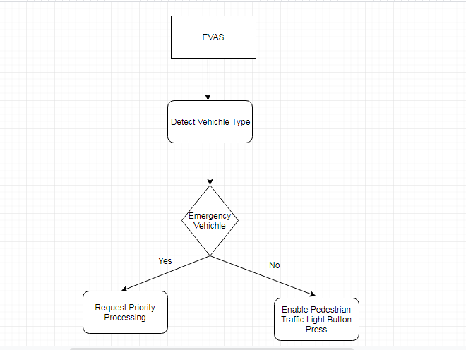

**Figure 2: EVAS Architecture**

(Source: Self-created)

## The architecture of the Traffic Control System

The architecture of the “Traffic Control system” consists of the number of components like "Dynamic Map" and others. It takes the input data for the real-time measurements of the traffic flow and controls the entire flow of the network. This system utilized the necessary number of the control architecture like "Traffic Stimulator", "Control Evaluation Module". The advantages of using this system are that the user can easily be able to calculate the optical flow of the methods using the background generations (Mahalank *et al.* 2016). The “Optical Flow" helps in the easy detection or the identification of the vehicles according to the colour that is input and then suggests it position. The detection of the parameters for the traffic can be determined using the numbers of procedures like "vehicles leave the intersections”, and the instantaneous speed or the velocity of the vehicles. The route planning services will get indicated or utilized for the detection of the position for the sensors and the analysis of the “GPS” receivers (Noaeen *et al.* 2017). The "Route planning devices" are basically equipped with the number of maps that are stored in the memory and the software. The constant-flow of the vehicle will be useful in tracking the number of data or the networks that arise into the system. The map-matching algorithm is utilized for the implementation of the architecture of the system. The "calculated Trajectory" can be utilized for the purpose of the tracking of the on-line vehicle, and it is most useful to all the necessary environments (Patil *et al.* 2019). ***[Referred to Appendix 4]***

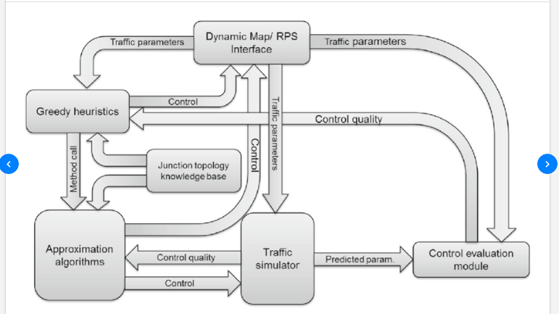

**Figure 3: TCS Architecture**

(Source: https://www.researchgate.net/publication/270675398_Design_and_Implementation_of_an_Emergency_Vehicle_Signal_Preemption_System_Based_on_Cooperative_Vehicle-Infrastructure_Technology)

There are different factors on which the system is dependents like the weather as the traffic in the bad weather can be a difficult task to maintain or manage. This system also depends on the inputs that are being processed by the controller as it will produce an accurate output for the system. The testing of the system can usually be performed or done by the "map visualisation" (Tonguz *et al*. 2017). The maintenance of the system must be done regularly, and it also required performing the regular updation so that the system can get prevented from the illegal attacks.

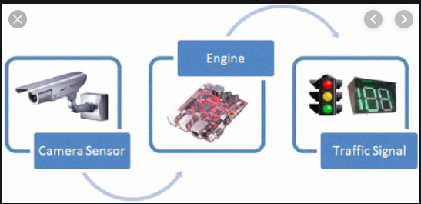

**Figure 4: Traffic Control System**

(Source:  https://www.researchgate.net/figure/Architecture-Diagram-of-Traffic-Signal-Control-System_fig1_305777861)

# UML diagrams

## Class Diagram

The "Class Diagram" is a representation of the necessary diagram that is used or utilized for the representation of the attributes or the classes for the system. The diagram shows or displays the methods that can be accessed or performed by each of the class or the attributes which are utilized by it. The diagram explains different classes of the "Traffic Control system" like "Role", "Permission", "Routes", "Traffic Class", and the "Diversions". The "Traffic Class" again consists of the attributes like "Traffic Id", "Traffic Name", "Traffic Type", "Traffic Description" and the others. The different methods that can be performed or accessed by these classes are "add Traffic", "search Traffic", "delete Traffic" and many others (Ugale *et al*. 2019). The “Dublin Central Traffic Control” system comprises of the attributes like the "Traffic Controller Id", "Traffic Controller Name", "Traffic Controller Description" and many others. Therefore, the class-diagram is an easy and useful concept or representation which helps the project to get implemented optimally (Wang *et al.* 2018).

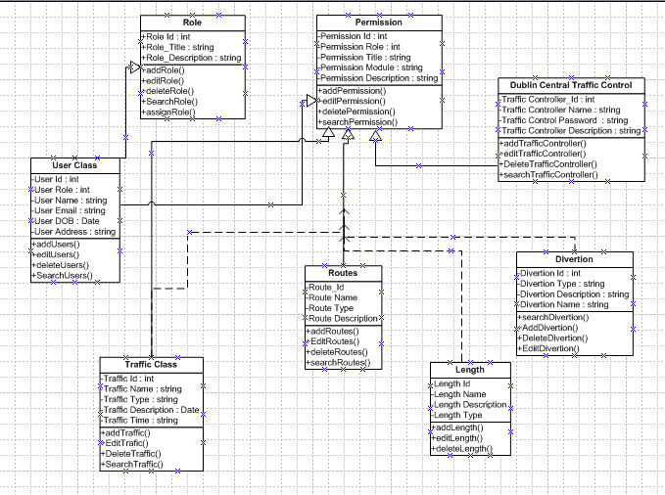

**Figure 5: Class Diagram**

(Source: Self-created)

## Use Case Diagram

The "Used Case Diagram" consisting of the necessary users for the system and the roles that are performed by each of them in the system. This shows how the system is utilized by the particular number of the user. The diagram shows that there are two users or the roles which are admin and the "Controller". The "Admin" uses the system for different cases like "Manage Traffic", "Manage Users", "Manage Routes" and others. The controller will access the system for the "Search Traffic Routes", "Manage Traffic Routes" and many others (Wang *et al.* 2018). The controller and the Adam both will utilize the system for "Login" and "Profile Updation". The system can also get utilized for the events like changing the password for the system.

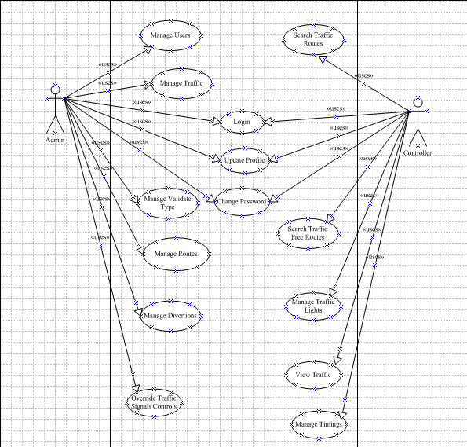

**Figure 6: Use Case Diagram**

(Source: Self-Created)

## Activity Diagram

The "Activity Diagram" shows the list of activities or the flow of the entire system that is going to get implemented. It describes the necessary stages that will be followed throughout the execution of a system (Younis and Moayeri, 2017). The diagram shows that at first, the user needs to login to the system, and then the system needs to check the permission level of the users. Once it is determined, then, the user can perform the necessary tasks like 'Manage Traffic", "Manage Routes' and others. Then, at last, the user logged out from the system after performing the required activities into the system.

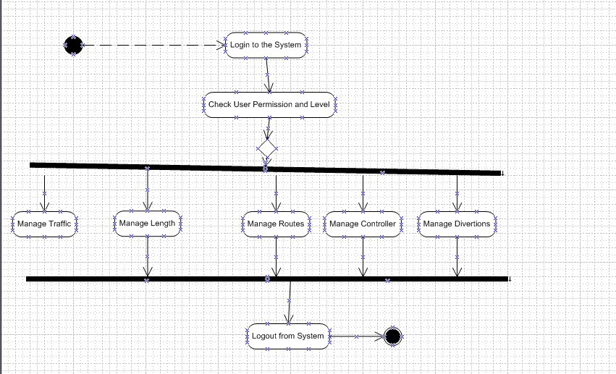

**Figure 7: Activity Diagram**

(Source: Self-Created)

## Sequence Diagram

The “Sequence Diagram" is a representation of the sequences or the stages that are followed by the system. It shows the range of the stages or the functions that are performed or implemented by the system. There are different stages in the system like "Login", "Forgot Password", "Verification", "Databases" and others (file.scirp.org, 2018). This diagram explains the functions that are performed by each of the stages into the system. The "Admin" at first enter into the "Login Page", and if the admin forgets the password, then that will be redirected to the "Forgot Password" page. The "Admin" if successfully enter the login details then that will move to the verification stages and if it is verified the authentication gets enabled and the user can get access to the other functionalities of the system. The authentic is basically checked through the database. The "Admin" if click on the forgot password could have the option for the "Security Question and Answers" which will be redirected to the "Database" for the checking (semanticscholar.org, 2019).

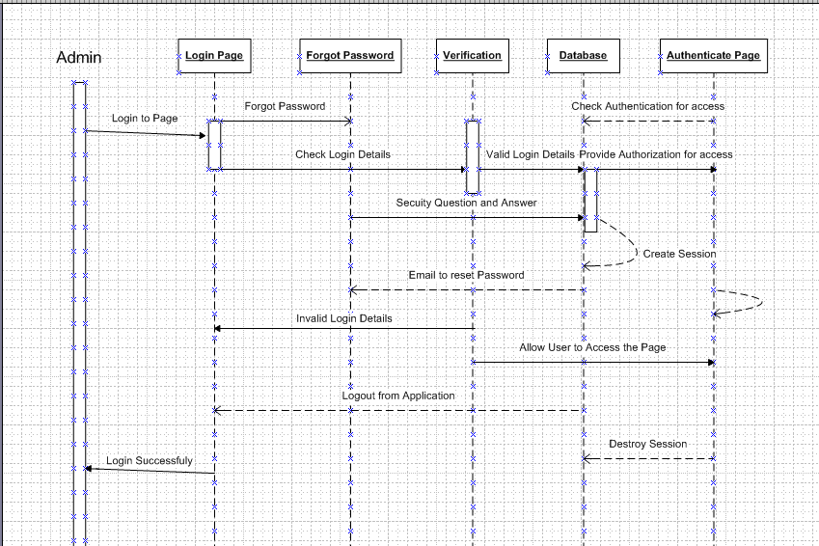

**Figure 8: Sequence Diagram**

(Source: Self-Created)

# Justification

The architecture of the design which is used is kept simply so that the user can find it easy to implement the entire functionalities into the system. The "Emergency Vehicle Approach system" is used to override the entire control of the traffic system and making it more flexible. This will help in reducing the necessary congestion that occurs and thus become hard to perform the management of the traffic system for the place. The "**EVAS**” will be helpful for the management of all the emergency vehicles through the priority of the flow of the vehicles in the traffic. This system will enhance the control of the traffic flow, and the priority vehicles will be able to perform the operations in a timely manner. The architecture will also be useful in reducing the amount or percentage of the congestion among the vehicles, and thus the problems can be reduced to some extent. It will also provide better control of the essential tools and resources will also be utilized to some greater extent.

The traffic system also includes the timing control features that are helpful in varying the duration of each signal in the traffic control. The changing level of flow of the vehicles needs the operator to control the signal timing and the phase sequence. The architecture that is designed supports the feature of varying the time sequence and the phase with which the lights change from one signal colour to another. The incorporation of the various sequence with which the lights change is included in the system design. This also defines the coordination of the signals and shows how they would operate with each control frequency. These features and the control specifications in the design of the "Traffic Control System" are efficient in handling the traffic flow in urban traffic. The proposed Process method is also effective in developing system software in a strategic method and using a systematic model. Hence, the system design for the TCS is a highly effective and standard process for handling the traffic.

The architecture is designed or planned using the necessary features like the map visualization, which will help in easy detection of the location for the vehicles. The system also provides flexibility in providing the correct signal or the traffic light by analysing the situation or the condition. The design is used because it will provide accurate results and less complexity in the operations of the system.

# Test Plan

The test plan gives various cases which are tested during the implementation of the system. The test phase of the system is used to identify if there are any limitations to the software development, design and implementation (semanticscholar.org, 2019). The test cases provide details of the various cases which are tested in variable environments on the software platform and renders the case to be successful or unsuccessful based on the results. The test plan has been created based on five test cases for the “Traffic Control System”. The table provides the details of the cases.

|  |  |  |  |  |  |
| --- | --- | --- | --- | --- | --- |
| **Case** | **Test Case Description** | **Procedure** | **Expected Result** | **Result Obtained** | **Pass/Fail** |
| 1 | EVA integration | The system will detect the approaching emergency vehicle and would instantly change the light to green to allow it to pass without waiting, or it can show a separate indicator light for the emergency vehicle to pass | The red traffic signal will change to Green | The red signal changed to Green | Pass |
| 2 | Multiway Signal Coordination | The vehicles approaching from four different directions will be stopped at two opposite lanes when there is more traffic in the other two lanes. | Green signal for the most congested path remains on.  The signals on the other two opposite lanes are Red to stop the flow of traffic. | The lights remain Red for two opposite lanes and green for the other two opposite lanes. | Pass |
| 3 | Timing variation | The time for which the signal remains Red or Green can be varied with the level of congestion and flow of traffic on the roads. | The time for which the light remains Green in the busy path is increased and is again reduced when the flow is less. | The green light remained on for 6mins when the flow of the traffic increased and then subsequently decreased to the minimum limit of 3mins when the number of vehicles reduced | Pass |
| 4 | Displaying countdown | The Countdown will be displayed whenever the signal goes red. | The Red Light is on.  The countdown for crossing the road is started. | The light goes from green to red. The countdown display is started. | Pass |
| 5 | Displaying Error Message | The user of the system will get the error message when the user fails to access a specific control system. | Error is filed accession to be displayed when the user puts the wrong password | Error Message displayed when the user enters the wrong password. | Pass |

**Table 1: Test Plan**

(Source: Self-created)

# Risk Plan

|  |  |  |
| --- | --- | --- |
| **Risks** | **Details** | **Mitigation** |
| **Technical Risks** | The system may fail to operate.  The system may not be able to communicate with the other field elements.  The data transmission may get interrupted.  The monitoring system can fail due to server problems.  The lights may become inoperative.  The timing delay may be wrongly programmed, which can lead to false phase detection. | The operator needs to check the system periodically and identify the faults. The operator in charge should also incorporate proper maintenance of the system.  Cloud computing features should be included to enable better communication system within the field elements.  The lights and the electrical system should be periodically checked.  The programming should also be checked and tested before execution to avoid the collision. |
| **Security Risks** | The threats of security can be seen when the infrastructure of the vehicle is to be increased. This vehicle infrastructure can affect all the ITS equipment that later on may cause several injuries. Many technical engineers are paying full attention to solve these issues (peektraffic.com, 2019). | Security of the programs I the traffic is important to identify all the threats that can be controlled by knowing the IT security controller. These It securities may contain some of the basic points.   1. “Knowing the environment”- Before creating any solution that is holistic. The IT organisation should know about the following management that is important to protect the infrastructure 2. The basic security risk should be found in any of “CIS security system control”.For example- the monitoring of the traffic and there internal as well as external assessments. 3. Develop core capabilities- the managers who are working with the roadway can able to plan and manage the incidents that are to be related to the security. This security can be analyzed from time to time where it is known that incident will be going to occur. |
| **Operational Risks** | Operational risk is created due to the involvement of the multiple numbers of parties who can able to handle all the procedure that is to be related to the transport. These operational risks mainly analyze those participants who are related to the dangerous goods.  The operator of the traffic signalling system may not be experienced or trained enough to handle the system (britannica.com, 2019). | The operator should be trained for the correct implementation and operation of the system. The operator should have sufficient knowledge in the domain to include various changes and overwrite the functions. |

**Table 2: Risk Plan**

(Source: Self-created)

# First Release Plan

The planning for the project launch will include taking into account the pre-requisites for the task. These include sharing information with the shareholders of the project. The resources that are available for the project should also be identified, which include managing backlog, agenda, data and charts.

The first Release plan for the software will be aimed at providing the project objectives and checking whether the system can perform its designated "functional and non-functional" activities. The steps that will be taken for this review is as provided below:

**Product Vision:** Get well acquainted with the goals and notify the users of the usability of the system.

**Identify User Stories:** This will help analyse the user needs. It can be updated from time to time.

**Review Release:** The software that will be launched will be taken feedback from time to time, and log files will be created for each release with update notes.

**Plan Schedule:** Make milestones within which the project activities are to be achieved and pass them onto the management.

**Map the expected story scenarios to result in cases:** The comparison will help identify the areas which can be worked upon and maintain the changelogs of the same.

**Communication Plan:** Will help convey the project information to relevant users and maintain the command hierarchy for the project (hindawi.com, 2019).

**Retrospect:** Continuous Feedback generation and updation from the users.

**Test Case:** Run with known test cases to match with the expected output.

**Re-Release:** Repeat the process until all objectives are met.

# Sample Code

The codes for the design of the suitable “Traffic Control System” present the detailed structure that is to be incorporated in the traffic control. The codes are done in the C programming language. The steps in the coding are implemented for use in the traffic control mechanism.

“#include

void Delay(int); //Delay Routine

void SupDelay(int); //Delay Routine

void main()

{

PINSEL2 = 0X00000000; // P1.24 TO P1.31 as GPIO

IO0DIR = 0X0000FFF0; // p1.24 TO P1.31 Configured as Output port.

while(1)

{

IO0SET=0x00003090; // D19 GREEN , ALL RED

Delay(500);

IO0CLR=0x00001000;

IO0SET=0x00002890;

SupDelay(100);

IO0CLR=0x000002890;

Delay(1);

IO0SET=0x00008490; // D22 GREEN , ALL RED

Delay(500);

IO0CLR=0x00008000;

IO0SET=0x00004490;

SupDelay(100);

IO0CLR=0x00004490;

Delay(1);

IO0SET=0x000024C0; // D13 GREEN ,ALL RED

Delay(500);

IO0CLR=0x00000040;

IO0SET=0x000024A0;

SupDelay(100);

IO0CLR=0x000024A0;

Delay(1);

IO0SET=0x00002610; //D16 GREEN ,ALLRED

Delay(500);

IO0CLR=0x00000200;

IO0SET=0x00002510;

SupDelay(100);

IO0CLR=0x00002510;

Delay(1);

}

}

void Delay(int n)

{

int p,q;

for(p=0;p<n;p++)

{

for(q=0;q<0xFFF0;q++);

}

}

void SupDelay(int n)

{

int p,q;

for(p=0;p<n;p++)

{

for(q=0;q<0xFFF0;q++);

for(q=0;q<0xFFF0;q++);

}

}”

# Conclusion

This report forms the overall idea about the control and coordination of the "Traffic Control System". The report effectively summarises the features of the system that will be designed. The functional and non-functional features of the design specifications are evaluated with the appropriate User Stories that outline the requirements from the system. The design and the architecture of the traffic system are clearly analysed and evaluated to present the most suitable features of the signal system. This design will help to incorporate various features that can give the best outcome for the "***Traffic Handling System***". Also, the analysis presents the most suitable model for the process design, which is followed for the software development in DCC. The process model adopted for the development of the ***“Traffic Control System”*** is the Agile method.

The justification for the implementation of the specific process model helps to understand the purpose and the robustness of the “Software Development Method”. Furthermore, the test plan with the test cases provides evidence for the successful implementation of the system and testing it for the successful operation. The risk plan provides an idea about the risk factors in the system handling and operation. Moreover, the first release plan is also provided in the report. Finally, the code for developing the system is presented in the report to support the specifications and the design features of the system. In conclusion, the report provides a clear idea about the design, features and the implementation of TCS.

# Reference List

**Book**

Ghani, I. ed., 2016. *Emerging innovations in agile software development*. UK: IGI Global.

**Journals**

Abbas, U.N., Zafar, N.A. and Ullah, F., 2016. Formal Modeling and Verification of Smart Traffic Environment with Design Aided by UML. *INTERNATIONAL JOURNAL OF ADVANCED COMPUTER SCIENCE AND APPLICATIONS*, *7*(12), pp.165-172.

Bettany, B., Johnstone, M.N. and Peacock, M., 2016. An investigation of potential wireless security issues in traffic lights.

Covell, M., Baluja, S. and Sukthankar, R., 2015, September. Micro-auction-based traffic-light control: Responsive, local decision making. In *2015 IEEE 18th International Conference on Intelligent Transportation Systems* (pp. 558-565). IEEE.

Dickerson, C.E., Ji, S. and Roslan, R., 2016, June. Formal methods for a system of systems analysis framework applied to traffic management. In *2016 11th System of Systems Engineering Conference (SoSE)* (pp. 1-6). IEEE.

Fleck, J.L., Cassandras, C.G. and Geng, Y., 2015. Adaptive quasi-dynamic traffic light control. *IEEE Transactions on Control Systems Technology*, *24*(3), pp.830-842.

Gao, B., Anvari, B., Tsotskas, C., Franco, P. and Box, S., 2017. Developing an open-source platform for the evaluation of intelligent traffic control algorithms.

Ghazal, B., ElKhatib, K., Chahine, K. and Kherfan, M., 2016, April. Smart traffic light control system. In *2016 third international conference on electrical, electronics, computer engineering and their applications (EECEA)* (pp. 140-145). IEEE.

Golechha, A., Agrawal, A., Surface, S. and Bhadane, A., 2016. Violation Detection at Traffic Signals Using RFID System. *Imp. J. Interdiscip. Res*, (5), pp.272-274.

Guo, X., Sun, H. and Wang, X., 2017, May. The design of the traffic signal coordinated control. In *AIP Conference Proceedings* (Vol. 1839, No. 1, p. 020137). AIP Publishing.

Jadhav, P., Kelkar, P., Patil, K. and Thorat, S., 2016. Smart traffic control system using image processing. *Int. Res. J. Eng. Technol*, *3*(03).

Johnson, N.S., Elzen, C.L.V.D. and Klas, C., Magna Electronics Inc, 2018. *Vehicle control system with traffic driving control*. U.S. Patent 9,988,047.

Kamiya, H., Sasaki, K. and Arai, O., Nihon Micronics KK, 2019. *Control server and control system for controlling traffic signals based on information from pressure sensors placed on a roadway*. U.S. Patent 10,249,187.

Keyvan-Ekbatani, M., Papageorgiou, M. and Knoop, V.L., 2015. Controller design for gating traffic control in presence of time-delay in urban road networks. *Transportation Research Procedia*, *7*, pp.651-668.

Mahalank, S.N., Malagund, K.B. and Banakar, R.M., 2016, August. Non functional requirement analysis in IoT based smart traffic management system. In *2016 International Conference on Computing Communication Control and automation (ICCUBEA)* (pp. 1-6). IEEE.

Noaeen, M., Abad, Z.S.H. and Far, B.H., 2017, September. Let’s hear it from RETTA: A Requirements Elicitation Tool for TrAffic management systems. In *2017 IEEE 25th International Requirements Engineering Conference (RE)* (pp. 450-451). IEEE.

Patil, A., Shedge, P., Patil, S., Patil, P. and Rasane, S., 2019. DYNAMIC TRAFFIC MANAGEMENT SYSTEM.

Tonguz, O. and Viriyasitavat, W., Carnegie Mellon University, 2017. *Methods and software for managing vehicle priority in a self-organizing traffic control system*. U.S. Patent 9,761,136.

Ugale, M., Bakshi, P., Bhalekar, R. and Desai, A., 2019. Intelligent Traffic Control System Using Image Processing. *Advancement in Image Processing and Pattern Recognition*, *2*(1).

Wang, Y., Yang, X., Liang, H. and Liu, Y., 2018. A review of the self-adaptive traffic signal control system based on future traffic environment. *Journal of Advanced Transportation*, *2018*.

Wang, Y., Yang, X., Liu, Y. and Liang, H., 2018. Evaluation and Application of Urban Traffic Signal Optimizing Control Strategy Based on Reinforcement Learning. *Journal of Advanced Transportation*, *2018*.

Younis, O. and Moayeri, N., 2017. Employing cyber-physical systems: Dynamic traffic light control at road intersections. *IEEE Internet of Things Journal*, *4*(6), pp.2286-2296.

**Online Article**

file.scirp.org, (2018*), Modulating Traffic Signal Phases to Realize Real-Time Traffic Control System*, Available at: https://file.scirp.org/pdf/JTTs_2016121914432855.pdf [Accessed on: 21.10.2019]

semanticscholar.org, (2019), *Adapting Signal Timings to Automated Incident Alarms within a Self-organized Traffic Control System*, Available at: https://pdfs.semanticscholar.org/433e/1554d0b51847ead7b2d853d25355d2c1f4b4.pdf [Accessed on: 21.10.2019]

semanticscholar.org, (2019), *Real-Time Vehicle Queue Detection at Urban Traffic Intersection using Image Processing*, Available at: https://pdfs.semanticscholar.org/a3a3/55564ae77ac7727314d025f985cd59af0d8d.pdf [Accessed on: 21.10.2019]

**Website**

britannica.com, (2019), *Traffic Control System*, Available at: https://www.britannica.com/technology/traffic-control [Accessed on: 21.10.2019]

cprime.com, (2019*), Agile Methodology*, Available at: https://www.cprime.com/resources/what-is-agile-what-is-scrum/ [Accessed on: 21.10.2019]

hindawi.com, (2019), Review on Traffic Control System, Available at: https://www.hindawi.com/journals/jat/2018/1096123/ [Accessed on: 21.10.2019]

peektraffic.com, (2019), *Traffic Operating Manual*, Available at: http://www.peektraffic.com/portal/sites/default/files/USTraffic%20170EATC%20Operating%20Manual_0.pdf [Accessed on: 21.10.2019]

# Appendices

**Appendix 1: Architecture of Traffic Control System**

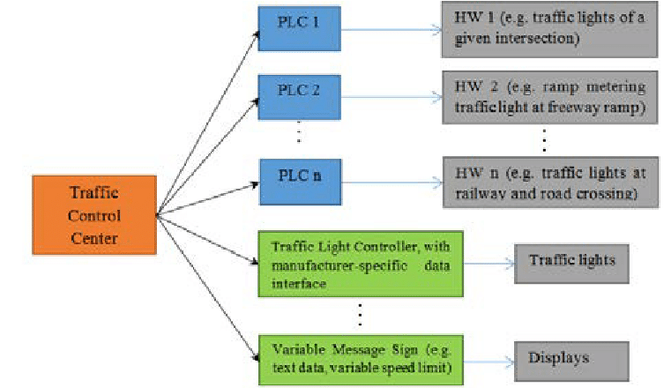

(Source: https://www.researchgate.net/figure/Road-traffic-control-system-architecture-in-the-test-track_fig4_318345157)

**Appendix 2: Agile Methodology**

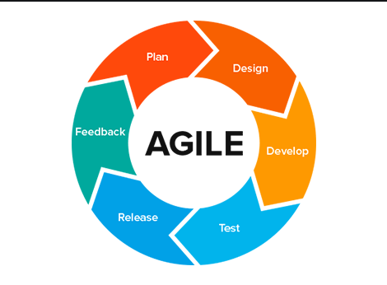

(Source: https://medium.com/@lizparody/waterfall-vs-agile-methodology-in-software-development-1e19ef168cf6)

**Appendix 3: Agile Methodology Benefits**

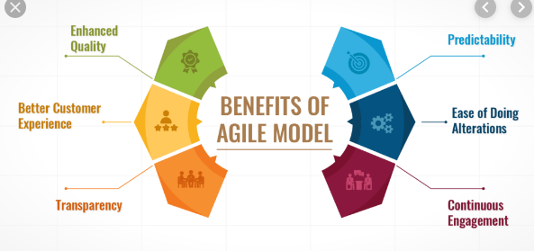

(Source: https://www.mindcypress.com/benefits-of-agile-training-and-best-courses/)

**Appendix 4: Road Traffic Control Structure**

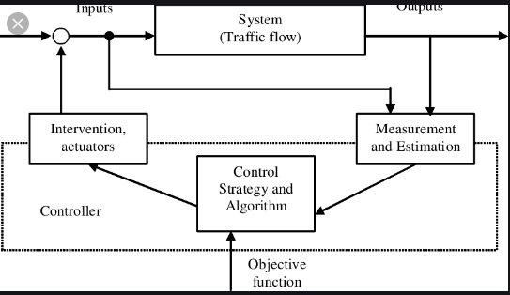

(Source: https://www.researchgate.net/figure/Structure-of-road-traffic-control_fig1_2290036730)

**Appendix 5: EVAS**

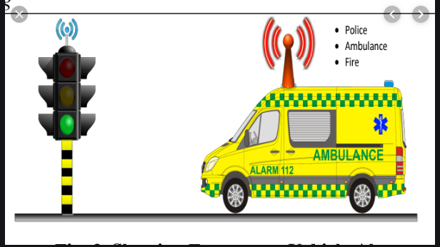

(Source: https://www.semanticscholar.org/paper/An-Approach-towards-Traffic-Management-System-using-Shaikh-Chandak/fb24269fb2ae1cc53dc22bdfea675d7e163c1264)