1. Java Basics
- Object-Oriented Programming Language (OOP): Everything in Java is associated with classes and objects.
- Platform Independent: Java programs run on the Java Virtual Machine (JVM), making them platform-independent.
• Platform Independent – Java code runs on any system with a JVM.
• Object-Oriented – Everything in Java is treated as an object.
• Simple – Easy to learn with a clean syntax and minimal complexity.
• Secure – Provides built-in security features like bytecode verification.
• Robust – Strong memory management and exception handling.
• Multithreaded – Supports concurrent execution using threads.
• Architecture Neutral – Compiled code is independent of architecture.
• Portable – Write once, run anywhere (WORA).
• High Performance – Just-In-Time compiler improves runtime performance.

🔹 2. Key Features of Java or principles

Basic Principles of Java Programming
Java is a widely-used, object-oriented programming language known for its simplicity, portability, and robustness. Its design is based on several key principles that make it powerful and widely adopted.

🔹 1. Simple
Java is designed to be easy to learn and use.
- Syntax is clean and similar to C/C++ but without complex features like pointers or operator overloading.
- Automatic memory management via Garbage Collection.

🔹 2. Object-Oriented
Java follows the Object-Oriented Programming (OOP) paradigm:
- Everything is modeled as objects (except primitive data types).
- Supports OOP principles:
  - Encapsulation
  - Inheritance
  - Polymorphism
  - Abstraction

🔹 3. Platform-Independent
Java code is compiled into bytecode using the Java compiler (javac), and this bytecode runs on any device with a Java Virtual Machine (JVM).
Write Once, Run Anywhere (WORA)

🔹 4. Secure
Java is designed with security features:
- No pointer manipulation (avoids memory corruption).
- Bytecode runs inside the JVM sandbox, preventing unauthorized access.
- Built-in libraries for encryption, authentication, etc.

🔹 5. Robust
Java is strong in memory management and exception handling.
- Garbage Collection handles memory automatically.
- Exception handling (try-catch blocks) helps prevent crashes.
- Compile-time and runtime checks reduce errors.

🔹 6. Multithreaded
Java has built-in support for multithreading—multiple tasks can run in parallel within the same program.
- Done using Thread class or Runnable interface.

🔹 7. Architecture-Neutral
Java bytecode is not dependent on any specific hardware or operating system architecture.

🔹 8. Portable
Java programs can run on any system with a compatible JVM. No need to recompile for different platforms.

🔹 9. High Performance
While not as fast as C/C++, Java uses Just-In-Time (JIT) compilation to convert bytecode into native code for performance.

🔹 10. Distributed
Java supports networking and remote method invocation (RMI), allowing programs to be distributed across networks.

🔹 3. Core Concepts

a. Class and Object
- Class: Blueprint for creating objects (e.g., class Car).
- Object: Instance of a class (e.g., Car myCar = new Car();).

b. Data Types
- Primitive: int, char, float, boolean, etc.
- Non-Primitive: Strings, Arrays, Objects.

c. Variables
- Store data. Types include:
  - Local
  - Instance
  - Static

d. Methods
- Block of code that performs an action.
public void greet() {
System.out.println("Hello");
}

The program structure in Java follows a specific syntax and organizational pattern. Here's a basic overview of how a typical Java program is structured:

Basic Java Program Structure
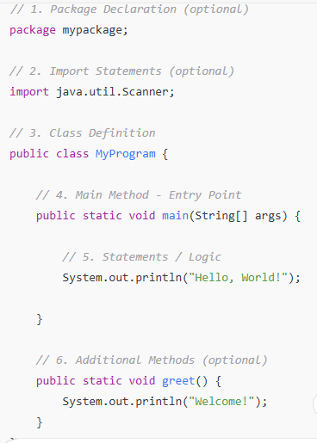

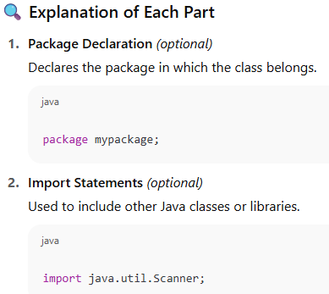

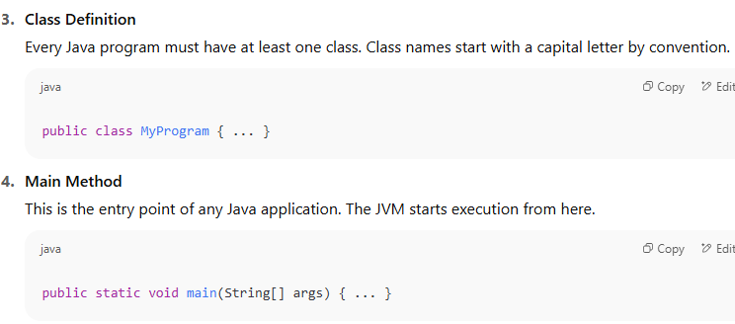

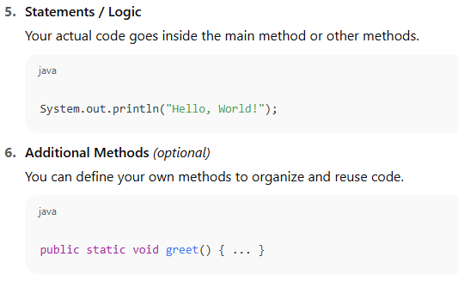

• Every Java file should have one public class whose name matches the filename (e.g., MyProgram.java).
• Code is organized into classes and methods.
• Java is case-sensitive.
• Use proper indentation and naming conventions for readability.

Elements or Tokens in Java Programs
In Java, a token is the smallest unit in a program that has meaning to the compiler. Java breaks down source code into tokens during the lexical analysis phase of compilation.
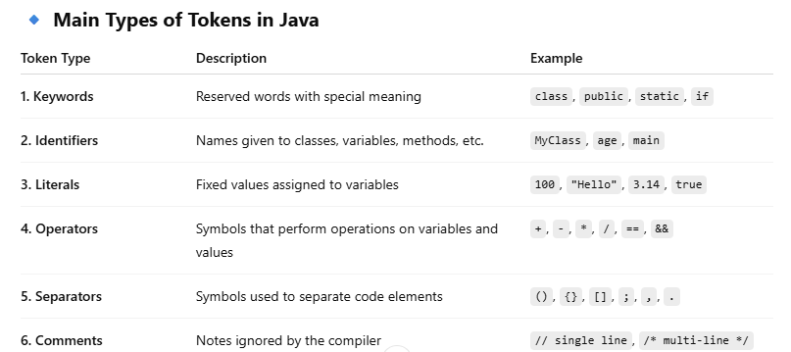

Detailed Overview

1. Keywords
- Predefined and reserved.
- Cannot be used as identifiers.
- Examples: int, class, if, else, new, try, void, extends.

2. Identifiers
- Names for variables, methods, classes, etc.
- Must begin with a letter (A–Z or a–z), underscore _, or dollar sign $.
- Cannot be a keyword.
- Example:
int age = 25; // 'age' is an identifier

3. Literals
- Constants directly written in the code.
- Types:
  - Integer: 10, 0, -55
  - Floating point: 3.14, 2.0
  - Char: 'A'
  - String: "Java"
  - Boolean: true, false

4. Operators
- Perform operations on variables and values.
- Types:
  - Arithmetic: +, -, *, /, %
  - Relational: ==, !=, >, <
  - Logical: &&, ||, !
  - Assignment: =, +=, -=
  - Unary: ++, --, -

5. Separators (Delimiters)
- Symbols that structure the code.
- Common separators:
  - Parentheses () – used in method calls and conditionals.
  - Braces {} – define blocks of code.
  - Brackets [] – define arrays.
  - Semicolon ; – ends a statement.
  - Comma , – separates parameters or variables.
  - Dot . – accesses members of classes or objects.

6. Comments
- Used for code documentation.
- Not executed by the compiler.

java Statements
In Java, a statement is a complete unit of execution. It's the smallest standalone element of a Java program that performs an action.
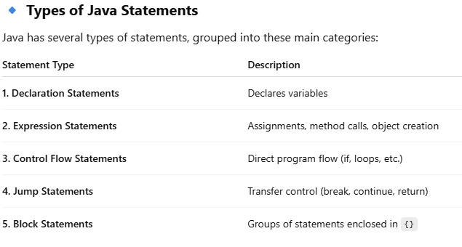

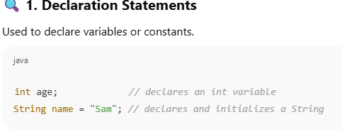

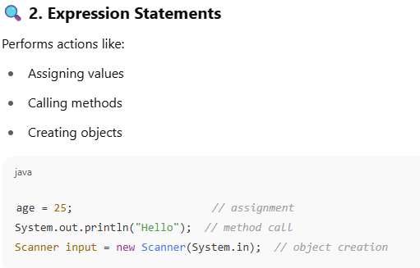

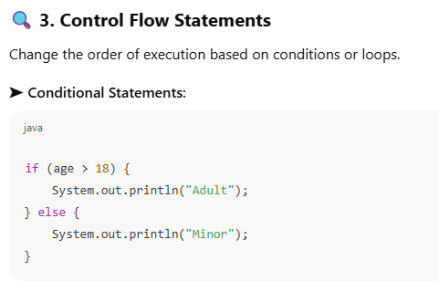

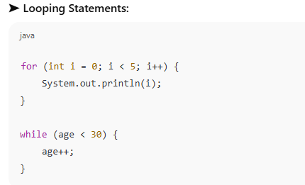

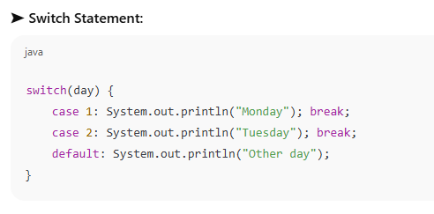
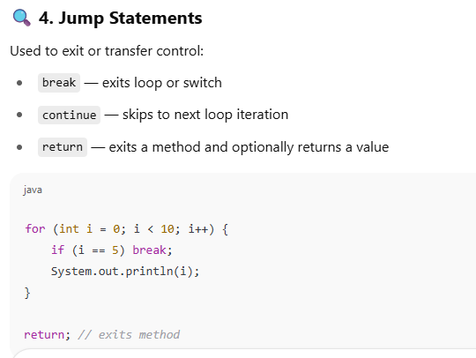

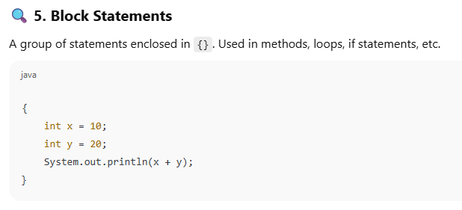

Command Line Arguments in Java
Command Line Arguments are values passed to a Java program at the time of execution via the terminal or command prompt.
They allow users to provide input when the program starts, rather than hardcoding it or using Scanner.
The main method has the following signature:
public static void main(String[] args)
- args is an array of String values that stores the arguments provided from the command line.
- Each argument is separated by a space.

Purpose of Command-Line Arguments
- Allow users to provide input without modifying code.
- Useful for dynamic behavior.

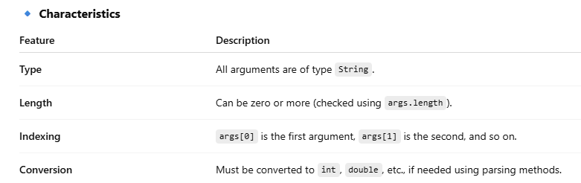

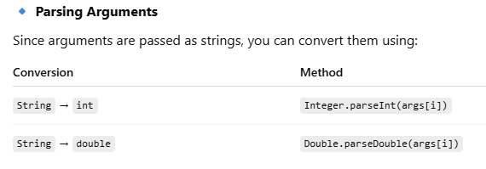
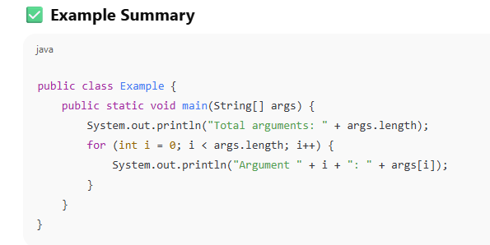

User Input to Programs:
In Java, user input can be taken in two main ways:

1. Command-Line Arguments
- Passed when the program is run via terminal.
- Available in the main(String[] args) method.
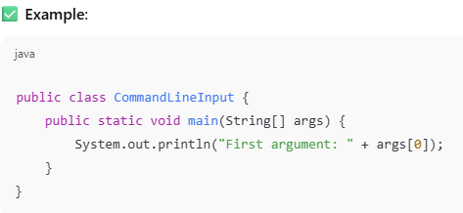

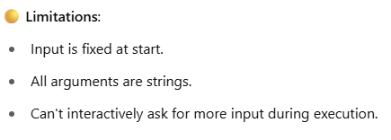

2. Using the Scanner Class (Most Common)
The Scanner class (in java.util) allows dynamic input during program execution, e.g., from keyboard.
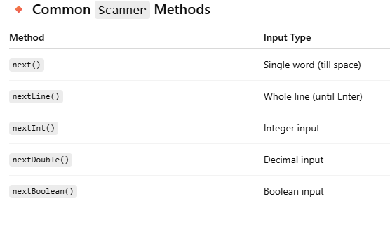
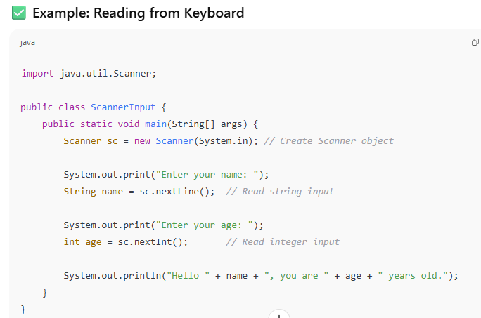

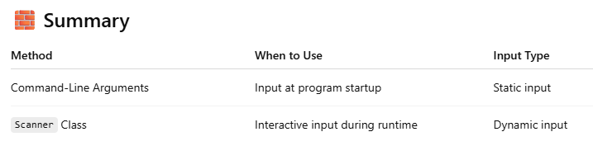

Escape Sequences in Java
Escape sequences are special characters used in Java strings and characters to represent non-printable characters or characters with special meaning (like newline, tab, etc.).
They begin with a backslash (\) and are used inside double quotes for String or single quotes for char.
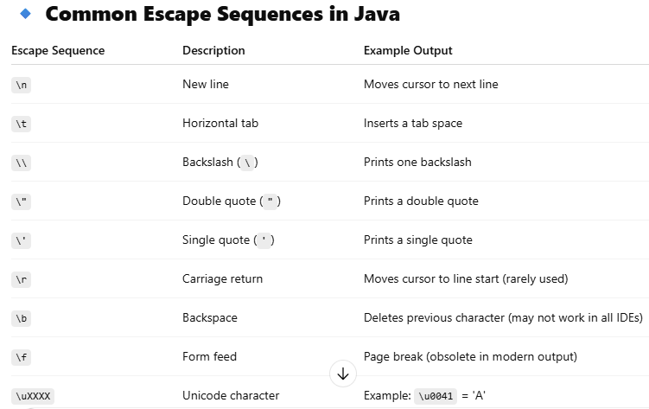

Comments in Java
Comments in Java are notes written inside code to explain it. They are ignored by the compiler and do not affect program execution.
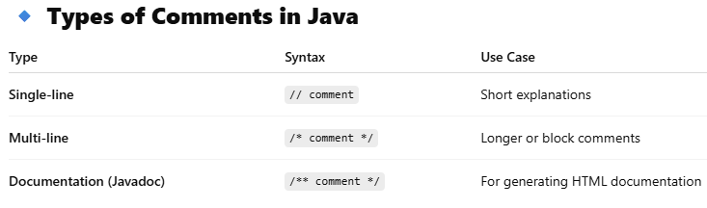

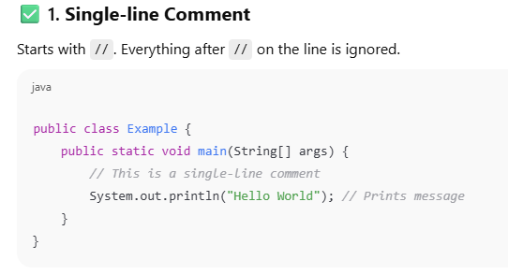

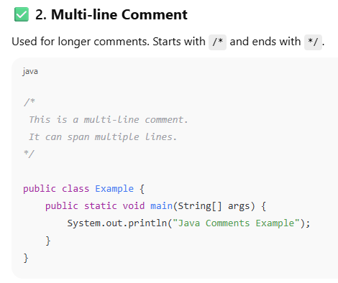

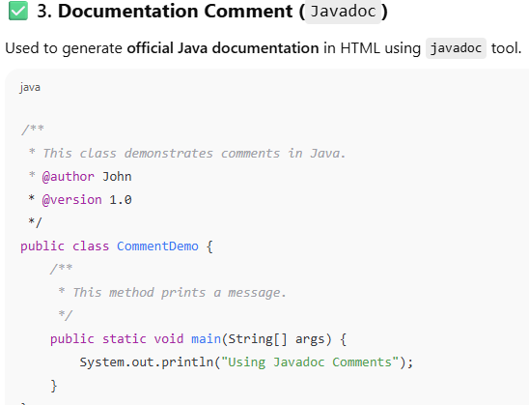

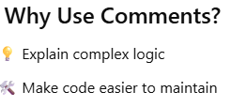

Programming style in Java refers to the set of guidelines and best practices for writing code that is:
- Readable (easy for others to understand)
- Consistent (follows the same patterns)
- Maintainable (easy to fix or improve later)
It’s not about how the program works (logic), but how the code looks and is organized.

1. Class Naming
- Use PascalCase.
- Start with an uppercase letter.
- Class names should be nouns.
public class StudentRecord {
// class contents
}

2. Method Naming
- Use camelCase.
- Start with a lowercase letter.
- Method names should be verbs or verb phrases.
public void calculateGrade() {
// method contents
}

3. Variable Naming
- Use camelCase.
- Use meaningful, descriptive names.
int studentAge;
String courseName;
4. Indentation & Braces
- Use 4 spaces for indentation (not tabs).
- Always use braces {} even for one-line if, for, etc.

if (isPassed) {
System.out.println("You passed!");
}

5. Comments
- Use comments to explain why, not what.
- Single-line: //
- Multi-line: /* ... */
- Use Javadoc (/** */) for public methods and classes.
// This calculates the final grade
public int calculateFinalGrade() {
// logic here
}

6. Constants
- Use ALL_CAPS_WITH_UNDERSCORES for constants.
- Mark them static final.
public static final double PI = 3.14159;

7. Keep Methods Short
- A method should do one thing.
- Aim for methods under 20–30 lines if possible.

Data Types, Variables, and Operators:
In Java, data types define the kind of data a variable can hold. They are categorized into two main types:
1. Primitive Data Types
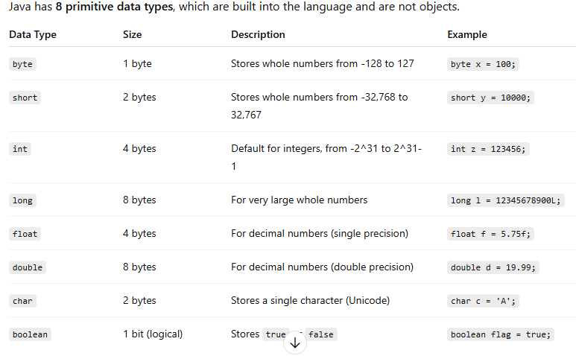

2. Non-Primitive (Reference/Object) Data Types
These refer to objects and include classes, arrays, interfaces, and more.
- String – Represents a sequence of characters
Example: String name = "Java";
- Arrays – Collection of similar elements
Example: int[] numbers = {1, 2, 3};
- Classes – User-defined types
Example:
class Person {
String name;
int age;
}
- Interfaces & Enums – Special types to support abstraction and constants

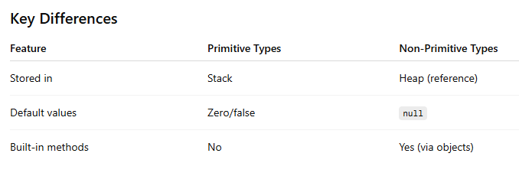

Declaration of Variables in Java

Basic Syntax
<data_type> <variable_name>;
You can also initialize it during declaration:
<data_type> <variable_name> = <value>;

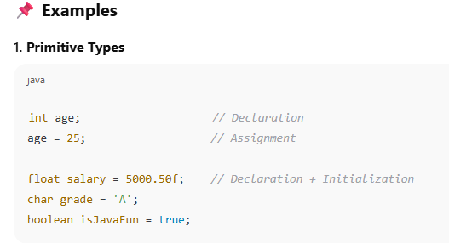

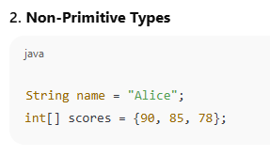

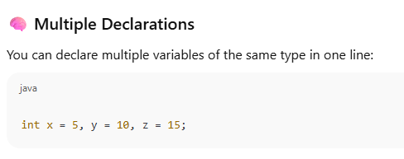

Variable Naming Rules
- Must start with a letter, _, or $
- Cannot start with a digit
- Cannot use Java reserved keywords (like class, int, if, etc.)
- Java is case-sensitive (age and Age are different)

Best Practices
- Use camelCase for variable names: studentName
- Choose meaningful names: score, not s
- Initialize variables when possible to avoid default values

Type Casting in Java
Type casting is converting a variable from one data type to another. In Java, type casting is classified into two types:

1. Widening Casting (Implicit)
- Converting a smaller type to a larger type.
- Done automatically by Java.
- No data loss.
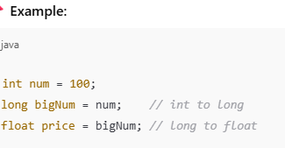

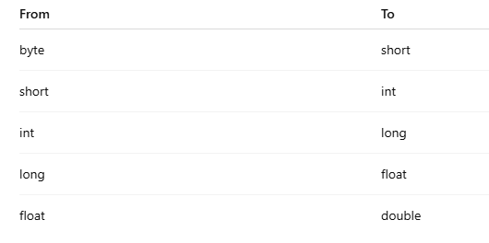

2.Narrowing Casting (Explicit)
- Converting a larger type to a smaller type.
- Requires manual casting using parentheses.
- May lose data or precision.
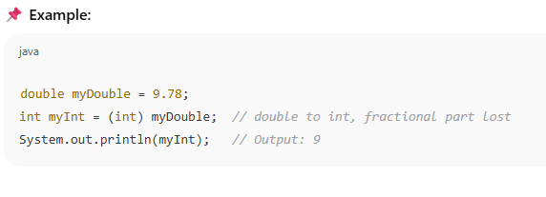

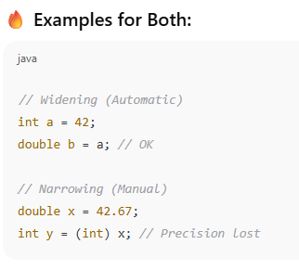

Types of Variable Scope in Java:

1. Local Scope (Local Variables)
- Declared inside a method, constructor, or block.
- Can only be used within that method/block.
- Created when the method is called, destroyed when it ends.
public void show() {
int number = 5; // local variable
System.out.println(number);
}
// number is NOT accessible outside show()

2. Instance Scope (Instance Variables)
- Declared inside a class but outside any method.
- Belongs to each object of the class.
- Accessible by all methods of the class (with this keyword if needed).
public class Student {
int age; // instance variable

public void setAge(int a) {
age = a;
}

public void printAge() {
System.out.println(age);
}
}

3. Class Scope (Static Variables)
- Declared with static keyword inside the class.
- Shared by all objects of the class.
- Accessible using the class name or from any static method.
public class Student {
static int totalStudents = 0; // class variable

public Student() {
totalStudents++;
}
}

4. Block Scope
- Defined inside if, for, while, or {} blocks.
- Exists only within that block.
public void test() {
if (true) {
int x = 10; // block scope
System.out.println(x);
}
// System.out.println(x); // ❌ Error: x is not visible here
}

Literal Constants in Java
In Java, a literal constant is a fixed value that you directly write in the code. It represents a specific value of a particular data type — like a number, character, or string — that does not change.

Types of Literal Constants in Java

1. Integer Literals
- Whole numbers (no decimal)
- Default type: int
- Examples:
int a = 100;
long b = 100000L; // 'L' for long

2. Floating-point Literals
- Numbers with decimal points
- Default type: double
- Examples:
float f = 3.14f; // 'f' for float
double d = 2.718; // double (default)

3. Character Literals
- A single character, in single quotes ' '
- Represented using Unicode
- Examples:
char ch = 'A';
char newline = '\n';

4. String Literals
- Sequence of characters, in double quotes " "
- Stored as objects of the String class
- Examples:
String name = "John";

5. Boolean Literals
- Only two values: true or false
- Used in logical expressions
- Examples:
boolean isJavaFun = true;

6. Null Literal
- null represents no object (used with object references)
- Example:
String s = null;

Example: Using Different Literals in a Program
public class LiteralExample {
public static void main(String[] args) {
int number = 42; // integer literal
float pi = 3.14f; // float literal
char grade = 'A'; // char literal
String message = "Hello Java"; // string literal
boolean passed = true; // boolean literal
String name = null; // null literal

System.out.println(message + " - Grade: " + grade);
}
}

What is a Symbolic Constant?
A symbolic constant is:
- A fixed value (it never changes)
- Given a name (symbol)
- Created using the keyword final
- Often made static and written in ALL_CAPS

Simple Example:
public class MathConstants {
public static final double PI = 3.14;

public static void main(String[] args) {
System.out.println("The value of PI is: " + PI);
}
}

What’s Happening?
- PI is a symbolic constant.
- It will always be 3.14.
- We cannot change its value later.

Formatted Output with printf() Method in Java
Java’s printf() method lets you print output in a formatted way — like controlling decimals, alignment, or spacing — similar to C-style formatting.
It belongs to the PrintStream class (like System.out), and is used like this:
System.out.printf("format string", values);
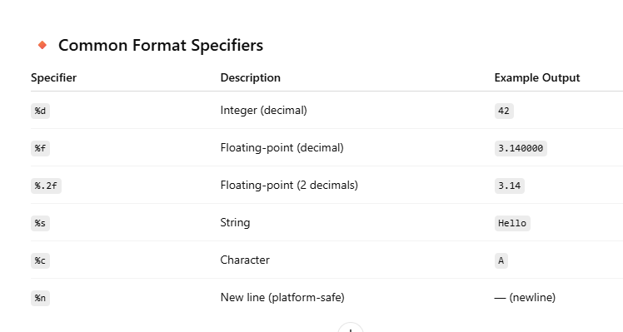

Static Variables and Methods in Java – Simple Explanation
In Java, the keyword **static** means something belongs to the class, not to individual objects (instances) of the class.

1. Static Variables (Class Variables)
A static variable is:
- Shared by all objects of a class.
- Only one copy exists in memory.
- Declared with the static keyword.

Syntax:
static dataType variableName;

Example:
public class Student {
static String school = "Green High"; // shared by all students
String name;

public Student(String name) {
this.name = name;
}

public void printInfo() {
System.out.println(name + " studies at " + school);
}
}

Usage:
Student s1 = new Student("Alice");
Student s2 = new Student("Bob");

s1.printInfo(); // Alice studies at Green High
s2.printInfo(); // Bob studies at Green High
If you change the static variable:
Student.school = "Blue High";
Now both s1 and s2 will print the new school.

2. Static Methods
A static method:
- Belongs to the class, not objects.
- Can be called without creating an object.
- Can only access static data (no instance variables directly).

Syntax:
static returnType methodName() {
// method code
}

Example:
public class MathUtil {
static int square(int x) {
return x * x;
}
}

Usage:
int result = MathUtil.square(5); // returns 25
You don’t need to create an object of MathUtil.

Rules for Static Methods:
- ✅ Can access static variables.
- ❌ Cannot use this keyword.
- ❌ Cannot access non-static (instance) variables/methods directly.

Final Attribute

final Attribute in Java — Simple Explanation
In Java, the keyword **final** is used to declare constants — values that cannot be changed once assigned.
When applied to attributes (variables or fields), it means:
✅ You can assign a value once only.
❌ You cannot modify it afterward.

Syntax:
final dataType variableName = value;

Example 1: Final Variable
public class Circle {
final double PI = 3.14; // final attribute

public double getArea(double radius) {
return PI * radius * radius;
}
}
- PI is a final attribute — it cannot be changed later.

Precedence and Associativity of Operators in Java (Simple)
In Java, operator precedence and associativity decide which operations are performed first when multiple operators appear in an expression.

1. What is Operator Precedence?
Precedence is the priority level of operators.
Operators with higher precedence are evaluated before lower ones.
Example:
int result = 10 + 2 * 5; // result = 10 + (2 * 5) = 20
- * has higher precedence than +, so it runs first.

2. What is Associativity?
Associativity defines the direction in which operators with the same precedence are evaluated.
- Most operators are left to right.
- A few (like = and ?:) are right to left.
📌 Example:
int x = y = 5; // right to left

Introduction to Operators in Java – Simple Explanation
Operators in Java are symbols used to perform operations on variables and values, such as adding numbers, comparing values, or assigning data.

Assignment Operator (=) in Java – Simple Explanation
The assignment operator = in Java is used to store a value into a variable.

Basic Syntax:
variable = value;
This means:
"Put the value on the right into the variable on the left."

Example:
int x = 10;
String name = "Alice";
- x is assigned the value 10
- name is assigned "Alice"

Multiple Assignment:
You can assign the same value to multiple variables like this:
int a, b, c;
a = b = c = 100;
Here:
- c = 100
- b = c
- a = b
Final result: a = b = c = 100

Basic Arithmetic Operators in Java – Simple Explanation
Java provides arithmetic operators to perform math operations like addition, subtraction, multiplication, etc.
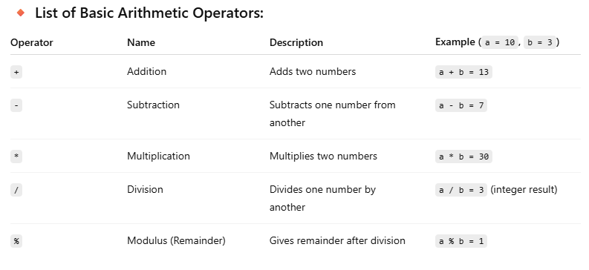

/ | Division | a / b
% | Modulus (remainder) | a % b

🔹 2. Relational / Comparison Operators
Used to compare two values:
Operator | Description | Example
== | Equal to | a == b
!= | Not equal to | a != b
> | Greater than | a > b
< | Less than | a < b
>= | Greater than or equal to | a >= b
<= | Less than or equal to | a <= b

3. Logical Operators
Used to combine multiple conditions:
Operator | Description | Example
&& | Logical AND | a > 5 && b < 10
` |  | `
! | Logical NOT | !(a > 5)

🔹 4. Assignment Operators
Used to assign values:
Operator | Description | Example
= | Assign | a = 5
+= | Add and assign | a += 3 (same as a = a + 3)
-= | Subtract and assign | a -= 2
*= | Multiply and assign | a *= 4
/= | Divide and assign | a /= 2
%= | Modulo and assign | a %= 3

🔹 5. Unary Operators
Operate on a single operand:
Operator | Description | Example
+ | Unary plus | +a
- | Unary minus | -a
++ | Increment | a++ or ++a
-- | Decrement | a-- or --a
! | Logical complement | !true → false
Bitwise operators in Java perform operations directly on the binary representations of integers. They are typically used for low-level programming, such as working with flags, manipulating bits, or optimizing performance.

6.Java Bitwise Operators
Operator | Symbol | Description | Example (for a = 5, b = 3)
AND | & | Bitwise AND | a & b → 1 (0101 & 0011 = 0001)
OR | ` | ` | Bitwise OR
XOR | ^ | Bitwise XOR (exclusive OR) | a ^ b → 6 (0101 ^ 0011 = 0110)

🔹 7. Ternary Operator
A shorthand for if-else:
condition ? value_if_true : value_if_false;
Example:
int result = (a > b) ? a : b;

control statements
Decission making statements
1.if else
2.switch

Loop statements
1.do while
2.while
3.for
4. for each
Jump statements
1.break
2.continue

If statement----if condition is true than execute the if block

Syntax:
if(condition)
{
Statements;
}

If else statement: if condition is true than excute if block otherwise execute else block.
Syntax:

if (condition){
Statements1;
}
else
{
Statements2;
}

If else ladder:

If(condition){
Statements1;
}
else if(condition){

Statements2;
}
else if(condition){

Statements3;
}
else

Statements4;
}

Nested if condition:

If (condition){
Statements1;
if(condition){
Statements2;
}

}

Do while:
If the number of iteration is not fixed and you must have to execute the loop at least once, it is recommended to use a do-while loop.
Syntax:
do{
Statements;
}
while(condition);

infinite do while:

do{
statements;
}while(true);

while:
Syntax:
While(condition)
{
Statements;
}

Infinite while loop:
Syntax infinite while loop:
While(true){
Statements;
}

for loop:
Syntax:
for(expression1;expression2;expression3)
{
Statements;
}

Nested for loop:

Syntax:
for(expression1;expression2;expression3)
{
for(expression1;expression2;expression3)
{
Statements;
}
}

Java Break Statement
When a break statement is encountered inside a loop, the loop is immediately terminated and the program control resumes at the next statement following the loop.
The Java break statement is used to break loop or switch statement. It breaks the current flow of the program at specified condition. In case of inner loop, it breaks only inner loop.
We can use Java break statement in all types of loops such as for loop, while loop and do-while loop.

Switch

Points to Remember
- There can be one or N number of case values for a switch expression.
- The case value must be of switch expression type only. The case value must be literal or constant. It doesn't allow variables.
- The case values must be unique. In case of duplicate value, it renders compile-time error.
- The Java switch expression must be of byte, short, int, long (with its Wrapper type), enums and string.
- Each case statement can have a break statement which is optional. When control reaches to the break statement, it jumps the control after the switch expression. If a break statement is not found, it executes the next case.
- The case value can have a default label which is optional

Syntax:
Switch(exp){
Case value1:statements;break;
Case value2: statements:break;
Case value3:statements;break;
Default:statements;
}

Continue:
In Java, the continue keyword is used within loops (for, while, or do-while) to skip the current iteration and proceed to the next iteration of the loop.

Syntax:
continue;

Example with for loop:
public class ContinueExample {
public static void main(String[] args) {
for (int i = 1; i <= 5; i++) {
if (i == 3) {
continue; // skip the rest of the loop when i == 3
}
System.out.println(i);
}
}
}
Output:
CopyEdit
1
2
4
5
The number 3 is skipped because of the continue statement.

