GIT History

* Linux kernel
* BitKeeper
* Announced project[git] on 6th Apr, 2005
* 16th June, 2005 GIT Managed Kernel 2.6.12 release.
* 1.0 released on 21st Dec,2005

GIT[meaning in British]:- Unpleasant person

Features:-

- Distributed source control system

- Open source

- Large and active community

For Download and information :-[www.gitforwindows.org](http://www.gitforwindows.org).

For macOS :- brew install git

Apple ships a binary package of git with Xcode.

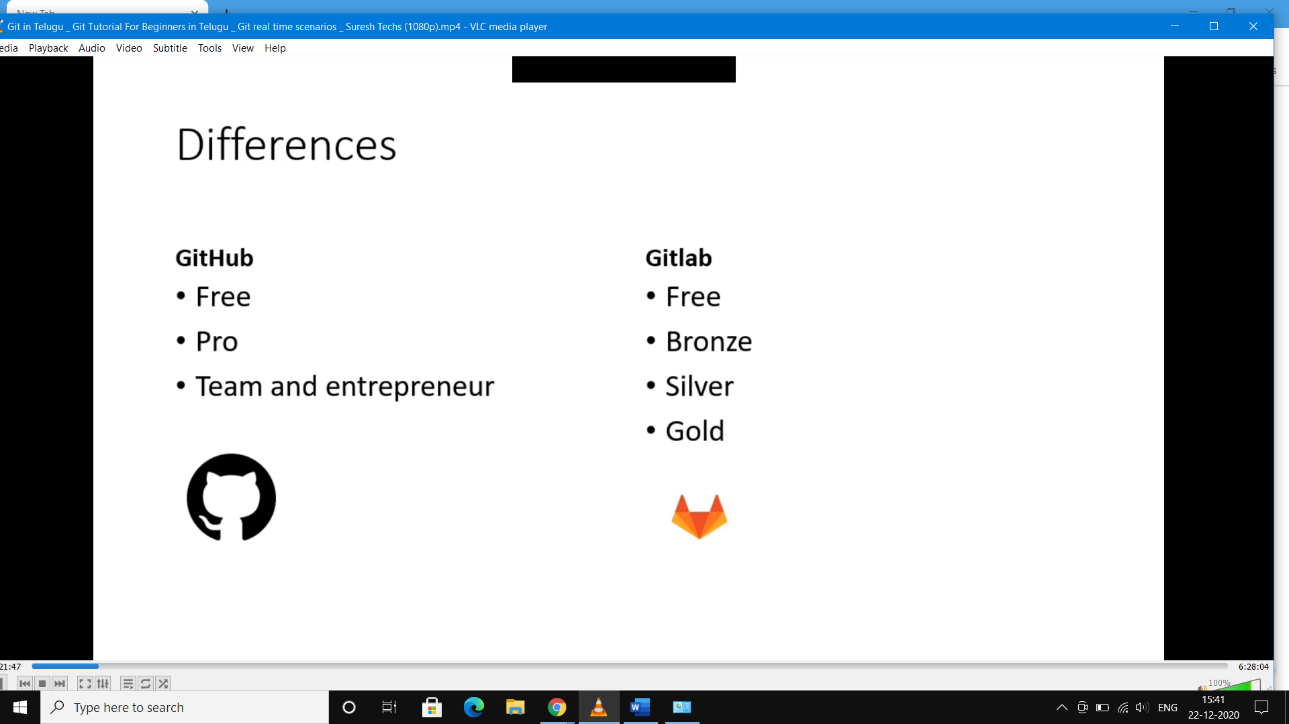

**Git config:-**

* --global
* --system
* --local

Ex:-

* git config --global 🡺 it shows global information like username,email..etc
* git config --global -e
* ex:- git config --global user.name “yourname”
  + - git config --global user.email “youremailid(githubs)

**git Help:-**

git **help** <”command name”>

[or]

git <”command name”> --**help**

man git -<command name> 🡺 not works all times properlly

in this way we get complete information about particular command .

**Configure notepad++ with git:-**

🡺install notepad++

🡺setup environment variable, give anew path of notepad [C:\Program Files (x86)\Notepad++]

Terms:-

Commit

Clone

Tracked/untracked files

Branch

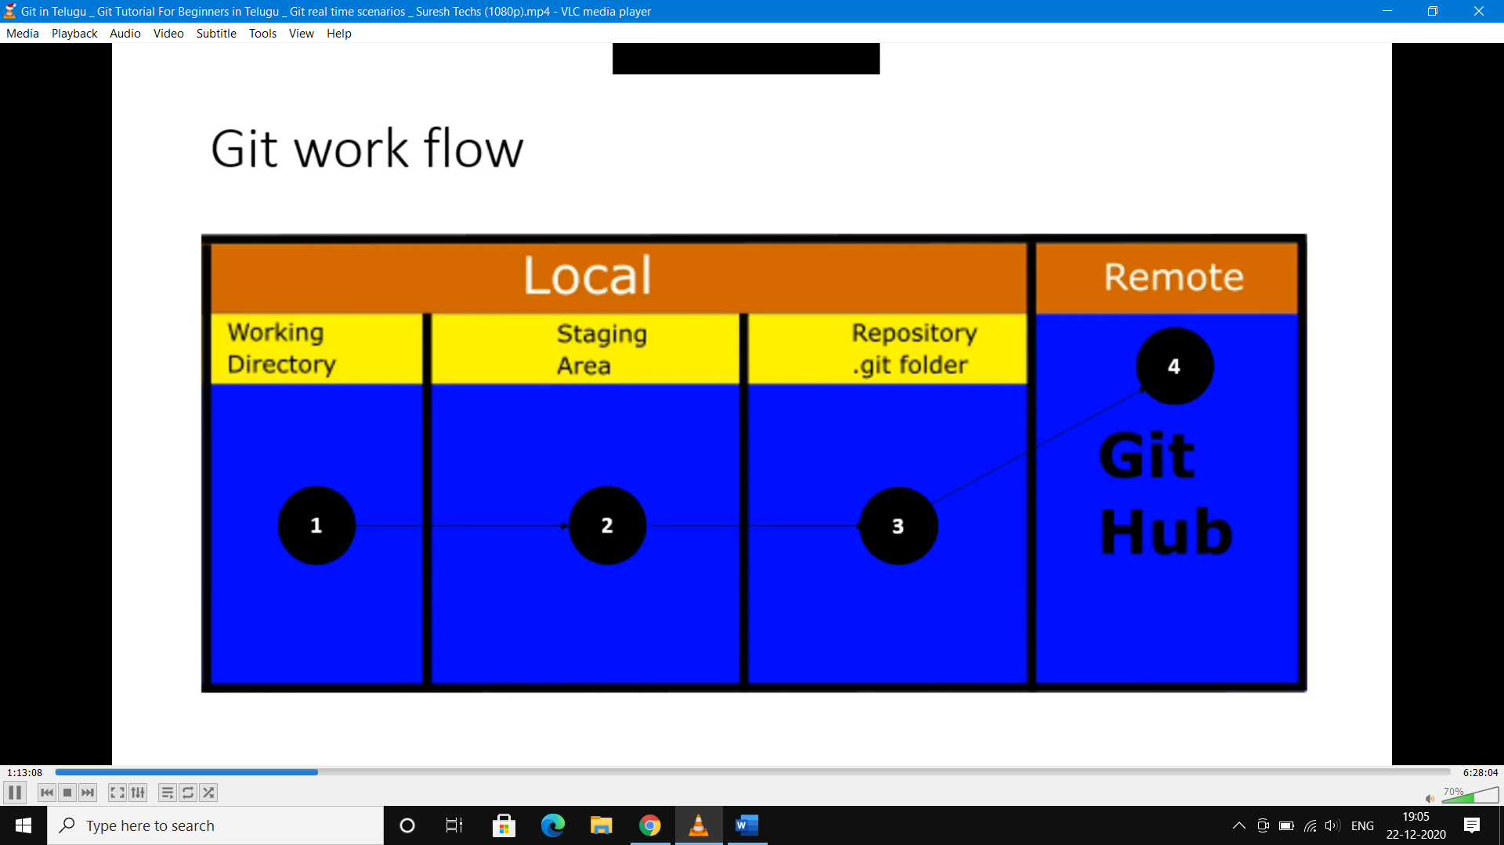

[staging area means Index Area]

master

origin

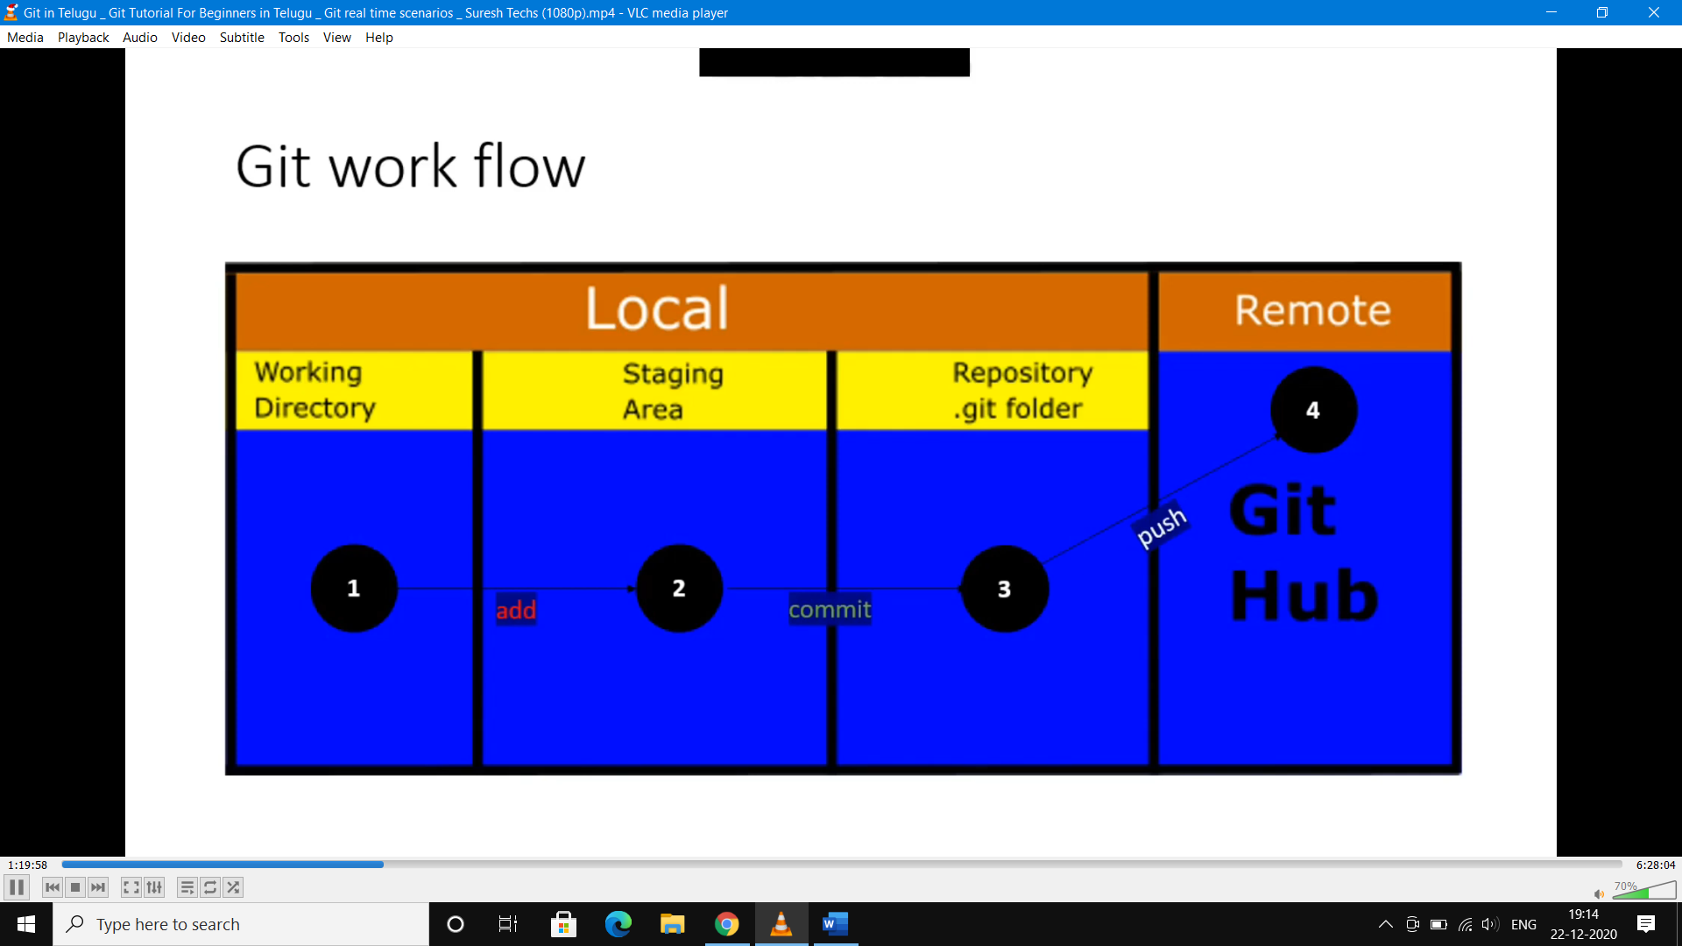

git clone :-

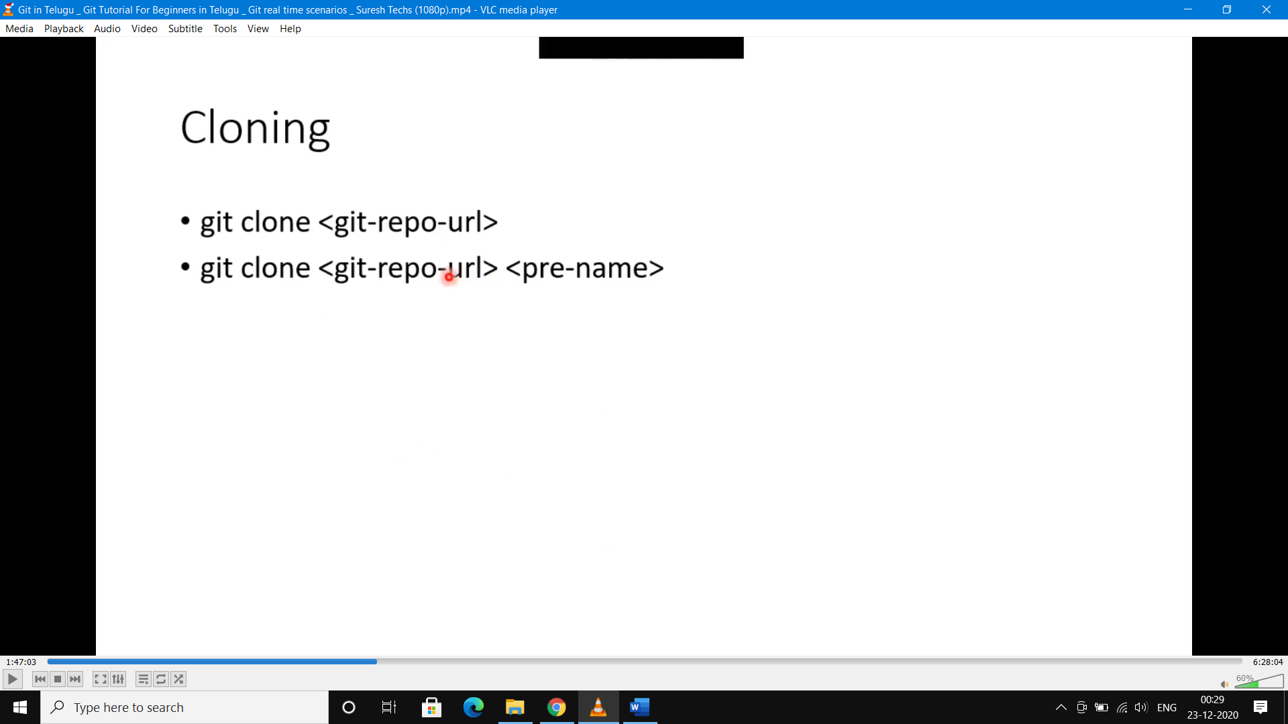

Here we change existing name t

o new name

In this we get repository with existing name