INTERNSHIP TECHNICAL REPORT
Grid-Forming & Grid-Following Inverter Control,
and Dynamic Modeling of AI Data Center Load, in PSCAD
PCS Average-Model GFL/GFM Control Development, and a Double-Conversion UPS
AI Data Center Load Model Aligned with the ERCOT / Texas A&M Reference Architecture
Prepared by: [Your Name]
Department / University: [Department, University]
Internship Supervisor: [Supervisor Name]
Internship Period: [Start Date] – [End Date]
Report Date: July 23, 2026

Table of Contents
(This table updates automatically. If it appears empty, right-click it and choose “Update Field,” or select it and press F9.)

1. Introduction & Objectives
Two industry pressures sit behind this internship. First, as more generation and storage on the bulk power system arrives as inverter-based resources (IBR), grid codes are increasingly requiring those resources to be able to form their own voltage and frequency reference — not just follow the grid — which is why Grid-Forming (GFM) control has moved from a research topic to a standard deliverable of a Power Conversion System (PCS) average model. Second, the rapid growth of AI/HPC data centers has created large, fast-ramping, power-electronic-dominated loads whose behavior during grid disturbances is not well captured by legacy composite load models, which is why ERCOT and NERC now require dedicated dynamic (EMT) models of these facilities for interconnection studies.
This report documents the internship work addressing both pressures, organized as two related work streams inside the same PSCAD modeling environment:
- Work Stream A — implementing a switchable Grid-Following (GFL) / Grid-Forming (GFM) control module inside an existing PCS average model, including SRF-PLL synchronization, cascaded power/current control for GFL, and P-f/Q-V droop plus Virtual Synchronous Machine (VSM) control for GFM.
- Work Stream B — building a double-conversion UPS representation of an AI data center's electrical infrastructure (rectifier, inverter, bidirectional DC/DC converter, battery, and voltage/frequency ride-through logic), aligned with the openly published ERCOT / Texas A&M reference model for large flexible load studies.
The two streams connect directly: in the reference UPS architecture, the rectifier is itself a grid-following converter synchronized by a PLL, and the inverter is a grid-forming converter regulated by P-f/Q-V droop — exactly the two control families built in Work Stream A. The GFL/GFM module work therefore doubles as the control foundation the UPS study in Work Stream B is built on.

1.1 Objectives
- Understand and implement SRF-PLL based synchronization for a grid-following converter, and tune it across a range of grid strengths (short-circuit ratio, SCR).
- Implement cascaded outer power-loop / inner current-loop control for GFL operation, including negative-sequence current control for unbalanced conditions.
- Implement P-f and Q-V droop control, and Virtual Synchronous Machine (VSM) control, for grid-forming operation, and compare their dynamic response.
- Study and replicate the double-conversion UPS architecture used in ERCOT/TAMU's public AI data center EMT model, including its rectifier, inverter, bidirectional DC/DC converter, battery/SOC block, and centralized VRT/FRT ride-through logic.
- Document the model structure, control design, and expected dynamic behavior for handoff and future PSCAD validation runs.

1.2 How to Read the “Day” Labels
Sections 3 and 4 are organized as a day-by-day progression (Day 1 – Day 13) to mirror how the work was actually built up, one control block at a time. These day numbers are indicative groupings of the material — please relabel them against your own logbook or calendar dates before presenting.

2. Background

2.1 Grid-Following (GFL) vs. Grid-Forming (GFM) Control
A grid-following converter behaves as a controlled current source. It measures the terminal voltage, uses a phase-locked loop (PLL) to track the grid's phase angle and frequency, and injects current at a magnitude and phase set by active/reactive power references. GFL control is simple, fast, and works well as long as a strong external voltage reference (the grid, or another grid-forming source) is present — but a GFL converter cannot set its own frequency or ride through a very weak or islanded grid, because it has nothing to synchronize to.
A grid-forming converter behaves as a controlled voltage source with its own internal frequency and voltage-magnitude reference, in the same conceptual role as a synchronous generator's rotor. It does not need a PLL to operate (though a PLL is often retained for monitoring/protection), can black-start a de-energized system, and can support voltage and frequency during weak-grid or islanded conditions. GFM behavior is typically implemented either as simple droop control (mimicking a governor's P-f droop and an AVR's Q-V droop) or as a Virtual Synchronous Machine (VSM), which explicitly emulates a synchronous generator's swing equation — giving the converter synthetic inertia (an inertia constant H) and damping (D), not just a steady-state droop slope.
As IBR penetration rises and system inertia from conventional generation falls, grid codes (including NERC guidance and standards such as IEEE 2800-2022) are increasingly asking new inverter-based plants, and battery energy storage in particular, to offer GFM capability rather than GFL-only. Building a PCS average model with a switchable GFL/GFM module, as in Work Stream A, mirrors exactly this industry shift.

2.2 Why AI Data Center Load Modeling Matters to ERCOT
Large data centers connect to the grid through uninterruptible power supply (UPS) systems built from rectifiers, inverters, and batteries — power electronics with their own fast, nonlinear ride-through logic. Several documented events have shown that this logic can cause a data center to disconnect — or a fleet of them to disconnect simultaneously — in response to a grid fault that would not have tripped a conventional load, creating a sudden, large loss of load that system operators had not modeled.
In response, ERCOT has been formalizing large-load interconnection and modeling requirements: an interim large-load interconnection process introduced in 2022, and a further formalization through NPRR1234 and PGRR115 (effective April 15, 2025), which redefined a “large load” as a facility with ≥ 75 MW peak demand and set standardized modeling and reactive-power study requirements. ERCOT has since indicated that generic composite load models are no longer considered sufficient for these facilities, and it is moving toward requiring detailed PSCAD/EMT models plus hardware-benchmarked converter model validation for large electronic loads (LELs) such as AI data centers, so that a facility's model can serve as its ride-through compliance case.
This is the regulatory and engineering context for Work Stream B: it reproduces, block by block, the openly published joint ERCOT / Texas A&M reference EMT model of a double-conversion UPS-based AI data center, described in the citation below, which is intended precisely to give industry a shared, non-proprietary starting point for this kind of study.
Primary reference for Work Stream B
X. Wang, X. Chen, P. Enjeti, F. C. Lin (Texas A&M University / Consortium on AI and Large Flexible Load), A. Yazdanpanah, J. Rose, Y. Cheng, A. Quedan, P. Kansal (ERCOT), “Dynamic Modeling of AI Data Center Load in PSCAD,” TAMU–ERCOT, Version 1.0, April 2026. Open-source PSCAD files available via ERCOT's Large Load Modeling page.

3. Work Stream A — GFL / GFM Control Module (PCS Average Model)

Day 1 — PCS Average Model and the GFL/GFM Module Interface
The starting point was an existing PCS average model into which a combined “GFL and GFM” control module was integrated (Figure 1). The module is designed to be reusable across both control philosophies: the same block accepts a mode selection and either follows the grid (GFL) or forms the local voltage (GFM), depending on how it is configured.
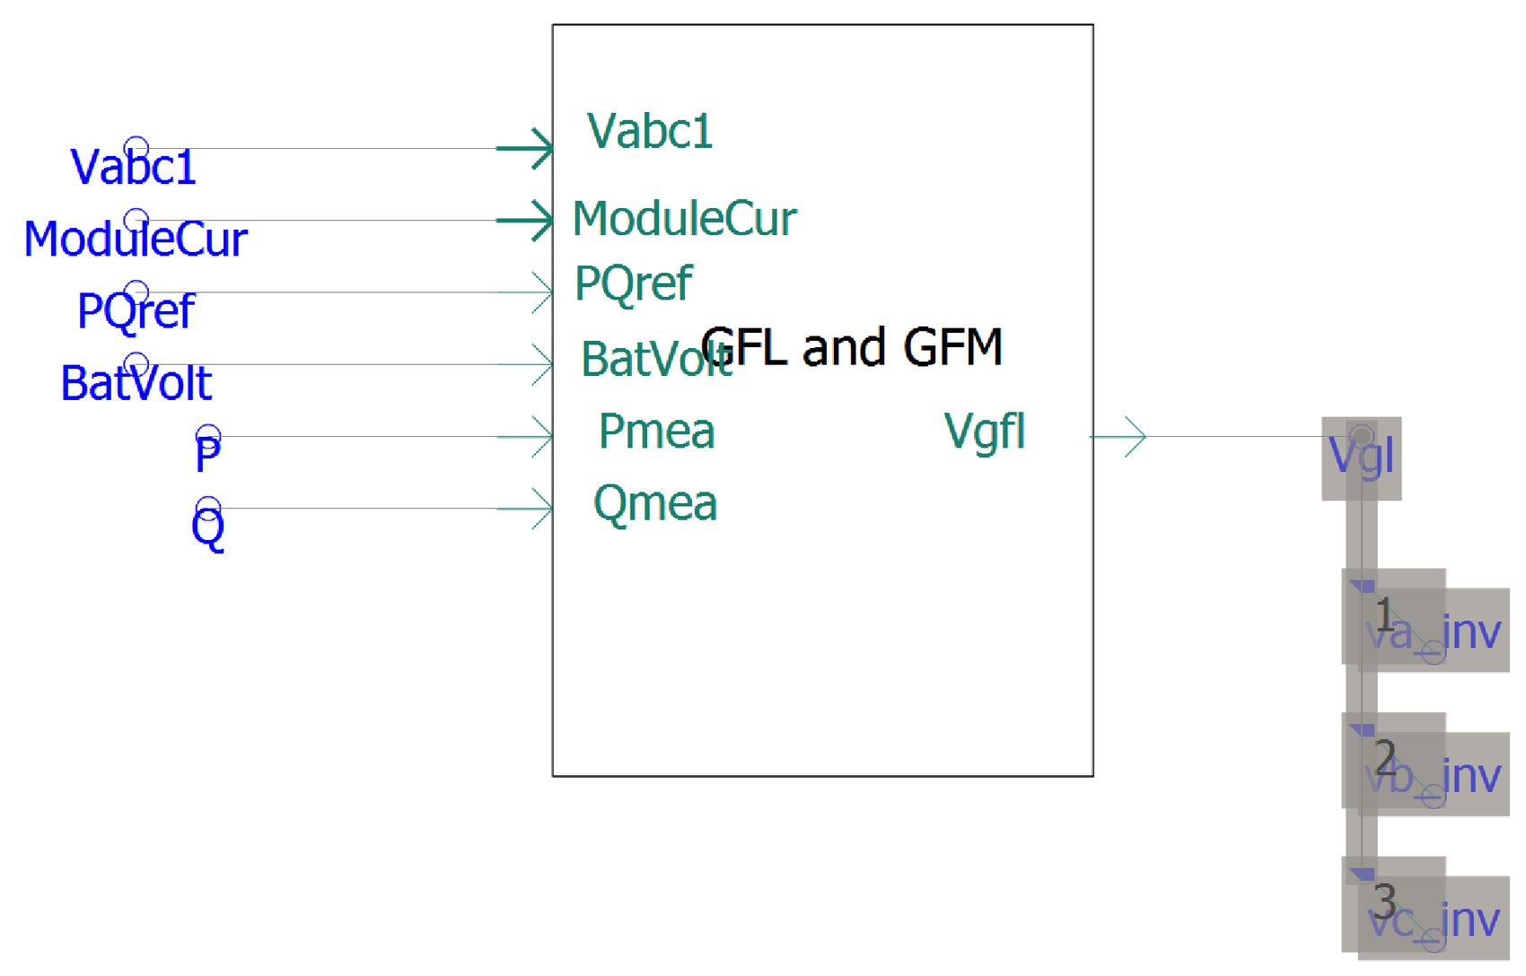
Figure 1. I/O interface of the combined GFL/GFM control module inside the PCS average model.
The module's inputs and outputs are summarized below.
Signal | Direction | Description
Vabc1 | In | Three-phase terminal (POI) voltage measurement, used by the PLL and by voltage feedback
ModuleCur | In | Three-phase converter/module current measurement, used by the current control loops
PQref (Pref, Qref1) | In | Active and reactive power references from the plant controller / dispatch
BatVolt | In | DC bus / battery voltage feedback
P, Q (Pmea, Qmea) | In | Measured active and reactive power, used as feedback for the outer loops and droop
Vgfl | Out | Three-phase voltage reference (Va_inv, Vb_inv, Vc_inv) sent to the inverter bridge / modulator

Day 2 — GFL Control: SRF-PLL Synchronization
Grid-following operation starts with phase tracking. The module uses a standard Synchronous Reference Frame PLL (SRF-PLL): the measured three-phase voltage is transformed into a rotating dq frame (Park/Clarke transform), and a PI controller drives the quadrature-axis component toward zero, which locks the dq frame to the grid voltage vector. The PLL's outputs are the estimated phase angle theta and angular frequency omega, which every other block in the module (current control, power calculation, dq/abc conversions) is built around.
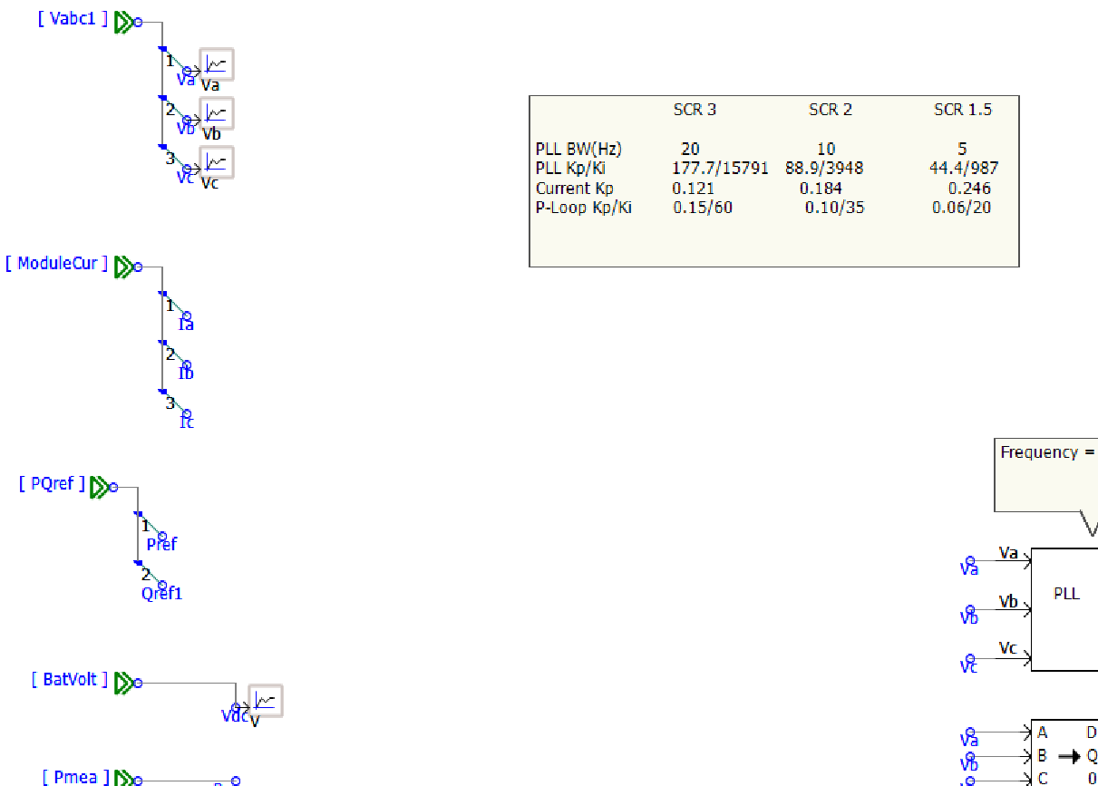
Figure 2. SRF-PLL block (Va, Vb, Vc → theta, omega) with the module's input legend and the SCR-dependent PLL tuning table.
A distinctive part of this step was tuning the PLL bandwidth to the strength of the grid it synchronizes to, expressed as short-circuit ratio (SCR). A weak grid (low SCR) has a voltage that is more sensitive to the converter's own current injection, so an aggressive, high-bandwidth PLL can interact with the network impedance and destabilize — the standard mitigation is to slow the PLL down as the grid gets weaker. The table captured in the diagram reflects exactly that trade-off:
Parameter | SCR 3 (strong) | SCR 2 | SCR 1.5 (weak)
PLL bandwidth | 20 Hz | 10 Hz | 5 Hz
PLL Kp / Ki | 177.7 / 15791 | 88.9 / 3948 | 44.4 / 987
Current-loop Kp | 0.121 | 0.184 | 0.246
P-loop Kp / Ki | 0.15 / 60 | 0.10 / 35 | 0.06 / 20
In other words, as SCR drops from 3 to 1.5, PLL bandwidth is deliberately cut by 4× (20 Hz → 5 Hz) to keep the synchronization loop stable, while the current-loop and outer power-loop gains are also retuned rather than left fixed. The diagram is also annotated with a 30 Hz test-frequency note next to the PLL block, indicating that part of the tuning/verification was exercised at a reduced system frequency to make the PLL's dynamic response easier to inspect, separate from the 60 Hz nominal-frequency operating point used elsewhere in the model.

Day 3 — GFL Control: Outer Power Loop and Inner Current Loop
With synchronization in place, the GFL path was completed with the conventional cascaded structure: an outer power loop that turns Pref/Qref into current references, and an inner current loop that turns those current references into a voltage command for the modulator.
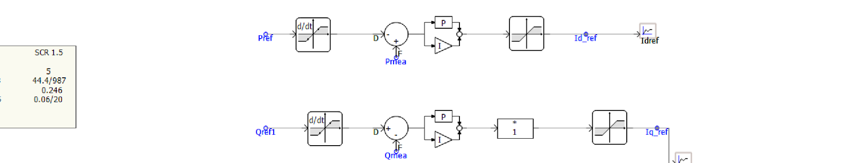
Figure 3. Outer power loop: Pref → Idref and Qref1 → Iqref, each through a derivative/deadband stage, a PI controller, and a ramp-rate limiter.
Pref and Qref1 are each passed through a derivative/deadband stage (to detect a change in reference rather than react to steady noise), compared against the measured power (Pmea, Qmea) in a PI controller, and then rate-limited before becoming the Idref / Iqref current references — the rate limiter keeps the converter from stepping current instantaneously on a reference change.
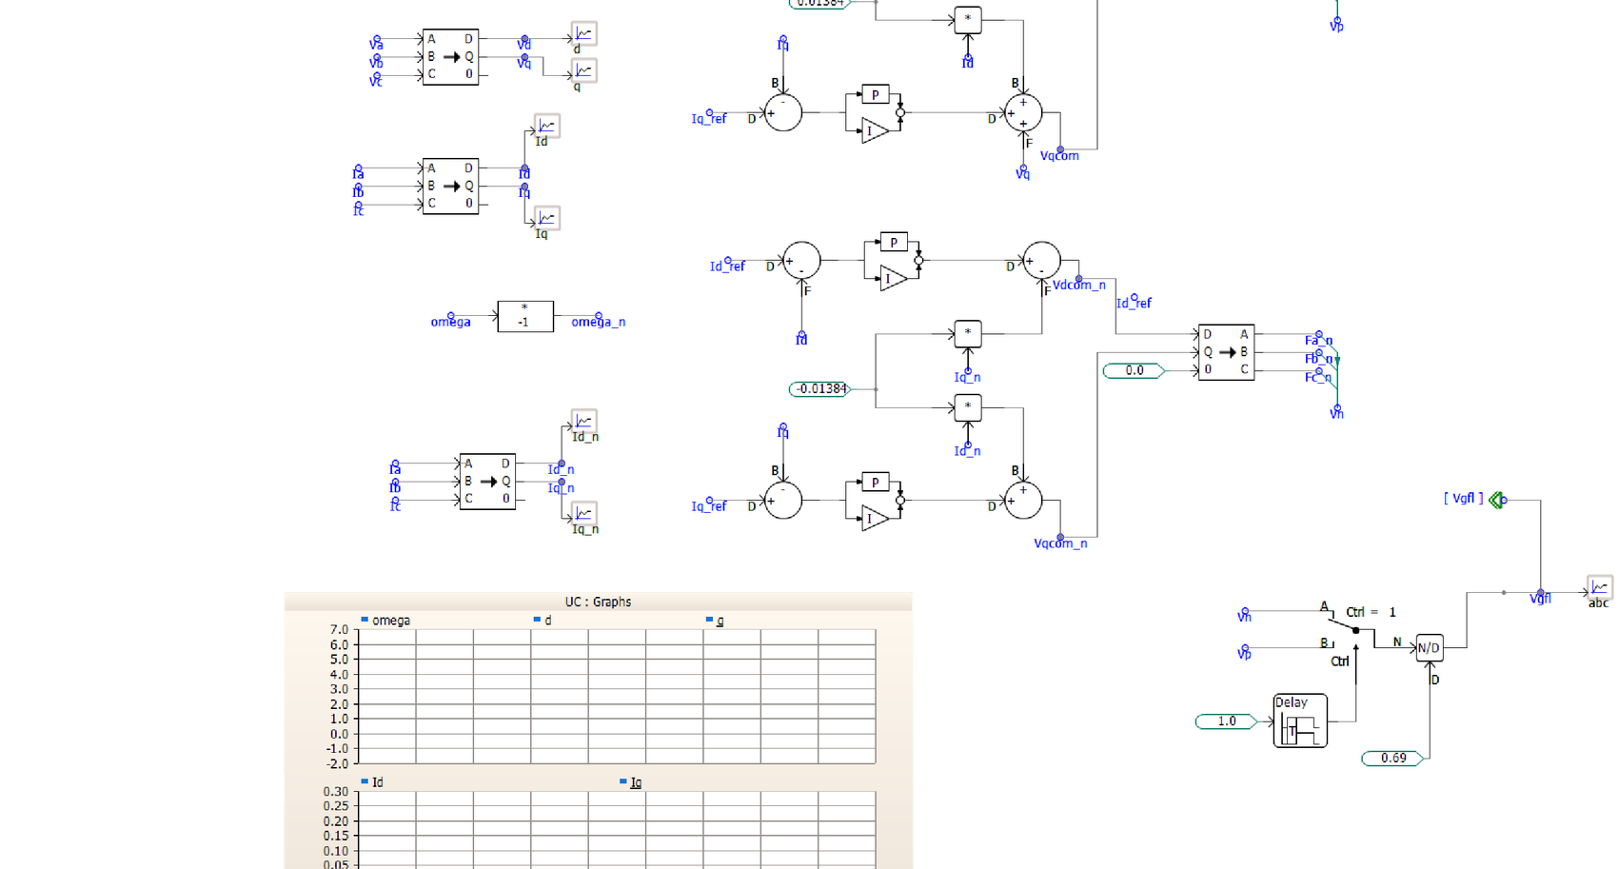
Figure 4. Inner current-loop control: abc→dq0 measurement transforms, decoupled Id/Iq PI control (Vdcom, Vqcom), and the mirrored negative-sequence path (Id_n, Iq_n → Vdcom_n, Vqcom_n) for unbalanced conditions.
The inner loop transforms the measured currents into the dq frame (Id, Iq) and regulates them to Idref/Iqref with independent PI controllers. Feed-forward decoupling terms (the 0.01384 pu gain blocks) cancel the cross-coupling that the rotating reference frame and converter-side inductance introduce between the d- and q-axis loops — without them, a step on one axis would disturb the other. The module mirrors this entire structure a second time using omega_n = −omega and a separate Id_n/Iq_n current pair, which is a negative-sequence control path: it lets the converter regulate negative-sequence current independently of positive-sequence current, which is what is needed for ride-through under unbalanced voltage sags rather than simply tripping.
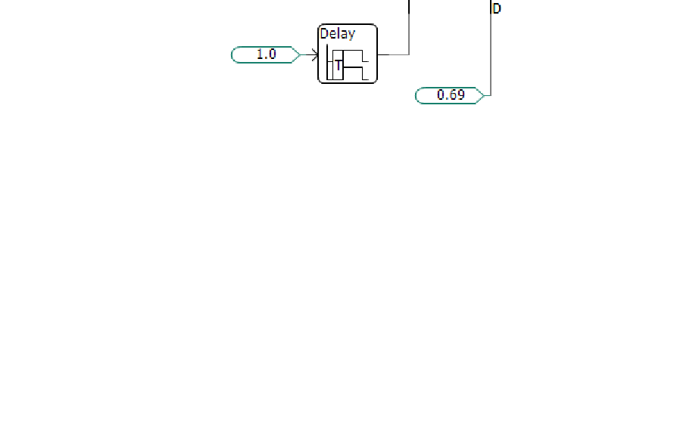
Figure 5. Output-stage selection and soft-start logic feeding the Vgfl output (Ctrl-selected source, ramp/Delay block, and final abc reconstruction).
Finally, a small switch/selection stage (Ctrl-driven A/B switch, a Delay block, and an N/D divider) manages how the dq voltage commands are assembled into the abc output Vgfl — functioning as a soft-start / mode-select gate so the module's output voltage reference ramps in cleanly rather than stepping when the module is enabled or when control mode changes.

GFL Illustrative Results
Note on the waveforms in this report
The PSCAD graph frames captured in the working diagrams (Figures 2–5) had not yet been populated with a simulation run at the time these diagrams were captured. The charts below are therefore illustrative / expected-behavior plots, built directly from the control equations and gain values shown in the diagrams (not exported PSCAD data). Replace them with your own run's output once available — the plot channel names (Freq_PLL, Idref/Iqref, etc.) already match the signal names used in the model.
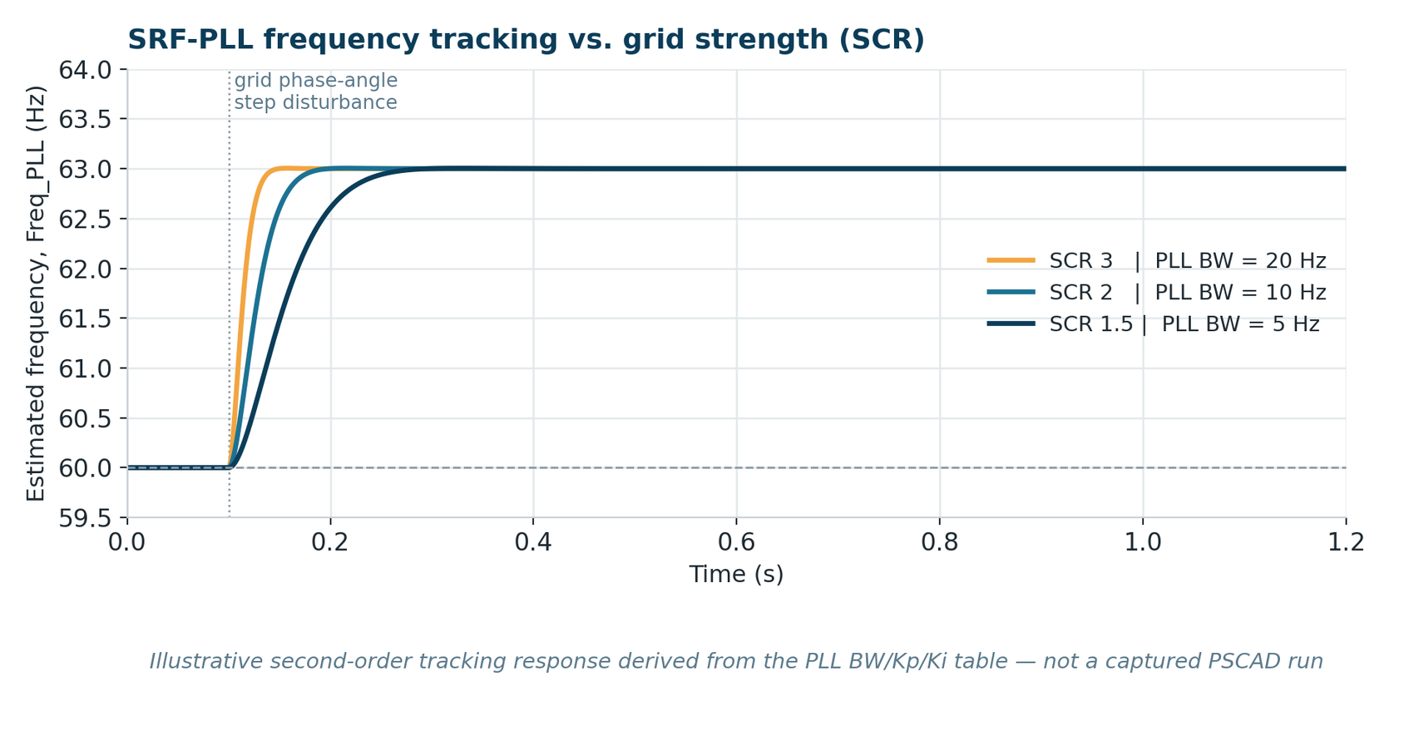
Figure 6. Illustrative SRF-PLL frequency-tracking response for the three SCR/bandwidth settings in the tuning table, following a grid phase-angle disturbance.
The expected pattern: at SCR 3 with a 20 Hz PLL bandwidth, the estimated frequency should settle fastest but with the most overshoot/ringing risk on a weak grid; at SCR 1.5 with a 5 Hz bandwidth, the response is slower but smoother and more robust to network interaction — the classic PLL bandwidth/stability trade-off the tuning table was built to manage.
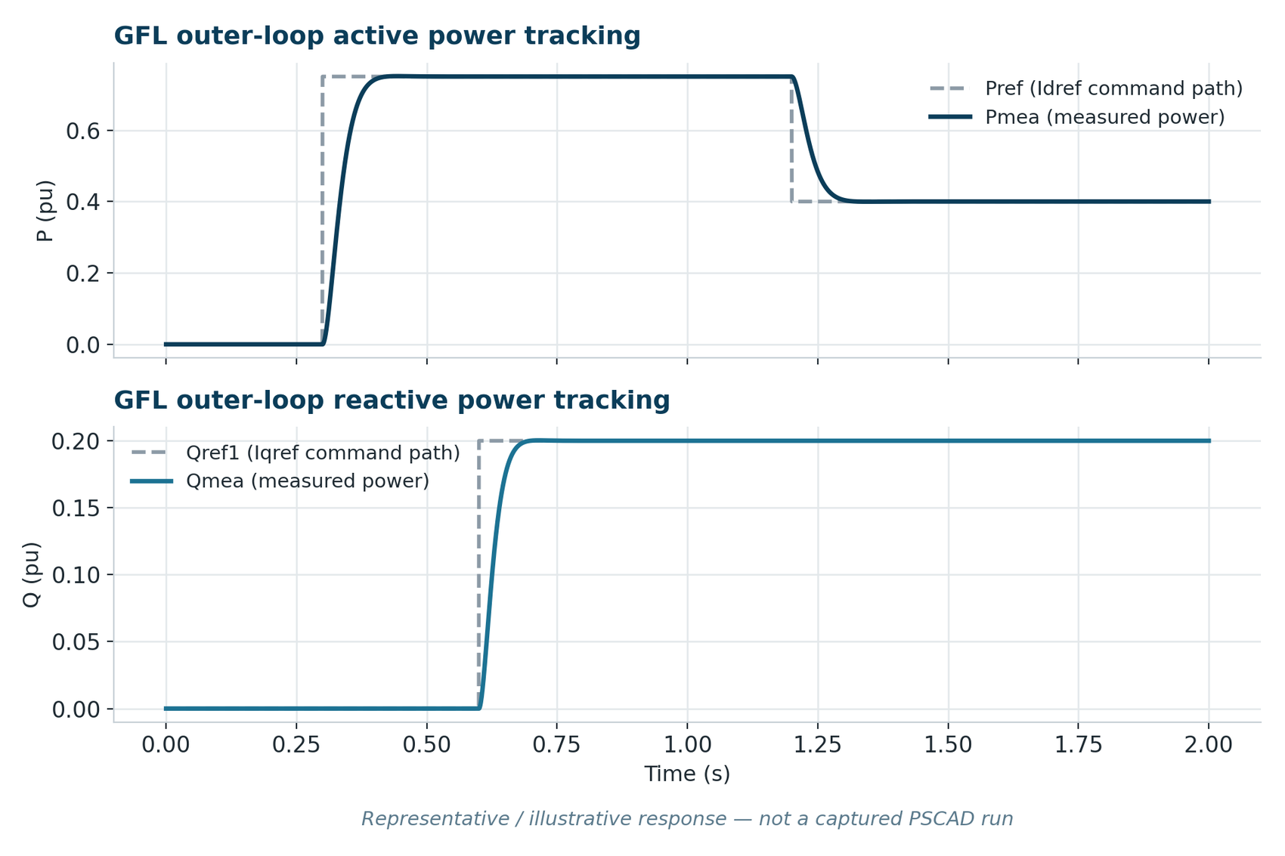
Figure 7. Illustrative outer-loop tracking of the active and reactive power references (Pref→Idref, Qref1→Iqref path) following step changes.

Day 4 — GFM Control: P-f and Q-V Droop
Grid-forming operation was implemented first as classical droop control, in direct analogy with a synchronous generator's governor (P-f droop) and automatic voltage regulator (Q-V droop).
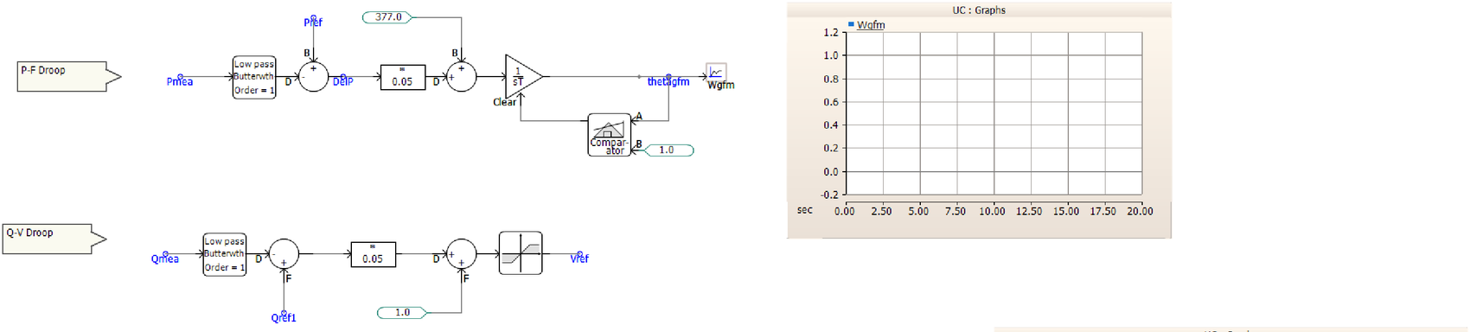
Figure 8. P-f droop (top) and Q-V droop (middle) control, generating the GFM inverter's frequency (Wgfm/thetagfm) and voltage reference (Vref).
In the P-f path, the measured power Pmea is low-pass filtered (a first-order Butterworth filter, which rejects switching/measurement noise so the droop responds to real power changes rather than ripple), compared against Pref, and multiplied by a droop gain of 0.05 (a 5% droop, in the same range as a typical governor droop setting). The result is added to the nominal angular frequency of 377 rad/s (2π×60 Hz) and integrated (1/sT) to produce the instantaneous phase angle thetagfm. A Comparator+Clear pair resets the integrator once the angle reaches its bound, implementing the modulo-2π wraparound a phase-angle integrator needs. The Q-V path mirrors this structure: filtered Qmea vs. Qref1, times the same 0.05 droop gain, added to the 1.0 pu nominal voltage and passed through a limiter to produce Vref.
Physically, this means: if the inverter is asked to supply more real power than its reference (Pmea > Pref), its own frequency droops downward in proportion to the 5% gain — exactly how parallel generators (or parallel GFM inverters) share load without needing to communicate with each other.

Day 5 — GFM Control: Virtual Synchronous Machine (VSM)
As an extension beyond simple droop, a Virtual Synchronous Machine (VSM) implementation was also built, which reproduces a synchronous generator's swing equation rather than just its steady-state droop slope:
2H · dω/dt = Pref − Pmea − D·(ω − ω₀)
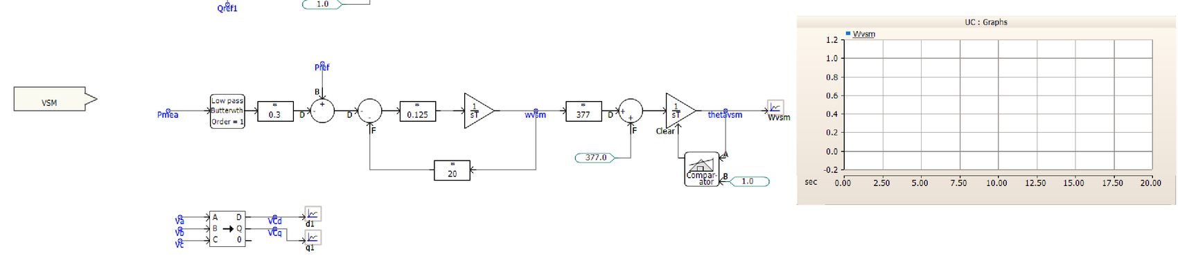
Figure 9. VSM control: filtered Pmea and Pref drive a damped swing-equation integrator (H ≈ 4 s inertia, D = 20 damping) to produce Wvsm/thetavsm; Va/Vb/Vc are also transformed to Vcd/Vcq for the voltage loop.
Mapping the diagram's gain blocks onto the swing equation: the 0.125 gain corresponds to 1/(2H), which implies an inertia constant H ≈ 4 s — a plausible synthetic-inertia value for a grid-scale BESS; the ×20 feedback path from the integrator output back into the summing junction implements the damping term D = 20; and the 0.3 gain on the filtered Pmea path shapes how strongly measured power feeds the swing dynamics before the Pref comparison. As before, the resulting speed deviation is scaled by 377 rad/s and integrated with the same Comparator/Clear wraparound logic used in the droop implementation, producing thetavsm.
The key difference from simple droop is dynamic, not just steady-state: because the swing equation contains an inertia term (2H), a sudden power imbalance changes the VSM's frequency gradually (a bounded rate-of-change-of-frequency, RoCoF) rather than jumping toward the new droop-implied operating point, while the damping term D still pulls the response back to a steady-state that is comparable to plain droop. This is exactly the “synthetic inertia” value proposition of VSM control for grids with declining synchronous-generator inertia.

GFM Illustrative Results
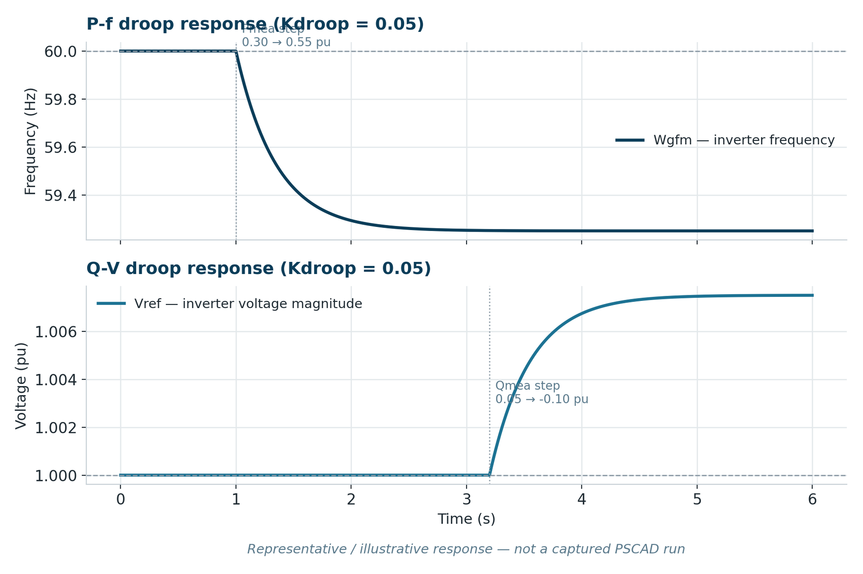
Figure 10. Illustrative P-f droop response (frequency, top) to a Pmea step, and Q-V droop response (voltage, bottom) to a Qmea step, each using the 5% droop gain from the diagrams.
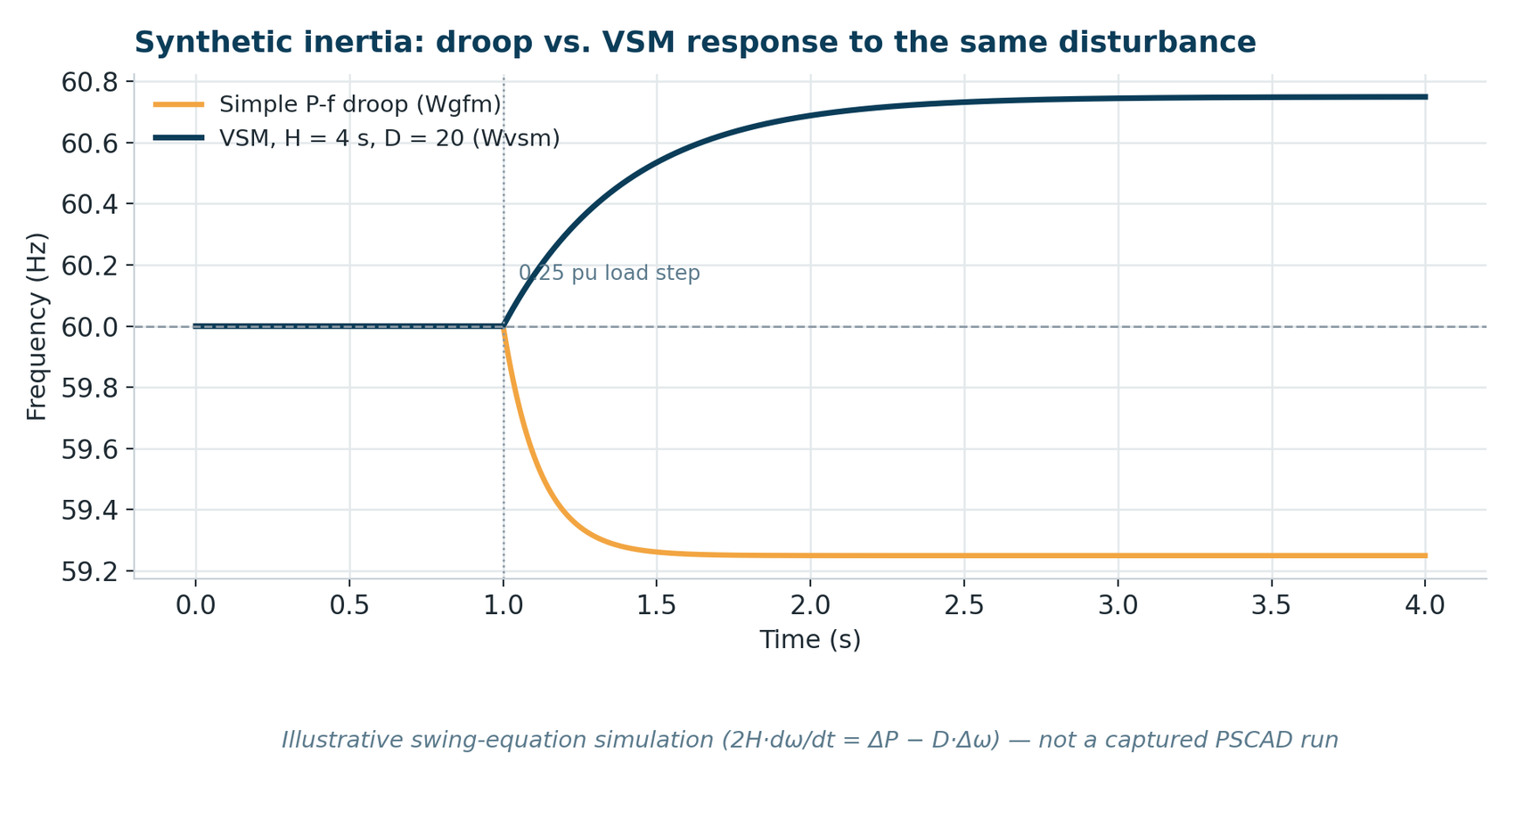
Figure 11. Illustrative comparison of simple droop (Wgfm) vs. VSM (Wvsm) frequency response to an identical 0.25 pu power step — the VSM curve shows a visibly slower initial rate-of-change-of-frequency (RoCoF) due to the H = 4 s virtual inertia, before both settle near the same steady state.
Both charts above are illustrative (see the note earlier in this section); they are provided as a template so the corresponding PSCAD run's Wgfm/Wvsm/Vref channels can be dropped in directly for the final presentation.

4. Work Stream B — Double-Conversion UPS Model for AI Data Center Load

Day 7 — Motivation and the ERCOT / TAMU Reference Model
Work Stream B applies the GFL/GFM building blocks from Work Stream A to a specific, high-relevance use case: representing an AI data center's power infrastructure for large-load interconnection studies. Rather than designing this from scratch, the model was built to align with the open-source EMT reference described in the callout below, which Texas A&M University and ERCOT jointly published specifically so industry has a shared, non-proprietary starting point — the reference model explicitly states it “does not intend to represent any specific data center design,” and is meant as a conceptual model that captures ride-through phenomena and mitigation options rather than a vendor-accurate design.
What the reference model provides
An open-source, modular, bottom-up PSCAD model (both switching and average versions) of a double-conversion UPS-based AI data center: rectifier, inverter, bidirectional DC/DC converter, battery ESS, VFD-based cooling load, and aggregated computing loads, plus a centralized voltage/frequency ride-through (VRT/FRT) module and three operating modes (bypass, normal converter, battery backup). Source: Wang et al., “Dynamic Modeling of AI Data Center Load in PSCAD,” TAMU–ERCOT, v1.0, April 2026.

Day 8 — Double-Conversion UPS Electrical Topology
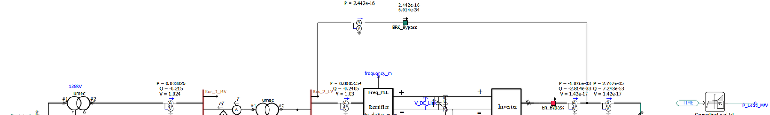
Figure 12. Main power circuit: 138 kV grid → 35 kV → 480 V step-down, static bypass breaker (BRK_Bypass), Rectifier → DC link → Inverter, and the Computing Load block driven by a ComputingLoad.txt profile.
The circuit follows a standard double-conversion (“on-line”) UPS layout. Utility power arrives at 138 kV and is stepped down through two transformers (138 kV/35 kV, then 35 kV/480 V) to the facility's low-voltage bus. From there, two parallel paths can supply the computing load:
- The bypass path (top, through BRK_Bypass) connects the load directly to the utility bus, with no power-electronic conversion in the path.
- The conversion path takes the AC bus through a Rectifier (AC→DC) that charges a DC link, then a DC-link capacitor, then an Inverter (DC→AC) that regulates a clean 480 V / 60 Hz supply to the load — continuously, in normal double-conversion operation, isolating the computing load from most upstream disturbances.
A DC-connected battery, through a bidirectional DC/DC converter, sits on the same DC link and can absorb or supply energy without disturbing this AC path. In the reference model's example ratings, the rectifier is sized at 1.5 MVA, the inverter and DC/DC converter at 1 MVA, the DC link at 900 V, and the battery at 600 V nominal — all values that also appear in the user's own diagram (900 V DC link, 600 V battery), consistent with this reference sizing. The ComputingLoad.txt profile referenced in the diagram is the mechanism the reference model uses to drive a realistic, time-varying IT load — in the published files it is real GPU power time-series data from the MIT Supercloud dataset, with the file simply containing a time column and a GPU-power column that the user can substitute with any other measured or synthetic load trace.

Day 9 — Core Conversion Blocks: Rectifier and Inverter

Rectifier (AC → DC): a grid-following converter
The rectifier is a three-phase, two-level voltage-source converter operating in grid-following mode — the same control family built in Work Stream A. It synchronizes to the grid through a PLL (the Freq_PLL block visible on the diagram) and uses the same dq-frame, decoupled, double-loop cascade (outer loop → inner current loop) described in Section 3.
- d-axis: normally regulates DC-link voltage (holding the DC bus stable so the inverter always has energy available); it can be switched to constant active-power control during rectifier reconnection, when the ramp rate rather than the DC-link error should set the power trajectory.
- q-axis: normally regulates reactive power (typically held at Q = 0), with an option for AC voltage support control if grid voltage support is required.
Because the rectifier behaves as a controlled current source from the grid's point of view, it also carries the ride-through-relevant ramp-rate limits: a fast ramp rate when taking over from bypass mode (to minimize the disturbance as power transfers from the static switch to the rectifier) or when tripping on a severe disturbance, and a slower, load-like ramp rate when reconnecting after a trip, so that reconnection does not itself look like a large step-load event to the grid.

Inverter (DC → AC): a grid-forming converter
The inverter is also a three-phase, two-level voltage-source converter, but operating in grid-forming mode — using exactly the P-f / Q-V droop control built in Work Stream A (Day 4), with the d-axis regulating AC voltage magnitude and the q-axis reference held at zero. This is the deliberate design choice that gives the double-conversion UPS its ride-through value: because the inverter forms its own voltage and frequency rather than following the grid, it keeps supplying stable 480 V / 60 Hz to the computing load even while the grid-side voltage is sagging or the rectifier is reacting — the computing load only “sees” a disturbance if the inverter itself cannot be sustained (i.e., if the DC link collapses).
The reference model adds one more droop term beyond standard P-f/Q-V: a VDC–VAC droop, which intentionally reduces the inverter's AC output voltage when the DC-link voltage sags. Lower AC voltage reduces the (roughly voltage-squared, for a resistive-equivalent load) power drawn by the computing load, which is a built-in, control-level way of protecting DC-link stability during a disturbance rather than relying solely on the battery.

Day 10 — Bidirectional DC/DC Converter and Battery State of Charge
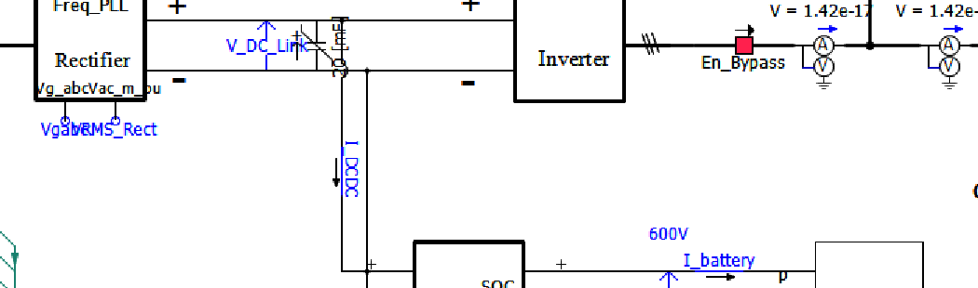
Figure 13. Battery interface: the SOC Bidirectional DC/DC converter between the 900 V DC link and the 600 V battery, with the SOC1 block reporting V_battery, I_battery, and SOC.

Bidirectional DC/DC converter
This is a buck/boost converter linking the DC link (high-voltage side, ≈900 V) to the battery (low-voltage side, ≈600 V), and it is the block that actually decides whether the battery is charging or discharging at any moment:
- Buck mode (charging): power flows from the DC link down to the battery. This mode uses single-loop power control — a PI controller tracks a charging-power reference (a modest set point, e.g. on the order of 0.1 MW in the reference sizing, well below the rectifier's spare capacity) so charging never competes with the computing load for rectifier capacity.
- Boost mode (discharging): power flows from the battery up to the DC link. This mode uses single-loop DC-link-voltage control — the converter's job shifts from “track a power target” to “hold the DC bus at its ordered voltage,” because during a rectifier trip or ride-through event the battery becomes the thing keeping the inverter (and therefore the computing load) alive.
This mode switch — power control while charging, voltage control while discharging — is the control-level expression of the UPS's core purpose: normally the battery is a managed, low-priority load; the moment the rectifier can no longer hold the DC link up, the battery becomes the DC link's primary regulator.

Battery / State of Charge (SOC) block
The battery itself is not modeled as an ideal, constant-voltage DC source. It uses a non-ideal (Thevenin-like) representation — an internal DC source in series with an output resistance — so that its terminal voltage sags under discharge current and recovers under light current or charging, which is what real battery packs do. Alongside the electrical terminals, the block outputs a State of Charge (SOC) signal, tracking the battery's remaining energy as it cycles between the charging mode above (SOC rising) and the discharging/backup mode (SOC falling while it supports the DC link). SOC does not directly appear in the converter's control loops in the reference design — the converter is commanded into charge or discharge mode by the higher-level VRT/FRT logic in Section 4.3 below — but SOC is essential for monitoring how much ride-through duration remains and for any future extension (e.g., blocking further discharge, or de-rating charging power, near SOC limits).

Day 11 — Voltage & Frequency Ride-Through (VRT/FRT) Module
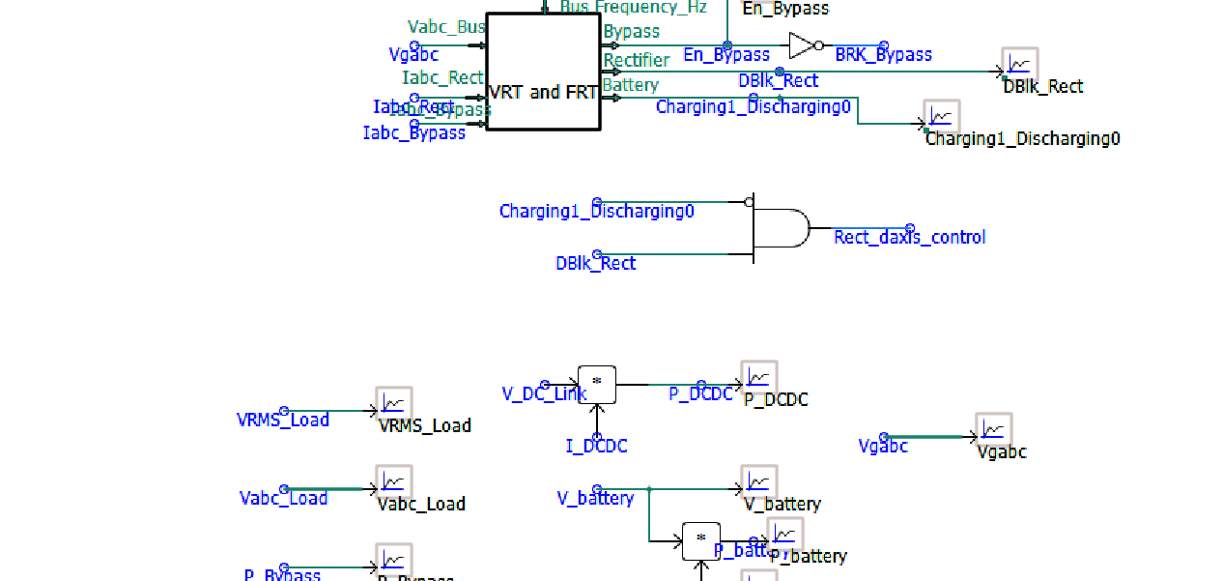
Figure 14. Centralized VRT and FRT logic: monitors bus voltage/frequency and rectifier/bypass current to drive Bypass, DBlk_Rect, and Charging1_Discharging0; a downstream AND gate (Rect_daxis_control) and a first-order filter shape the inverter power setpoint.
This block is the UPS's supervisory brain. It continuously monitors the point-of-common-coupling voltage and frequency, the rectifier's AC current, and the bypass breaker's current, and compares them against configurable multi-point ride-through curves (with independent settings for over/undervoltage, over/underfrequency, and overcurrent, each with its own hold-up time). Based on those comparisons it drives three coordinated outputs: whether the bypass breaker should be open or closed (Bypass / En_Bypass / BRK_Bypass), whether the rectifier should be blocked or deblocked (DBlk_Rect), and whether the battery converter should be in charging or discharging mode (Charging1_Discharging0). A downstream AND gate (Rect_daxis_control) combines the charge/discharge state with the rectifier block state to help select the rectifier's d-axis control mode, and the inverter's power order is passed through a first-order lag (P_Inv → P_Inv_Setpoint) so that mode-transition power changes are smoothed rather than stepped.
The inverter itself is intentionally never blocked by this logic — the reference design keeps it continuously deblocked precisely so the computing load never loses supply while the rectifier/bypass/battery negotiate which upstream source is feeding the DC link.

Day 12 — Operating Modes and Illustrative Ride-Through Results
Mode | Path to load | Rectifier | Battery
Bypass | Direct from utility bus, through BRK_Bypass | Idle / trickle-charging the battery only | Standby or charging
Normal converter | Rectifier → DC link → Inverter | Regulates DC-link voltage (GFL) | Buck mode, charging
Battery backup | Battery → DC/DC → DC link → Inverter | Blocked / tripped | Boost mode, discharging, regulates DC-link voltage
Under normal, healthy grid conditions the UPS runs in bypass mode — the most efficient path, with no conversion losses. On a voltage or frequency excursion beyond the bypass breaker's ride-through curve, control transfers to normal converter mode, where the GFL rectifier and GFM inverter jointly regulate the DC link and the output bus. If the disturbance is severe enough that the rectifier itself trips, the system falls through to battery backup mode, where the battery alone sustains the DC link until the grid recovers and the rectifier can be reconnected (with a ramp-rate-limited, load-like reconnection, as noted in Section 4.2).
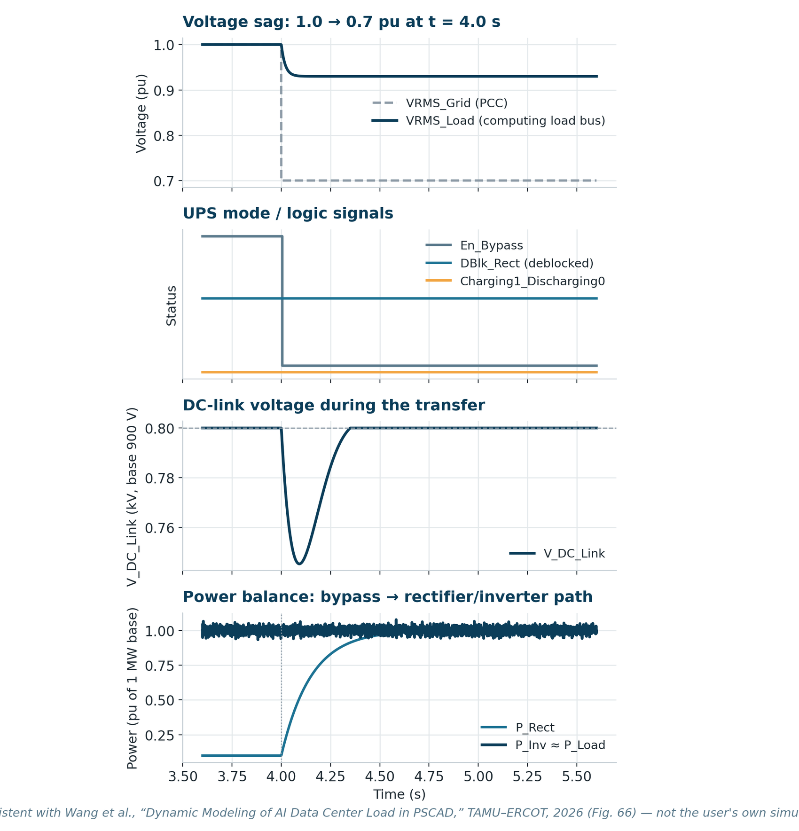
Figure 15. Illustrative bypass → normal-converter-mode transfer for a 1.0→0.7 pu voltage sag: grid vs. load RMS voltage, mode/logic signals, DC-link voltage, and the power hand-off from the bypass path to the rectifier/inverter path.
This pattern is drawn to match the qualitative shape reported for the reference model's own sag test case (a 1.0→0.7 pu sag transferring the load from bypass to normal-converter mode): the bypass breaker opens once the sag crosses its threshold, the inverter almost immediately takes over the load bus so load-side voltage dips only briefly, the DC link shows a short transient dip while the rectifier re-establishes regulation, and computing-load power is held essentially constant throughout — the entire point of the double-conversion topology.
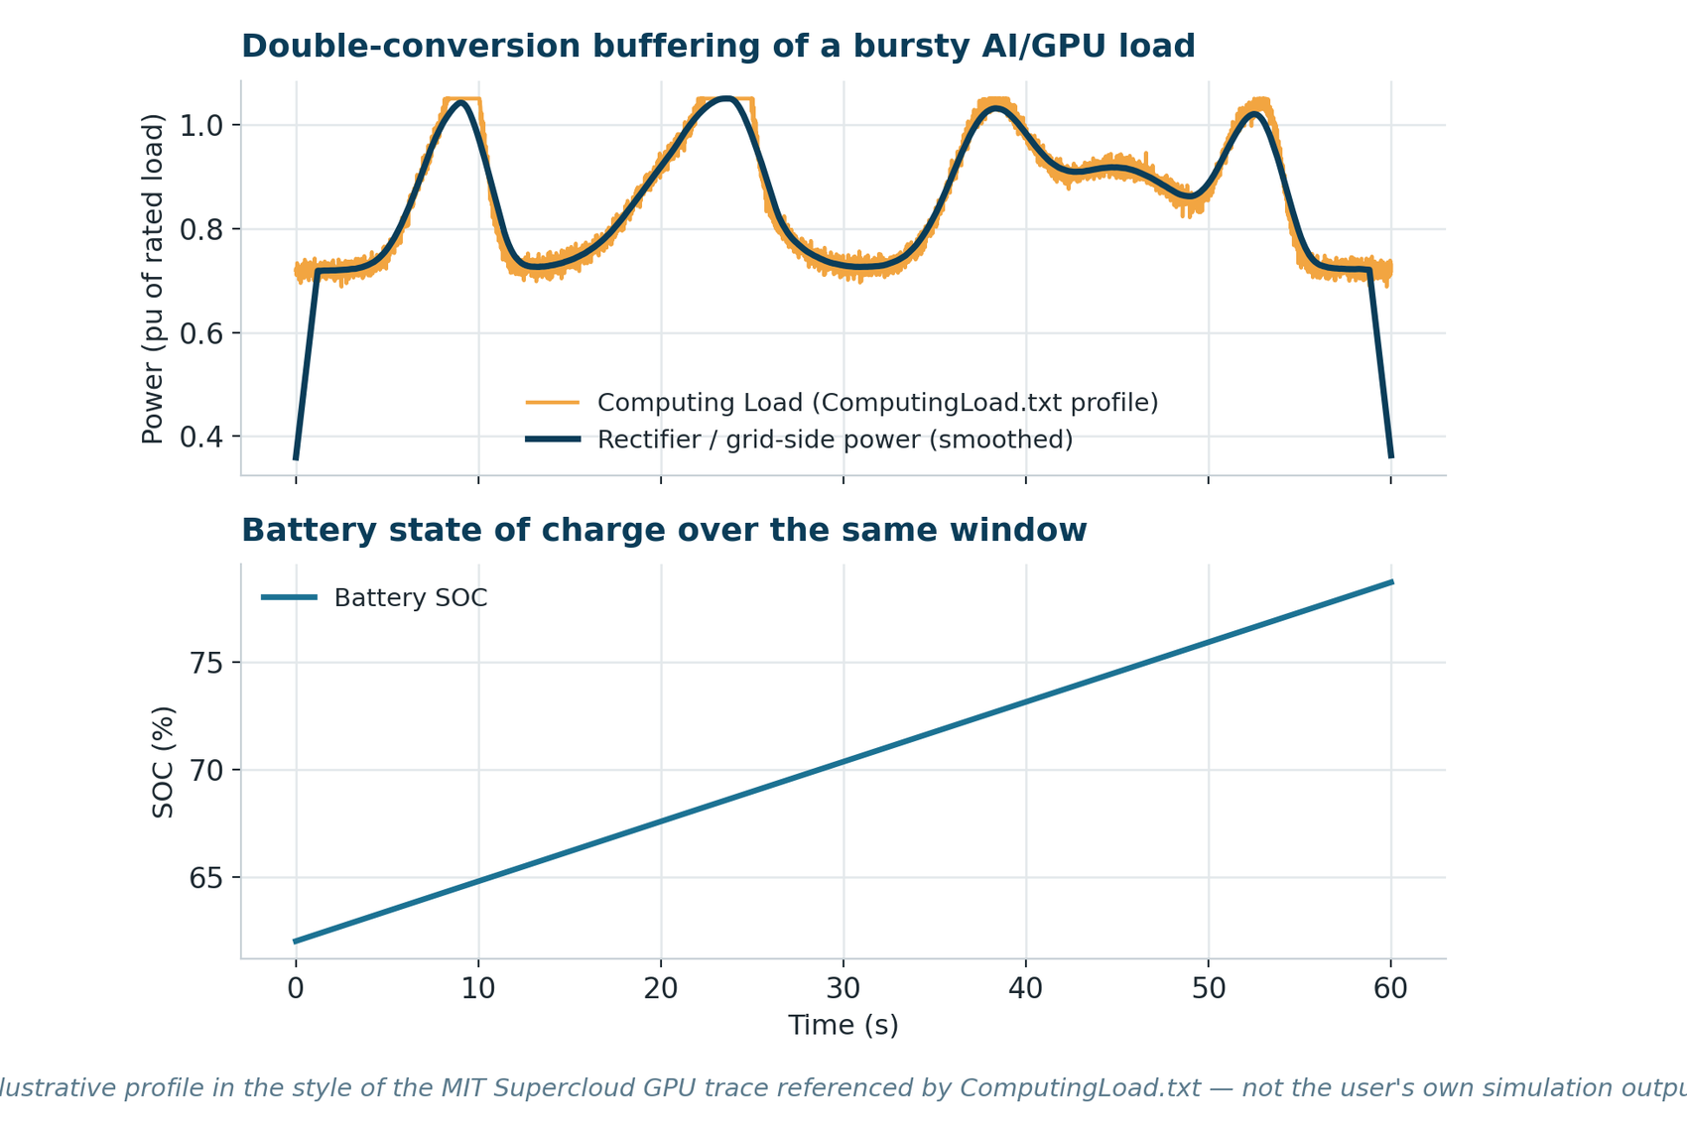
Figure 16. Illustrative bursty computing-load profile (in the style of the GPU time-series ComputingLoad.txt trace) against a smoothed rectifier/grid-side power draw, and the resulting battery SOC trend.
This second chart illustrates a different, non-fault benefit of the same topology: because the DC link buffers energy and the rectifier's power reference is ramp-rate limited, fast, bursty swings in the computing load (typical of real AI/GPU training workloads) do not need to appear as equally fast swings on the grid side — the battery and DC-link capacitor absorb the short-timescale fluctuation while the rectifier, and therefore the grid, sees a much smoother power draw.

5. Summary of Work Completed

Work Stream A — GFL/GFM control module
- Integrated a combined GFL/GFM control module into the existing PCS average model, with a clearly defined signal interface (Vabc1, ModuleCur, PQref, BatVolt, P/Q feedback → Vgfl).
- Implemented and tuned an SRF-PLL for grid-following synchronization across three grid-strength (SCR) operating points, adjusting PLL bandwidth, PLL gains, current-loop gains, and power-loop gains together as SCR drops.
- Implemented the GFL outer power loop and inner dq current loop, including feed-forward decoupling and a full negative-sequence control path for unbalanced-condition ride-through.
- Implemented GFM control two ways — P-f/Q-V droop, and a Virtual Synchronous Machine with explicit inertia (H) and damping (D) terms — and reasoned through the expected RoCoF/inertia difference between them.

Work Stream B — AI data center UPS model
- Reproduced the double-conversion UPS electrical topology from the ERCOT/TAMU reference model: 138 kV → 35 kV → 480 V grid interface, bypass breaker, rectifier, DC link, inverter, and battery via a bidirectional DC/DC converter.
- Mapped the rectifier to grid-following control and the inverter to grid-forming (P-f/Q-V, plus VDC–VAC) droop control — directly reusing the Work Stream A control designs.
- Documented the bidirectional DC/DC converter's buck/boost mode logic (charging = power control, discharging = DC-link voltage control) and the non-ideal battery/SOC block.
- Documented the centralized VRT/FRT ride-through module and the resulting three operating modes (bypass, normal converter, battery backup), and how they transition into one another during a grid disturbance.

6. Key Learnings
- PLL bandwidth is not a fixed design constant — it is a stability lever that must be co-tuned with grid strength (SCR); the same logic (slow down control loops as the grid gets weaker) shows up repeatedly across PLL, current-loop, and power-loop gains.
- GFM control's real advantage over GFL is not just “no PLL needed” — it is that GFM can define an operating point that a downstream load or bus can synchronize to, which is exactly why the reference UPS model uses a grid-forming inverter to protect the computing load from upstream disturbances.
- VSM control is best understood as droop control plus an explicit inertia term — same steady-state droop slope, but a bounded rate-of-change-of-frequency during the transient, which is the specific property grid codes are asking for as synchronous inertia declines.
- A double-conversion UPS's ride-through performance is a coordinated, multi-converter behavior (rectifier ramp rates, inverter droop, DC/DC mode switching, and centralized VRT/FRT logic all acting together) rather than the property of any single block.
- Building against a public, peer-reviewed reference model (rather than an ad hoc representation) made it possible to sanity-check every block's rated values (e.g., 900 V DC link, 600 V battery, 1–1.5 MVA converter ratings) against a documented source.

7. Future Work / Next Steps
- Run the completed PSCAD cases and replace every illustrative chart in this report with the actual captured Freq_PLL, Idref/Iqref, Wgfm/Wvsm, and UPS ride-through channel data.
- Validate PLL and current-loop tuning at each SCR point against a formal small-signal stability margin (e.g., impedance-based or eigenvalue analysis), not just step-response inspection.
- Extend the VSM comparison into a multi-disturbance study (multiple step sizes, and a fault-ride-through case) to quantify RoCoF and frequency-nadir improvement over droop.
- Exercise the UPS model's bypass → normal-converter → battery-backup transitions across the full LVRT/HVRT curve, not just the two sag depths used for illustration here, and compare against the reference model's own published results.
- Load the real ComputingLoad.txt (or an equivalent site-specific load trace) and quantify how much the DC link/battery reduce grid-side power fluctuation, to support an interconnection-study-style writeup.
- Compare switching-model vs. average-model runtimes and dynamic accuracy on this specific model, following the methodology in the reference report, to choose the right model fidelity for future large-scale studies.

8. References
[1] X. Wang, X. Chen, P. Enjeti, F. C. Lin, A. Yazdanpanah, J. Rose, Y. Cheng, A. Quedan, P. Kansal, “Dynamic Modeling of AI Data Center Load in PSCAD,” TAMU–ERCOT, Version 1.0, April 2026.
[2] ERCOT, “Large Load Modeling” (open-source AI data center PSCAD model and documentation).
[3] Electric Power Engineers (EPE), “ERCOT: New Dynamic Model Submission Requirements for Large Loads.”
[4] PSC Consulting, “Data Center Load Modeling and Assessment” (ERCOT NPRR1234 / PGRR115 large-load interconnection requirements).
[5] IEEE Std 2800-2022, “IEEE Standard for Interconnection and Interoperability of Inverter-Based Resources (IBRs) Interconnecting with Associated Transmission Electric Power Systems.”
[6] NERC Reliability Guideline, “Improvements to Interconnection Requirements for BPS-Connected Inverter-Based Resources” (grid-forming / grid-following control background).

