PWD

It shows the path of present working directory

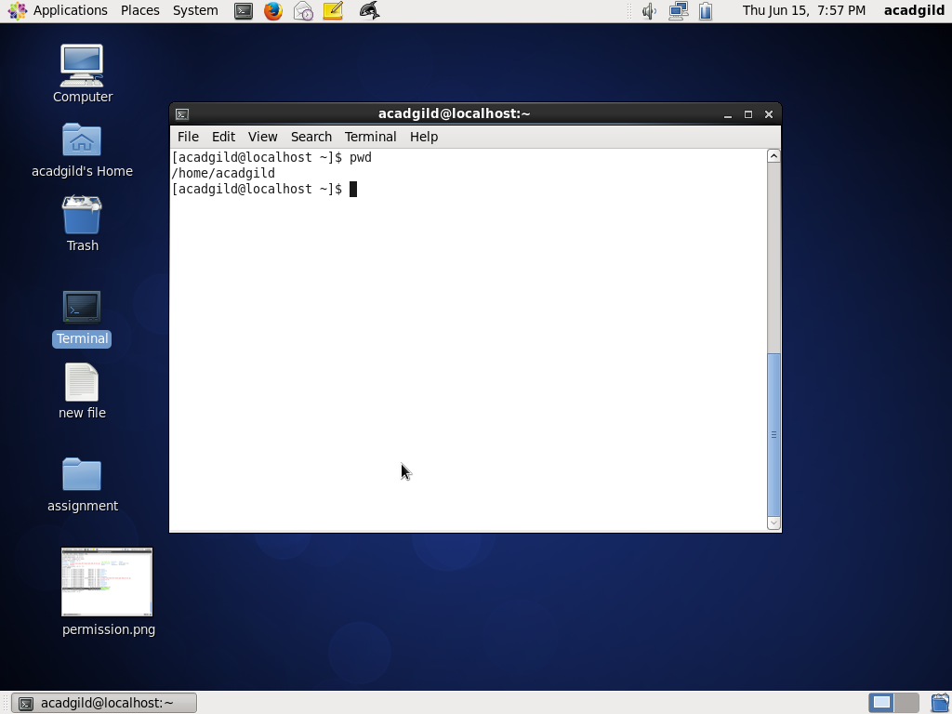

VI command

This command is used to open the file and data can be written and saved in the file

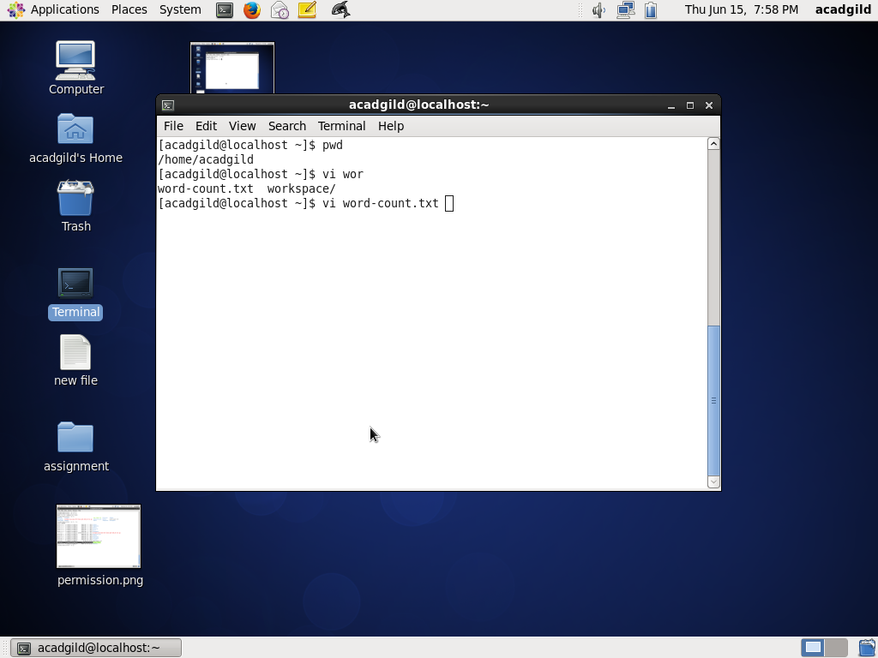

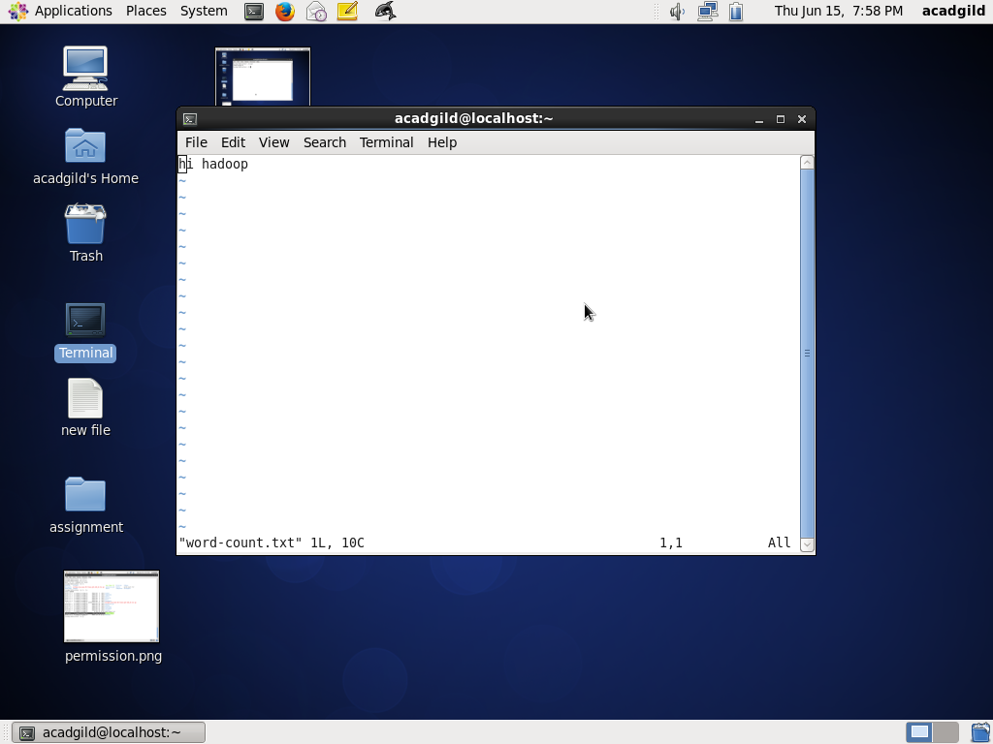

Touch command

This command is used to create new empty file

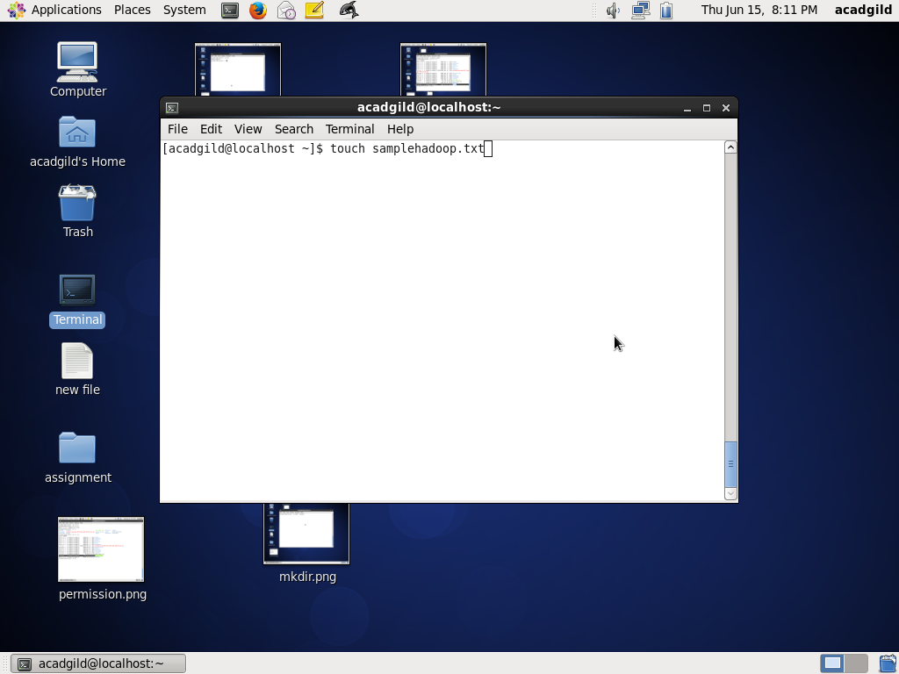

Mkdir command : This command is used to create folder

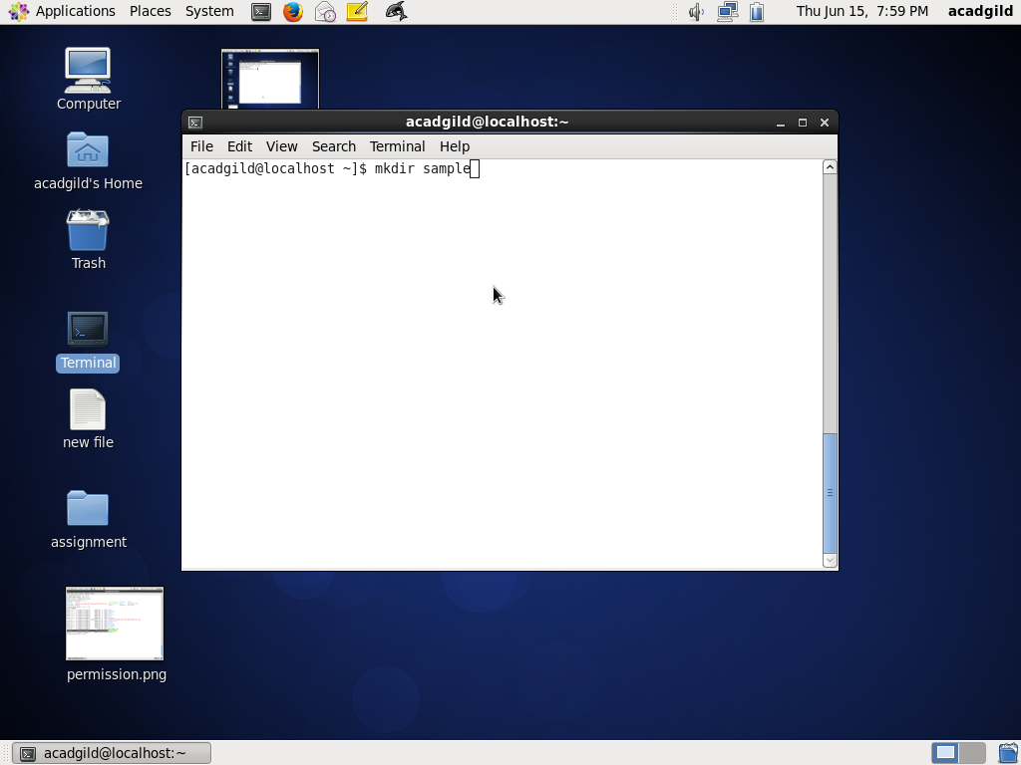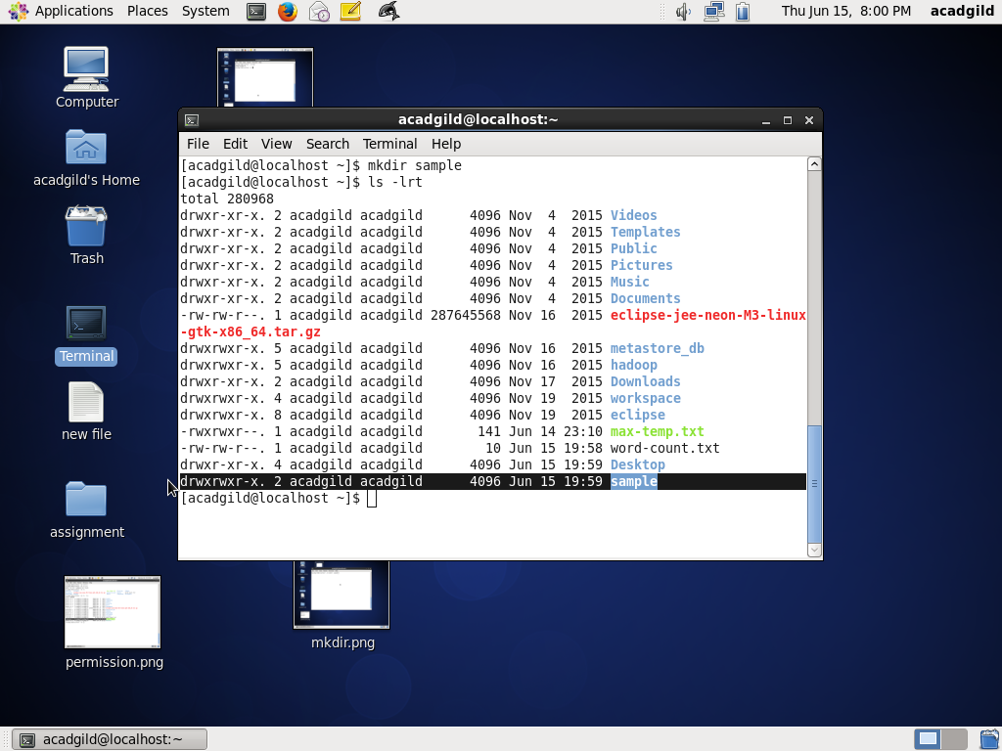

RM command

This command is used to remove the file or folder

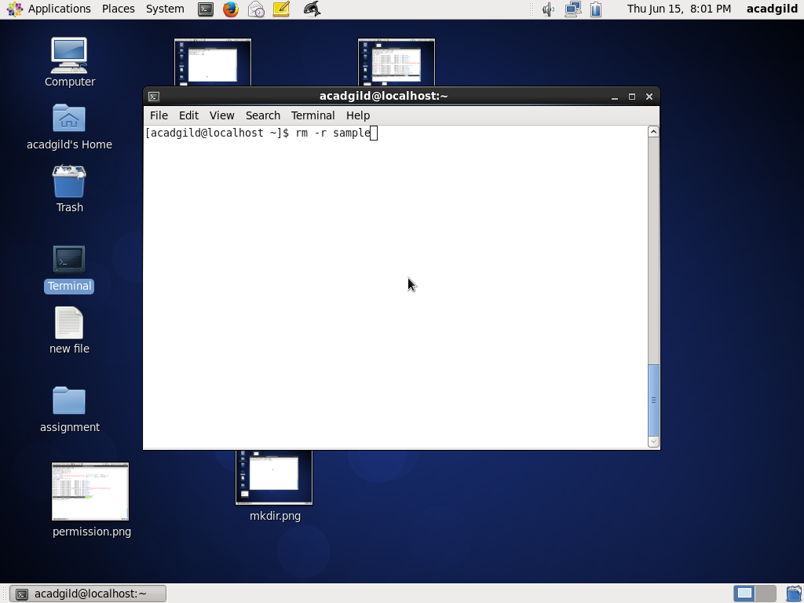

Ls command

This command is used to list all the folders and files present in the current directory

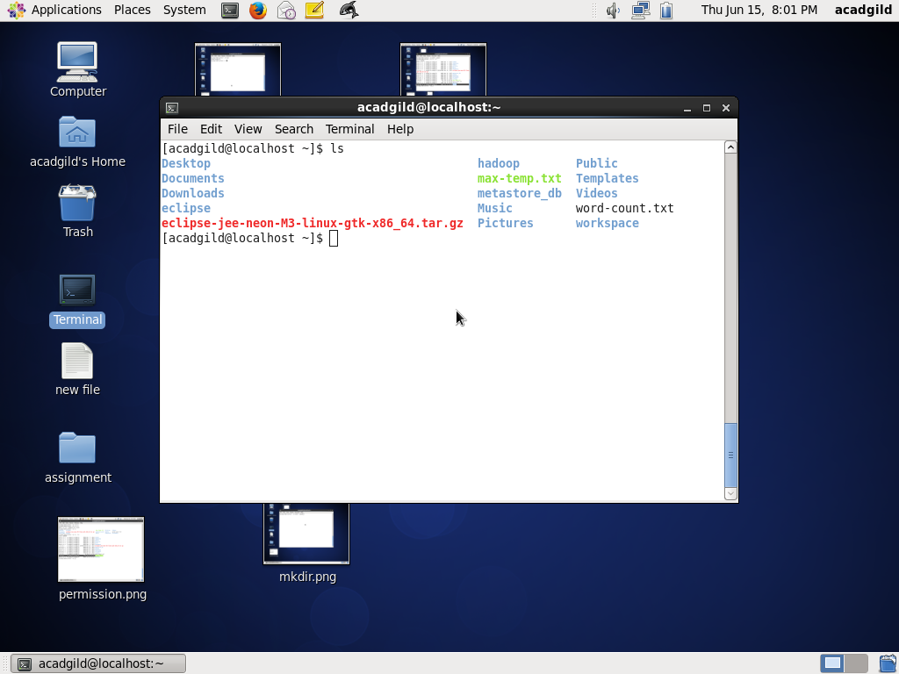

Echo command

This command is used to print the content

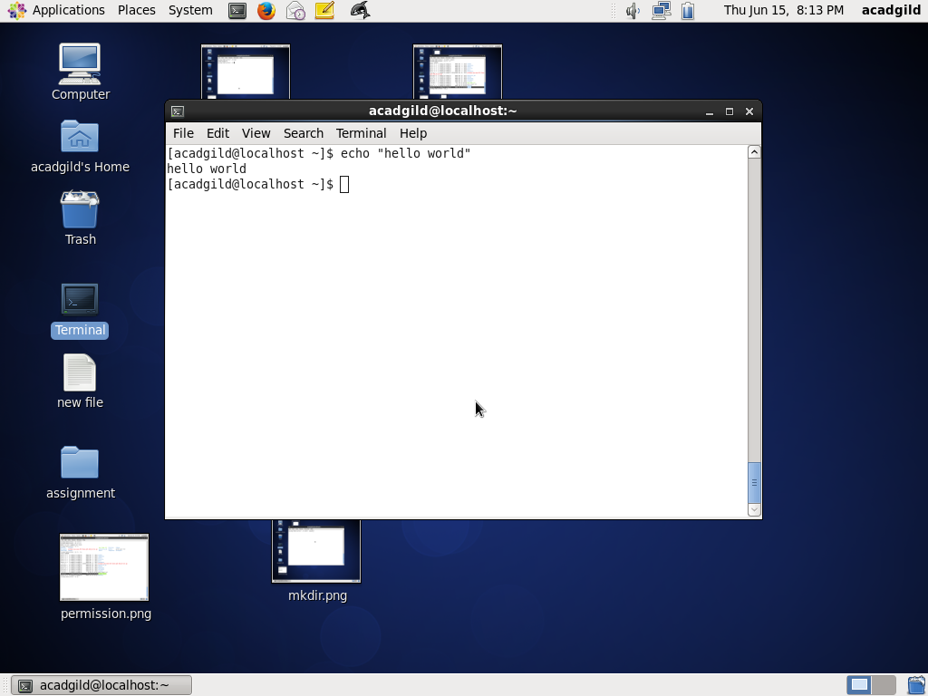

Cat Command

This command is used to display the content in the file



Who command

This command is used to display system date etc

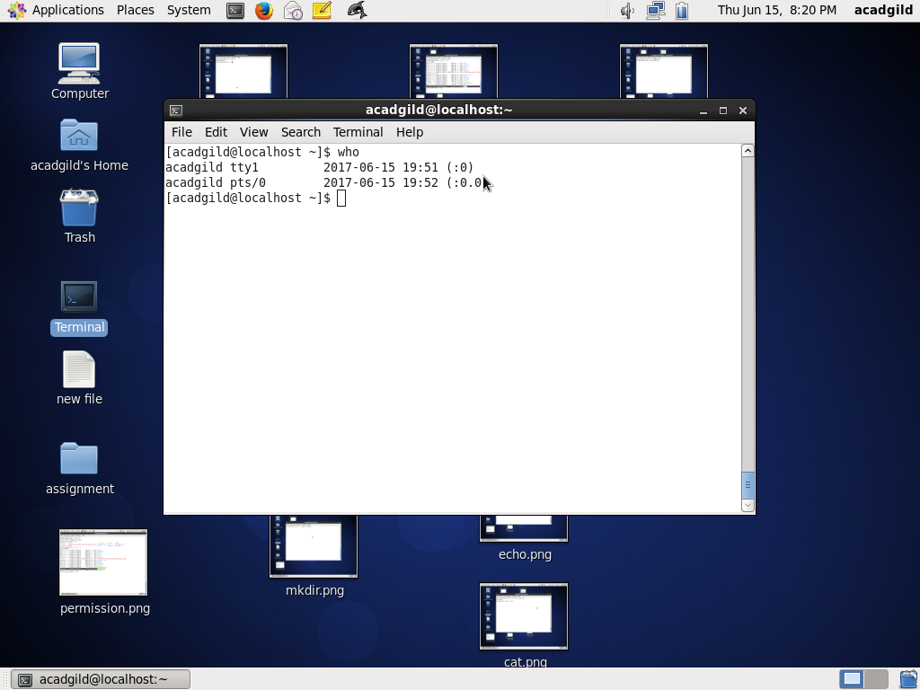

Cd Command

This command is used to change/move to the specified directory

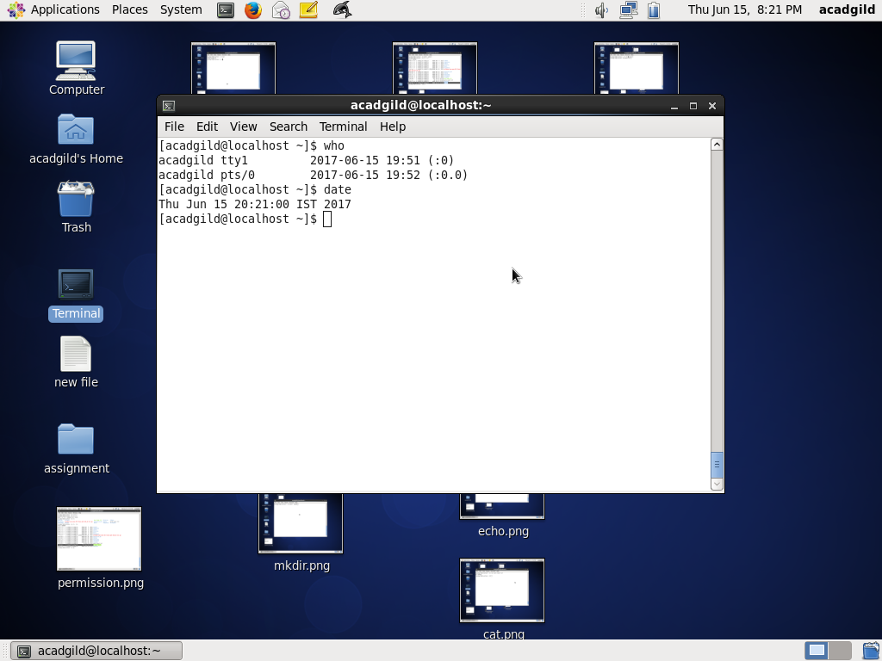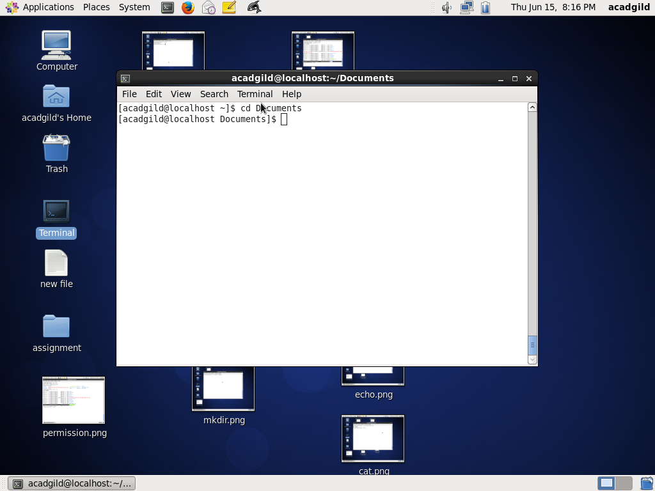

Date command

This command is used to display the date



Cal command

This command is used to display the calendar

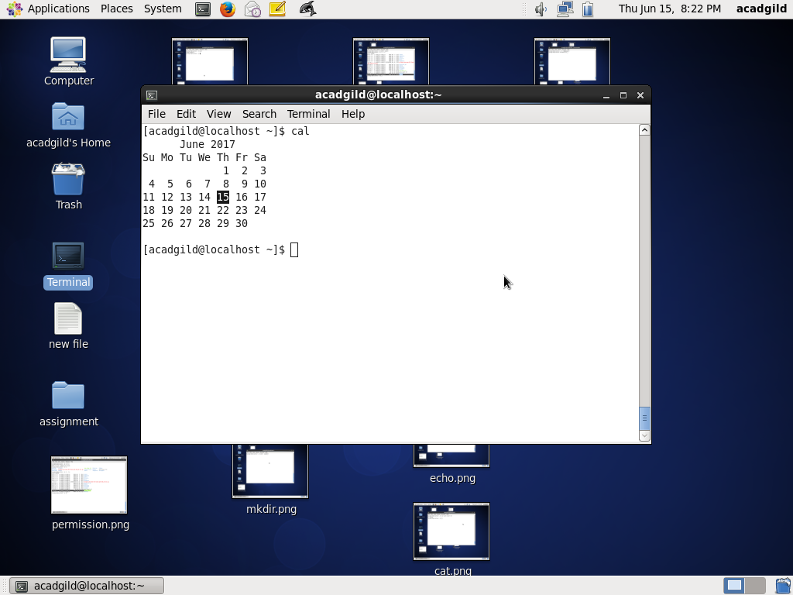

Mv command

This command is used to rename the file or folder

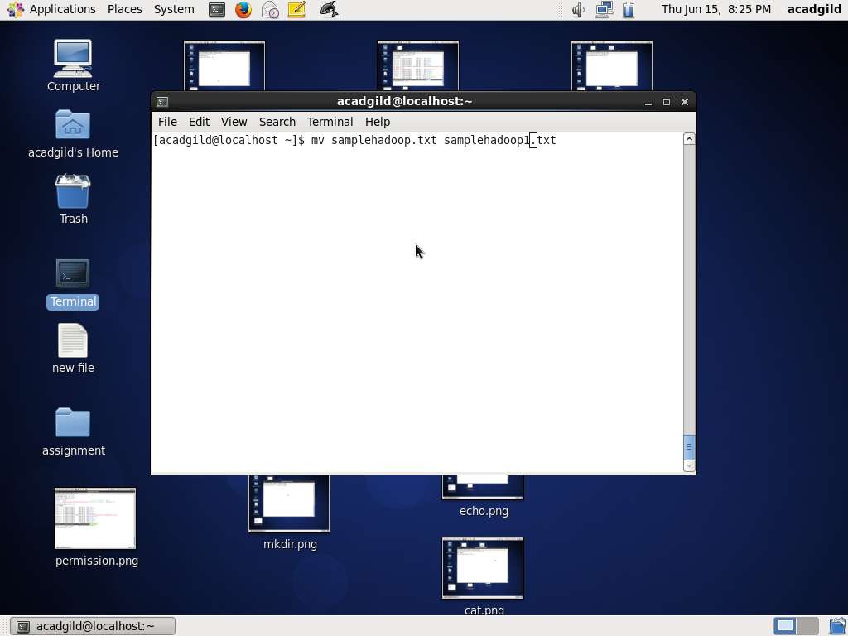

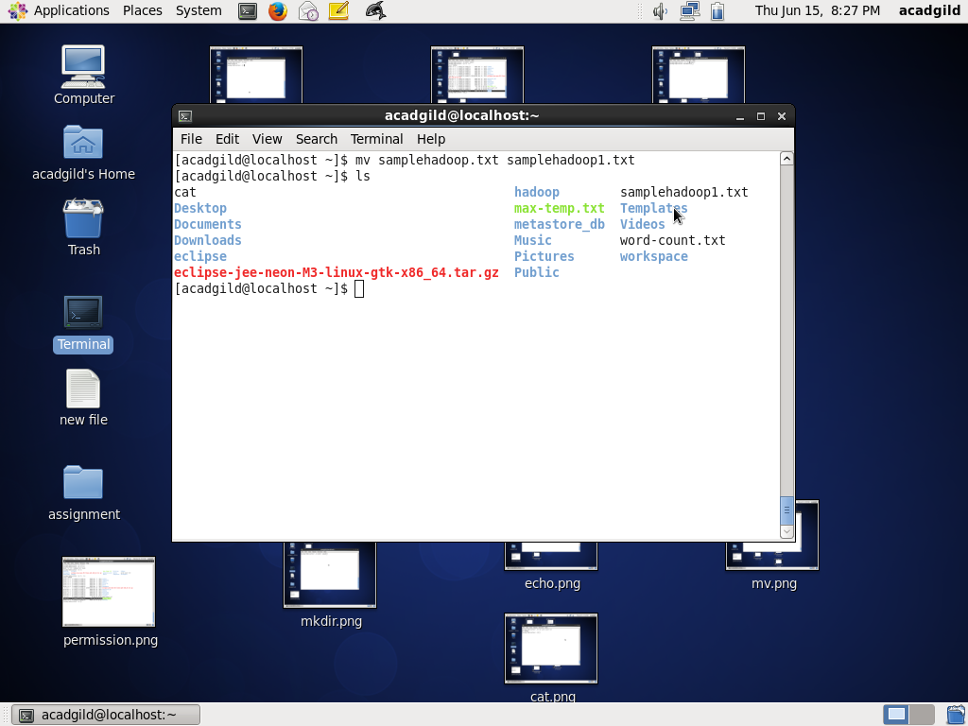

Cp command

This command is used to copy the file or folder from one location to another

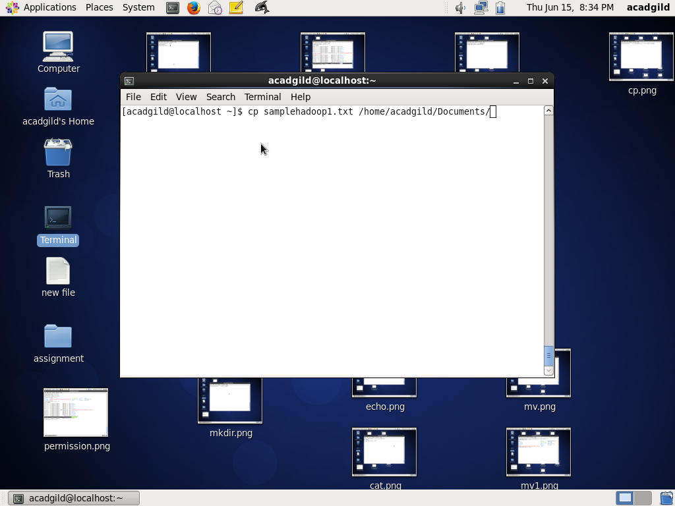

Which command

This command is used to show the location of the file or etc

