QUANTUM COMPUTING – GROUP RESEARCH ASSIGNMENT
Final Report
Group 20
Noise and Error Mitigation
Implemented with Qiskit + Qiskit Aer (Python)

Team Details
# | Student Name | Roll / Reg. No. | Role / Main Contribution
1 | G Srikaanth | 1MS23CY015 | Team to fill
2 | Devansh Sharma | 1MS23CY014 | Team to fill

Course / Section | Quantum Computing; section: Team to fill
Faculty Guide | Team to fill
Date of Submission | Team to fill
Report (PDF) link | Team to fill: Google Drive link to the PDF
Code repository / Colab link | https://github.com/srikantlose/quantum-error-mitigation-bench (public)  Interactive results dashboard and study guide: https://quantum-error-mitigation-bench.vercel.app

Assigned Group Brief (pre-filled – do not edit)
This table reproduces your group’s assignment from the consolidated assignment sheet. Your report must address every row.
Research problem | Noise and Error Mitigation
Detailed problem statement | Investigate whether a selected error-mitigation method improves the output quality of a noisy quantum circuit.
Research objective | Test a simple error-mitigation technique.
Dataset required | Iris binary or small expectation-value circuit
Qubits | 2,4,6
Circuit depth / algorithm parameter | Depth 2,4
Noise levels | Ideal, low, moderate
Common run settings | 1024; 5 seeds
Baseline / comparison | No mitigation baseline
Metrics to observe | Accuracy/fidelity before and after mitigation, overhead
Expected research analysis | Effectiveness and cost of mitigation
Fixed parameters (assignment document) | Qubits: 2, 4; Noise: No noise, low noise, medium noise; Shots: 1024.
Experimental tasks | 1. Select a circuit. 2. Establish a noiseless reference. 3. Add noise. 4. Apply a suitable error-mitigation technique if supported. 5. Compare results before and after mitigation.
Expected results | Error comparison, output distribution analysis, circuit overhead, and a discussion of mitigation limitations.

Common settings for all groups
Item | Standard requirement
Environment | Python 3.x, Qiskit, Qiskit Aer, NumPy, Pandas, Matplotlib, Scikit-learn
Data split | Stratified 80:20 train-test split; same split for classical and quantum models; fit scaling/PCA on training data only
Repeated runs | 5 random seeds where feasible; report mean ± standard deviation
Shots | 1024 per circuit execution
N0 – Ideal | No noise
N1 – Low noise | 0.1% single-qubit, 0.5% two-qubit, 1% readout error
N2 – Moderate noise | 1% single-qubit, 2% two-qubit, 3% readout error
N3 – High (optional) | 3%–5% gate error and higher readout error (stress test)
Noise model | Depolarizing error + readout error (thermal relaxation optional if documented)
Minimum experiments | At least 6 controlled experiments, varying at least two parameters
Reporting | Tables/plots, limitations, research gap, fair comparison; do not claim quantum advantage without evidence

1. Problem Understanding and Objectives (2 marks)

1.1 Problem statement
Current noisy intermediate-scale quantum (NISQ) processors make mistakes in both their gates and their measurements. These errors bias the expectation values a circuit returns, usually shrinking them toward zero, and the bias grows with the number of qubits and the circuit depth. Full quantum error correction would remove the bias, but it needs many physical qubits per logical qubit and hardware that does not yet exist at useful scale [1]. Quantum error mitigation is the practical alternative for today's devices: it runs extra circuits and post-processes their results classically to remove bias from averaged quantities, without extra qubits [13]. Mitigation is not free. It costs extra circuits, shots and circuit depth, it can amplify statistical noise, and each method targets only part of the noise. This project asks whether two widely used methods, readout error mitigation (REM) and zero-noise extrapolation (ZNE), and their combination actually improve the output of a noisy circuit; what each costs; and whether the improvement carries through to a downstream quantum machine-learning task. We study this in a controlled Qiskit Aer simulation with the course-standard noise levels, on a parameterized circuit (2, 4 and 6 qubits; depth 2 and 4) and on a variational quantum classifier (VQC) for the Iris binary task, compared against Logistic Regression and SVM. The question matters because every near-term quantum algorithm depends on reading accurate expectation values from noisy hardware, and choosing a mitigation method means trading accuracy against cost.

1.2 Objectives
O1. Build a controlled, reproducible noisy-simulation testbed in Qiskit Aer with the course noise levels N0–N3 (2, 4 and 6 qubits; depth 2 and 4; 1024 shots; 5 seeds per condition).
O2. Implement REM (full and tensored) and ZNE (global folding with Richardson extrapolation), alone and combined, and measure the change in expectation-value error, Hellinger fidelity and success probability against the no-mitigation baseline.
O3. Measure each method's cost (circuits, shots, transpiled depth, two-qubit gates) and test whether the gains carry into a VQC on Iris binary, compared with Logistic Regression and SVM on identical data splits.
O4. Propose two lower-cost variants, tensored REM and variance-optimal ZNE shot allocation, and test both with data.

1.3 Research questions / hypotheses
RQ1. Do REM, ZNE and their combination reduce expectation-value error and improve the output distribution of a noisy circuit across noise levels N0–N3, 2–6 qubits and depth 2–4?
RQ2. What does each method cost in circuits, shots, depth and two-qubit gates, how does that scale with qubit count, and can cheaper variants (tensored REM, optimal shot allocation) keep the benefit?
RQ3. Do expectation-value improvements translate into better VQC classification metrics on Iris binary, and how does the VQC compare with Logistic Regression and SVM on identical inputs?
Ten hypotheses (H1–H10) were stated before the runs and are evaluated against the data in Table 5 (Section 6.2).

2. Literature Review (3 marks)
# | Authors, Year | Title / Venue / DOI | Method & dataset | Key finding and limitation
1 | K. Temme, S. Bravyi, J. M. Gambetta, 2017 [2] | Error mitigation for short-depth quantum circuits. Phys. Rev. Lett. 119, 180509. DOI: 10.1103/PhysRevLett.119.180509 | Theory: two schemes for short-depth circuits, extrapolation to the zero-noise limit (Richardson's deferred approach to the limit) and quasi-probability resampling of randomized circuits. | Expectation values can be corrected without extra qubits. Limitation (stated by the authors): the circuit size these schemes can handle is limited by the rate at which errors are introduced.
2 | A. Kandala et al., 2019 [5] | Error mitigation extends the computational reach of a noisy quantum processor. Nature 567, 491–495. DOI: 10.1038/s41586-019-1040-7 | Superconducting processor: extrapolation from a collection of experiments at varied noise; single- and two-qubit experiments, then variational optimization of Hamiltonians for chemistry and magnetism. | Suppressing incoherent errors recovers otherwise inaccessible accuracy with no hardware modifications. Limitation: demonstrated on chemistry and magnetism problems; not applied to a classification task.
3 | T. Giurgica-Tiron, Y. Hindy, R. LaRose, A. Mari, W. J. Zeng, 2020 [6] | Digital zero noise extrapolation for quantum error mitigation. IEEE QCE 2020, 306–316. DOI: 10.1109/QCE49297.2020.00045 | Introduces unitary folding U(U†U)ᵏ and parameterized noise scaling (gate-level access only) and compares extrapolation methods, including an adaptive one. | Benchmarks show 18× to 24× error reduction over unmitigated circuits. Limitation (for our setting): folding assumes the added gates scale the noise proportionally, and extrapolation still amplifies shot noise.
4 | S. Bravyi, S. Sheldon, A. Kandala, D. C. McKay, J. M. Gambetta, 2021 [7] | Mitigating measurement errors in multiqubit experiments. Phys. Rev. A 103, 042605. DOI: 10.1103/PhysRevA.103.042605 | IBM Quantum hardware: tensor-product and correlated Markovian readout-noise models with rates extracted from calibration data; graph states with n ≤ 12 and 20-qubit random-Clifford states. | Measurement errors can be mitigated by classical post-processing with the inverse noise matrix. Limitation: overhead grows exponentially in εn (ε the maximum error rate); the tensor-product model ignores correlations.
5 | M. Schuld, R. Sweke, J. J. Meyer, 2021 [15] | Effect of data encoding on the expressive power of variational quantum-machine-learning models. Phys. Rev. A 103, 032430. DOI: 10.1103/PhysRevA.103.032430 | Theory: a quantum model written as a partial Fourier series in the data, with frequencies set by the encoding gates. | Repeating simple encoding gates gives richer frequency spectra; a single ry(x) encoding gives only frequencies {−1, 0, +1}. Limitation (for our setting): concerns expressivity, not noise or mitigation.
6 | S. Wang, E. Fontana, M. Cerezo, K. Sharma, A. Sone, L. Cincio, P. J. Coles, 2021 [16] | Noise-induced barren plateaus in variational quantum algorithms. Nat. Commun. 12, 6961. DOI: 10.1038/s41467-021-27045-6 | Theory: proof for a generic ansatz (including QAOA and UCC) under local Pauli noise, with numerical heuristics for QAOA on a realistic noise model. | Gradients vanish exponentially in qubit count when depth grows linearly with it, so noise alone can block training. Limitation (for our setting): concerns training under noise, whereas we study noise and mitigation at inference time.
7 | R. Takagi, S. Endo, S. Minagawa, M. Gu, 2022 [11] | Fundamental limits of quantum error mitigation. npj Quantum Inf. 8, 114. DOI: 10.1038/s41534-022-00618-z | Theory: universal bounds on how far mitigation can reduce error as a function of sampling overhead. | For local depolarizing noise in layered circuits the sampling overhead grows exponentially with depth; PEC is optimal for local dephasing noise. Limitation (for our setting): theoretical bounds rather than measured performance of specific methods.
8 | Z. Cai et al., 2023 [13] | Quantum error mitigation. Rev. Mod. Phys. 95, 045005. DOI: 10.1103/RevModPhys.95.045005 | Review of proposed mitigation methods, their in-principle efficacy and hardware demonstrations. | Identifies commonalities and limitations, and notes the method should be chosen according to the dominant type of noise. Limitation (for our setting): a review, not a controlled benchmark.

2.1 Research gap
The reviewed papers study readout mitigation [7], [8] and extrapolation-based mitigation [2], [5], [6] mostly separately, often at hardware scale, and report gains as estimator bias rather than in cost-normalized terms. Theoretical work bounds the cost of mitigation [11], [12] but does not compare specific methods side by side, and QML work [14]–[16] rarely asks whether mitigation's effect on expectation values survives into classification metrics measured against classical baselines on identical inputs. This project addresses that gap at small, fully controlled scale: one paired protocol in which every method post-processes the same shots, across a physics-style testbed and a QML task, reporting error, cost and their trade-off together, and testing two lower-cost variants: tensored REM, following the direction of [7], and variance-optimal ZNE shot allocation, which to our knowledge is not addressed directly in the papers reviewed.

3. Algorithm / Circuit Design (3 marks)

3.1 Dataset and preprocessing
Dataset & source (URL / sklearn loader) | Track B: Iris dataset (R. A. Fisher, 1936; UCI Machine Learning Repository, DOI 10.24432/C56C76), loaded with sklearn.datasets.load_iris. Binary task: versicolor (+1) vs. virginica (−1).  Track A uses no dataset: random parameterized parity circuits with an exact statevector reference (the "small expectation-value circuit" option).
Samples / features / classes | 100 samples (50 versicolor, 50 virginica), 4 features (sepal length and width, petal length and width), 2 classes. Setosa is excluded because it is linearly separable from the other two classes, which would make the task trivial.
Feature reduction (PCA / selection) and final feature count | n = 2 qubits: PCA to 2 components, fitted on the training split. n = 4 qubits: all 4 features, no reduction. One feature per qubit.
Scaling method (fit on training data only) | StandardScaler, then PCA (n = 2 only), then MinMaxScaler to [0, π]. Every step is fitted on the 80 training samples only; test samples are transformed and clipped to [0, π]. A unit test checks that refitting on train + test gives different parameters.
Train / test split (stratified 80:20), random seed | Stratified 80:20 (80 train / 20 test) with train_test_split(..., stratify=y, random_state=derive_seed("qml_split", seed)) for seeds 0–4. The VQC, Logistic Regression and SVM use the identical index arrays.

3.2 Encoding, ansatz / algorithm
Track A circuit
Each instance has n qubits and L layers. A layer applies ry(θ) then rz(φ) to every qubit, then the linear CNOT chain cx(0,1), cx(1,2), …, cx(n−2, n−1), giving 2nL single-qubit gates and (n−1)L CNOTs. Angles are drawn uniformly from [0, 2π) from a seeded stream and redrawn until the exact parity satisfies |E_exact| ≥ 0.3 (median 2 draws, at most 35; selected |E_exact| from 0.311 to 0.872). This keeps the signal well above the shot-noise floor (σ ≈ 0.031 at 1024 shots), where relative error is defined. Random layered rotations with a CNOT chain give entangled states whose output is sensitive to noise on every qubit, and the gate set {ry, rz, cx} is exactly the set the noise model covers.
Measurement and observable
All qubits are measured in the computational basis. The observable is the global parity ⟨Z⊗…⊗Z⟩ = Σₓ p(x)·(−1)^(number of 1s in x), which lies in [−1, 1]. A bit flip on any qubit flips its sign, so it is maximally sensitive to both gate and readout noise and makes the effect of mitigation easy to see. The exact reference E_exact comes from a statevector simulation; distribution metrics (Hellinger fidelity, TVD, success probability of the most likely ideal bitstring) compare against the exact noiseless distribution.
Readout error mitigation (REM)
For each of the 2ⁿ basis states a calibration circuit prepares it with ry(π) gates (staying inside the noisy gate basis) and measures it with 1024 shots. Column j of the assignment matrix A is the measured distribution when state j was prepared, A[i, j] = P(measure i | prepared j). The mitigated quasi-probabilities are q = A⁻¹p̃ (least squares if cond(A) > 10⁸, which happened 0 times). The parity is computed from the unprojected q, which keeps it linear and unbiased; q is projected onto the probability simplex [17] only for Hellinger fidelity and TVD. Tensored REM [7] measures only the all-|0⟩ and all-|1⟩ states, builds a 2×2 matrix per qubit and forms A = A₍ₙ₋₁₎ ⊗ … ⊗ A₀, assuming independent readout errors: 3 circuits per estimate at any n, instead of 1 + 2ⁿ.
Zero-noise extrapolation (ZNE)
Global unitary folding [6] replaces the circuit U with U(U†U)ᵏ for scale factor λ = 2k + 1 ∈ {1, 3, 5}: the ideal output is unchanged, but the circuit runs λ times the gates and roughly λ times the noise. U† negates every rotation angle and cx is its own inverse, so folded circuits stay in the noisy basis. Circuits are transpiled at optimization_level 0 so the U†U pairs are not cancelled. Richardson extrapolation [2] gives E₀ = Σᵢ γᵢE(λᵢ) with γ = (15/8, −5/4, 3/8); linear and exponential [4] fits are recorded as diagnostics. Measurements are not folded, so ZNE alone cannot remove readout error; ZNE+REM applies REM to the counts at each λ before extrapolating.
Track B: variational quantum classifier
Each scaled feature xₖ ∈ [0, π] is encoded as ry(xₖ) on qubit k (angle encoding), so ⟨Zₖ⟩ = cos xₖ before the ansatz; [0, π] maps the minimum to |0⟩ and the maximum to |1⟩ without wrap-around. The ansatz is the same ry–rz–CNOT-chain block as Track A with 2nL trainable weights (8, 16, 16 and 32 for (n, L) = (2, 2), (2, 4), (4, 2), (4, 4)). The output is f(x) = ⟨Z^⊗n⟩ ∈ [−1, 1] and the prediction is sign f(x), with 0 mapped to +1. Training minimizes the mean squared error against y ∈ {+1, −1} with COBYLA (maxiter = max(300, 25 × parameters)) on the exact StatevectorEstimator, batching all 80 training samples per objective call. Training is noiseless on purpose: it isolates noise and mitigation to inference time and avoids the noise-induced vanishing gradients proved by Wang et al. [16]. A single encoding layer limits the model to Fourier frequencies {−1, 0, +1} per feature [15], a stated limitation. At test time each sample's circuit is run at every noise level with none, REM, ZNE and ZNE+REM (1024 shots per circuit), sharing one calibration across the 20 test samples.

3.3 Circuit diagram(s)
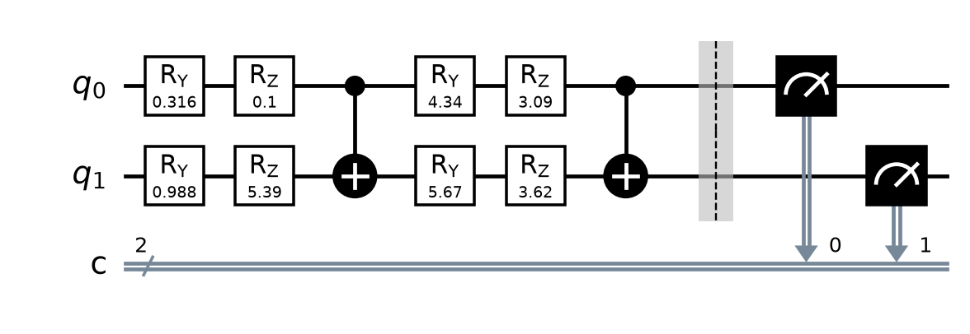
Figure 1: Track A, smallest configuration (n = 2, L = 2; the seed-0 instance actually run), with measurement.
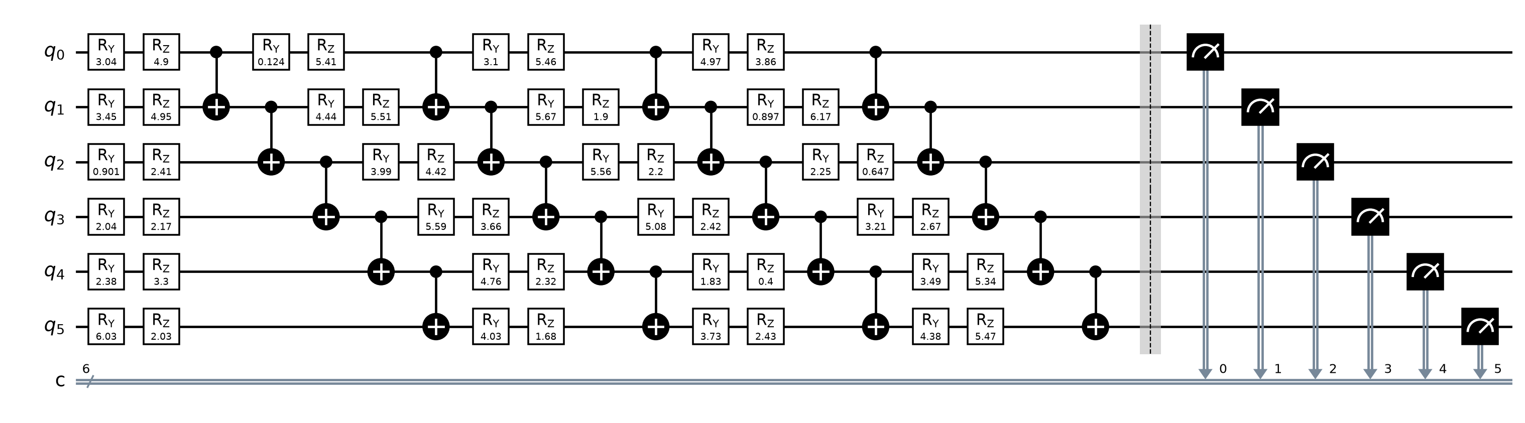
Figure 2: Track A, largest configuration (n = 6, L = 4; seed-0 instance). Each layer is ry and rz on every qubit, then a CNOT chain.
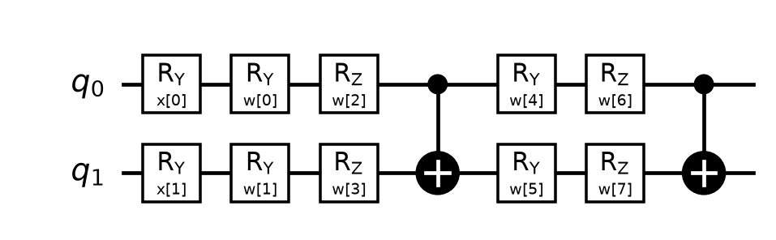
Figure 3: VQC, smallest configuration (n = 2, L = 2): angle encoding ry(x[k]), then the trainable ansatz with weights w[k].
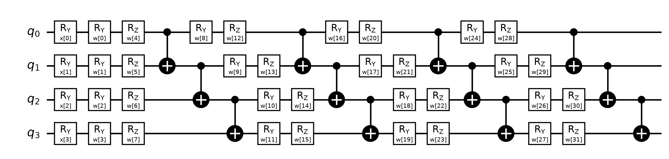
Figure 4: VQC, largest configuration (n = 4, L = 4): 4 features, 32 trainable weights.
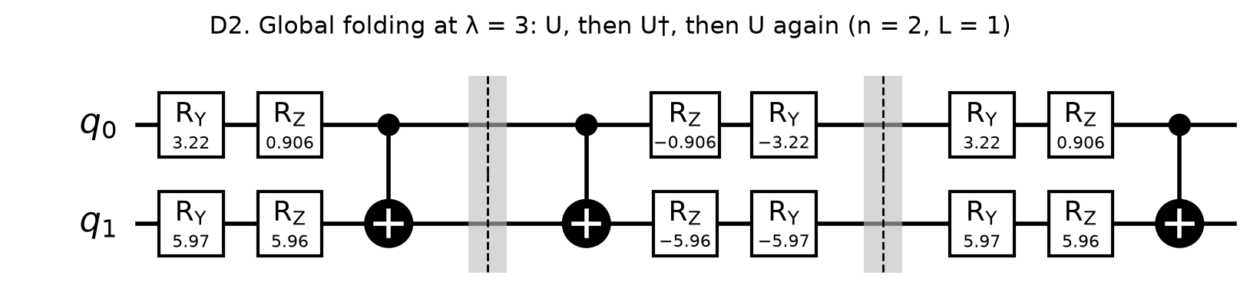
Figure 5: Global folding at λ = 3 (n = 2, L = 1): U, then U†, then U again. Same ideal output, three times the gates.
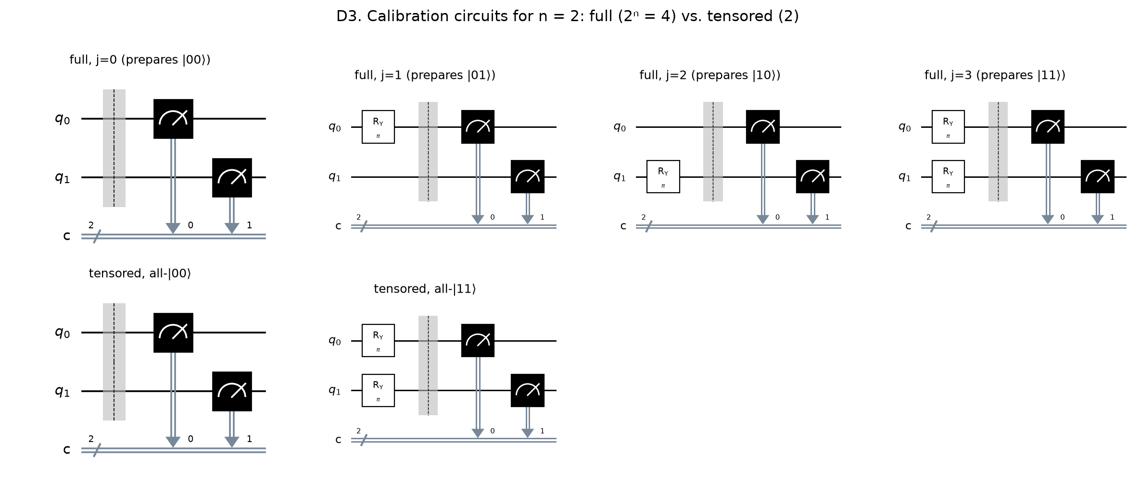
Figure 6: Calibration circuits for n = 2: full REM (2ⁿ = 4 circuits) vs. tensored REM (2 circuits at any n).
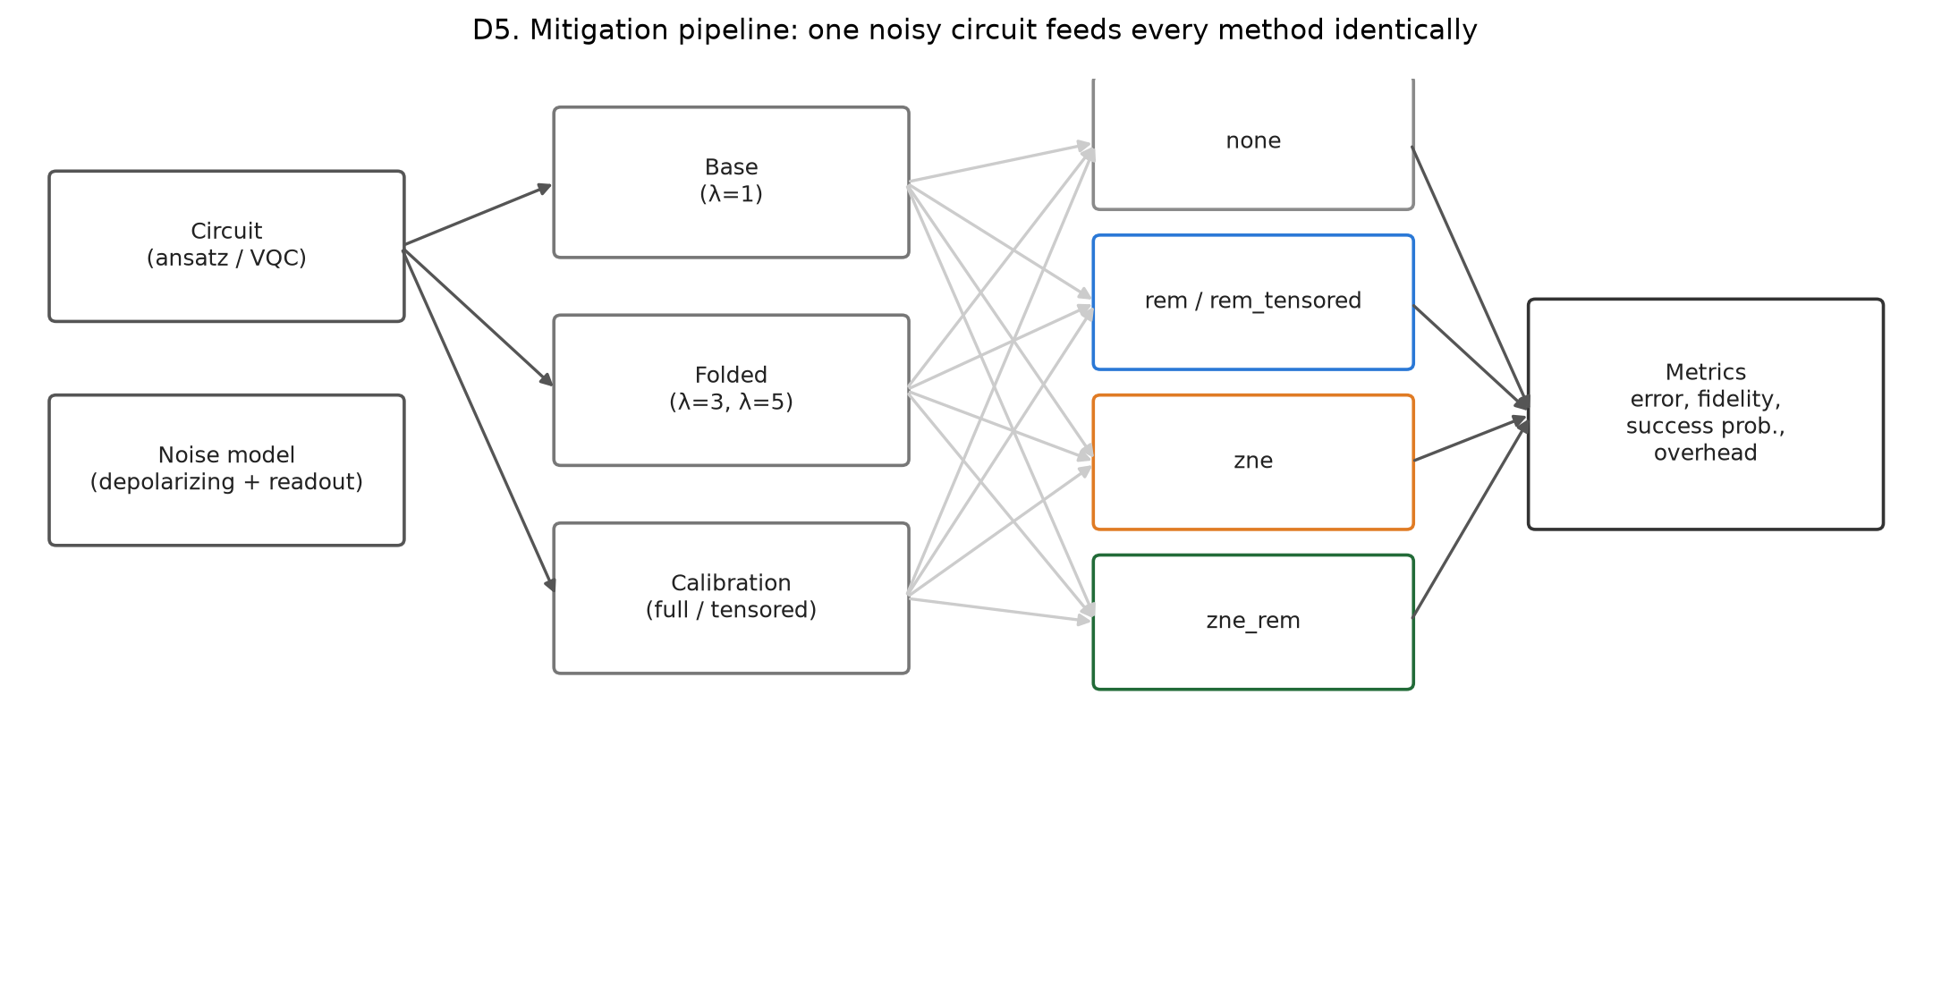
Figure 7: Mitigation pipeline: one circuit's base, folded and calibration runs feed every method from the same shots.

3.4 Parameter table
Parameter | Value(s) used | Justification
Number of qubits | Track A: 2, 4, 6  Track B: 2, 4 | 2 and 4 are the course standard; 6 is in the group brief and exposes full REM's 2ⁿ calibration growth (65 circuits per estimate at n = 6).
Circuit depth / algorithm parameter | L = 2, 4 layers (ry–rz–CNOT chain)  ZNE scale factors λ = 1, 3, 5 | Course depths. λ = 1, 3, 5 are the smallest odd factors reachable by global folding and give a quadratic Richardson fit.
Optimizer & iterations | VQC: COBYLA, maxiter = max(300, 25 × parameters). (n, L) = (2, 2): maxiter 300, 244–300 evaluations used; (n, L) = (2, 4): maxiter 400, 400 evaluations used; (n, L) = (4, 2): maxiter 400, 400 evaluations used; (n, L) = (4, 4): maxiter 800, 800 evaluations used.  Track A: no optimizer (fixed random angles) | Derivative-free and robust for 8–32 parameters; the iteration budget grows with the parameter count.
Shots | 1024 | Course standard; shot-noise σ ≈ 0.031 at E = 0. The shot-allocation experiment keeps the total 3 × 1024 = 3072 but splits it unevenly across λ.
Noise levels used | N0 ideal; N1 low (0.1% / 0.5% / 1%); N2 moderate (1% / 2% / 3%); N3 high (3% / 5% / 5%, stress test) | Course levels (single-qubit / two-qubit / readout). N3 probes where ZNE should strain and is reported separately.
Random seeds | 5 seeds (0–4) per condition; every random number from derive_seed(*parts), a SHA-256 hash of named parts | Mean ± SD over 5 seeds as required; a rerun reproduces every output exactly except two wall-clock columns.

4. Qiskit Implementation (4 marks)

4.1 Environment and reproducibility
Item | Value
Python version | 3.11.15 (uv-managed virtual environment)
Qiskit version | 2.5.2
Qiskit Aer version | 0.17.2
scikit-learn / NumPy version | scikit-learn 1.9.1 / NumPy 2.4.6 (also SciPy 1.17.1, pandas 3.0.6, Matplotlib 3.11.2)
Simulator / backend | Qiskit Aer (AerSimulator), method="density_matrix"; transpiled at optimization_level 0 to the basis {ry, rz, cx}
Random seeds (data split, model, simulator) | Seeds 0–4. Data split derive_seed("qml_split", seed); PCA derive_seed("qml_pca", seed); VQC initial weights derive_seed("qml_init", n, L, seed); LR/SVM derive_seed("qml_lr" / "qml_svm", n, seed). Track A circuit angles derive_seed("circuit", n, L, seed); simulator and transpiler derive_seed("sim" / "transpile", n, L, noise, seed, purpose) (Track B: "qml_sim" / "qml_transpile").
Noise-model parameters (N1 / N2 / N3) | N1: p₁ = 0.001, p₂ = 0.005, p_ro = 0.01  N2: p₁ = 0.01, p₂ = 0.02, p_ro = 0.03  N3: p₁ = 0.03, p₂ = 0.05, p_ro = 0.05  depolarizing_error(p₁, 1) on ry and rz; depolarizing_error(p₂, 2) on cx; symmetric ReadoutError with flip probability p_ro on every qubit
Hardware used (CPU / RAM / runtime) | AMD Ryzen 5 7600 (6 cores / 12 threads), 31.1 GB RAM as reported by Windows, Windows 11 Pro; CPU only.  Runtime: Track A sweep 17.1 s (600 rows); Track B 494.1 s (360 rows, including VQC training); shot-allocation experiment 115.1 s; test suite 186 passed in 40.06s.

4.2 Code structure
The code is a Python package, qem (src/qem/), driven by command-line scripts. It runs end to end from a clean environment with pip install -r requirements.txt and pip install -e .. Repository (public): https://github.com/srikantlose/quantum-error-mitigation-bench.
- config.py: loads and validates config/experiment.yaml (noise levels, grid, seeds, shots); fixed settings such as optimization_level 0 are enforced.
- seeds.py: derive_seed(*parts), a SHA-256-based seed per purpose; every random number in the project comes from here.
- circuits.py: the Track A ansatz, instance selection, fold_global, and full and tensored calibration circuits.
- observables.py: parity, success probability and the exact statevector reference.
- noise.py and execution.py: NoiseModel construction and the Aer executor with the gate-basis guard.
- mitigation/readout.py, mitigation/zne.py, mitigation/pipeline.py: REM (full, tensored, simplex projection), Richardson/linear/exponential extrapolation, and the pipeline that feeds every method the same shots.
- metrics.py and experiment.py: per-run metrics and the Track A sweep (results/raw/runs.csv).
- qml/ (data, vqc, classical, evaluate, runner): Track B preprocessing, VQC training, LR and SVM baselines and noisy evaluation.
- improvement.py: the variance-optimal ZNE shot-allocation experiment.
- analysis.py and plotting.py: summary tables, statistical tests and figures; scripts/build_report.py fills the report from these outputs so no result number is typed by hand.
The full pipeline, in order:
python scripts/run_sweep.py --config config/experiment.yaml # Track A
python scripts/run_qml.py --config config/experiment.yaml # Track B
python scripts/run_improvement.py --config config/experiment.yaml # shot allocation
python scripts/analyze.py --config config/experiment.yaml # tables and statistics
python scripts/make_plots.py --config config/experiment.yaml # figures
python scripts/make_design_figures.py --config config/experiment.yaml
pytest -q # 186 tests
The 186 tests check, among other things, that folded circuits have the same statevector and exactly λ times the gates, the Richardson weights, that with readout-only noise REM recovers the exact value within 4σ where no mitigation does not, the overhead formulas, that preprocessing never sees test data, and that a rerun reproduces runs.csv exactly (apart from the two wall-clock columns) and every raw counts, circuit and calibration file byte for byte.

4.3 Noise model implementation
The noise model is built once per noise level in src/qem/noise.py and attached to an AerSimulator in src/qem/execution.py:
from qiskit_aer import AerSimulator
from qiskit_aer.noise import NoiseModel, ReadoutError, depolarizing_error

def build_noise_model(
level: NoiseLevelConfig, one_q_gates: Sequence[str], two_q_gates: Sequence[str]
) -> NoiseModel | None:
if level.p1 == 0 and level.p2 == 0 and level.p_ro == 0:
return None
nm = NoiseModel()
if level.p1 > 0:
nm.add_all_qubit_quantum_error(depolarizing_error(level.p1, 1), list(one_q_gates))
if level.p2 > 0:
nm.add_all_qubit_quantum_error(depolarizing_error(level.p2, 2), list(two_q_gates))
if level.p_ro > 0:
# Row k gives P(measured | prepared k).
nm.add_all_qubit_readout_error(ReadoutError([[1 - level.p_ro, level.p_ro], [level.p_ro, 1 - level.p_ro]]))
return nm

# src/qem/execution.py, Executor.__init__: one simulator per noise level
for name, lvl in self._levels.items():
nm = build_noise_model(lvl, cfg.noise.one_qubit_gates, cfg.noise.two_qubit_gates)
if nm is None:
self._sims[name] = AerSimulator(method=cfg.simulator.method)
else:
self._sims[name] = AerSimulator(method=cfg.simulator.method, noise_model=nm)

# Executor.run: transpile at optimization_level 0 to {ry, rz, cx}, then
result = sim.run(tcircs, shots=shots, seed_simulator=seed).result()
Gate errors are attached by gate name to every ry and rz (one-qubit) and cx (two-qubit) instruction, and the readout error is symmetric and identical on every qubit. Because noise is attached by name, any other gate would run noise-free, so the executor asserts before and after transpiling that every circuit contains only {ry, rz, cx, measure, barrier}. The exact noisy reference E_noisy_exact comes from a density-matrix run of the same circuit with no shots, which lets us split the unmitigated bias exactly into a gate part and a readout part.

4.4 Screenshots of working code and outputs
Environment and version print-out (run in the project environment):
Python 3.11.15 | Windows-10-10.0.26200-SP0
qiskit 2.5.2
qiskit-aer 0.17.2
numpy 2.4.6 | scipy 1.17.1 | pandas 3.0.6
matplotlib 3.11.2 | scikit-learn 1.9.1
simulator aer_simulator_density_matrix (method=density_matrix)
Successful runs (final lines of the saved logs in results/logs/):
2026-10-07 05:26:51,445 INFO qem.experiment: sweep finished: 600 rows in 17.1s
2026-10-07 05:26:51,447 INFO qem.experiment: spot-check: mean abs_error of none at moderate (0.1809) > low (0.0622)
2026-10-07 05:35:14,342 INFO qem.qml.runner: track B sweep finished: 360 rows in 494.1s
2026-10-07 05:37:18,275 INFO qem.improvement: improvement sweep finished: 120 rows in 115.1s
2026-10-07 05:37:18,275 INFO qem.improvement: spot-check: mean empirical std ratio (optimal/uniform) = 0.874 (theory ~0.885)
pytest -q: 186 passed in 40.06s
Sample output: the interactive results dashboard built from the result files, deployed at https://quantum-error-mitigation-bench.vercel.app.
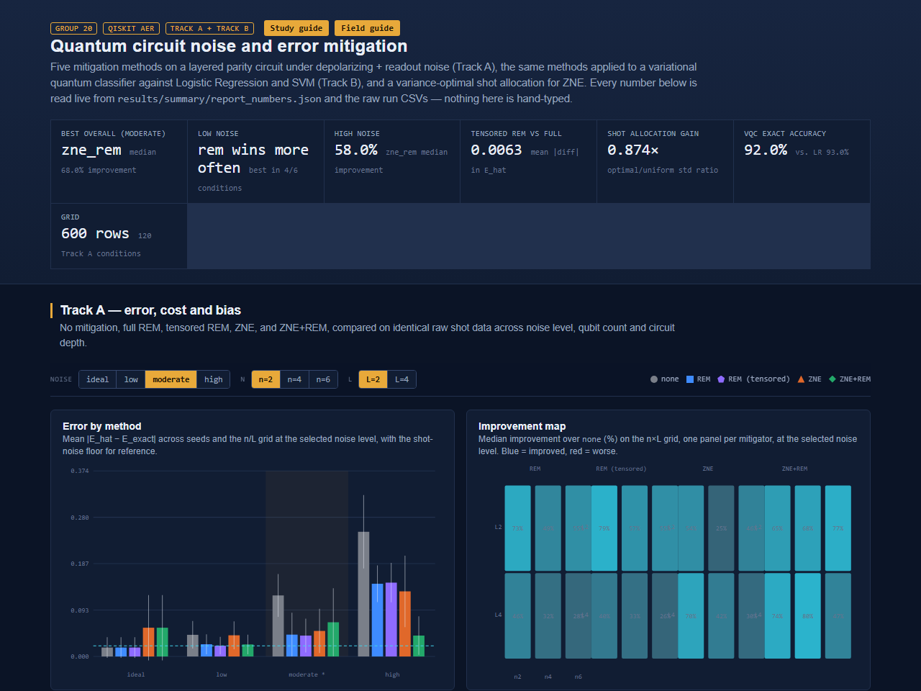
Figure 8: Screenshot of the deployed results dashboard: headline numbers, error by method and noise level, and the improvement map.

5. Experiments and Visualization (3 marks)

5.1 Experiment configuration
Table 1. Experiment configuration (the recommended matrix; all eight rows were run).
Exp. | Qubits | Depth / parameter | Noise | Shots | Notes (dataset, seeds, optimizer iterations)
E1 | 2 | 2 | N0 – None | 1024 | Track A: 5 seeds × 5 methods. Track B: VQC on 2 PCA features, COBYLA maxiter 300 (244–300 evaluations used), 4 mitigation methods.
E2 | 2 | 4 | N0 – None | 1024 | Track A as E1. Track B: VQC, COBYLA maxiter 400 (400 used).
E3 | 4 | 2 | N0 – None | 1024 | Track A as E1. Track B: VQC on all 4 features, COBYLA maxiter 400 (400 used).
E4 | 4 | 4 | N0 – None | 1024 | Track A as E1. Track B: VQC on all 4 features, COBYLA maxiter 800 (800 used).
E5 | 4 | 4 | N1 – Low | 1024 | As E4 at N1 (0.1% / 0.5% / 1%); all methods; also the shot-allocation experiment (50 repetitions).
E6 | 4 | 4 | N2 – Moderate | 1024 | As E4 at N2 (1% / 2% / 3%); all methods; also the shot-allocation experiment.
E7 | 6 | 4 | N0 – None | 1024 | Track A only (Track B uses 2 and 4 qubits); 5 seeds × 5 methods.
E8 | 6 | 4 | N2 – Moderate | 1024 | Track A only; full REM needs 65 circuits per estimate here.
These eight rows are a subset of the full factorial design that was run. Track A covered every combination of n ∈ {2, 4, 6}, L ∈ {2, 4}, N0–N3 and 5 seeds (120 conditions, 600 method rows). Track B covered every combination of n ∈ {2, 4}, L ∈ {2, 4}, N0–N3 and 5 seeds with four mitigation methods, plus the exact VQC, Logistic Regression and SVM (360 rows). The shot-allocation experiment produced 120 rows at N1 and N2. Every circuit execution used 1024 shots, except the allocation experiment, which kept the total budget of 3 × 1024 = 3072 shots but split it unevenly across λ.

5.2 Results table
Table 2. Track A results for E1–E8, mean ± SD over 5 seeds. Primary metric: absolute parity error |E_hat − E_exact| after REM and after ZNE+REM. Secondary metric: Hellinger fidelity of the output distribution, before → after REM. Total gates and two-qubit gates: transpiled base circuit / summed over the three ZNE circuits (λ = 1, 3, 5). Depth: base circuit / deepest ZNE circuit (λ = 5). Baseline: no mitigation.
Exp. | Primary metric (mean ± SD) | Secondary metric | Total gates | Two-qubit gates | Depth | Baseline value
E1 | REM: 0.018 ± 0.021  ZNE+REM: 0.058 ± 0.066 | 0.999 → 0.999 | 10 / 90 | 2 / 18 | 6 / 30 | 0.018 ± 0.021
E2 | REM: 0.026 ± 0.021  ZNE+REM: 0.053 ± 0.041 | 0.999 → 0.999 | 20 / 180 | 4 / 36 | 12 / 60 | 0.026 ± 0.021
E3 | REM: 0.016 ± 0.011  ZNE+REM: 0.051 ± 0.016 | 0.996 → 0.996 | 22 / 198 | 6 / 54 | 9 / 45 | 0.016 ± 0.011
E4 | REM: 0.013 ± 0.009  ZNE+REM: 0.042 ± 0.042 | 0.997 → 0.997 | 44 / 396 | 12 / 108 | 17 / 85 | 0.013 ± 0.009
E5 | REM: 0.040 ± 0.025  ZNE+REM: 0.080 ± 0.035 | 0.991 → 0.994 | 44 / 396 | 12 / 108 | 17 / 85 | 0.071 ± 0.027
E6 | REM: 0.144 ± 0.028  ZNE+REM: 0.051 ± 0.021 | 0.952 → 0.968 | 44 / 396 | 12 / 108 | 17 / 85 | 0.209 ± 0.039
E7 | REM: 0.027 ± 0.011  ZNE+REM: 0.049 ± 0.031 | 0.981 → 0.981 | 68 / 612 | 20 / 180 | 19 / 95 | 0.027 ± 0.011
E8 | REM: 0.173 ± 0.056  ZNE+REM: 0.109 ± 0.049 | 0.908 → 0.927 | 68 / 612 | 20 / 180 | 19 / 95 | 0.240 ± 0.052
At N0 mitigation cannot help: REM is an exact no-op (largest change 0) and ZNE only adds variance; it was worse than no mitigation in 26/30 runs. At N1 (E5), REM roughly halves the error while ZNE does not help. At N2 (E6, E8) every method helps and ZNE+REM is best. Full tables for all 120 conditions are in results/summary/table_error.md and table_fidelity.md.
Table 3. Track B results: VQC on the 20-sample test set, mean ± SD over n ∈ {2, 4}, L ∈ {2, 4} and 5 seeds (20 runs per row; LR and SVM: 10 runs). Margin retention = mean(E_hat · sign E_exact) / mean |E_exact|.
Noise | Method | Accuracy | Mean |E_hat − E_exact| | Margin retention
ideal | none | 0.920 ± 0.041 | 0.019 ± 0.003 | 0.997 ± 0.009
ideal | rem | 0.920 ± 0.041 | 0.019 ± 0.003 | 0.997 ± 0.009
ideal | zne | 0.922 ± 0.044 | 0.044 ± 0.008 | 0.994 ± 0.025
ideal | zne_rem | 0.922 ± 0.044 | 0.044 ± 0.008 | 0.994 ± 0.025
low | none | 0.920 ± 0.047 | 0.053 ± 0.024 | 0.907 ± 0.037
low | rem | 0.917 ± 0.049 | 0.030 ± 0.010 | 0.966 ± 0.030
low | zne | 0.907 ± 0.054 | 0.058 ± 0.009 | 0.942 ± 0.039
low | zne_rem | 0.907 ± 0.054 | 0.053 ± 0.006 | 1.004 ± 0.043
moderate | none | 0.917 ± 0.041 | 0.172 ± 0.078 | 0.670 ± 0.098
moderate | rem | 0.920 ± 0.041 | 0.101 ± 0.056 | 0.814 ± 0.078
moderate | zne | 0.910 ± 0.042 | 0.116 ± 0.044 | 0.801 ± 0.068
moderate | zne_rem | 0.910 ± 0.042 | 0.070 ± 0.015 | 0.976 ± 0.047
high | none | 0.900 ± 0.056 | 0.301 ± 0.117 | 0.411 ± 0.128
high | rem | 0.902 ± 0.055 | 0.222 ± 0.105 | 0.575 ± 0.133
high | zne | 0.905 ± 0.046 | 0.214 ± 0.107 | 0.603 ± 0.144
high | zne_rem | 0.902 ± 0.050 | 0.121 ± 0.069 | 0.847 ± 0.130
exact (noiseless) | VQC | 0.920 ± 0.041 | 0 (reference) | 1 (reference)
– | Logistic Regression | 0.925 ± 0.049 | – | –
– | SVM (RBF) | 0.915 ± 0.034 | – | –

5.3 Graphs and figures
Figure 9 shows the error of every method for each (n, L) at N0–N2 (the N3 stress level is reported separately, in Tables 2 and 4 and results/summary/table_error.md). At N2, every mitigated method is below the baseline in every (n, L) cell; at N0, the ZNE-based methods are worse than the baseline in every cell. Pooled over all circuits, the unmitigated error rises from 0.021 (N0) to 0.062 (N1), 0.181 (N2) and 0.310 (N3). Figure 10 shows the error against qubit count at N2 for each depth, and Figure 11 gives the median improvement for every (n, L) cell at N1 and N2.
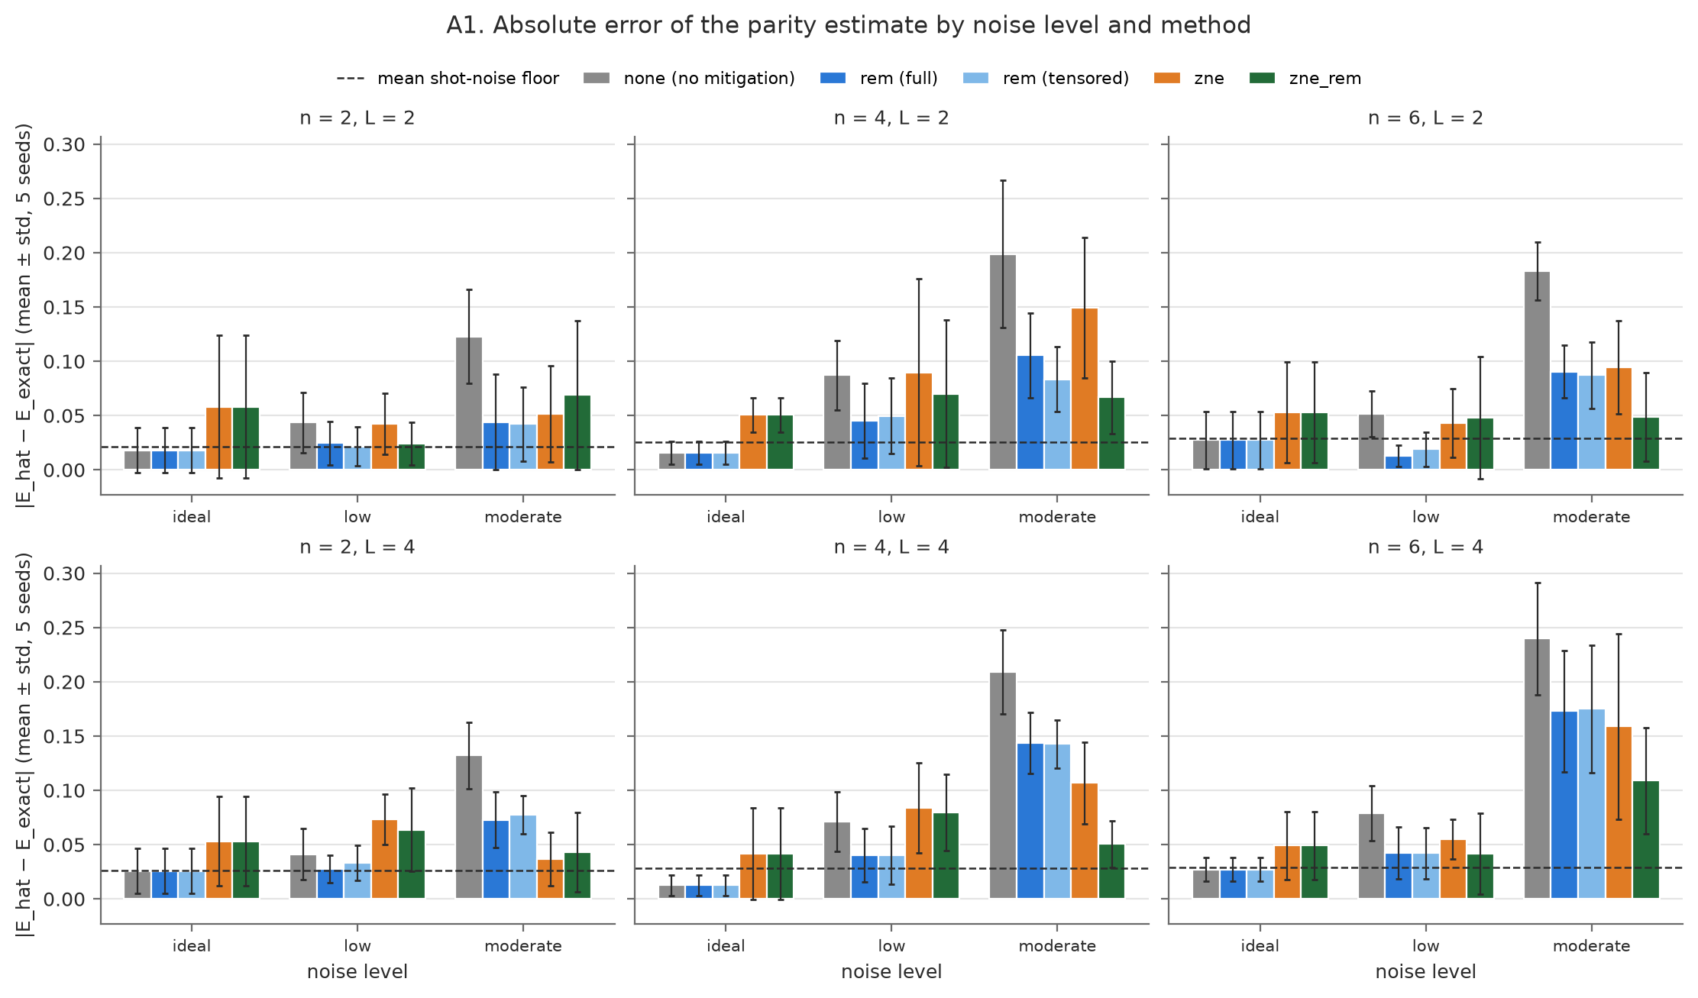
Figure 9: Absolute parity error (mean ± SD over 5 seeds) by noise level (N0–N2) and method, one panel per (n, L); dashed line: mean shot-noise floor.
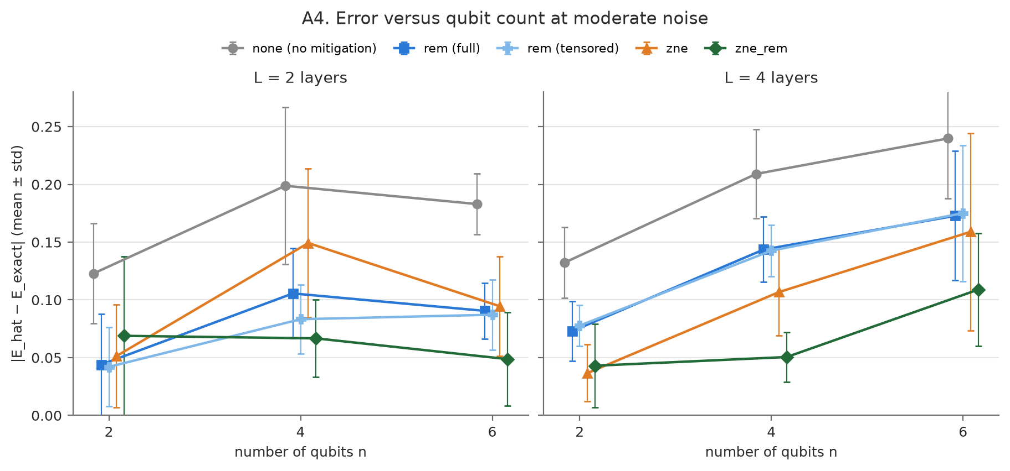
Figure 10: Absolute error vs. qubit count at N2, one panel per depth (mean ± SD over 5 seeds).
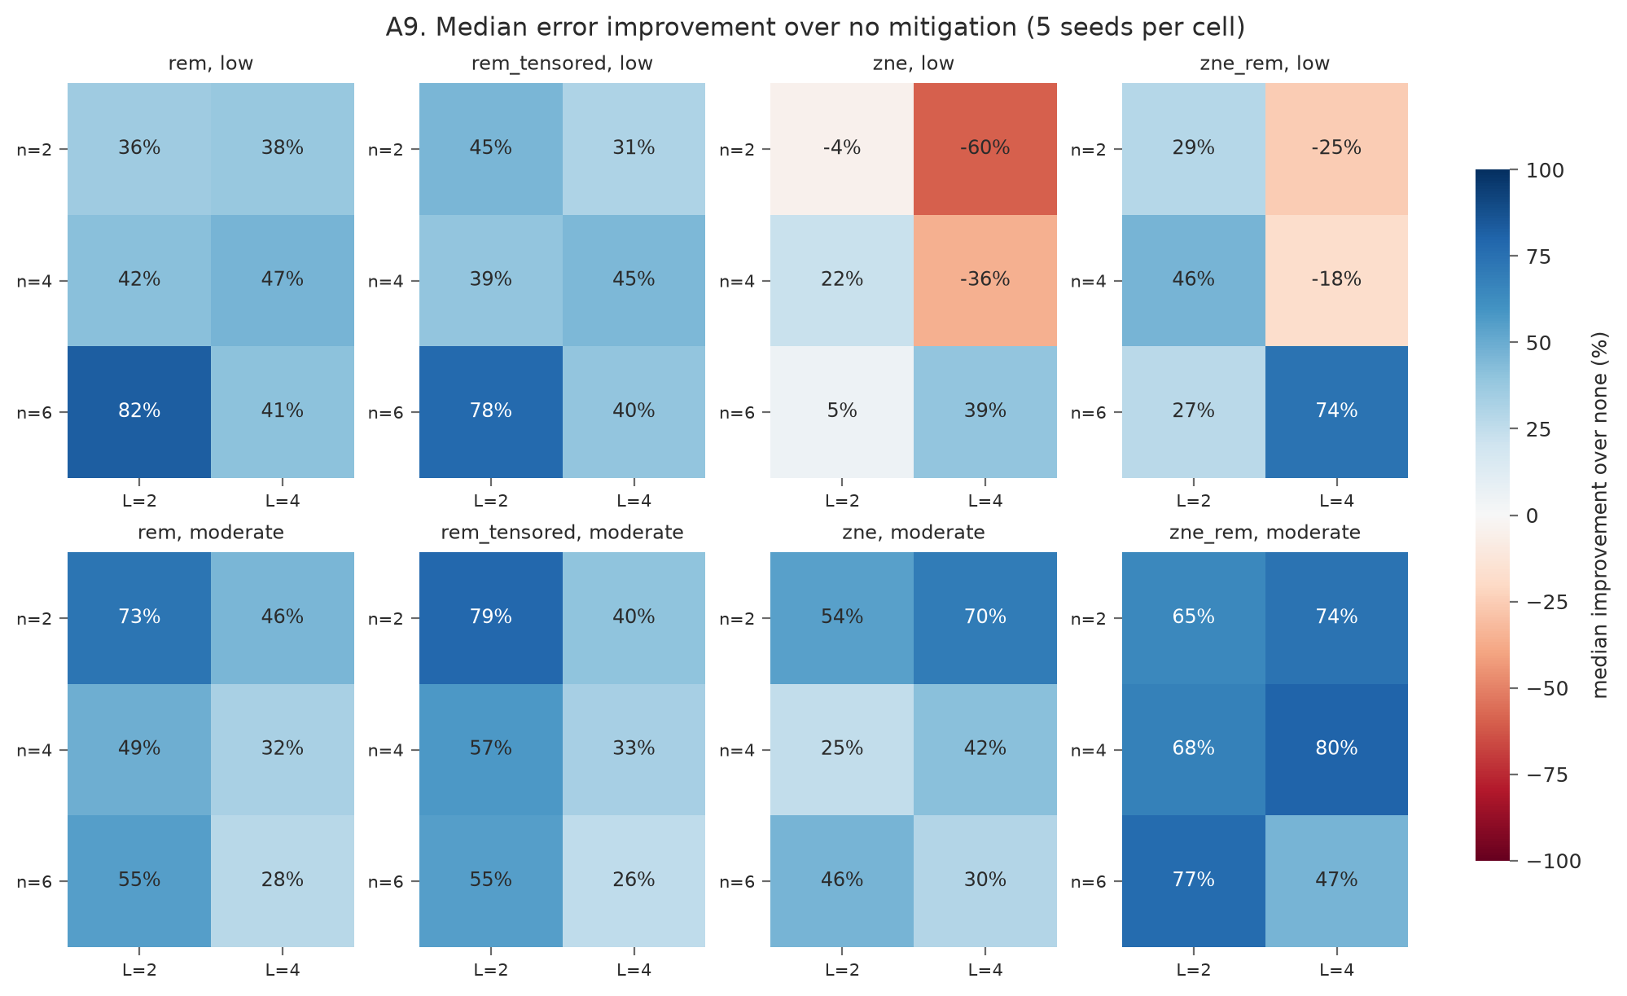
Figure 11: Median improvement over no mitigation (%) for every (n, L) cell at N1 and N2 (5 seeds per cell).
Figure 12 compares the measured output distribution with the exact one for one circuit (n = 4, L = 4, N2, seed 0): noise spreads probability away from the most likely outcomes, and REM (full and tensored) moves it back. Figures 13 and 14 quantify this over the grid: at N2, REM raises Hellinger fidelity in 6/6 (n, L) cells (mean gain 0.0160) and raises the success-probability ratio toward 1.
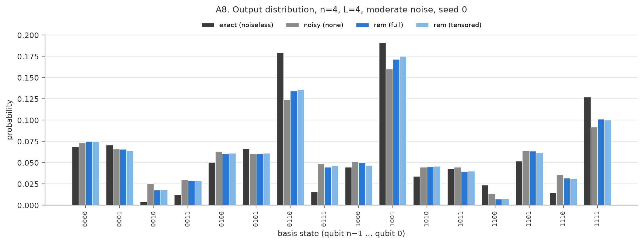
Figure 12: Output distribution for n = 4, L = 4, N2, seed 0: exact, unmitigated, full REM and tensored REM.
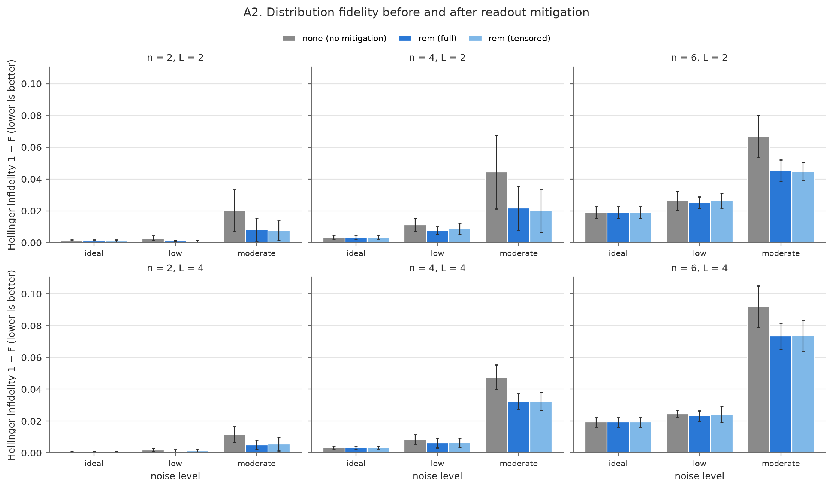
Figure 13: Hellinger infidelity (1 − F) by noise level (N0–N2): no mitigation vs. full and tensored REM, one panel per (n, L).
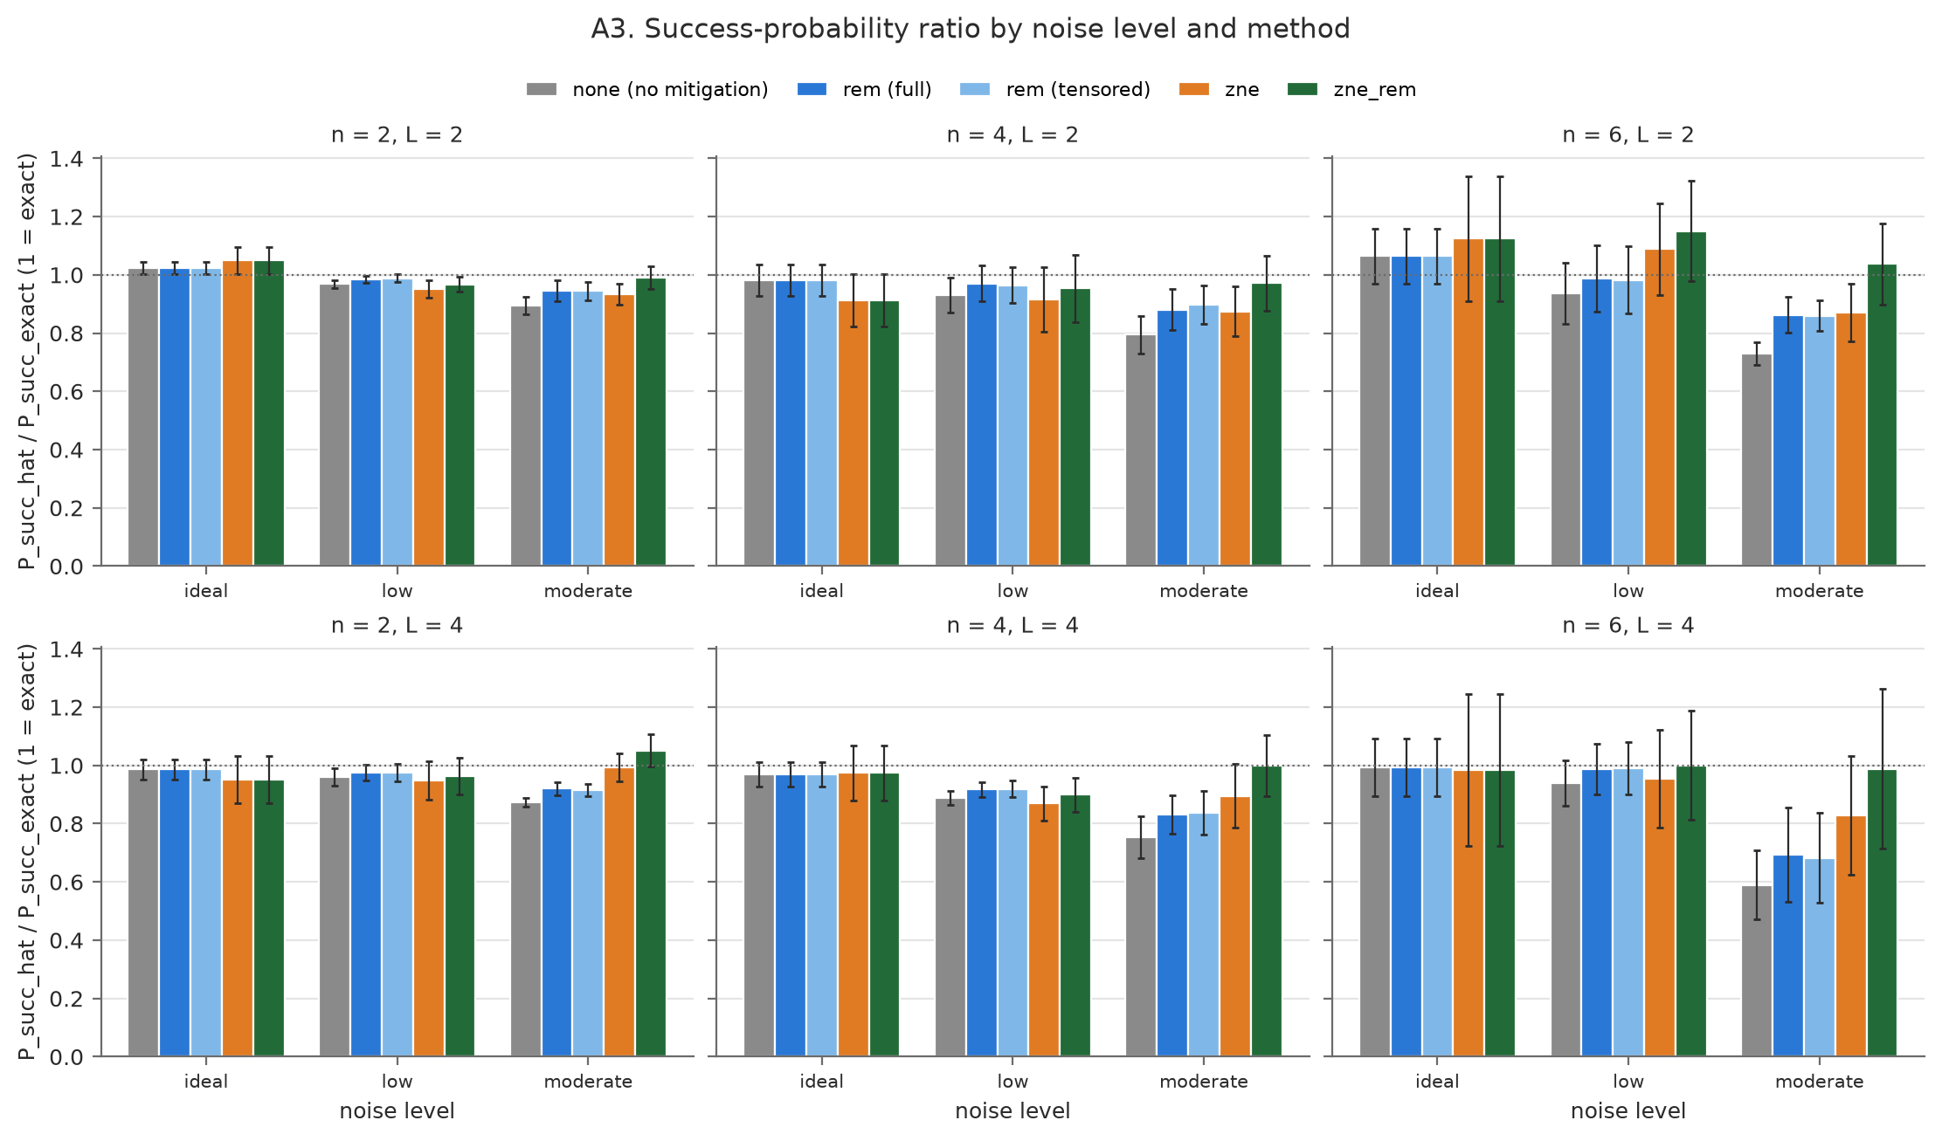
Figure 14: Success-probability ratio P_succ_hat / P_succ_exact (1 = exact) by noise level (N0–N2) and method, one panel per (n, L).
Figure 15 shows the ZNE extrapolation for one circuit (n = 4, L = 4, N2, seed 0; exact parity 0.408, unmitigated 0.197). Extrapolating the raw points (ZNE) gives 0.256, still short of the exact value, partly because readout error is not folded; extrapolating the REM-corrected points (ZNE+REM) gives 0.325, closer but not exact. Figure 16 shows the bias–spread trade-off at N2, pooled over all circuits: unmitigated estimates are shrunk toward 0 (median oriented error −0.183); REM, tensored REM and ZNE each remove about half of that shrinkage (medians −0.093, −0.091, −0.098); only ZNE+REM is centred near zero (+0.015), and the ZNE-based methods have the widest spread (SD 0.072 and 0.080, against 0.059 with no mitigation).
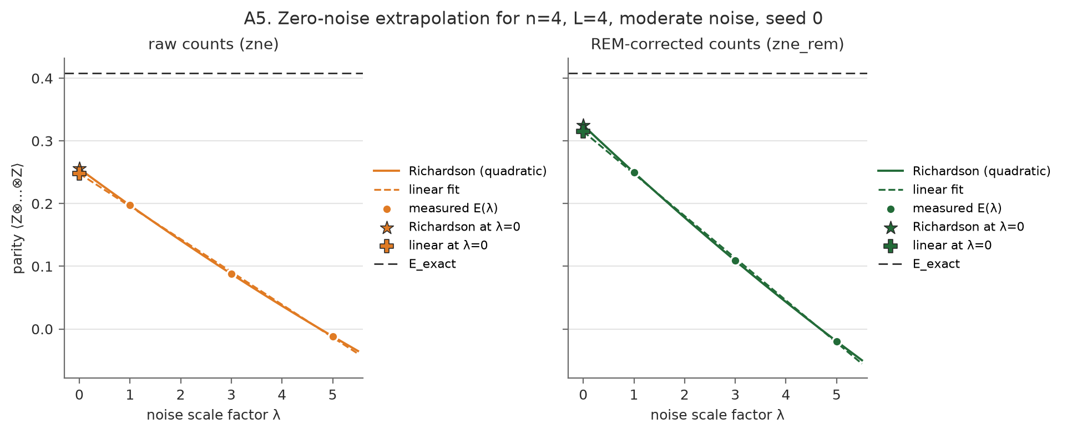
Figure 15: ZNE extrapolation for n = 4, L = 4, N2, seed 0: raw counts (ZNE) vs. REM-corrected counts (ZNE+REM).
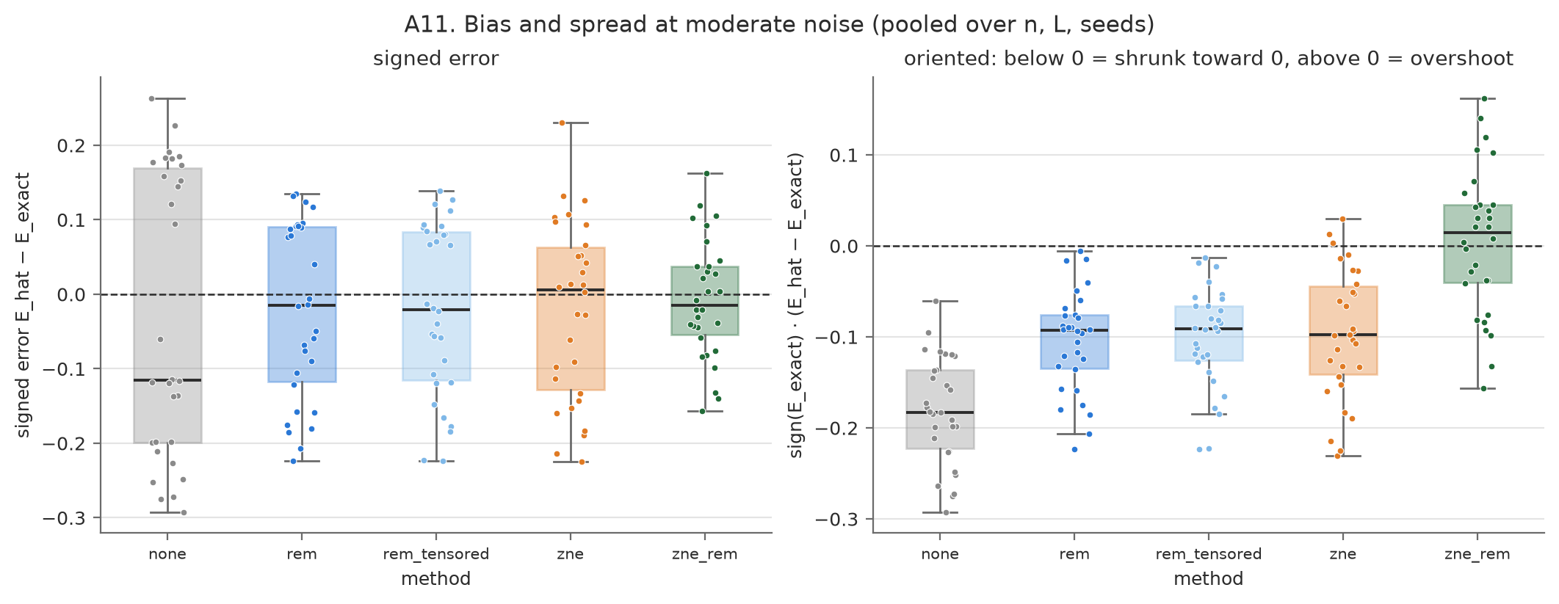
Figure 16: Bias and spread at N2, pooled over n, L and seeds: signed error (left) and error oriented so that negative means shrunk toward 0 (right).
For Track B, Figure 17 shows that VQC accuracy barely moves with noise (N0–N3) and stays close to Logistic Regression and SVM. Figures 18 and 19 show what accuracy hides: the mean expectation error grows with noise, and for n = 4, L = 2 the outputs shrink toward 0 at N2 and N3, mostly without changing sign, while ZNE+REM pulls them back toward the diagonal. Figure 20 shows the noiseless training curves.
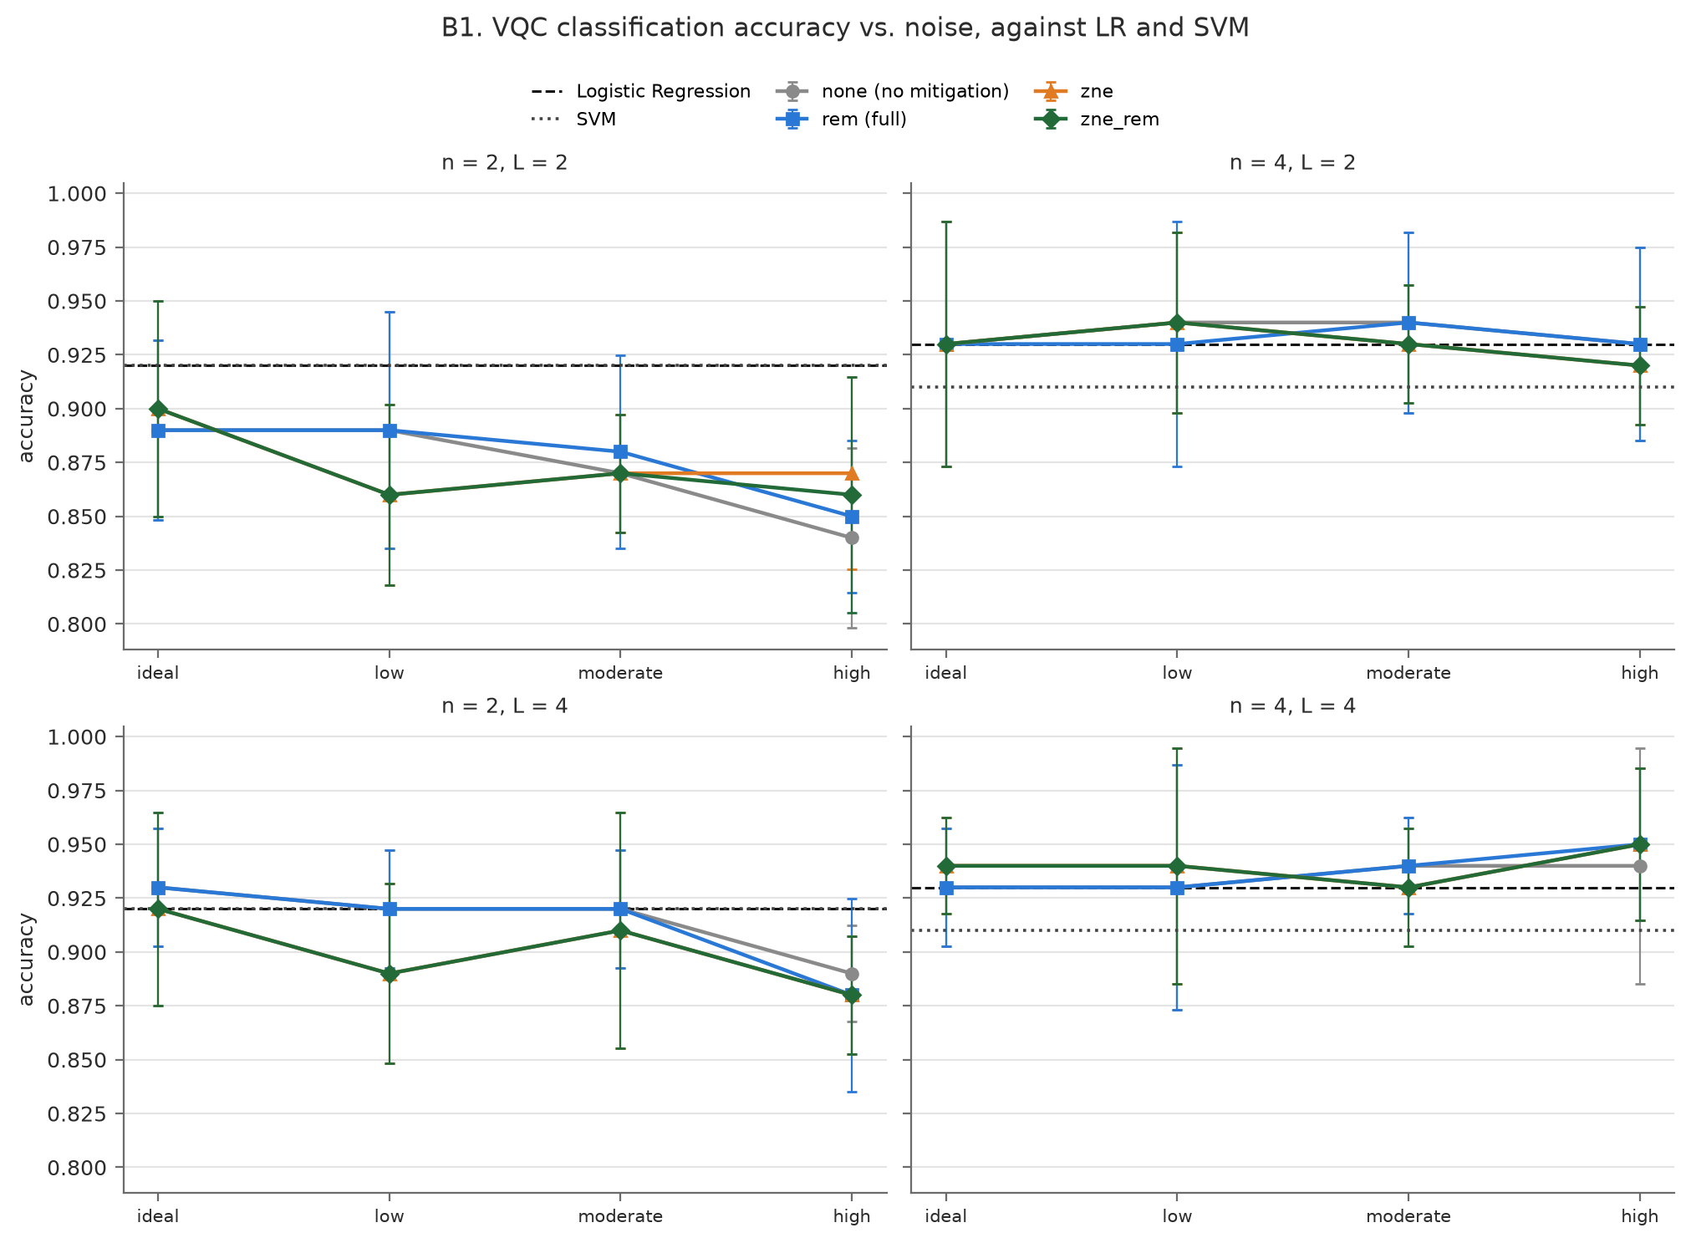
Figure 17: VQC test accuracy vs. noise level (N0–N3) by method, one panel per (n, L) (mean ± SD over 5 seeds); Logistic Regression and SVM as horizontal lines.
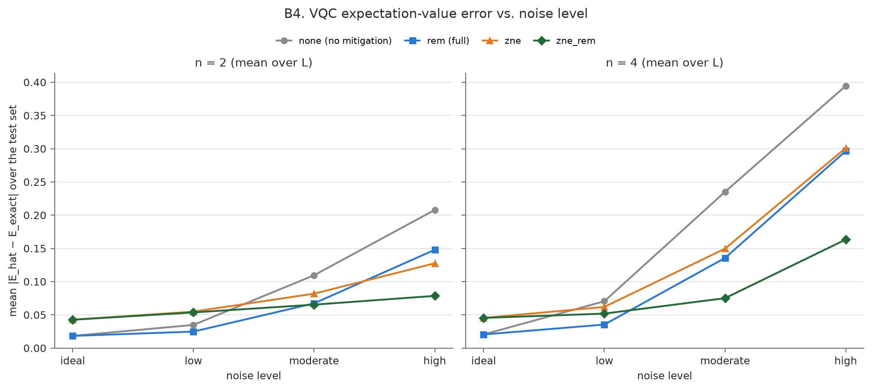
Figure 18: Mean |E_hat − E_exact| over the VQC test set vs. noise level, for n = 2 and n = 4 (mean over L).
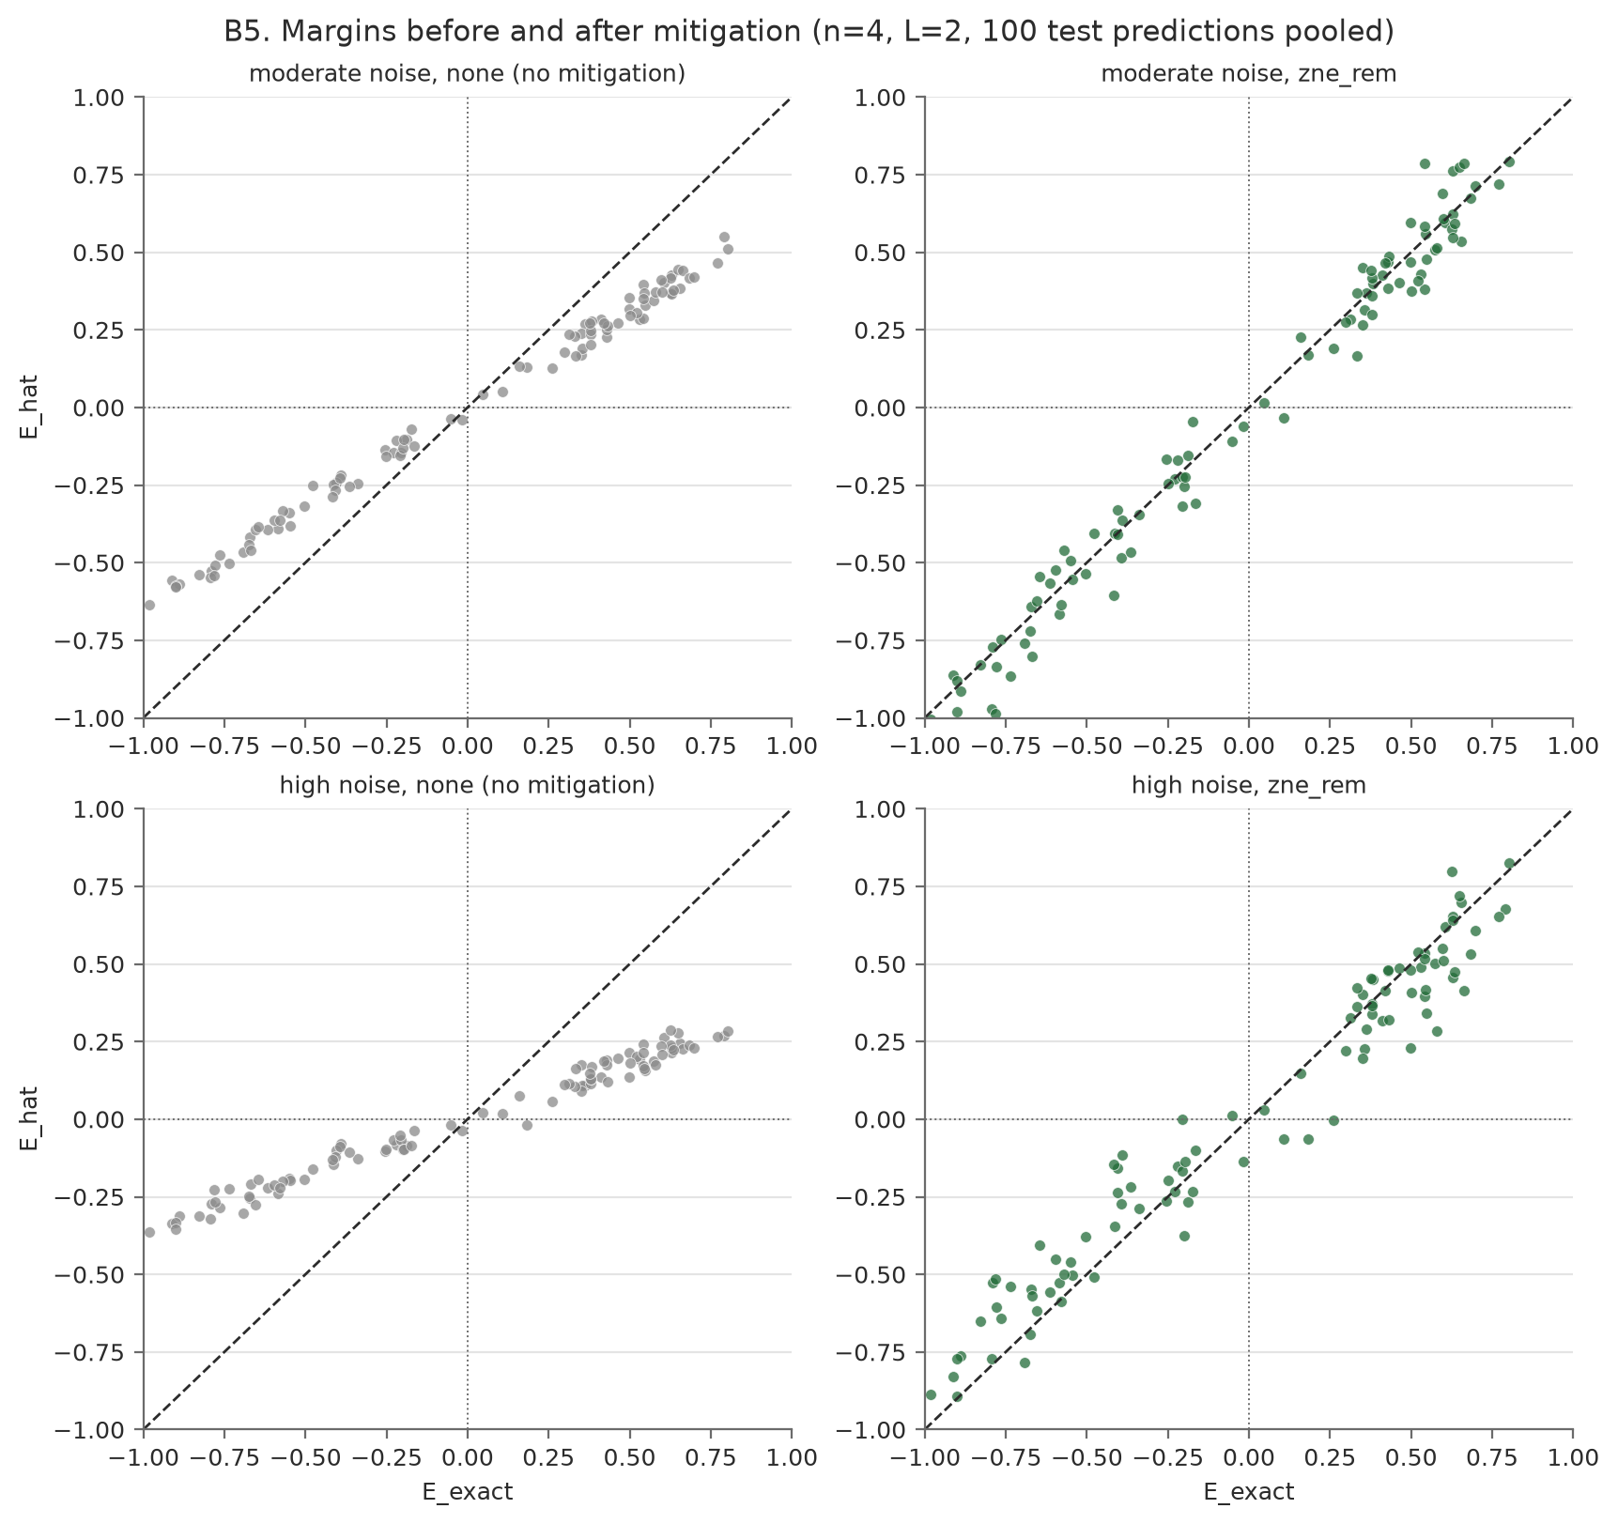
Figure 19: E_hat against E_exact for n = 4, L = 2 (100 test predictions pooled over 5 seeds) at N2 and N3, without mitigation and with ZNE+REM; the diagonal is E_hat = E_exact.
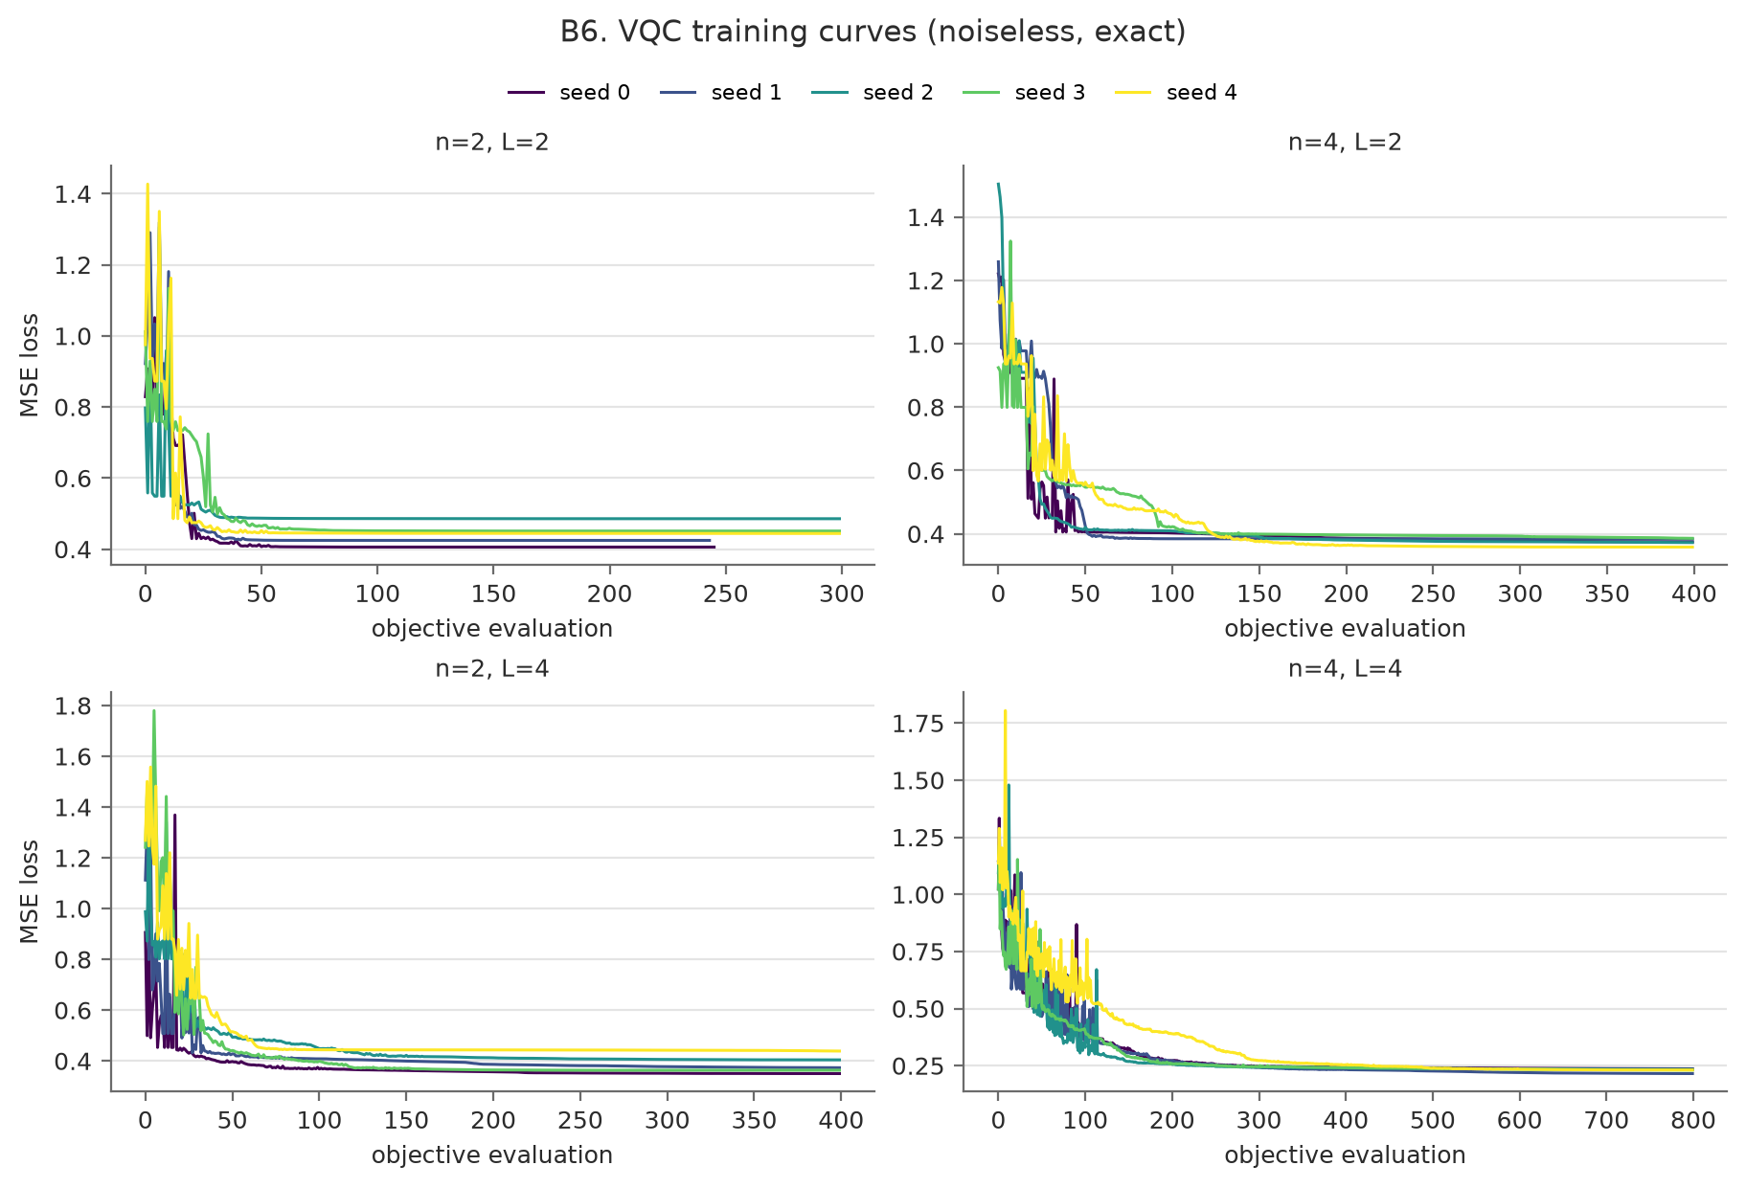
Figure 20: VQC training curves (noiseless): MSE loss against COBYLA objective evaluations, per (n, L) and seed.
Figure 21 compares tensored and full REM condition by condition (points on the diagonal agree). Figure 22 compares the empirical standard deviation of the Richardson estimate under uniform and variance-optimal shot allocation at the same 3072-shot budget, averaged over the 5 circuit instances of each condition: the optimal split is lower in 12 of 12 conditions.
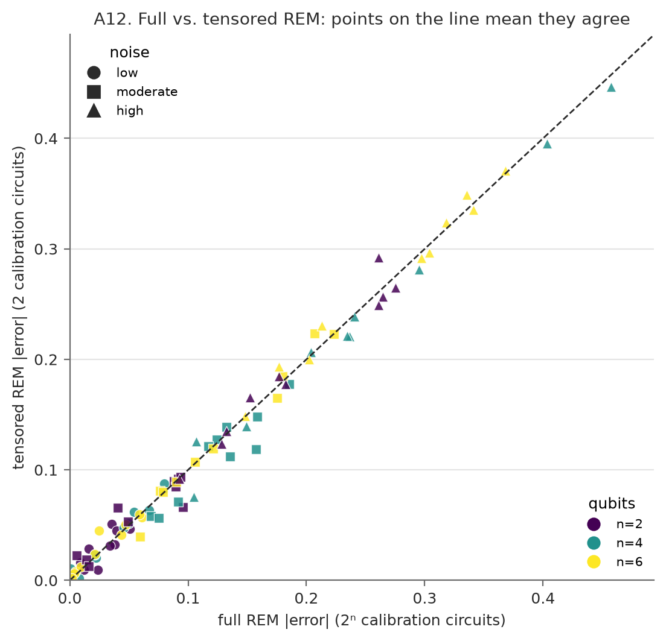
Figure 21: Full vs. tensored REM absolute error for every condition at N1–N3 (marker: noise level; colour: qubit count).
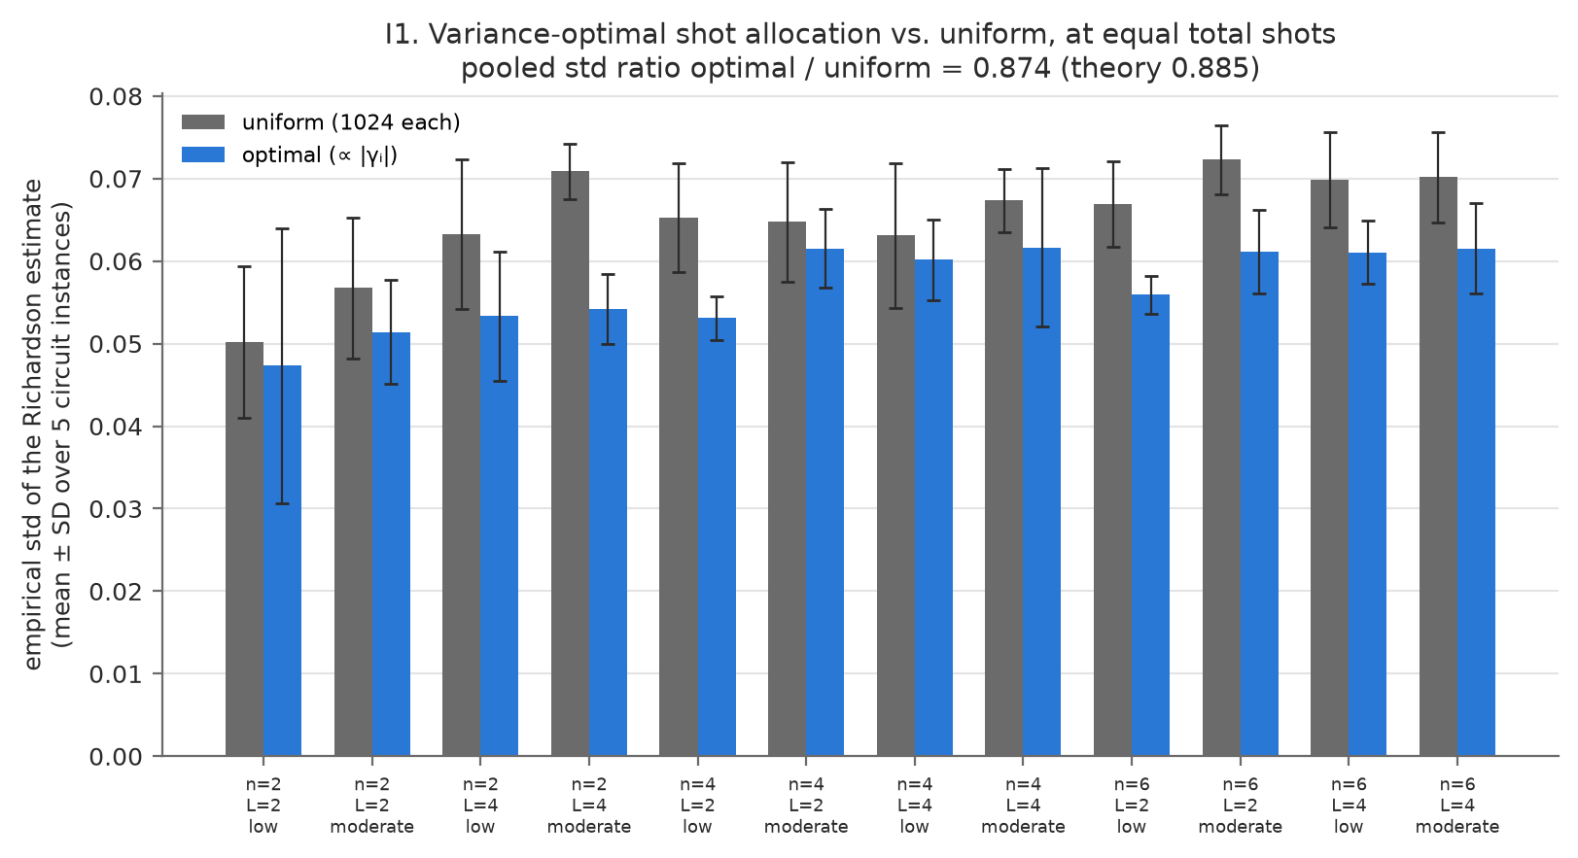
Figure 22: Empirical std of the Richardson estimate, uniform vs. optimal allocation at 3072 total shots (mean ± SD over the 5 circuit instances of each condition).

6. Comparative Analysis (2 marks)

6.1 Comparison with baseline
Table 4. Methods against the no-mitigation baseline (Track A pooled over n, L and 5 seeds: 30 runs per noise level) and the VQC against the classical baselines (identical splits and features).
Model / method | Primary metric (mean ± SD) | Resources (qubits / depth / gates) | Remarks
No mitigation (baseline) | |error| N2: 0.181 ± 0.059  N1: 0.062 ± 0.030 | 1 circuit; base depth 6–19; 2–20 CNOTs | Error grows 0.021 → 0.062 → 0.181 → 0.310 from N0 to N3.
REM (full) | N2: 0.105 ± 0.056  N1: 0.032 ± 0.024 | 5/17/65 circuits (n = 2/4/6); depth and CNOTs unchanged | Median cut 43% at N2 (p = 1.9e-09), 42% at N1 (p = 8.0e-08).
REM (tensored) | N2: 0.101 ± 0.055  N1: 0.034 ± 0.024 | 3/3/3 circuits; depth and CNOTs unchanged | Median cut 48% at N2 (p = 1.9e-09); within 0.0063 of full REM.
ZNE (Richardson) | N2: 0.100 ± 0.067  N1: 0.065 ± 0.045 | 3/3/3 circuits; 9× CNOTs; up to 5.00× depth | Median cut 44% at N2 (p = 3.7e-09); not significant at N1 (1%, p = 0.984).
ZNE + REM | N2: 0.064 ± 0.046  N1: 0.055 ± 0.045 | 7/19/67 circuits; 9× CNOTs; up to 5.00× depth | Best at N2: median cut 68% (p = 4.7e-08), lowest error in 4/6 cells.
VQC, exact (noiseless) | Accuracy 0.920 ± 0.041 | 2–4 qubits; 8–32 parameters; 2–12 CNOTs | Comparable to LR and SVM; no quantum advantage is claimed.
Logistic Regression | Accuracy 0.925 ± 0.049 | Classical (C = 1, max_iter = 1000) | Same split, same preprocessed features.
SVM (RBF) | Accuracy 0.915 ± 0.034 | Classical (C = 1, gamma = "scale") | Same split, same preprocessed features.

6.2 Effect of noise and resources
Effectiveness (RQ1). At N2 every method reduces the error (Table 4, Figure 9): median cuts of 43% (REM), 48% (tensored REM), 44% (ZNE) and 68% (ZNE+REM), all significant in pooled Wilcoxon tests. At N1 the picture changes: REM still helps (42%, p = 8.0e-08), but ZNE alone shows no significant benefit (1%, p = 0.984) because its variance amplification outweighs a small gate bias. At the N3 stress level every method still helps (29%, 25%, 19%, 58%) and ZNE+REM stays strongest.
Why the pattern (readout vs. gate noise). Splitting the unmitigated bias exactly with the noisy density matrix shows that readout causes 60% of it at N1 but only 40% at N2, as gate noise grows with circuit size. REM fixes only readout and ZNE only gate noise, so REM matters more at N1, ZNE more at N2, and only the combination addresses both (H2, H3).
Variance. ZNE's standard deviation is 2.38×, 2.42×, 2.70× and 2.07× the baseline's at N0–N3, against 2.28× predicted by the Richardson weights. Each ratio compares two standard deviations estimated from 30 runs, which carries roughly ±19% relative uncertainty, so these values are consistent with theory. At N0 there is no bias to remove, and ZNE was worse than no mitigation in 26/30 runs (Figure 9).
Cost (RQ2). Per estimate, full REM needs 1 + 2ⁿ circuits (5/17/65 at n = 2, 4, 6) while tensored REM needs a constant 3; ZNE needs 3 circuits but 9× the CNOTs and up to 5.00× the depth (95 at the deepest); ZNE+REM needs the sum (Figures 23 and 24). Simulator wall time is not hardware time, so circuit and shot counts are the meaningful cost figures.
Downstream classification (RQ3). The exact VQC reaches 0.920 mean accuracy, comparable to Logistic Regression (0.920 / 0.930 for n = 2 / 4) and SVM (0.920 / 0.910) on identical inputs (Tables 3 and 4). At N3, unmitigated margin retention falls to 0.411 and mean expectation error rises to 0.301, yet accuracy only drops from 0.920 to 0.900; ZNE+REM restores margin retention to 0.847 with almost no change in accuracy (0.903). Accuracy depends only on the sign of the output and moves in 5% steps on 20 test samples, so it is too coarse to show what the continuous metrics show.
Cheaper variants (RQ4). Tensored REM matches full REM to within 0.0063 on average (worst 0.0388) at 3 circuits instead of up to 65, and variance-optimal shot allocation (1646,1097,329 shots at λ = 1, 3, 5) gives a standard deviation 0.874× the uniform split's, against 0.885× predicted. No quantum advantage is claimed anywhere.
Table 5. Hypotheses and verdicts.
 | Hypothesis | Verdict | Evidence
H1 | Unmitigated error grows with noise level, n and L. | Partly supported | Rises with noise level in all 6 (n, L) cells (pooled 0.021 → 0.062 → 0.181 → 0.310). Averaged over the other parameter, error is lowest at n = 2 and higher at L = 4 than L = 2 at N1–N3, but not in every cell: at N2, n = 4, L = 2 has 0.199 vs 0.183 for n = 6, L = 2, because each cell uses different circuit instances (Figures 9 and 10).
H2 | REM removes most of the readout bias, improves fidelity and success probability, and leaves the gate-noise bias. | Supported | REM's remaining error at N2 (0.105) is close to the gate part of the bias (0.111); fidelity and P_succ improve (Figures 13 and 14).
H3 | ZNE removes much of the gate-noise bias but not the readout bias, because measurements are not folded. | Supported | No significant benefit at N1, where readout is 60% of the bias; a large one at N2 (readout share 40%).
H4 | ZNE+REM is best at N1 and N2; ZNE degrades at N3. | Partly supported | Best at N2 (4/6 cells) and N3 (median 58%); at N1 plain REM wins more often (4/6 vs 1/6). No runaway failure at N3 (Richardson out of range 0/120), but more exponential fits fail.
H5 | ZNE has higher variance than no mitigation; at N0 it is no better. | Supported | Std ratio 2.07×–2.70× (theory 2.28×, within the ±19% sampling uncertainty of 30 runs); worse than no mitigation at N0 in 26/30 runs.
H6 | REM uses 1+2ⁿ circuits, tensored REM 3, ZNE 3 with 9× CNOTs and ≈5× depth, ZNE+REM the sum. | Supported | Measured 5/17/65, 3/3/3, 3/3/3 and 7/19/67; 9× CNOTs, 5.00× depth (Figure 23).
H7 | Exact VQC accuracy is comparable to or below LR and SVM. | Supported | VQC 0.920 vs LR 0.920/0.930 and SVM 0.920/0.910 (n = 2 / 4).
H8 | Noise shrinks margins but keeps their sign; mitigation restores margins more than accuracy. | Supported | N3: margin retention 0.411 → 0.847 with ZNE+REM, accuracy 0.900 → 0.903 (Figures 18 and 19).
H9 | Tensored REM matches full REM within shot noise. | Supported | Mean |difference| 0.0063, max 0.0388 (Figure 21).
H10 | Optimal shot allocation cuts ZNE's std by about 11% at equal budget. | Supported | Measured ratio 0.874 vs 0.885 predicted (Figure 22).

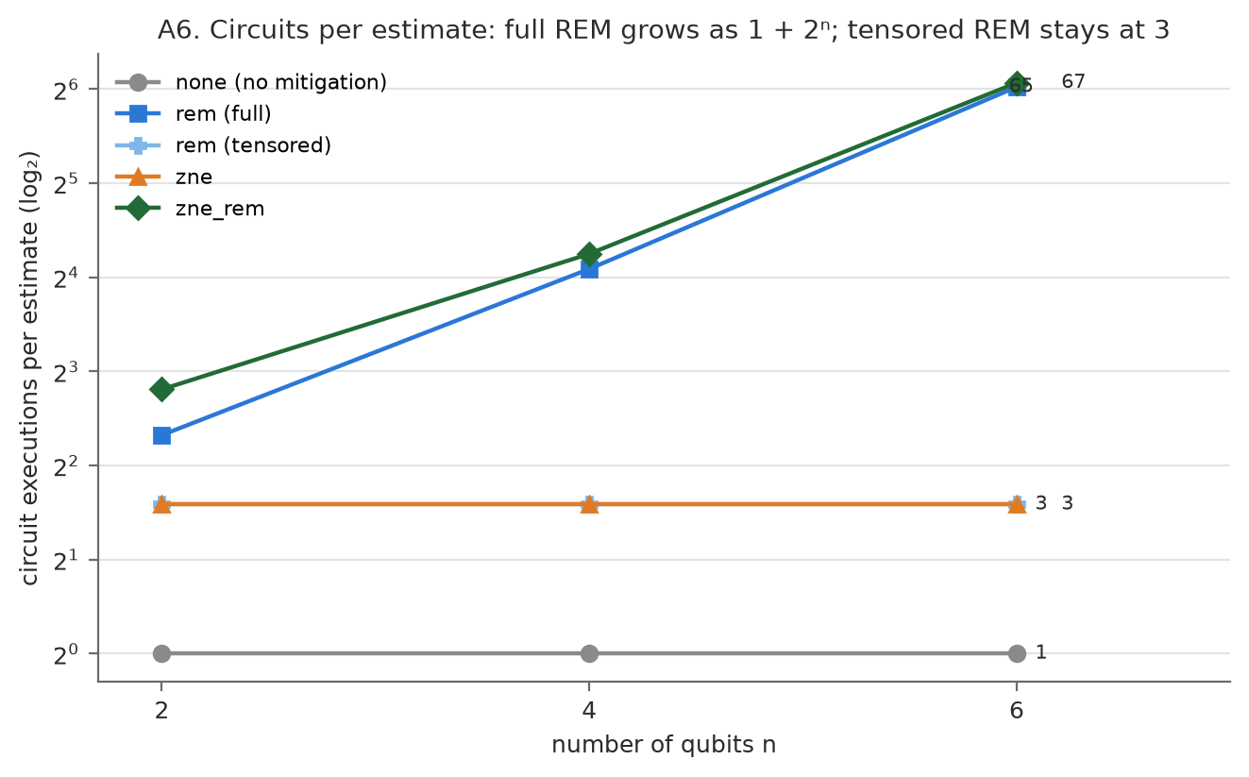
Figure 23: Circuits per estimate vs. qubit count: full REM grows as 1 + 2ⁿ, tensored REM stays at 3.
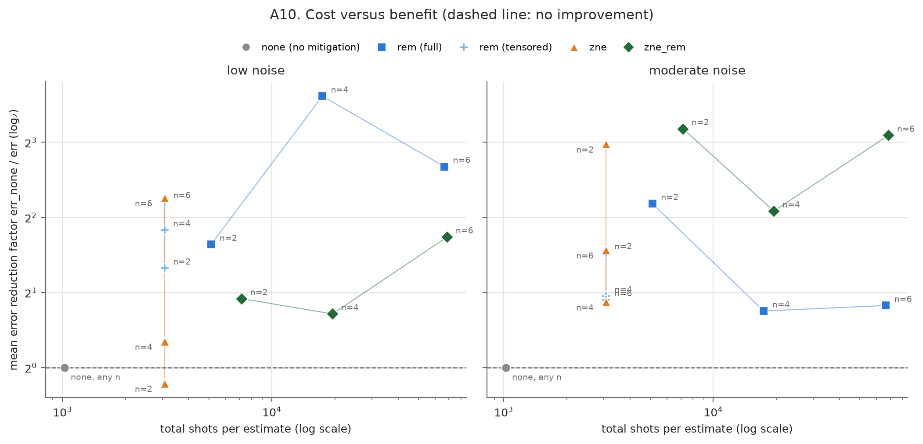
Figure 24: Cost (total shots per estimate) against benefit (mean error reduction factor), both on log scales, at N1 and N2; dashed line: no improvement.

7. Research Gap, Limitations and Proposed Improvement (2 marks)

7.1 Limitations
- Simulation only. The depolarizing-plus-readout model is incoherent and memoryless; real devices add coherent errors, crosstalk, T1/T2 relaxation, drift and leakage.
- ZNE. It amplifies variance (measured 2.07×–2.70×, consistent within sampling uncertainty with the 2.28× theory), its extrapolation model can mismatch the true decay (the exponential fit failed in 10/120 ZNE conditions), it never removes readout error, and its deepest folded circuit (95 deep, 5× the base) could exceed coherence times on hardware.
- REM. Full calibration costs 2ⁿ circuits; REM assumes stable readout; it can produce negative quasi-probabilities (largest negative mass 0.0186); it does nothing for gate noise. Tensored REM also assumes uncorrelated readout, which holds by construction in our noise model, so the comparison favours it.
- Small samples. Three qubit counts, two depths and 5 seeds per condition limit statistical power; with 20 test samples per seed, accuracy moves in 5% steps.
- Selection bias. Track A keeps only circuits with |E_exact| ≥ 0.3, so near-zero-parity circuits are not covered.
- VQC. Trained noise-free with a single encoding layer, which limits expressivity [15]; noise-aware training was not attempted [16].
- Scale and time. At most 6 qubits; simulator wall time is not hardware execution time.

7.2 Proposed improvement / future direction
Tested in this study. (1) Tensored REM: 2 calibration circuits instead of 2ⁿ, matching full REM within 0.0063 on average. (2) Variance-optimal ZNE shot allocation: minimizing Var(E₀) = Σᵢγᵢ²σᵢ²/Nᵢ subject to ΣNᵢ = N gives Nᵢ ∝ |γᵢ|σᵢ, so 3072 shots split as 1646,1097,329 instead of 1024 each; the measured standard deviation fell to 0.874× the uniform split (theory 0.885×) at the same total cost.
Proposed next step: validate on real hardware with correlated readout. Run the same paired protocol (same circuits, same shots shared across methods) on an IBM Quantum device, comparing full REM, tensored REM and matrix-free M3 mitigation [8], with and without ZNE. Why it should help: our results favour tensored REM partly because simulated readout errors are independent by construction. Real devices have correlated readout errors and drift, so a hardware run would show whether the 2-circuit calibration still matches the 2ⁿ one, and whether M3 recovers the gap at larger qubit counts where full calibration is impossible. The same run would test whether folding scales real, partly coherent noise as cleanly as it scales our depolarizing noise.
Further directions: data re-uploading to lift the VQC's Fourier-frequency limit [15], noise-aware VQC training with the caveats of [16], and probabilistic error cancellation or Clifford data regression on a smaller, targeted grid.

8. Key Findings Summary for Journal Paper
Top 3 findings (with numbers) | 1. At N2, ZNE+REM cut the median parity error by 68% (REM 43%, tensored REM 48%, ZNE 44%; all pooled Wilcoxon p ≤ 4.7e-08); at N1, ZNE alone gave no significant benefit (1%, p = 0.984) while REM gave 42%.  2. Tensored REM matched full REM within 0.0063 mean |difference| using 3 circuits instead of up to 65, and variance-optimal shot allocation reduced ZNE's std to 0.874× (theory 0.885×) at an equal 3072-shot budget.  3. On the VQC at N3, ZNE+REM restored margin retention from 0.411 to 0.847 while accuracy barely changed (0.900 vs 0.903); the exact VQC (0.920) is comparable to LR and SVM.
Best configuration (qubits / depth / noise) and why | Largest median error cut overall: ZNE+REM at N3, n = 4, L = 2 (87%), at the stress level. At the headline levels: REM at N1, n = 6, L = 2 (82%), error 0.051 ± 0.021 → 0.013 ± 0.010; and ZNE+REM at N2, n = 4, L = 4 (80%), error 0.209 ± 0.039 → 0.051 ± 0.021. Why: REM alone wins where readout dominates the bias (readout share 65% in that N1 cell); ZNE+REM wins where gate noise dominates (readout share 29% in that N2 cell). Where cost matters, tensored REM gives the same benefit as full REM (within 0.0063) for 3 circuits at any n.
What is new compared with the reviewed literature? | A paired, cost-normalized side-by-side comparison of full REM, tensored REM, ZNE and ZNE+REM in which every method processes the same shots, carried through to a VQC compared with LR and SVM on identical inputs, plus an empirical test of variance-optimal ZNE shot allocation.
Negative / unexpected results | ZNE alone was not significant at N1 and was worse than no mitigation at N0 in 26/30 runs. Unmitigated error grows with noise in every cell but not monotonically with n and L in every cell (H1 only partly supported). No runaway ZNE failure at N3 (Richardson out of range 0/120), although exponential fits failed more often. Classification accuracy was insensitive to both noise and mitigation.
Figures/tables suitable for the paper (IDs) | Figures 9, 11, 19, 21, 22 and 24; Tables 2, 3, 4 and 5.
Suggested keywords | Quantum error mitigation; zero-noise extrapolation; readout error mitigation; NISQ; variational quantum classifier; Qiskit Aer; depolarizing noise; shot allocation

Conclusion
REM, ZNE and their combination all reduce expectation-value error once gate noise is significant (N2 and N3), and ZNE+REM is the strongest method there, with a median error cut of 68% at N2. At low noise (N1), REM (full or tensored) is the dependable choice, and ZNE alone does not help because its variance cost outweighs a small bias. Costs scale as expected: 1 + 2ⁿ circuits for full REM, 3 for tensored REM, 3 circuits with 9× the CNOTs and up to 5× the depth for ZNE, and the sum for ZNE+REM. On the variational classifier, mitigation restores the decision margins strongly but barely moves accuracy, which is too coarse a measure on 20 test samples, and the exact VQC is comparable to, not better than, Logistic Regression and SVM. Both proposed cheaper variants worked: tensored REM matched full REM at a fraction of the circuits, and variance-optimal shot allocation reduced ZNE's standard deviation close to the predicted amount at the same budget.
Recommendation. Use REM by default (tensored once full calibration becomes impractical). Add ZNE, preferably combined with REM, when gate noise is large relative to shot noise and the extra depth and shots are affordable; skip ZNE when noise is already low. For classification tasks, judge mitigation by expectation error and margins, not by accuracy alone.

References
[1] J. Preskill, "Quantum computing in the NISQ era and beyond," Quantum, vol. 2, p. 79, 2018, doi: 10.22331/q-2018-08-06-79.
[2] K. Temme, S. Bravyi, and J. M. Gambetta, "Error mitigation for short-depth quantum circuits," Phys. Rev. Lett., vol. 119, no. 18, p. 180509, 2017, doi: 10.1103/PhysRevLett.119.180509.
[3] Y. Li and S. C. Benjamin, "Efficient variational quantum simulator incorporating active error minimization," Phys. Rev. X, vol. 7, no. 2, p. 021050, 2017, doi: 10.1103/PhysRevX.7.021050.
[4] S. Endo, S. C. Benjamin, and Y. Li, "Practical quantum error mitigation for near-future applications," Phys. Rev. X, vol. 8, no. 3, p. 031027, 2018, doi: 10.1103/PhysRevX.8.031027.
[5] A. Kandala, K. Temme, A. D. Córcoles, A. Mezzacapo, J. M. Chow, and J. M. Gambetta, "Error mitigation extends the computational reach of a noisy quantum processor," Nature, vol. 567, pp. 491–495, 2019, doi: 10.1038/s41586-019-1040-7.
[6] T. Giurgica-Tiron, Y. Hindy, R. LaRose, A. Mari, and W. J. Zeng, "Digital zero noise extrapolation for quantum error mitigation," in Proc. IEEE Int. Conf. Quantum Computing and Engineering (QCE), 2020, pp. 306–316, doi: 10.1109/QCE49297.2020.00045.
[7] S. Bravyi, S. Sheldon, A. Kandala, D. C. McKay, and J. M. Gambetta, "Mitigating measurement errors in multiqubit experiments," Phys. Rev. A, vol. 103, no. 4, p. 042605, 2021, doi: 10.1103/PhysRevA.103.042605.
[8] P. D. Nation, H. Kang, N. Sundaresan, and J. M. Gambetta, "Scalable mitigation of measurement errors on quantum computers," PRX Quantum, vol. 2, no. 4, p. 040326, 2021, doi: 10.1103/PRXQuantum.2.040326.
[9] R. LaRose et al., "Mitiq: A software package for error mitigation on noisy quantum computers," Quantum, vol. 6, p. 774, 2022, doi: 10.22331/q-2022-08-11-774.
[10] Y. Kim et al., "Evidence for the utility of quantum computing before fault tolerance," Nature, vol. 618, pp. 500–505, 2023, doi: 10.1038/s41586-023-06096-3.
[11] R. Takagi, S. Endo, S. Minagawa, and M. Gu, "Fundamental limits of quantum error mitigation," npj Quantum Inf., vol. 8, p. 114, 2022, doi: 10.1038/s41534-022-00618-z.
[12] Y. Quek, D. Stilck França, S. Khatri, J. J. Meyer, and J. Eisert, "Exponentially tighter bounds on limitations of quantum error mitigation," Nat. Phys., vol. 20, pp. 1648–1658, 2024, doi: 10.1038/s41567-024-02536-7.
[13] Z. Cai et al., "Quantum error mitigation," Rev. Mod. Phys., vol. 95, no. 4, p. 045005, 2023, doi: 10.1103/RevModPhys.95.045005.
[14] V. Havlíček et al., "Supervised learning with quantum-enhanced feature spaces," Nature, vol. 567, pp. 209–212, 2019, doi: 10.1038/s41586-019-0980-2.
[15] M. Schuld, R. Sweke, and J. J. Meyer, "Effect of data encoding on the expressive power of variational quantum-machine-learning models," Phys. Rev. A, vol. 103, no. 3, p. 032430, 2021, doi: 10.1103/PhysRevA.103.032430.
[16] S. Wang, E. Fontana, M. Cerezo, K. Sharma, A. Sone, L. Cincio, and P. J. Coles, "Noise-induced barren plateaus in variational quantum algorithms," Nat. Commun., vol. 12, p. 6961, 2021, doi: 10.1038/s41467-021-27045-6.
[17] J. A. Smolin, J. M. Gambetta, and G. Smith, "Efficient method for computing the maximum-likelihood quantum state from measurements with additive Gaussian noise," Phys. Rev. Lett., vol. 108, no. 7, p. 070502, 2012, doi: 10.1103/PhysRevLett.108.070502.
[18] R. A. Fisher, "The use of multiple measurements in taxonomic problems," Ann. Eugenics, vol. 7, no. 2, pp. 179–188, 1936, doi: 10.1111/j.1469-1809.1936.tb02137.x.
[19] R. A. Fisher, "Iris," UCI Machine Learning Repository, 1936, doi: 10.24432/C56C76.
[20] A. Javadi-Abhari et al., "Quantum computing with Qiskit," arXiv:2405.08810, 2024, doi: 10.48550/arXiv.2405.08810.
[21] Qiskit contributors, "Qiskit: An open-source framework for quantum computing," Zenodo, doi: 10.5281/zenodo.2573505. Version used: qiskit 2.5.2.
[22] Qiskit Aer contributors, "Qiskit Aer: high-performance simulators for Qiskit," version 0.17.2. [Online]. Available: https://github.com/Qiskit/qiskit-aer
[23] F. Pedregosa et al., "Scikit-learn: Machine learning in Python," J. Mach. Learn. Res., vol. 12, pp. 2825–2830, 2011. Version used: 1.9.1.

Appendix A – Contribution Statement
Student | Specific contribution (coding / experiments / writing / analysis)
G Srikaanth (1MS23CY015) | Team to fill
Devansh Sharma (1MS23CY014) | Team to fill

Appendix B – Declaration
We declare that this work is our own, that all sources are cited, that experiments were actually run and results are not fabricated, and that any use of AI tools (including code assistants) is disclosed below. We consent to the use of this work, with acknowledgement, in a research paper prepared by the faculty guide.
AI tools used (name & purpose) | Team to complete: list every AI tool used, including code assistants, and its purpose
Signature of team members

Appendix C – Submission Checklist
- ☐ Report in PDF format (file name: Group20_Quantum_Report.pdf)
- ☑ Code runs end-to-end; repository / Colab link works for the faculty
- ☐ Circuit diagrams and screenshots are legible
- ☑ At least 6 controlled experiments with 1024 shots and ≥2 varied parameters
- ☑ Mean ± SD over 5 seeds where feasible; noise levels N0–N2 reported
- ☑ At least 5 papers reviewed and a research gap stated
- ☑ Limitations and a proposed improvement included
- ☐ Google Form submitted (one submission per group, by the group leader)

Evaluation (for faculty use)
Component | Marks | Awarded / remarks
Problem understanding and objectives | 2
Literature review (min. 5 papers, research gap) | 3
Algorithm / circuit design | 3
Qiskit implementation | 4
Experiments and visualization | 3
Comparative analysis | 2
Research gap and proposed improvement | 2
Report clarity and response to questions | 1
Total | 20

