Smart Grid Energy Forecasting
A Project Based Learning Report Submitted in partial fulfilment of the requirements for the award of the degree

of

Bachelor of Technology
in the Department of CSE
25SC2107E Machine Learning
Submitted by
2510030006: Nyshadham Srikar
2510030008: G. Pranav
2510030147: U. Yogendra
2510030246: Mallala Sri Charan
2510030412: Akhil Sagar
Under the guidance of
Dr. Subhranginee Das



Department of CSE
Koneru Lakshmaiah Education Foundation, Aziz Nagar
Aziz Nagar – 500075
OCTOBER 2026
Abstract
Smart Grid Energy Forecasting predicts daily-average electricity load and compares the estimate with generation supplied by the user. It uses historical German energy records and daily mean temperature, covering 3,549 days from January 2015 to September 2024. Two XGBoost regressors use generation, weather, and calendar features. The main model also uses actual load from one and seven days earlier. In the reported chronological evaluation, this model achieved a held-out R² of 0.871173, a mean absolute error of 406.598, and a root mean squared error of 552.333. The fallback model achieved an R² of 0.775441. A Tkinter interface lets users retrieve temperature, select a model, and make predictions. It then compares generation with predicted demand, showing overproduction, underproduction, or a balanced state within a ±5% tolerance. The application provides an educational tool for exploring demand estimates and generation differences.

List of Figures
Figure 1. Training and prediction architecture 7
Figure 2. Monthly means of daily load and selected-source generation 8
Figure 3. Repository-reported test R² comparison 14

List of Tables
Table 1. Dataset fields and interpretation 8
Table 2. Model input features 9
Table 3. XGBoost training configuration 10
Table 4. Chronological dataset partitions 12
Table 5. Functional verification scenarios 13
Table 6. Repository-reported evaluation results 14
Table 7. Illustrative generation-balance outputs 15

Table of Contents
Abstract 2
List of Figures 3
List of Tables 4
1. Introduction 6
1.1 Background and motivation 6
1.2 Problem statement and objectives 6
1.3 Scope and project contribution 6
2. Methodology 7
2.1 System architecture 7
2.2 Dataset and daily preprocessing 8
2.3 Feature engineering 9
2.4 XGBoost model development 10
2.5 Prediction, weather lookup, and desktop interface 11
3. Experiments 12
3.1 Experimental design 12
3.2 Evaluation metrics and reproducibility 12
3.3 Functional verification 13
4. Results 14
4.1 Predictive performance 14
4.2 Generation-balance interpretation 15
5. Conclusion 16
References 17

Smart Grid Energy Forecasting

1. Introduction

1.1 Background and motivation
Electricity demand changes with daily activity, weather, and calendar patterns. Forecasting uses historical measurements to estimate demand before the actual load is fully observed. In this project, the estimate helps users assess whether a proposed generation level may exceed or fall short of demand. Its usefulness depends on the quality of the data and on whether the required inputs are available when the prediction is made.
Demand follows several patterns at once. Weekdays often differ from weekends, nearby days can have similar loads, and the same weekday in the previous week can provide useful context. Temperature and annual routines also create seasonal variation. The model represents these effects using calendar features, daily temperature, and recent load observations, rather than relying on a date or a single historical average.
The application works at daily resolution. Its output is the average measured load for a UTC calendar day, rather than a 24-hour load profile or a daily energy total. Generation must therefore be entered on a comparable daily-average scale. Averaging hourly power readings retains a power-like scale; summing or integrating energy over a day gives a different quantity. The report keeps the dataset's numerical units because the application does not convert or enforce physical units.

1.2 Problem statement and objectives
The task is to estimate daily realized load from a date, daily-average generation, daily mean temperature, and, when available, recent actual load. The application then reports the difference between generation and estimated demand. Generation and temperature are required in both modes. Lag mode also requires actual load from one and seven days before the selected date, so a date alone is not enough to make a prediction.
The project aims to prepare consistent daily energy and weather data, represent weekday and annual patterns, and evaluate two XGBoost regressors with a chronological holdout. A fallback model allows prediction when recent load history is unavailable. Input validation and a desktop interface help users enter data and interpret the signed generation difference. Training, inference, and presentation are separated so that prediction logic can be tested without opening the GUI.

1.3 Scope and project contribution
The project brings weather-based load estimation, manually entered load history, and a generation-balance display into one application. Lag mode is intended for cases where recent observations are available and predictive performance is the priority. Fallback mode allows use without those observations. Both modes share the same base inputs, making the choice between them straightforward. [1]
This prototype uses historical German data to explore electricity demand forecasting. It does not monitor a live grid, control switching equipment, optimize generator schedules, or account for transmission constraints. The balance label compares two daily averages within a specified tolerance. The remaining sections describe the data, model development, interface, evaluation, and limits of the reported results.

2. Methodology

2.1 System architecture
The application has separate components for data, training, prediction, and the desktop interface. The training script, train_daily_xgboost.py, reads combined.csv, constructs features, fits both models, evaluates them, and saves the outputs. Shared functions in predict.py validate inputs, retrieve temperature, load the models, build prediction features, and calculate the balance. The Tkinter interface in gui.py calls these functions. [1, 3, 4]
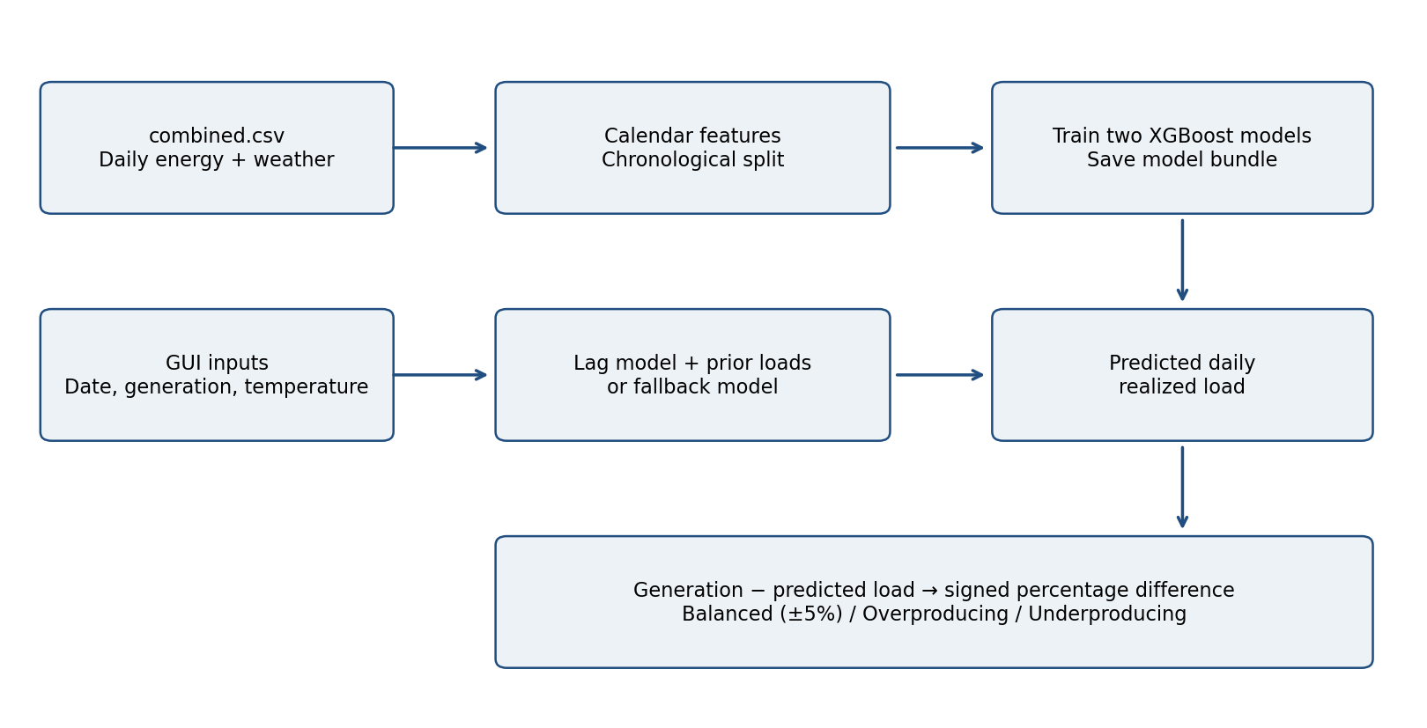
Figure 1. Training and prediction architecture, derived from the repository code.
Training uses measured daily load as the target and saves both fitted models in a pickle bundle. For each prediction, the application loads this bundle and builds a single-row feature matrix from the user's inputs. It therefore does not need to retrain for every request. The training and prediction code use consistent feature definitions.
The lag model adds earlier actual load values to the common features; the fallback model uses only the common features. Users choose the mode explicitly in the GUI. Missing or invalid lag values produce an error rather than an automatic switch to fallback mode, so the displayed result always corresponds to the selected model.

Artifacts and responsibilities
Training saves daily_xgboost_model.pkl, metrics.json, and test_predictions.csv in artifacts_daily/. These files contain the fitted models; the scores, feature names, lag definitions, and test period; and each test day's actual load, prediction, and actual-minus-predicted residual, respectively. The training script generates these outputs, but they are absent from the tracked repository snapshot inspected for this report.

2.2 Dataset and daily preprocessing
The repository identifies German Electrical Load 2015–2024 as the source of its energy data. It includes the original hourly dataframe.csv, the prepared dataframe_daily_cleaned.csv, weather_data.csv, and the merged combined.csv. The current training script reads the merged daily file directly; it does not repeat the hourly preprocessing. [1, 2, 5]
Table 1. Dataset fields and interpretation.
Field | Interpretation
date | UTC calendar date; parsed as a timezone-aware timestamp
current_energy_generation | Daily average of the hourly sum of 11 selected generation sources
realized_load | Daily average measured electrical load; regression target
temperature_celsius | Daily mean air temperature in °C

According to the project documentation, selected generation columns are summed for each hourly record, then averaged over the 24 observations in a day. Biomass is excluded from this total. Realized load is averaged over the same daily observations. The resulting generation variable is therefore the project's aggregate of selected sources and should not be treated as a complete generation balance for the German power system. [2]
Weather data come from Open-Meteo for Frankfurt, Germany, at latitude 50.1109° N and longitude 8.6821° E. The repository describes averaging hourly two-metre air temperatures in UTC and joining the daily values to the energy records by date. Frankfurt provides a consistent weather proxy, although one location cannot represent temperature across every demand region. [1]
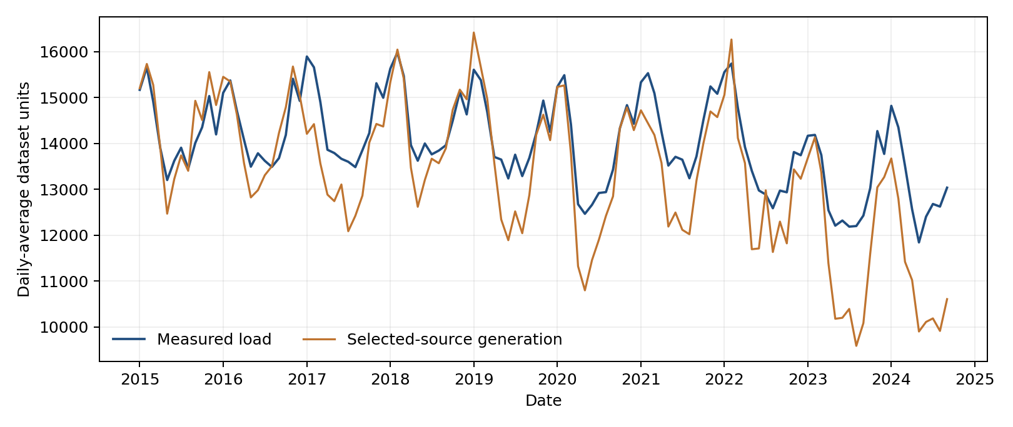
Figure 2. Monthly means calculated from the committed daily dataset.
Inspection of combined.csv confirms 3,549 rows from 2015-01-01 to 2024-09-18, with no empty fields. Row order matters because the training script partitions the data by position. Before adding new data or constructing lags, date order, duplicate dates, gaps, numeric validity, and weather coverage should be checked explicitly.

2.3 Feature engineering
Both models convert the date and supplied values into five base features. The main model adds two features for historical load. The continuous target is realized_load. Feature names and their order are kept consistent between training and inference. [3, 4]
Table 2. Model input features.
Feature | Construction / role
current_energy_generation | User input; available daily-average generation scenario
temperature_celsius | User-entered or retrieved daily mean temperature
day_of_week | Monday = 0 through Sunday = 6
day_of_year_sin | sin(2π × day_of_year / 365.25)
day_of_year_cos | cos(2π × day_of_year / 365.25)
load_lag_1 | Actual realized load from one day earlier; lag model only
load_lag_7 | Actual realized load from seven days earlier; lag model only

The weekday feature captures recurring differences between working days and weekends. Annual sine and cosine features place the day of year on a continuous cycle, allowing the model to distinguish positions within the year without a sharp break between December and January. The implementation uses 365.25 as the divisor, giving an approximate annual-period encoding.
The training script creates historical-load features with target.shift(1) and target.shift(7). Only the lag model drops the first seven rows, which lack complete history. Its fitting and test indices are adjusted by seven so that validation and test boundary dates remain unchanged. The fallback model keeps every row of base features.

Information availability and forecast horizon
For a lag-mode prediction on 2024-01-15, the user must enter measured load from 2024-01-14 and 2024-01-08. These are supplied manually at inference, and the future target is not a direct feature. During holdout evaluation, however, actual previous-day loads are available for successive test dates. The score thus describes rolling predictions made as new historical observations become available. It does not describe a multi-day forecast made at one starting point without later measurements.
Generation is an input for the date being predicted. For future use, it must be a planned or estimated value available when the prediction is made. Temperature must likewise come from an available forecast or an explicit scenario. Evaluation with realized same-day generation and archived weather does not measure the additional uncertainty involved in estimating these inputs. Prospective demand forecasts should state this assumption.

2.4 XGBoost model development
XGBRegressor models the nonlinear relationship between the features and realized load. It combines regression trees through gradient boosting, adding trees to improve the fit to the remaining errors under the chosen objective. Shallow trees, row and feature sampling, and regularization constrain model complexity. [3]
Table 3. XGBoost training configuration.
Parameter | Implemented value
n_estimators | 1,500 maximum
max_depth | 3
learning_rate | 0.03
subsample | 0.85
colsample_bytree | 0.90
min_child_weight | 5
reg_lambda | 4
objective | reg:squarederror
eval_metric | rmse
early_stopping_rounds | 75
tree_method | hist
random_state / n_jobs | 42 / −1

Both regressors use the same configuration, making feature availability their main difference. The script first fits the fallback model on the five base features. It then builds the lag features and fits the main model on rows with sufficient history. An earlier validation block monitors training for each model, while the final holdout is reserved for evaluation.
Training stops when validation RMSE fails to improve for 75 rounds. The setting of 1,500 estimators is a maximum, not the number of trees necessarily used in every run. The README reports a saved best iteration of 1,114 for its documented run. This value may change when dependencies or data change. [1]

Training algorithm
The script parses the merged daily data and calculates the chronological split indices before constructing the common features. It fits and scores the fallback model, then creates one-day and seven-day target shifts and removes rows lacking lag history. Finally, it fits and scores the lag model and saves the model bundle, metrics, and test-day predictions. The current script has no scaling stage, hyperparameter search, or comparison with other forecasting algorithms.
Ordinary predictions use the saved models, while retraining requires a separate user action. The GUI runs training in a background thread and sends completion through a queue. The main thread then reloads the model bundle and refreshes the displayed scores.

2.5 Prediction, weather lookup, and desktop interface
The desktop window, Energy Production Monitor, accepts an ISO-style date, non-negative generation, and a finite daily mean temperature. Selecting lag mode reveals fields for actual load from one and seven days earlier; fallback mode hides them. Results show predicted realized load, generation minus predicted load, the percentage difference, and the balance label. [4]

Validation and inference
parse_date() interprets the date. validate_inputs() rejects invalid dates, negative generation, and non-finite numbers; in lag mode, it also rejects missing, negative, NaN, or infinite earlier-load values. build_features() then creates a single-row base feature matrix, and predict_realized_load() selects the requested model and returns a floating-point prediction. Before dividing by that prediction, calculate_balance() checks that it is finite and greater than zero.

Temperature retrieval
fetch_temperature() first searches weather_data.csv for the selected date, allowing offline lookup when a historical value is stored locally. Otherwise, it uses Open-Meteo's archive endpoint for dates more than five days old and the forecast endpoint for recent or future dates. Requests use daily mean temperature for Frankfurt in UTC. Automatic lookup is rejected beyond 16 days ahead, when the user must enter an expected temperature manually. This is an application limit; the external service may still lack data for a date within that range.
HTTP failures, connection errors, invalid responses, missing fields, and unavailable temperatures are shown as user-facing errors. Users can edit a retrieved value to explore a weather scenario. Lookup currently runs synchronously in the GUI, so a slow request can delay interaction. A worker thread would improve responsiveness.

Generation comparison
For supplied generation G and predicted realized load ŷ, the application calculates Δ = G − ŷ and p = 100Δ / ŷ. It labels the state Balanced when |p| ≤ 5. Otherwise, a positive difference is Overproducing and a negative difference is Underproducing. The signed difference and percentage remain visible even within the balanced tolerance.
The balance label compares generation with the model's demand estimate. It does not account for imports, exports, transmission losses, reserves, storage, or grid constraints. It should therefore be read as a planning indicator, rather than a full assessment of physical grid adequacy.

3. Experiments

3.1 Experimental design
The data are split chronologically so that later observations remain outside model fitting. With N = 3,549 rows, test_start = floor(0.80N) = 2,839 and fit_end = floor(0.90 × test_start) = 2,555. The fallback model therefore uses 2,555 fitting rows, 284 validation rows, and 710 test rows. Lag construction removes seven fitting rows from the main model. [3]
Table 4. Chronological dataset partitions, checked from combined.csv.
Partition | Fallback / lag rows | Date range
Fitting | 2,555 / 2,548 | 2015-01-01 / 2015-01-08 to 2021-12-29
Validation | 284 / 284 | 2021-12-30 to 2022-10-09
Testing | 710 / 710 | 2022-10-10 to 2024-09-18

Validation determines when training stops. Test labels are used to calculate metrics after fitting and are not fitting targets. The lag features for rolling test-day predictions include actual earlier loads. This matches a setting in which yesterday's observation is available before each prediction, rather than a recursive forecast of all 710 days made at once.

3.2 Evaluation metrics and reproducibility
Mean absolute error is MAE = (1/n)Σ|yᵢ − ŷᵢ|. It expresses the average magnitude of error in the target’s units. Root mean squared error is RMSE = √[(1/n)Σ(yᵢ − ŷᵢ)²]. Because errors are squared before averaging, RMSE is more sensitive to large deviations. The coefficient of determination is R² = 1 − Σ(yᵢ − ŷᵢ)² / Σ(yᵢ − ȳ)². R² is dimensionless and should not be interpreted as a percentage of individual predictions that are correct.
The repository includes requirements.txt and commands for creating a Python virtual environment, installing dependencies, running train_daily_xgboost.py, launching gui.py, and executing pytest. Python must also have Tkinter available. Because requirements.txt specifies minimum versions rather than a complete lockfile, exact reproduction may depend on library versions and the platform.
To reproduce an experiment, the repository commit, complete dependency versions, prepared data, metrics.json, and test_predictions.csv should be retained together. This report checks source code and dataset metadata and cites the project's documented evaluation values. It does not claim that training, GUI testing, or the test suite was run independently for this report.

3.3 Functional verification
The unit tests in test_predict.py cover feature creation, date and numeric validation, local weather lookup, lag-mode requirements, fallback prediction, model loading, and balance calculations. Some require trained artifacts, so a complete test run must follow training when the bundle is absent. The reviewed tests show intended coverage; their presence does not establish that they were executed. [6]
Table 5. Functional verification scenarios derived from implementation and tests.
Scenario | Expected behavior
Valid date, generation and temperature | Base features contain inputs and the correct weekday
Malformed or impossible date | Validation error explaining date format
Negative or non-finite generation | Reject the input
Non-finite temperature | Reject the input
Historical date saved locally | Return a finite local temperature
Date 17 days into the future | Reject automatic temperature retrieval
Lag mode with missing or invalid loads | Reject the request
Fallback mode without load history | Use the fallback model
Generation 95, 100 or 105; prediction 100 | Balanced at and within ±5%
Generation 120 / 80; prediction 100 | Overproducing / Underproducing
Missing trained model bundle | Application requests model training

Recommended end-to-end procedure
• Install the declared dependencies and confirm that Tkinter is available. Run python train_daily_xgboost.py in the project environment and check that all three artifacts are created, then run python -m pytest -q. Open python gui.py and select a historical date. Retrieve its local temperature, enter generation and valid earlier-load values, and request a prediction in lag mode. Switch to fallback mode and confirm that the lag fields disappear and prediction works without them.
• Check error handling with an impossible date, negative generation, and missing lag inputs. The interface should show an error without displaying a newly fabricated result. Press Train model to verify that the progress indicator runs and the scores update on completion. Test weather-service failures separately from local lookup, because they depend on connectivity.
• Additional checks should cover invalid model predictions, training failures, unavailable API responses, exact feature ordering, gaps in refreshed data, and values on either side of the ±5% boundary. The existing test file does not establish complete GUI coverage or physical grid correctness.

4. Results

4.1 Predictive performance
README and DAILY_REPORT.md report the following results for the final 710-day holdout, covering 10 October 2022 to 18 September 2024. The values below are reproduced from those documents. The inspected tracked snapshot lacks the generated artifact directory, so they could not be recomputed directly from saved predictions. [1, 2]
Table 6. Repository-reported evaluation results; errors are in target units.
Model | R² | MAE | RMSE
Weather + calendar + 1/7-day lags | 0.871173 | 406.598 | 552.333
Weather + calendar fallback | 0.775441 | Not reported | Not reported

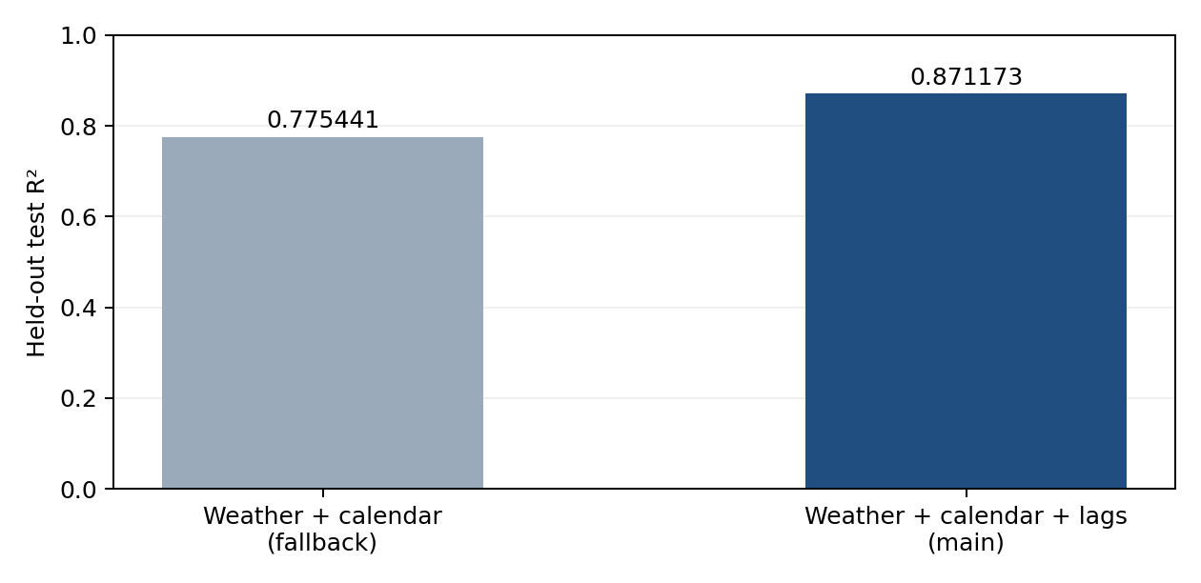
Figure 3. Repository-reported held-out R² for the two implemented models.
The lag model's R² is 0.095732 points higher than the fallback model's. This is consistent with recent actual loads adding useful information beyond generation, temperature, and calendar features, and supports using lag mode when those observations are known. The experiment did not include persistence, seasonal-naïve forecasting, linear regression, or other boosting models, so it does not establish an advantage over those baselines.
For this holdout, R² = 0.871173 indicates substantially less squared error than predicting the test-set mean. It does not mean that 87.1173% of predictions are exact. MAE = 406.598 gives the average absolute error in dataset units. The higher RMSE of 552.333 reflects the greater weight assigned to large errors by the squared-error measure.
The fallback model can estimate load without history, including for dates outside the local dataset if generation and temperature are supplied. Its lower test score shows the tradeoff observed in this evaluation period. Accepting a far-future date in the interface does not establish reliable prediction beyond the historical data distribution.

4.2 Generation-balance interpretation
The interface turns the continuous load estimate into one of three generation-balance states. The examples below use a hypothetical predicted load of 10,000 units to illustrate the arithmetic. They are not results from running a trained model.
Table 7. Illustrative outputs for a predicted load of 10,000 units.
Generation | Difference | Percentage | Status
9,000 | −1,000 | −10% | Underproducing
9,500 | −500 | −5% | Balanced
10,000 | 0 | 0% | Balanced
10,500 | +500 | +5% | Balanced
11,000 | +1,000 | +10% | Overproducing

Both boundary values, −5% and +5%, are included in Balanced. Generation can therefore exceed predicted load and still receive this label if the difference is within tolerance. Showing the signed difference and percentage alongside the label helps users distinguish a tolerable difference from exact equality.

5. Conclusion
Smart Grid Energy Forecasting links prepared daily energy and temperature records to demand prediction and generation comparison. XGBoost uses calendar features in both modes, with actual load from one and seven days earlier added in lag mode. Fallback mode allows prediction without those observations. The Tkinter interface provides model selection, temperature retrieval, manual entry, training, and prediction in one desktop application.
Over the reported 710-day chronological holdout, the lag model achieved R² = 0.871173, MAE = 406.598, and RMSE = 552.333. The fallback model's R² was 0.775441. These documented results support the use of recent-load features in the evaluated setting, while the fallback remains available when history is unknown. The generation comparison reports a signed difference and treats values within ±5% as balanced.
The prototype provides an educational tool for examining demand estimates and generation scenarios. Its results assume that recent actual loads become available during rolling prediction and that same-date generation and weather inputs are known or supplied. Daily averages and incomplete physical accounting limit what the balance display can tell users, so it should not be used as a grid-control instruction.

References
[1] Srikar0006. Smart-Grid-Energy-Forecasting: README.md. GitHub repository. https://github.com/srikar0006/Smart-Grid-Energy-Forecasting. Snapshot 4a3b5536487d76aba53351b1075403fd01d171c2, inspected 6 October 2026.
[2] Srikar0006. DAILY_REPORT.md and combined.csv. Same repository and snapshot. Sources for published evaluation values, transformation description, and directly checked daily dataset metadata.
[3] Srikar0006. train_daily_xgboost.py. Same repository and snapshot. Primary source for feature construction, split indices, hyperparameters, evaluation, and artifact generation.
[4] Srikar0006. predict.py and gui.py. Same repository and snapshot. Primary sources for validation, weather routing, inference, balance logic, and desktop behavior.
[5] German Electrical Load 2015–2024. Kaggle dataset credited in the repository. https://www.kaggle.com/datasets/vsevolodnedora/german-electrical-load-2015-2024. Dataset provenance is recorded as cited by the project; the upstream dataset was not independently inspected for this report.
[6] Srikar0006. test_predict.py and requirements.txt. Same repository and snapshot. Sources for test definitions and declared Python dependencies.
[7] Open-Meteo. Historical Weather API documentation: https://open-meteo.com/en/docs/historical-weather-api; Forecast API documentation: https://open-meteo.com/en/docs. Service references linked by the project. The specific request behavior described here is grounded in predict.py.

