**PROJECT STATUS REPORT**

**Autism Spectrum Disorder Detection Using ML**

**For the week ending 30/08/2023**

|  |  |  |  |
| --- | --- | --- | --- |
| **Milestones** | **Planned Date** | **Actual Date** | **Comments [Reson for Delay]** |
| **Project Planning** | **22nd August** | **22nd August** | **No delay** |
| **Dataset Selection/Analysis** | **23rd August** | **24th August** | **Changed the dataset the next day** |
| **Cleaning and Analysis** | **23rd August** | **25th August** | **Extended as the dataset was changed** |
|  | **26th August** | **26th August** | **No delay** |
| **More changes and Encoding** | **26th August** | **26th August** | **No delay** |
| **Training model** | **28th August** | **29th August** | **Needed more knowledge to proceed with the algorithms.** |
|  |  |  |  |
|  |  |  |  |

**Accomplishments/Achievements of this week**

|  |
| --- |
| **Found a dataset consisting of required amount of data.** |
| **Understood the data and analysed the data.**  **Recorded the occurrence of the autism based on Univariant and Bivariant Analysis.** |
| **Improved our knowledge on the working of ML by referring and reading through blogs and papers.** |
| **Applied 5 algorithms such as Logistic Regression , KNN , Decision Tree , Random Forest, SVM on the test and train data.** |
|  |
|  |
|  |
|  |

**Screenshots**

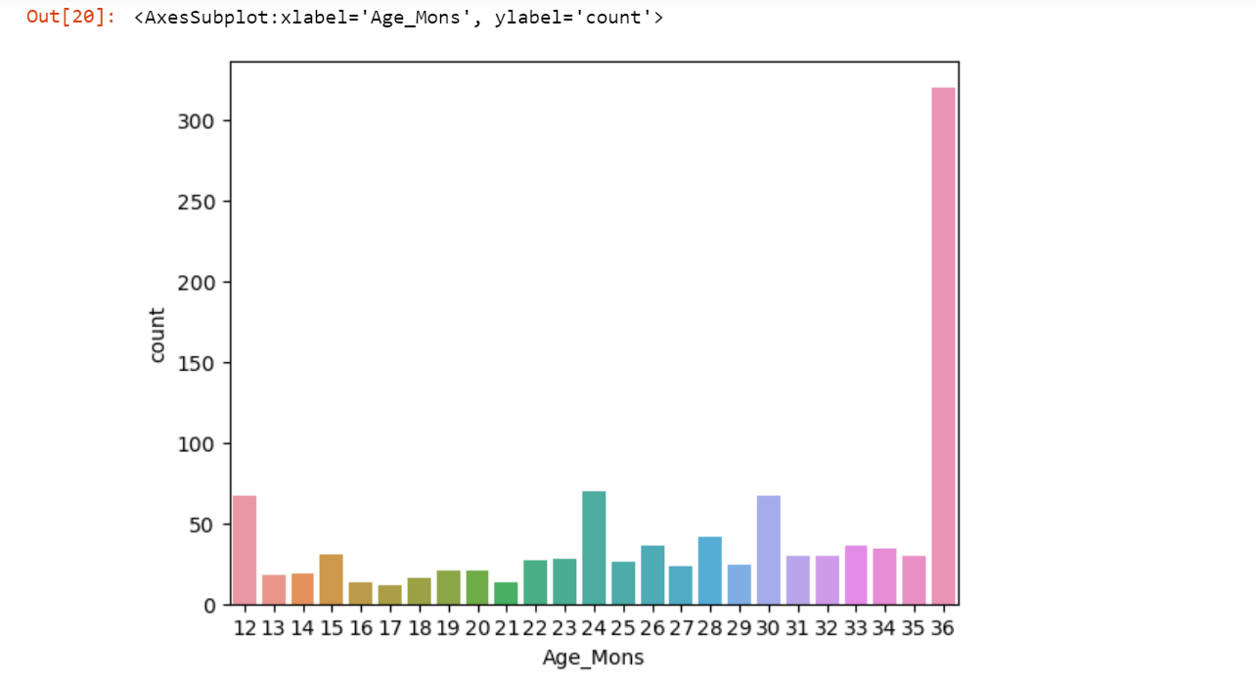

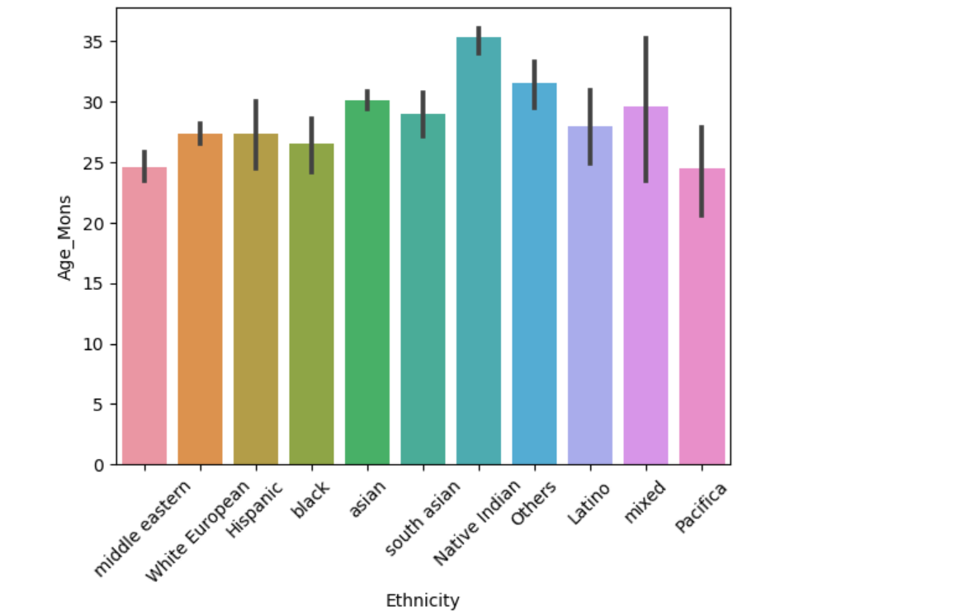

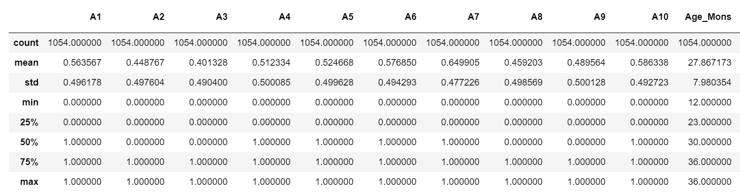

**A1-A10 represents the questions posed during the self assessment test.**

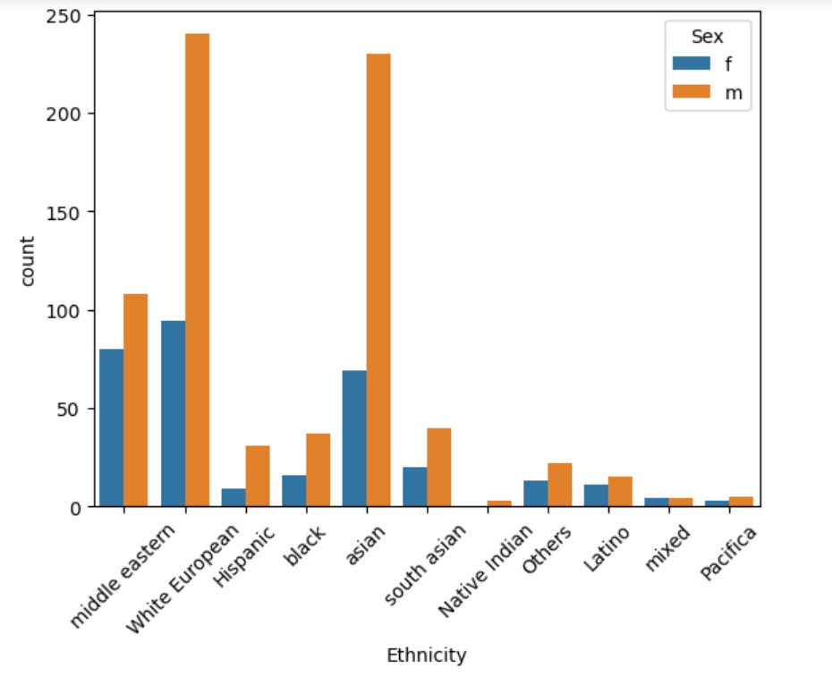

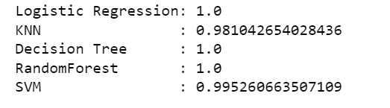

**Student’s name and signature:**

**Srikar G S S Shreya Rajesh Prajwal N**