AGRONEXUS AI — COMPLETE PROJECT ARCHITECTURE
Architecture diagrams, data flow, ADIE-1, ACER, ML services, data model, deployment and operational explanation

1. Architecture Purpose
AgroNexus AI is designed as a software-first agricultural decision-support system. The core architectural principle is that individual ML models should generate evidence, while a dedicated decision layer (ADIE-1) evaluates candidate interventions using the current agricultural context, constraints, model evidence and prior outcome knowledge. ACER (Action–Context Effect Record) closes the loop by recording what action was taken, under what context, what was expected, what was observed and how the result differed.

2. Complete Architecture
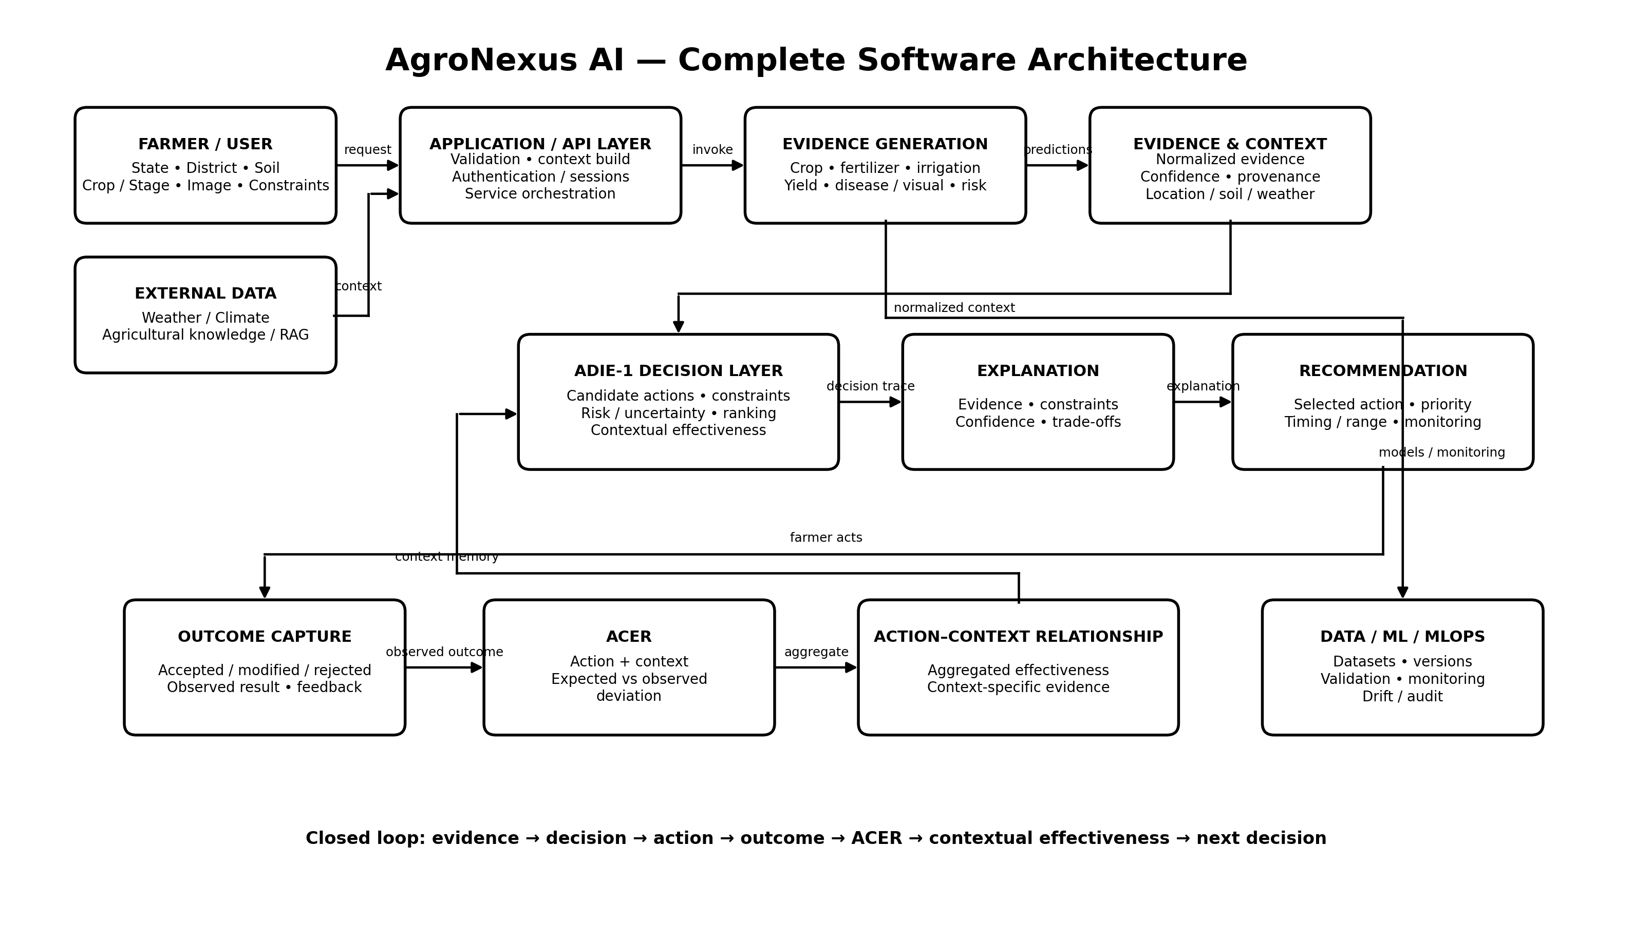
Figure 1. Complete AgroNexus software architecture. The architecture separates user interaction, external data, evidence-generating ML services, context/evidence storage, ADIE-1 decisioning, explanation, recommendation delivery and the closed-loop ACER learning layer.

Layer-by-layer explanation
1. Farmer / User Layer
Collects the information available to the farmer, including state, district, soil information, crop information/stage, plant images and farm constraints. The interface should avoid requiring the user to understand the internal ML pipeline.
2. External Data Layer
Provides software-accessible contextual information such as weather/climate data and agricultural knowledge documents. External information is treated as evidence with a source and timestamp rather than silently becoming ground truth.
3. Application / API Layer
Validates requests, builds the analysis context, calls the relevant services, handles sessions/authentication and returns structured results to the frontend.
4. Evidence Generation Layer
Contains specialist predictive models. Examples include crop recommendation, fertilizer recommendation, irrigation/water requirement, yield prediction and disease/visual-risk inference. Each model should return a prediction plus confidence/metadata where available.
5. Evidence & Context Layer
Normalizes model outputs and contextual variables so different services can be consumed by ADIE-1 consistently. Context includes location, soil, weather, crop and other relevant conditions.
6. ADIE-1 Decision Layer
The central decision mechanism. It does not simply select the highest ML probability. It creates candidate actions, applies constraints, considers uncertainty and prior contextual effectiveness, ranks actions and selects the recommendation.
7. Explanation Layer
Converts the decision into a farmer-readable explanation: evidence used, important constraints, confidence/uncertainty, expected benefits/trade-offs and alternatives.
8. Recommendation Layer
Produces the actionable output: selected intervention, priority, recommended range/timing where supported, expected outcome and monitoring/follow-up instructions.
9. Outcome Layer
Captures whether the farmer accepted, modified, rejected or deferred the recommendation and records subsequent feedback/outcomes.

10. ACER Layer
Stores the action-context-outcome relationship in a structured record and computes the deviation between expected and observed outcome.
11. Action–Context Relationship Layer
Aggregates repeated ACER records to estimate how effective an intervention tends to be under a particular context. This becomes reusable evidence for future ADIE-1 decisions.
12. Data/ML/MLOps Layer
Supports training datasets, preprocessing, model versions, validation, monitoring, drift checks, logs and auditability.

3. End-to-End Data & Decision Flow
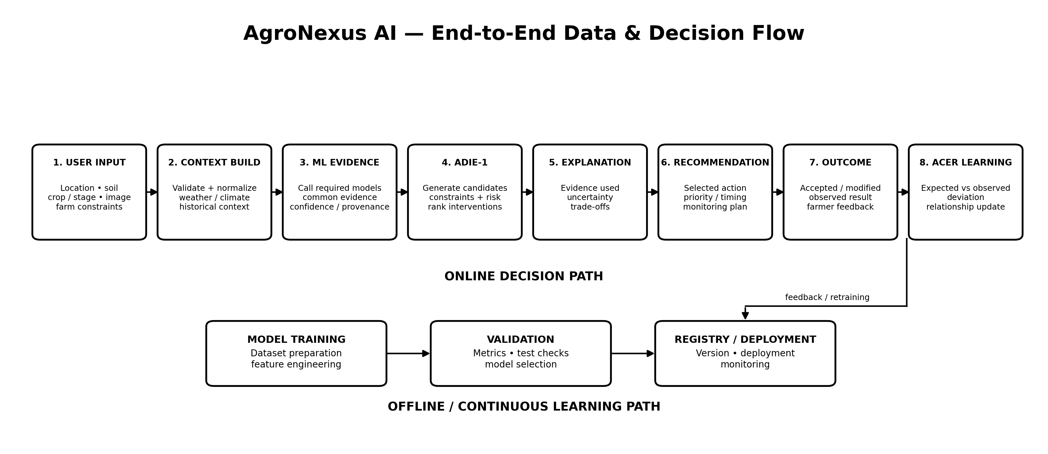
Figure 2. The online decision path and the separate model-development/retraining path.
1. User input: The farmer provides the minimum information required for the selected analysis. For crop recommendation this includes the agreed location and soil-related inputs; other modules can require additional information.
2. Context build: The backend validates and normalizes the input and attaches contextual information such as weather and relevant historical context.
3. ML evidence: Only the specialist models required for the decision are called. Outputs are converted to a common evidence structure.
4. ADIE-1: The decision engine considers evidence, constraints and context-relevant prior outcomes and generates/ranks candidate interventions.
5. Explanation: The system prepares a traceable reason for the selected action.
6. Recommendation: The frontend receives a structured recommendation rather than an unstructured model response.
7. Outcome: The system later captures what actually happened.
8. ACER learning: The outcome becomes a structured learning record that can influence later decisions.

4. ADIE-1 — Agricultural Decision & Intervention Engine
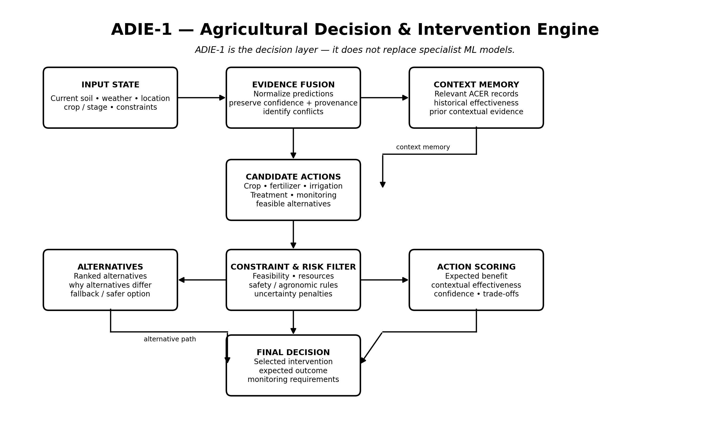
Figure 3. Internal logic of ADIE-1.
ADIE-1 is the architectural component that differentiates AgroNexus from a collection of independent prediction APIs. The specialist models answer questions such as 'which crop is likely suitable?' or 'what fertilizer class is predicted?'. ADIE-1 answers the broader decision question: 'given the current context, constraints, evidence and prior experience, which intervention should be recommended now?'
Input state: Current agricultural context plus model-generated evidence.
Evidence fusion: Normalizes evidence, preserves provenance and confidence, and identifies conflicts.
Context memory: Retrieves prior outcome evidence relevant to the present context.
Candidate action generation: Creates feasible alternatives instead of assuming the first model prediction is automatically the final action.
Constraint and risk filter: Removes or penalizes options that violate known constraints, resource limits or risk rules.
Action scoring: Ranks remaining actions using predicted benefit, contextual effectiveness, uncertainty and trade-offs.
Final decision: Returns the selected intervention together with expected outcome and monitoring requirements.

5. ACER — Action–Context Effect Record
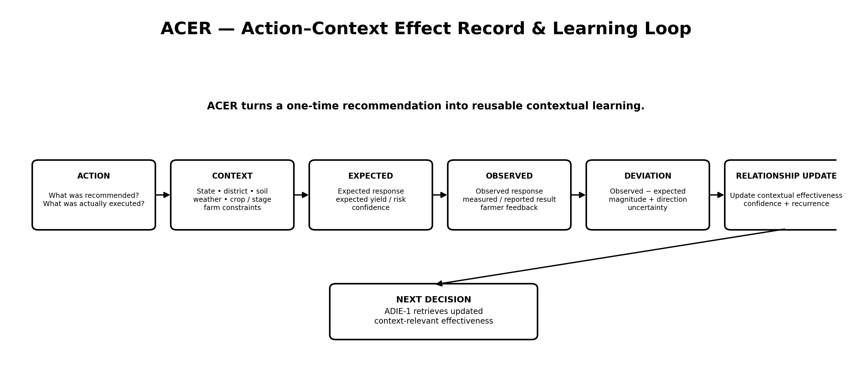
Figure 4. ACER closes the recommendation → execution → outcome → learning loop.
ACER should be treated as a first-class data object, not merely a feedback comment. The minimum conceptual record is: action, execution context, expected outcome, observed outcome and deviation. Additional fields such as timestamps, confidence, source, crop stage and farmer feedback can be retained when available.
The important research idea is contextual effectiveness. A fertilizer or treatment action may work well in one soil/weather/crop-stage context and less well in another. Repeated ACER records allow AgroNexus to represent this relationship explicitly rather than assuming that one global recommendation rule is equally effective everywhere.

6. ML Services and Their Architectural Role
Module | Primary job | Typical input | Output to ADIE-1
Crop Recommendation | Rank/classify suitable crops | Location, soil, N/P/K, pH, climate/weather and agreed dataset features | Crop candidates + confidence
Fertilizer Recommendation | Recommend fertilizer category/strategy | Soil nutrients, crop, stage, climate/context and available features | Fertilizer candidates + confidence
Irrigation / Water | Estimate irrigation requirement or action | Crop, stage, weather, soil/moisture-related variables where available | Water requirement / action evidence
Yield Prediction | Estimate expected production/yield | Crop, region, season, area and environmental/agronomic variables | Expected yield / uncertainty
Disease / Visual Risk | Analyze plant image and identify disease evidence | Uploaded plant image + crop context | Disease class/localization/confidence
Risk / Advisory Services | Convert contextual signals into warnings or risk evidence | Weather, crop stage, disease/yield/context signals | Risk score / alert evidence
Important: these modules remain specialist evidence generators. They should not independently own the final intervention decision when multiple evidence sources or contextual trade-offs are involved.

7. Software Deployment / Technology Architecture
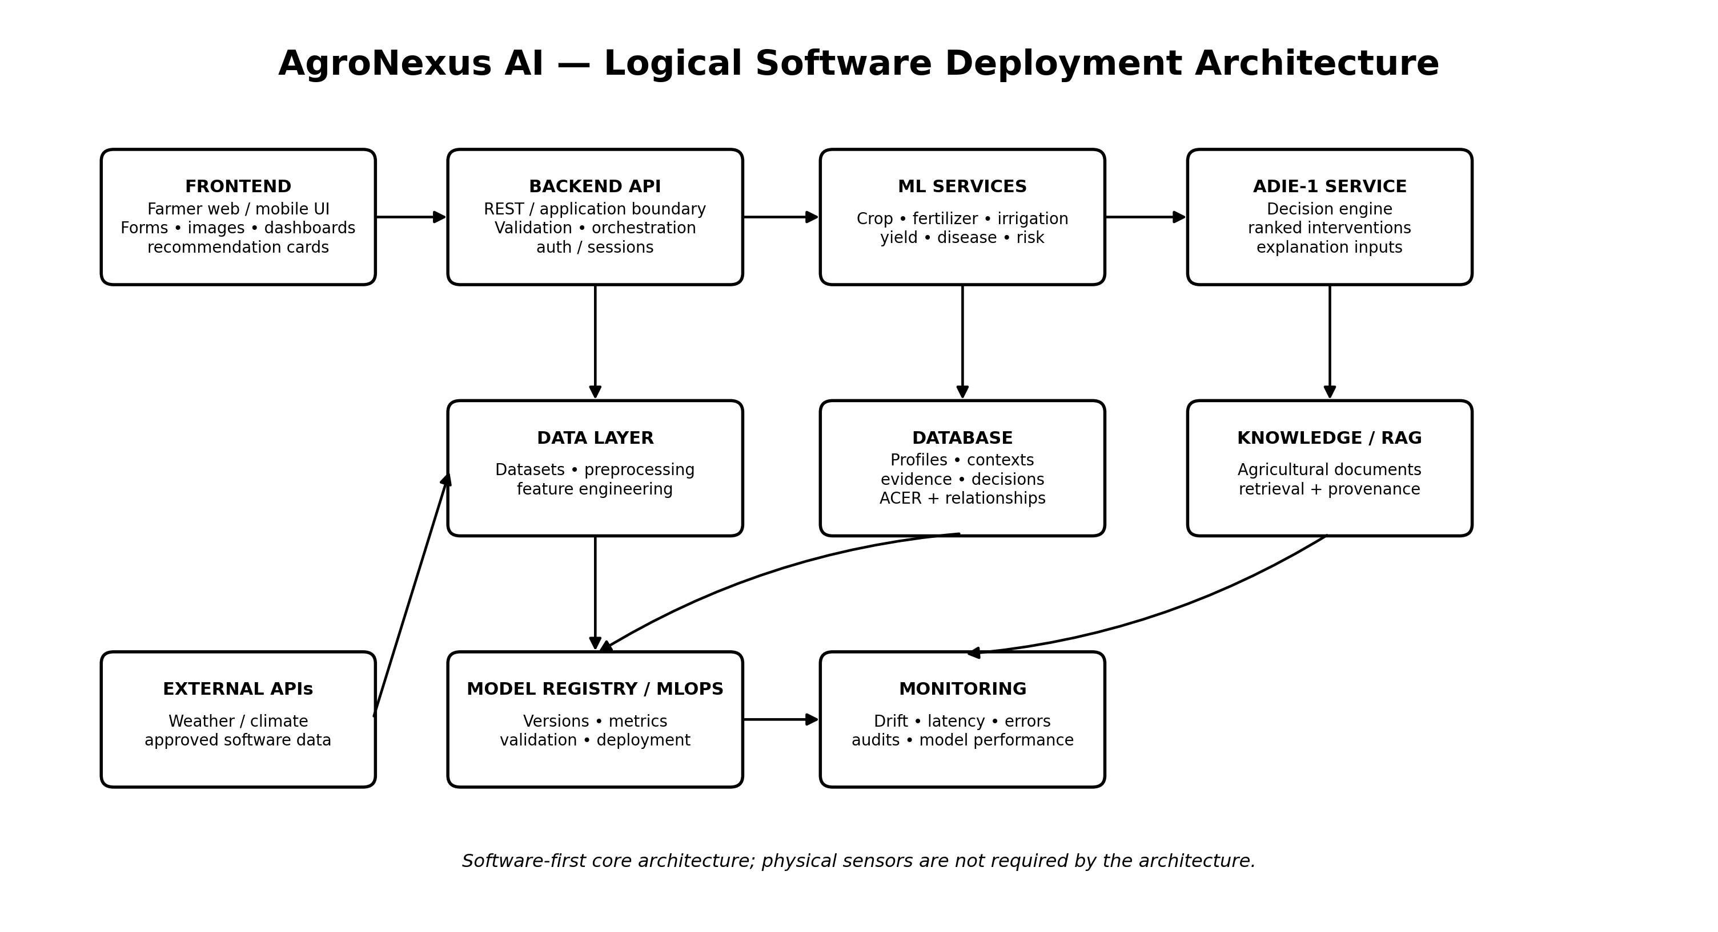
Figure 5. Logical software deployment architecture. Technology names shown are implementation choices/targets and can be changed without changing the conceptual architecture.
Frontend: The farmer-facing application: forms, image upload, dashboards, recommendation cards, explanations and outcome/feedback capture.
Backend API: The application boundary responsible for validation, orchestration, authentication/session handling and routing to model/decision services.
ML services: Independently deployable inference modules for the specialist predictive tasks.
ADIE-1 service: A separate decision service that consumes structured evidence and returns ranked interventions plus explanation inputs.
Database: Stores users/farm profiles, contexts, evidence logs, decisions, ACER records, action-context relationships and audit information.
Knowledge/RAG layer: Retrieves relevant agricultural documents/knowledge when the product requires grounded advisory explanations. Retrieved knowledge should retain provenance.
External APIs: Weather/climate and other approved software data sources.
Model registry / MLOps: Maintains model versions, validation metrics, deployment status, drift and operational monitoring.

8. Logical Data Model
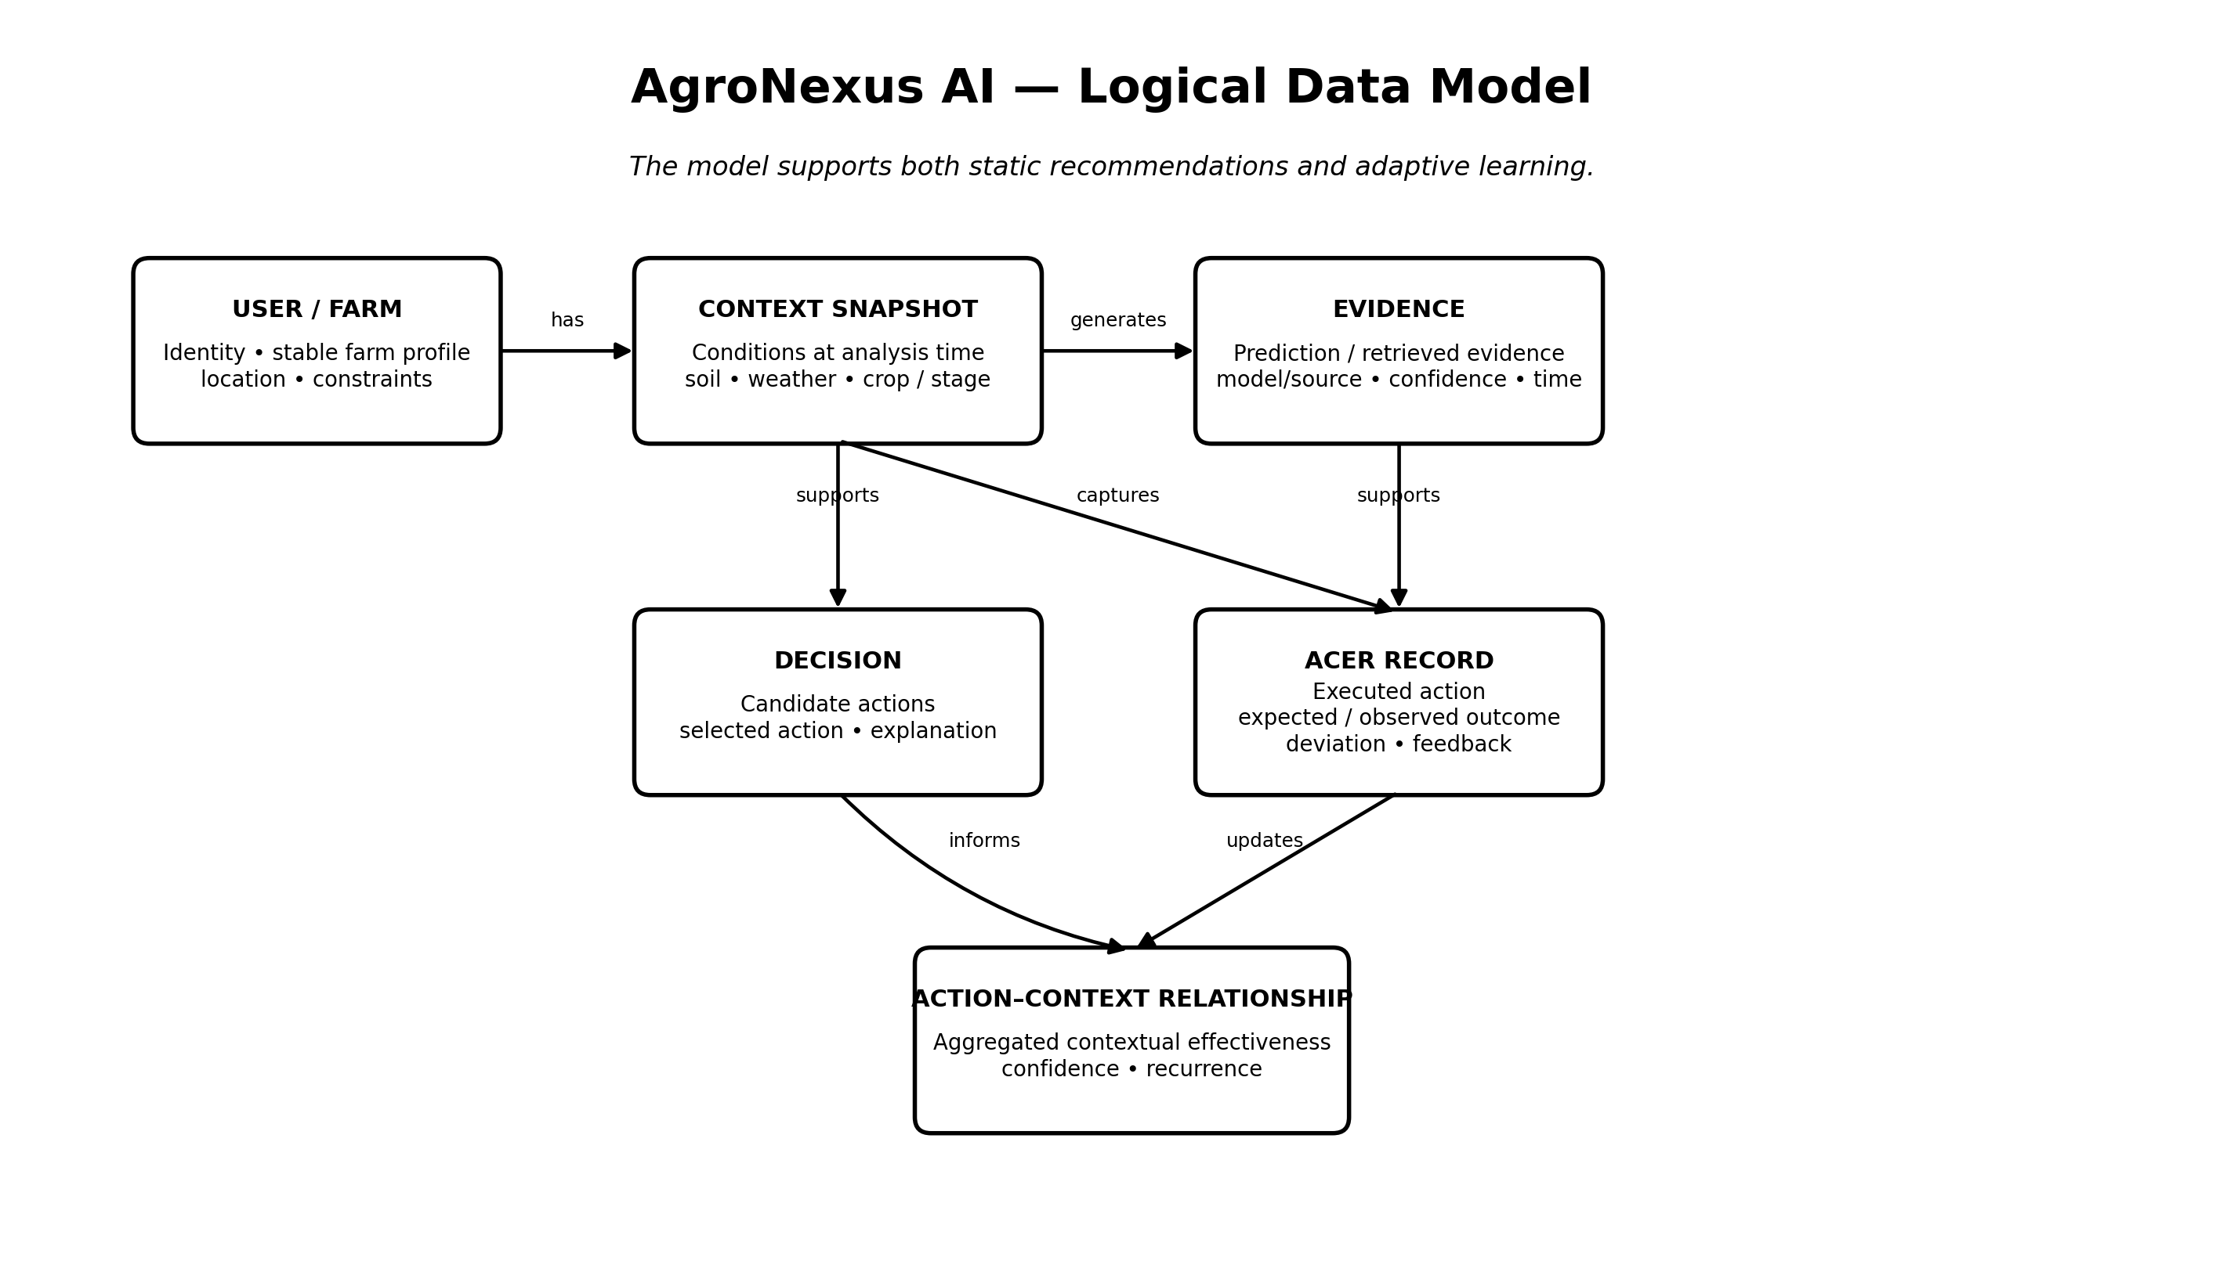
Figure 6. Logical entities required to support both static recommendations and adaptive learning.
User / Farm: Identity and relatively stable farm profile information.
Context Snapshot: The conditions under which an analysis/decision occurred. This is essential for context-conditioned learning.
Evidence: Prediction or retrieved evidence with model/source, confidence and timestamp.
Decision: Candidate actions, selected action and explanation/decision metadata.
ACER Record: The executed action plus expected/observed outcomes and deviation.
Action–Context Relationship: Aggregated contextual effectiveness derived from multiple ACER records.

9. Request / Response Concept
At the API boundary, the application should use structured objects. A conceptual analysis request contains location, soil information, crop information, optional image evidence and user/farm constraints. The response contains evidence, decision, explanation, confidence, expected outcome and an identifier that can later be associated with the ACER record.
Conceptual request:
AnalysisRequest = { location, soil_context, crop_context, image?, farm_constraints?, requested_module }
Conceptual response:
DecisionResponse = { context_id, evidence[], candidate_actions[], selected_action, explanation, confidence, expected_outcome, monitoring_plan }
Conceptual ACER:
ACER = { acer_id, decision_id, action, context_snapshot, expected_outcome, observed_outcome, deviation, farmer_feedback, timestamp }

10. Security, Reliability and Governance
Input validation: Reject malformed or physically implausible values before they reach models.
Provenance: Keep the model/data/API source and timestamp associated with important evidence.
Model versioning: Store the model version used for each prediction so later ACER analysis can be audited.
Uncertainty: Avoid presenting low-confidence predictions as certainty.
Audit trail: Record the evidence and decision path needed to reconstruct why an action was recommended.
Fallback behavior: When required evidence is missing or conflicting, ADIE-1 should be able to request more information, lower confidence or return a safer fallback rather than fabricate certainty.
Human control: The farmer remains the decision-maker; AgroNexus is a decision-support system.
Data privacy: Farm/user information should be separated from public datasets and protected according to the application's security requirements.

11. What Makes the Architecture Different
The novelty target should not be described as 'using AI for agriculture' or 'using Random Forest/YOLO/XGBoost'. Those are established approaches. The stronger architectural contribution is the separation between predictive evidence and adaptive intervention decisioning, combined with persistent Action–Context Effect Records and a feedback loop that can update context-specific intervention effectiveness.
In simplified form: ML predicts → ADIE-1 decides → farmer acts → outcome is observed → ACER records the result → action-context effectiveness is updated → ADIE-1 uses the learned relationship on the next decision.

12. Recommended Build Order
1. Freeze the input schema and parameter definitions for each ML module.
2. Complete data cleaning, feature engineering, train/validation/test methodology and model selection for the core ML services.
3. Expose each selected model through a consistent inference interface.
4. Implement the context/evidence representation and storage layer.
5. Implement ADIE-1 first as a deterministic, testable decision engine before adding more adaptive learning.
6. Implement ACER storage and outcome capture.
7. Implement action-context relationship aggregation and retrieval.
8. Connect ADIE-1 to contextual relationships and run static-vs-adaptive evaluation.
9. Integrate the frontend, explanation layer and monitoring.
10. Evaluate the complete closed loop using controlled historical/simulated outcome data before claiming real-world improvement.

13. Architecture Summary
AgroNexus is therefore best understood as a layered agricultural intelligence platform rather than a single ML model. The frontend collects farm context; the backend orchestrates evidence generation; specialist ML models produce predictions; ADIE-1 evaluates interventions; the explanation layer makes the decision understandable; and ACER creates the persistent feedback mechanism needed for context-conditioned adaptation. This architecture keeps the core product software-first and allows individual models to be improved without redesigning the overall decision mechanism.

