#### BLOOD DONORS

A

Case Study Report

Submitted in partial fulfilment of the

Requirements for the Course of

**Theme-based project**

IN

**BE ¾ (IT) II-SEMESTER**

By

**P.Shashank**

**1602-16-737-043**

**K.Srikar**

**1602-16-737-049**

**P.Varshith**

**1602-16-737-056**



**Department of Information Technology**

**Vasavi College of Engineering (Autonomous)**

**Ibrahimbagh, Hyderabad-31**

**2018-19**

**Vasavi College of Engineering (Autonomous)**

**Ibrahimbagh, Hyderabad-31**

**Department of Information Technology**



**DECLARATION BY THE CANDIDATES**

We,**P.Shashank,K.Srikar,P.Varshith** bearing hall ticket numbers, **1602-16-737-043, 1602-16-737-049,1602-16-737-056** respectively, hereby declare that the Case study report entitled **“BLOOD DONORS”** under the guidance of **Mrs.B.Leelavathy ,** Assistant Professor, Department of Information Technology, VCE, Hyderabad is submitted in partial fulfilment of the requirement for the course of **Theme Based Project - Lab** in BE ¾ (IT) II-Semester.

This is a record of Bonafide work carried out by us and the Design embodied in this project report has not been submitted by any others.

P.Shashank

1602-16-737-043

K.Srikar

1602-16-737-049

P.Varshith

1602-16-737-056

**Vasavi College of Engineering (Autonomous)**

**Ibrahimbagh, Hyderabad-31**

**Department of Information Technology**



**BONAFIDE CERTIFICATE**

Thisis to certify that the project entitled **“BLOOD DONORS”** being submitted by **P.Shahsnk,K.Srikar,P.Varshith** bearing hall ticket numbers **1602-16-737-043,1602-16-737-049,1602-16-737-056,** in partial fulfilment of the requirement for the course of **Theme Based Project- Lab** in BE ¾ (IT) II-Semester is a record of bonafide work carried out by him/her under my guidance.

**Mrs.B.Leelavathy, Dr.K.Ram Mohan Rao,**

**Assistant professor, Professor & HOD,**

**Internal Guide. Dept. of IT.**

**External Examiner**

**ACKNOWLEDGEMENT**

We are thankful to our mentor Mrs.B.Leelavathy for helping us and guiding us throughout the course whenever required.

We are thankful to Dr. K Ram Mohan Rao, Head of Department (IT), and Vasavi College of Engineering for providing the necessary arrangements and support to complete our project work successfully.

P.Shashank

1602-16-737-043

K.Srikar

1602-16-737-049

P.Varshith

1602-16-737-056

**TABLE OF CONTENTS**

1. Abstract------------------------------------------------------06

2. Introduction--------------------------------------------------07

I. Requirements--------------------------09

3. Related Work------------------------------------------------------10

4. Proposed Work---------------------------------------------------

1. Use Cases------------------------------11
2. UI Prototypes And Screenshots----------13
3. Architecture And Technology Used-----14
4. UML Design-------------------------------15
5. Implementation-------------------18
6. Testing----------------------------20

6. Results -----------------20

7. Discussion and Future Work --------------21

8. References---------------------21

**ABSTRACT**

The idea is to create a website which allows the users to registers themselves as donors and also to request blood whenever required.

To start with, any user who is willing to donate blood or who wants to request blood must register them-selves on the Registration portal

Once the users complete their registration they are eligible to request or donate blood to others.

For requesting blood, the user needs to fill out of form with various details like type of blood required, location etc. On submitting the form the list of all donors in that particular area whose blood group is matched with the requested blood group is displayed.

The user can then proceed to contact any donor on the list, and communicate about what to do further.

**INTRODUCTION**

According to the Red Cross, while approximately 38 percent of our population is eligible to donate blood, only about 10 percent of those who are eligible actually donate. The demand for donated blood in our nation’s hospitals, however, is consistently high. In fact, it is estimated that roughly 40,000 pints of this life-saving blood are used every single day, and the demand never stops.

There is a constant need for regular blood supply because blood can only be stored for a limited amount of time before use. Regular blood donations by a sufficient number of healthy people are needed to ensure that safe blood will be available whenever and wherever it is required.

A decision to donate blood can save a life or even several if your blood is separated into its components which can be used individually for patients with specific conditions.

Though many people today are interested in donation of blood, due to lack of information or having no idea about how and where to donate blood, they are not able to do so. Our website aims at helping all such people by providing a medium for those who want blood to request donors.

Users who register on the website have the options of donating as well as requesting blood. When a user requests for blood, depending on the location of the user, all the users within a 5km range of the user with the matched blood group will be displayed and the user can contact them (details of the user will be provided on the page).

**REQUIREMENTS**

Data base management:

* Control the database and keep track of all the users.

Performance requirements:

* The system shall accommodate high number of users without any fault.
* Responses to view information shall take no longer than 5 seconds to appear on the screen.

Safety requirements:

* System shall not cause any harm to human users.

Security requirements:

* Users will not be able to view donor details unless until they themselves are registered on the website.
* Secure database.

**RELATED WORKS**

Improvements:

Our approach is quiet similar to the existing blood donation websites. The only difference is that we plan to provide a feature for the donors where their details will be shared with the user who requested them only if the donor is willing to donate blood. There will be a “REQUSTS” section where the user can see the list of requests that he/she has received. Only if they accept that particular request, the details of that donor will be sent to the requested user. In this way security of the users can be improved as the details of the users will not be shared easily.

Limitations:

There will be a 10-digit validation for the entered mobile number, but there is no way to know whether the entered mobile number is valid or not. Also the location of the user is inputted via a text field. The location detection of the user would be a more efficient approach but due to some problems the feature could not be implemented.

**PROPOSED WORK**

I.USE CASE

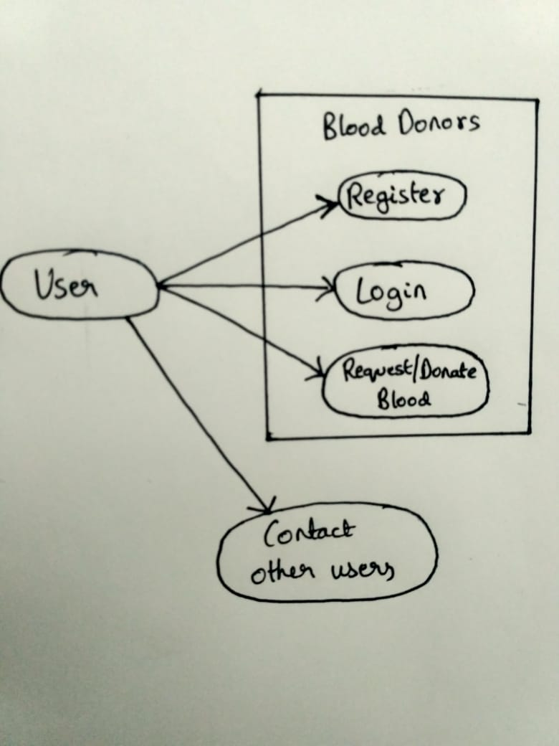

Use case is a software and system engineering term that describes how user uses a system to accomplish a particular goal. A view describes the functionality of the system as perceived by an external actor. An actor interacts with the system; it can be a user or another system. The use case view is for customers, designers, developers and testers. The functions of the systems are described as a number of use cases in the use case view. The systems for some functions are represented by use cases.

Three basic elements that make up a use case are:

Actors: Type of users interacting with the system. Here individuals and corporates or institutions are actors.

System: Functional requirements that specify the intended behaviour of the system.

Goal: Use cases are typically intended to fulfil the goals. Here creating an interacting environment for individuals and corporates or institutions.

**II. UI PROTOTYPES**

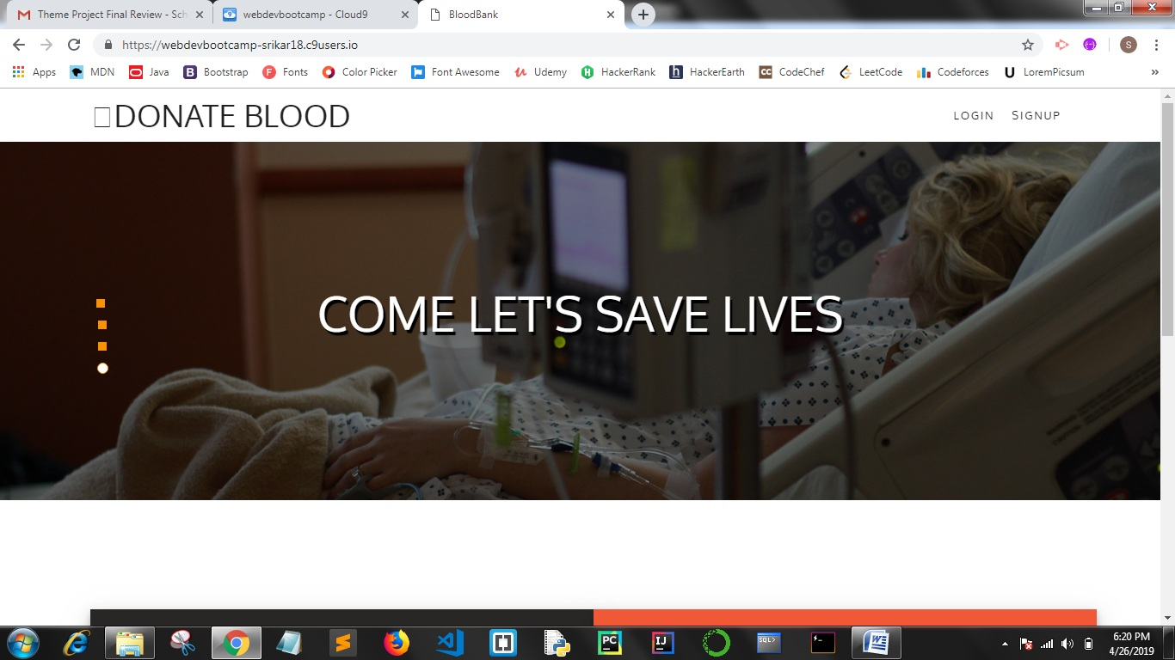

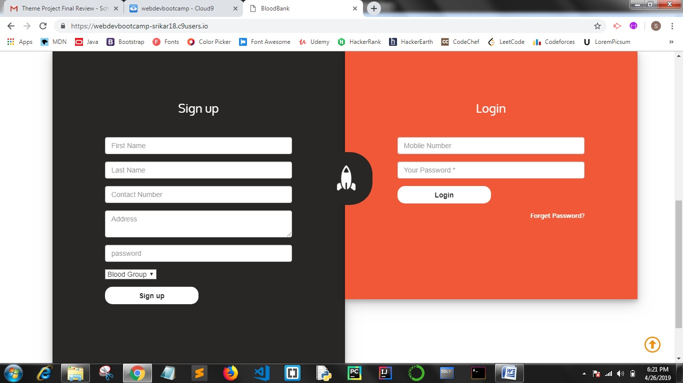

**III. Architecture and Technology Used:**

The project is implemented using MEN Stack.

Frameworks used are:

**Front End:**

* HTML
* CSS
* JAVASCRIPT
* BOOTSRAP

**Back End:**

* MongoDB
* Mongoose
* ExpressJS

**IV.DESIGN**

UML Static diagrams: Data flow diagram

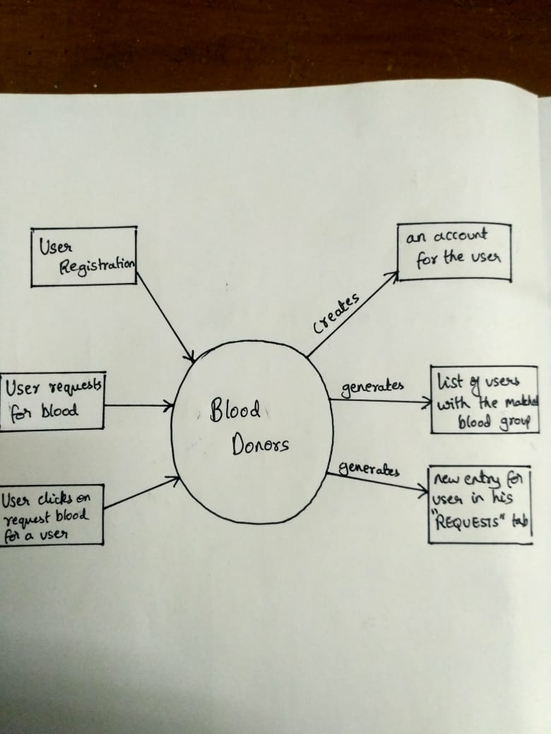

**II. UML Run time diagram:**

**Sequence flow**

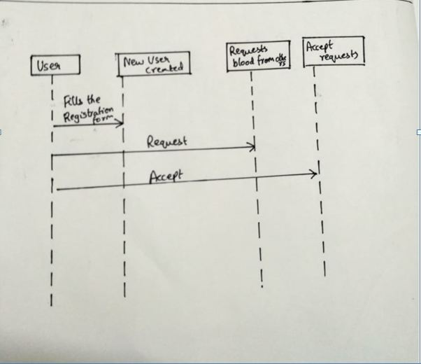

User operation module

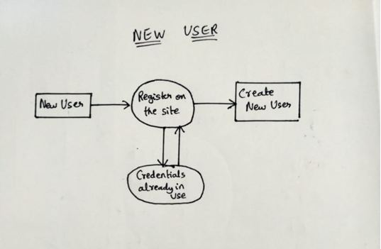

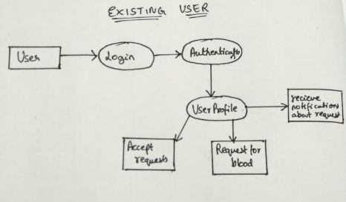

**V.IMPLEMENTATION**

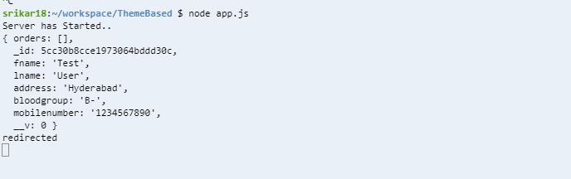

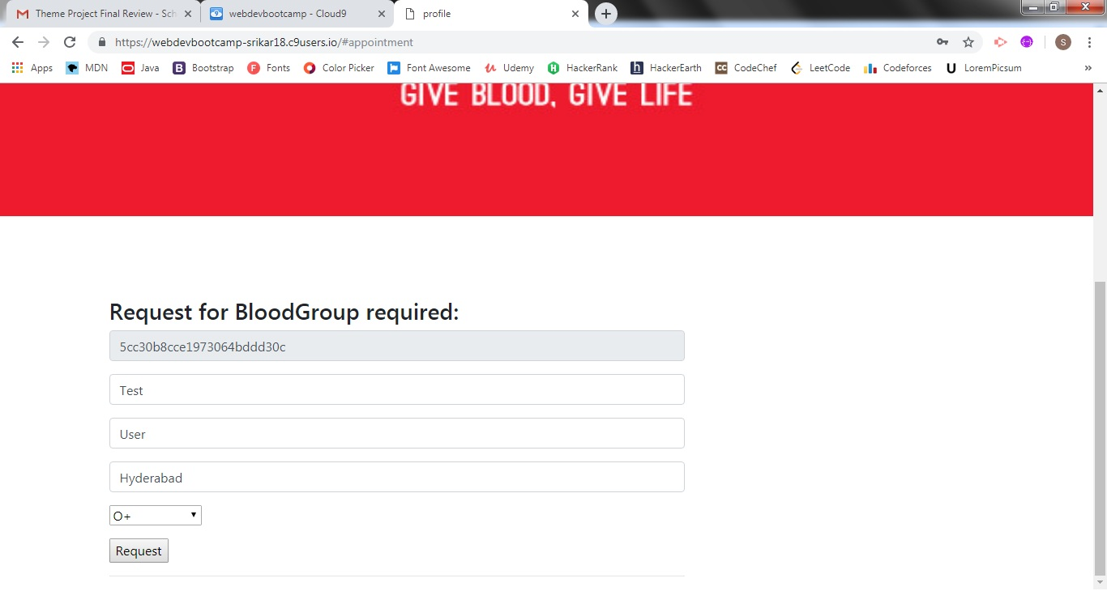

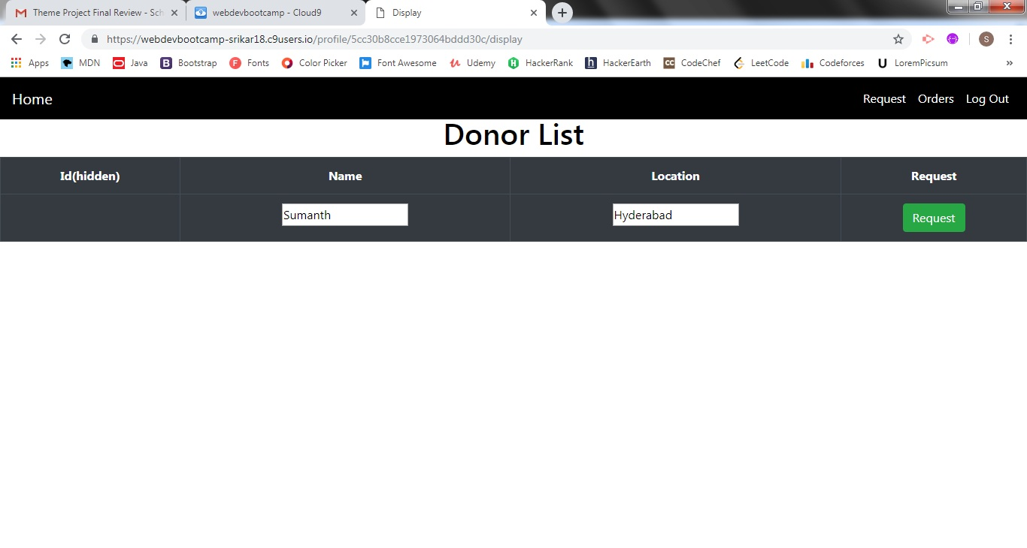

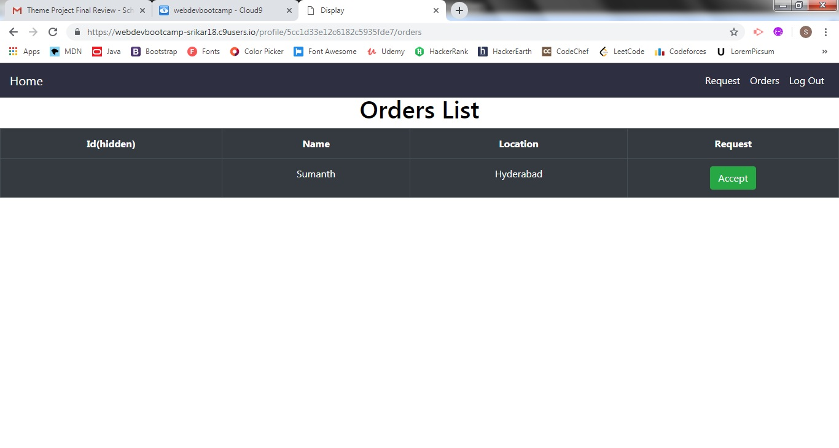

**VI.TESTING**

Validations are performed on the all fields in the registration form. The user can enter only alphabets in certain entries like First Name, Last Name, and Address etc. Also mobile number validation is performed by checking if the entry given is of length 10 and has only numbers.

Also during login, the user has to enter the correct details. Else he will get redirected to the home page.

If the user with same credentials already exists, the registration will not be allowed.

**RESULTS**

Our website aims at user security. Since the details of the donors will be shared only after the donor accepts the request, the details are kept secret. The other implementation of the website are quiet similar to the already existing ones.

**DISCUSSIONS AND FUTURE WORK**

We are planning on adding extra features like automatic location detection. Also once a user has requested for blood, he should not be able to see the details of donors instantly. The donor himself should accept the request of that user (for mutual agreement purpose), only then the details of the donor will be visible to the user. Also to check whether the mobile number entered by the user is valid or not an OTP will be sent to the user. Only on entering the OTP, he should be able to register himself onto the website.

**REFERENCES**

* GitHub Repositories
* Sample Projects in Udemy
* Articles