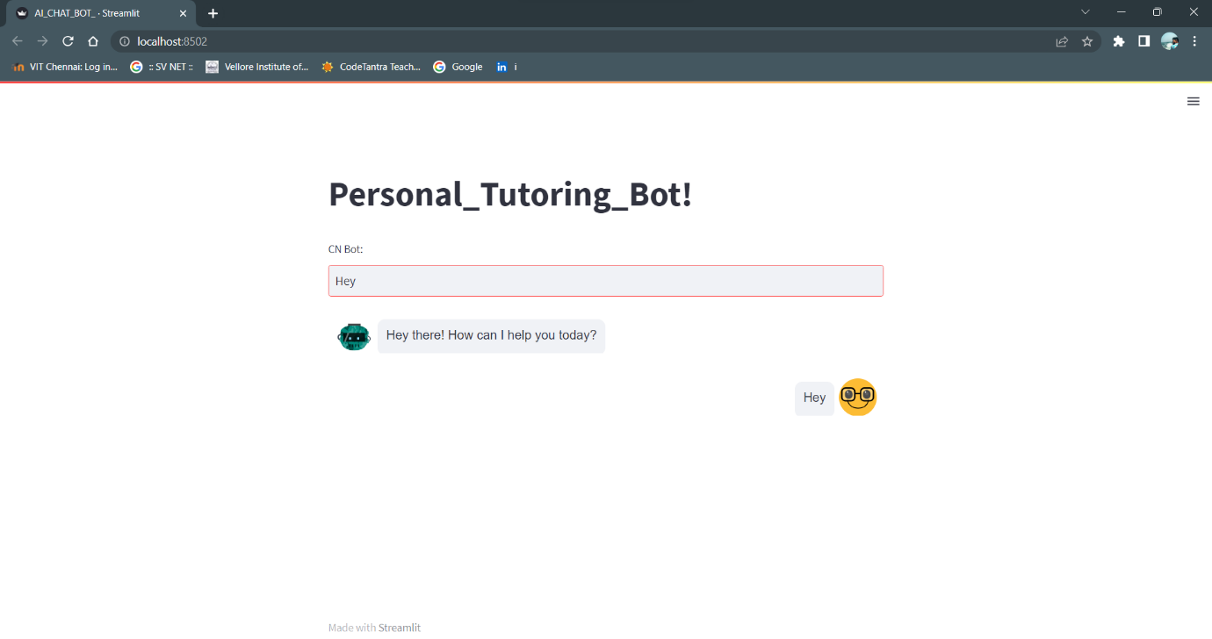

*The AI bot, developed as an AI-powered virtual tutor, demonstrates its versatility by effectively responding to a wide range of prompts, ensuring its suitability for various user inquiries. It engages in conversational interactions and provides informative and accurate responses. From a friendly greeting to addressing specific queries like the required skills for a data scientist, the bot showcases its ability to work seamlessly and deliver optimal support. Its reliability as a personal tutoring AI chatbot is evident through its consistent provision of accurate and valuable information, enhancing the overall user experience.*