docker build -t 9177746670/ml-pipeline:latest .

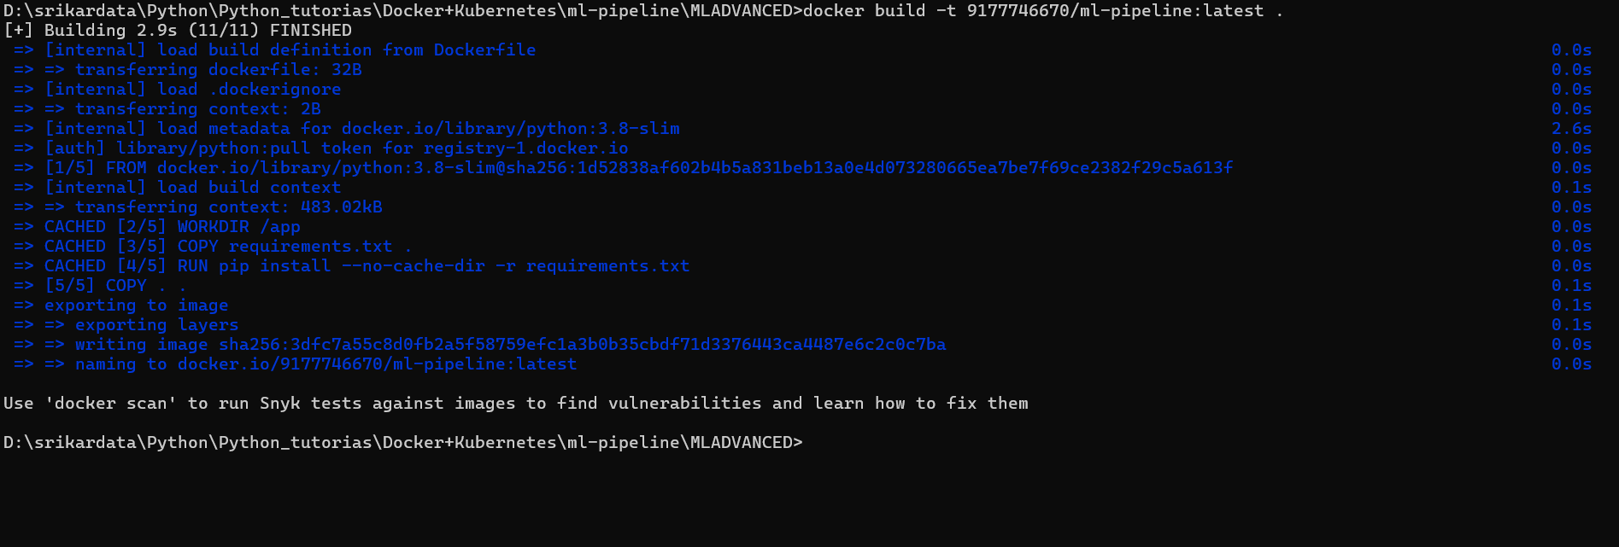

>docker run --rm -v D:/srikardata/Python/Python_tutorias/Docker+Kubernetes/ml-pipeline/MLADVANCED:/app 9177746670/ml-pipeline:latest python data_ingest.py



docker run --rm -v D:/srikardata/Python/Python_tutorias/Docker+Kubernetes/ml-pipeline/MLADVANCED:/app 9177746670/ml-pipeline:latest python feature_engineer.py



Model Trained



Delete all Kubernetes jobs

kubectl delete jobs --all  
  
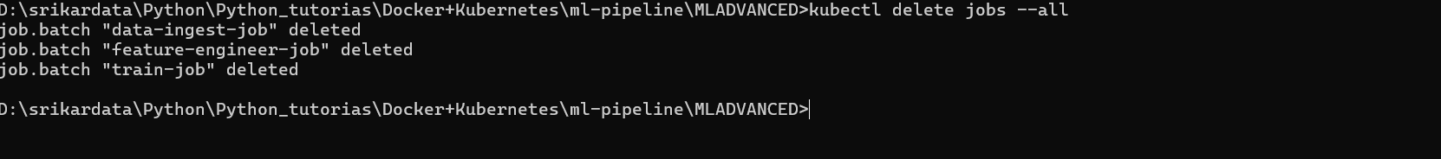

kubectl apply -f k8s_job_data_ingest.yaml



kubectl apply -f k8s_job_feature_engineer.yaml



kubectl apply -f k8s_job_train.yaml



kubectl get pods



O/P

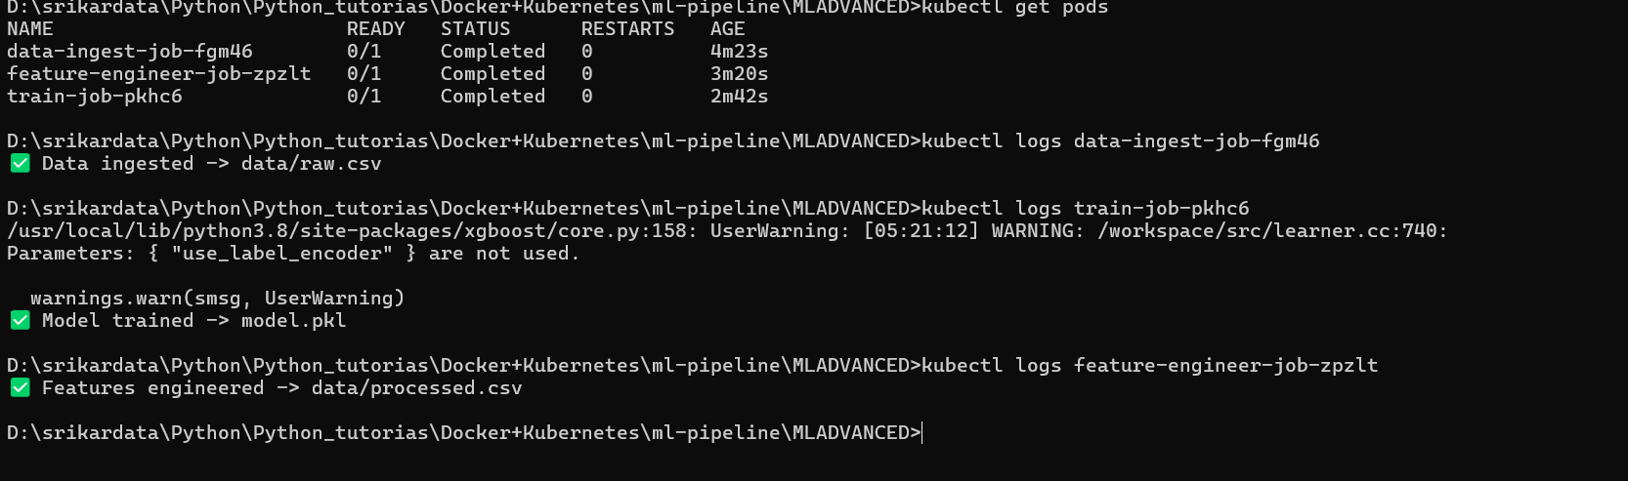

To remove the warnings from MODEL  
  
pip install --upgrade xgboost