Concept | Covered | Senior Developer Notes
Flask App Factory | ✅ | Modular, testable apps
Blueprints | ✅ | Separation of concerns
Environment-based config | ✅ | Dev/prod configs via .env
Authentication | ✅ | Session-based, login/logout
Authorization | Partial | Role-based or admin access can be added
SQLAlchemy ORM | ✅ | Models, relationships, db.create_all()
Caching | ✅ | SimpleCache; production needs Redis/Memcached
Logging & Monitoring | ✅ | Basic logger set up; extendable
Cart Count Optimization | ✅ | Cached to reduce DB load
Payment Integration | ❌ | Razorpay/Stripe next
Security | Partial | Password hashing, CSRF, HTTPS to add
Testing | ❌ | Unit/Integration tests pending
payment Integration
Monitoring & Advanced Logging
Advanced Caching
Email notifications (order confirmation).
Security hardening (rate limiting, input validation, HTTPS, CSRF).
Few QUESTIONS
Q-1) where this code is coming? base.html
<a href="{{ url_for('cart.view_cart') }}"
class="nav-link cart-link">
Cart
{% if cart_count > 0 %}
<span class="cart-badge">
{{ cart_count }}
</span>
{% endif %}
</a>

- Flask calls inject_cart_count() before rendering every template.
- It checks if the user is logged in (current_user.is_authenticated):
  - If not logged in → returns cart_count = 0.
  - If logged in → fetches the cart from DB.
- Applies caching for performance (cache_key per user).
- Returns a dictionary: {"cart_count": count}
2) How does this works? Base.html
<a href="{{ url_for('cart.view_cart') }}"
class="nav-link cart-link">
<blueprint_name>.<function_name> cart.view_cart
url_for() function -> url_for('some_endpoint')
In Cart.py we have something like this
@cart_bp.route("/cart") # this is blueprint_name
@login_required
def view_cart(): # this is function_name
3) How does this work? -> cart.py
@cart_bp.route("/cart")
@login_required
def view_cart():
"""
Display all items in the logged-in user's cart.
"""

# Fetch cart items belonging to the current user
# joinedload loads product details in the same query
items = (
CartItem.query
.options(joinedload(CartItem.product))
.join(Cart)
.filter(Cart.user_id == current_user.id)
.all()
)
# Load all the items added to the cart
if not items:
flash("Your cart is empty", "info")
return render_template("cart.html", items=[], total=0)
# If cart is empty then render your cart is empty message
items = (
CartItem.query
.options(joinedload(CartItem.product))
.join(Cart)
.filter(Cart.user_id == current_user.id)
.all()
)
CartItem.query = Starts a query on the CartItem table. Equivalent to SELECT * FROM cart_item if you were writing raw SQL.
.options(joinedload(CartItem.product))
# this is a eager loading Without joinedload, SQLAlchemy would make one extra query per cart item to fetch the product — N+1 query problem.
joinedload tells SQLAlchemy:
“Load the related Product objects in the same query using a JOIN.”
SELECT cart_item.*, product.* FROM cart_item LEFT JOIN product ON cart_item.product_id = product.id

Example Added like these
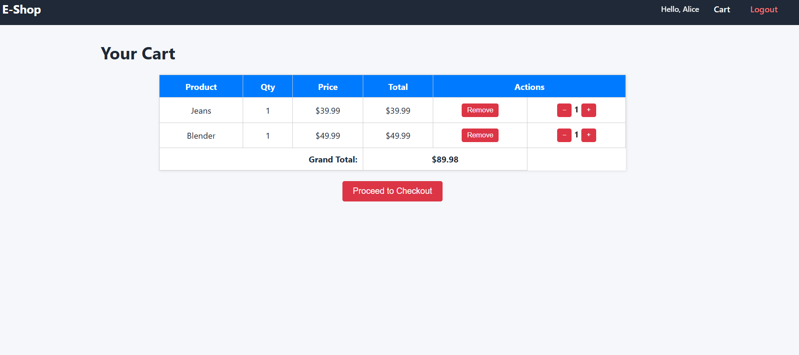

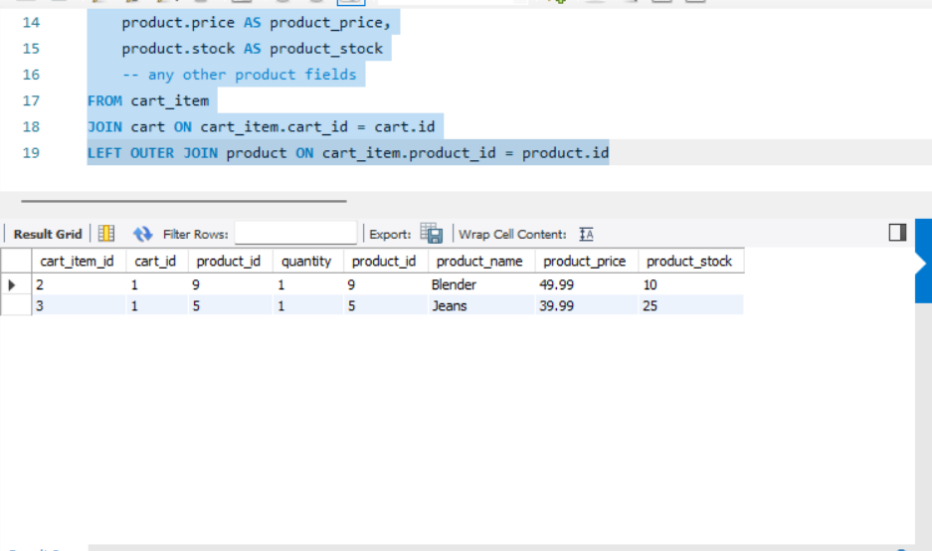

SELECT
cart_item.id AS cart_item_id,
cart_item.cart_id,
cart_item.product_id,
cart_item.quantity,
product.id AS product_id,
product.name AS product_name,
product.price AS product_price,
product.stock AS product_stock
-- any other product fields
FROM cart_item
JOIN cart ON cart_item.cart_id = cart.id
LEFT OUTER JOIN product ON cart_item.product_id = product.id
User table: ex id =1 for alice@example.com
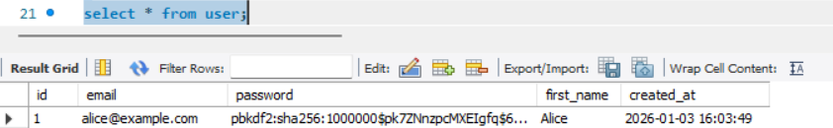
Cart table have user_id when he adds to the cart
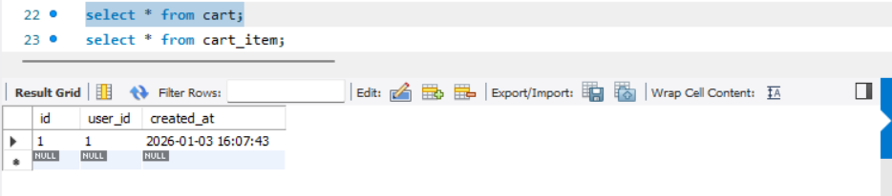
Cart_item table is like a bridge between cart and product have cart table id column mapped to cart_item table cart_id column
product table id column mapped to the cart item table product id

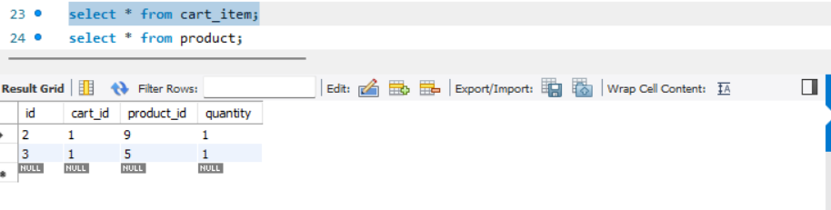

total = sum(item.product.price * item.quantity for item in items)
return render_template("cart.html", items=items, total=total) # here it will send the data items + total to the render_template -> cart.html
total -> will get the total price for added items cart and items are added for the user
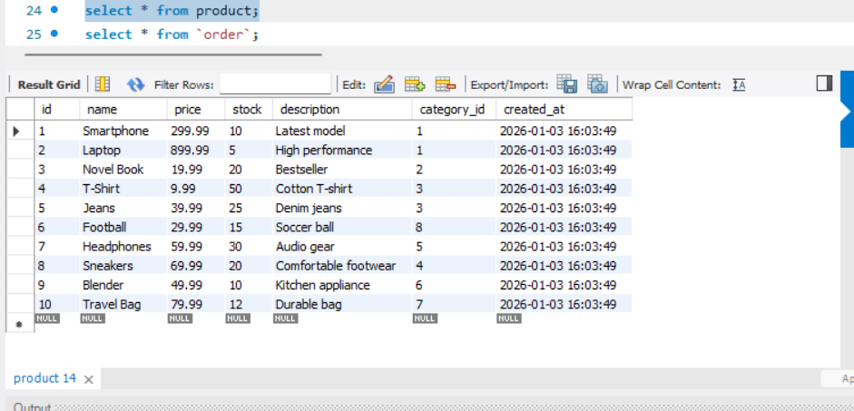
Q-4) What does this do?
total = sum(item.product.price * item.quantity for item in items)
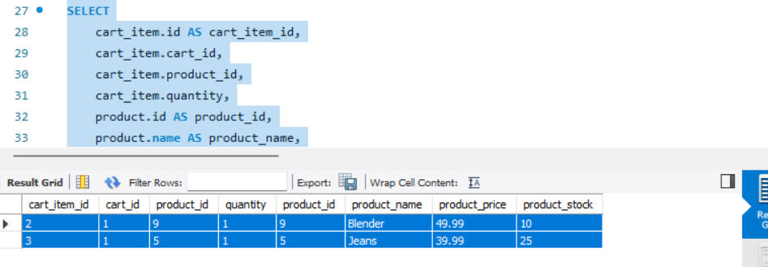
After this for each record it will calculate
1*49.99 + 1 * 39.99 = $89.98
Here in Grand total it will be added 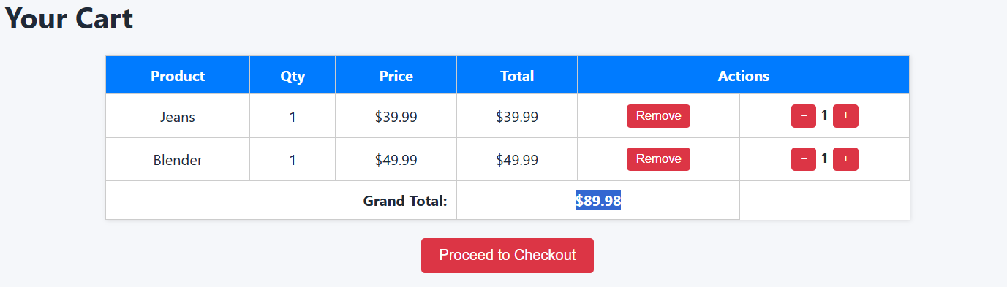
Yes, it iterates over each cart item in memory and calculates price × quantity. Since the cart size is small and product data is eagerly loaded, this is efficient and avoids unnecessary SQL complexity.
When not to use this approach
If you had:
Thousands of rows
Reports / analytics
Admin dashboards
When cart is small its fine
Q-5) What this code does
<td>
<form method="POST"
action="{{ url_for('cart.remove_from_cart', item_id=item.id) }}">
<button type="submit">Remove</button>
</form>
</td>
This creates a Remove button for one cart item
When clicked, it sends a POST request to your Flask route
hat route removes the item from the cart in the database
url_for('cart.remove_from_cart', item_id=item.id) -> Blueprint, FunctionName + itemid
In the cart.py
@cart_bp.route("/remove-from-cart/<int:item_id>", methods=["POST"])
@login_required
def remove_from_cart(item_id):
In the init,py
cart_bp = Blueprint("cart", __name__)

Q-6) What does this code does
cart_item = (
CartItem.query
.options(joinedload(CartItem.product))
.get_or_404(item_id)
)
CartItem.id == item_id if no rows exist
raises 404 Not Found
stops executing the function
what does this say .options(joinedload(CartItem.product))
“When you load this CartItem, also load its related Product in the same query.” Because CartItem has a relationship:
class CartItem(db.Model):
product = db.relationship("Product")
With joinedload:
product data is loaded eagerly
no extra DB hit later
.get_or_404(item_id) is equivalent to cart_item = CartItem.query.get(item_id)
if not cart_item: abort(404)
Looks up by PRIMARY KEY
Fast (uses index)
Clean error handling

SELECT cart_item.*,
product.*
FROM cart_item
LEFT OUTER JOIN product
ON cart_item.product_id = product.id
LEFT OUTER JOIN cart on
cart_item.id = cart.id
This will get automatically the latest cart id which has to be removed
Q-7) What does this code does
@cart_bp.route("/add-to-cart/<int:product_id>", methods=["POST"])
@login_required
def add_to_cart(product_id):
"""
Add a product to the user's cart.
"""

# Fetch product or return 404 if it does not exist
product = Product.query.get_or_404(product_id) – Gets the Product ID(example-id)
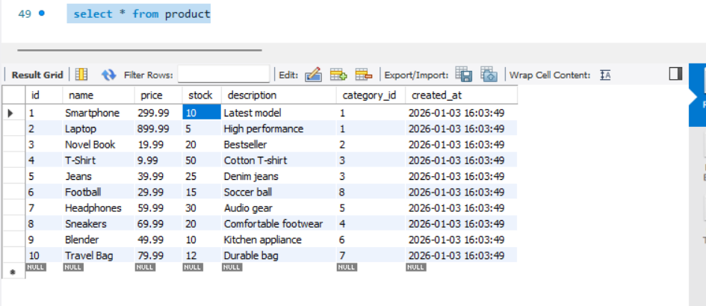

# Check stock availability
if product.stock < 1:
flash("Product is out of stock", "error")
return redirect(url_for("views.home"))
Above logic checks if products are not stock then do the business logic example column stock
# Get user's cart (one cart per user)
cart = current_user.cart # Give me the Cart object related to this User object
This will generate a result with this query
SELECT * FROM cart WHERE user_id = current_user.id

# Create cart if it doesn't exist
if not cart:
cart = Cart(user_id=current_user.id)
db.session.add(cart)

# flush() assigns cart.id without committing to DB
db.session.flush()
Add cart for user and do flush because commit we will do later

# Check if product already exists in cart
cart_item = CartItem.query.filter_by(
cart_id=cart.id,
product_id=product.id
).first()
check if product is already added to the cart
if cart_item:
# Prevent adding more items than available stock
if cart_item.quantity >= product.stock:
flash("No more stock available", "warning")
if condition checks again if stocks are not there then don’t add
else:
cart_item.quantity += 1
flash(f"{product.name} quantity updated in cart", "success")
this above else will add the quantity to the cart_item -> product
else:
# Add new product to cart
cart_item = CartItem(
cart_id=cart.id,
product_id=product.id,
quantity=1
)
db.session.add(cart_item)
flash(f"{product.name} added to cart", "success")

# Save changes
db.session.commit()
this else will add the product to the cart_item as newly since its not added

return redirect(url_for("cart.view_cart"))
Q-8) What does this code does
@cart_bp.route("/cart/increase/<int:item_id>", methods=["POST"])
@login_required
def increase_quantity(item_id):
"""
Increase quantity of a cart item (up to stock limit).
"""

item = CartItem.query.get_or_404(item_id) # this will execute the query
From the below query
SELECT cart_item.*,
product.*
FROM cart_item
LEFT OUTER JOIN product
ON cart_item.product_id = product.id
LEFT OUTER JOIN cart on
cart_item.id = cart.id;# this one will get from what we are adding

if item.quantity < item.product.stock: # if quantity not adding more than stock the add and commit
item.quantity += 1
db.session.commit()

return redirect(url_for("cart.view_cart"))

Q-9) auth.py will have /signup, /login and /logout functionalities
Q-10) Models.py will create the table structures prior running applications
cart = db.relationship(
"Cart",
uselist=False,
backref="user"
)
cart is an ORM attribute where user is related with Cart table and it is one to one since we say uselist=false
with backref=user
get 2 directions
current_user.cart # get cart from user
cart.user # get user from cart
Q-11) # One category → many products
products = db.relationship(
"Product",
backref="category"
)

Q-12)
# One category → many products
products = db.relationship(
"Product",
backref="category"
)
One category can have many products
Q-13)
# Each product must belong to a category
category_id = db.Column(
db.Integer,
db.ForeignKey("category.id"),
nullable=False
)

Each product will have one category
Q-14) db.UniqueConstraint(
"name",
"category_id",
name="uq_product_name_category"
),
#prevent duplicate product names within the same category

