Imp: Concept
Flask does not create default routes Every URL must be explicitly defined?
1) Blueprints help us organize routes and scale the application cleanly.
Blueprints allow us to group related routes together. Instead of putting all routes in one file, we can split them into modules like health, auth, bookings, etc. This makes the code cleaner, easier to maintain, and scalable for large applications.
create_app()?
2) It creates and configures the Flask application.
create_app() is an application factory. It creates a new Flask app instance, registers routes and configurations, and then returns the app. This pattern makes the app easier to test, configure, and scale
Useful:
Allows different configs (dev, test, prod)
Makes unit testing easy
Avoids global state issues
create_app() = build the app
app.run() = start the server
3) Why doesn’t / work but /health does?
Because we only defined /health, not /.Flask does not create routes automatically. Every URL must be explicitly defined. Since we only created a /health route, that endpoint works. The root / returns 404 because no route exists for it.
4) requirements.txt
flask-sqlalchemy → ORM
flask-migrate → DB migrations (future)
werkzeug.security → password hashing
5) key lines of code
db.init_app(app) links DB to Flask
create_all() creates tables (simple, fine for now)
6) Password storage
Never store plain passwords
Hashing logic stays inside model
Clean & reusable

PostMan:
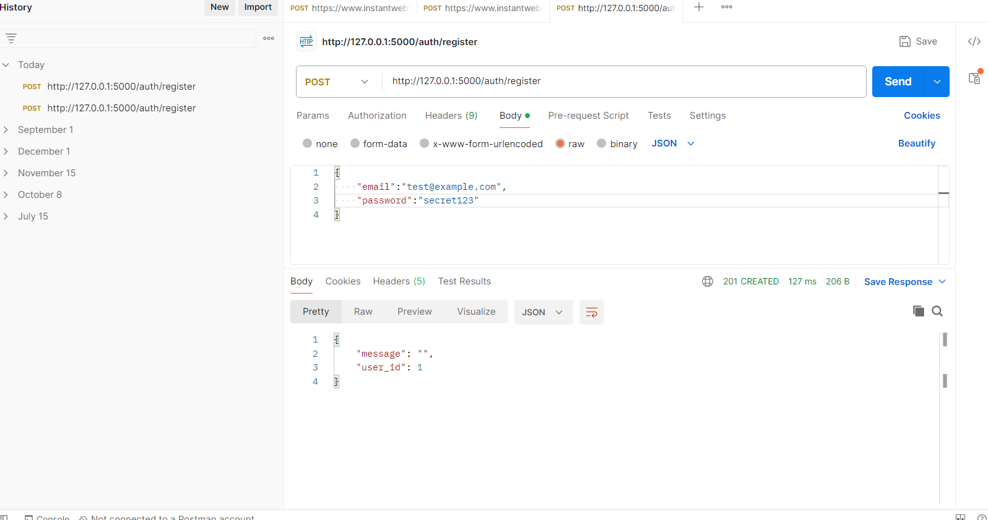
Pseudo-elements (::before / ::after) can be used to create overlays without adding extra HTML. rgba() colors allow semi-transparent overlays.
z-index ensures stacking order: overlay behind text, text in front.
position: relative/absolute is needed to make z-index work.
-----------------------------
| Hero Section |
|---------------------------|
| Text & Button (z-index:2)| <-- Your h2, p, button
|---------------------------|
| Overlay (z-index:1) | <-- semi-transparent black layer
|---------------------------|
| Background Image | <-- hotel image
-----------------------------
Background Image
- Set with background: url(...) no-repeat center/cover;.
- Always at the bottom layer.
Overlay
- Created using .hero::before pseudo-element.
- Semi-transparent using rgba(0,0,0,0.5).
- Covers the entire hero section (position:absolute; top:0; left:0; width:100%; height:100%).
- Stays behind text by default if we set text z-index higher.
Text & Button
- Your h2, p, .btn.
- Positioned relative (position: relative) so z-index: 2 works.
- Renders above the overlay, visible even on bright backgrounds.

/auth/register → API (POST)
/register → HTML page (GET)
I follow UI spacing heuristics, visual balance, and validate designs using browser DevTools instead of hardcoding random values
DB Conditions:
Availability is calculated on the backend and enforced again at booking time to prevent race conditions.

