Adaptive Software Engineering

Name: K.Srikar
Roll no: 2420090111
Section - 1

Git WorkFlows
Step 1: Create a GitHub Account
Open Git WorkFlows.
Sign up using an email address.
Verify the email address.
Set up the Git WorkFlows account.

Step 2: Create a Repository
Log in to Git WorkFlows.
Click New Repository.
Enter the repository name: S1_2420030783_Practical_Course.
Select Public or Private.
Add a README file if required.
Click Create Repository.

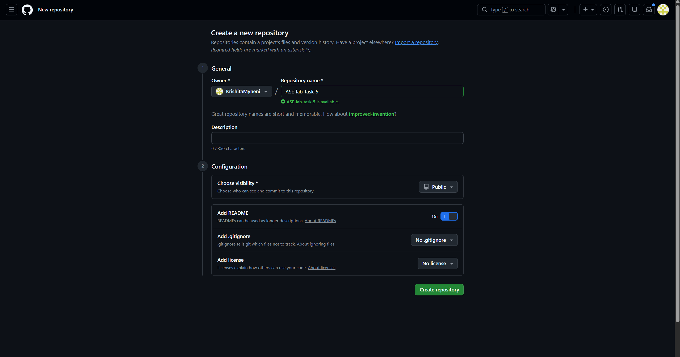
Step 3: Create a Local Git Repository
Open the project folder for the ASE practical work in the terminal and use:
git init
This initializes a new Git repository for the practical project.
Step 4: Check Git Status
git status
This shows modified files, untracked files, staged files, and the current branch.
Step 5: Add Files
To add a particular file:
git add filename
To add all files:
git add .
This moves the changes to the staging area.
Step 6: Create a Commit
git commit -m "Setup ASE practical work"
A commit saves the staged changes with a message describing the changes.
Step 7: Connect the Local Repository to Git WorkFlows
git remote add origin <repository-url>
This connects the local repository to the Git WorkFlows repository.
To check the remote:
git remote -v
Step 8: Push Code to Git WorkFlows
git push -u origin main
This uploads the local commits to the main branch of the Git WorkFlows repository.
After the first push, we can usually use:
git push

Step 9: README.md
README.md is a Markdown file used to provide information about a project.
It can contain:
• Project title
• Description
• Features
• Installation steps
• Usage
• Technologies used
• Author information
Example:
# ASE Practical Course
This is my first Git WorkFlows project.
## Technologies
- HTML
- CSS
- JavaScript

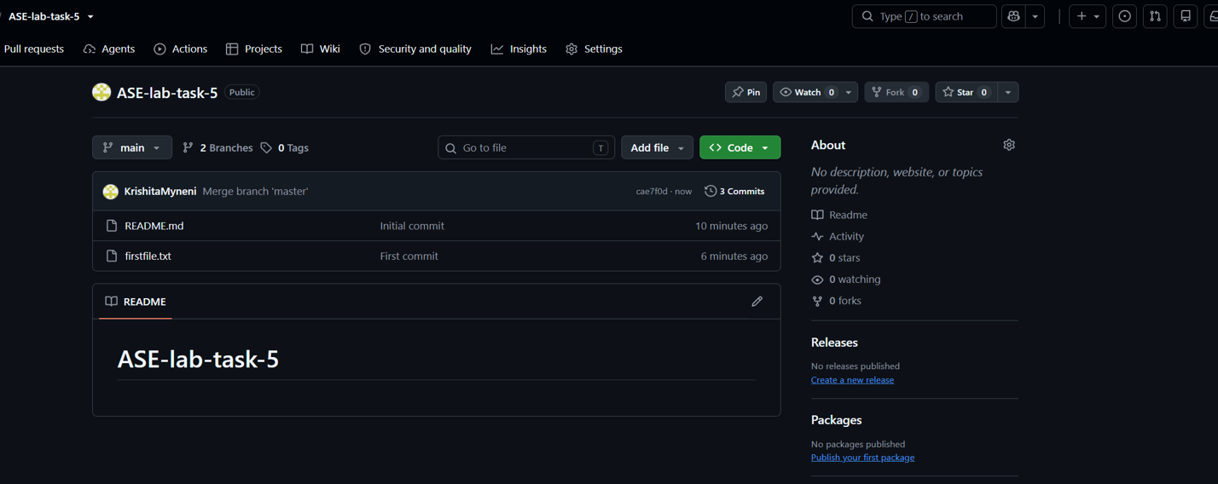
Step 10: Delete a Repository
Open the repository.
Go to Settings.
Scroll to Danger Zone.
Select Delete this repository.
Confirm the repository name.
Confirm deletion.

