Name: K.Srikar
Roll no:2420090111
Experiment 2: ERP Case Study
Problem Statement: Select a real-world ERP case study, identify functional requirements and user stories, choose a suitable software development process model and technology stack, and propose an implementation and evaluation strategy.
Real-World Case Study: University ERP Management System
1. Functional Requirements
Student
- Register and login to the ERP portal
- View academic information
- View course and timetable details
- Register for courses
- View attendance and academic records
- Pay fees online
- Track academic requests
- View fee payment history
- Submit feedback
ERP Administrator
- Manage student records
- Manage courses and departments
- Update academic and fee records
- View student details
- Process student requests
- Generate academic and fee reports

2. User Stories
User ID | User Story | Priority
US-01 | As a student, I want to register on the ERP portal so that I can access academic services. | High 8
US-02 | As a student, I want to log in securely so that my academic information is protected. | High 6
US-03 | As a student, I want to view my courses and timetable so that I can plan my semester. | High
US-04 | As a student, I want to register for courses so that I can complete my semester registration. | High
US-05 | As a student, I want to update my selected courses before the registration deadline. | Medium2
US-06 | As a student, I want to view my attendance so that I can monitor my eligibility. | High
US-07 | As a student, I want to pay semester fees online securely. | High
US-08 | As a student, I want to track my academic requests. | Medium
US-09 | As an administrator, I want to add and update student records. | High
US-10 | As an administrator, I want to maintain course and fee records. | High
US-11 | As an administrator, I want to generate academic reports. | Medium
US-12 | As an administrator, I want to manage student accounts. | Medium
3. Selected Software Development Process Model
Agile Scrum
Reason for Selection
- Requirements change frequently.
- Continuous customer feedback.
- Incremental feature delivery.
- Faster development cycles.
- Easy bug fixing.
- Suitable for web-based applications.

Sprint Plan
Sprint | Features
Sprint 1 | User Registration & Login
Sprint 2 | Course Catalog & Timetable
Sprint 3 | Course Registration
Sprint 4 | Attendance & Academic Records
Sprint 5 | Fee Payment Module
Sprint 6 | ERP Administrator Dashboard
Sprint 7 | Testing & Deployment

4. Programming Language Selection
Backend
- Java (Spring Boot)
Reasons
- Secure
- Scalable
- Enterprise-level applications
- REST API support
- Excellent database connectivity
Frontend
- HTML5
- CSS3
- JavaScript
- React.js

Database
- MySQL
Other Technologies
- REST API
- JWT Authentication
- Stripe/Razorpay Fee Payment Module
- Git
- Docker
- AWS Cloud

5. System Architecture
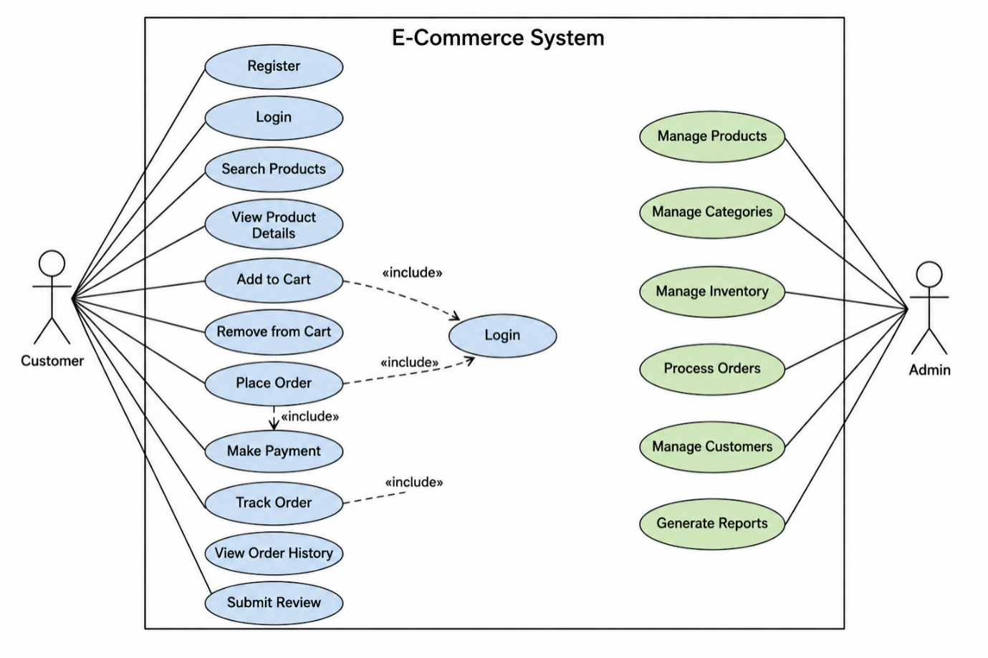

6. Implementation Strategy
Phase 1 – Requirement Analysis
- Gather customer requirements.
- Create Software Requirement Specification (SRS).
- Prepare use case diagrams.

Phase 2 – System Design
- Design database schema.
- Design UI wireframes.
- Create UML diagrams.
- Develop system architecture.
Phase 3 – Development
- Implement user authentication.
- Develop product catalog.
- Create shopping cart.
- Integrate payment gateway.
- Build admin dashboard.
Phase 4 – Testing
Unit Testing
- Login
- Registration
- Product search
Integration Testing
- Course Registration + Fee Payment
- Attendance + Student Records
System Testing
- Complete application testing
User Acceptance Testing (UAT)
- Verify business requirements.

Phase 5 – Deployment
- Docker Container
- AWS EC2
- MySQL Database
- Nginx Web Server

7. Evaluation Strategy
Evaluation Parameter | Method
Functional Accuracy | Requirement verification
Performance | Load testing using JMeter
Security | Authentication and penetration testing
Reliability | Continuous monitoring
Usability | User feedback survey
Scalability | Concurrent user testing
Maintainability | Code review and documentation

10. Expected Outcomes
- Centralized university ERP platform.
- Easy access to academic information.
- Reliable student and academic record management.
- Accurate attendance and fee updates.
- Secure online fee payments.
- Improved student and staff experience.
- Scalable architecture for future ERP modules.

