**ASSIGNMENT-1**

Create a VPC with 2 subnets and 2 route tables and internet gateway

* Launch 3 instances
* Attach 1 instance with EBS

___________________________________________________________

Create a VPC(virtual private cloud)

Search for VPC in search space of AWS home page and click on VPC (Pic-1)

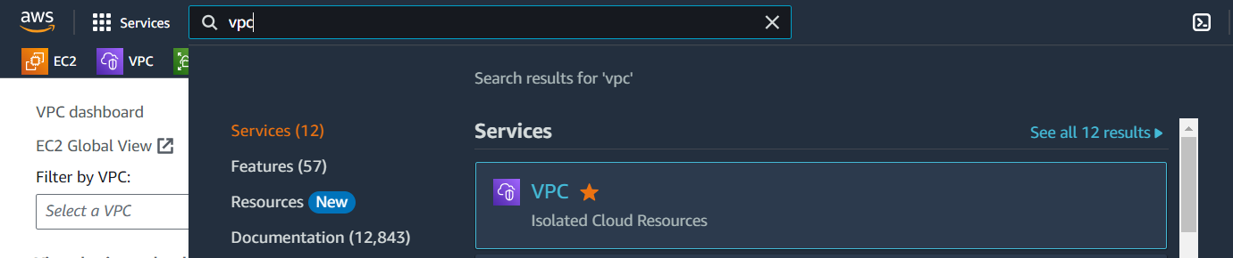

Pic-1

Now click on Your VPCs option from VPC menu of VPC page (Pic-2)

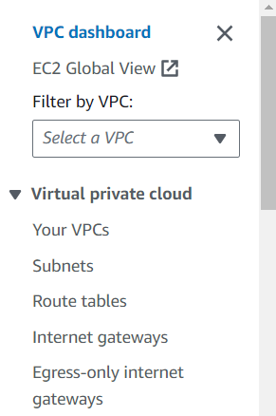

Pic-2

Now click on Create VPC to create our custom VPC (pic3)

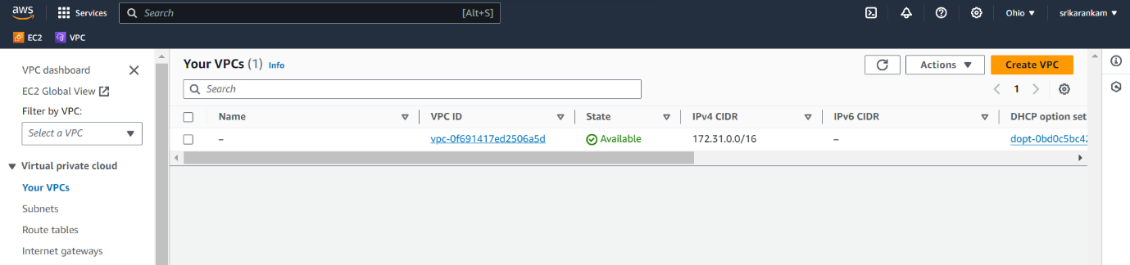Pic-3

Now We have to give the details for our VPC and

finally click on Create VPC(pic -4)

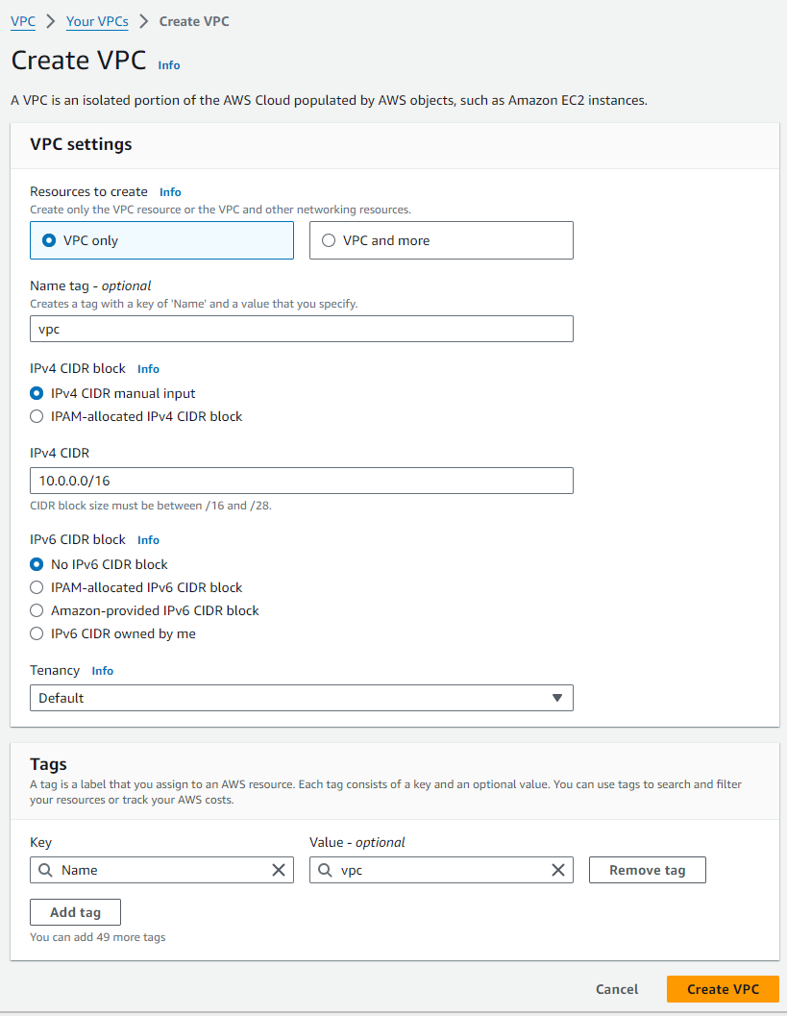

Pic-4

Now we created our custom VPC successfully.

Now click on Subnets to create Subnets to our custom VPC (Pic-5)

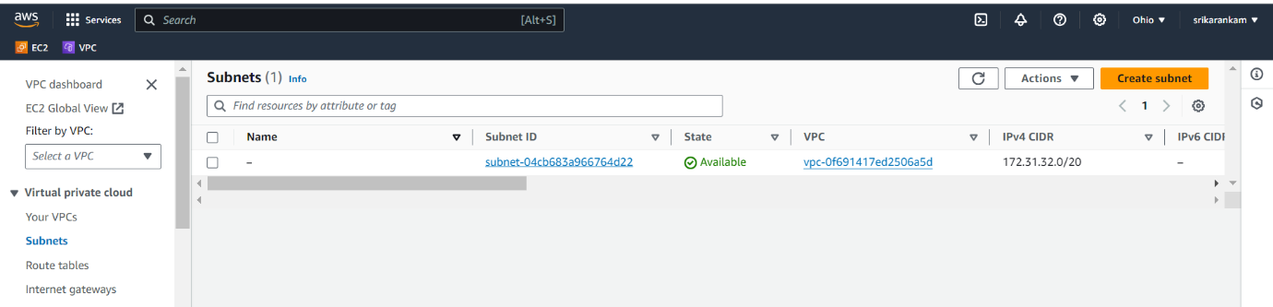

Pic-5

Then create two subnets public and private

We have select the our custom VPC-ID,Subnet name, choose only one availability Zone,IPv4 subnet CIDR block to give the IP, then finally create subnet

Public subnet(Pic-6)

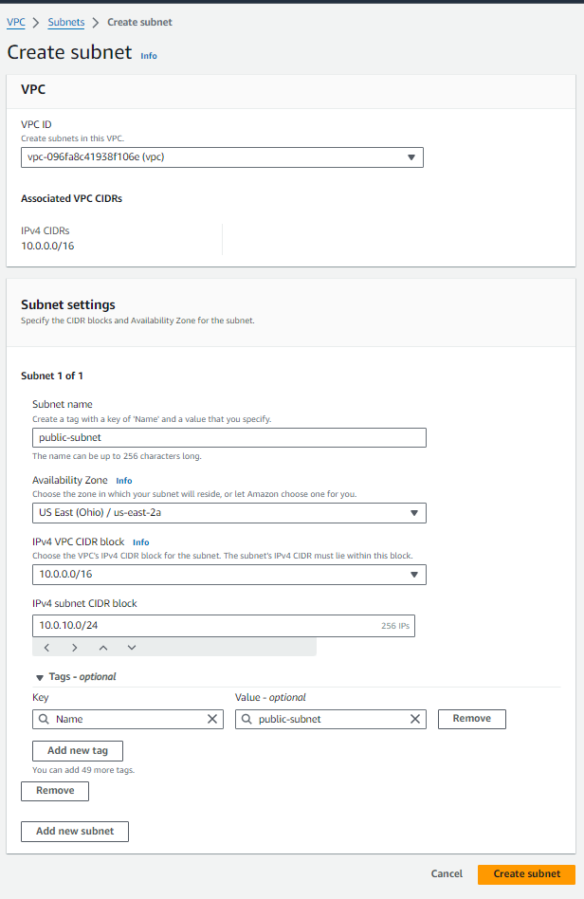

Pic-6

Private Subnet(pic-7)

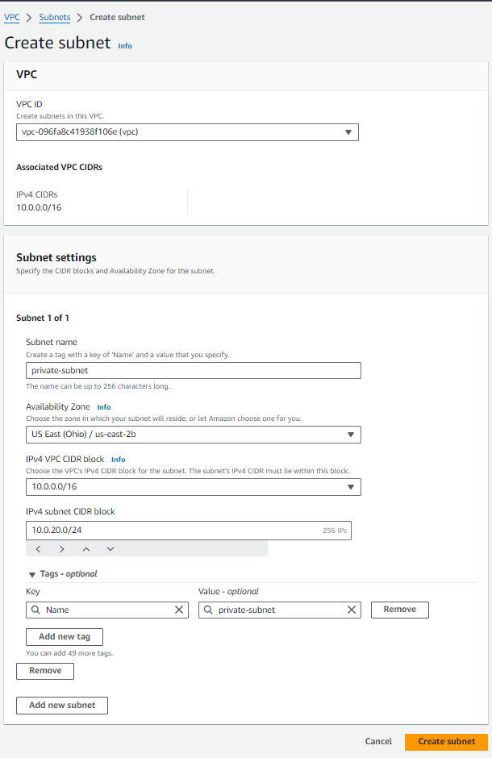

Pic-7

Now we created two Subnets to our custom VPC successfully (Pic-8)

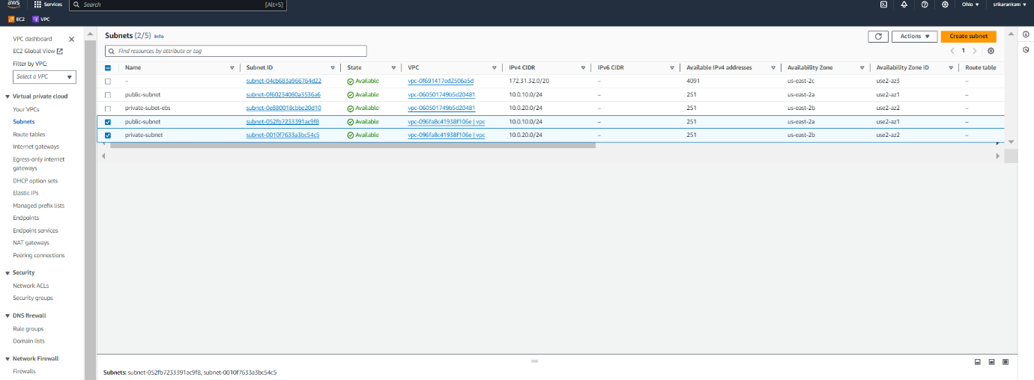Pic-8

Now click on Internet gateways from menu bar and click on Create internet gateway.(Pic-9)

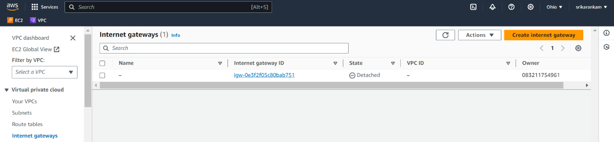

Pic-9

Now, we have give name to our internet gateway and finally click on Create internet gateway.(Pic-10)

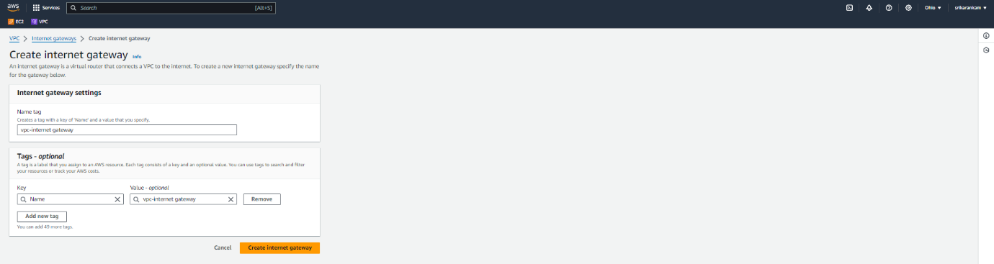

Pic-10

Then click on Actions and click on Attach to VPC(Pic-11)

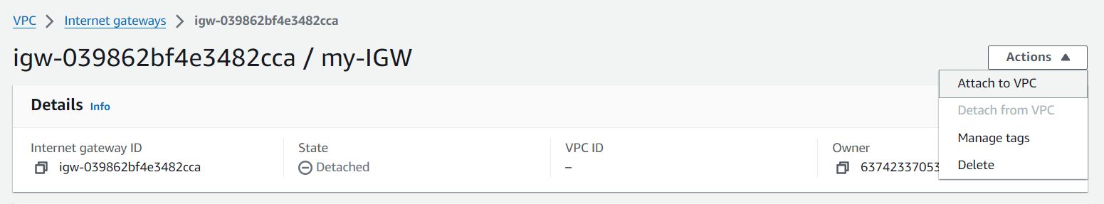

Pic-11

Now we have select our custom VPC in that Available VPCs so we already created it our custom VPC. and Finally click on Attach internet gateway.(Pic-12)

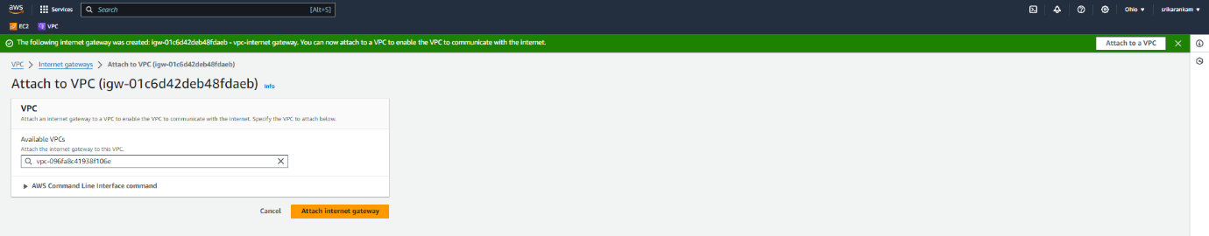

Pic-12

Now we created internet gateway to our custom VPC successfully(Pic-13)

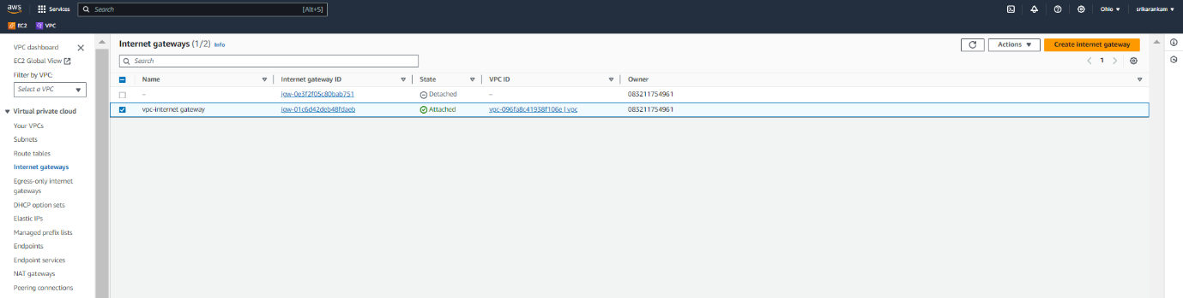

Pic-13

Now we have to create 2 route tables (one is public and another one is private). Click on Route tables from menu bar and click on Create route table (Pic-14)

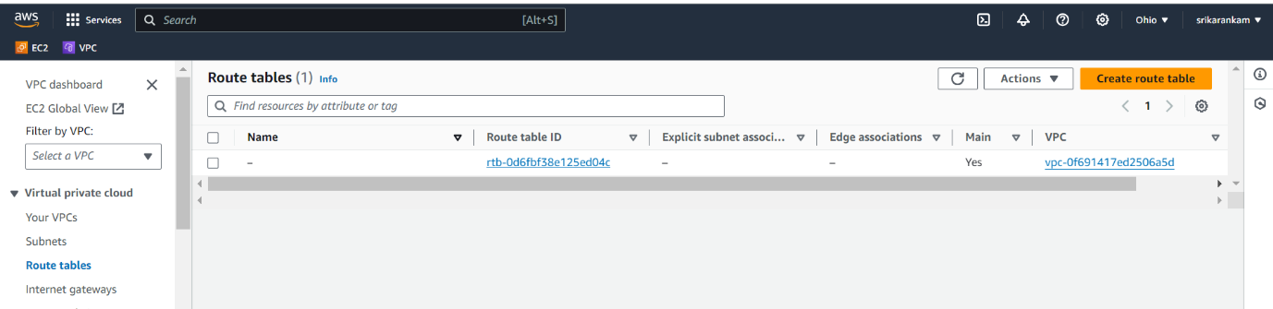

Pic-14

Then give name to route table and select our custom VPC and finally click on Create route table(Pic-15)

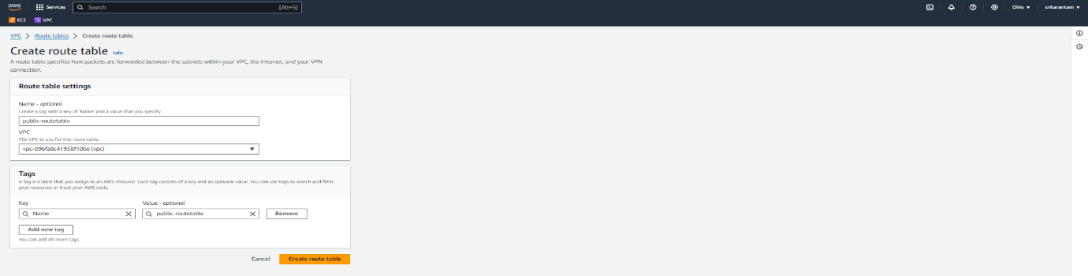

Pic-15

Now click on Actions, click on Edit routes (Pics-16)

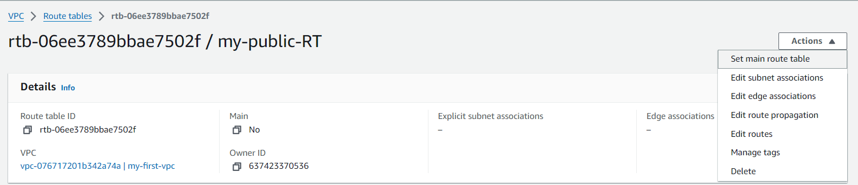

Pic-16

click on Add route. Select 0.0.0.0/0 as Destination(Pic-17)

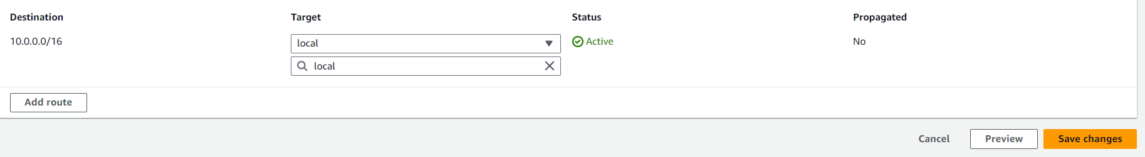

Pic17

Select Internet gateway from drop down list ,we have select use id like this igw-0e3f2f05c80bab751 and choose that one to our Internet gateway(Pic-18)

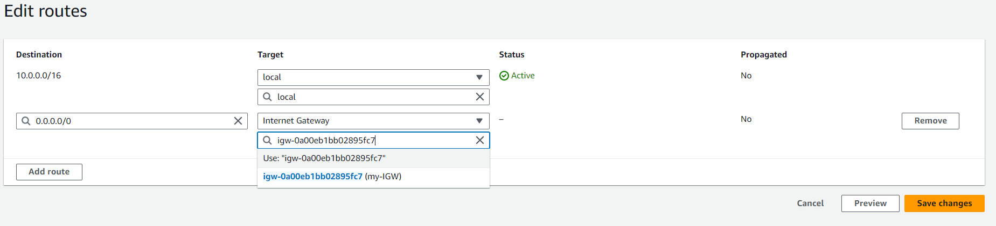

Pic18

finally click on Save changes.(pic-19)

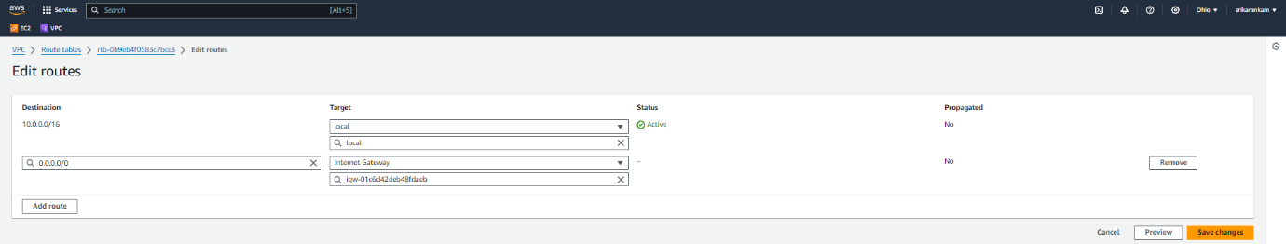

Pic19

Then click on Subnet associations and Edit subnet associations.(Pics-20)

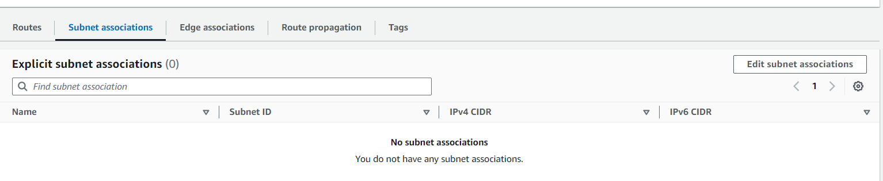

Pic-20

Select public subnet check box and Save associations.(Pic-21)

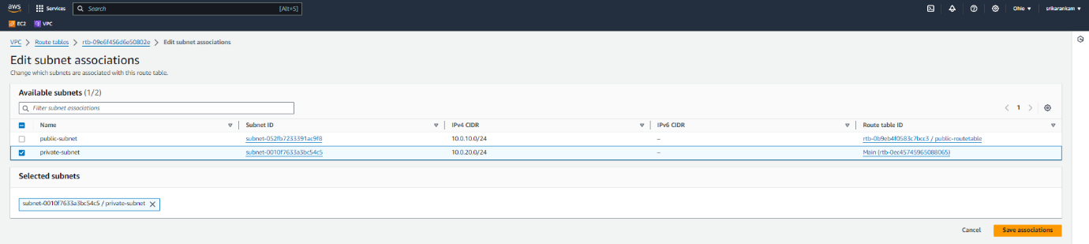

Pic-21

Create one more route table (private-subnet) and associate with private subnet.

*Note: To the private route table, we are no giving internet gateway access to private, because we want to make it as private subnet

Now we created two route table to our custom VPC successfully(Pic-22)

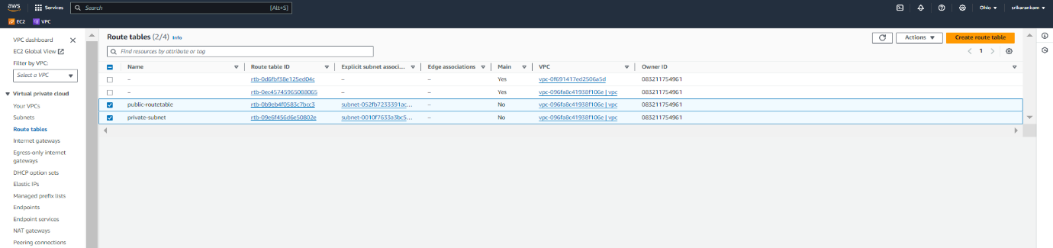

Pic-22

VPC with 2 subnets and 2 route tables and internet gateway successfully created.

Create one EC2 Instances

Search for EC2 in search space of AWS home page and click on EC2(Pic-23)

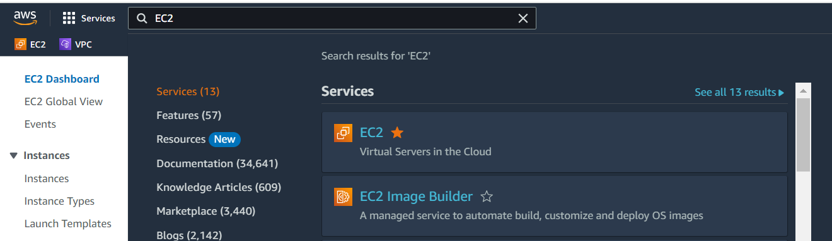

Pic-23

Now Create one ec2 instance.(Pic-24)

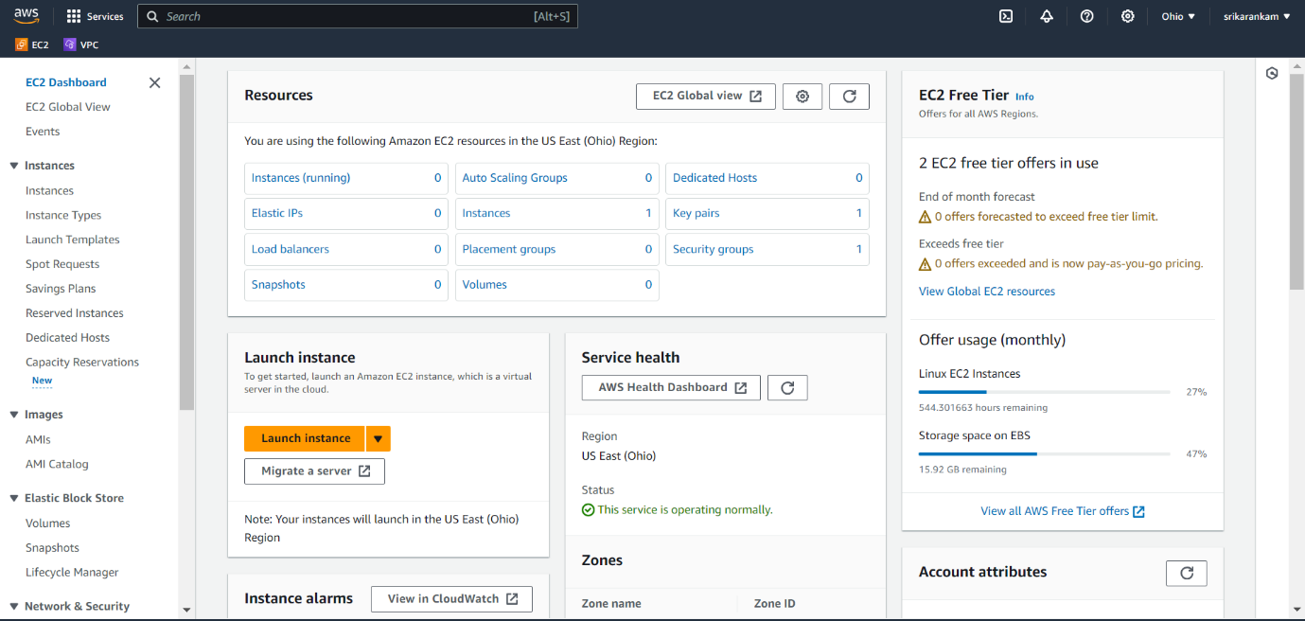

Pic-24

Then launch the ec2 instance, then We have to give the details for our ec2(EBS)Instance and then we have mention some details like we have name, OS type to start, instance type, keypair(login),network setting.

click on Launch instance(Pic-25)

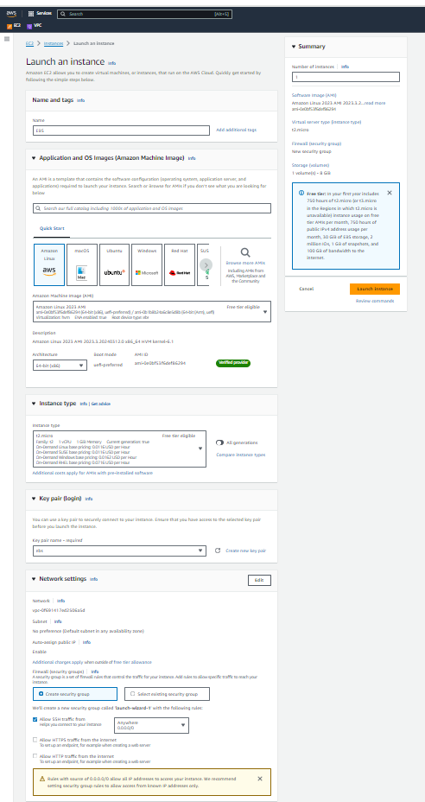

Pic-25

Now we created one EC2 Instance successfully.

Now click on Elastic Block Store option from EC2 instance menu

Then click on volumes.(Pic-26)

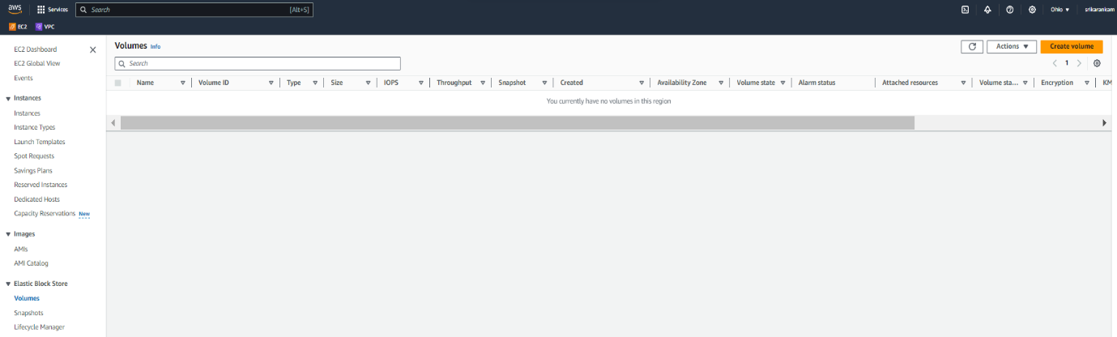

Pic26

create a Volume in the volume setting so that We have to give the details for volume type, size, availability zone.

Then click on create volume(Pic-27)

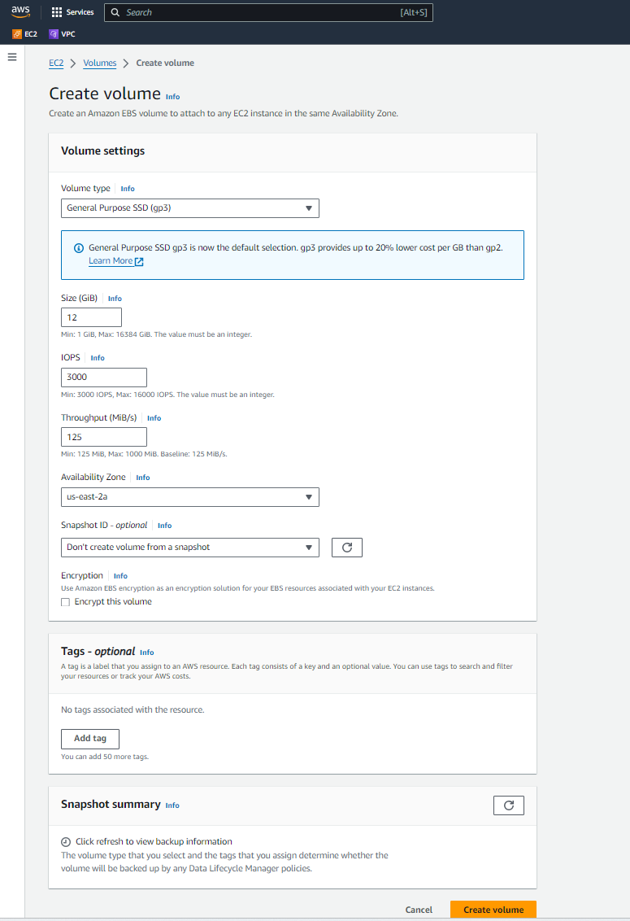

Pic-27

*Note: We have to EBS storage in same availability zone that our instance is running

The volume created successfully (Pic-28)

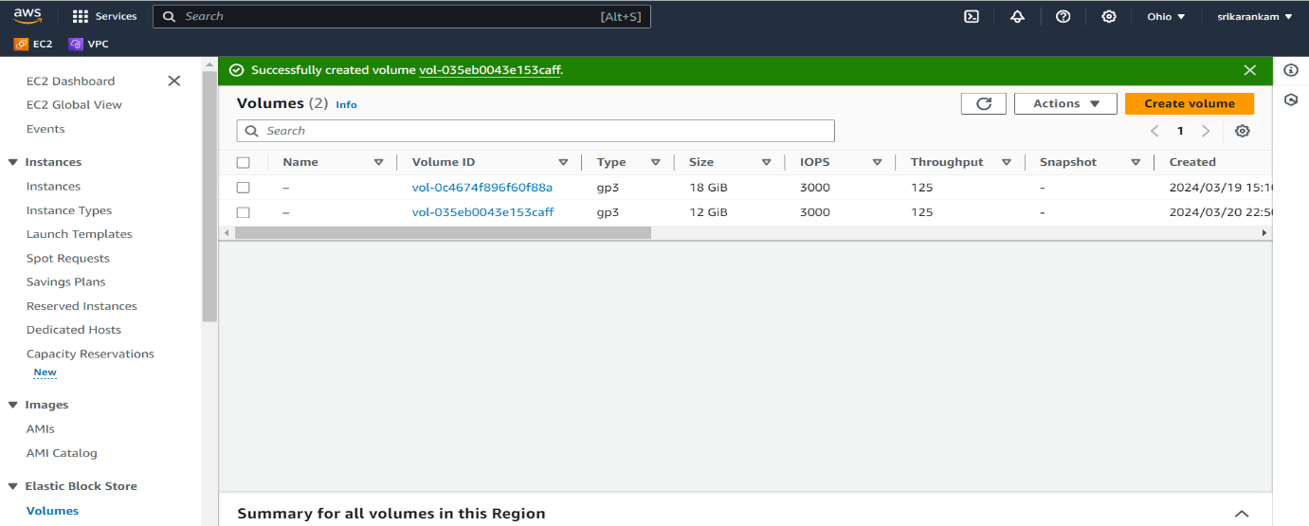

Pic-28

The volume is given 12 Gib.

Once the volume has been create click on actions in that click on attach volume (Pic-29)

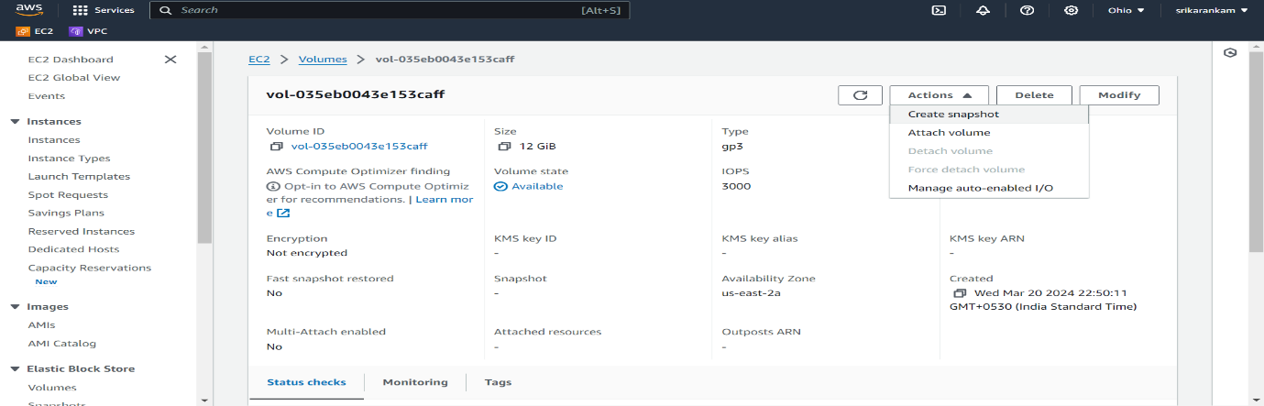

Pic-29

now we have to select our instance and click on Attach volume, Then volume id: vol-035eb0043e153caff is finally attached to the instance.

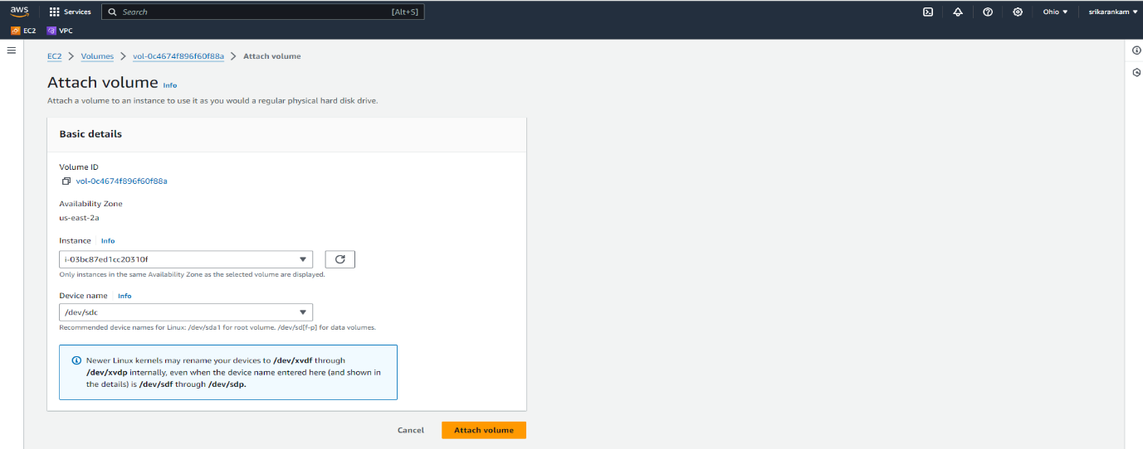

Pic-30

Go to instances, select our public-ebs instance and click on Connect(Pic-31)

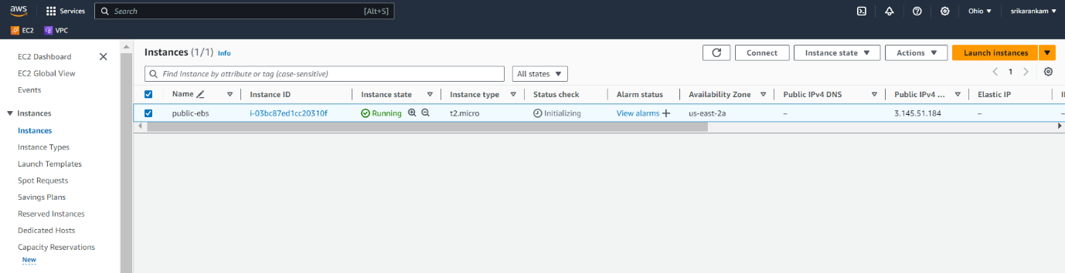

Pic-31

Click on SSH client in connect to instance page(Pic-32)

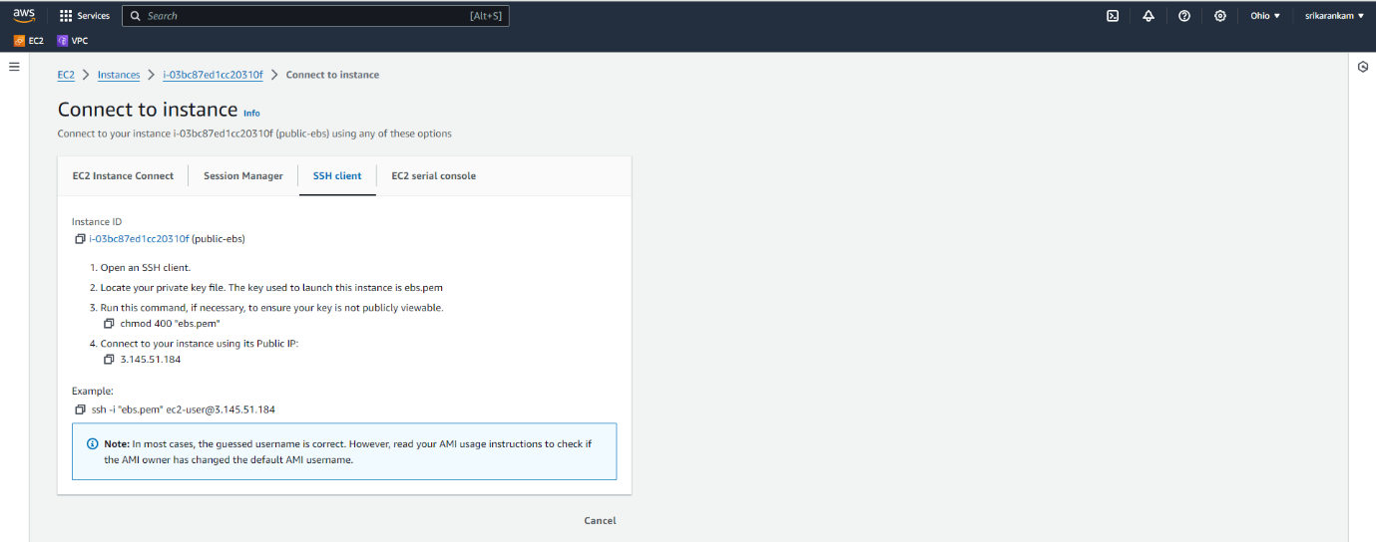

Pic-32

Now go to Gitbash window

Run this commands, to give permission

 chmod 400 "ebs.pem"

ssh -i "ebs.pem" [ec2-user@3.145.51.184](mailto:ec2-user@3.145.51.184) (Pic-33)

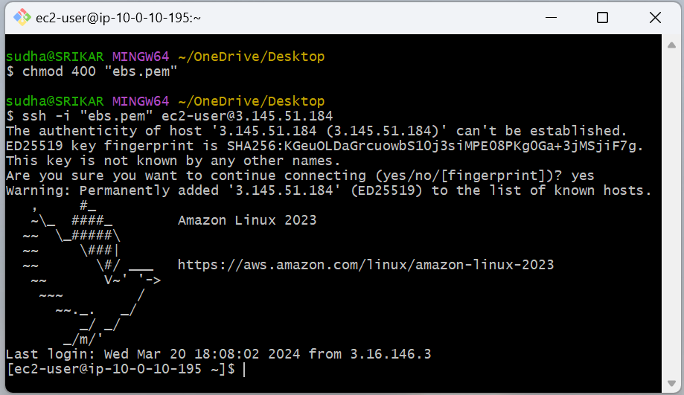

Pic-33

Run this commands

sudo -i (to change to root user)

df –h (to check the disk space)

lsblk (to list out block devices)

file –s /dev/xvdb (to check whether we have file system on this device)

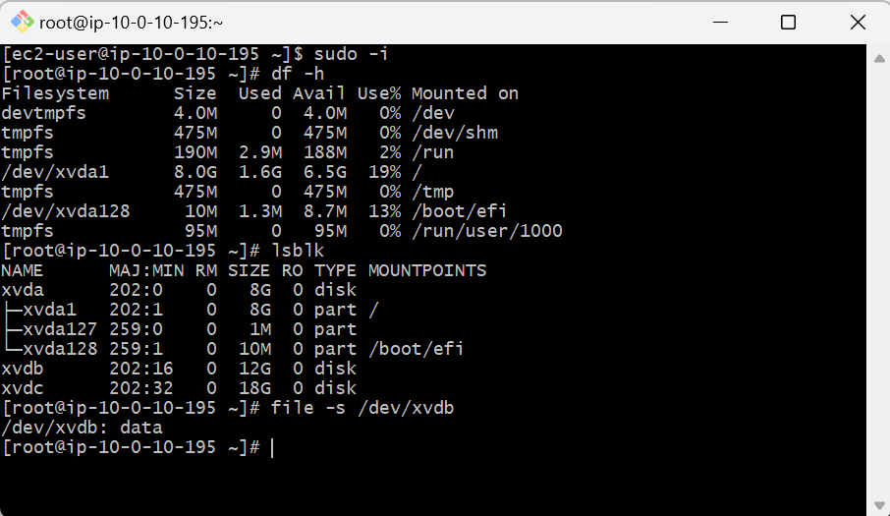

Pic-34

Then Run is command

Clear (to clear the screen)

Then we don’t have a file system. To create file system run this command and check weather we have file system or not.

mkfs -t xfs /dev/xvdb

now it clear we have file system. Now create one nested directory to mount our volume.

🡪mkdir –p srikar/sudhakar

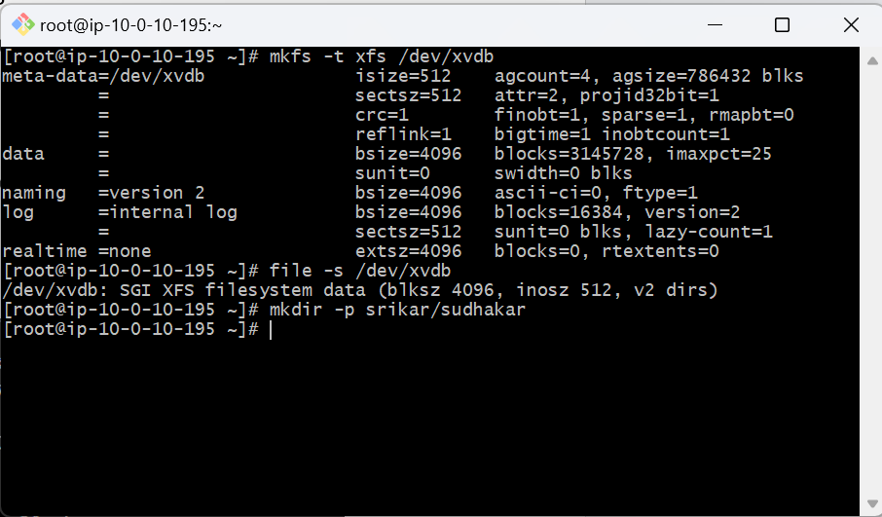

Pic-35

Now check mount volume by Run this command

mount /dev/xvdb srikar/sudhakar

run this command

df –h

to check whether our volume is attached or not (Pic-36)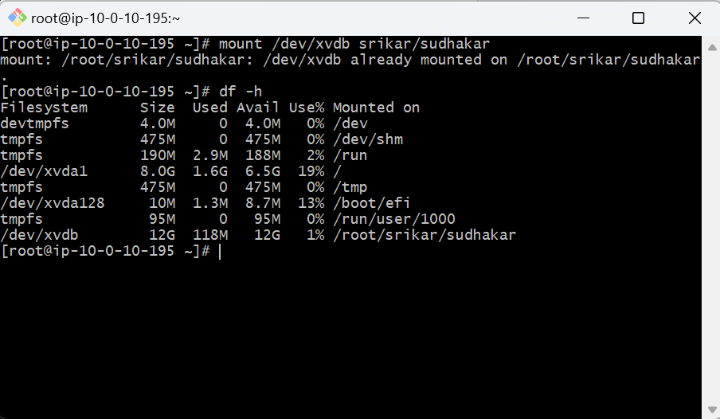

Pic-36.

Finally our volume is attached.