Name:-B Srikar Slot :-c
Reg.192312346 ECA3102 - NANO ELECTRONICS
EXP.NO:8
Simulation of VI Characteristics of FINFET, CNTFET and GFET using NanoHub
- FINFET
case Study 1: Simulate & obtain the current spectrum characteristics for the last bias point of FinFET. Analyze the performance for different Oxide layer thicknesses
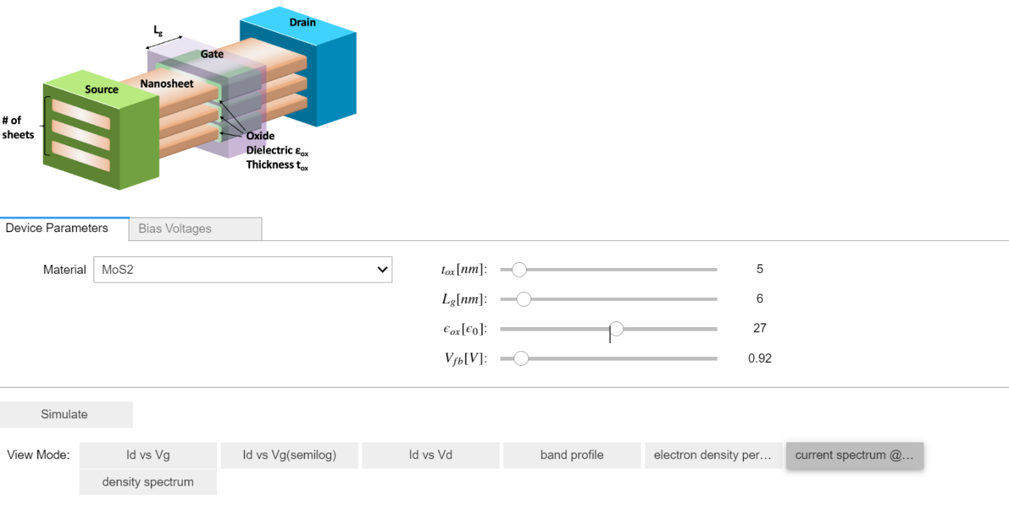
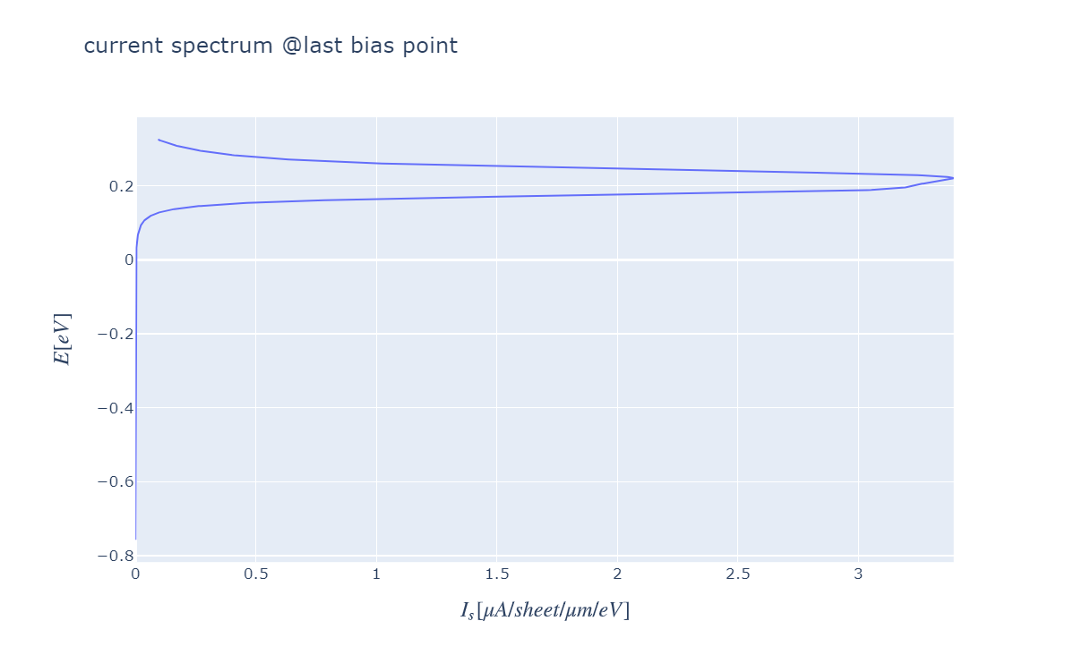

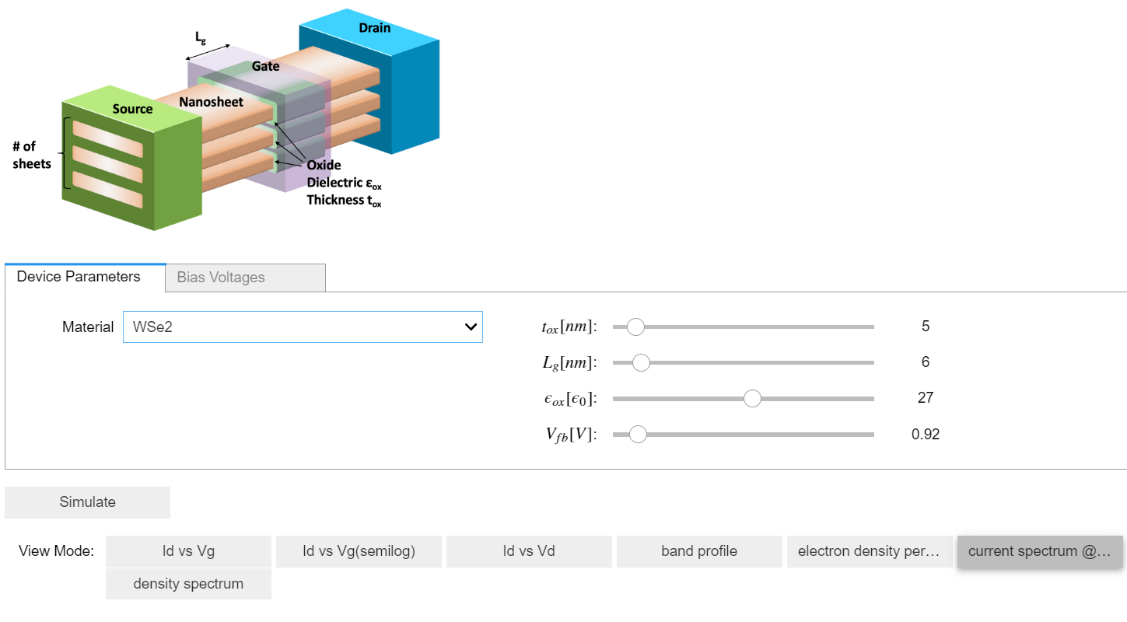
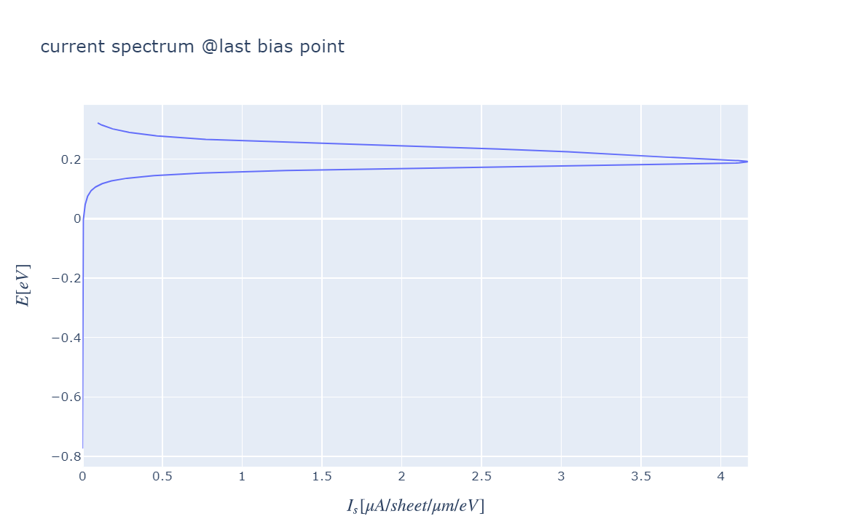
Result Interpretation
- The current spectrum at the last bias point shows smooth electron transport, indicating proper operation of the FinFET device with stable carrier conduction.
- As the oxide layer thickness is reduced, the gate control over the channel improves, resulting in higher drain current and better device performance.
- The simulation confirms that thinner oxide layers provide improved current conduction and switching characteristics, while thicker oxide layers reduce current due to weaker gate control.
Case Study 2: Simulate & obtain the electron density per sheet characteristics of FinFET. Analyze its performance with different Gate region length
MoS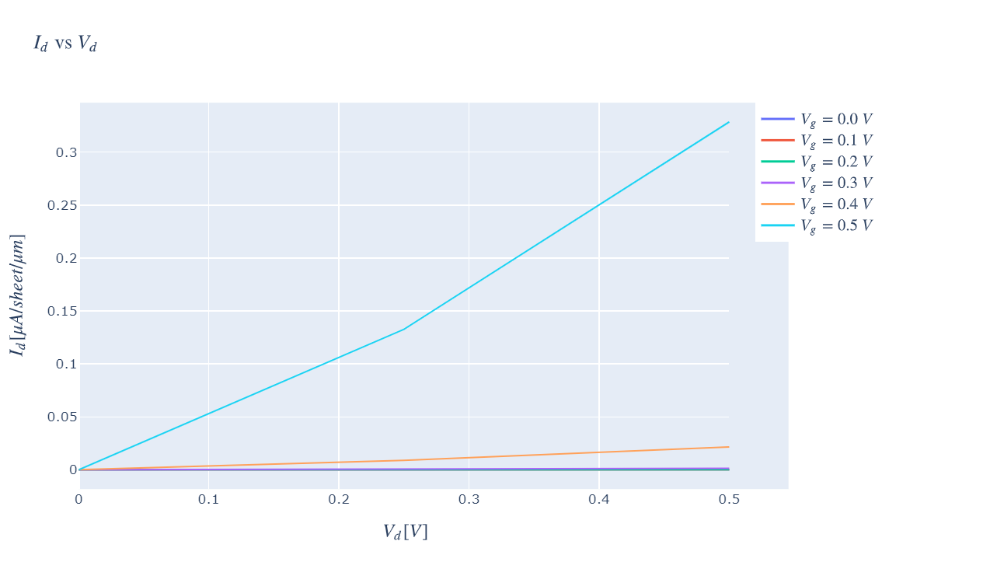
WSe2

Result Interpretation
- The electron density sheet increases with increasing gate voltage (Vg), indicating improved channel formation and carrier transport.
- A shorter gate region length provides better electrostatic control, resulting in higher electron density and improved device performance.
- The simulation confirms that both MoS₂ and WSe₂ FinFETs exhibit effective channel modulation, making them suitable for low-power, high-speed nanoelectronic applications.
Conclusion
- The FinFET simulation successfully obtained the electron density sheet characteristics for different gate region lengths.
- Reducing the gate region length improved gate control and enhanced electron density in the channel.
- Overall, the results demonstrate that optimizing the gate region length enhances FinFET performance, making it suitable for advanced nanoscale electronic devices.
(b) CNTFET

Case study 1: Simulate & Obtain the VI characteristics of CNT-FET by varying Schottky barrier and oxide thickness
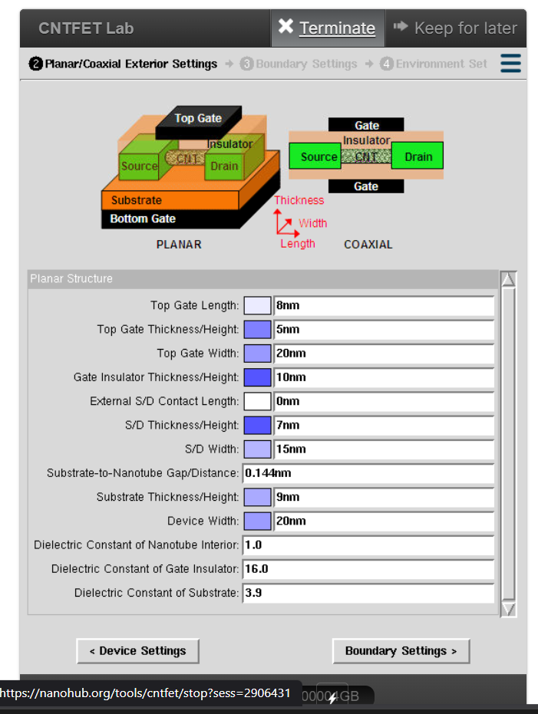
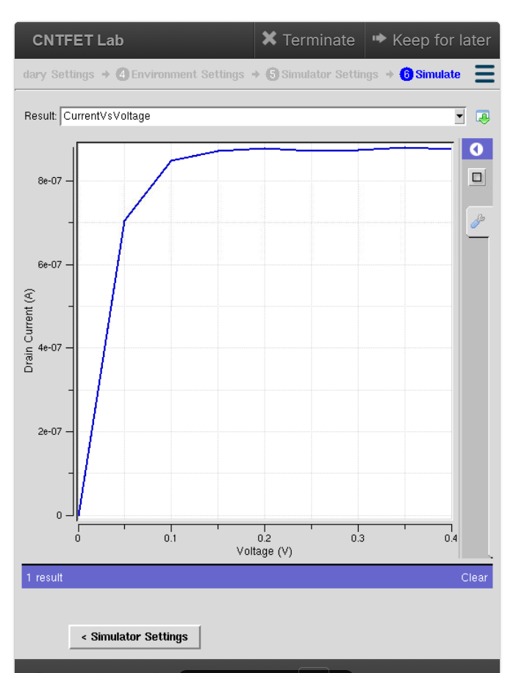
Result Interpretation
- The drain current (Id) increases with an increase in drain voltage (Vds), confirming the normal VI characteristics of the CNTFET.
- Reducing the oxide thickness improves gate control over the channel, resulting in higher drain current and better device performance.
- Increasing the Schottky barrier height reduces carrier injection at the source/drain contacts, leading to lower drain current and reduced device conductivity.
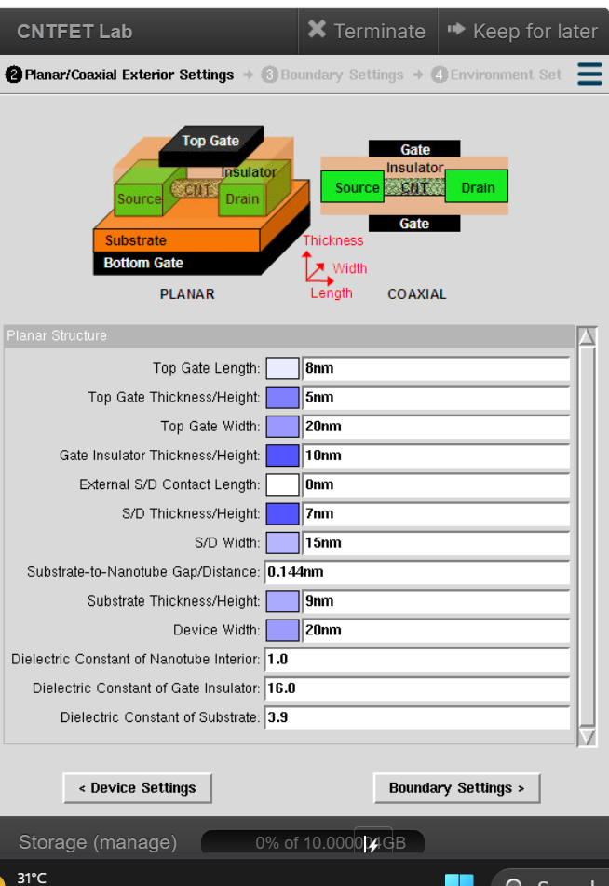
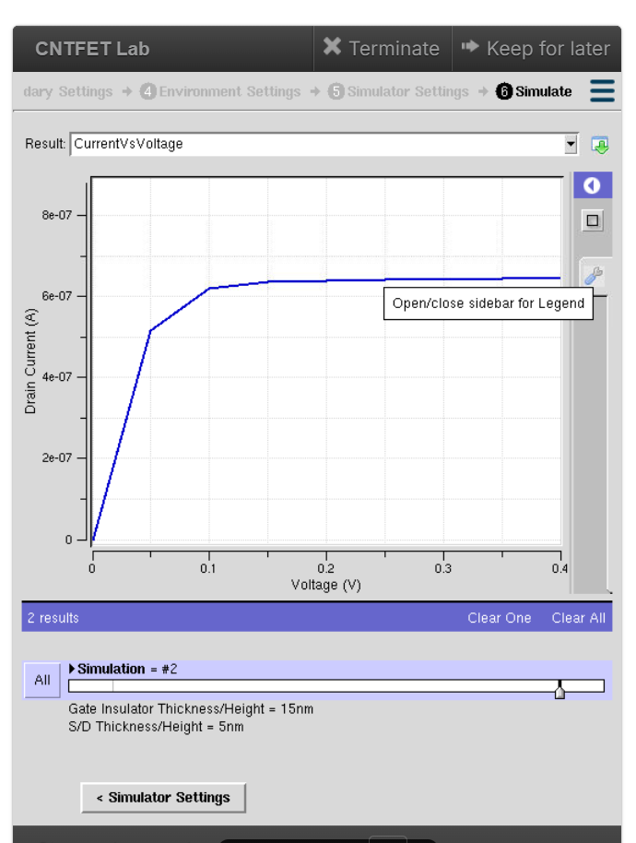
Result Interpretation
- The drain current (Id) increases with increasing drain voltage (V), confirming the normal I–V characteristics of the CNTFET.
- The current rises rapidly at lower voltages and gradually reaches saturation at higher voltages, indicating stable device operation.
- With a gate insulator thickness of 15 nm, the CNTFET exhibits controlled carrier transport and maintains steady current, demonstrating effective transistor performance.
Conclusion
- The CNTFET simulation successfully obtained the I–V characteristics by varying the gate insulator (oxide) thickness.
- The drain current increased with the applied voltage and reached saturation, demonstrating proper CNTFET operation.
- The results indicate that oxide thickness influences the electrical performance of the CNTFET, making it an important parameter in optimizing high-speed, low-power nanoelectronic devices.
(c) GFET
Case Study 1:How does varying the gate voltage (Vgs) affect the drain current (Ids) in a GFET?
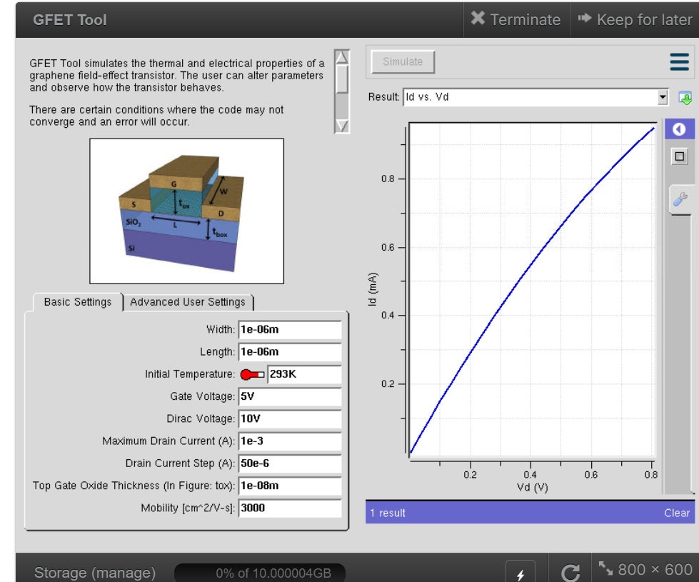
Result Interpretation
- The drain current (Ids) increases as the gate voltage (Vgs) is increased, indicating improved channel conductivity in the GFET.
- The Id–Vd characteristics show that higher gate voltage enhances carrier concentration, resulting in increased current flow through the graphene channel.
- The simulation confirms that the gate voltage effectively controls the drain current, demonstrating the excellent electrostatic control and high carrier mobility of the GFET.
Case Study 2: What factors determine the maximum drain current (Ids,max​ ) in a Graphene Field Effect Transistor (GFET)?
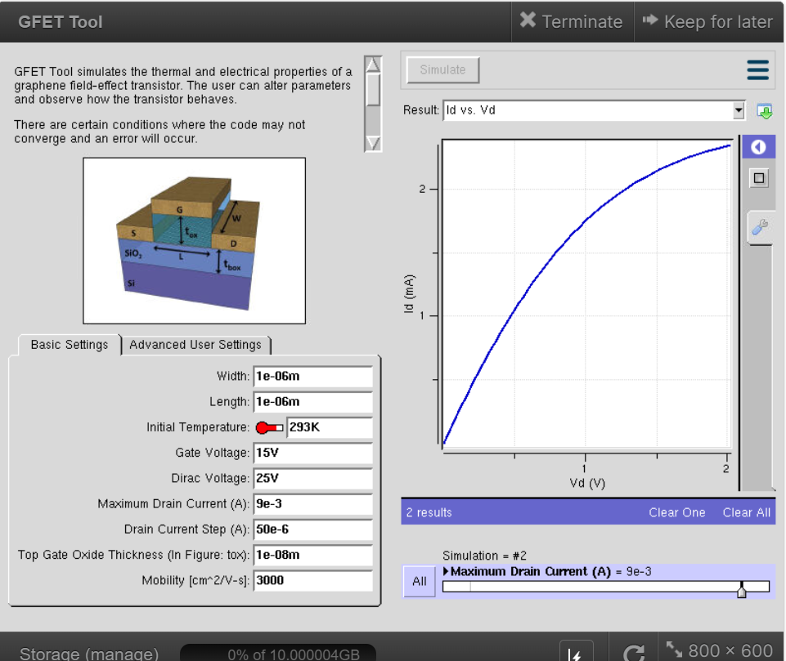

Result Interpretation
- The drain current (Id) increases with increasing drain voltage (Vd), demonstrating the normal output characteristics of the GFET.
- At a gate voltage of 15 V, the GFET exhibits a higher drain current due to increased carrier concentration in the graphene channel.
- The drain current increases rapidly at lower drain voltages and gradually approaches saturation at higher voltages, indicating stable device operation and effective gate control.
Exp. 9. Simulation of Tunneling Magnetoresistance (TMR) by Varying Barrier Height using NanoHUB
Case Study 1: Characteristics of TMR with barrier height of 0.85eV
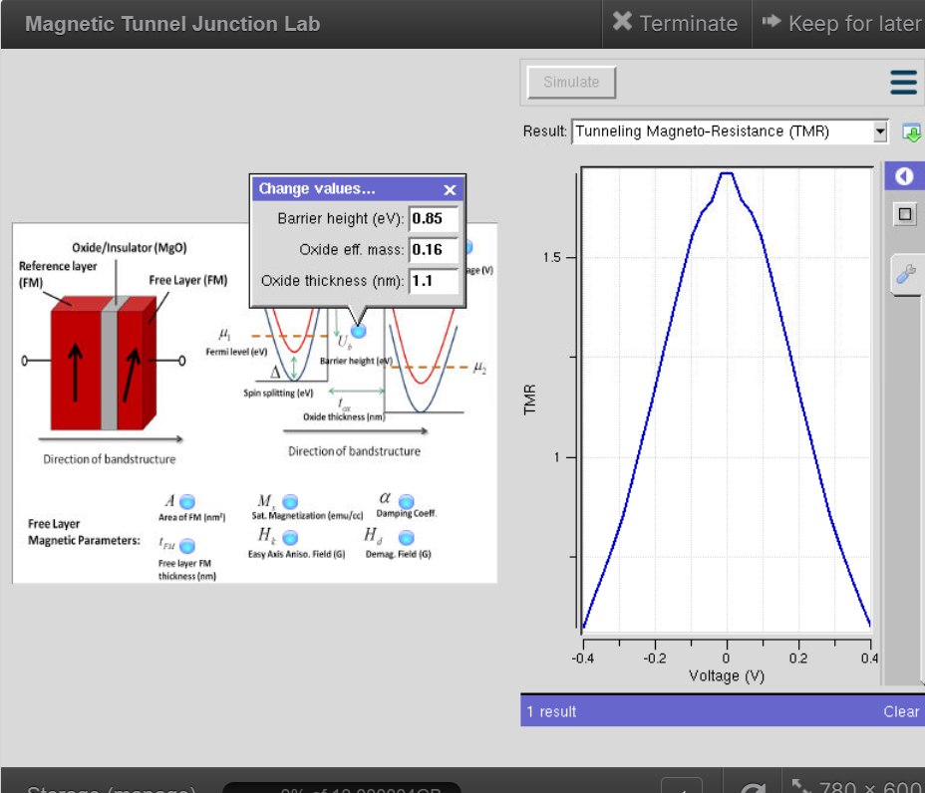

Case Study 2: Characteristics of TMR with barrier height of 1.0eV
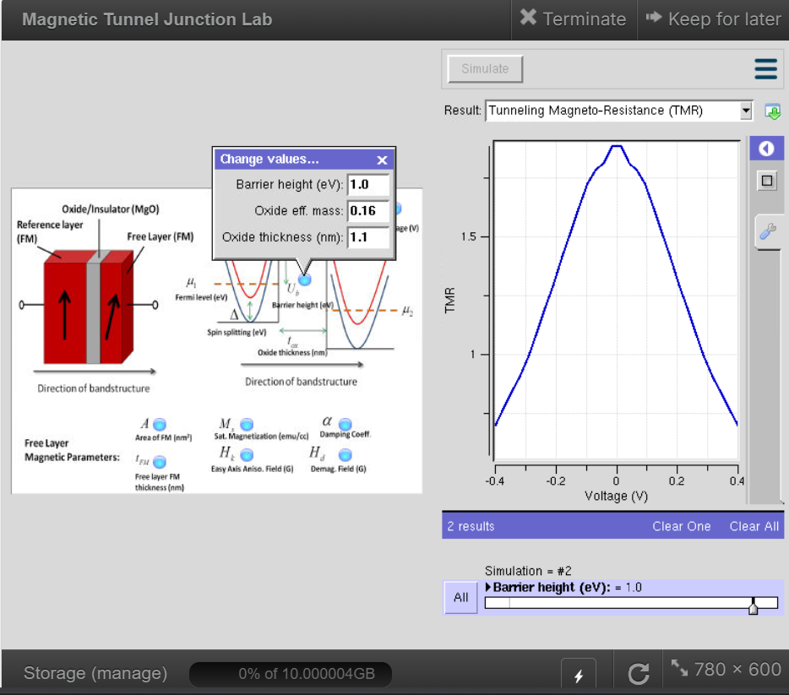
Result Interpretation
- The TMR characteristic exhibits a maximum value near 0 V bias and decreases gradually as the applied voltage increases in either direction.
- Increasing the barrier height from 0.85 eV to 1.0 eV modifies the tunneling behaviour and influences the magnitude of the TMR response.
- The simulation confirms that barrier height is a critical parameter affecting electron tunneling and the overall performance of the Magnetic Tunnel Junction (MTJ).
Exp. 1. Simulation of scattering and absorption of Multi-layer Sphere and Core-Shell Nanoparticle using Mie-Plot tool
Case Study 1: Scattering and absorption spectra for a single-layer sphere (core only)
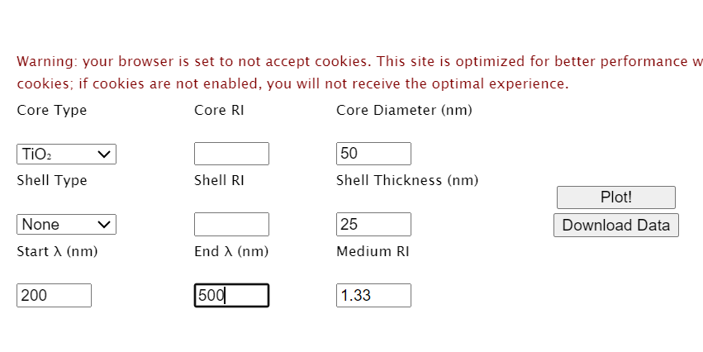
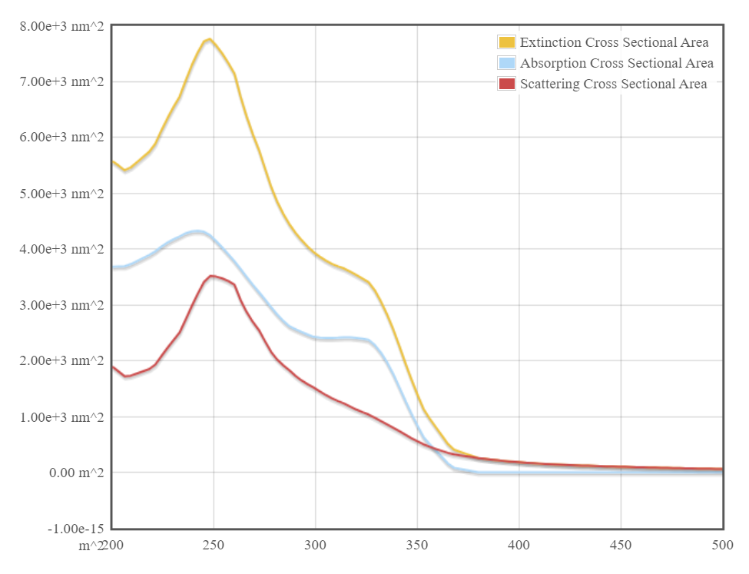
Case Study 2: Simulate the optical response of a gold (Au) nanoparticle of 50 nm diameter in water medium.
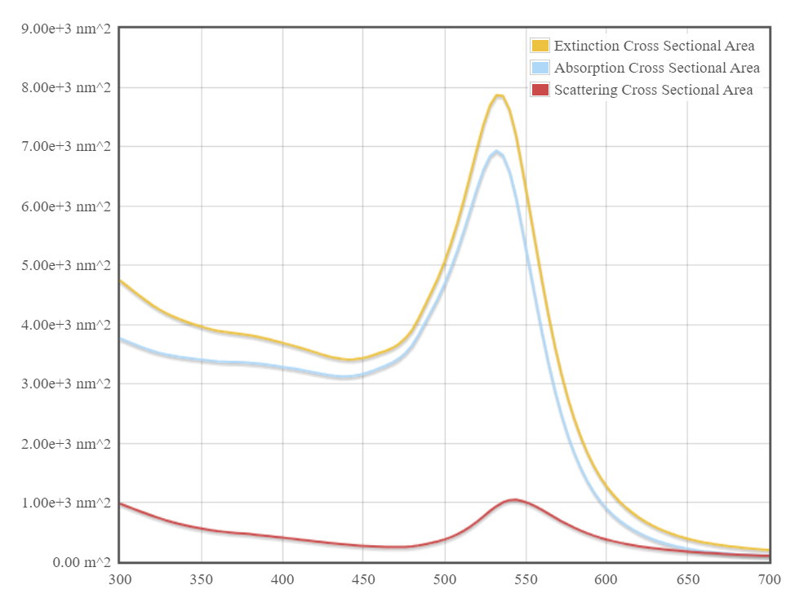
Case Study 3: Simulate a core–shell nanoparticle with a gold core (30 nm) and silica shell (10 nm).
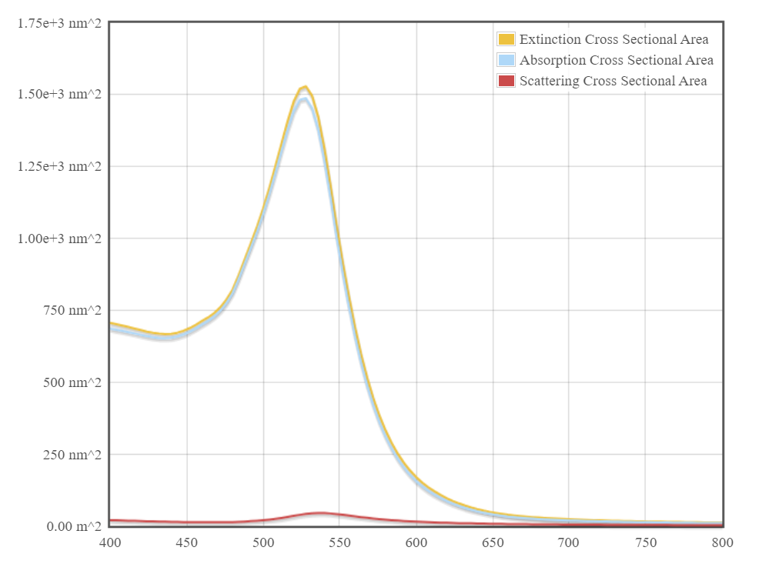
Result Interpretation :-
- The extinction, absorption, and scattering cross-sections vary with wavelength, indicating the optical response of the single-layer nanoparticle.
- A distinct peak is observed at the resonance wavelength, where the nanoparticle exhibits maximum light absorption and scattering.
- The simulation confirms that the optical characteristics of the nanoparticle depend on its material properties and particle size, making it suitable for plasmonic and sensing applications.

