Name: B. Srikar Course: Nanoelectronics
Reg no: 192312346 Course code: ECA3102

Exp. 2. Simulation of Density of States of Quantum Well Structure with
Various Nanometer Thickness.

Case Study 1: Simulate the density of states of quantum well of thickness 0.5 nm

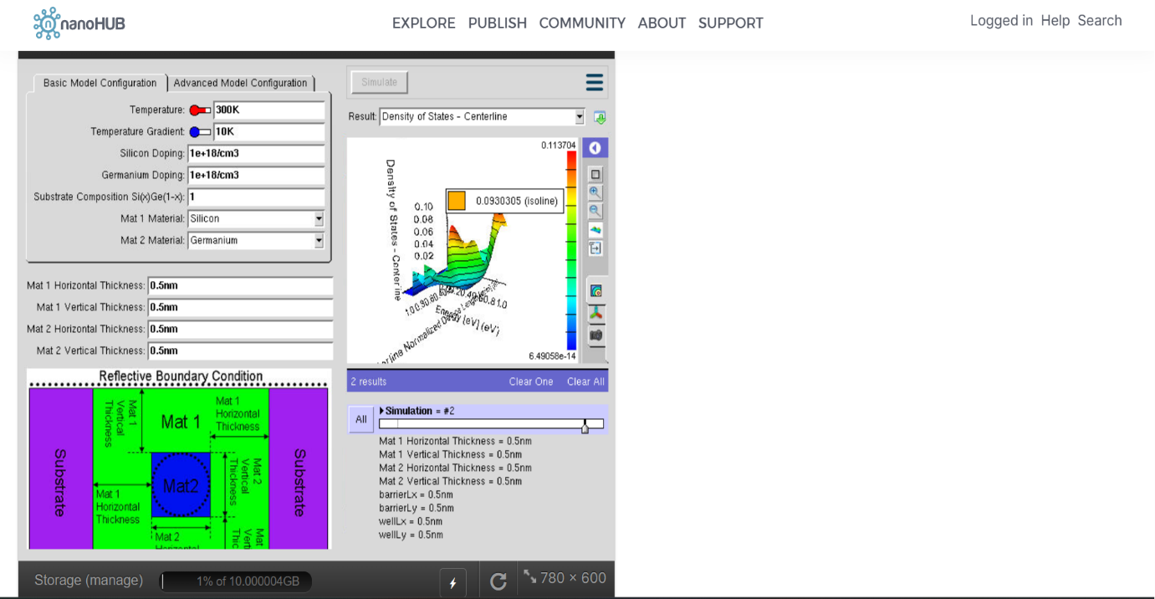

Case Study 2: Simulate the density of states of quantum well of thickness 0.6 nm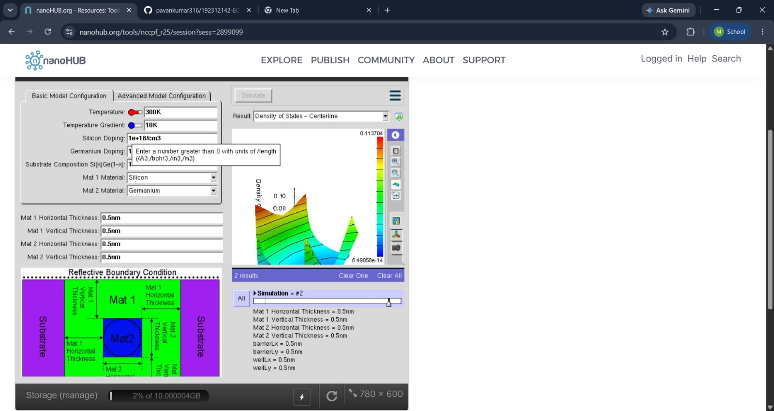

Exp. 3. Simulation of Energy States of Quantum Dot using NanoHub
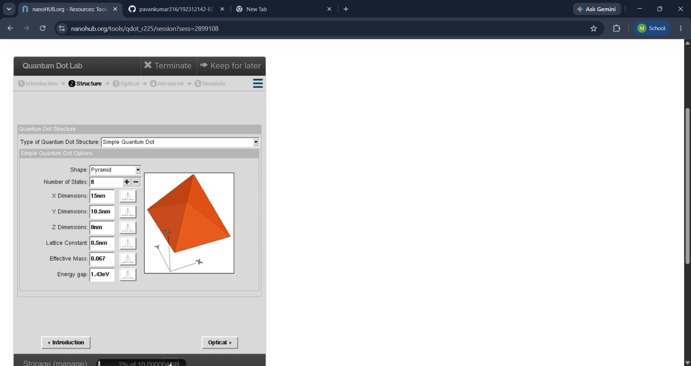

Case Study 1: Simulate the energy states of cylindrical quantum dots of X=15 nm, Y = 10.5nm
and Z = 8 nm.
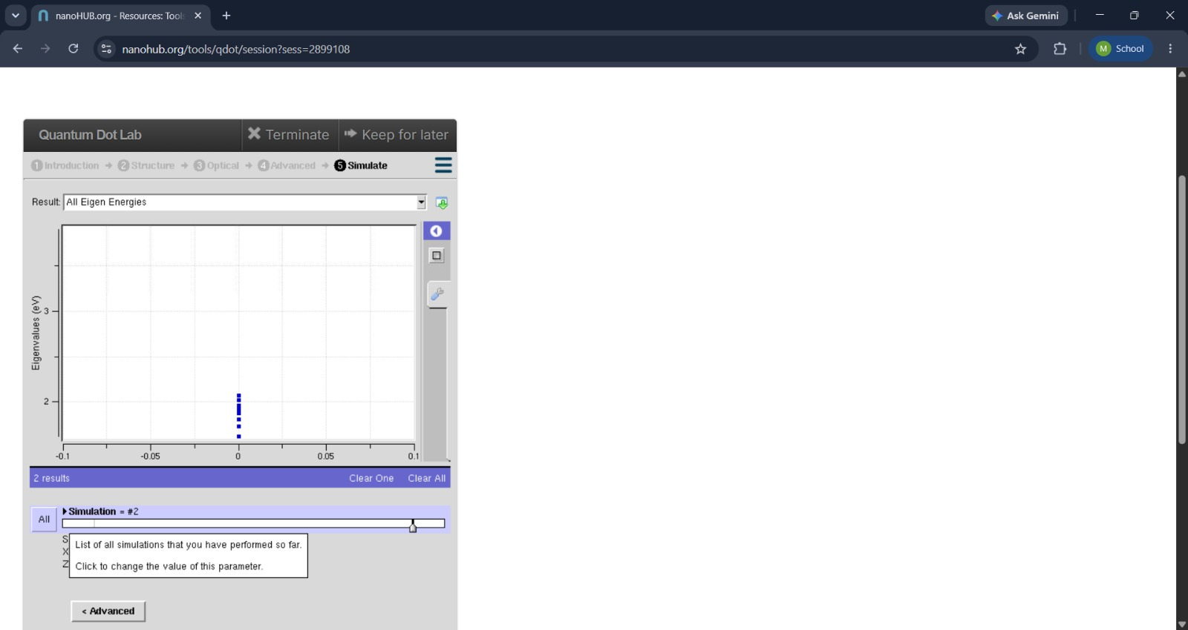

Case Study 2: Simulate the energy states of two layer cuboid quantum dots

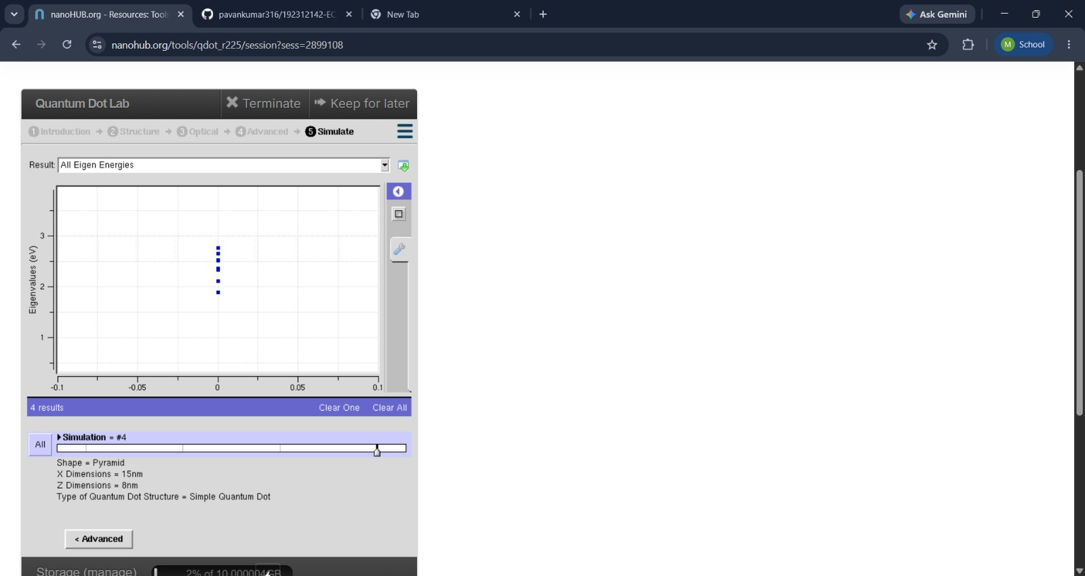

Exp. 4. Kronig Penney Model

Case Study 1: Simulate the output for Triangular well

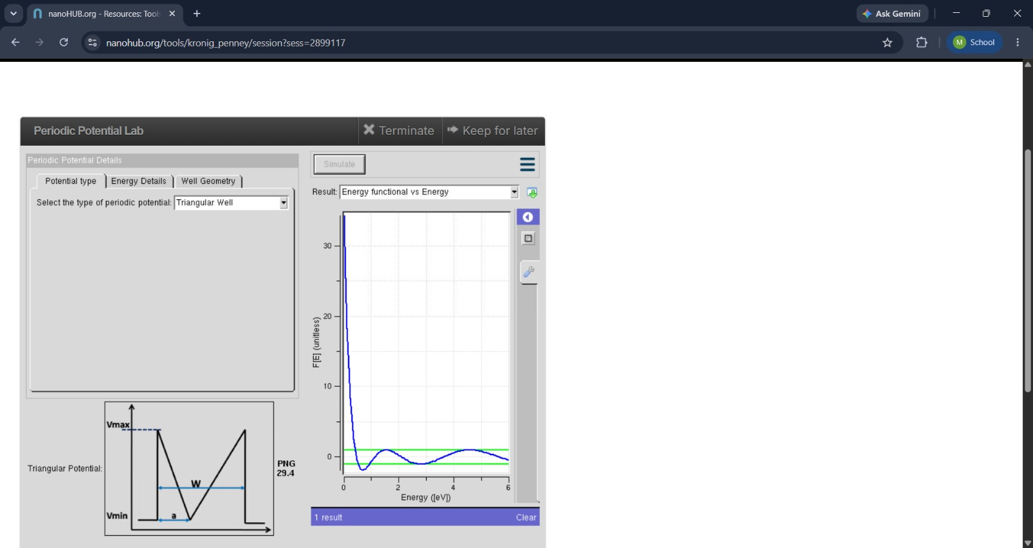

Case Study 2: Simulate the output for Sinusoidal Potential
