Software Architecture and Design Specification
Remote Laboratory Equipment Reservation System
Team 16 | Version 1.1 | 10 October 2026 | Draft for faculty review
This document translates the project SRS into a proposed architecture and detailed design. It defines modules, data relationships, transaction rules, interfaces and security controls for implementation and testing. The design is proposed; no implemented system or verified performance result is claimed.
Team member | SRN
Shristi Shukla | PES1UG24AM268
Soha Rafiq | PES1UG24AM278
Spoorthy M | PES1UG24AM280
Sreekar Bandi | PES1UG24AM282

Revision history
Version | Date | Author | Change
1.0 | 10 October 2026 | Team 16 | Initial architecture and design based on SRS version 1.0
1.1 | 10 October 2026 | Team 16 | Review clarified utilization, login cooldown, versions and concurrent retries

Approvals
Faculty approval is pending. No approval or signature has been recorded.

Contents
1 Introduction
2 Document overview
3 Architecture
4 Design
5 Appendices

1 Introduction

1.1 Purpose
Define how the system will satisfy the requirements in Team16_Remote_Laboratory_SRS.docx. This document provides a shared implementation baseline and a source of design references for the Software Test Plan.

1.2 Scope
The design covers online equipment browsing, reservations, approvals, cancellation, maintenance blocks, account administration, in-app notifications, actual usage and utilization reporting. Remote refers to online booking; equipment use occurs physically in the lab. Hardware control, payments, email and SMS, public registration and automatic experiment execution are excluded.

1.3 Audience
Project developers, student testers, faculty reviewers, lab administrators and technicians.

1.4 Definitions
SRS: Software Requirements Specification. SAD: Software Architecture and Design Specification. STP: Software Test Plan. RTM: Requirements Traceability Matrix. ADR: Architecture Decision Record. RBAC: Role-Based Access Control. CSRF: Cross-Site Request Forgery. UTC: Coordinated Universal Time.

2 Document overview

2.1 How to use this document
Section 3 describes the architecture, modules, data model, risks and security. Section 4 defines booking transactions, sequence diagrams, API contracts and user interaction. Section 5 records decisions, references and proposed tools. Design identifiers retain the DS references used in the SRS RTM.

2.2 Related documents
Baseline: Team16_Remote_Laboratory_SRS.docx version 1.0. Course reference: SAD_Template (1).docx. Assignment: SE_Project_Team_Assignment_E.xlsx, Team 16. The STP is the next deliverable and shall reuse the TC-F, TC-NF and TC-SR identifiers from the SRS. Changes to booking policies must be reflected in all three documents.

3 Architecture

3.1 Goals and constraints
Maintain one consistent equipment schedule, prevent overlapping held reservations, enforce role and lab permissions, and preserve booking history. Meet the SRS prototype targets: 95th-percentile read response within 2 seconds under 50 concurrent test users and 1,000 reservations; restore within 60 minutes from a backup no older than 24 hours. These are test targets, not achieved measurements.
Pending and Approved requests hold slots. Every booking requires administrator approval. Intervals use [start, end); adjacent reservations are allowed. Each equipment record represents one device. Availability screens are advisory; final acceptance is always decided by the server transaction.

3.2 Stakeholders and concerns
Stakeholder | Design concern
Students | Clear availability, fair conflict handling, own history and private records
Lab administrators | Correct decisions, equipment management and meaningful utilization
Technicians | Maintenance validation and simple actual usage recording
Project team and faculty | Readable modules, traceability, feasible implementation and measurable tests

3.3 Architecture and UML class diagram
The system uses three layers: presentation, application and persistence. Backend services are modules in one application, rather than independently deployed services. Only the backend accesses the database.
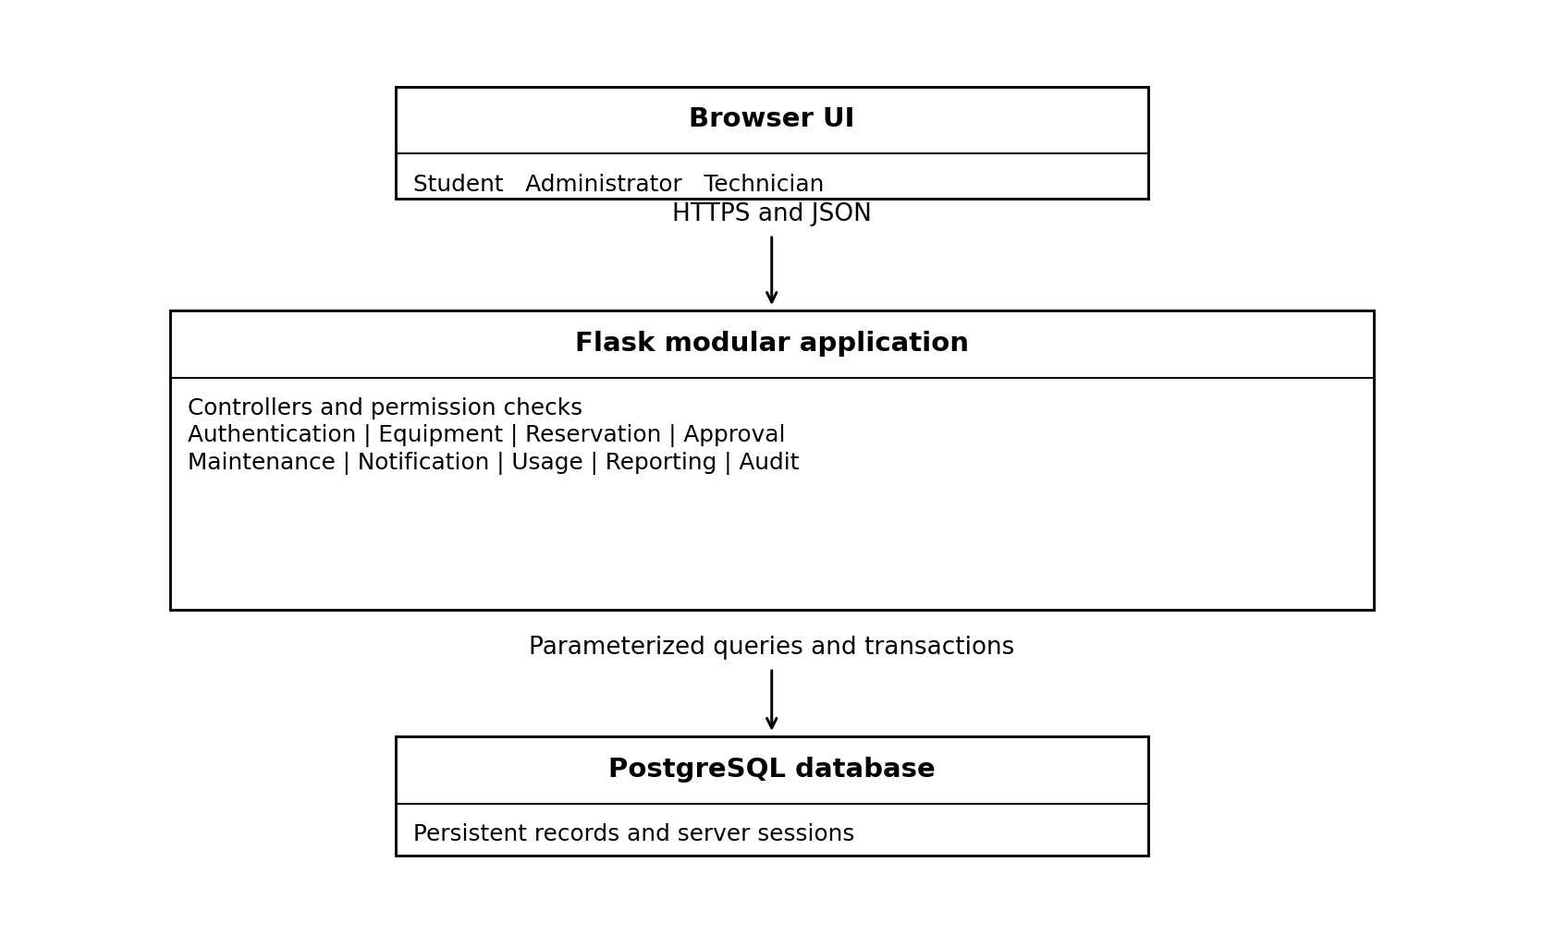
Figure 1 Proposed layered architecture
The domain class model on the next page shows the central entities and UML multiplicities. User roles are assigned through LabMembership rather than trusting roles sent by the browser. A student may reserve equipment across labs; staff authority is restricted to assigned labs.

3.3.1 Domain class model
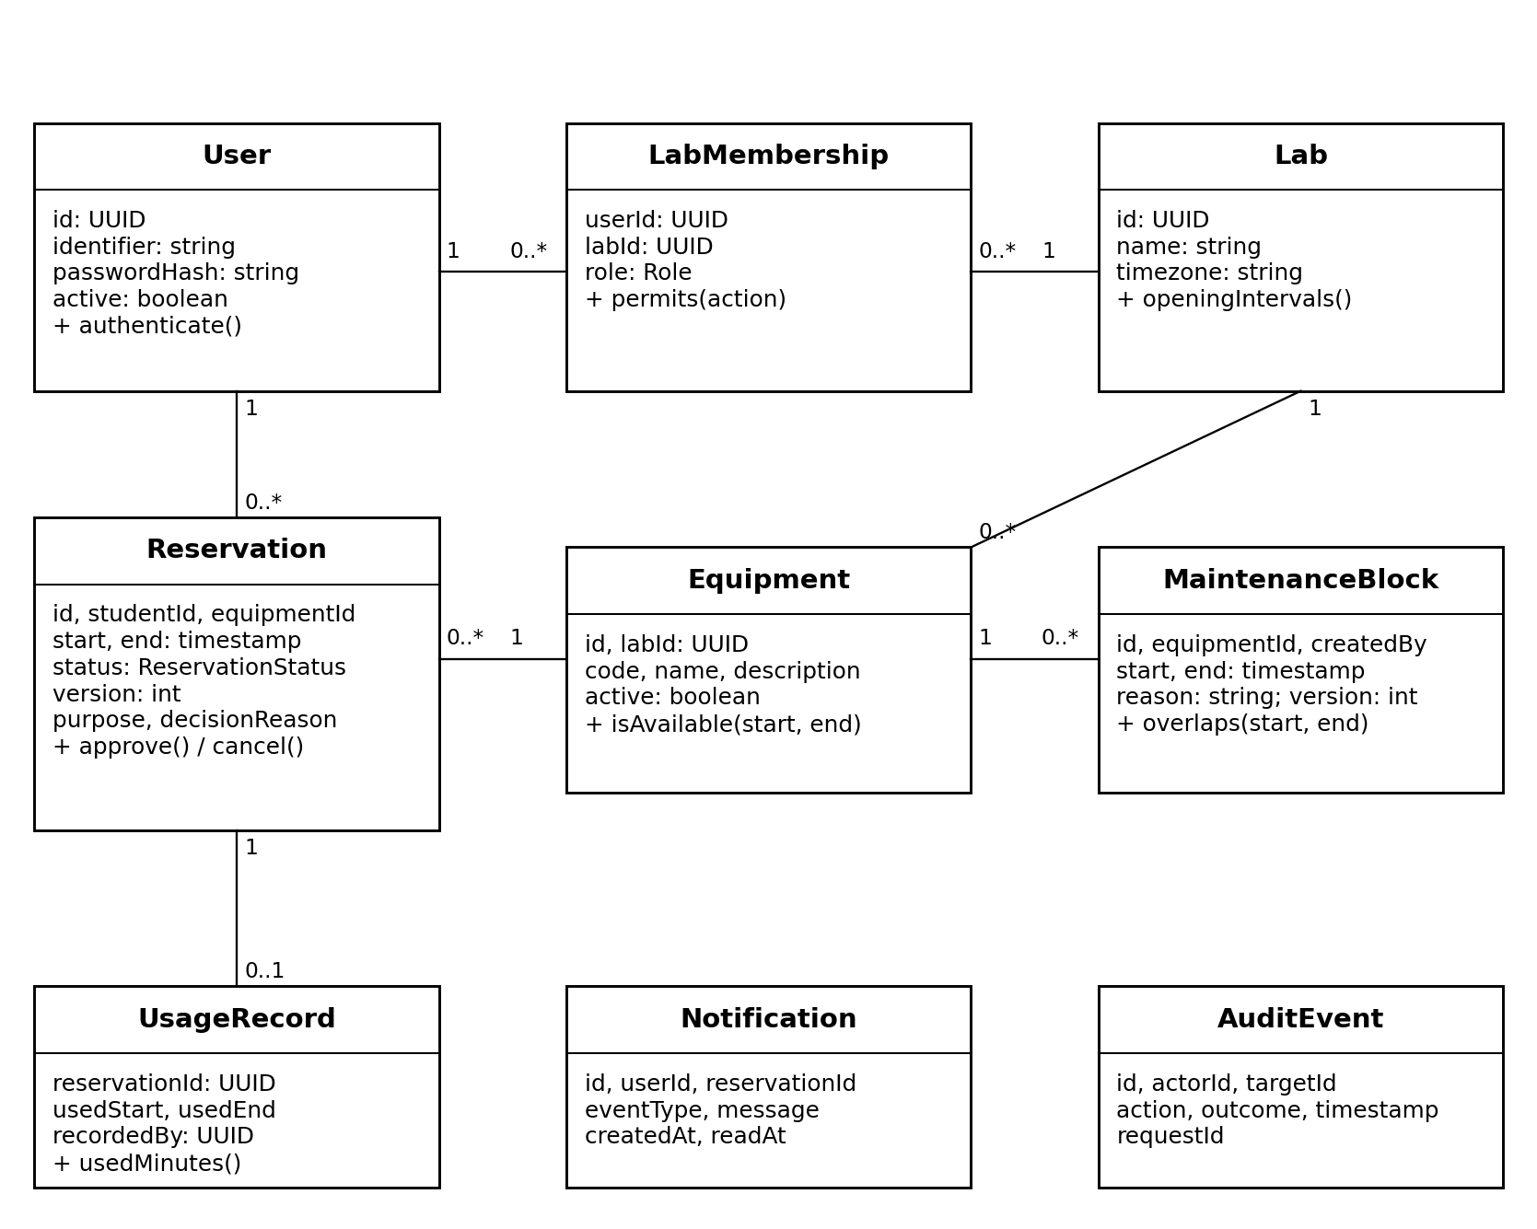
Figure 2 UML class diagram with attributes operations and multiplicities
User to Reservation denotes the student who owns the request. LabMembership connects one User and one Lab and carries a role. Lab to Equipment is one to many. Equipment to Reservation and MaintenanceBlock is one to many. Reservation to UsageRecord is one to zero or one. Notification belongs to one User and optionally one Reservation; AuditEvent refers to an actor and target. These last reference relationships are described here to keep the diagram readable.

3.3.2 Supporting persistent records
Session stores a hashed opaque session token, user ID and last activity timestamp. LoginAttempt stores account failure counts and cooldown timestamps. IdempotencyRecord stores user ID, operation, key, normalized request hash and the original successful response. LabOpeningInterval stores weekly opening windows and date overrides. These implementation records support the domain model and do not create additional user-facing features.

3.4 Component descriptions

Authentication
DS-Authentication — Login, logout, provisioned accounts, lab roles, disabled accounts, sessions and login throttling. SRS mapping: LAB-F-001, 002, 018.

Equipment
DS-Equipment — Catalogue, search, lab metadata and safe equipment updates or deactivation. SRS mapping: LAB-F-003, 004, 013.

Reservation
DS-Reservation — Availability, atomic booking, own history and cancellation. SRS mapping: LAB-F-005–009.

Approval
DS-Approval — Pending queue, version-checked approval and rejection. SRS mapping: LAB-F-010–012.

Maintenance
DS-Maintenance — Maintenance intervals and validation against held bookings. SRS mapping: LAB-F-014.

Notification
DS-Notification — Persistent in-app event messages created with the booking transaction. SRS mapping: LAB-F-015.

Usage
DS-Usage — Usage timestamps, no-shows and completion after the reservation ends. SRS mapping: LAB-F-016.

Reporting
DS-Reporting — Period-based actual utilization and unrecorded usage counts. SRS mapping: LAB-F-017.

Audit
DS-Audit — Timestamped state-change records with actor and outcome. SRS mapping: LAB-F-019.

3.5 Chosen architecture pattern and rationale
A layered modular monolith keeps deployment and debugging manageable for a four-person student team. Controllers handle HTTP and input shape; services apply policies and transaction boundaries; repositories perform parameterized queries. Shared permission and audit utilities avoid duplicate security logic. Microservices are not selected because this scope does not require separate deployment or distributed transactions.

3.6 Technology stack and data stores
Layer | Proposed choice | Reason
Presentation | HTML, CSS and JavaScript with server templates | Simple forms and dashboards without a separate frontend build
Application | Python with Flask | One modular application with explicit controllers and services
Persistence | PostgreSQL with parameterized driver queries | Relational keys, durable transactions and equipment row locks
Deployment | HTTPS reverse proxy and production application server | Same-origin deployment and secure transport
Testing | pytest, browser checks and a load-test tool | Unit, integration, end-to-end and NFR verification
Exact dependency versions will be selected and pinned during implementation. A production application server is required for deployment; the development server is for local work only. Secrets and database credentials are supplied through environment configuration.

3.6.1 Data rules and indexes
UUID primary keys identify users, labs, equipment and reservations. User identifiers and equipment codes are unique. Foreign keys preserve relationships; equipment is deactivated rather than deleted. Timestamps use timezone-aware storage in UTC and are displayed in Asia/Kolkata. Opening hours are evaluated in the lab timezone. Reservation and maintenance intervals require start < end.
Indexes support equipment lab and active status, reservations by equipment and start time, student history, pending requests by lab, and maintenance by equipment. UsageRecord has a unique reservation reference. IdempotencyRecord has a unique user, operation and key combination. Reservation and MaintenanceBlock each store an integer version incremented on every update for stale-request detection. Core records are retained throughout the project; long-term institutional retention policy remains to be confirmed.

3.7 Risks and mitigations
Risk | Mitigation
Two concurrent bookings | Lock the equipment row before validating and creating either reservation
Maintenance racing a booking | Use the same equipment lock for both operations
Pending requests hold slots indefinitely | Administrator queue shows request age; release only by explicit rejection or cancellation under current SRS
Network failure after saving | Idempotent retry and history reconciliation avoid duplicate records
Inaccurate utilization | Record actual usage, show unrecorded reservations and distinguish occupancy from usage
Database loss or downtime | Daily backups, restore drill and clear unavailable response
Unauthorized lab management | Server role, lab membership and ownership checks on every action

3.8 Traceability to requirements
The following references resolve every design identifier proposed in the SRS. Test cases remain planned and will be detailed in the STP.
Design reference | SRS requirements | Design location
DS-Authentication | LAB-F-001, 002, 018 | 3.4 and 4.1–4.3
DS-Equipment | LAB-F-003, 004, 013 | 3.4 and 4.1–4.3
DS-Reservation | LAB-F-005–009 | 3.4 and 4.1–4.3
DS-Approval | LAB-F-010–012 | 3.4 and 4.1–4.3
DS-Maintenance | LAB-F-014 | 3.4 and 4.1–4.3
DS-Notification | LAB-F-015 | 3.4 and 4.1–4.3
DS-Usage | LAB-F-016 | 3.4 and 4.1–4.3
DS-Reporting | LAB-F-017 | 3.4 and 4.1–4.3
DS-Audit | LAB-F-019 | 3.4 and 4.1–4.3
DS-Performance | LAB-NF-001 | 3.6 indexes and 4.4 metrics
DS-Data integrity | LAB-NF-002 | 4.1 transaction protocol
DS-Usability | LAB-NF-003 | 4.5 task flow
DS-Accessibility | LAB-NF-004 | 4.5 keyboard and labels
DS-Recovery | LAB-NF-005 | 4.4 backup and restore
DS-Security | LAB-SR-001–005; LAB-SO-001–002 | 3.9 security architecture

3.9 Security architecture
DS-Security enforces authentication and permission checks in the server before reading private records or changing state. The browser receives only data authorized for that user. All roles and lab memberships are loaded from the database. Passwords use salted adaptive hashing; session identifiers are random, opaque and revocable server-side. Disabling an account invalidates its sessions and is rechecked on protected requests.
HTTPS is enforced in deployment. Session cookies use Secure, HttpOnly and SameSite attributes. A CSRF token is checked on state-changing requests. Passwords, cookies, tokens and connection secrets are omitted from logs. Five failed login attempts for an account within a 15-minute window trigger a further 15-minute cooldown; sessions expire after 30 minutes of inactivity. Queries use parameters, input lengths and formats are validated, and displayed free text is escaped.
STRIDE threat | Control | SRS reference
Spoofing | Password verification, login throttling and session expiry | SR-002, SR-004
Tampering | Permission checks, input validation and atomic writes | SR-001, SR-005
Repudiation | Actor, timestamp, target and request ID in audit records | F-019
Information disclosure | HTTPS, private record checks and secret-free logs | SR-001–003
Denial of service | Login throttling, bounded requests and database lock timeout | SR-004; NF-001
Elevation of privilege | Server role and lab checks; no browser-controlled role changes | SR-001
Only the application database identity writes audit events; users have no audit-edit endpoint. This supports review of actions but is not a claim of cryptographic non-repudiation. Database credentials use limited privileges and backup access is restricted.

4 Design

4.1 Design overview
Controllers call services, which use repositories within explicit transactions. Booking mutations follow a shared locking protocol. Notifications and successful audit events are inserted in the same transaction as the state change, so a rollback leaves no misleading success message.

4.1.1 Booking transaction protocol
1. Validate active account, role, payload and CSRF token. Begin a database transaction using Read Committed isolation.
2. Acquire SELECT FOR UPDATE on the equipment row. All booking, decision, cancellation, equipment-status, maintenance and opening-hour changes affecting that equipment follow this protocol. If multiple equipment rows must be locked, acquire them in sorted ID order.
3. Check the idempotency key under its unique constraint. An existing key with the same request returns its saved response; an existing key with different content returns 409 Conflict.
4. Recheck active equipment, future interval, lab opening windows and any overlap after the lock has been acquired. Overlap is new_start < existing_end and new_end > existing_start. Only Pending and Approved reservations hold slots.
5. Insert the Pending reservation, notification, audit event and idempotency response. Commit together and release the lock. A failed validation rolls back without creating a reservation. A concurrent unique-key insertion failure also rolls back the entire transaction; the service then reads the committed key record and returns the original response or 409 if the content differs.
Locking a stable equipment row is essential: locking only existing reservations would not protect an empty schedule. Because every writer for that equipment first acquires the same row lock, a later transaction validates against the prior committed result. The browser never decides whether a booking is conflict-free. Database access outside the service protocol is prohibited.

4.1.2 Other state changes
Approval locks equipment before the reservation, checks the expected version and Pending status, and revalidates eligibility excluding the reservation itself. Rejection requires a reason and releases the hold. Student cancellation is limited to own future Pending or Approved requests. Administrator cancellation for maintenance requires a reason and notifies the affected student.
Maintenance create or update rejects overlaps with any held reservation. Overlapping maintenance blocks may exist, but reporting subtracts their union once. Equipment deactivation is blocked while held reservations exist. Opening-hour changes lock all affected equipment in sorted order and are rejected if they would invalidate any held request. Existing records are never silently rescheduled.
Usage is a single interval contained within the reserved interval. A no-show has both usage timestamps empty and zero minutes. Completion requires Approved status and a reservation end time in the past. Reporting clips usage and bookable intervals to the selected date range. Bookable minutes equal opening minutes minus the union of maintenance minutes within opening hours. Utilization equals 100 × recorded used minutes / bookable minutes. A zero denominator displays Not applicable. For example, 480 opening minutes minus 60 maintenance minutes gives 420 bookable minutes; 210 used minutes gives 50% utilization. An Approved past booking with no usage record remains unrecorded until staff complete it.

4.1.3 Reservation state transitions
From | To | Authorized action
Pending | Approved | Administrator approves an eligible request
Pending | Rejected | Administrator rejects with reason
Pending or Approved | Cancelled | Student before start or administrator with reason
Approved | Completed | Technician or administrator after end with usage or no-show
Rejected, Cancelled, Completed | No further state | Historical terminal record

4.2 UML sequence diagrams

4.2.1 Student reserves equipment
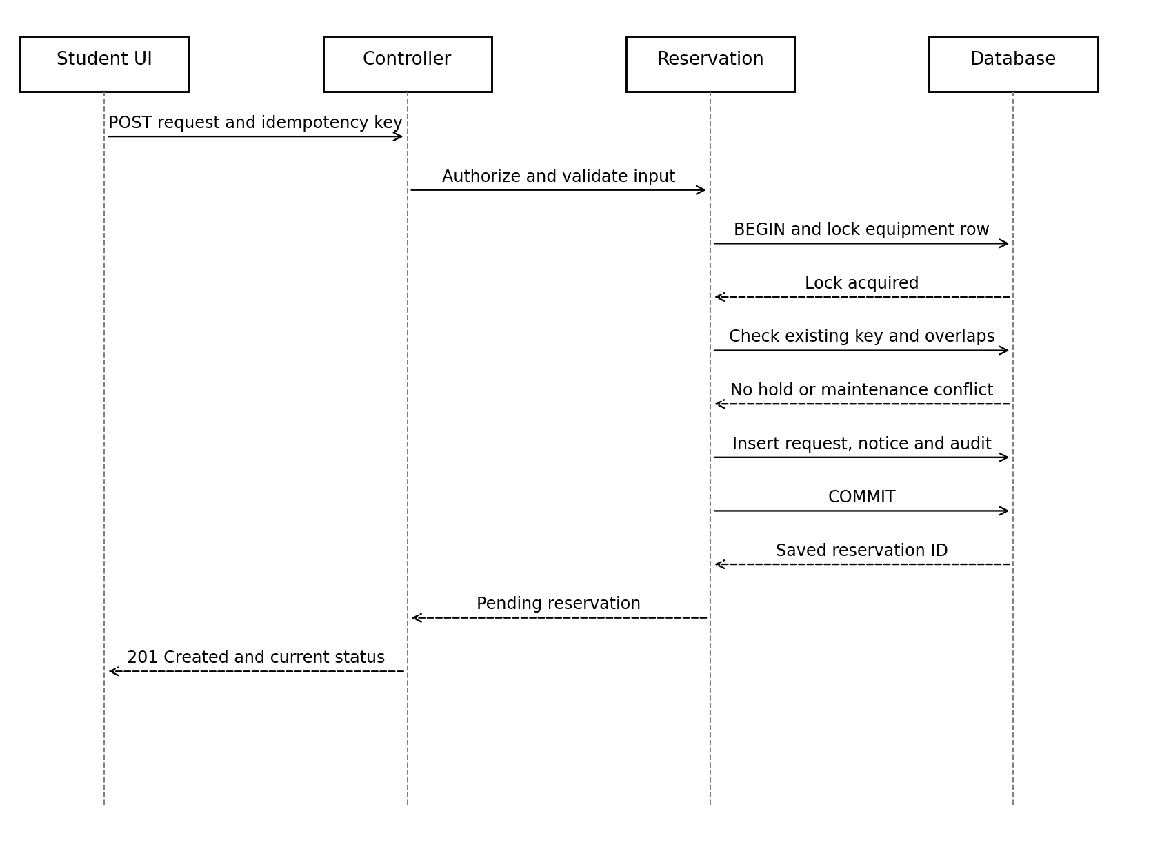
Figure 3 Successful reservation sequence
Failure paths: invalid input returns 422; missing session returns 401; forbidden action returns 403; unavailable or overlapping slot returns 409. A validation failure rolls back. A retry with the same successful idempotency key returns the original response. A lock timeout returns 503 with a retry message; it does not create a booking.

4.2.2 Administrator decides a request
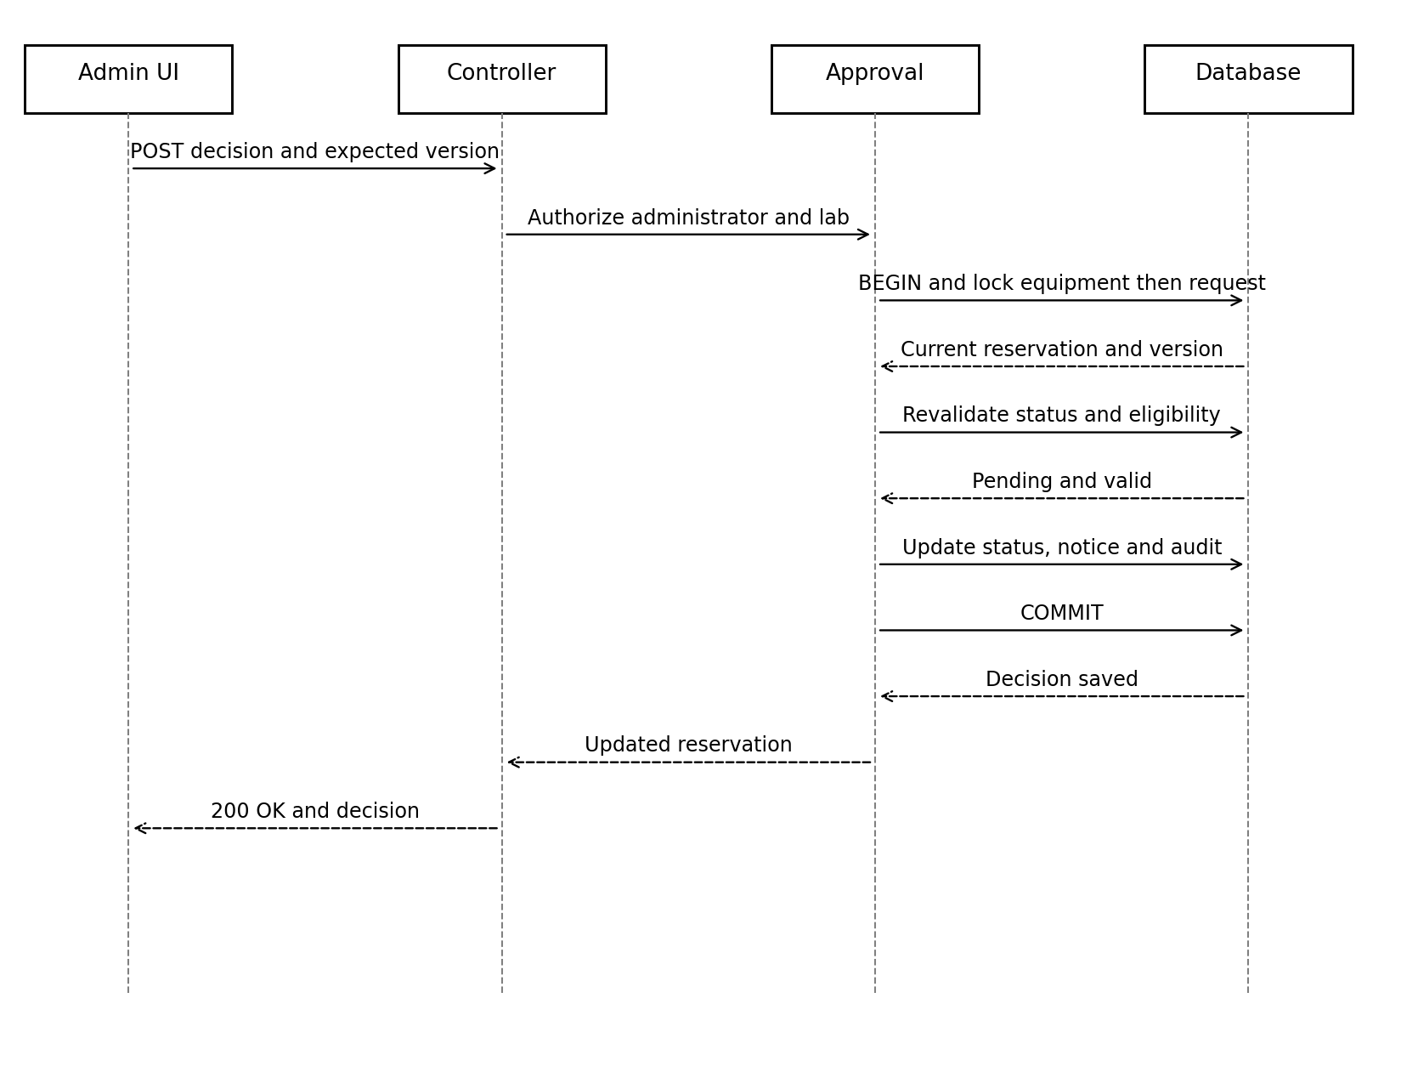
Figure 4 Successful approval sequence
The rejection flow uses the same transaction but validates a non-empty reason rather than slot eligibility. A stale version or non-Pending request returns 409. Unauthorized lab access returns 403. Notification and audit insertions commit with the decision. The student reads the persistent notification on the next dashboard request; no external messaging service is required.

4.3 API design
The proposed interface uses same-origin JSON endpoints under /api. Protected calls use a server session cookie. State-changing requests include X-CSRF-Token. Identifiers are UUID strings and datetimes use ISO 8601 with an explicit offset. Examples below are synthetic. Responses exclude password hashes, session secrets and other students’ private records.

4.3.1 Authentication and equipment interfaces
Method and endpoint | Input | Output and permission
POST /api/auth/login | identifier, password | 200 user ID and authorized roles; sets session cookie
POST /api/auth/logout | CSRF token | 204; invalidates server session
GET /api/equipment | Optional name, lab_id, page | 200 active equipment list; authenticated user
GET /api/equipment/{id}/availability | date in YYYY-MM-DD | 200 opening, held and blocked intervals; authenticated user
POST /api/equipment | code, name, lab_id, description | 201 equipment; administrator for lab
PATCH /api/equipment/{id} | Editable metadata or active flag | 200 updated record; administrator; 409 on invalid deactivation

4.3.2 Reservation interface
POST /api/reservations — Student only. Required header: Idempotency-Key, 1 to 128 characters. The server derives student_id from the session. Request: {"equipment_id":"<UUID>","start":"2026-10-15T10:00:00+05:30","end":"2026-10-15T11:00:00+05:30","purpose":"Machine learning lab experiment"}. Success 201: {"id":"<UUID>","status":"Pending","version":1}. Errors: 401, 403, 404, 409, 422 or 503 as defined below.
GET /api/reservations?scope=mine returns only the current student’s requests. Administrators may use scope=lab with an authorized lab_id and optional status=Pending. POST /api/reservations/{id}/cancel takes {"expected_version":1,"reason":"Schedule changed"}; student cancellation uses the SRS before-start rule. Administrator cancellation requires a non-empty reason. Success 200 returns status Cancelled and an incremented version.

4.3.3 Approval interface
POST /api/reservations/{id}/decision — Administrator for the equipment lab. Request: {"decision":"Approved","expected_version":1}. Rejection uses {"decision":"Rejected","reason":"Equipment needed for a scheduled class","expected_version":1}. Only Approved or Rejected is accepted. Success 200: {"id":"<UUID>","status":"Approved","version":2}. A repeated or stale decision returns 409; insufficient lab authority returns 403.

4.3.4 Maintenance usage and reporting interfaces
Method and endpoint | Input | Output and permission
POST /api/maintenance | equipment_id, start, end, reason | 201 block; technician or administrator; 409 on held booking overlap
PATCH /api/maintenance/{id} | start, end, reason, expected_version | 200 updated block; same lab check and conflict validation
DELETE /api/maintenance/{id} | expected_version | 204; technician or administrator for lab
POST /api/reservations/{id}/usage | used_start, used_end or no_show=true; expected_version | 200 Completed; staff for lab; 422 for invalid usage
GET /api/reports/utilization | lab_id, from_date, to_date | 200 equipment metrics; administrator for lab
GET /api/notifications | Optional page | 200 current user notifications only
POST /api/users | identifier, initial_password, memberships | 201 provisioned account; administrator within allowed lab scope
PATCH /api/users/{id} | active or lab-scoped membership changes | 200; administrator may change only authorized lab memberships; global disable restricted to accounts wholly within managed scope
Account administration must not grant authority over an unmanaged lab. Accounts spanning multiple labs cannot be globally disabled by a single-lab administrator. Initial account bootstrap is an explicit restricted deployment operation, not a public endpoint. Changes are audited.

4.3.5 Validation and error contract
Purpose and maintenance reasons are trimmed, non-empty and at most 500 characters. Search input is at most 100 characters. Date ranges are valid inclusive local dates; the server converts them to a half-open interval ending at midnight after to_date. List responses use page size 20 with a maximum of 100. Unknown or unexpected writable fields are rejected.
Status | Meaning
400 | Malformed JSON or missing required request header
401 | Missing, invalid, disabled or expired session
403 | Insufficient role, wrong lab, wrong owner or invalid CSRF token
404 | Requested authorized resource does not exist
409 | Slot conflict, stale version, invalid state or reused key with different content
422 | Valid JSON with invalid fields, interval or usage
503 | Database unavailable or lock wait timed out
Error body: {"error":{"code":"SLOT_CONFLICT","message":"This equipment is unavailable for the selected interval.","request_id":"<UUID>"}}. Field validation may add a fields object. Responses never expose SQL statements or stack traces. Unauthorized requests do not alter state.

4.4 Error handling logging and monitoring
Every request receives a correlation ID. Expected validation and conflict errors return clear messages. Unexpected failures roll back the transaction, record a sanitized diagnostic event and return a generic error. Failed business actions may record a separate sanitized attempt event after rollback; success audit events remain part of the successful transaction.
DS-Performance uses indexed queries and paginated lists. Monitor response percentiles, error rate, database lock timeouts, login failures and booking conflicts. DS-Data integrity is verified through restart tests and 20 simultaneous overlapping requests. No measurement is considered passed without test evidence.
DS-Recovery schedules daily database backups to restricted storage separate from the live database. A restore drill measures backup age, restore duration, record counts and sample booking correctness. The target is recovery point within 24 hours and recovery time within 60 minutes. Backup automation and restore evidence are implementation tasks.

4.5 UX design
Student flow: log in, search equipment, select date and interval, enter purpose, review details and submit. Confirmation displays the reservation ID and Pending status without suggesting that approval has already occurred. A conflict refreshes availability and preserves the entered purpose. Network uncertainty presents a retry or history check using the original idempotency key.
The administrator dashboard separates Pending requests from decided records and shows request age. Approve and Reject actions display equipment, student and interval; rejection requires a reason. The maintenance screen shows affected bookings and prevents saving a conflicting block. Staff usage forms accept a valid usage interval or a no-show option.
DS-Usability is evaluated with the SRS first-time-user task. DS-Accessibility provides labelled controls, visible keyboard focus, text labels for status, clear validation messages and keyboard access to all core actions. Status must not rely on colour alone. Responsive layout supports desktop and mobile widths.

4.6 Open issues and next steps
Faculty review should confirm that Pending requests hold slots, booking requires approval and remote use means online reservation. The current design follows these SRS policies and does not assume automatic pending-request expiry. Lab opening hours, institutional retention policy and the administrator bootstrap owner remain configuration or governance decisions.
Next steps are to finalize the STP, pin dependencies, implement database migrations and module interfaces, and execute traceable tests. Any approved policy change must update the SRS, SAD and STP together. No additional features are committed by this document.

5 Appendices

5.1 Glossary
Held reservation: Pending or Approved record that occupies an interval. Idempotency: repeating a successful request with the same key returns its original result. Optimistic version check: reject a change if the submitted version no longer matches. Utilization: actual recorded use divided by bookable time, not the number of approved bookings.

5.2 Architecture decision records
ID | Decision | Rationale and tradeoff
ADR-001 | Layered modular monolith | Simple deployment; modules share one backend process and database
ADR-002 | PostgreSQL and equipment row locks | Consistent booking and maintenance; operations for one equipment item serialize
ADR-003 | Persistent in-app notifications | Fits SRS scope; users must open the app to read notifications
ADR-004 | Server-side revocable sessions | Logout and disabling take effect; session records require expiry cleanup
ADR-005 | Actual usage-based utilization | Meaningful lab report; depends on staff recording usage

5.3 References
1. Team 16, Remote Laboratory Equipment Reservation System SRS, version 1.0, 10 October 2026.
2. Supplied course SAD_Template (1).docx and SE_Project_Team_Assignment_E.xlsx.
3. PostgreSQL official documentation, SELECT and locking clauses, https://www.postgresql.org/docs/current/sql-select.html, accessed 10 October 2026.
4. Flask official documentation, Security Considerations, https://flask.palletsprojects.com/en/stable/web-security/, accessed 10 October 2026.
The selected locking and cookie controls are supported by the official documentation; the application protocol and numeric targets are project design decisions.

5.4 Tools and verification plan
Proposed implementation tools: VS Code, Python and Flask, PostgreSQL, a parameterized database driver and Git. Test tools: pytest, browser developer tools and a load-test tool selected during STP preparation. Diagrams in this document are UML-style class and sequence drawings. Before acceptance, tests must cover normal flows, invalid states, adjacent intervals, concurrency, authorization, restart recovery and the SRS metrics.

