Software Requirements Specification
Remote Laboratory Equipment Reservation System
Team 16 | Version 1.0 | 10 October 2026 | Draft for faculty review
This document defines the proposed requirements, interfaces, security controls and acceptance criteria for a web-based laboratory equipment reservation system. It provides the baseline for the later architecture specification and test plan. Implementation and test results are not claimed in this draft.
Team member | SRN
Shristi Shukla | PES1UG24AM268
Soha Rafiq | PES1UG24AM278
Spoorthy M | PES1UG24AM280
Sreekar Bandi | PES1UG24AM282

Revision history
Version | Date | Change | Approval
1.0 | 10 October 2026 | Initial project-specific SRS | Pending faculty review

Approvals
Course coordinator or assigned faculty approval is pending. No signature or approval has been recorded.

Contents
1 Introduction
2 Overall description
3 External interface requirements
4 System features
5 Non functional and security requirements
6 Quality attributes and acceptance tests
7 System models and diagrams
8 Requirements traceability matrix

1 Introduction

1.1 Purpose
Specify what students, lab administrators and technicians can do, how reservations are validated, and how each requirement will be verified. The intended readers are the project team, faculty reviewers, developers and testers.

1.2 Scope
The system enables students to view equipment and availability, submit requests for time slots, receive approval decisions, cancel future requests, and view reservation history. Lab administrators manage equipment, approve or reject requests, and report utilization. Technicians record maintenance blocks and equipment usage.
Remote means online reservation and administration. Physical equipment access and operation take place in the laboratory. Remote hardware control, payments, procurement, automatic experiment execution and university-wide identity integration are outside this proposed scope.

1.3 Audience
Students use the reservation interface. Lab administrators and technicians use management screens. Faculty and the project team use this specification to assess design and testing coverage.

1.4 Definitions and references
Term | Meaning
FR / NFR | Functional requirement / non-functional requirement
SRS / SAD / STP | Requirements specification / architecture and design specification / software test plan
RTM | Requirements traceability matrix
Slot | A start and end time for one equipment item
Utilization | Recorded used minutes divided by bookable minutes in the selected period
Pending | A valid request awaiting an administrator decision
Source documents: SE_Project_Team_Assignment_E.xlsx, Team 16 assignment; SRS_Template for SE (1).docx, supplied course structure and minimum requirement counts. The detailed operating policies and numeric targets below are proposed project decisions, subject to faculty review.

2 Overall description

2.1 Product perspective
A browser-based application replaces manual slot coordination with one shared equipment catalogue and reservation record. The server is the authority for permissions, time validation and conflict checks. A database stores users, equipment, reservations, maintenance blocks, notifications, usage records and audit events.

2.2 Major product functions
Authentication; equipment browsing and search; availability checking; reservation submission; approval and rejection; cancellation; maintenance scheduling; notifications; history; usage recording; utilization reporting; audit logging.

2.3 User roles
Role | Responsibilities and limits
Student | Browse active equipment, request slots, cancel own future requests and view own records.
Lab administrator | Manage equipment and user roles, decide requests, view lab reservations and utilization reports.
Technician | Manage maintenance blocks and record usage for assigned lab equipment; cannot grant roles or approve requests.

2.4 Operating environment
The proposed system runs in a desktop or mobile browser over HTTPS with an application server and relational database. Testing will use recent installed versions of Chrome and Edge and a local or hosted test server. Exact framework, database product and deployment choices belong in the SAD.

2.5 Constraints and operating rules
Each reservable record represents one uniquely identified physical equipment item. Multiple identical devices are separate items. All requests require administrator approval. Times are displayed in Asia/Kolkata and stored consistently with timezone information. Start times must be in the future and end times later than start times, within configured lab opening hours.
Intervals use [start, end): adjacent slots are allowed. Two intervals overlap when new_start < existing_end and new_end > existing_start. Pending and Approved requests hold their slots; Rejected, Cancelled and Completed requests do not. Conflict validation and creation must occur atomically so concurrent requests cannot both reserve the same slot.
The allowed lifecycle is Pending to Approved, Rejected or Cancelled; Approved to Cancelled before the start, or Completed after the end. Students may cancel only their own Pending or Approved requests before the start. A technician or administrator records completion after the reserved interval ends, including zero usage for a no-show. Historical records are retained.
A maintenance block cannot overlap a Pending or Approved request. The responsible administrator must resolve affected bookings first, recording a cancellation reason and notifying the student. Existing valid records cannot be silently overwritten.

2.6 Assumptions and dependencies
User accounts and lab roles are provisioned by the administrator; public self-registration is not required. Lab staff maintain accurate equipment details and usage records. Internet access is needed for new transactions. In-app notifications are required; email and SMS integrations are excluded. Opening hours are configurable; no fixed institutional policy is assumed.

3 External interface requirements

3.1 User interfaces
The student interface shall provide login, equipment catalogue, date and slot selection, request confirmation, reservation history and notifications. The administrator interface shall provide request decisions, equipment and account management, and utilization reports. The technician interface shall provide maintenance scheduling and usage recording. Forms shall identify invalid inputs without deleting valid values. Confirmation screens show equipment, date, start, end and current status.

3.2 Hardware interfaces
Only a standard computer or phone with browser and network connectivity is required. No direct equipment, sensor, barcode reader or laboratory controller interface is included.

3.3 Software interfaces
The browser exchanges structured request and response data with the application server. The server reads and writes persistent records through a database interface. Protected requests include authenticated session context. Failed operations return a clear validation, permission or conflict error. Detailed endpoint contracts will be specified in the SAD.

3.4 Communications
Deployed browser-to-server traffic shall use HTTPS. Reservation submission shall use an idempotency identifier so retries cannot create duplicate bookings. If a response is lost, the client shall reconcile the result using that identifier or reservation history before initiating a new request. Offline booking is not supported.

4 System features
Requirement IDs are LAB-F-001 through LAB-F-019. All are proposed requirements. TC-F-001 through TC-F-019 are planned test references, to be expanded in the STP. Stakeholders and priorities are shown in the RTM.

4.1 Login
LAB-F-001 — The system shall authenticate active provisioned users with their registered identifier and password.
Acceptance criterion: Valid credentials open the correct role dashboard; incorrect or disabled credentials do not.
Planned test: TC-F-001. Dependency: Authentication component. Priority: High.

4.2 Logout
LAB-F-002 — The system shall end the current session when the user selects logout.
Acceptance criterion: The previous session cannot access a protected endpoint after logout.
Planned test: TC-F-002. Dependency: Authentication component. Priority: High.

4.3 Equipment catalogue
LAB-F-003 — The system shall display equipment name, unique ID, lab, description and operational status.
Acceptance criterion: The displayed catalogue matches stored active equipment records.
Planned test: TC-F-003. Dependency: Equipment component. Priority: High.

4.4 Equipment search
LAB-F-004 — The system shall allow students to filter equipment by name or lab.
Acceptance criterion: Matching equipment is shown; an empty result displays a clear message.
Planned test: TC-F-004. Dependency: Equipment component. Priority: Medium.

4.5 Availability
LAB-F-005 — The system shall show available slots for an equipment item and selected date using opening hours, held reservations and maintenance blocks.
Acceptance criterion: Held and blocked intervals appear unavailable; adjacent non-overlapping intervals remain available.
Planned test: TC-F-005. Dependency: Reservation component. Priority: High.

4.6 Submit request
LAB-F-006 — The system shall create a Pending reservation with equipment, student, start time, end time and purpose after validation.
Acceptance criterion: A valid request receives a unique ID and Pending status; invalid times or empty purpose are rejected without creating a record.
Planned test: TC-F-006. Dependency: Reservation component. Priority: High.

4.7 Conflict prevention
LAB-F-007 — The system shall reject overlapping requests for the same equipment and unavailable equipment atomically.
Acceptance criterion: Two simultaneous overlapping requests produce at most one held reservation; the other receives a conflict message.
Planned test: TC-F-007. Dependency: Reservation component. Priority: High.

4.8 Own history
LAB-F-008 — The system shall display each student’s own reservations with equipment, interval and current status.
Acceptance criterion: The student can see their own records and cannot retrieve another student’s private reservation history.
Planned test: TC-F-008. Dependency: Reservation component. Priority: High.

4.9 Cancel request
LAB-F-009 — The system shall allow students to cancel their own future Pending or Approved reservations.
Acceptance criterion: Cancellation releases the slot and preserves the historical record; started or other users’ reservations cannot be cancelled by the student.
Planned test: TC-F-009. Dependency: Reservation component. Priority: High.

4.10 Review requests
LAB-F-010 — The system shall allow administrators to view Pending requests and their details for their lab.
Acceptance criterion: All lab Pending requests are listed with student, equipment, interval and purpose.
Planned test: TC-F-010. Dependency: Approval component. Priority: High.

4.11 Approve request
LAB-F-011 — The system shall allow administrators to approve a Pending request after revalidating equipment and slot eligibility.
Acceptance criterion: A valid Pending request becomes Approved; an invalid or non-Pending request is not approved.
Planned test: TC-F-011. Dependency: Approval component. Priority: High.

4.12 Reject request
LAB-F-012 — The system shall allow administrators to reject a Pending request with a non-empty reason.
Acceptance criterion: The request becomes Rejected, its slot is released and the reason is visible to its student.
Planned test: TC-F-012. Dependency: Approval component. Priority: High.

4.13 Manage equipment
LAB-F-013 — The system shall allow administrators to add and edit equipment and deactivate it only when no Pending or Approved reservations remain.
Acceptance criterion: Duplicate IDs are rejected; deactivation with held bookings is blocked; historical records remain accessible.
Planned test: TC-F-013. Dependency: Equipment component. Priority: High.

4.14 Maintenance blocks
LAB-F-014 — The system shall allow technicians and administrators to create, edit and remove maintenance intervals with reasons after conflict validation.
Acceptance criterion: Blocked intervals cannot be reserved; overlapping held bookings prevent creation or expansion of the block.
Planned test: TC-F-014. Dependency: Maintenance component. Priority: High.

4.15 Notifications
LAB-F-015 — The system shall create an in-app notification for submission, approval, rejection, cancellation and affected maintenance-related cancellation.
Acceptance criterion: Each successful event produces a persistent notification for the affected student; failed events produce none.
Planned test: TC-F-015. Dependency: Notification component. Priority: High.

4.16 Usage recording
LAB-F-016 — The system shall allow technicians and administrators to record actual usage within an Approved reservation and mark it Completed after the end time.
Acceptance criterion: Usage must be nonnegative and no longer than the reserved duration; no-show usage is zero; unauthorized changes are denied.
Planned test: TC-F-016. Dependency: Usage component. Priority: High.

4.17 Utilization report
LAB-F-017 — The system shall allow administrators to view per-equipment utilization for a selected past date range.
Acceptance criterion: Report shows used minutes, bookable minutes and percentage; a zero denominator displays Not applicable.
Planned test: TC-F-017. Dependency: Reporting component. Priority: Medium.

4.18 Manage accounts
LAB-F-018 — The system shall allow administrators to provision accounts, assign allowed lab roles and disable accounts.
Acceptance criterion: Disabled accounts cannot start new sessions or perform protected actions; existing reservations remain recorded.
Planned test: TC-F-018. Dependency: Authentication component. Priority: High.

4.19 Audit events
LAB-F-019 — The system shall record actor, timestamp, action, target and outcome for booking decisions, cancellations, equipment changes, maintenance and role changes.
Acceptance criterion: Each tested state change has an audit event containing no password or session secret.
Planned test: TC-F-019. Dependency: Audit component. Priority: High.

5 Non functional and security requirements
These measurable values are proposed prototype targets and have not yet been validated.

5.1 Performance
LAB-NF-001 — The system shall respond to catalogue, availability and history requests within 2 seconds at the 95th percentile with 50 concurrent test users and 1,000 reservations.
Acceptance: Load test after warm-up with representative records; report percentile and error count. Planned test: TC-NF-001.

5.2 Data integrity
LAB-NF-002 — The system shall preserve committed reservations across an application restart and prevent conflicting holds under concurrent requests.
Acceptance: Restart test and 20 concurrent submissions for the same interval produce no data loss and at most one successful hold. Planned test: TC-NF-002.

5.3 Usability
LAB-NF-003 — The system shall allow at least 4 of 5 first-time student testers to submit a valid reservation within 3 minutes without assistance.
Acceptance: Observed task test excluding account provisioning; record completion and time. Planned test: TC-NF-003.

5.4 Accessibility
LAB-NF-004 — The system shall support keyboard navigation, visible focus, form labels and readable status text on all core booking screens.
Acceptance: Manual keyboard and label checks complete login, search, booking and cancellation without a mouse. Planned test: TC-NF-004.

5.5 Recovery
LAB-NF-005 — The system shall support a daily backup and restore with a recovery point target of 24 hours and recovery time target of 60 minutes.
Acceptance: Restore drill validates record counts and sample bookings; record backup age and restoration duration. Planned test: TC-NF-005.

5.6 Security objectives
LAB-SO-001 — Protect account credentials and private student records from unauthorized disclosure.
LAB-SO-002 — Protect reservation integrity and restrict administrative and maintenance operations to authorized lab roles.

5.7 Security requirements
LAB-SR-001 — The system shall enforce role, lab and record-ownership checks on every protected server operation.
Acceptance: Direct unauthorized endpoint calls are denied and do not alter data. Planned test: TC-SR-001. Objective: LAB-SO-001 and LAB-SO-002.
LAB-SR-002 — The system shall store passwords only as salted adaptive hashes and exclude credentials and session secrets from logs.
Acceptance: Inspect stored records and logs; no plaintext credentials or reusable session secrets appear. Planned test: TC-SR-002. Objective: LAB-SO-001.
LAB-SR-003 — The system shall use HTTPS for deployed traffic and protect sessions using secure, HttpOnly cookies and CSRF validation for state-changing requests.
Acceptance: HTTP is redirected or denied; session flags are verified; a missing or invalid CSRF token is rejected. Planned test: TC-SR-003. Objective: LAB-SO-001 and LAB-SO-002.
LAB-SR-004 — The system shall throttle failed logins after five failures for an account in a 15-minute window for the next 15 minutes and expire sessions after 30 minutes of inactivity.
Acceptance: The sixth attempt is blocked during the cooldown; an inactive expired session cannot perform a protected operation. Planned test: TC-SR-004. Objective: LAB-SO-001.
LAB-SR-005 — The system shall validate inputs on the server and use parameterized database operations.
Acceptance: Malformed inputs and injection payloads are rejected or treated as data without bypassing authorization or changing unintended records. Planned test: TC-SR-005. Objective: LAB-SO-002.

6 Quality attributes and acceptance tests
Acceptance requires every High-priority FR, all five NFRs and all five security requirements to pass its planned tests. Medium-priority FRs must pass or receive an explicitly documented faculty-approved deferral. No unresolved critical defect may remain. The RTM must have a verified result for every implemented requirement. Until execution, all test statuses remain Not executed.
Test suites cover authentication and authorization, catalogue, valid and invalid bookings, concurrent conflicts, boundary intervals, approval decisions, cancellation, maintenance, notifications, no-shows, utilization calculation, performance, recovery and accessibility. Tests use synthetic users and equipment; no actual student credentials are needed.

6.1 Utilization acceptance example
For a selected period, bookable minutes equal configured opening minutes minus the union of maintenance intervals within opening hours. Used minutes equal recorded actual usage within the period. Reservations without usage records contribute zero actual usage and must be shown separately as unrecorded. Example: 480 opening minutes minus 60 maintenance minutes gives 420 bookable minutes. With 210 used minutes, utilization is 50%. Booking occupancy may be listed separately and must not be labelled actual utilization.

7 System models and diagrams
The following UML use-case diagrams separate student functions from lab management. Associations show which actor initiates each function; the dashed include relationship represents mandatory validation during submission. Authentication is a precondition for protected functions.

7.1 Student use cases
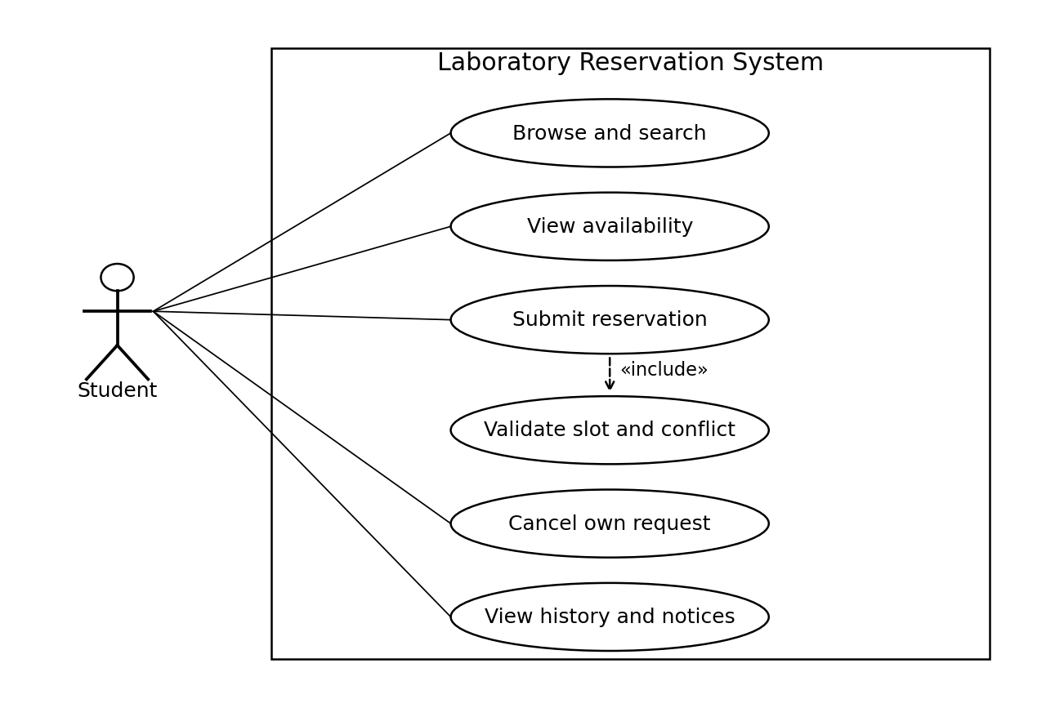

7.2 Lab management use cases
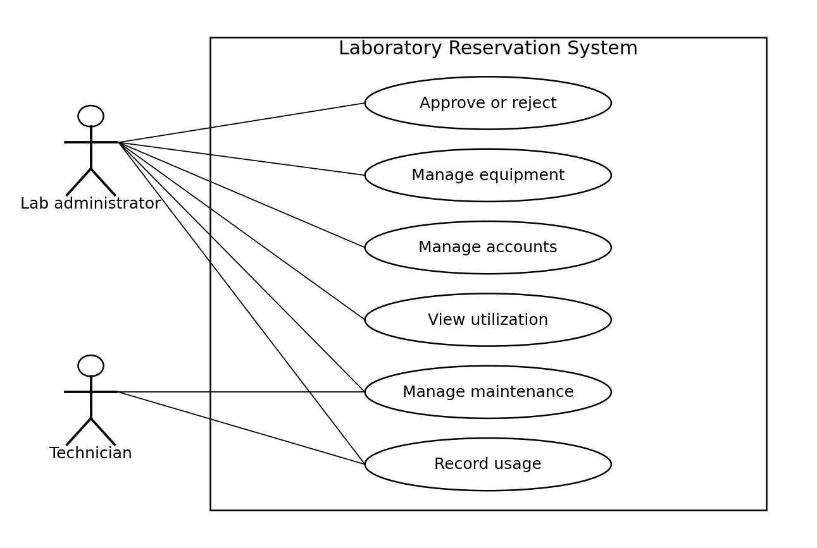

7.3 Key use case specifications

Reserve equipment
Actor: Student. Preconditions: Authenticated active account; equipment is active.
Main flow: Choose equipment and future interval; enter purpose; submit; server validates permission, hours and overlaps atomically; save Pending request; create notification.
Exception flow: Invalid interval, maintenance or held slot: reject without creating a reservation. Duplicate retry: return existing result.
Postcondition: One Pending reservation holds the interval.

Decide a request
Actor: Lab administrator. Preconditions: Authenticated administrator assigned to the lab; request is Pending.
Main flow: Open request; choose Approve or Reject; revalidate for approval or require rejection reason; save decision; notify student.
Exception flow: Unauthorized, stale state or ineligible slot: deny the decision and preserve current state.
Postcondition: Approved holds the slot; Rejected releases it.

Block maintenance
Actor: Technician or lab administrator. Preconditions: Authenticated role assigned to the equipment lab.
Main flow: Choose equipment and maintenance interval; enter reason; validate; save block.
Exception flow: If held bookings overlap, reject and ask the administrator to resolve them before retrying.
Postcondition: Future requests cannot use the blocked interval.

8 Requirements traceability matrix
Design references below are proposed identifiers for the forthcoming SAD, not completed design artifacts. N means Not executed. Later STP test cases shall reuse these IDs. Acceptance criteria are defined in Sections 4 and 5.
Requirement | Section | Priority | Module | Design ref | Test ref | Status
LAB-F-001 | 4.1 | High | Authentication | DS-Authentication | TC-F-001 | N
LAB-F-002 | 4.2 | High | Authentication | DS-Authentication | TC-F-002 | N
LAB-F-003 | 4.3 | High | Equipment | DS-Equipment | TC-F-003 | N
LAB-F-004 | 4.4 | Medium | Equipment | DS-Equipment | TC-F-004 | N
LAB-F-005 | 4.5 | High | Reservation | DS-Reservation | TC-F-005 | N
LAB-F-006 | 4.6 | High | Reservation | DS-Reservation | TC-F-006 | N
LAB-F-007 | 4.7 | High | Reservation | DS-Reservation | TC-F-007 | N
LAB-F-008 | 4.8 | High | Reservation | DS-Reservation | TC-F-008 | N
LAB-F-009 | 4.9 | High | Reservation | DS-Reservation | TC-F-009 | N
LAB-F-010 | 4.10 | High | Approval | DS-Approval | TC-F-010 | N
LAB-F-011 | 4.11 | High | Approval | DS-Approval | TC-F-011 | N
LAB-F-012 | 4.12 | High | Approval | DS-Approval | TC-F-012 | N
LAB-F-013 | 4.13 | High | Equipment | DS-Equipment | TC-F-013 | N
LAB-F-014 | 4.14 | High | Maintenance | DS-Maintenance | TC-F-014 | N
LAB-F-015 | 4.15 | High | Notification | DS-Notification | TC-F-015 | N
LAB-F-016 | 4.16 | High | Usage | DS-Usage | TC-F-016 | N
LAB-F-017 | 4.17 | Medium | Reporting | DS-Reporting | TC-F-017 | N
LAB-F-018 | 4.18 | High | Authentication | DS-Authentication | TC-F-018 | N
LAB-F-019 | 4.19 | High | Audit | DS-Audit | TC-F-019 | N
LAB-NF-001 | 5.1 | High | Performance | DS-Performance | TC-NF-001 | N
LAB-NF-002 | 5.2 | High | Data integrity | DS-Data integrity | TC-NF-002 | N
LAB-NF-003 | 5.3 | High | Usability | DS-Usability | TC-NF-003 | N
LAB-NF-004 | 5.4 | High | Accessibility | DS-Accessibility | TC-NF-004 | N
LAB-NF-005 | 5.5 | High | Recovery | DS-Recovery | TC-NF-005 | N
LAB-SR-001 | 5.7 | High | Security | DS-Security | TC-SR-001 | N
LAB-SR-002 | 5.7 | High | Security | DS-Security | TC-SR-002 | N
LAB-SR-003 | 5.7 | High | Security | DS-Security | TC-SR-003 | N
LAB-SR-004 | 5.7 | High | Security | DS-Security | TC-SR-004 | N
LAB-SR-005 | 5.7 | High | Security | DS-Security | TC-SR-005 | N

8.1 Stakeholder and objective mapping
Students are the source stakeholders for LAB-F-001 through LAB-F-009 and LAB-F-015. Administrators are the source stakeholders for LAB-F-010 through LAB-F-013 and LAB-F-017 through LAB-F-019. Lab staff are the source stakeholders for LAB-F-014 and LAB-F-016. NFRs and security controls are proposed by the project team for all users. LAB-SO-001 maps to LAB-SR-001 through LAB-SR-004; LAB-SO-002 maps to LAB-SR-001, LAB-SR-003 and LAB-SR-005.

