**Exercise 1: Implementing the Singleton Pattern**

**Scenario:**

You need to ensure that a logging utility class in your application has only one instance throughout the application lifecycle to ensure consistent logging.  
  
**Program**

**Main.java**  
public class Main {  
 public static void main(String[] args) {  
 Logger logger1 = Logger.*getInstance*();  
 logger1.log("This is the first log message.");  
  
 Logger logger2 = Logger.*getInstance*();  
 logger2.log("This is the second log message.");  
  
 System.*out*.println("Are both logger instances the same? " + (logger1 == logger2));  
 }  
}

**Logger.java**  
public class Logger {  
 private static Logger *instance*;  
  
 private Logger() {  
 System.*out*.println("Logger Initialized");  
 }  
  
 public static Logger getInstance() {  
 if (*instance* == null) {  
 *instance* = new Logger();  
 }  
 return *instance*;  
 }  
 public void log(String message) {  
 System.*out*.println("[LOG]: " + message);  
 }  
}

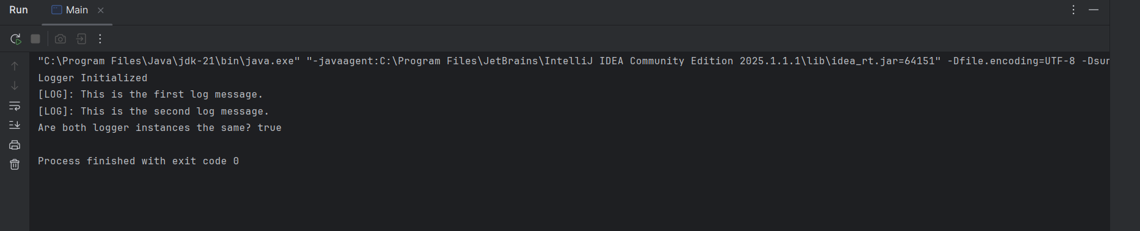

**Exercise 2: Implementing the Factory Method Pattern**

**Scenario:**

You are developing a document management system that needs to create different types of documents (e.g., Word, PDF, Excel). Use the Factory Method Pattern to achieve this.

**Document.java – Interface**

public interface Document {

void open();

}

**WordDocument.java**

public class WordDocument implements Document {

public void open() {

System.out.println("Opening Word document.");

}

}

**PdfDocument.java**

public class PdfDocument implements Document {

public void open() {

System.out.println("Opening PDF document.");

}

}

**ExcelDocument.java**

public class ExcelDocument implements Document {

public void open() {

System.out.println("Opening Excel document.");

}

}

**DocumentFactory.java – Abstract Factory**

public abstract class DocumentFactory {

public abstract Document createDocument();

}

**WordFactory.java**

public class WordFactory extends DocumentFactory {

public Document createDocument() {

return new WordDocument();

}

}

**PdfFactory.java**

public class PdfFactory extends DocumentFactory {

public Document createDocument() {

return new PdfDocument();

}

}

**ExcelFactory.java**

public class ExcelFactory extends DocumentFactory {

public Document createDocument() {

return new ExcelDocument();

}

}

**Main.java**

public class Main {

public static void main(String[] args) {

DocumentFactory wordFactory = new WordFactory();

Document wordDoc = wordFactory.createDocument();

wordDoc.open();

DocumentFactory pdfFactory = new PdfFactory();

Document pdfDoc = pdfFactory.createDocument();

pdfDoc.open();

DocumentFactory excelFactory = new ExcelFactory();

Document excelDoc = excelFactory.createDocument();

excelDoc.open();

}

}

