**JUnit Testing Exercises**

**Exercise 1: Setting Up JUnit Scenario**:

You need to set up JUnit in your Java project to start writing unit tests.

Steps: 1. Create a new Java project in your IDE (e.g., IntelliJ IDEA, Eclipse).

2. Add JUnit dependency to your project. If you are using Maven, add the following to your pom.xml: junit junit 4.13.2 test

3. Create a new test class in your project.

**Output** 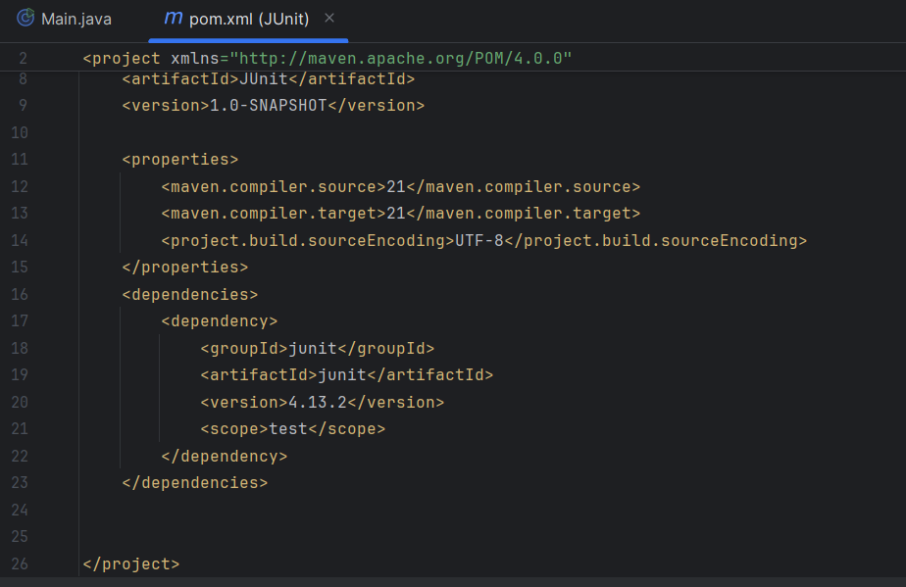

**Exercise 3: Assertions in JUnit Scenario:**

You need to use different assertions in JUnit to validate your test results.

Steps: 1. Write tests using various JUnit assertions.

public class AssertionsTest {

public void testAssertions() {

assertEquals(5, 2 + 3);

assertTrue(5 > 3);

assertFalse(5 < 3);

assertNull(null);

assertNotNull(new Object());

}

}

**Output**

