**PL/SQL Exercises – WEEK 2**

**Exercise 1: Control Structures**

**Scenario 1:** The bank wants to apply a discount to loan interest rates for customers above 60 years old.

* + **Question:** Write a PL/SQL block that loops through all customers, checks their age, and if they are above 60, apply a 1% discount to their current loan interest rates.

**Scenario 2:** A customer can be promoted to VIP status based on their balance.

* + **Question:** Write a PL/SQL block that iterates through all customers and sets a flag IsVIP to TRUE for those with a balance over $10,000.

**Scenario 3:** The bank wants to send reminders to customers whose loans are due within the next 30 days.

* + **Question:** Write a PL/SQL block that fetches all loans due in the next 30 days and prints a reminder message for each customer.

**Code for Scenario 1**

BEGIN

FOR cust_rec IN (

SELECT CustomerID

FROM Customers

WHERE MONTHS_BETWEEN(SYSDATE, DOB) / 12 > 60

) LOOP

UPDATE Loans

SET InterestRate = InterestRate - 1

WHERE CustomerID = cust_rec.CustomerID;

END LOOP;

COMMIT;

END;

**Output for Scenario 1**

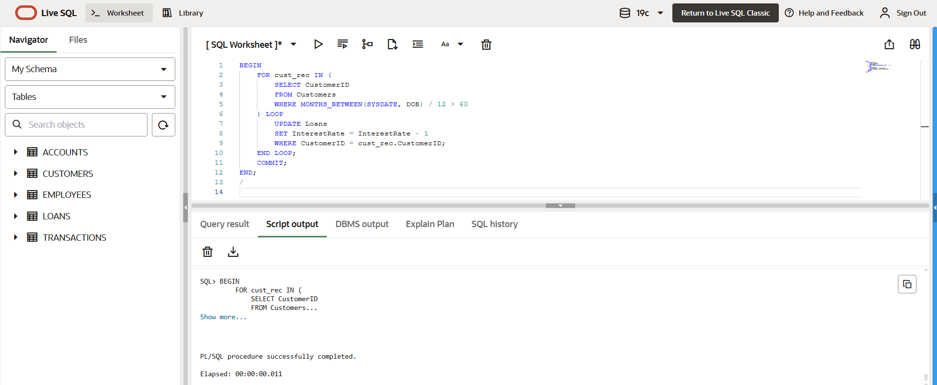

**Code for Scenario 2**

BEGIN

FOR cust IN (

SELECT CustomerID

FROM Customers

WHERE Balance > 10000

) LOOP

UPDATE Customers

SET IsVIP = 'Y'

WHERE CustomerID = cust.CustomerID;

END LOOP;

COMMIT;

END;

**Output for Scenario 2**

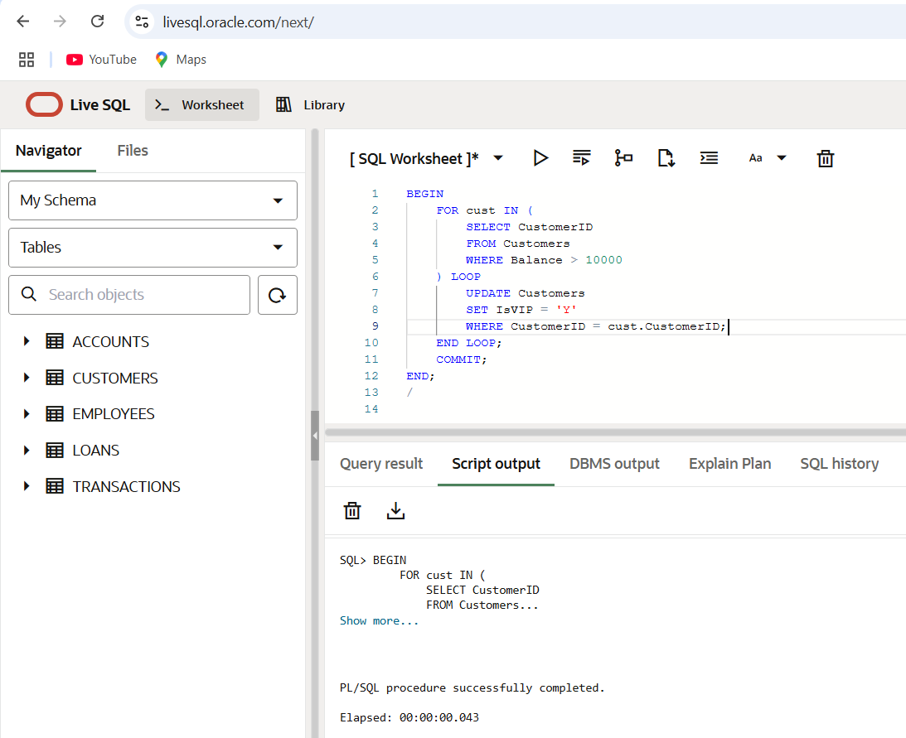

**Code for Scenario 3**

BEGIN

FOR loan_rec IN (

SELECT C.Name AS cust_name, L.EndDate AS due_date

FROM Customers C

JOIN Loans L ON C.CustomerID = L.CustomerID

WHERE L.EndDate BETWEEN SYSDATE AND SYSDATE + 30

) LOOP

DBMS_OUTPUT.PUT_LINE('Reminder: Dear ' || loan_rec.cust_name ||

', your loan is due on ' || TO_CHAR(loan_rec.due_date, 'DD-Mon-YYYY'));

END LOOP;

END;

**Output for Scenario 3**

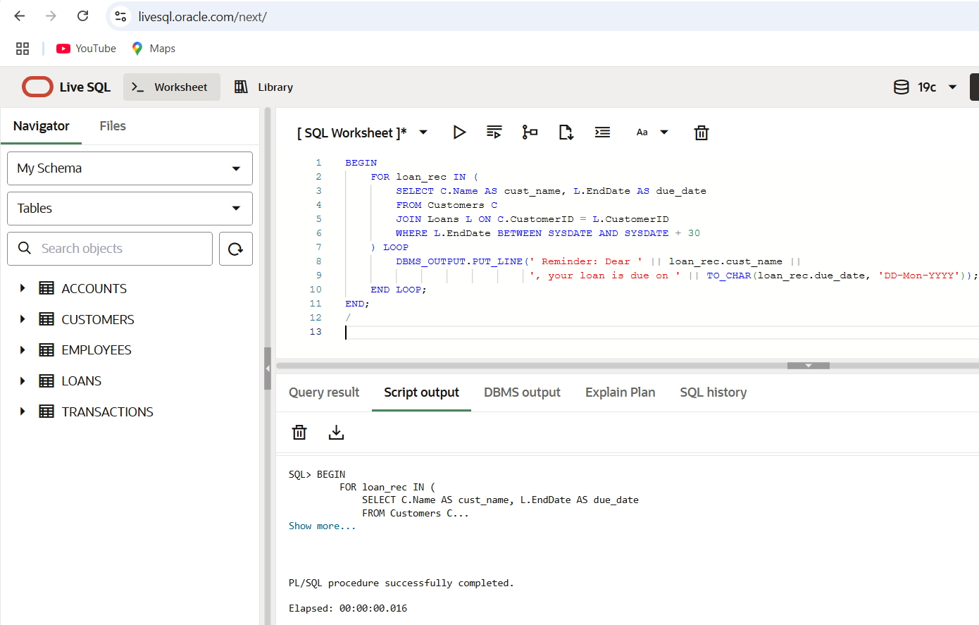

**Exercise 3: Stored Procedures**

**Scenario 1:** The bank needs to process monthly interest for all savings accounts.

* + **Question:** Write a stored procedure **ProcessMonthlyInterest** that calculates and updates the balance of all savings accounts by applying an interest rate of 1% to the current balance.

**Scenario 2:** The bank wants to implement a bonus scheme for employees based on their performance.

* + **Question:** Write a stored procedure **UpdateEmployeeBonus** that updates the salary of employees in a given department by adding a bonus percentage passed as a parameter.

**Scenario 3:** Customers should be able to transfer funds between their accounts.

**Question:** Write a stored procedure **TransferFunds** that transfers a specified amount from one account to another, checking that the source account has sufficient balance before making the transfer.

**Code for Scenario 1**

CREATE OR REPLACE PROCEDURE ProcessMonthlyInterest IS

BEGIN

FOR acc IN (

SELECT AccountID, Balance

FROM Accounts

WHERE AccountType = 'Savings'

) LOOP

UPDATE Accounts

SET Balance = Balance + (Balance * 0.01)

WHERE AccountID = acc.AccountID;

END LOOP;

COMMIT;

END;

EXEC ProcessMonthlyInterest;

SELECT * FROM Accounts WHERE AccountType = 'Savings';

**Output for Scenario 1**

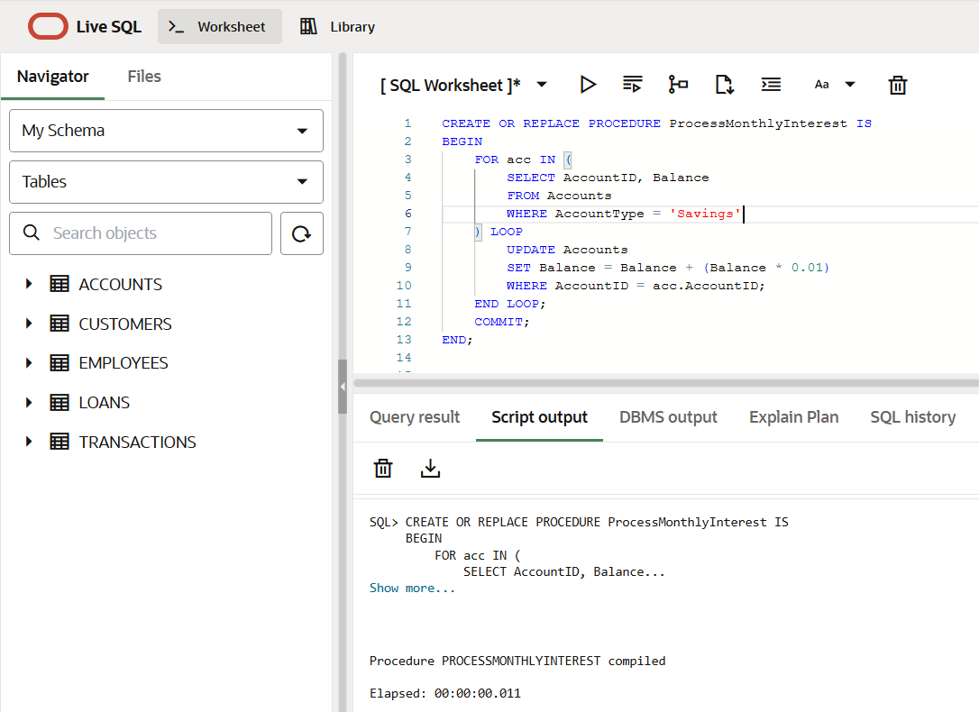

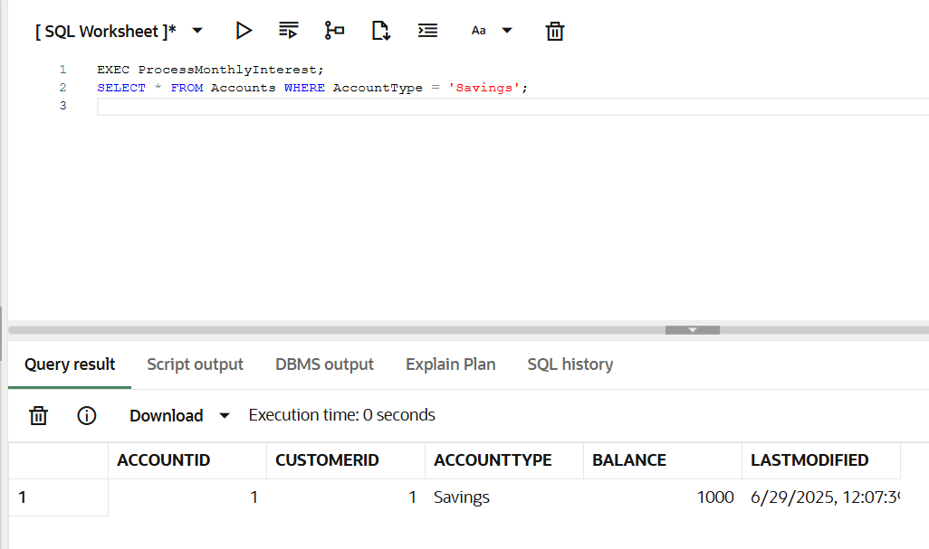

**Code for Scenario 2**

CREATE OR REPLACE PROCEDURE UpdateEmployeeBonus (

dept_name IN VARCHAR2,

bonus_percent IN NUMBER

) IS

BEGIN

UPDATE Employees

SET Salary = Salary + (Salary * bonus_percent / 100)

WHERE Department = dept_name;

COMMIT;

END;

EXEC UpdateEmployeeBonus('IT', 10);

SELECT * FROM Employees WHERE Department = 'IT';

**Output for Scenario 2**

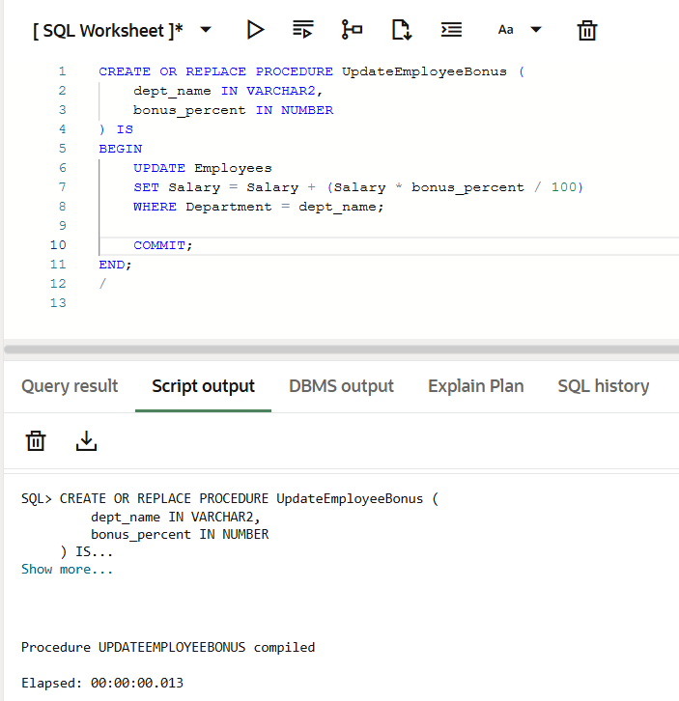

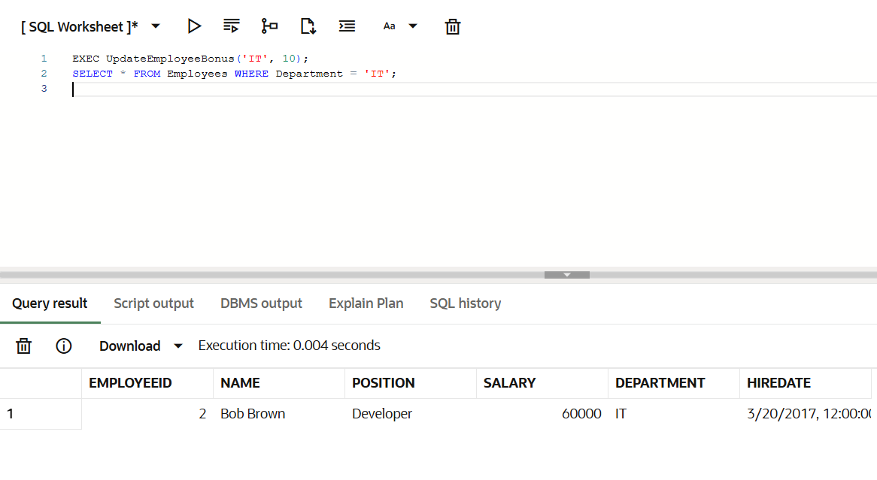

**Code for Scenario 3**

CREATE OR REPLACE PROCEDURE TransferFunds (

from_account IN NUMBER,

to_account IN NUMBER,

amount IN NUMBER

) IS

from_balance NUMBER;

BEGIN

-- Get balance of source account

SELECT Balance INTO from_balance

FROM Accounts

WHERE AccountID = from_account;

-- Check if sufficient funds

IF from_balance < amount THEN

RAISE_APPLICATION_ERROR(-20001, 'Insufficient balance in source account');

ELSE

-- Deduct from source

UPDATE Accounts

SET Balance = Balance - amount

WHERE AccountID = from_account;

-- Add to destination

UPDATE Accounts

SET Balance = Balance + amount

WHERE AccountID = to_account;

COMMIT;

END IF;

END;

EXEC TransferFunds(1, 2, 300);

SELECT * FROM Accounts WHERE AccountID IN (1, 2);

**Output for Scenario 3**

