**Hands on 1**

**Create a Spring Web Project using Maven**   
  
**Program**  
SpringLearnApplication.java

package com.cognizant.spring_learn;  
  
import org.springframework.boot.SpringApplication;  
import org.springframework.boot.autoconfigure.SpringBootApplication;  
  
@SpringBootApplication  
public class SpringLearnApplication {  
  
 public static void main(String[] args) {  
 System.*out*.println("Application Starting...");  
 SpringApplication.*run*(SpringLearnApplication.class, args);  
 System.*out*.println("Application Started Successfully.");  
 }  
}

**Output**  
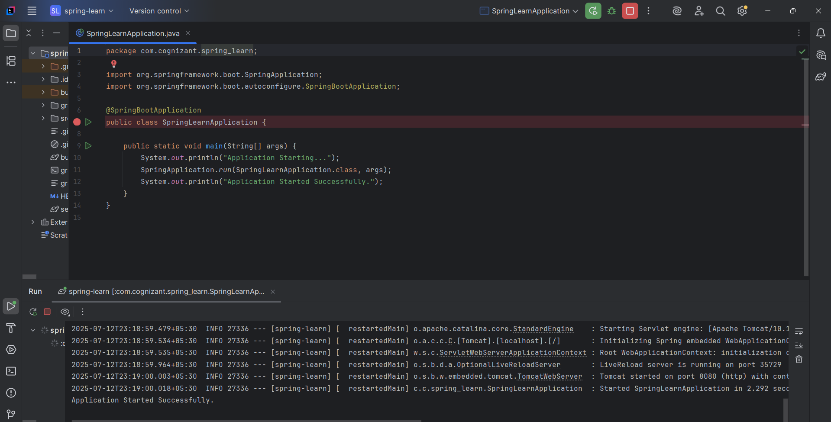

**Hands on 2**

**Spring Core – Load SimpleDateFormat from Spring Configuration XML**   
  
path: src/main/resources/date-format.xml  
**date-format.xml**  
<?xml version="1.0" encoding="UTF-8"?>

<beans xmlns="http://www.springframework.org/schema/beans"

xmlns:xsi="http://www.w3.org/2001/XMLSchema-instance"

xsi:schemaLocation="http://www.springframework.org/schema/beans

https://www.springframework.org/schema/beans/spring-beans.xsd">

<bean id="dateFormat" class="java.text.SimpleDateFormat">

<constructor-arg value="dd/MM/yyyy" />

</bean>

</beans>  
  
**SpringLearnApplication.java**  
package com.cognizant.spring_learn;  
import org.springframework.boot.SpringApplication;  
import org.springframework.boot.autoconfigure.SpringBootApplication;  
import org.springframework.context.ApplicationContext;  
import org.springframework.context.support.ClassPathXmlApplicationContext;  
import java.text.ParseException;  
import java.text.SimpleDateFormat;  
import java.util.Date;  
@SpringBootApplication  
public class SpringLearnApplication {  
 public static void displayDate() {  
 ApplicationContext context = new ClassPathXmlApplicationContext("date-format.xml");  
 SimpleDateFormat format = context.getBean("dateFormat", SimpleDateFormat.class);  
 try {  
 Date date = format.parse("31/12/2018");  
 System.out.println("Parsed Date: " + date);  
 } catch (ParseException e) {  
 System.out.println("Failed to parse date: " + e.getMessage());  
 }  
 }  
  
 public static void main(String[] args) {  
 System.out.println("Application Starting...");  
 SpringApplication.run(SpringLearnApplication.class, args);  
 System.out.println("Application Started Successfully.");  
 displayDate();   
 }  
}

**Output**  
