**1) Hello World RESTful Web Service**   
  
Write a REST service in the spring learn application created earlier, that returns the text "Hello World!!" using Spring Web Framework. Refer details below:  
  
**Method:** GET  
**URL:** /hello  
**Controller:** com.cognizant.spring-learn.controller.HelloController  
**Method Signature:** public String sayHello()  
**Method Implementation:** return hard coded string "Hello World!!"  
**Sample Request**: http://localhost:8083/hello  
**Sample Response:** Hello World!!   
  
  
**Code**

**HelloController.java**  
package com.cognizant.spring_learn.controller;  
  
import org.slf4j.Logger;  
import org.slf4j.LoggerFactory;  
import org.springframework.web.bind.annotation.GetMapping;  
import org.springframework.web.bind.annotation.RestController;  
  
@RestController  
public class HelloController {  
  
 private static final Logger *LOGGER* = LoggerFactory.*getLogger*(HelloController.class);  
  
 @GetMapping("/hello")  
 public String sayHello() {  
 *LOGGER*.info("START - sayHello()");  
 String message = "Hello World!!";  
 *LOGGER*.info("END - sayHello()");  
 return message;  
 }  
}  
  
**SpringLearnApplication.java**

package com.cognizant.spring_learn;  
  
import org.springframework.boot.SpringApplication;  
import org.springframework.boot.autoconfigure.SpringBootApplication;  
  
@SpringBootApplication  
public class SpringLearnApplication {  
  
 public static void main(String[] args) {  
 SpringApplication.*run*(SpringLearnApplication.class, args);  
 }  
}

**Output**  
  
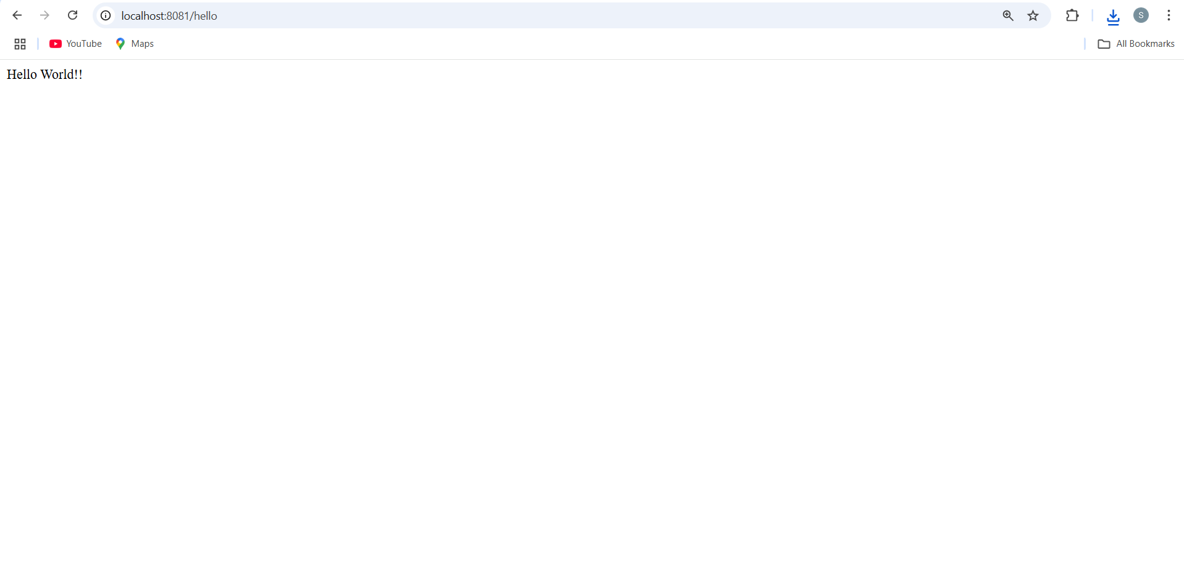  
  
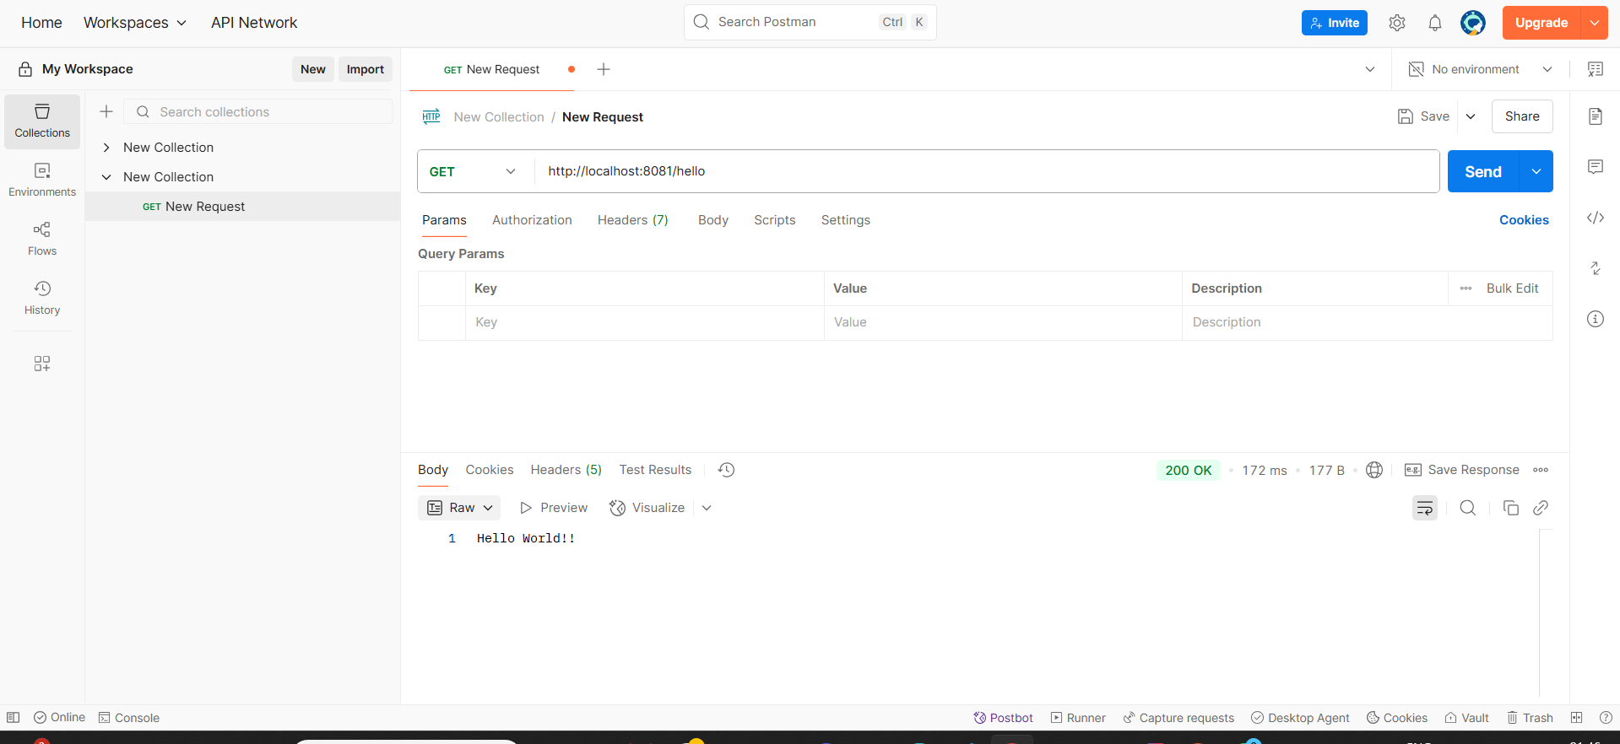  
  
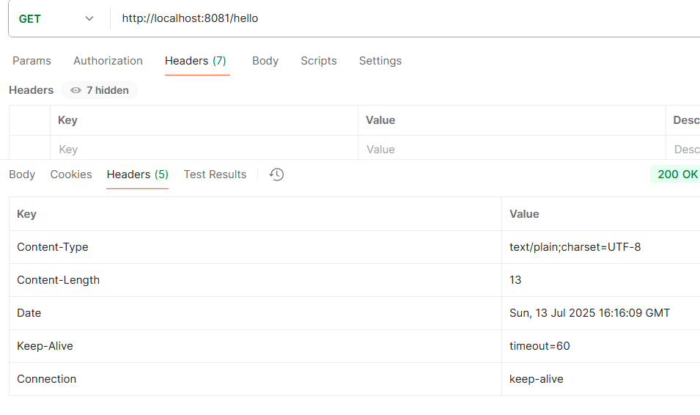  
2) **REST - Country Web Service**   
  
Write a REST service that returns India country details in the earlier created spring learn application.  
  
**URL**: /country  
**Controller**: com.cognizant.spring-learn.controller.CountryController  
**Method Annotation**: @RequestMapping  
**Method Name**: getCountryIndia()  
**Method Implementation**: Load India bean from spring xml configuration and return  
**Sample Request**: http://localhost:8083/country  
  
**Code**

**SpringLearnApplication.java**  
package com.cognizant.spring_learn;  
  
import org.springframework.boot.SpringApplication;  
import org.springframework.boot.autoconfigure.SpringBootApplication;  
  
@SpringBootApplication  
public class SpringLearnApplication {  
  
 public static void main(String[] args) {  
 SpringApplication.*run*(SpringLearnApplication.class, args);  
 }  
}  
 **Country.java**

package com.cognizant.spring_learn.model;  
  
public class Country {  
 private String code;  
 private String name;  
  
 // Getters and setters  
 public String getCode() {  
 return code;  
 }  
  
 public void setCode(String code) {  
 this.code = code;  
 }  
  
 public String getName() {  
 return name;  
 }  
  
 public void setName(String name) {  
 this.name = name;  
 }  
}  
 **CountryController.java**

package com.cognizant.spring_learn.controller;  
  
import com.cognizant.spring_learn.model.Country;  
import org.springframework.context.ApplicationContext;  
import org.springframework.context.support.ClassPathXmlApplicationContext;  
import org.springframework.web.bind.annotation.RequestMapping;  
import org.springframework.web.bind.annotation.RestController;  
  
@RestController  
public class CountryController {  
  
 @RequestMapping("/country")  
 public Country getCountryIndia() {  
 ApplicationContext context = new ClassPathXmlApplicationContext("country.xml");  
 Country country = (Country) context.getBean("in");  
 return country;  
 }  
}  
  
  
**country.xml**  
<?xml version="1.0" encoding="UTF-8"?>  
<beans xmlns="http://www.springframework.org/schema/beans"  
 xmlns:xsi="http://www.w3.org/2001/XMLSchema-instance"  
 xsi:schemaLocation="http://www.springframework.org/schema/beans  
 http://www.springframework.org/schema/beans/spring-beans.xsd">  
  
 <bean id="in" class="com.cognizant.spring_learn.model.Country">  
 <property name="code" value="IN"/>  
 <property name="name" value="India"/>  
 </bean>  
  
</beans>

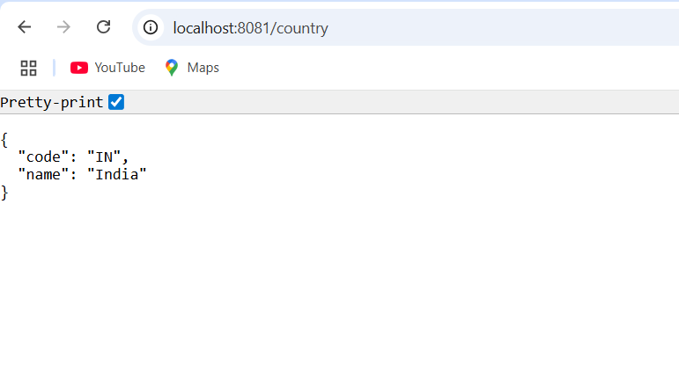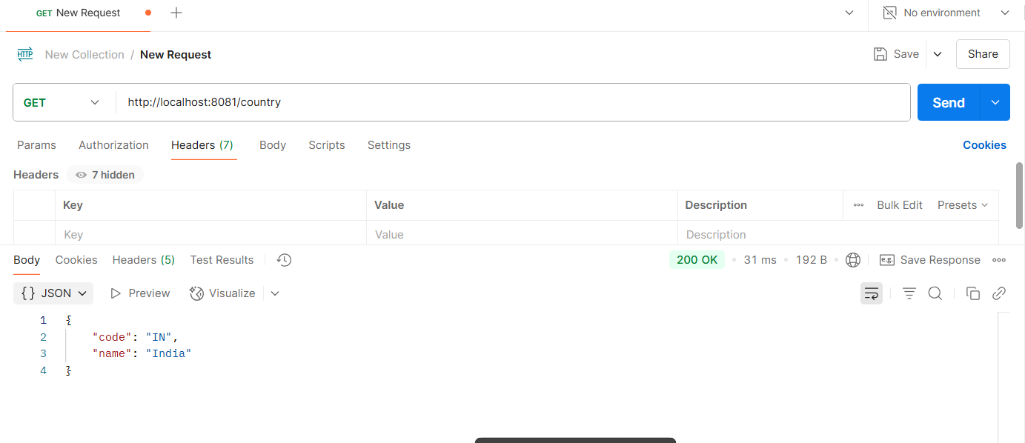

**3) REST - Get country based on country code**Write a REST service that returns a specific country based on country code. The country code should be case insensitive.  
  
Controller: com.cognizant.spring-learn.controller.CountryController  
Method Annotation: @GetMapping("/countries/{code}")  
Method Name: getCountry(String code)  
Method Implemetation: Invoke countryService.getCountry(code)   
Service Method: com.cognizant.spring-learn.service.CountryService.getCountry(String code)  
  
Service Method Implementation:

* Get the country code using @PathVariable
* Get country list from country.xml
* Iterate through the country list
* Make a case insensitive matching of country code and return the country.
* Lambda expression can also be used instead of iterating the country list

Sample Request: <http://localhost:8083/country/in>  
 **Code**

**Country.java**  
package com.cognizant.spring_learn.model;  
  
public class Country {  
 private String code;  
 private String name;  
  
 // Getters and setters  
 public String getCode() {  
 return code;  
 }  
  
 public void setCode(String code) {  
 this.code = code;  
 }  
  
 public String getName() {  
 return name;  
 }  
  
 public void setName(String name) {  
 this.name = name;  
 }  
}  
  
**CountryService.java**

package com.cognizant.spring_learn.service;  
  
import com.cognizant.spring_learn.model.Country;  
import org.springframework.context.ApplicationContext;  
import org.springframework.context.support.ClassPathXmlApplicationContext;  
import org.springframework.stereotype.Service;  
  
import java.util.List;  
  
@Service  
public class CountryService {  
  
 public Country getCountry(String code) {  
 ApplicationContext context = new ClassPathXmlApplicationContext("country.xml");  
 List<Country> countries = (List<Country>) context.getBean("countryList");  
  
 // Case-insensitive search using lambda  
 return countries.stream()  
 .filter(c -> c.getCode().equalsIgnoreCase(code))  
 .findFirst()  
 .orElse(null); // or throw exception if preferred  
 }  
}  
**CountryController.java**

package com.cognizant.spring_learn.controller;  
  
import com.cognizant.spring_learn.model.Country;  
import com.cognizant.spring_learn.service.CountryService;  
import org.springframework.beans.factory.annotation.Autowired;  
import org.springframework.web.bind.annotation.*;  
  
@RestController  
public class CountryController {  
  
 @Autowired  
 private CountryService countryService;  
  
 @GetMapping("/country/{code}")  
 public Country getCountry(@PathVariable String code) {  
 return countryService.getCountry(code);  
 }  
}  
**country.xml**  
<?xml version="1.0" encoding="UTF-8"?>  
<beans xmlns="http://www.springframework.org/schema/beans"  
 xmlns:xsi="http://www.w3.org/2001/XMLSchema-instance"  
 xsi:schemaLocation="http://www.springframework.org/schema/beans  
 http://www.springframework.org/schema/beans/spring-beans.xsd">  
  
 <bean id="countryList" class="java.util.ArrayList">  
 <constructor-arg>  
 <list>  
 <bean class="com.cognizant.spring_learn.model.Country">  
 <property name="code" value="IN"/>  
 <property name="name" value="India"/>  
 </bean>  
 <bean class="com.cognizant.spring_learn.model.Country">  
 <property name="code" value="US"/>  
 <property name="name" value="United States"/>  
 </bean>  
 <bean class="com.cognizant.spring_learn.model.Country">  
 <property name="code" value="JP"/>  
 <property name="name" value="Japan"/>  
 </bean>  
 </list>  
 </constructor-arg>  
 </bean>  
  
</beans>

