**ReactJS-HOL**

**1.ReactJS-HOL**  
Task: Create a new React Application with the name “myfirstreact”, Run the application to print “welcome to the first session of React” as heading of that page.

Created a React App named "myfirstreact"- npx create-react-app myfirstreact

Navigate to the project directory - cd myfirstreact

myfirstreact → src → App.js

**App.js**  
import React from 'react';

function App() {

return (

<div>

<h1>Welcome to the first session of React</h1>

</div>

);

}

export default App;

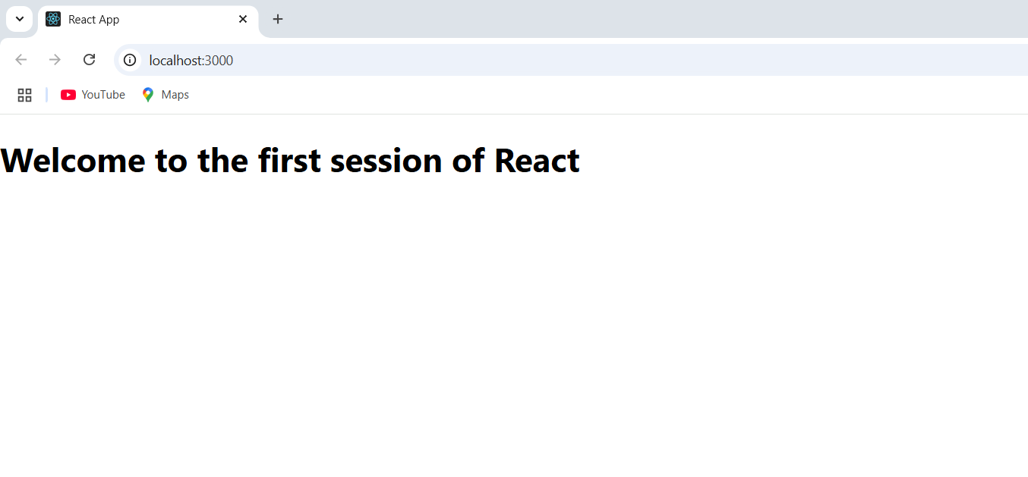

**2.ReactJS-HOL**

Task: Create a react app for Student Management Portal named StudentApp and create a component named Home which will display the Message “Welcome to the Home page of Student Management Portal”. Create another component named About and display the Message “Welcome to the About page of the Student Management Portal”. Create a third component named Contact and display the Message “Welcome to the Contact page of the Student Management Portal”. Call all the three components.  
  
In the src directory created a folder named- Components and inside it, created 3 files namely Home.js, About.js, Contact.js  
  
**Home.js**

import React, { Component } from 'react';

class Home extends Component {

render() {

return (

<div>

<h2>Welcome to the Home page of Student Management Portal</h2>

</div>

);

}

}

export default Home;  
  
**About.js**  
import React, { Component } from 'react';

class About extends Component {

render() {

return (

<div>

<h2>Welcome to the About page of Student Management Portal</h2>

</div>

);

}

}

export default About;  
  
**Contact.js**  
import React, { Component } from 'react';

class Contact extends Component {

render() {

return (

<div>

<h2>Welcome to the Contact page of Student Management Portal</h2>

</div>

);

}

}

export default Contact;

**App.js**import React from 'react';

import Home from './Components/Home';

import About from './Components/About';

import Contact from './Components/Contact';

function App() {

return (

<div>

<h1>Student Management Portal</h1>

<Home />

<About />

<Contact />

</div>

);

}

export default App;  
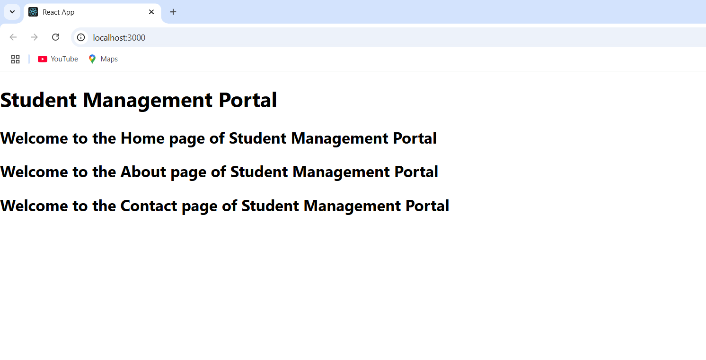

**3.ReactJS-HOL**  
Task: Create a react app for Student Management Portal named scorecalculatorapp and create a function component named “CalculateScore” which will accept Name, School, Total and goal in order to calculate the average score of a student and display the same.

Created react app   
npx create-react-app scorecalculatorapp

cd scorecalculatorapp  
  
**CalculateScore.js**  
// src/Components/CalculateScore.js

import React from 'react';

import '../Stylesheets/mystyle.css';

function CalculateScore(props) {

const { name, school, total, goal } = props;

const score = ((total / goal) * 100).toFixed(2);

return (

<div className="container">

<h1 className="heading">Student Details:</h1>

<p><b className="label-name">Name:</b> <span className="value-name">{name}</span></p>

<p><b className="label-school">School:</b> <span className="value-school">{school}</span></p>

<p><b className="label-total">Total:</b> <span className="value-total">{total} Marks</span></p>

<p><b className="label-score">Score:</b> <span className="value-score">{score}%</span></p>

</div>

);

}

export default CalculateScore;  
  
Created a folder Stylesheets inside src and added mystyle.css.  
**mystyle.css**

.container {

text-align: center;

margin-top: 50px;

font-family: Arial, sans-serif;

}

.heading {

color: brown;

font-size: 30px;

margin-bottom: 20px;

}

.label-name {

color: blue;

font-weight: bold;

}

.label-school {

color: red;

font-weight: bold;

}

.label-total {

color: purple;

font-weight: bold;

}

.label-score {

color: green;

font-weight: bold;

}

.value-name {

color: violet;

}

.value-school {

color: hotpink;

}

.value-total {

color: black;

}

.value-score {

color: green;

}  
  
**App.js**import React from 'react';

import CalculateScore from './Components/CalculateScore';

function App() {

return (

<div>

<CalculateScore

name="Steeve"

school="DNV Public School"

total={284}

goal={300}

/>

</div>

);

}

export default App;

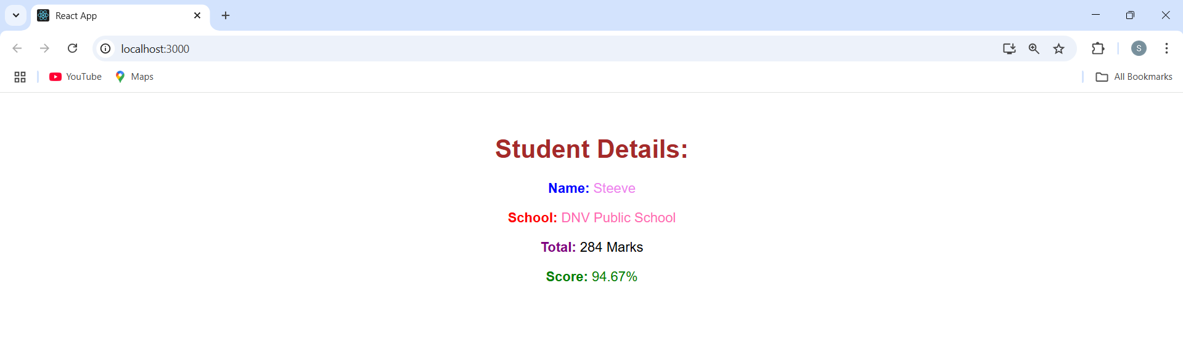

**4.ReactJS-HOL**Task: Implement componentDidMount() and componentDidCatch() life cycle hook by creating a blog application.  
Created React App : npx create-react-app blogapp

cd blogapp

In src/Post.js **Post.js**class Post {

constructor(id, title, body){

this.id = id;

this.title = title;

this.body = body;

}

}

export default Post;  
  
In src/Posts.js  
**Posts.js**  
import React from "react";

import Post from "./Post";

class Posts extends React.Component {

constructor(props) {

super(props);

this.state = {

posts: []

};

}

loadPosts = () => {

fetch("https://jsonplaceholder.typicode.com/posts")

.then(response => response.json())

.then(data => {

const postObjects = data.map(item => new Post(item.id, item.title, item.body));

this.setState({ posts: postObjects });

})

.catch(error => {

console.error("Error fetching posts:", error);

});

}

componentDidMount() {

this.loadPosts();

}

componentDidCatch(error, info) {

alert("An error occurred: " + error);

}

render() {

return (

<div>

<h2>Posts</h2>

{this.state.posts.map(post => (

<div key={post.id}>

<h3>{post.title}</h3>

<p>{post.body}</p>

<hr />

</div>

))}

</div>

);

}

}

export default Posts;

**App.js**import React from "react";

import Posts from "./Posts";

function App() {

return (

<div className="App">

<h1>Blog Application</h1>

<Posts />

</div>

);

}

export default App;

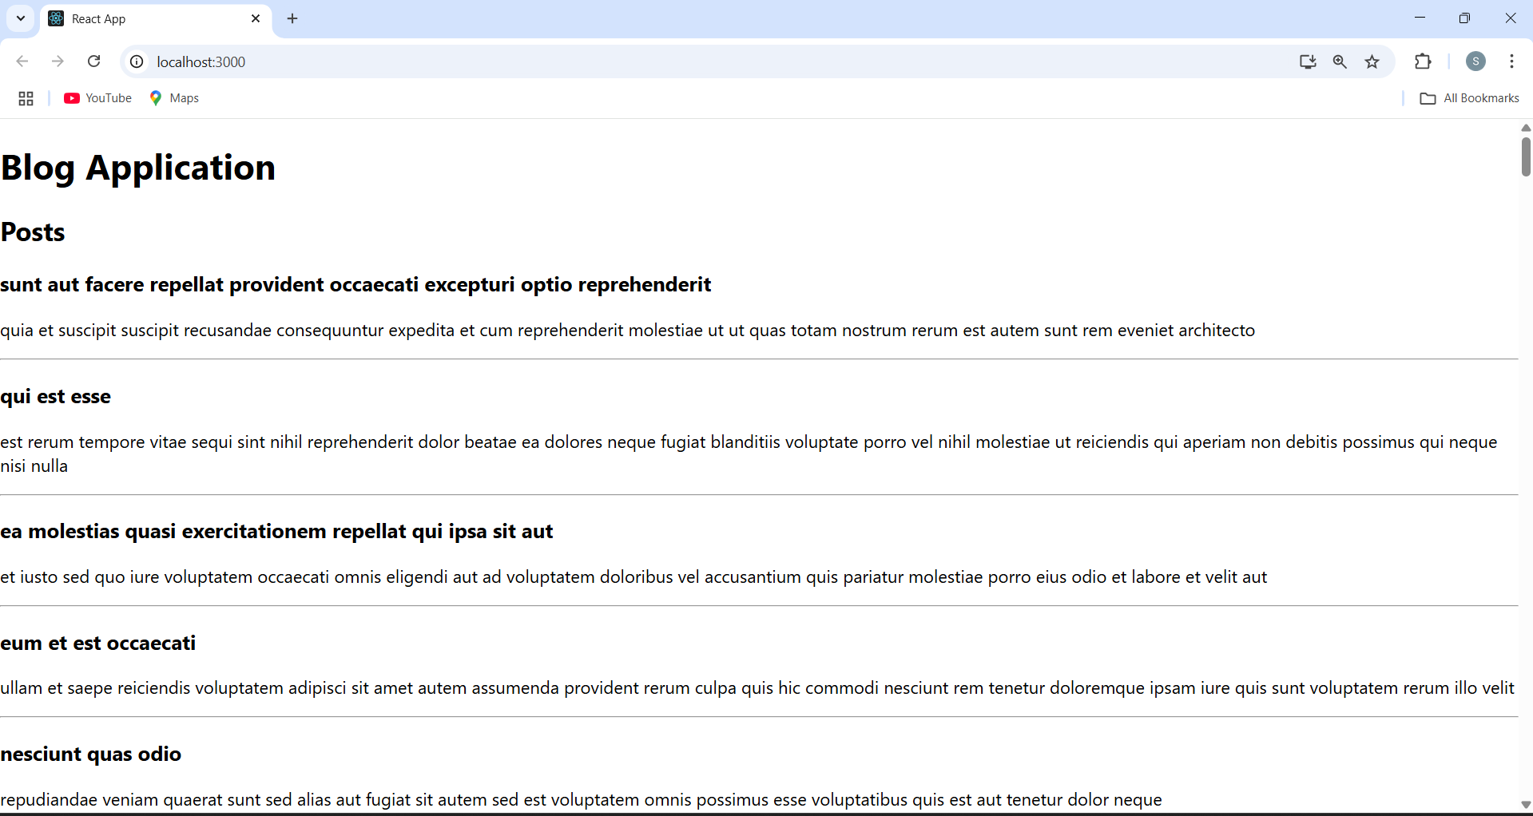

**5.ReactJS-HOL  
Task:**  
**CohortDetails.js**  
import React from 'react';

import styles from './CohortDetails.module.css';

const CohortDetails = ({ cohorts }) => {

return (

<div>

<h1>Cohorts Details</h1>

{cohorts.map((cohort, index) => {

const titleStyle = {

color: cohort.status.toLowerCase() === 'ongoing' ? 'green' : 'blue'

};

return (

<div key={index} className={styles.box}>

<h3 style={titleStyle}>{cohort.name}</h3>

<dl>

<dt>Started On</dt>

<dd>{cohort.startDate}</dd>

<dt>Current Status</dt>

<dd>{cohort.status}</dd>

<dt>Coach</dt>

<dd>{cohort.coach}</dd>

<dt>Trainer</dt>

<dd>{cohort.trainer}</dd>

</dl>

</div>

);

})}

</div>

);

};

export default CohortDetails;  
  
**CohortDetails.module.css**  
.box {

width: 300px;

display: inline-block;

margin: 10px;

padding: 10px 20px;

border: 1px solid black;

border-radius: 10px;

}

dt {

font-weight: 500;

}

**App.js**

import React from 'react';

import CohortDetails from './components/CohortDetails/CohortDetails';

const cohortData = [

{

name: 'INTADMDF10 -.NET FSD',

startDate: '22-Feb-2022',

status: 'Scheduled',

coach: 'Aathma',

trainer: 'Jojo Jose'

},

{

name: 'ADM21JF014 - Java FSD',

startDate: '10-Sep-2021',

status: 'Ongoing',

coach: 'Apoorv',

trainer: 'Elisa Smith'

},

{

name: 'CDBJF21025 - Java FSD',

startDate: '24-Dec-2021',

status: 'Ongoing',

coach: 'Aathma',

trainer: 'John Doe'

}

];

function App() {

return (

<div className="App">

<CohortDetails cohorts={cohortData} />

</div>

);

}

export default App;  
