INSURANCE MANAGEMENT

DATA BASE MANAGEMENT SYSTEM

MINI PROJECT REPORT

Submitted by
RA2311028010012 – PRABHU SAI K
RA2311028010011 –SAI HARSHITH N

Under the guidance of
Dr.P.Mahalakshmi
(Assistant Professor, NWC)

In partial satisfaction of the requirements for the degree of

BACHELOR OF TECHNOLOGY
in
COMPUTER SCIENCE & ENGINEERING w/s in CLOUD COMPUTING



SCHOOL OF COMPUTING
SRM INSTITUTE OF SCIENCE AND TECHNOLOGY KATTANKULATHUR - 603203


COLLEGE OF ENGINEERING & TECHNOLOGY SRM INSTITUTE OF SCIENCE & TECHNOLOGY
S.R.M. NAGAR, KATTANKULATHUR – 603 203

BONAFIDE CERTIFICATE

Certified that this project report “INSURANCE MANAGEMENT” is the bonafide work of Prabhu Sai [RA2311028010012], Sai harshith [RA2311028010011] B.tech(CSE) who carried out the mini project work under my supervision for the course 21CSC205P- Database Management systems in SRM Institute of Science and Technology during the academic year 2024-2025(Even sem).

SIGNATURE SIGNATURE

Dr. P Mahalakshmi Dr. M Lakshmi
Assistant Professor Head of the Department
Dept. of NWC Dept. of NWC

ABSTRACT

The Insurance Management System is a Java Swing-based application with MySQL as the database, designed to efficiently manage insurance policies, claims, premium payments, and customer interactions. The system provides distinct features for both admins and customers, ensuring smooth operations and data accuracy.
Admins have full control over the system. They can manage users, update or delete customer details, oversee policy records, process claims, handle premium payments, track agent performance, and post important notices. Admins can also monitor and resolve customer complaints regarding agents.
Customers can log in to their dashboard to update personal details, browse available policies, purchase or renew policies, view payment history, and file claims. Automated alerts notify them about premium due dates, claim updates, and important policy changes.
Using Java Swing for the frontend and MySQL for data storage, the system ensures secure transactions, real-time policy updates, and efficient data management. The implementation of normalization, triggers, constraints, and concurrency control enhances data accuracy, security, and system performance. This project aims to simplify insurance operations while providing a user-friendly and efficient experience for both customers and administrators.

INTRODUCTION

Introduction:
The Insurance Management System is a Java Swing-based application with MySQL that simplifies the process of managing insurance policies, claims, and customer interactions. Whether you’re an admin handling policies and payments or a customer looking to purchase or renew a policy, this system ensures a smooth and efficient experience. Admins can manage policy details, user information, claims, and premium payments with ease, while customers can browse available policies, file claims, and track their payment history. It is designed to reduce manual work, ensure data accuracy, and provide a seamless experience for both administrators and customers.
.

Purpose:
The primary purpose of the Insurance Management System is to eliminate the challenges of manual insurance management by providing an automated solution. The system aims to:
- Simplify policy purchase, renewal, and claims processing for customers and administrators.
- Provide a central platform to manage policy details, user information, claims, and premium payments.
- Enhance customer satisfaction through an intuitive interface and efficient service handling.
- Reduce errors and improve accuracy in policy tracking, payment processing, and record-keeping.
- Save time and effort for both insurance providers and customers by automating repetitive tasks.

Scope:
For Admins:
- Log in and access the home page.
- Update or manage customer details.
- Add and manage insurance policies and policy types.
- Process customer claims and approve or reject them.
- Handle premium payments and track payment history.
- Post important notices for customers.
- View reports on policies, claims, and payments.

For Customers:
- Log in to access the dashboard.
- Update personal details and view policy information.
- Browse available insurance policies and purchase or renew them.
- File claims and track claim status.
- View payment history and premium due dates.
- Receive notifications on policy updates and claim approvals.

.

Importance:

The Insurance Management System is essential because it simplifies operations for both admins and customers. For admins, it acts like a digital assistant, managing policies, tracking users, processing claims, handling premium payments, and keeping records organized—all in just a few clicks. No more paperwork or manual errors.
For customers, it’s all about convenience. They can easily browse policies, purchase or renew insurance, file claims, and track their payments without any hassle. It’s fast, secure, and ensures a smooth insurance management experience.

PROBLEM STATEMENT

Managing an insurance business manually can be challenging. Keeping track of policies, customer details, claims, and premium payments can become complex and time-consuming. Errors in claim processing, misplaced records, and the lack of an organized system often lead to frustration for both admins and customers.
Admins spend a significant amount of time handling repetitive tasks like updating customer details, managing policy renewals, processing claims, and tracking payments. Customers, on the other hand, struggle to find a simple way to browse policies, purchase insurance, file claims, or track their payments efficiently.
Without an efficient system, the business faces difficulties in organization, resulting in poor customer experience and operational inefficiencies. This project aims to address these issues by developing a
user-friendly Life Insurance Management System that automates key tasks, minimizes errors, and enhances the overall experience for both admins and customers.

WHAT IS ER DIAGRAM?

ER Diagram (Short Explanation)

An Entity-Relationship (ER) Diagram is a visual representation of a database that shows entities (tables), attributes (columns), and relationships between them. It helps in designing a well-structured database before implementation.

Key Components:

- Entities: Real-world objects (e.g., User, BlogPost, Comment).

- Attributes: Properties of entities (e.g., User_ID, Name, Email).

- Relationships: Connections between entities (e.g., "User writes BlogPost").

- Cardinality: Defines the relationship type (1:1, 1:M, M:N).

ER DIAGRAM SYMBOLS
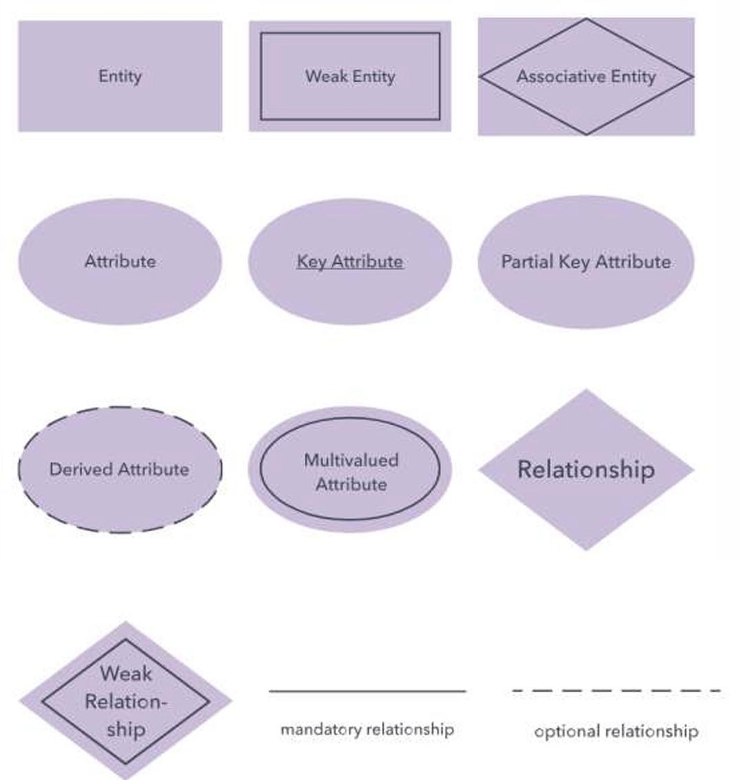

ENTITIES, ATTRIBUTES AND RELATIONS IN THIS PROJECT

ENTITIES & ATTRIBUTES-
- User –
  - User_ID
  - User_Name
  - password
  - adress
  - Gender
- Admins–
- admin_id
- user_id
- salary
- Role
- Department
- Policy Types –
  - policy_type_id
  - type_name
  - Description
- Policies –
  - policy_id
  - customer_id
  - policy_type_id
  - coverage_amount
  - premium_amount
  - start_date
  - end_date
  - status
5 Claims–
  - claim_id
  - policy_id
  - claim_amount
  - claim_date
  - status
  - reason
6. Payment –
  - payment_id
  - customer_id
  - payment_date
  - payment_amount
  - payment_method
  - transaction_id
  - status
7 PaymentHistory –
  - payment_history_id
  - payment_id
  - payment_date
  - amount_paid
  - payment_status

8 Claims History–
  - claims_history_id
  - claim_id
  - claim_date
  - claim_status
  - claim_amount

9 Policy Renewal –
  - renewal_id,
  - policy_id,
  - renewal_date
  - renewal_status
10 Agents –
  - agent_id
  - user_id
  - email
  - phone_number
  - assigned_customers_count
11 Noticeboard–
  - notice_id
  - admin_id
  - Message
  - posting_date
12 Complaints
  - complaint_id
  - customer_id
  - agent_id
  - complaint_details
  - status
  - complaint_date
13 Login
  - login_id
  - user_id
  - username password

14 Customers
  - customer_id
  - user_id
  - Name
  - date_of_birth
  - contact_number
  - address
  - registration_date

Relationships Between Entities

Relationship | Type | Foreign Key Location
User → Admins | 1:1 | user_id in Admins
User → Customers | 1:1 | user_id in Customers
Policy Types → Policies | 1:M | policy_type_id in Policies
Customers → Policies | 1:M | customer_id in Policies
Policies → Claims | 1:M | policy_id in Claims
Claims → Claims History | 1:1 | claim_id in Claims History (FK & PK)
Policies → Policy Renewal | 1:M | policy_id in Policy Renewal
Customers → Payment | 1:M | customer_id in Payment
Payment → Payment History | 1:1 | payment_id in Payment History (FK & PK)
Admins → Noticeboard | 1:M | admin_id in Noticeboard
Customers → Complaints | 1:M | customer_id in Complaints
Agents → Complaints | 1:M | agent_id in Complaints
User → Login | 1:1 | user_id in Login

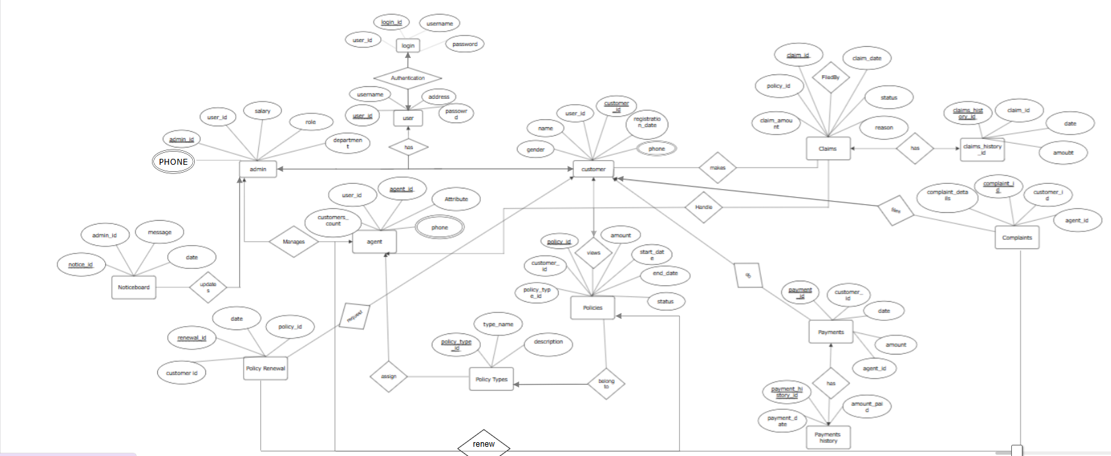
ER DIAGRAM

-Conversion of ER to Relational Table
CREATE DATABASE InsuranceDB;
USE InsuranceDB;

-- User Table
CREATE TABLE User (
User_ID INT PRIMARY KEY AUTO_INCREMENT,
User_Name VARCHAR(100) NOT NULL,
Password VARCHAR(255) NOT NULL,
Address TEXT,
Gender VARCHAR(10)
);

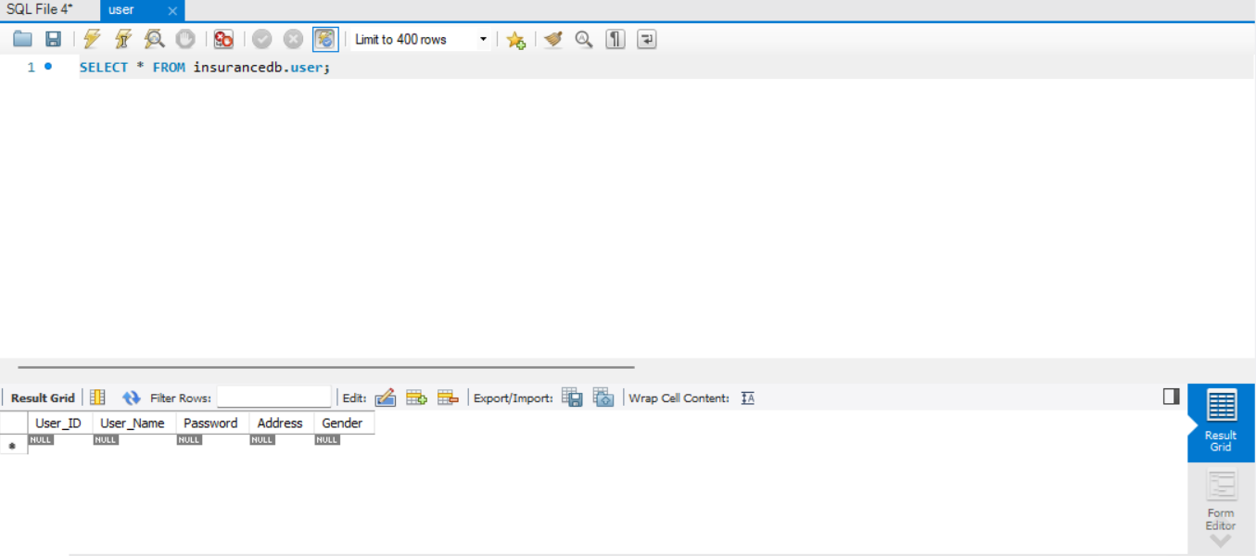
-- Admin Table
CREATE TABLE Admins (
Admin_ID INT PRIMARY KEY AUTO_INCREMENT,
User_ID INT UNIQUE,
Salary DECIMAL(10,2),
Role VARCHAR(50),
Department VARCHAR(100),
FOREIGN KEY (User_ID) REFERENCES User(User_ID)
);
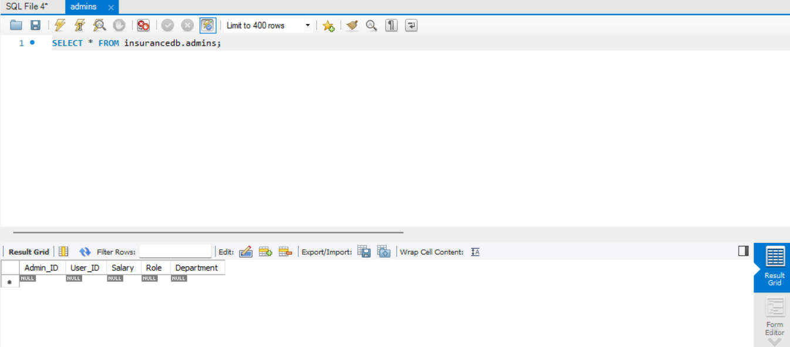

-- Policy Types Table
CREATE TABLE PolicyTypes (
Policy_Type_ID INT PRIMARY KEY AUTO_INCREMENT,
Type_Name VARCHAR(100) NOT NULL,
Description TEXT
);
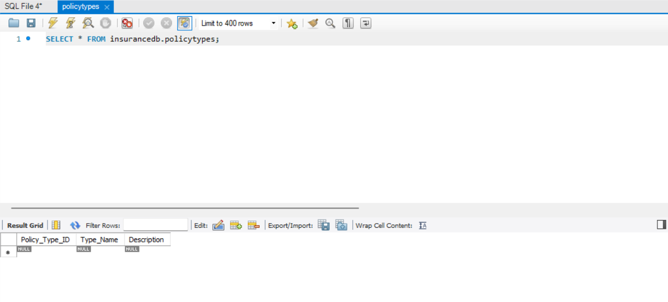
-- Customers Table
CREATE TABLE Customers (
Customer_ID INT PRIMARY KEY AUTO_INCREMENT,
User_ID INT UNIQUE,
Name VARCHAR(100) NOT NULL,
Date_of_Birth DATE,
Address TEXT,
Registration_Date DATE,
FOREIGN KEY (User_ID) REFERENCES User(User_ID)
);
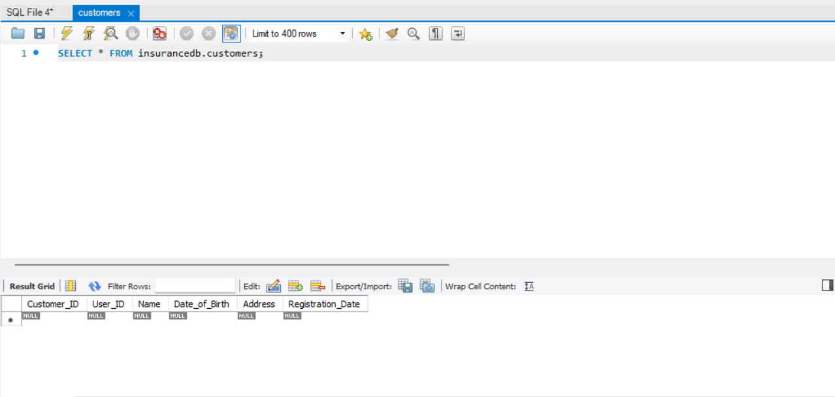
-- Policies Table
CREATE TABLE Policies (
Policy_ID INT PRIMARY KEY AUTO_INCREMENT,
Customer_ID INT,
Policy_Type_ID INT,
Coverage_Amount DECIMAL(12,2),
Premium_Amount DECIMAL(12,2),
Start_Date DATE,
End_Date DATE,
FOREIGN KEY (Customer_ID) REFERENCES Customers(Customer_ID),
FOREIGN KEY (Policy_Type_ID) REFERENCES PolicyTypes(Policy_Type_ID)
);
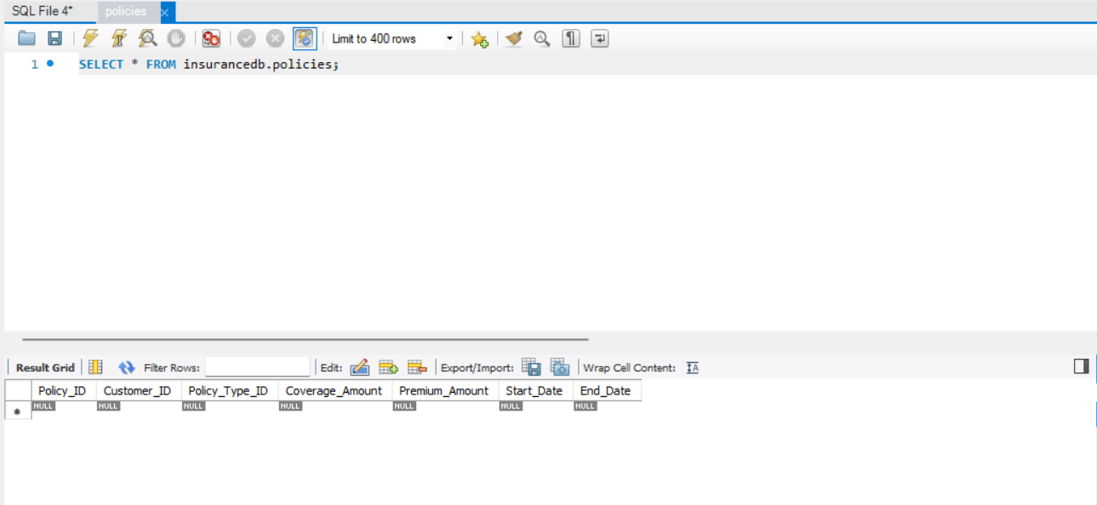
CREATE TABLE Claims (
Claim_ID INT PRIMARY KEY AUTO_INCREMENT,
Policy_ID INT,
Claim_Amount DECIMAL(12,2),
Claim_Date DATE,
Status VARCHAR(20), -- Replaced ENUM with VARCHAR
Reason TEXT,
FOREIGN KEY (Policy_ID) REFERENCES Policies(Policy_ID)
);

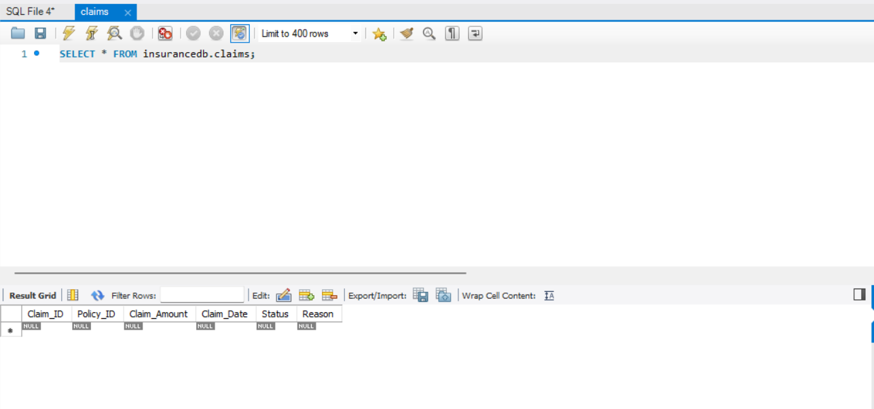

CREATE TABLE Payment (
Payment_ID INT PRIMARY KEY AUTO_INCREMENT,
Customer_ID INT,
Payment_Date DATE,
Payment_Amount DECIMAL(12,2),
Payment_Method VARCHAR(50),
Transaction_ID VARCHAR(100),
Status VARCHAR(20), -- Replaced ENUM with VARCHAR
FOREIGN KEY (Customer_ID) REFERENCES Customers(Customer_ID)
);
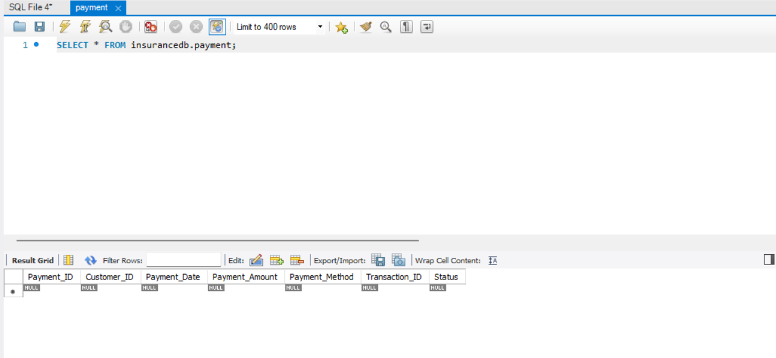
CREATE TABLE PaymentHistory (
Payment_History_ID INT PRIMARY KEY AUTO_INCREMENT,
Payment_ID INT,
Payment_Date DATE,
Amount_Paid DECIMAL(12,2),
Payment_Status VARCHAR(20), -- Replaced ENUM with VARCHAR
FOREIGN KEY (Payment_ID) REFERENCES Payment(Payment_ID)
);
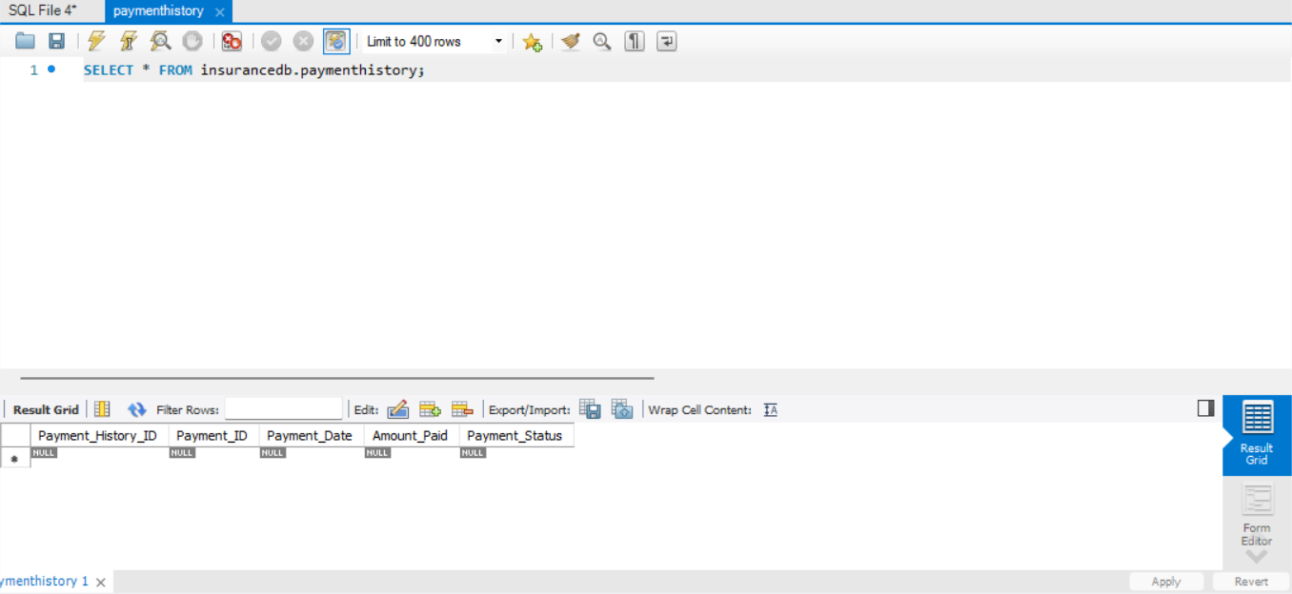
CREATE TABLE ClaimsHistory (
Claims_History_ID INT PRIMARY KEY AUTO_INCREMENT,
Claim_ID INT,
Claim_Date DATE,
Claim_Status VARCHAR(20), -- Replaced ENUM with VARCHAR
Claim_Amount DECIMAL(12,2),
FOREIGN KEY (Claim_ID) REFERENCES Claims(Claim_ID)
);
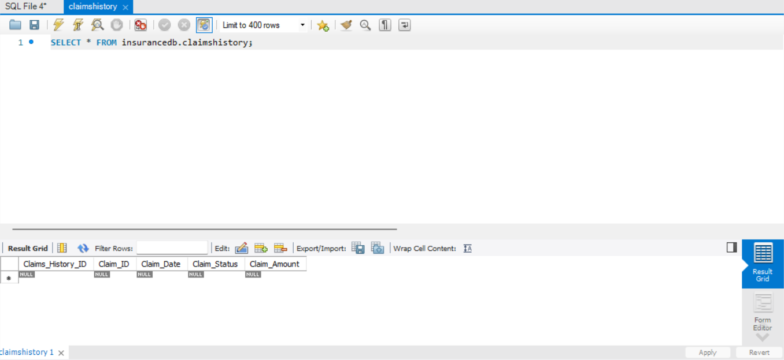
CREATE TABLE PolicyRenewal (
Renewal_ID INT PRIMARY KEY AUTO_INCREMENT,
Policy_ID INT,
Renewal_Date DATE,
Renewal_Status VARCHAR(20), -- Replaced ENUM with VARCHAR
FOREIGN KEY (Policy_ID) REFERENCES Policies(Policy_ID)
);
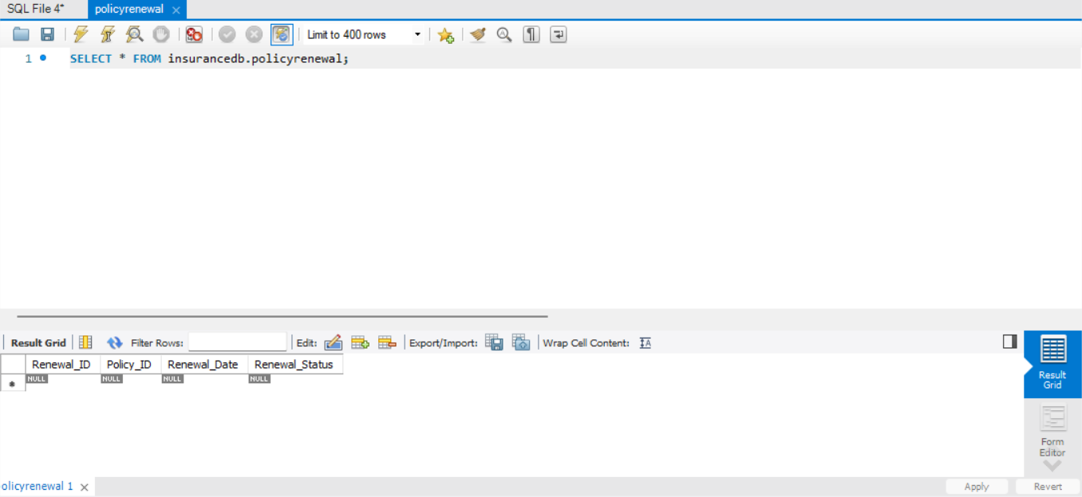
-- Noticeboard Table
CREATE TABLE Noticeboard (
Notice_ID INT PRIMARY KEY AUTO_INCREMENT,
Admin_ID INT,
Message TEXT,
Posting_Date DATE,
FOREIGN KEY (Admin_ID) REFERENCES Admins(Admin_ID)
);
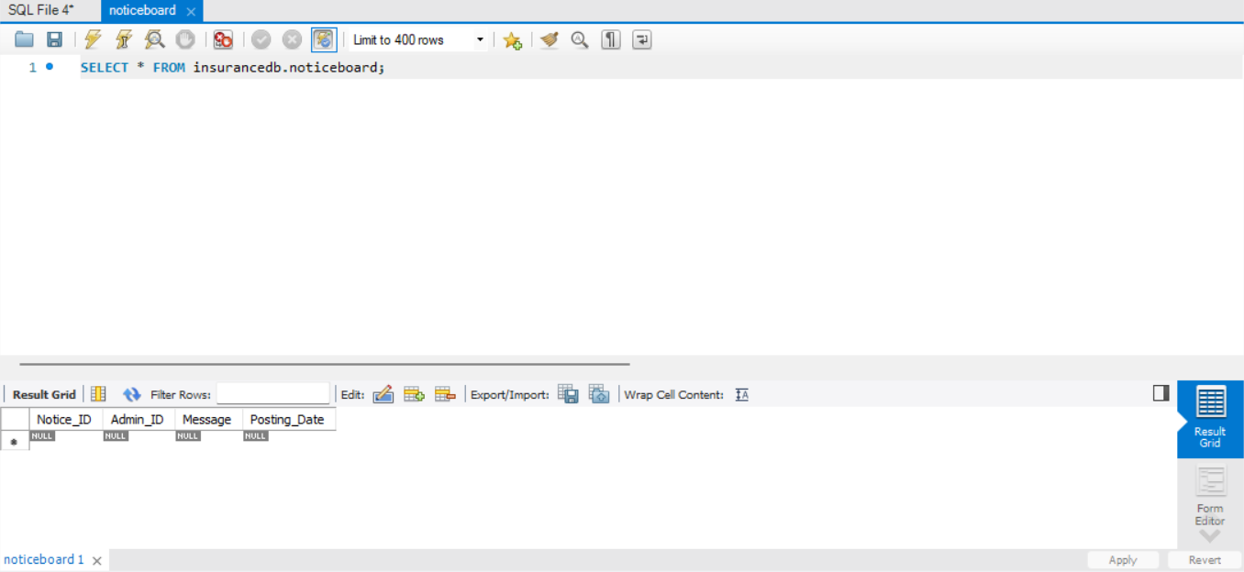
-- Complaints Table
CREATE TABLE Complaints (
Complaint_ID INT PRIMARY KEY AUTO_INCREMENT,
Customer_ID INT,
Agent_ID INT,
Complaint_Details TEXT,
Complaint_Date DATE,
FOREIGN KEY (Customer_ID) REFERENCES Customers(Customer_ID),
FOREIGN KEY (Agent_ID) REFERENCES Agents(Agent_ID)
);
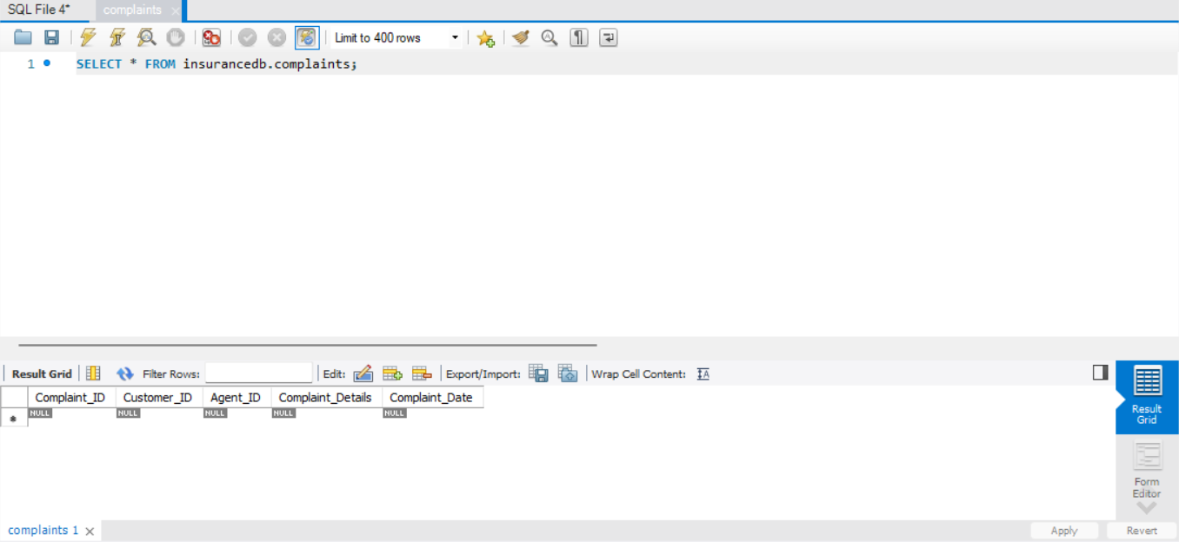
-- Login Table
CREATE TABLE Login (
Login_ID INT PRIMARY KEY AUTO_INCREMENT,
User_ID INT,
Username VARCHAR(100) UNIQUE NOT NULL,
Password VARCHAR(255) NOT NULL,
FOREIGN KEY (User_ID) REFERENCES User(User_ID)
);
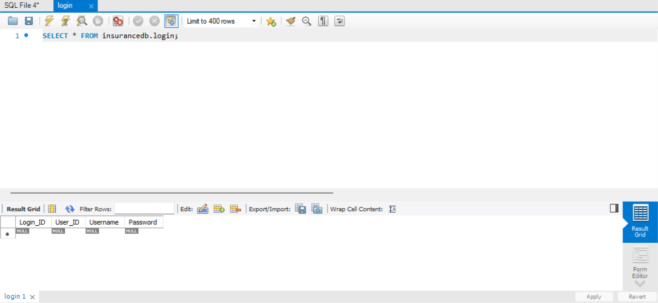
CREATE TABLE Agents (
Agent_ID INT PRIMARY KEY AUTO_INCREMENT,
User_ID INT UNIQUE,
Email VARCHAR(100),
Assigned_Customers_Count INT,
FOREIGN KEY (User_ID) REFERENCES User(User_ID)
);

CREATE TABLE Agent_PhoneNumbers (
Agent_ID INT,
Phone_Number VARCHAR(15),
PRIMARY KEY (Agent_ID, Phone_Number),
FOREIGN KEY (Agent_ID) REFERENCES Agents(Agent_ID)
);
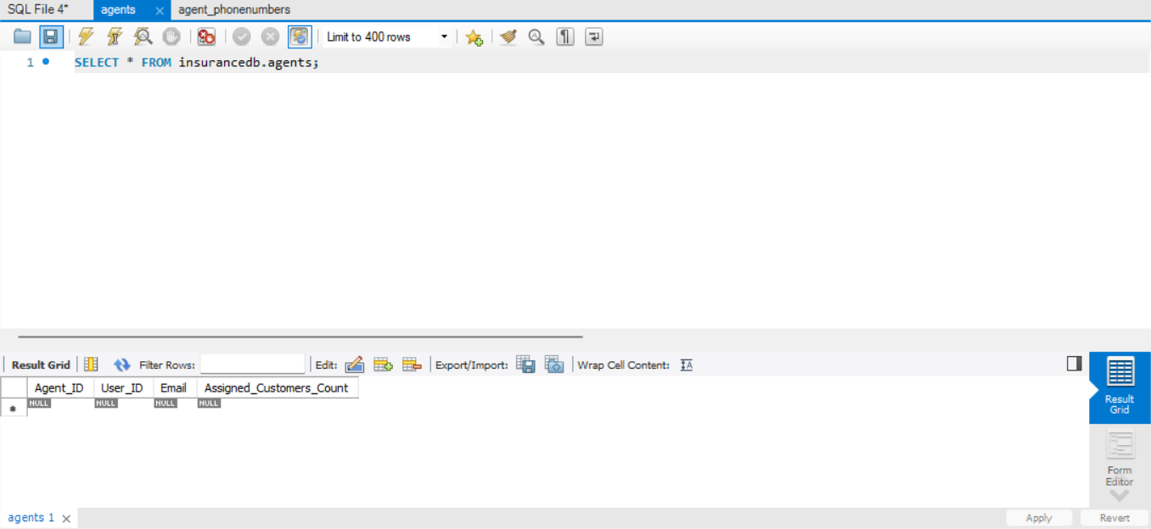
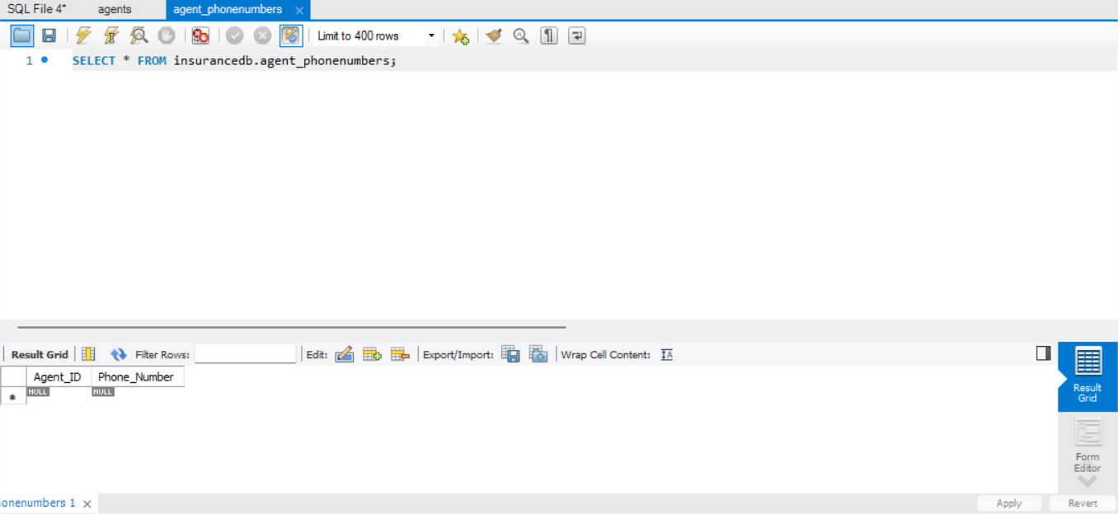
CREATE TABLE Customer_PhoneNumbers (
Customer_ID INT,
Phone_Number VARCHAR(15),
PRIMARY KEY (Customer_ID, Phone_Number),
FOREIGN KEY (Customer_ID) REFERENCES Customers(Customer_ID)
);
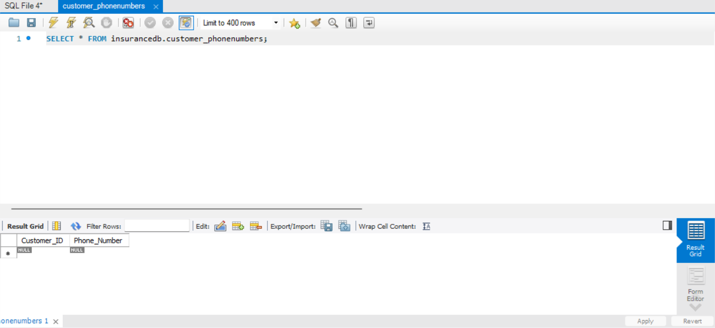

CREATE TABLE Update_Notices (
Update_ID INT PRIMARY KEY ,
Admin_ID INT,
Notice_ID INT,
FOREIGN KEY (Admin_ID) REFERENCES Admins(Admin_ID),
FOREIGN KEY (Notice_ID) REFERENCES Noticeboard(Notice_ID)
);

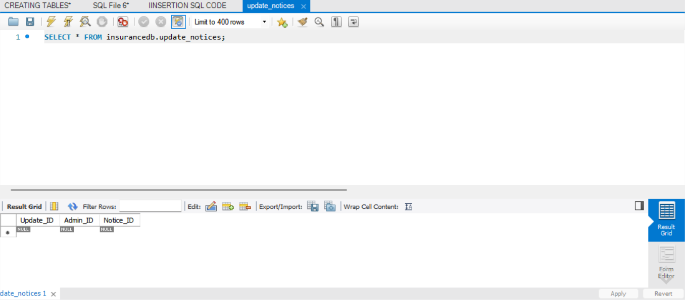

CREATE TABLE Admin_Manages_Agents (
Manage_ID INT PRIMARY KEY ,
Admin_ID INT,
Agent_ID INT,
FOREIGN KEY (Admin_ID) REFERENCES Admins(Admin_ID),
FOREIGN KEY (Agent_ID) REFERENCES Agents(Agent_ID)
);

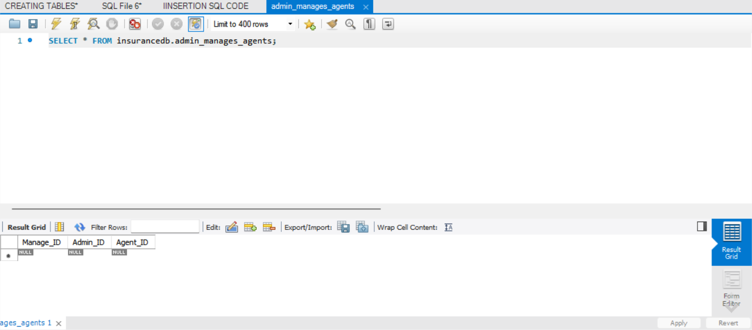

INSERTING SAME VALUES INTO TABLES

INSERT INTO User (User_ID, User_Name, Password, Address, Gender) VALUES
(01, 'USER1', 'U1PASS', 'U1ADRS', 'Male'),
(02, 'USER2', 'U2PASS', 'U2ADRS', 'Female'),
(03, 'USER3', 'U3PASS', 'U3ADRS', 'Male'),
(04, 'USER4', 'U4PASS', 'U4ADRS', 'Female'),
(05, 'USER5', 'U5PASS', 'U5ADRS', 'Male');
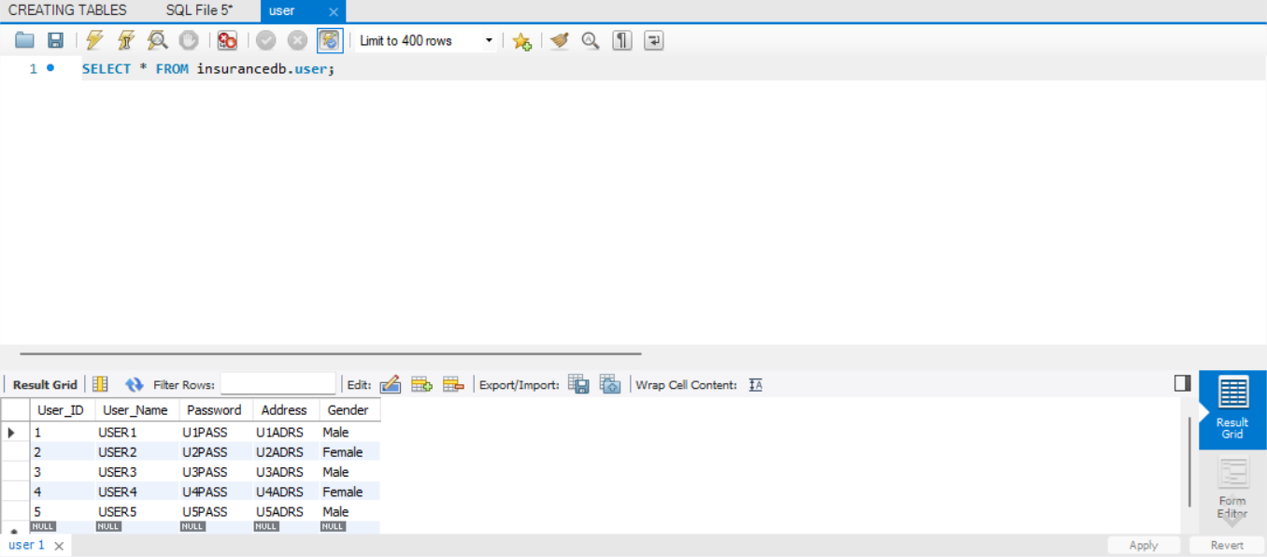
INSERT INTO Admins (Admin_ID, User_ID, Salary, Role, Department) VALUES
(01, 01, 50000.00, 'Manager', 'Finance'),
(02, 02, 45000.50, 'Supervisor', 'HR'),
(03, 03, 60000.75, 'Director', 'Operations'),
(04, 04, 55000.25, 'Analyst', 'IT'),
(05, 05, 48000.00, 'Coordinator', 'Marketing');
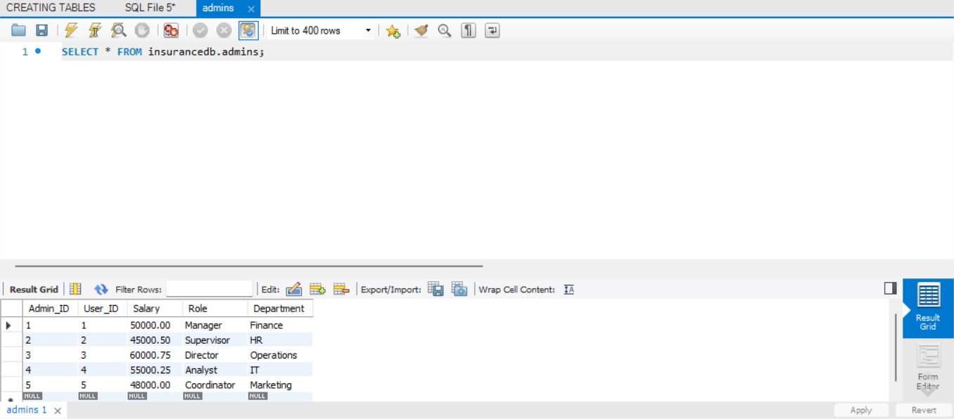
INSERT INTO Admin_Contacts (Contact_ID, Admin_ID, Contact_Number) VALUES
(01, 01, '9876543210'),
(02, 02, '8765432109'),
(03, 03, '7654321098'),
(04, 04, '6543210987'),
(05, 05, '5432109876');

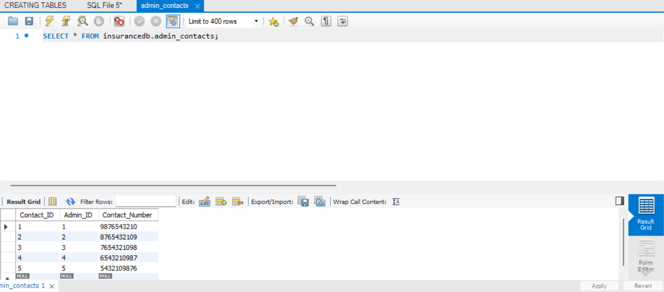

INSERT INTO Customers (Customer_ID, User_ID, Date_of_Birth, Registration_Date) VALUES
(1, 6, '1995-07-10', '2024-03-06'),
(2, 7, '1992-05-15', '2024-03-06'),
(3, 8, '1998-09-20', '2024-03-06'),
(4, 9, '1990-11-25', '2024-03-06'),
(5, 10, '1997-03-30', '2024-03-06'); 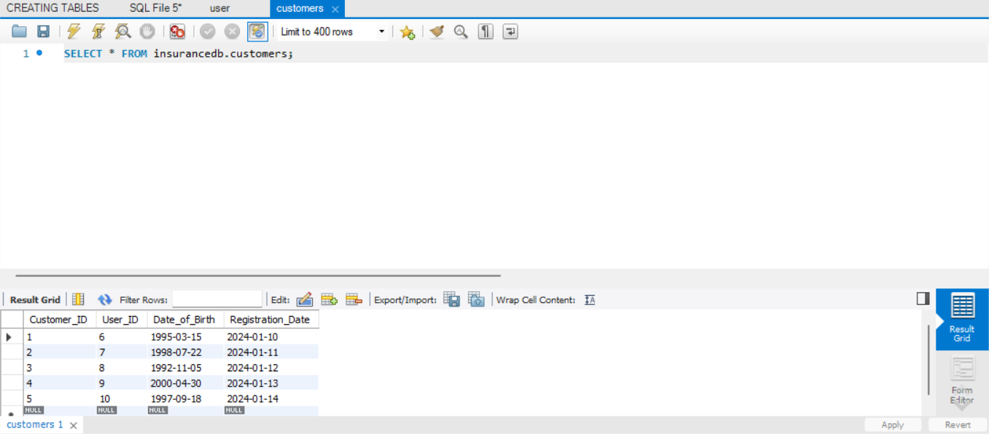
INSERT INTO Customer_PhoneNumbers (Customer_ID, Phone_Number) VALUES
(1, '9876543210'),
(2, '9123456789'),
(3, '8765432109'),
(4, '9988776655'),
(5, '8899776655');
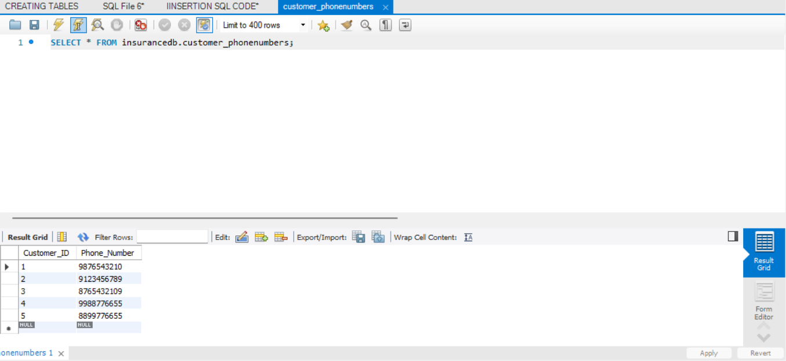
INSERT INTO PolicyTypes (Policy_Type_ID, Type_Name, Description) VALUES
(1, 'P1TYPE1', 'This is Policy Type 1'),
(2, 'P2TYPE2', 'This is Policy Type 2'),
(3, 'P3TYPE3', 'This is Policy Type 3'),
(4, 'P4TYPE4', 'This is Policy Type 4'),
(5, 'P5TYPE5', 'This is Policy Type 5');
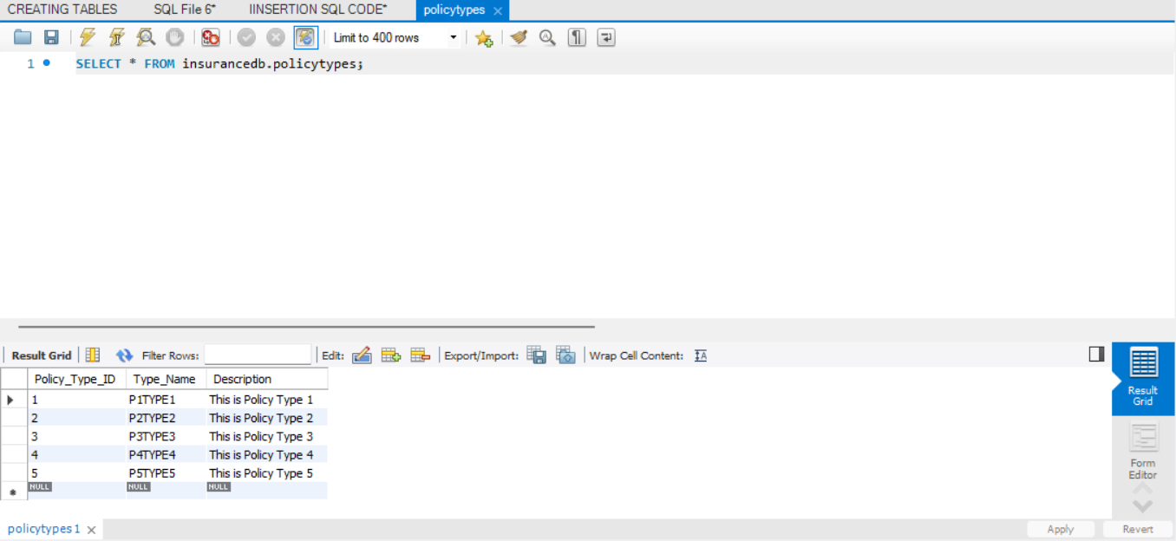
INSERT INTO Policies (Policy_ID, Customer_ID, Policy_Type_ID, Coverage_Amount, Premium_Amount, Start_Date, End_Date) VALUES
(101, 1, 1, 500000.00, 5000.00, '2024-01-01', '2029-01-01'),
(102, 2, 2, 750000.00, 7500.00, '2024-02-01', '2029-02-01'),
(103, 3, 3, 1000000.00, 10000.00, '2024-03-01', '2029-03-01'),
(104, 4, 4, 1200000.00, 12000.00, '2024-04-01', '2029-04-01'),
(105, 5, 5, 1500000.00, 15000.00, '2024-05-01', '2029-05-01');

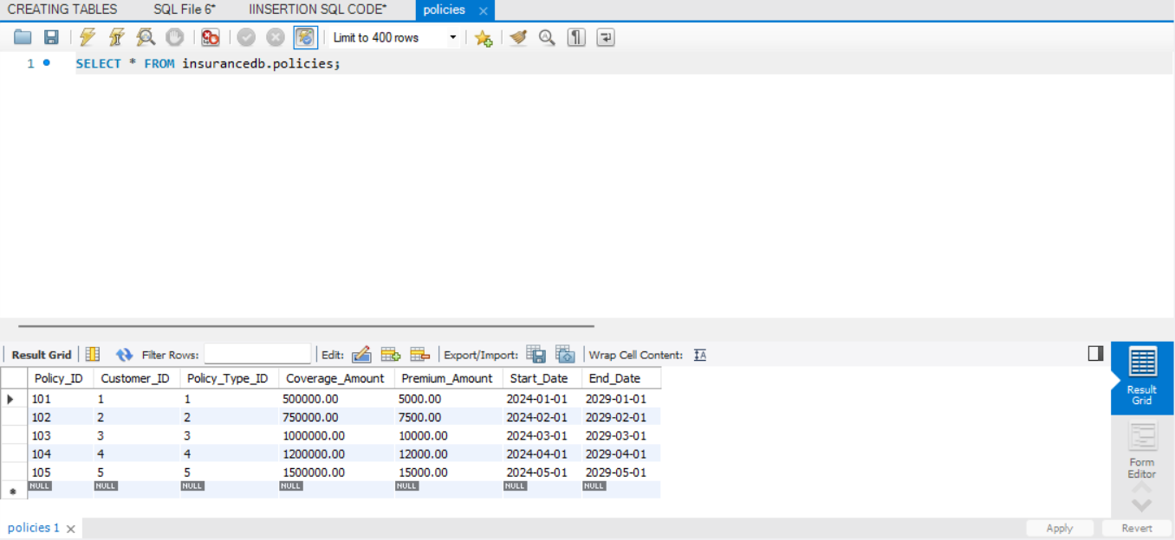

INSERT INTO PolicyRenewal (Renewal_ID, Policy_ID, Renewal_Date) VALUES
(201, 101, '2025-01-01'),
(202, 102, '2025-02-01'),
(203, 103, '2025-03-01'),
(204, 104, '2025-04-01'),
(205, 105, '2025-05-01');

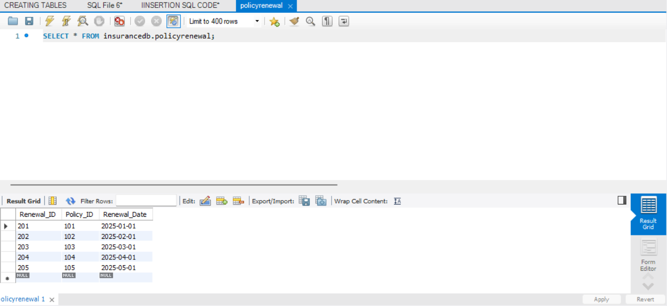
INSERT INTO Claims (Claim_ID, Policy_ID, Claim_Amount, Claim_Date, Reason) VALUES
(301, 101, 5000.00, '2025-02-15', 'Medical Expenses'),
(302, 102, 10000.00, '2025-03-10', 'Car Accident'),
(303, 103, 7500.00, '2025-04-05', 'Property Damage'),
(304, 104, 12000.00, '2025-05-20', 'Health Emergency'),
(305, 105, 6000.00, '2025-06-25', 'Theft Claim');

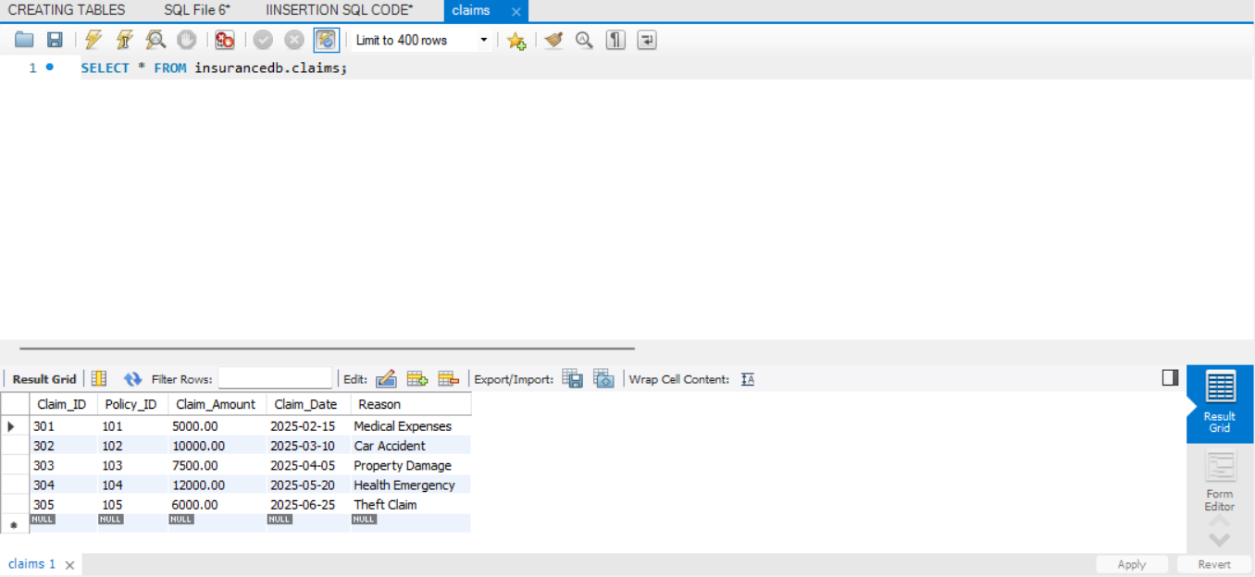

INSERT INTO ClaimsHistory (Claims_History_ID, Claim_ID, Claim_Date, Claim_Amount) VALUES
(401, 301, '2025-02-15', 5000.00),
(402, 302, '2025-03-10', 10000.00),
(403, 303, '2025-04-05', 7500.00),
(404, 304, '2025-05-20', 12000.00),
(405, 305, '2025-06-25', 6000.00);

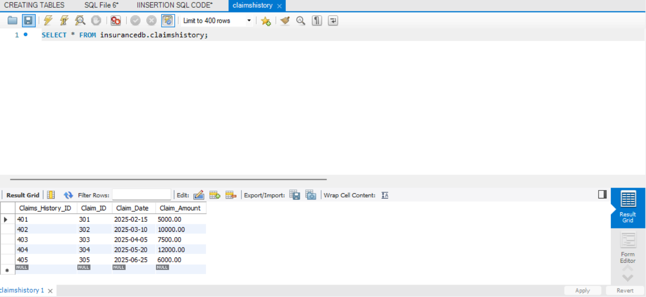
INSERT INTO Payment (Payment_ID, Customer_ID, Payment_Date, Payment_Amount, Payment_Method, Transaction_ID) VALUES
(501, 1, '2025-02-10', 1500.00, 'Credit Card', 'TXN1001'),
(502, 2, '2025-02-15', 2500.50, 'Debit Card', 'TXN1002'),
(503, 3, '2025-03-05', 1800.75, 'Net Banking', 'TXN1003'),
(504, 4, '2025-03-20', 3200.00, 'UPI', 'TXN1004'),
(505, 5, '2025-04-10', 2900.30, 'Cash', 'TXN1005');

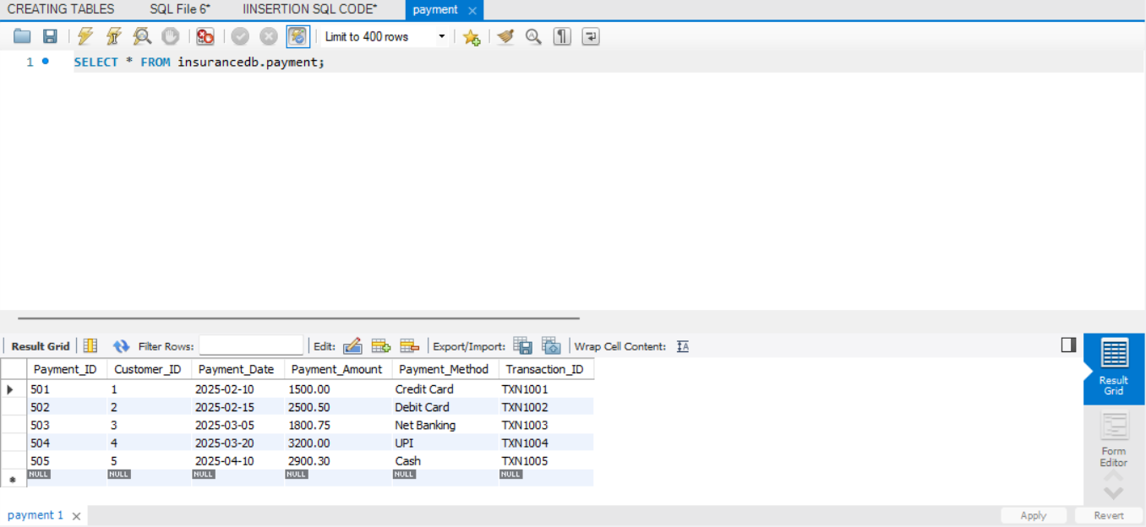

INSERT INTO PaymentHistory (Payment_History_ID, Payment_ID, Payment_Date, Amount_Paid) VALUES
(1001, 501, '2025-02-10', 1500.00),
(1002, 502, '2025-02-15', 2500.50),
(1003, 503, '2025-03-05', 1800.75),
(1004, 504, '2025-03-20', 3200.00),
(1005, 505, '2025-04-10', 2900.30);

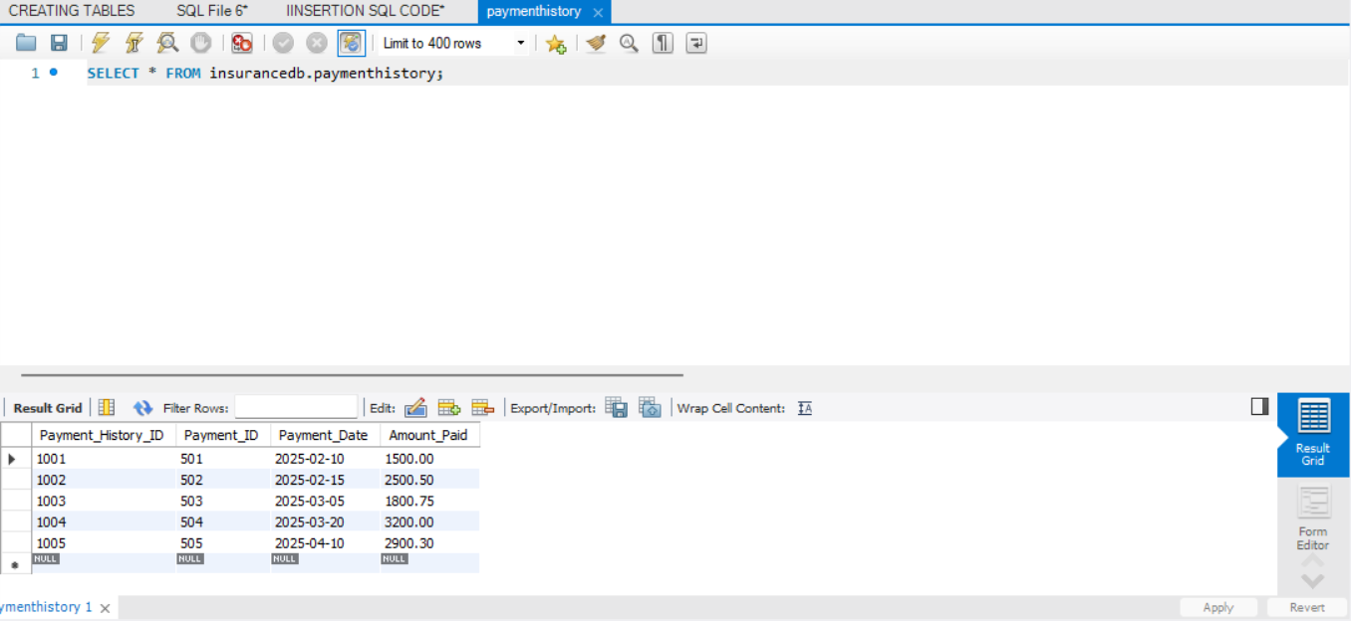
INSERT INTO Agents (Agent_ID, User_ID, Email, Assigned_Customers_Count) VALUES
(201, 6, 'agent1@email.com', 5),
(202, 7, 'agent2@email.com', 3),
(203, 8, 'agent3@email.com', 7),
(204, 9, 'agent4@email.com', 4),
(205, 10, 'agent5@email.com', 6);

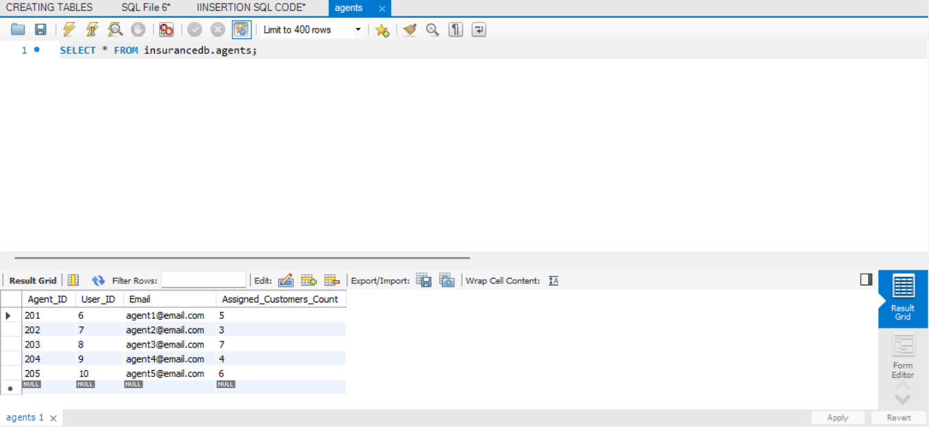

INSERT INTO Agent_PhoneNumbers (Agent_ID, Phone_Number) VALUES
(201, '9991112233'),
(201, '8882223344'),
(202, '7773334455'),
(203, '6664445566'),
(204, '5556667788'),
(205, '4447778899');
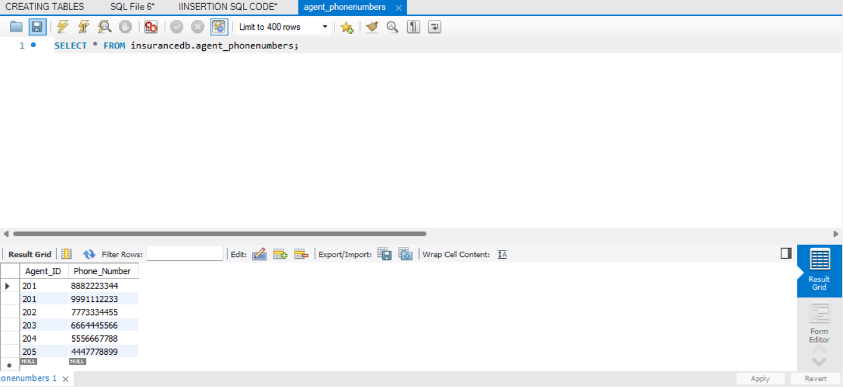
INSERT INTO Noticeboard (Notice_ID, Admin_ID, Message, Posting_Date) VALUES
(301, 1, 'MSG 1', '2024-03-10'),
(302, 2, 'MSG 2', '2024-03-12'),
(303, 3, 'MSG 3', '2024-03-15'),
(304, 4, 'MSG 4', '2024-03-18'),
(305, 5, 'MSG 5', '2024-03-20');

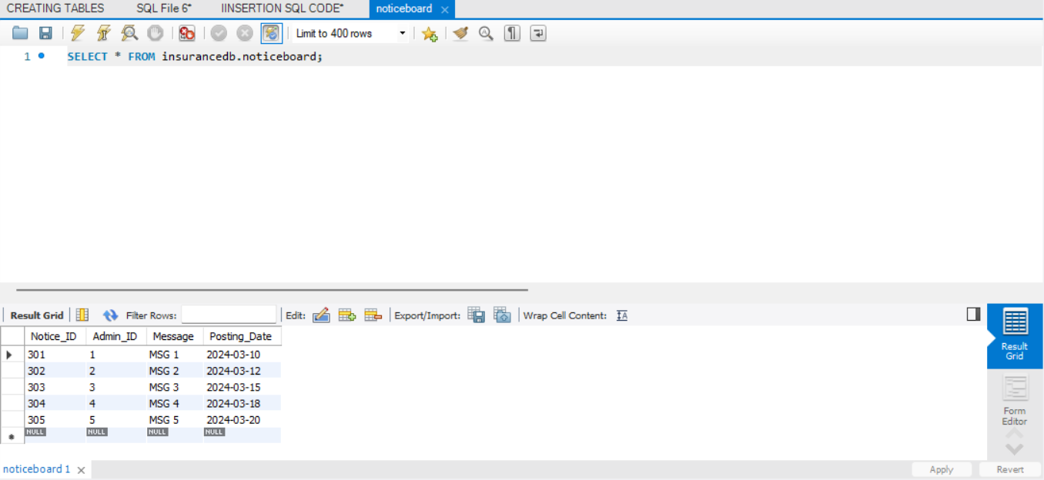

INSERT INTO Complaints (Complaint_ID, Customer_ID, Agent_ID, Complaint_Details, Complaint_Date) VALUES
(1, 1, 201, 'COMPL1', '2024-03-01'),
(2, 2, 202, 'COMPL2', '2024-03-02'),
(3, 3, 203, 'COMPL3', '2024-03-03'),
(4, 4, 204, 'COMPL4', '2024-03-04'),
(5, 5, 205, 'COMPL5', '2024-03-05');
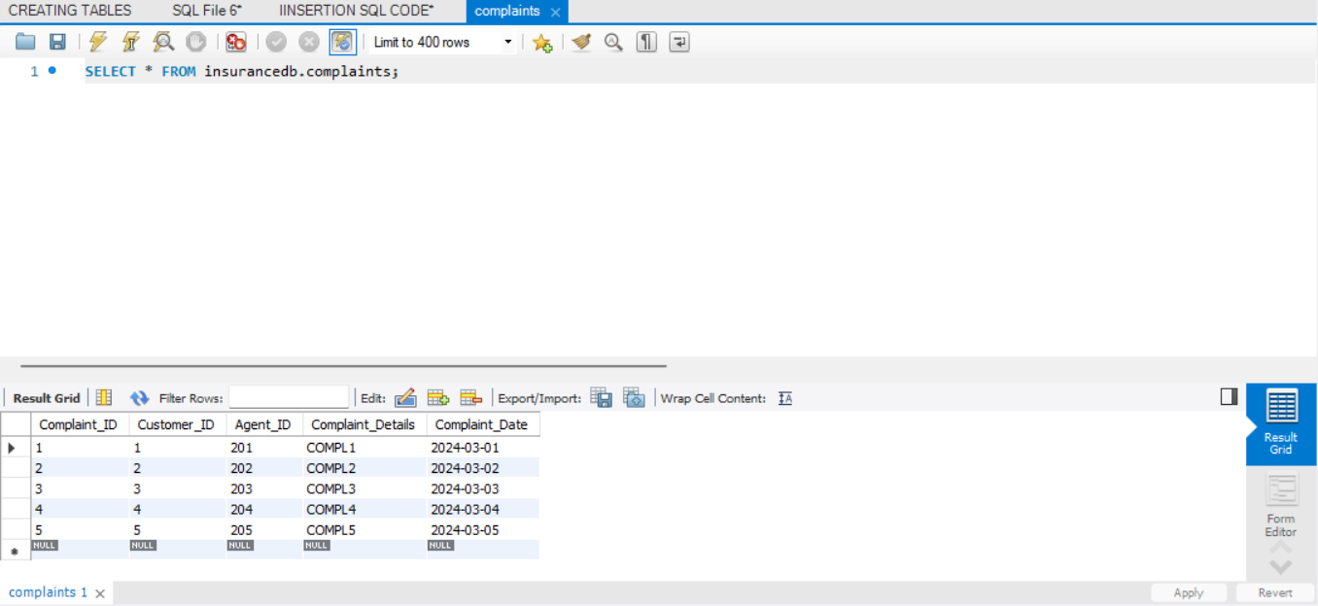
INSERT INTO Login (Login_ID, User_ID, Username, Password) VALUES
(101, 1, 'USER1', 'PASS1'),
(102, 2, 'USER2', 'PASS2'),
(103, 3, 'USER3', 'PASS3'),
(104, 4, 'USER4', 'PASS4'),
(105, 5, 'USER5', 'PASS5');

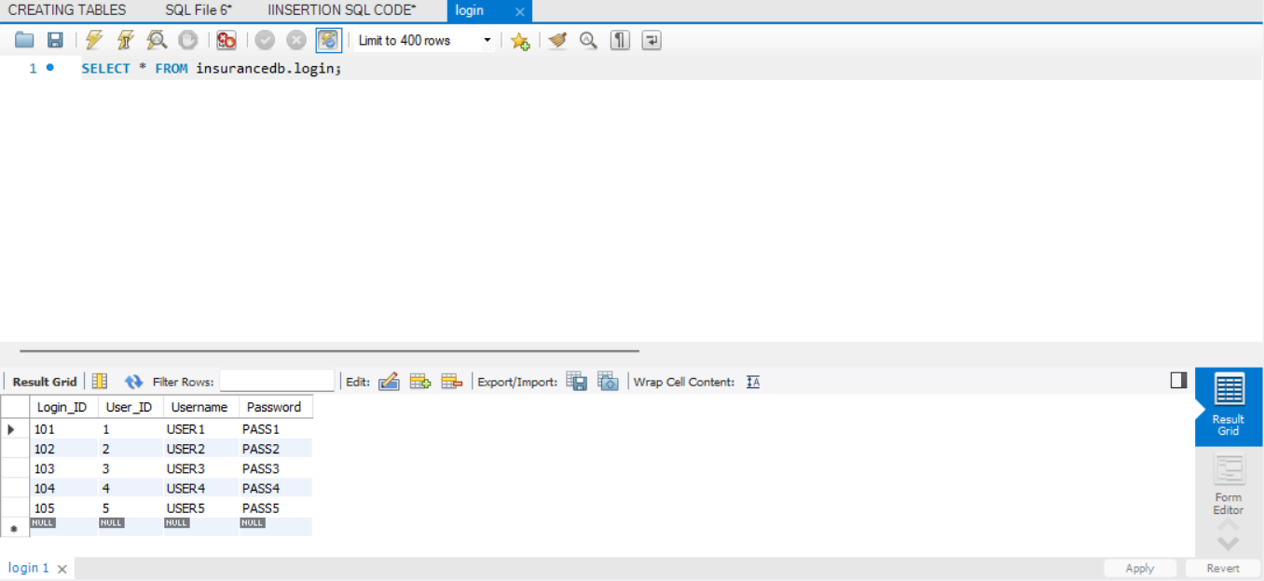
Introduction
In the domain of insurance management, efficiently handling customer policies and claims is crucial. SQL set operations—Union, Intersect, and Except—can be leveraged to simplify and optimize data retrieval for various business use cases. These operations allow us to combine, compare, and filter data across different datasets, enhancing decision-making and user experience.
This report focuses on three specific use cases related to insurance policies:
- Viewing all policies owned by a customer.
- Identifying policies that have been claimed.
- Checking eligibility for a No-Claim Bonus (NCB).

Understanding Set Operations in SQL
1️Union (All Policies Owned by the Customer)
- The Union operation is used to combine two result sets while eliminating duplicates.
- In this context, it helps retrieve all policies a customer owns, whether claimed or unclaimed.
- SQL Query:
SELECT P.Policy_ID, P.Customer_ID
FROM Policies P
UNION
SELECT C.Policy_ID, P.Customer_ID
FROM Claims C
JOIN Policies P ON C.Policy_ID = P.Policy_ID;
- This query ensures that all policies related to a customer are displayed.
2️ Intersect (Claimed Policies)
- The Intersect operation fetches records that exist in both result sets.
- This helps in identifying policies for which claims have been filed.
- SQL Query:
SELECT Policy_ID FROM Policies
INTERSECT
SELECT Policy_ID FROM Claims;
- The result set will contain only those policy IDs that have been claimed.
3️ Except (NCB Eligibility - Unclaimed Policies)
- The Except operation retrieves records that exist in the first dataset but not in the second.
- This is useful for determining which policies are eligible for a No-Claim Bonus.
- SQL Query:
SELECT Policy_ID FROM Policies
EXCEPT
SELECT Policy_ID FROM Claims;
- The result contains policies that have not been claimed, making them eligible for NCB.
Use Case Implementation
To enhance customer experience, these set operations can be used to create interactive features within an insurance management system:
- View All Policies (Union): Displays all policies a customer owns.
- View Claimed Policies (Intersect): Shows only the policies that have been claimed.
- Check NCB Eligibility (Except): Lists policies eligible for a No-Claim Bonus.
By integrating these queries into the system, customers can efficiently track their policy status, claims, and potential bonuses, improving transparency and service efficiency.

Conclusion
Set operations like Union, Intersect, and Except provide an effective way to manage and analyze insurance data. These SQL operations help streamline policy tracking, claims processing, and eligibility verification for bonuses, thereby enhancing the overall insurance experience for customers.

VIWES
In database management, Views are virtual tables created by storing the result of a SQL query. They help simplify complex queries, improve data security, and enhance performance by reducing redundant query executions.
Views are particularly useful in insurance management systems, where different stakeholders need quick and structured access to policy and claim data. By defining stored queries, businesses can efficiently track policy renewals, claims, customer eligibility, and more without writing repetitive SQL queries.

1) UpcomingPolicyRenewals VIEW
The UpcomingPolicyRenewals view helps track insurance policies that are nearing their renewal date within the next 30 days. By using this view, insurance providers can proactively notify customers about upcoming renewals, ensuring timely payments and uninterrupted coverage.
This view calculates the remaining days until the policy expires using the DATEDIFF function and filters policies whose end date falls within the next 30 days. It simplifies renewal tracking and enhances customer engagement by enabling timely reminders

CODE
CREATE VIEW UpcomingPolicyRenewals AS
SELECT
P.Policy_ID,
P.Customer_ID,
P.Policy_Type_ID,
P.Coverage_Amount,
P.Premium_Amount,
P.End_Date,
DATEDIFF(P.End_Date, CURDATE()) AS Days_Left
FROM Policies P
WHERE P.End_Date BETWEEN CURDATE() AND DATE_ADD(CURDATE(), INTERVAL 30 DAY);
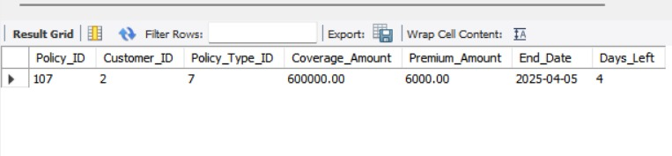
2) ActivePolicies VIEW

The ActivePolicies view lists all insurance policies that are currently active, i.e., those whose end date is later than the current date. This view helps insurance providers monitor and track all active policies in their system, ensuring they are properly managed and renewed when necessary.

CODE
CREATE VIEW ActivePolicies AS
SELECT Policy_ID, Customer_ID, Policy_Type_ID, Coverage_Amount, Premium_Amount, End_Date
FROM Policies
WHERE End_Date > CURDATE()

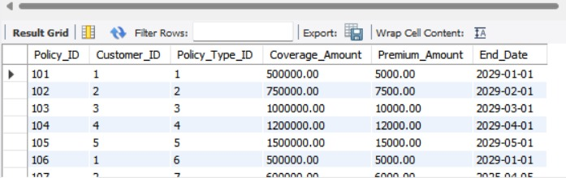

4) CustomerPayments VIEW
The CustomerPayments view provides a summary of all payments made by customers, including the payment date, amount, and method. This view helps insurance companies track customer payments and ensure proper accounting.
CODE:
CREATE VIEW CustomerPayments AS
SELECT Payment_ID, Customer_ID, Payment_Date, Payment_Amount, Payment_Method
FROM Payment;
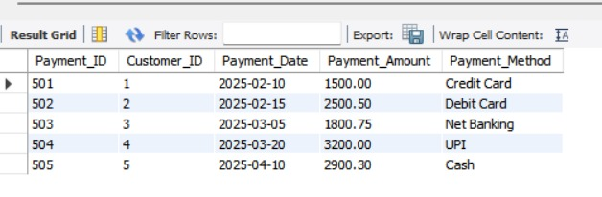
5) AdminNotices VIEW
The AdminNotices view lists all the notices posted by the admins. This view helps track important messages or announcements made by the administration to ensure they are visible to relevant stakeholders.

CODE:
CREATE VIEW AdminNotices AS
SELECT Notice_ID, Admin_ID, Message, Posting_Date
FROM Noticeboard;
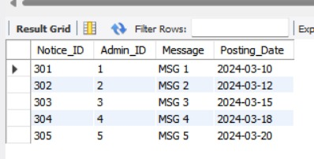
3) PendingClaims VIEW

The PendingClaims view helps track all claims that have been filed. By using this view, insurance providers can easily identify claims that have been submitted and are waiting for processing or approval.

CODE
CREATE VIEW PendingClaims AS
SELECT Claim_ID, Policy_ID, Claim_Amount, Claim_Date, Reason
FROM Claims;

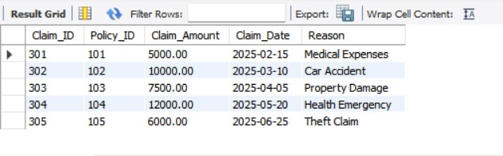

Triggers
Triggers are automated actions in a database that are executed when certain events occur, such as inserting, updating, or deleting records in a table. They help maintain data integrity and ensure that specific operations are performed automatically, reducing manual intervention and the chances of errors.
In the context of the insurance project, triggers are used to streamline processes such as updating policy end dates, tracking claims history, managing payment records, and ensuring data consistency across multiple tables. By implementing triggers, we can automate key operations, improve efficiency, and ensure the accuracy of data across the system.
These triggers, for example, automatically update the Policies table when a policy is renewed, maintain the ClaimHistory table whenever a new claim is made, and prevent duplicate phone numbers for customers. This automation helps insurance companies focus more on customer service and less on administrative tasks.
1) Update Policy EndDate
DELIMITER //

CREATE TRIGGER UpdatePolicyEndDate
AFTER INSERT ON PolicyRenewal
FOR EACH ROW
BEGIN
DECLARE policyType INT;
DECLARE extensionYears INT;
DECLARE currentEndDate DATE;

-- Get the Policy Type and Current End Date
SELECT Policy_Type_ID, End_Date INTO policyType, currentEndDate
FROM Policies
WHERE Policy_ID = NEW.Policy_ID;

-- Get the Extension Years from PolicyTypes
SELECT Extension_Years INTO extensionYears
FROM PolicyTypes
WHERE Policy_Type_ID = policyType;

-- Update the End_Date based on the extension years
UPDATE Policies
SET End_Date = DATE_ADD(currentEndDate, INTERVAL extensionYears YEAR)
WHERE Policy_ID = NEW.Policy_ID;
END;
//

DELIMITER ;

2) UpdateClaimHistory After Claim Processing

DELIMITER //

CREATE TRIGGER InsertClaimHistory
AFTER INSERT ON Claims
FOR EACH ROW
BEGIN
-- Insert claim details into ClaimsHistory after claim is made
INSERT INTO ClaimsHistory (Claim_ID, Claim_Date, Claim_Amount)
VALUES (NEW.Claim_ID, NEW.Claim_Date, NEW.Claim_Amount);
END;
//

DELIMITER ;

3) UpdateCustomerPaymentHistory After Payment
This trigger updates the PaymentHistory table each time a payment is made by a customer.
DELIMITER //

CREATE TRIGGER InsertPaymentHistory
AFTER INSERT ON Payment
FOR EACH ROW
BEGIN
-- Insert payment details into PaymentHistory after payment is made
INSERT INTO PaymentHistory (Payment_ID, Payment_Date, Amount_Paid)
VALUES (NEW.Payment_ID, NEW.Payment_Date, NEW.Payment_Amount);
END;
//

DELIMITER ;
4) UpdateAgentCustomerCount After New Customer Assignment
This trigger updates the Assigned_Customers_Count in the Agents table whenever a new customer is assigned to an agent.
DELIMITER //

CREATE TRIGGER UpdateAgentCustomerCount
AFTER INSERT ON Policies
FOR EACH ROW
BEGIN
-- Increment the assigned customer count for the agent
UPDATE Agents
SET Assigned_Customers_Count = Assigned_Customers_Count + 1
WHERE Agent_ID = NEW.Agent_ID;
END;
//

DELIMITER ;
5) PreventDuplicatePhoneNumbers After Inserting Customer Phone Number
This trigger prevents the insertion of duplicate phone numbers for customers in the Customer_PhoneNumbers table.
DELIMITER //

CREATE TRIGGER PreventDuplicatePhoneNumbers
BEFORE INSERT ON Customer_PhoneNumbers
FOR EACH ROW
BEGIN
-- Check if the phone number already exists for the customer
IF EXISTS (SELECT 1 FROM Customer_PhoneNumbers WHERE Customer_ID = NEW.Customer_ID AND Phone_Number = NEW.Phone_Number) THEN
SIGNAL SQLSTATE '45000' SET MESSAGE_TEXT = 'Duplicate phone number is not allowed for the customer.';
END IF;
END;
//

DELIMITER ;

