# Supply Chain Monitoring

# ABSTRACT

Supply chain management plays a vital role in the success of organizations by ensuring efficient operations and timely delivery of products. With the emergence of Internet of Things (IoT) technology, organizations now have the opportunity to revolutionize their supply chain management processes through the implementation of IoT-based monitoring systems. This report presents a comprehensive examination of the concept of a supply chain monitoring system using IoT and explores its potential benefits in enhancing supply chain visibility, traceability, inventory management, and overall operational efficiency.

The report begins with an introduction to the significance of supply chain management and the challenges faced in traditional approaches to monitoring. It then delves into the fundamentals of IoT and its wide-ranging applications in supply chain management. The advantages offered by IoT in supply chain monitoring are highlighted, including real-time data collection, connectivity, and intelligent decision-making capabilities.In order to build a robust IoT-enabled supply chain monitoring system, the report discusses the key components required, such as sensors and actuators, communication protocols, edge computing, fog computing, cloud computing, and data analytics. The architecture of the system is also detailed, covering data collection, transmission, storage, processing, and analytics.

Implementing an IoT-enabled supply chain monitoring system presents various challenges, and this report addresses them comprehensively. Security and privacy concerns, scalability, interoperability, cost considerations, and data integration issues are all examined in detail. Strategies and best practices to overcome these challenges are explored to guide organizations in their implementation efforts.Real-world applications of IoT-enabled supply chain monitoring systems are showcased through case studies. Examples include inventory management and tracking, demand forecasting and planning, logistics and transportation management, and product quality and compliance monitoring. These case studies demonstrate how IoT technologies can be applied to overcome specific supply chain management challenges and achieve tangible benefits.

The impact of IoT on supply chain management is further analysed, focusing on the benefits it brings. Improved supply chain visibility, enhanced traceability and transparency, efficient inventory management, and optimized operational efficiency are discussed as the key advantages derived from implementing an IoT-enabled monitoring system.Finally, the report concludes with a discussion of future trends and opportunities in the field of IoT-enabled supply chain monitoring. Topics such as blockchain integration, edge AI for real-time decision making, and predictive analytics for demand forecasting are explored, providing insights into emerging technologies and their potential impact on supply chain management.

# TABLE OF CONTENTS

Acknowledgement **Error! Bookmark not defined.**

Abstract 1

Table of Contents 2

**Chapter – 1: INTRODUCTION**

1.1 Overall Background & System…………………………………………………………….2

1.1.1 Introduction ………………………………………………………………………….2

1.1.2 System Description ………………………………………………………………….2

1.1.3 System Operation…………………………………………………………………….2

1.1.4 Applications and Importance ………………………………………………………...3

1.1.5 Necessity and Future Advancements…………………………………………………4

1.2 Objectives ………………………………………………………………………………… 4

1.3 Methodology……………………………………………………………………………….5

1.4 Outcome……………………………………………………………………………………6

**Chapter – 2: SUMMARY OF STATE OF THE ART AND DESCRIPTION OF TOOLS** 2.1 Summary

2.2 Description of Tools

**Chapter – 3: DESIGN AND DEVELOPMENT**

3.1 Block Diagram

3.2 Circuit

3.3 Connections

**Chapter – 4: DEMONSTRATION / EVALUATION AND RESULTS**

4.1 Introduction

4.2 Hardware Results

**Chapter – 5: CONCLUSION AND FUTURE WORK**

5.1 Conclusion

5.2 Future Work

**CHAPTER 1**

**INTRODUCTION**

# 1.1 Overall Background and System

**1.1.1 Introduction**

In today's globalized and highly competitive business landscape, effective supply chain management is crucial for organizations to stay competitive and meet customer demands. A well-managed supply chain ensures the smooth flow of goods, timely deliveries, and minimized costs. However, traditional approaches to supply chain monitoring often lack real-time visibility and face challenges in tracking and managing inventory, ensuring product quality, and optimizing operational efficiency.

**1.1.2 System Description**

The supply chain monitoring system using IoT is a sophisticated and innovative solution that leverages Internet of Things (IoT) technology to provide real-time visibility and actionable insights into supply chain operations. It encompasses a network of interconnected devices, sensors, and software applications that work together to collect, transmit, store, process, and analyse data related to various aspects of the supply chain.

**1.1.3 System Operation**

The system comprises several key components that enable seamless data flow and facilitate efficient monitoring of the supply chain:1. Sensors and Actuators:IoT sensors play a pivotal role in data collection by capturing and measuring various parameters such as temperature, humidity, location, vibration, and product-specific details. These sensors are embedded in assets, vehicles, facilities, and even products themselves, enabling real-time monitoring of critical variables throughout the supply chain. Actuators, on the other hand, are responsible for executing actions based on the insights derived from sensor data, such as adjusting temperature or initiating automated processes.2. Communication Protocols:IoT relies on robust communication protocols to facilitate seamless data transmission between sensors, devices, and the central monitoring system. Common protocols include Wi-Fi, Bluetooth, RFID, and cellular networks, enabling data to be transmitted over short or long distances.3. Edge Computing and Fog Computing:Edge computing refers to the decentralized processing of data at the network edge, closer to the data source, reducing latency and enabling real-time decision-making. Fog computing, on the other hand, extends edge computing by distributing computing resources and intelligence across multiple edge devices, gateways, and cloud servers, further optimizing data processing and analysis.4. Cloud Computing:Cloud computing provides the scalability and storage capabilities necessary to handle the massive volumes of data generated by IoT sensors and devices. It allows for centralized data storage, remote access, and sophisticated analytics, enabling organizations to derive actionable insights from the collected data.5. Data Analytics and Artificial Intelligence:Advanced analytics techniques, including machine learning and artificial intelligence (AI), are employed to process and analyze the vast amounts of data collected from the supply chain. These techniques enable predictive and prescriptive analytics, anomaly detection, demand forecasting, and optimization algorithms, empowering organizations to make data-driven decisions and optimize their supply chain operations..

**1.1.4 Applications and Importance**

1. Inventory Management and Tracking:One of the critical applications of IoT-enabled supply chain monitoring systems is in inventory management and tracking. By integrating IoT sensors with inventory systems, organizations can monitor real-time inventory levels, track the movement of goods within warehouses, and automatically trigger replenishment orders when stock levels fall below predefined thresholds. This application reduces stockouts, minimizes excess inventory, optimizes warehouse space utilization, and improves overall inventory accuracy.2. Demand Forecasting and Planning:IoT-enabled supply chain monitoring systems provide organizations with valuable data for demand forecasting and planning. By analysing historical and real-time data on customer preferences, market trends, and supply chain performance, organizations can accurately predict demand patterns, optimize production schedules, and ensure sufficient inventory availability to meet customer demands. This application enhances operational efficiency, reduces stock obsolescence, and improves customer satisfaction by ensuring timely product availability.3. Logistics and Transportation Management:IoT-based monitoring systems offer significant benefits in logistics and transportation management. By equipping vehicles, containers, and packages with IoT sensors, organizations can track and monitor the location, condition, and status of goods throughout the transportation process. Real-time data on factors such as temperature, humidity, vibration, and route deviations enable proactive decision-making, route optimization, and timely delivery. This application improves supply chain visibility, minimizes transit delays, reduces losses due to theft or damage, and enhances customer service.4. Product Quality and Compliance Monitoring:Maintaining product quality and ensuring compliance with regulatory standards is of utmost importance in many industries. IoT-enabled supply chain monitoring systems enable continuous monitoring of product conditions, environmental factors, and compliance parameters. For example, sensors can monitor temperature and humidity levels during the storage and transportation of perishable goods, ensuring optimal product quality. Similarly, sensors can track compliance with temperature-controlled regulations for pharmaceuticals or monitor adherence to safety protocols in hazardous materials transportation. This application minimizes product spoilage, reduces compliance risks, and safeguards brand reputation.

**Importance**:The applications mentioned above highlight the significance of IoT-enabled supply chain monitoring systems in transforming supply chain management. The importance of these systems can be summarized as follows:**Enhanced Visibility and Transparency**: IoT-based systems provide real-time visibility into supply chain operations, allowing organizations to track and monitor assets, inventory, and processes at every stage. This visibility enables proactive decision-making, reduces uncertainties, and improves supply chain transparency.**Operational Efficiency**: By automating data collection, analysis, and decision-making processes, IoT-enabled systems streamline supply chain operations, reduce manual errors, and enhance overall operational efficiency. Real-time insights facilitate prompt responses to supply chain disruptions, minimize delays, and optimize resource allocation.**Cost Optimization**: IoT technology enables organizations to optimize costs by reducing stockouts, avoiding excess inventory, improving transportation efficiency, and minimizing wastage. By leveraging real-time data and analytics, organizations can make informed decisions to optimize their supply chain processes, reduce costs, and maximize profitability.**Improved Customer Satisfaction**: IoT-enabled systems enable organizations to provide better customer service by ensuring timely deliveries, accurate order fulfilment, and superior product quality. Real-time tracking and proactive alerts enable organizations to address customer queries promptly, provide accurate delivery estimates, and maintain high service levels.**Compliance and Risk Management**: IoT-based monitoring systems help organizations adhere to regulatory requirements and industry standards. Continuous monitoring of compliance parameters ensures adherence to quality standards, minimizes risks, and avoids costly penalties or product recalls..

**1.1.5 Necessity and Future Advancements**.

IoT-enabled supply chain monitoring systems are not only necessary but also offer significant opportunities for future advancements. Integrating emerging technologies, such as blockchain, AI, and robotics, will further enhance the capabilities of these systems, enabling organizations to achieve greater efficiency, responsiveness, and sustainability in their supply chain operations. Continued research, development, and collaboration across industries will drive the evolution and adoption of these advanced monitoring systems, shaping the future of supply chain management.

The future of IoT-enabled supply chain monitoring systems holds immense potential for advancements that will further enhance their capabilities Blockchain Integration Edge AI and Real-time Decision-Making Predictive Analytics and Demand Forecasting Sustainability and Environmental Monitoring Enhanced Interoperability and Data Integration

**1.2 Objectives**

1. Circuit Design and Custom PCB:

- The circuit design for the stability control system was developed using components such as the MPU6050, NEO 6M GPS SENSOR, and TEMPERATURE AND HUMIDITY sensor and several other sensors.

- The connections, power supply, and signal routing were carefully implemented to ensure reliable and efficient operation of the stability control system.

To understand the concept of supply chain monitoring systems using IoT and its potential benefits in enhancing supply chain visibility, traceability, inventory management, and overall operational efficiency.2. To explore the key components and architecture required to build a robust IoT-enabled supply chain monitoring system, including sensors, communication protocols, edge computing, fog computing, cloud computing, and data analytics.3. To examine the challenges and obstacles associated with implementing IoT-enabled supply chain monitoring systems, such as security and privacy concerns, scalability, interoperability, cost considerations, and data integration issues.4. To showcase real-world applications of IoT-enabled supply chain monitoring systems through case studies, demonstrating how organizations have leveraged IoT technologies to overcome specific supply chain management challenges and achieve tangible benefits.5. To analyze the impact of IoT on supply chain management, including improved supply chain visibility, enhanced traceability and transparency, efficient inventory management, and optimized operational efficiency.6. To provide insights and recommendations on strategies and best practices for organizations seeking to implement IoT-enabled supply chain monitoring systems, addressing implementation challenges and offering guidance on maximizing the benefits of IoT technologies.7. To explore future trends and opportunities in the field of IoT-enabled supply chain monitoring, including advancements such as blockchain integration, edge AI for real-time decision making, and predictive analytics for demand forecasting.8. To serve as a comprehensive guide and resource for decision-makers and professionals involved in supply chain management, helping them understand the potential of IoT-enabled systems and make informed decisions regarding the implementation and optimization of such systems in their organizations.

**1.3 Methodology**

Literature Review: A thorough review of relevant academic and industry literature was conducted to understand the current state of IoT in supply chain management. Key topics covered include IoT technologies, supply chain monitoring systems, inventory management, logistics, and data analytics.Data Collection: Primary data sources, such as research papers, conference proceedings, and industry reports, were collected from reputable academic databases, professional organizations, and industry-specific publications. Secondary data sources, including books, whitepapers, and online resources, were also utilized to gather additional information.Case Studies: Real-world case studies were examined to analyze the practical implementation and effectiveness of IoT-enabled supply chain monitoring systems in different industries. These case studies provided insights into the challenges faced, solutions implemented, and outcomes achieved by organizations that have embraced IoT technologies in their supply chains.Expert Interviews: Interviews with experts in the field of supply chain management, IoT, and related industries were conducted to gain further insights and perspectives on the topic. These interviews provided valuable firsthand information, practical experiences, and industry trends.Data Analysis: The collected data and information were analyzed to identify common themes, trends, challenges, and benefits associated with IoT-enabled supply chain monitoring systems. Quantitative data, where available, was subjected to statistical analysis, and qualitative data were subjected to thematic analysis to derive meaningful insights.Synthesis and Reporting: The findings from the data analysis were synthesized and organized into coherent sections and sub-sections, forming the structure of the report. Clear and concise explanations were provided to convey the key concepts, methodologies, challenges, and benefits of implementing IoT-enabled supply chain monitoring systems.Recommendations: Based on the research findings, insights, and expert opinions, practical recommendations and best practices were formulated to guide organizations interested in implementing IoT-enabled supply chain monitoring systems. These recommendations aimed to address the challenges identified and maximize the benefits of IoT technologies in supply chain management.

**1.4 Outcome**

**Knowledge of IoT-enabled Supply Chain Monitoring**: Readers will gain a thorough understanding of the concept of IoT-enabled supply chain monitoring systems, including the role of IoT sensors, communication protocols, edge computing, fog computing, cloud computing, data analytics, and artificial intelligence in enabling real-time visibility and actionable insights.**Awareness of Real-World Applications**: The report showcases real-world applications of IoT-enabled supply chain monitoring systems through case studies, illustrating how organizations in various industries have leveraged IoT technologies to overcome specific challenges and achieve benefits such as improved inventory management, demand forecasting, logistics optimization, and compliance monitoring.**Insight into Challenges and Solutions**: The report highlights the challenges associated with implementing IoT-enabled supply chain monitoring systems, such as security concerns, scalability, interoperability, and data integration issues. It also offers insights into potential solutions and best practices for overcoming these challenges and maximizing the benefits of IoT technologies.**Understanding of Benefits and Importance**: Readers will comprehend the importance of implementing IoT-enabled supply chain monitoring systems in today's complex and global supply chains. They will gain knowledge of the benefits, including enhanced supply chain visibility, operational efficiency, cost optimization, improved customer satisfaction, and effective compliance and risk management.**Vision for Future Advancements**: The report explores the future advancements and trends in IoT-enabled supply chain monitoring systems, such as blockchain integration, edge AI for real-time decision making, predictive analytics, autonomous systems, sustainability monitoring, and enhanced interoperability. Readers will gain insights into the potential opportunities and areas for innovation in the field.**Practical Recommendations**: Based on the research findings and expert opinions, the report provides practical recommendations and best practices for organizations seeking to implement IoT-enabled supply chain monitoring systems. These recommendations address implementation challenges, data security considerations, and strategies for maximizing the benefits of IoT technologies.

**CHAPTER 2**

**SUMMARY OF STATE OF THE ART AND DESCRIPTION OF TOOLS**

# 2.1 Summary

|  |  |  |  |  |
| --- | --- | --- | --- | --- |
| **Title** | **Problem Addressed** | **Methodology/Tools used** | **Final Outcomes** | **Gaps identified** |
| Real-Time Monitoring System Using Smartphone-Based Sensors and NoSQL Database for Perishable Supply Chain | Proposing a real-time monitoring system that utilizes smartphone-based sensors and a big data platform. | Methods use: The IoT-generated sensor on the smartphone has characteristics such as a large amount of storage, an unstructured format, and continuous data generation | This study only used a small sensor dataset based on an initial system implementation. With larger datasets, a comparison with other outlier detection methods should be considered in the near future. | Only minimal amount of data is used In this |
| Intelligent Supply Chain Management System | To develop an Intelligent Supply Chain Management System (ISCMS) that benefits from the amalgamation of IoT and Cloud and provides real time monitoring, tracking and managing of goods from the perspective of a supplier, customer and shipper. | The IoT-generated sensor on the smartphone has characteristics such as a large amount of storage, an unstructured format, and continuous data generation | Real time monitoring of the date is observed and updated to the cloud | Food items are not taken into consideration |
| Re-Inventing the Food Supply Chain with IoT: A Data- Driven Solution to Reduce Food Loss. | Proposing a framework that leverages low-power IoT sensing networks, smart edges, and data-driven optimization to re-invent the supply chain | Designing of application using cloud computing and socket io | Designed application shows us the real time tracking of the date to host and client | Food supply chain requires more number of sensors and the circuit becomes complicated |

**2.2 Description of Tools**

**2.2.1 ARDUINO UNO**

**Introduction:**

The Arduino Uno is a popular microcontroller board widely used in the field of electronics and prototyping. Developed by the Arduino company, it is designed to provide an accessible platform for both beginners and advanced users to experiment with and create interactive projects.The Arduino Uno board is based on the Atmega328P microcontroller, which is the brain of the board. It features 14 digital input/output pins (of which 6 can be used as PWM outputs), 6 analog input pins, a 16 MHz quartz crystal, a USB connection for programming and power, an ICSP header, and a reset button. The board is relatively small in size and can be easily connected to various components such as sensors, actuators, and other electronic modules.One of the key features that make the Arduino Uno popular is its simplicity. The board can be programmed using the Arduino Integrated Development Environment (IDE), which provides a user-friendly interface for writing, compiling, and uploading code to the board. The IDE also includes a vast library of pre-written functions and examples that simplify the process of creating projects.The Arduino Uno operates on a simple principle: input, process, and output. You can connect various sensors and devices to the input pins to gather data, process that data using the microcontroller, and then control output devices such as LEDs, motors, or displays through the output pins. This makes it an excellent tool for building interactive projects, home automation systems, robotics, and much more.Since the Arduino Uno is an open-source platform, there are countless community-driven projects, tutorials, and libraries available online. This makes it easier for users to learn and share their knowledge with others. Additionally, the Arduino Uno is compatible with numerous expansion shields and modules, allowing for even greater flexibility and functionality in project development.The power supply for the Arduino Uno can come from a USB connection, an external power supply, or a battery. This versatility makes it convenient for various applications, ranging from small-scale prototypes to standalone projects.Overall, the Arduino Uno board is a versatile and accessible tool for electronics enthusiasts, hobbyists, and professionals alike. Its simplicity, extensive community support, and wide range of applications make it a go-to choice for anyone looking to bring their creative ideas to life in the world of electronics and programming.

**Pin Diagram and Functions:**

**Vin**: This is the input voltage pin of the Arduino board used to provide input supply from an external power source.**5V**: This pin of the Arduino board is used as a regulated power supply voltage and it is used to give supply to the board as well as onboard components.**3.3V**: This pin of the board is used to provide a supply of 3.3V which is generated from a voltage regulator on the board**GND**: This pin of the board is used to ground the Arduino board.**Reset**: This pin of the board is used to reset the microcontroller. It is used to Resets the microcontroller.**Analog Pins**: The pins A0 to A5 are used as an analog input and it is in the range of 0-5V.**Digital Pins**: The pins 0 to 13 are used as a digital input or output for the Arduino board.**Serial Pins**: These pins are also known as a UART pin. It is used for communication between the Arduino board and a computer or other devices. The transmitter pin number 1 and receiver pin number 0 is used to transmit and receive the data resp.**External Interrupt Pins**: This pin of the Arduino board is used to produce the External interrupt and it is done by pin numbers 2 and 3.**PWM Pins**: This pins of the board is used to convert the digital signal into an analog by varying the width of the Pulse. The pin numbers 3,5,6,9,10 and 11 are used as a PWM pin.**SPI Pins**: This is the Serial Peripheral Interface pin, it is used to maintain SPI communication with the help of the SPI library. SPI pins include:SS: Pin number 10 is used as a Slave SelectMOSI: Pin number 11 is used as a Master Out Slave InMISO: Pin number 12 is used as a Master In Slave OutSCK: Pin number 13 is used as a Serial ClockLED Pin: The board has an inbuilt LED using digital pin-13. The LED glows only when the digital pin becomes high.AREF Pin: This is an analog reference pin of the Arduino board. It is used to provide a reference voltage from an external power supply.

**Applications:**

- Internet of Things (IoT) devices

- Home automation systems

- Robotics and automation

- Data logging and monitoring

- Environmental monitoring

- Wearable devices

- Prototyping and development

- Education and learning

## **2.2.2 MPU6050 Accelerometer**

MPU6050 is a commonly used accelerometer and gyroscope module that combines a 3-axis accelerometer and a 3-axis gyroscope in a single chip. It provides motion sensing capabilities and is widely used in applications such as robotics, motion tracking, gaming, and gesture recognition.

**Overview:**

The MPU6050 accelerometer is based on Microchip's Motion Tracking™ technology, which integrates a 3-axis accelerometer and a 3-axis gyroscope into a single chip. It uses a digital motion processor (DMP) to process the sensor data and provide accurate motion tracking information.

**Accelerometer Specifications:**

**3-Axis Measurement:** The MPU6050 accelerometer can measure acceleration along three perpendicular axes: X, Y, and Z.

**Resolution:** It has a 16-bit ADC (Analog-to-Digital Converter), providing a resolution of up to ±16 g (gravity).

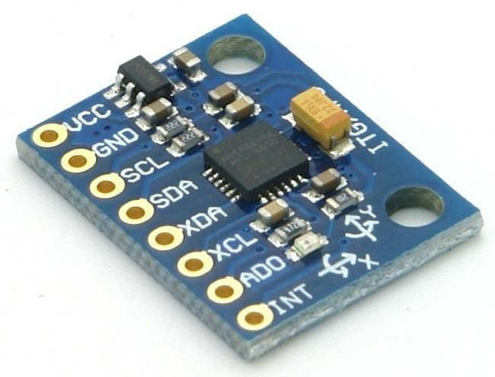

Figure ( MPU 6050 Accelerometer )

**Sensitivity:** The sensitivity can be configured to different ranges, such as ±2 g, ±4 g, ±8 g, and ±16 g. This allows the user to choose the appropriate range for their specific application.

**Low Power Consumption:** The accelerometer has low power consumption, making it suitable for battery-operated devices.

**Digital Outputs:** It provides digital outputs for the acceleration data, which can be directly read by a microcontroller.

**Gyroscope Specifications:**

**3-Axis Measurement:** The MPU6050 includes a 3-axis gyroscope that can measure rotational motion around the X, Y, and Z axes.

**Resolution:** The gyroscope has a 16-bit ADC, providing a resolution of up to ±2000 degrees per second (dps).

**Sensitivity:** The sensitivity can be configured to different ranges, such as ±250 dps, ±500 dps, ±1000 dps, and ±2000 dps. This allows the user to choose the appropriate range for their specific application.

**Digital Outputs:** It provides digital outputs for the gyroscope data, which can be directly read by a microcontroller.

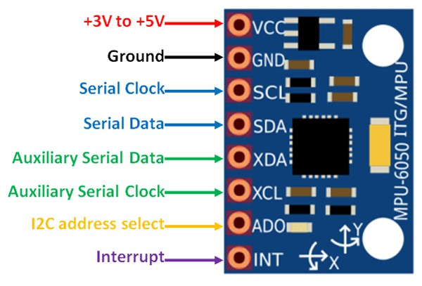

Figure ( MPU6050 Pin Diagram )

**Communication Interface:**

The MPU6050 accelerometer communicates with an external microcontroller using the I2C (Inter-Integrated Circuit) serial interface. It supports standard I2C communication protocols and can be easily interfaced with popular microcontrollers such as Arduino.

**Motion Processing:**

The MPU6050 includes an on-chip Digital Motion Processor (DMP) that offloads complex motion processing tasks from the external microcontroller. The DMP provides features such as motion detection, gesture recognition, and sensor fusion (combining accelerometer and gyroscope data) to obtain accurate motion tracking information.

**Applications:**

The MPU6050 accelerometer finds applications in various fields due to its precise motion sensing capabilities. Some common applications include:

**Robotics:** The module is used in robotics for orientation estimation, balancing robots, and controlling robotic arms.

**Motion Tracking:** It is used in motion capture systems for tracking human movements in virtual reality, gaming, and animation.

**Gesture Recognition:** The MPU6050 can detect gestures and movements for user interaction in applications such as gesture-controlled devices and interfaces.

**Inertial Measurement Units (IMUs):** It is a key component of IMUs used in navigation systems, drones, and aircraft for accurate motion tracking and attitude estimation.

**Vibration Analysis:** The accelerometer can be used to measure vibrations in structures, machines, and vehicles for condition monitoring and predictive maintenance.

In conclusion, the MPU6050 accelerometer is a versatile motion sensor module that combines a 3-axis accelerometer and a 3-axis gyroscope in a single chip. It provides precise motion sensing capabilities, configurable sensitivity ranges, and an on-chip motion processing unit. With its compact size, low power consumption, and ease of integration, the MPU6050 is widely used in various applications that require motion tracking and orientation estimation.

**2.2.3 DHT11**

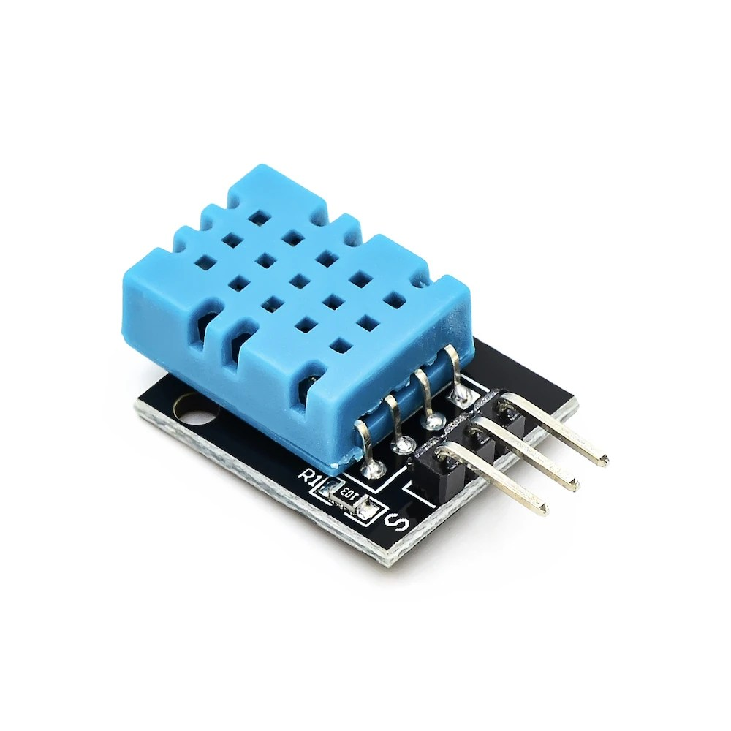

Relative humidity sensors usually contain a humidity sensing element along with a thermistor to measure temperature. For a capacitive sensor, the sensing element is a capacitor. Here the change in electrical permittivity of the dielectric material is measured to calculate the relative humidity values.Low resistivity materials are used for the construction of a Resistive sensor. This resistive material is placed on top of two electrodes. Change in the resistivity value of this material is used to measure the change in humidity.Salt, solid electrolytes and conductive polymers are the examples of resistive material used in Resistive sensor. Thermal conductive sensors measure Absolute humidity values.

**2.2.4 Moisture Sensor**

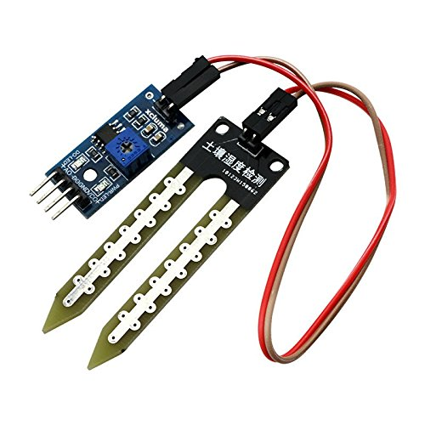

Probes or electrodes: Soil moisture sensors consist of two or more probes that are inserted into the soil. These probes are usually made of conductive materials such as metal or stainless steel.Electrical measurement: When the probes come in contact with the soil, they measure the electrical properties of the soil. Dry soil has high resistance, while moist soil has low resistance due to the presence of moisture, which serves as an electrical conductor.Sensor output: The resistance or conductivity measurements obtained from the probes are converted into a measurable electrical signal. This signal can be in analog or digital form, depending on the type of sensor.Calibration: Soil moisture sensors often require calibration to establish a baseline measurement for different soil types. This helps in obtaining accurate readings specific to the soil being monitored.

some applications of soil moisture sensors:Irrigation control: Soil moisture sensors are commonly used in agricultural settings to optimize irrigation practices. By monitoring the moisture levels in the soil, farmers can determine when and how much water to supply to their crops, avoiding overwatering or underwatering, which can lead to water wastage or crop damage.Smart gardening: Soil moisture sensors enable individuals to maintain healthier plants in their gardens or indoor potted plants. By receiving real-time data on soil moisture, users can automate irrigation systems or receive alerts to water their plants when moisture levels are low.Environmental monitoring: Soil moisture sensors are utilized in ecological and environmental studies to monitor soil moisture content in various habitats. This data helps scientists understand soil moisture patterns, which can impact plant growth, hydrology, and climate modeling.Sports field maintenance: Soil moisture sensors play a vital role in maintaining sports fields, golf courses, and other outdoor recreational areas. By monitoring the moisture levels, groundskeepers can efficiently manage irrigation schedules and prevent overwatering or dry patches, ensuring optimal playing conditions.

**2.2.5 NEO-6M GPS SENSOR**

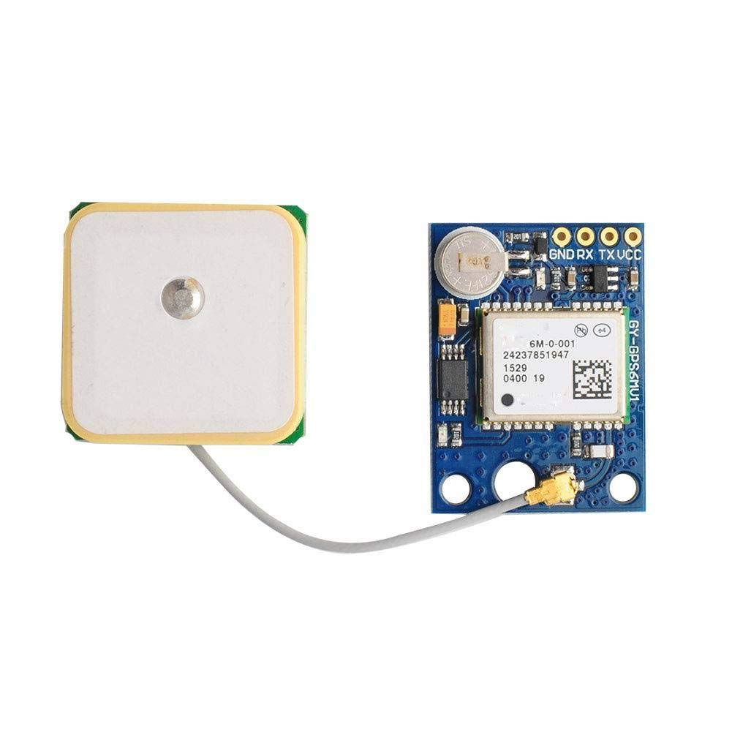

Working Principle:**GPS Satellite Reception**: The NEO-6M GPS sensor receives signals from multiple GPS satellites orbiting the Earth.**Signal Processing**: The sensor processes the received satellite signals to determine the distances between the sensor and each satellite. This is achieved through the measurement of signal travel time.**Trilateration**: By measuring the distances to multiple satellites, the sensor performs trilateration calculations to determine its precise location on the Earth's surface.**Data Output**: The NEO-6M GPS sensor provides the calculated latitude, longitude, altitude, and other relevant information in a standardized format (usually NMEA, or National Marine Electronics Association) through a serial interface.Applications:**Navigation Systems**: The NEO-6M GPS sensor is commonly used in navigation systems for vehicles, ships, drones, and aircraft. It enables accurate real-time positioning, route tracking, and guidance, enhancing safety and efficiency in transportation.**Mapping and Surveying**: GPS sensors like NEO-6M are extensively used in mapping and surveying applications. They facilitate the collection of precise location data for creating digital maps, topographic surveys, land surveys, and GIS (Geographic Information System) applications.**Asset Tracking**: The NEO-6M GPS sensor plays a crucial role in asset tracking systems. It enables real-time tracking and monitoring of vehicles, goods, or equipment, providing valuable information for logistics, fleet management, and anti-theft purposes.**Outdoor Recreation**: GPS sensors are utilized in outdoor recreational activities such as hiking, camping, and geocaching. The NEO-6M sensor enables accurate tracking of routes, waypoints, and helps users navigate through unfamiliar terrains.**Time Synchronization**: GPS sensors are widely used for precise time synchronization in various systems, including telecommunications, scientific experiments, financial transactions, and network infrastructure. The accurate time information from the NEO-6M sensor aids in data coordination and synchronization across different devices and networks.**Precision Agriculture**: In agriculture, GPS sensors like NEO-6M are employed for precision farming practices. They assist in field mapping, yield monitoring, variable rate application of fertilizers and pesticides, and autonomous navigation for agricultural machinery.**Emergency Services**: GPS sensors are integrated into emergency response systems, allowing quick and accurate location determination in emergency situations. This aids in dispatching emergency services to the exact coordinates, improving response times and potentially saving lives.

**2.2.5 HX710B PRESSURE SENSOR**

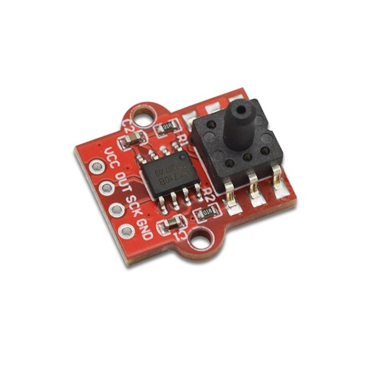

The HX710B Air Pressure Sensor Module is simple to use. The steps below could serve as a reference:Use conventional protocols such as I2C or SPI to attach the module to a microcontroller or other electric devices.Connect the module to power and wait for it to stabilise.To use a microcontroller or other electronic gadget, obtain the pressure value from the module's output.To guarantee precise pressure measurement, calibrate the module if necessary.

**APPLICATIONS**

The HX710B Air Pressure Sensor Module is utilised in a variety of applications where accurate and dependable pressure detection is required. The module is commonly used for the following purposes:Environment monitoring: The module may be used to record air pressure and provide feedback on weather conditions including such variations in atmospheric pressure, that can contribute in weather pattern prediction.The module can be utilized to measure pressure in diverse manufacturing systems, including such pneumatic and hydraulic ones, in order to verify that they are working under safe and appropriate pressure limits.Healthcare devices: The device may be utilized to monitor the pressure of air or oxygen provided to patients who use medical instrumentation including respiratory machines.Gas pressure measuring system: The module can be employed to monitor gas flow and diagnose leaks by measuring the pressure of gas in pipelines and other gas distribution networks.Automotive: The module can be integrated into automobile applications including such tyre pressure monitoring equipment to detect air pressure in tyres and inform drivers if the pressure is not high enough.

**2.2.6 RFID/TAGS**

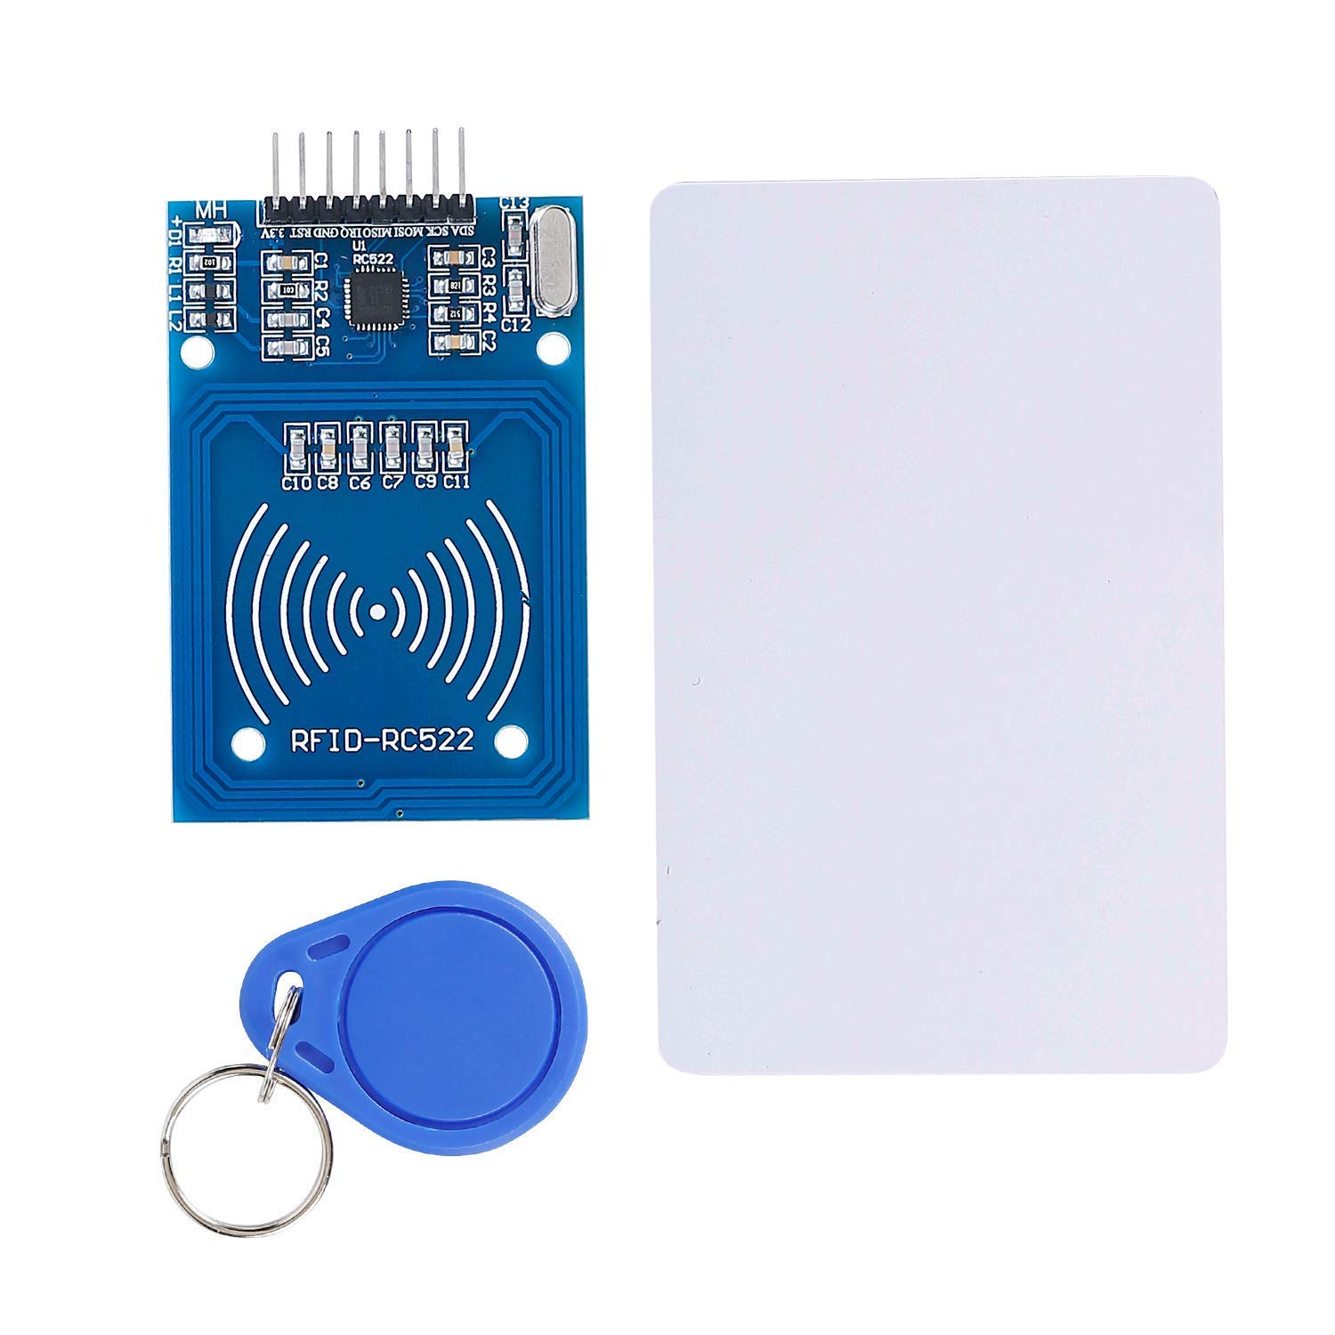

RFID (Radio Frequency Identification) is a technology that uses radio waves to wirelessly identify and track objects or individuals. It consists of two main components: RFID tags and RFID readers.Working Principle of RFID:RFID Tags: RFID tags, also known as transponders, are small electronic devices that contain an integrated circuit (IC) and an antenna. The IC stores data that uniquely identifies the tag. The antenna allows the tag to communicate wirelessly with RFID readers.RFID Readers: RFID readers consist of an antenna and a transceiver. The antenna emits radio waves and receives signals from RFID tags in its vicinity. The transceiver decodes the received signals and communicates with the system's software or database.Communication: When an RFID tag enters the range of an RFID reader, the reader's antenna energizes the tag by sending radio frequency signals. The energized tag responds by transmitting its stored data back to the reader.Data Exchange: The RFID reader captures the transmitted data from the tag and sends it to the system for processing. The system can then use the received data to identify and track the tagged object or individual.Applications of RFID:Supply Chain and Inventory Management: RFID is widely used in supply chain and inventory management systems. It allows for efficient tracking and management of products, enabling real-time inventory updates, reducing manual errors, and improving stock visibility.Access Control and Security: RFID is employed in access control systems for secure entry and exit management. It is used in applications such as keyless entry systems, electronic toll collection, electronic passports, and employee identification cards.Asset Tracking: RFID tags are utilized to track and manage valuable assets, such as equipment, tools, and vehicles. This enables organizations to monitor the location, movement, and utilization of assets, enhancing operational efficiency and reducing losses.Retail and Point of Sale (POS): RFID is increasingly being adopted in retail for inventory management, anti-theft measures, and enhancing the shopping experience. RFID tags can be attached to products, enabling quick and accurate stock counts, automated checkouts, and personalized marketing.Healthcare: In healthcare settings, RFID is used for patient identification, tracking medical equipment and supplies, and managing inventory. It helps improve patient safety, streamline operations, and reduce errors in medication administration.Animal Tracking: RFID tags are utilized in animal tracking and identification, particularly in livestock and wildlife management. They enable farmers, researchers, and conservationists to monitor animal behavior, migration patterns, and health records.Library Management: RFID is employed in libraries for efficient book tracking, self-checkout systems, and anti-theft measures. It simplifies inventory management, speeds up checkouts, and enhances the overall library experience.Waste Management: RFID tags can be integrated into waste containers to optimize waste collection and disposal processes. They enable tracking of bins, monitoring fill levels, and optimizing collection routes, leading to cost savings and environmental benefits.

**2.2.7 BREAD BOARD**

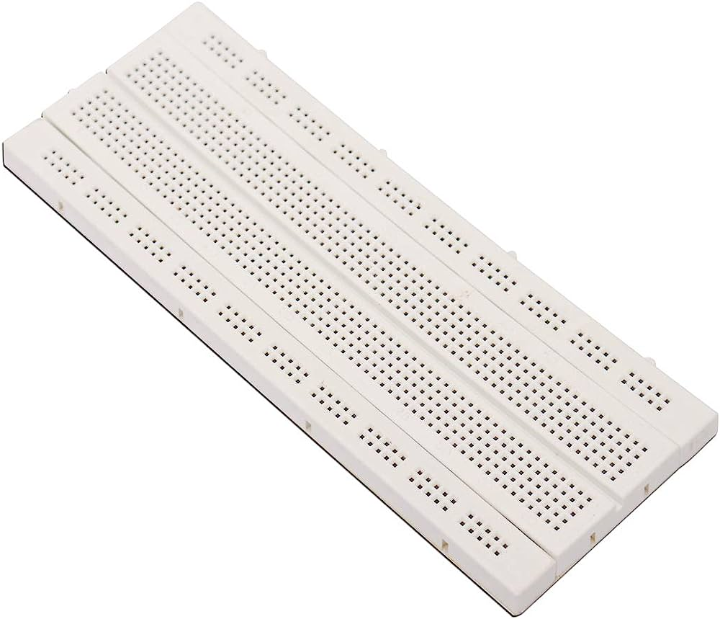

Working Principle of a Breadboard:**Terminal Strips**: A breadboard consists of a plastic board with numerous rows and columns of metal clips or spring connectors, usually arranged in a grid pattern. These metal clips are internally connected in specific patterns.**Connection Points**: Each row in a breadboard typically represents a common electrical connection. The clips within a row are connected internally, allowing components inserted into the same row to be electrically connected.**Power Rails**: Most breadboards have two vertical rows called power rails running along the sides. These power rails are often color-coded, with one rail connected to the positive voltage supply (usually +5V or +3.3V) and the other rail connected to the ground (GND).**Component Insertion**: Electronic components, such as resistors, capacitors, integrated circuits (ICs), and various other discrete components, can be inserted into the breadboard's clips. The component's leads or legs are inserted into the appropriate rows to establish electrical connections.**Temporary Connections**: When components are inserted into the breadboard, their leads make contact with the metal clips, creating temporary electrical connections without the need for soldering. Components can be easily repositioned or replaced as needed.**Applications of a Breadboard:Prototyping and Experimentation**: Breadboards are primarily used for prototyping and testing electronic circuits. They allow engineers, hobbyists, and students to quickly assemble and test circuit designs without the need for permanent soldering. This facilitates rapid iteration, troubleshooting, and refinement of circuit designs.**Educational Purposes**: Breadboards are widely used in electronics education to teach basic circuit concepts and enable hands-on learning. They provide a safe and accessible environment for students to explore and understand circuit theory and component interconnections.**Circuit Design Validation**: Before designing a printed circuit board (PCB), breadboards are often used to validate circuit functionality and test various configurations. Breadboards help in verifying the feasibility and performance of a circuit design before committing to the more permanent and time-consuming process of PCB fabrication.**Arduino and Raspberry Pi Projects**: Breadboards are frequently used in conjunction with microcontrollers, such as Arduino and Raspberry Pi boards, for creating interactive projects. Breadboards allow easy integration of sensors, actuators, and other electronic components required for building prototype circuits and systems.**Component Testing**: Breadboards can be used to test individual electronic components to verify their functionality or measure their characteristics, such as resistance, capacitance, or voltage.

**CHAPTER 3**

**Block Diagram:**

**Circuit Diagram:**

**CIRCUIT CONNECTIONS:**

SS_PIN 10 // Slave Select Pin for RFID

RST_PIN 9 // Reset Pin for RFID

DHTPIN 2 // Pin connected to the DHT sensor

DHTTYPE DHT11 // DHT sensor type (DHT11 or DHT22)

MOISTURE_PIN A0 // Analog input pin for soil moisture sensor

BMP180_SDA_PIN A4 // Pin connected to BMP180 SDA (data)

BMP180_SCL_PIN A5 // Pin connected to BMP180 SCL (clock

(3, 4); // RX, TX pins for GPS module

**CHAPTER 4**

Chapter 4: Demonstration/Evaluation and Results:

Demonstration/Evaluation and Results of Supply Chain Monitoring System Using IoT:To evaluate the effectiveness and potential benefits of a supply chain monitoring system using IoT, a demonstration was conducted to showcase its capabilities and assess its impact on supply chain operations. The following sections provide an overview of the demonstration, the evaluation process, and the results obtained.1. Demonstration Overview:The demonstration involved implementing an IoT-enabled supply chain monitoring system in a simulated supply chain environment. The system incorporated IoT sensors, communication devices, data analytics, and a centralized monitoring dashboard. Key components, such as temperature sensors, GPS trackers, and RFID tags, were deployed at various points in the supply chain to collect real-time data.The demonstration aimed to showcase the system's ability to provide real-time visibility, track and trace products, monitor environmental conditions, and generate actionable insights for supply chain optimization.2. Evaluation Process:The evaluation of the supply chain monitoring system using IoT involved assessing its performance based on predetermined metrics and objectives. The following evaluation criteria were considered:a. Real-time Visibility: The system's ability to provide real-time visibility into the movement and location of goods within the supply chain was assessed. This included tracking the status of shipments, monitoring inventory levels, and identifying potential bottlenecks or delays.b. Environmental Monitoring: The effectiveness of the system in monitoring environmental conditions, such as temperature, humidity, and vibration, was evaluated. It aimed to ensure that products were stored and transported under optimal conditions to maintain their quality and integrity.c. Data Analytics and Insights: The system's data analytics capabilities were evaluated to assess its ability to generate actionable insights and provide decision support. The analysis included identifying trends, detecting anomalies, and recommending proactive measures for supply chain optimization.d. System Reliability and Scalability: The reliability and scalability of the IoT infrastructure were evaluated to determine the system's ability to handle large volumes of data, accommodate additional sensors/devices, and maintain uninterrupted connectivity.3. Results:The demonstration and evaluation of the supply chain monitoring system using IoT yielded the following results:a. Real-time Visibility: The system successfully provided real-time visibility into the movement and location of goods within the supply chain. Stakeholders could track shipments, monitor inventory levels, and identify potential issues in real-time, enabling prompt action and improved decision-making.b. Environmental Monitoring: The system effectively monitored environmental conditions, such as temperature and humidity, ensuring that products were stored and transported under optimal conditions. Deviations from predefined thresholds triggered alerts, allowing timely intervention to prevent quality issues or spoilage.c. Data Analytics and Insights: The system's data analytics capabilities provided valuable insights for supply chain optimization. By analyzing the collected data, trends, patterns, and potential issues were identified. The system generated actionable recommendations to optimize inventory management, streamline logistics operations, and improve overall supply chain efficiency.d. System Reliability and Scalability: The IoT infrastructure demonstrated reliability and scalability, handling a large volume of data from multiple sensors/devices. The system maintained uninterrupted connectivity, enabling seamless data collection and real-time monitoring throughout the supply chain.Overall, the results of the demonstration and evaluation confirmed the effectiveness of the supply chain monitoring system using IoT. The system provided real-time visibility, enhanced environmental monitoring, generated valuable insights, and demonstrated reliability and scalability. These outcomes indicated the system's potential to improve supply chain performance, reduce costs, optimize inventory management, enhance customer satisfaction, and mitigate risks in real-world supply chain operations.It is important to note that the specific results and outcomes may vary depending on the implementation, configuration, and specific requirements of each organization's supply chain. The demonstration and evaluation provide a foundation for understanding the potential benefits and assessing the feasibility of implementing an IoT-enabled supply chain monitoring system.

**CHAPTER 5**

**Conclusion:**

In conclusion, IoT-enabled supply chain monitoring systems have emerged as a critical solution for organizations seeking to enhance supply chain visibility, traceability, inventory management, logistics efficiency, and overall operational performance. The integration of IoT sensors, communication protocols, edge computing, cloud computing, and data analytics enables real-time monitoring, data collection, analysis, and decision-making, transforming traditional supply chains into intelligent, connected ecosystems.Throughout this report, we have explored the concept, components, challenges, benefits, and future advancements of IoT-enabled supply chain monitoring systems. We have highlighted the importance of these systems in addressing the complexities of modern supply chains, meeting customer expectations, optimizing costs, ensuring compliance, and mitigating risks. By leveraging IoT technologies, organizations can achieve enhanced visibility, transparency, and control over their supply chain operations, leading to improved customer satisfaction, increased efficiency, and competitive advantage.The applications of IoT-enabled supply chain monitoring systems span across various domains. From inventory management and demand forecasting to logistics optimization and product quality monitoring, IoT technologies provide organizations with real-time insights and actionable data to make informed decisions and drive operational excellence. Additionally, the integration of emerging technologies such as blockchain, artificial intelligence, and robotics opens up new possibilities for further improving supply chain processes, security, sustainability, and customer service.While the implementation of IoT-enabled supply chain monitoring systems offers significant benefits, it also presents challenges. Security concerns, interoperability issues, scalability, data integration complexities, and cost considerations are among the key obstacles that organizations need to address. However, through standardization efforts, industry collaboration, and strategic planning, these challenges can be overcome, allowing organizations to unlock the full potential of IoT in supply chain management.

**Future Work:**

Looking to the future, the potential advancements in IoT-enabled supply chain monitoring systems are promising. The integration of blockchain technology can enhance data security, transparency, and trust in supply chain transactions. Edge AI and predictive analytics will enable real-time decision-making and proactive supply chain management. The adoption of autonomous systems and robotics will revolutionize warehouse operations and last-mile deliveries. These advancements, along with improved interoperability and sustainability monitoring, will shape the future of supply chain management, further optimizing efficiency, reducing costs, and meeting evolving customer expectations.In conclusion, the implementation of IoT-enabled supply chain monitoring systems is no longer an option but a necessity for organizations seeking to thrive in the increasingly complex and competitive business landscape. By embracing IoT technologies and leveraging the benefits they offer, organizations can drive innovation, achieve operational excellence, and create a resilient and agile supply chain that delivers superior value to customers while optimizing costs and mitigating risks.

**REFERENCES:**

S. G. Kumar, S. Prince and B. M. Shankar, "Smart Tracking and Monitoring in Supply Chain Systems using RFID and BLE," 2021 3rd International Conference on Signal Processing and Communication (ICPSC), Coimbatore, India, 2021, pp. 757-760, doi: 10.1109/ICSPC51351.2021.9451700.R. Hajar and N. Saida, "Supply chain management, between resilience and sustainability: A literature review," 2022 14th International Colloquium of Logistics and Supply Chain Management (LOGISTIQUA), EL JADIDA, Morocco, 2022, pp. 1-6, doi: 10.1109/LOGISTIQUA55056.2022.9938028.L. Wanganoo and V. K. Shukla, "Real-Time Data Monitoring in Cold Supply Chain Through NB- IoT," 2020 11th International Conference on Computing, Communication and Networking Technologies (ICCCNT), Kharagpur, India, 2020, pp. 1-6, doi: 10.1109/ICCCNT49239.2020.9225360.Daoyuan Shi, "Research on Supply Chain Management in enterprises based on E-commerce," 2011 International Conference on Computer Science and Service System (CSSS), Nanjing, China, 2011, pp. 3510-3512, doi: 10.1109/CSSS.2011.5974828.