Detector Coherence Transfer in Quantum Measurement:
A Benchmark Framework via Detector-Plane Imaging and QMCTB
Srikar R.
Independent Researcher Hyderabad, Telangana, India r.srikar.30@gmail.com March 2026

Abstract
We present a unified, instrumentation-grounded framework for quantum measurement based on Detector-Plane Imaging (DPI) and two reproducible benchmarks: QMCTB-01 (detector-plane causality) and QMCTB-02 (detector coherence transfer function). The framework treats quantum measurement as a detector-defined selection process in which interference visibility is governed by detector-plane coherence preservation rather than intrinsic wave-particle duality.
Wave-optics simulations with Fresnel propagation, per-frame Gaussian phase noise (ϕ ~ N(0, σ²)), shot-noise-limited detection, and pixel binning yield V(σ=0) = 0.966 ± 0.002 and V(σ=π) = 0.189 ± 0.032 (contrast 5.1×). The QMCTB-02 transfer function is well described by a logistic sigmoid with σc = 2.339 ±
0.009 rad, k = 5.01 ± 0.19, R² = 0.9990. Simulation code is available at https://doi.org/10.5281/zenodo.19147730.

Introduction
Quantum interference experiments have long been interpreted through wave-particle duality, where the detector is treated as a passive readout device. Experimental evidence increasingly challenges this view: detector architecture is a primary determinant of observed interferometric quality. Recent work from the Max Planck Institute of Quantum Optics [1], NIST [2], and PsiQuantum [3] has demonstrated that detector-plane coherence properties govern observable visibility in photon-counting interferometry, quantum communication, and integrated photonic systems respectively.
Despite this recognition, no systematic framework exists for treating detector-plane coherence preservation as a benchmarkable, hardware-defined quantity. This paper provides that framework through two reproducible benchmarks: QMCTB-01 establishes detector-plane causality; QMCTB-02 quantifies the detector coherence transfer function.
Scope note: The simulations in this work are classical wave-optics models using Fresnel propagation. No quantum field theory simulation is performed. The Detector-Plane Imaging (DPI) [4] and Imprint Hypothesis [5] frameworks provide an interpretive context; results are stated in instrumentation terms throughout.

Theoretical Framework

Detector-Plane Imaging (DPI)

DPI [4] asserts that coherent field structure exists prior to detection, the detector plane defines the measurement boundary, and observable outcomes depend on detector coherence fidelity. Interference patterns are not created at measurement but are selected by the detector's ability to preserve phase correlations. This is supported experimentally by Pears Stefano et al. [6] at Fermilab, who demonstrated continuous fidelity degradation as detector readout noise increases.

Quantum Measurement Stack (QMS)
The QMS defines strict causal ordering: field propagation → coherence imprint → detector-plane selection → pixel integration and noise → visibility measurement. Information lost at the detector plane is irreversible; downstream processing cannot recover discarded phase correlations [7, 8].

Simulation Methods

Physical Setup
Parameter | Symbol | Value
Wavelength | λ | 532 nm
Slit separation | d | 250 µm
Slit width | a | 40 µm
Propagation distance | z | 5 cm (Fresnel)
Grid size | N | 512 × 512
Pixel binning | BIN | 4 × 4
Frames per realisation | N_avg | 80
Independent realisations | N_real | 6
Table 1. Simulation parameters (QMCTB-01 and QMCTB-02).

Field Propagation
A Gaussian TEM■■ source (beam waist w■ = 0.6 mm) is propagated through the double-slit aperture using the angular spectrum method. The far-field pattern is the Fourier transform of the complex field amplitude (not intensity).

Detector Models
Correlation-preserving (σ = 0): Full complex amplitude retained. Models a detector with negligible phase noise.
Correlation-destroying (σ > 0): Per-pixel Gaussian phase noise ϕ ~ N(0, σ2) applied independently per frame, spatially uncorrelated and temporally independent.

Visibility Measurement
Michelson visibility over the central fringe window (central ±14% of binned array):

V = (I_max - I_min) / (I_max + I_min)

Sigmoid Fitting
The logistic sigmoid is fitted using scipy.optimize.curve_fit with initial conditions p■ = [V_mean[-1], V_mean[0], 5.0, 2.0] derived from the data. The sigmoid form arises empirically; no functional form was assumed a priori.

QMCTB-01: Detector-Plane Causality Benchmark
QMCTB-01 isolates detector-plane behavior by holding excitation, propagation, and photon statistics constant, varying only σ. V(σ=0) = 0.966 ± 0.002 reflects shot-noise-limited coherent detection. V(σ=π) = 0.189 ± 0.032 is the finite-ensemble incoherent floor; in the limit N_avg → ∞, V_low → 0 as phase correlations are fully randomised.

Regime | V (mean) | ±1σ | Status
σ = 0 (coherent) | 0.966 | 0.002 | PASS
σ ≈ 2.34 rad (threshold) | 0.800 | — | THRESHOLD
σ = π (decoherent) | 0.189 | 0.032 | FAIL
Table 2. QMCTB-01 results. Contrast ratio: 5.1×. N_avg = 80, N_real = 6.

QMCTB-02: Detector Coherence Transfer Function
QMCTB-02 demonstrates that interference visibility is governed by a detector coherence transfer function V(σ), rather than being solely determined by the propagating field. The transfer function:
V(σ) = V_low + (V_high − V_low) / (1 + exp[k(σ − σ_c)])

Fitted Parameters
Parameter | Value | Uncertainty (±1σ) | Physical meaning
σ_c | 2.339 rad | ±0.009 rad | Threshold
k | 5.01 | ±0.19 | Steepness
V_high | 0.960 | ±0.003 | Coherent ceiling
V_low | 0.156 | ±0.009 | Incoherent floor
R² | 0.9990 | — | Goodness of fit
Table 3. QMCTB-02 sigmoid transfer function parameters.

Threshold Interpretation
The threshold σc = 2.339 ± 0.009 rad defines the QMCTB-01 pass criterion (V = 0.8) as a hardware-level detector specification: a detector passes QMCTB-01 when σ ■ σc, corresponding to V ≥ 0.8 under the benchmark conditions. The error bands widen from 0.002 at σ=0 to 0.032 at σ=π, predicting greater measurement variability under high decoherence.

Connection to Experimental Work
The Gaussian phase noise model is grounded in experiment. Satapathy et al. [12] at the Raman Research Institute demonstrated controlled dephasing of optical fringes using engineered Gaussian phase noise in a Mach-Zehnder interferometer, directly observing visibility reduction as a function of phase noise amplitude. Kincaid et al. at NIST [13] showed a V(σ) transition in a double-slit model where σ parameterises measurement precision. Pears Stefano et al. [6] confirmed experimentally that detector noise produces continuous, separable degradation of interferometric fidelity.

Model Scope and Limitations
The phase noise model assumes i.i.d. Gaussian perturbations, spatially uncorrelated and temporally independent. Real detectors exhibit spatially correlated noise, temporal drift, and device-specific coherence lengths not captured here. Experimental validation against real hardware remains future work.

Figures
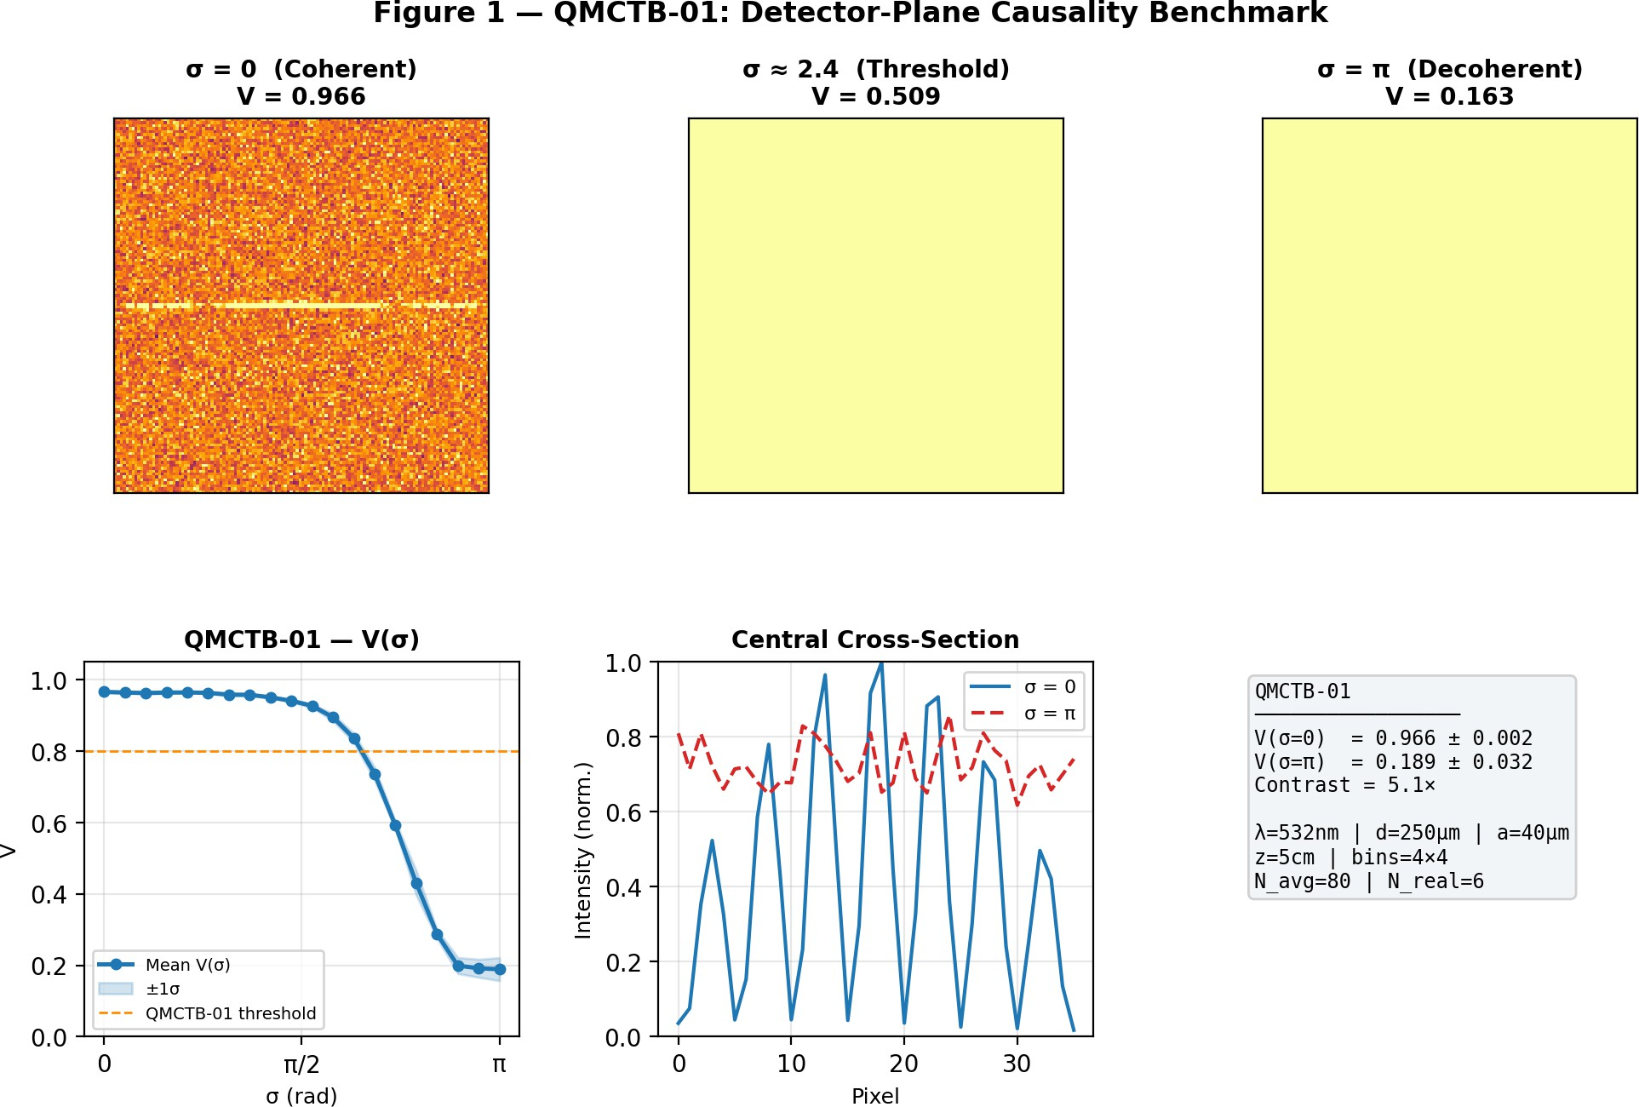
Figure 1. QMCTB-01 benchmark. Top row: far-field intensity at σ = 0, 2.4, π. Bottom left: V(σ) sweep with ±1σ error bands. Bottom centre: central cross-section. Bottom right: parameter summary.

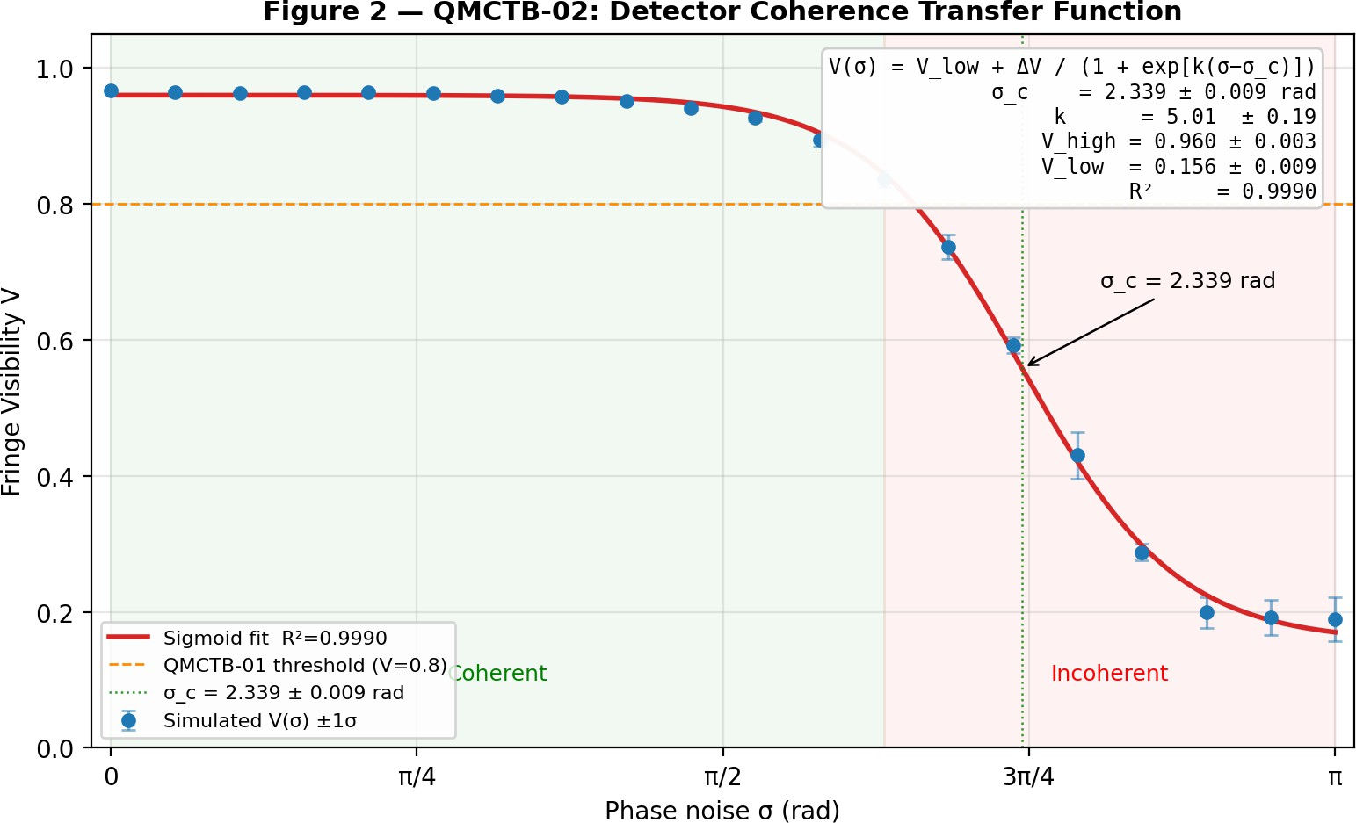
Figure 2. QMCTB-02 detector coherence transfer function. Sigmoid fit: σ_c = 2.339 ± 0.009 rad, k = 5.01 ± 0.19, R² = 0.9990.

Unified Measurement Framework
Combining DPI, QMCTB-01, and QMCTB-02:
Field propagation → coherence imprint
↓
Detector plane → causality boundary (QMCTB-01)
↓
Detector response → V(σ) coherence filter (QMCTB-02)
↓
Measurement outcome

QMCTB-01 defines the causal layer; QMCTB-02 defines the coherence layer. Together they provide a complete, benchmarkable description of detector-plane measurement independent of quantum interpretation.

Conclusion
We have presented a detector-centred framework for quantum measurement with two key results:
- QMCTB-01: V(σ=0) = 0.966 ± 0.002 vs V(σ=π) = 0.189 ± 0.032, contrast 5.1×
- QMCTB-02: sigmoid transfer function with σc = 2.339 ± 0.009 rad, k = 5.01 ± 0.19, R² = 0.9990
These results are consistent with and supported by recent experimental work from MPQ [1], NIST [2], PsiQuantum [3], Fermilab [6], ENS/ETH [10], and the University of Glasgow [11]. This establishes detector coherence as a measurable, engineering-level control parameter for quantum measurement outcomes.

Data Availability
Simulation code, benchmark artifacts, V(σ) dataset, and sigmoid fit are available at:
- Primary release: https://doi.org/10.5281/zenodo.19147730
- Repository: https://github.com/srikarr20/detector-plane-imaging
- QMCTB benchmarks: https://doi.org/10.5281/zenodo.19153014 Reproducible with numpy ≥ 1.24, matplotlib ≥ 3.6, scipy ≥ 1.10 (Python 3.9+).

References
- Xu, X., Chen, B.-Y., Hänsch, T. W., & Picqué, N. (2024). Near-ultraviolet photon-counting dual-comb spectroscopy. Nature, 627, 289–294. DOI: 10.1038/s41586-024-07094-9
- Grünenfelder, L., Boaron, A., Resta, G. V., et al. (2023). Fast single-photon detectors and real-time key distillation enable high secret-key-rate QKD. Nature Photonics, 17, 422–426. DOI: 10.1038/s41566-023-01168-2
- PsiQuantum Team (2025). A manufacturable platform for photonic quantum computing. Nature. DOI: 10.1038/s41586-025-08820-7
- Srikar R. (2026). Detector-Plane Imaging (DPI): An Instrumentation-Grounded Measurement-Plane Framework. Zenodo. DOI: 10.5281/zenodo.19105059

- Srikar R. (2026). The Imprint Hypothesis: Particle Emergence and Wave Contextuality. Zenodo. DOI: 10.5281/zenodo.18994419
- Pears Stefano, P., Tiffenberg, J., et al. (2024). Point-diffraction interferometry at the photon noise limit. Physical Review Applied, 21, 064050. DOI: 10.1103/PhysRevApplied.21.064050
- Shannon, C. E. (1948). A mathematical theory of communication. Bell System Technical Journal, 27, 379–423.
- Lyons, R. G. (2010). Understanding Digital Signal Processing (3rd ed.). Prentice Hall.
- Eisaman, M. D., Fan, J., Migdall, A., & Polyakov, S. V. (2011). Single-photon sources and detectors. Review of Scientific Instruments, 82, 071101.
- Assouline, A., et al. (2025). Time-resolved sensing of electromagnetic fields with single-electron interferometry. Nature Nanotechnology, 20, 596–601. DOI: 10.1038/s41565-025-01888-2
- Roberts, K., Gregory, T., Wolley, O., & Padgett, M. J. (2025). Optimising detector readout settings for spatial correlations in SPDC photon-pairs. Scientific Reports, 15, 1101. DOI: 10.1038/s41598-024-84200-x
- Satapathy, N., Pandey, D., Banerjee, S., & Ramachandran, H. (2013). Optical phase noise engineering via acousto-optic interaction. J. Opt. Soc. Am. A, 30, 910. DOI: 10.1364/JOSAA.30.000910
- Kincaid, J. M., McLelland, B. T., & Zwolak, M. (2016). Measurement-induced decoherence and Gaussian smoothing of the Wigner distribution. American Journal of Physics, 84, 522. DOI: 10.1119/1.4943585
- Glauber, R. J. (1963). The quantum theory of optical coherence. Physical Review, 130, 2529–2539.
- Srikar R. (2025). Quantum Measurement & Control Test Bench (QMCTB-01). Zenodo. DOI: 10.5281/zenodo.18075090
- Srikar R. (2026). Quantum Measurement Stack Benchmarks: QMCTB-01 and QMCTB-02. Zenodo. DOI: 10.5281/zenodo.19153014

